Pre 1.1)

a.
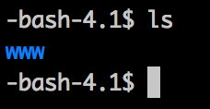

b.
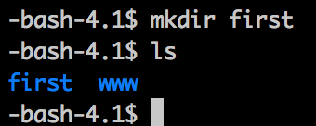

c.
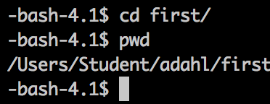

d.
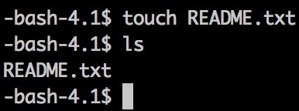

e.
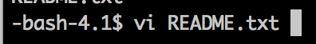



f.
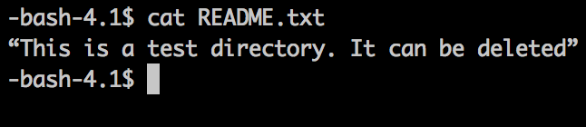

Pre 1.2)

Telnet transfers all data unencrypted over the network. It comes form a time when network security was not a big thing. You can see things such as passwords in plaintext if someone is using telnet. SSH, on the other hand, has been designed to be secure. All connections are encrypted. OpenBSD creates SSH and they patch vulnerabilities that are found.

FTP and FTPS are used for file transfers. The FTP protocol transfers data using two channels – command and data. The command channel is responsible for accepting client connection. The data channel is responsible for the actual transfer of data. FTP uses an unencrypted channel. Any data sent over these channels can be intercepted and read. FTPS on the other hand is more secure. The data travels over the network with SSL encryption.

Sources:
http://www.linuxquestions.org/questions/linux-networking-3/why-you-should-use-ssh-instead-of-telnet-388664/
http://www.jscape.com/blog/bid/75602/Understanding-Key-Differences-Between-FTP-FTPS-and-SFTP

