Linked Lists and the gdb Debugger

Patricia Gavelek, Anders Dahl
Gavelek.p@husky.neu.edu
dahl.a@husky.neu.edu

Submit date: Feb 7th, 2016
Due Date: Feb 8th, 2016

Abstract
This lab focuses on using gdb as a tool for debugging. It allows for step-by-step execution and memory inspection. Linked list data structures, where insertions and deletions have a constant cost, will also be introduced. A program capable of handling a linked list of people will be produced. The overall goal of this lab is to become familiar with both gdb and linked lists.

Introduction
This lab focuses on using gdb as a tool for debugging. It allows for step-by-step execution and memory inspection. Linked list data structures, where insertions and deletions have a constant cost, will also be introduced. Gdb will be used to debug and even break the linked list program. The overall goal of this lab is to become familiar with both gdb and linked lists.

Lab Discussion
The pre-lab consisted of the menu and the navigational aspects needed in the code. It made sure that the user could to navigate the different functions that were to be implemented. In order to develop the program, the C programming language, the gcc compiler, and the gdb debugger were all used.

Results and Analysis
Assignment 1
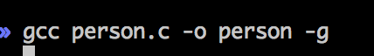
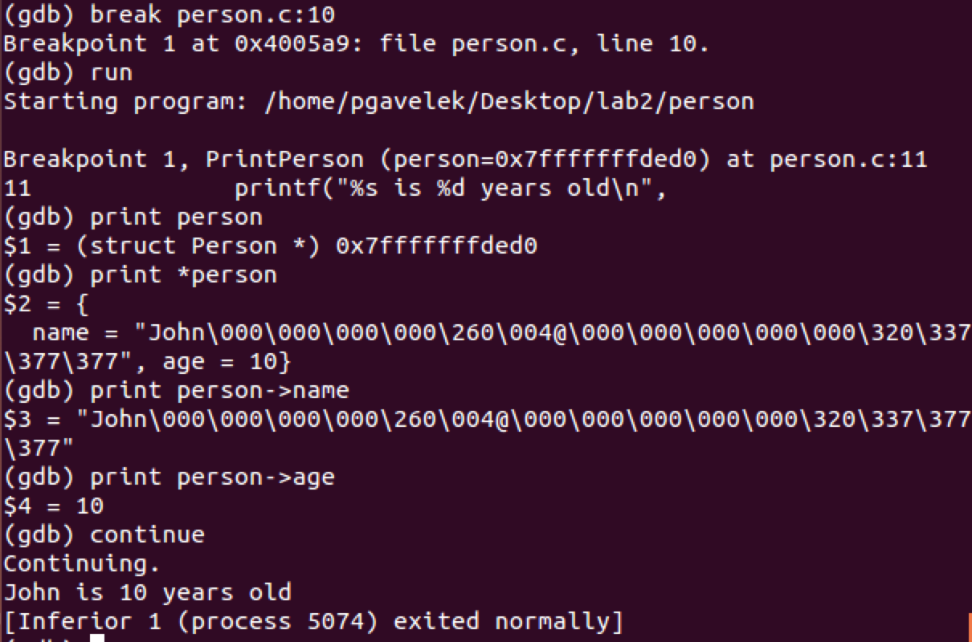
(gdb) print person: Prints the address pointing to a Person structure.

(gdb) print *person: Dereferences the address and prints the actual structure. Its associated values are also shown since they are part of the structure.

(gdb) print person→name: Dereferences the address and prints the value of the structure's name field. → name is a shorthand for *person.name

(gdb) print person→age: Deferences the address and prints the value of the structure's age field. → age is a shorthand for *person.age

Assignment 2 – Code (All of the new code, given code not included):
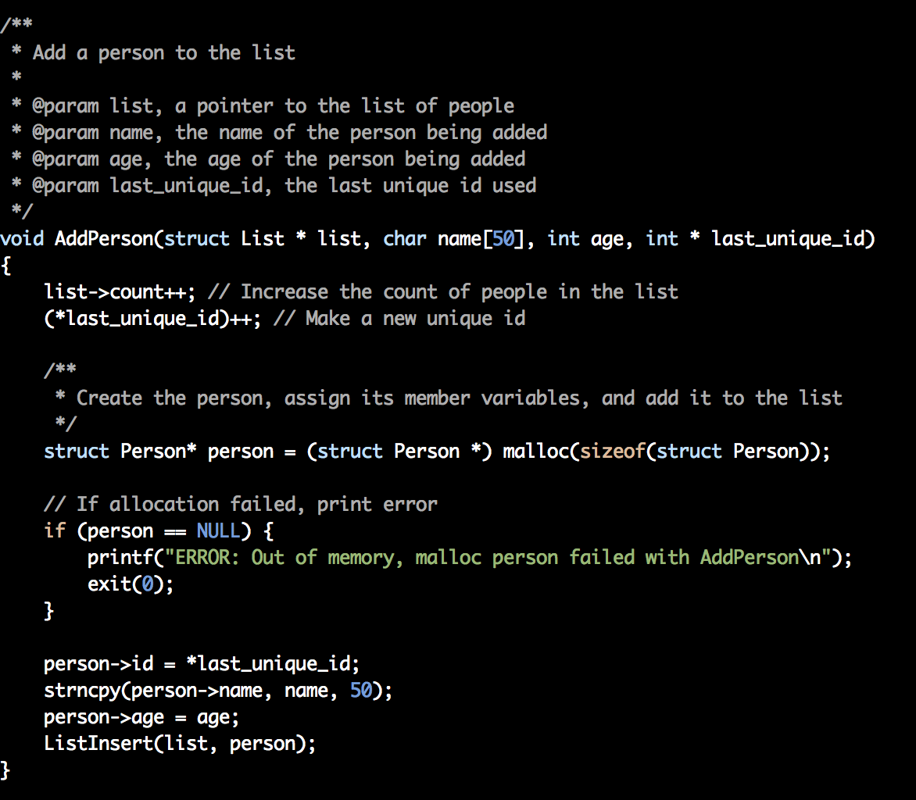
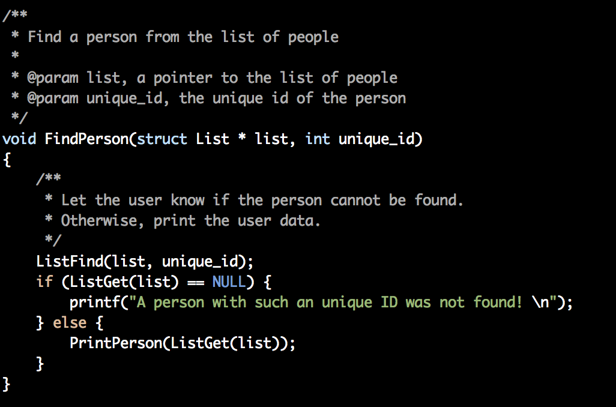

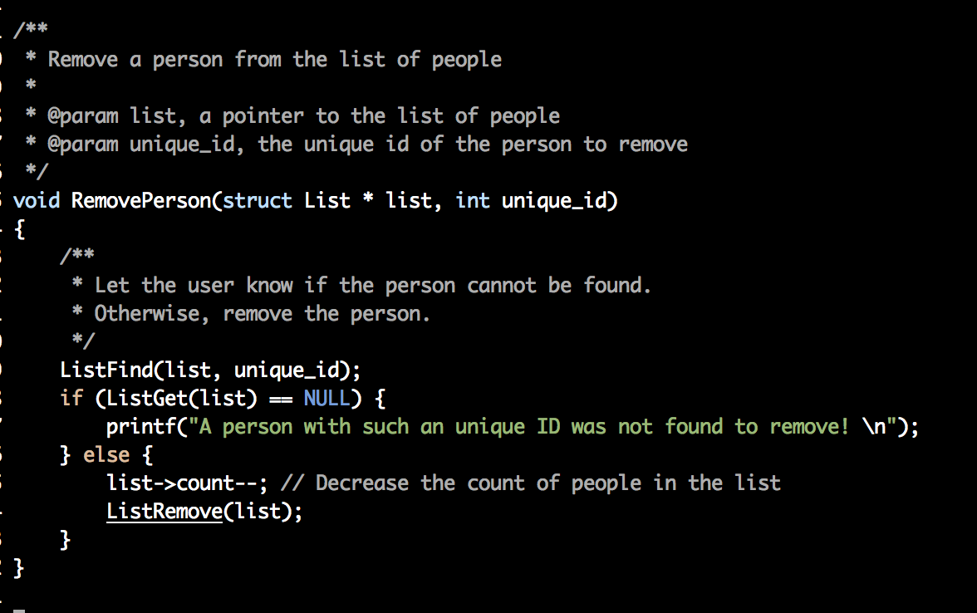
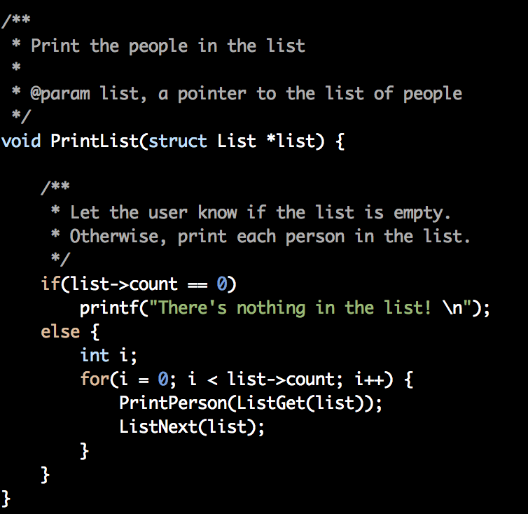

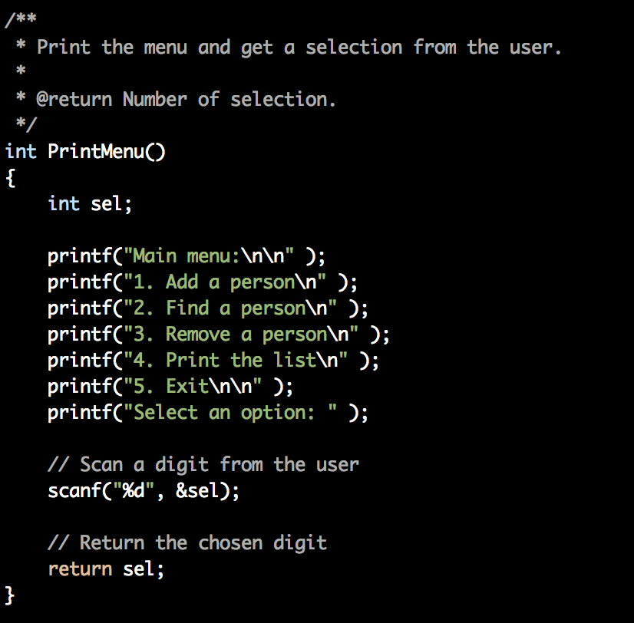

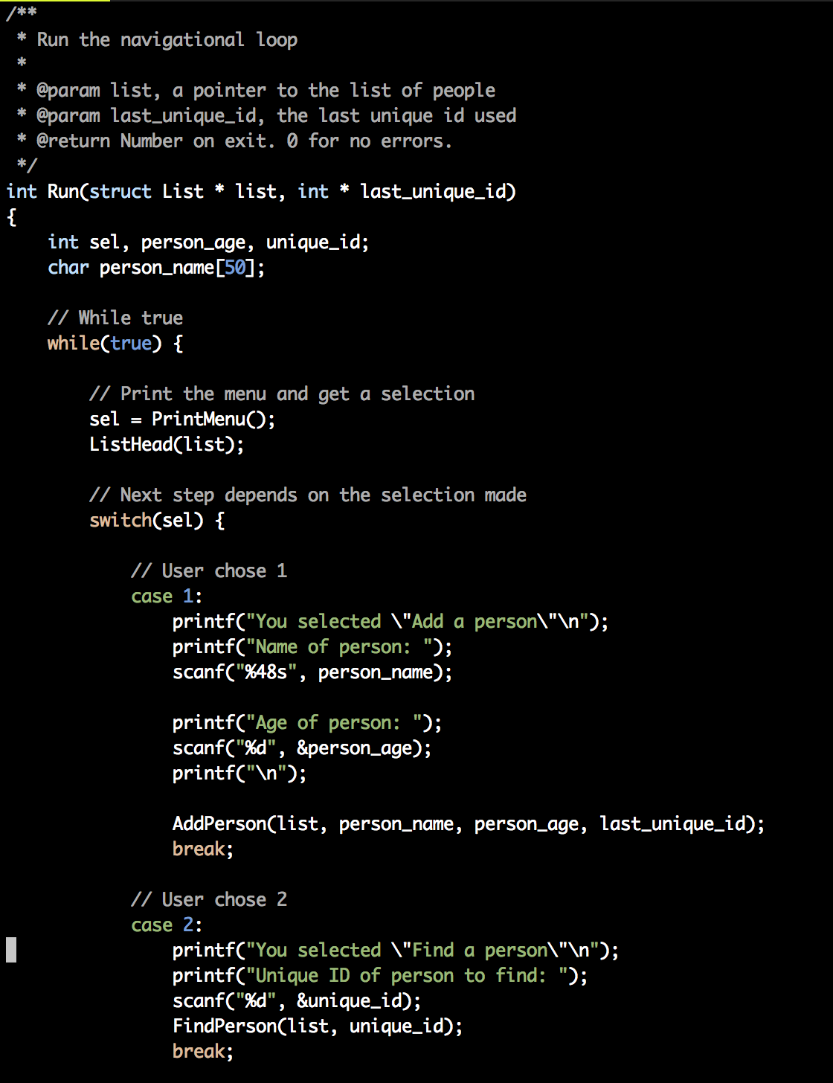
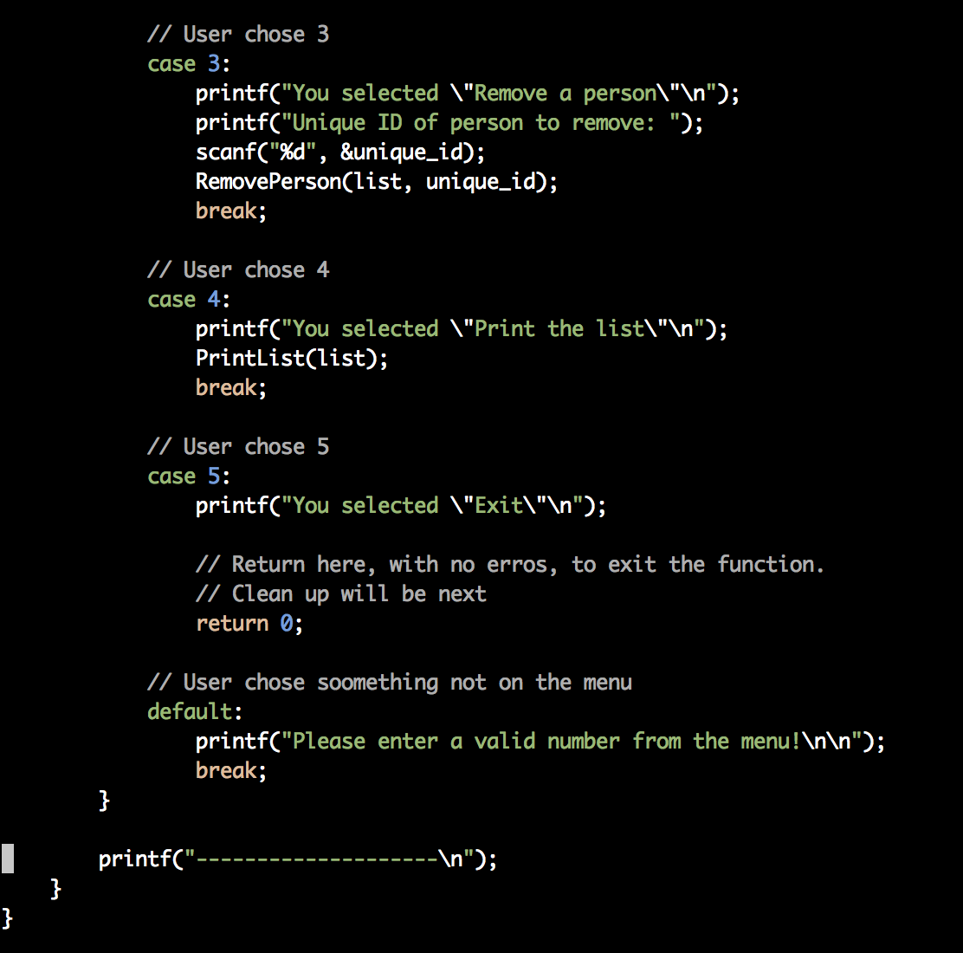

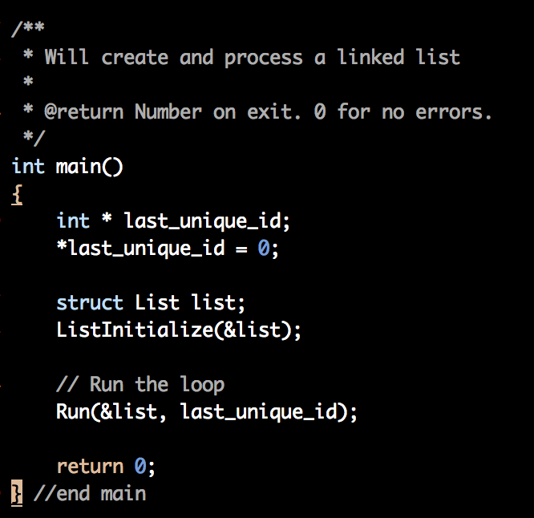

Assignment 3 – Running of the Code:
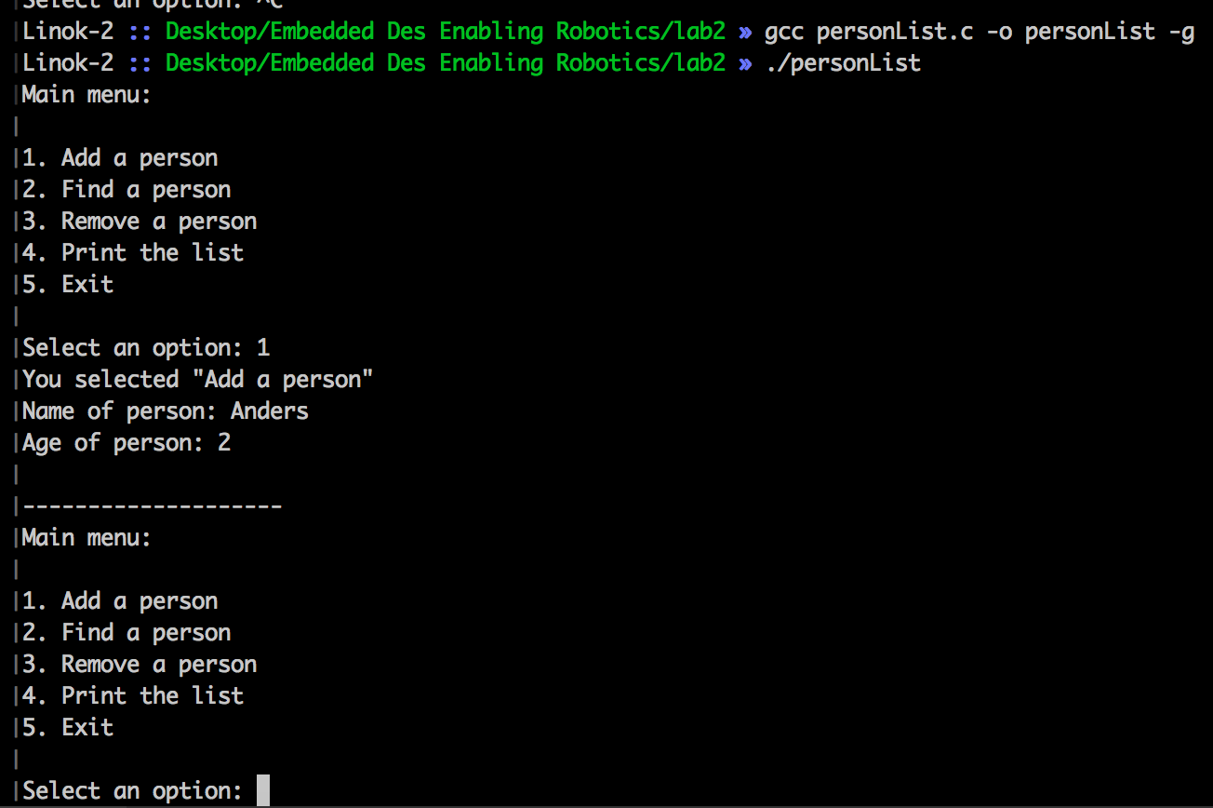
Option 1: Here the correct results are shown. We added a person, and it gets added to the program's list of people. We would have to print the list in order to see it, however.

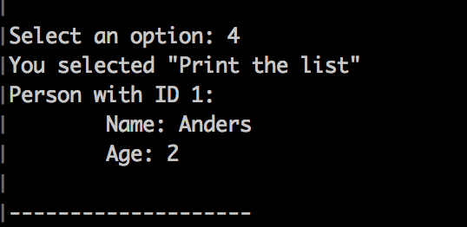

Option 4: We print the list, and as expected, the added person shows up.

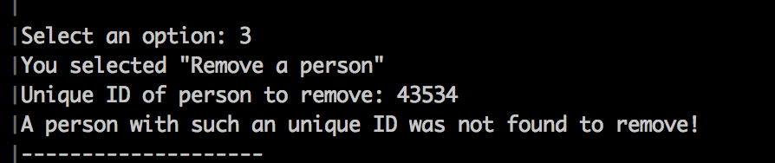

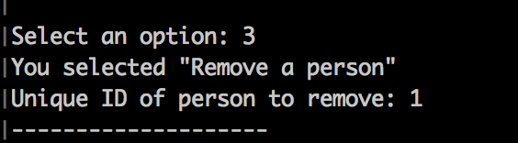

Option 3: If we try to remove a person who does not exist, we get an error. Otherwise, it removes the person.

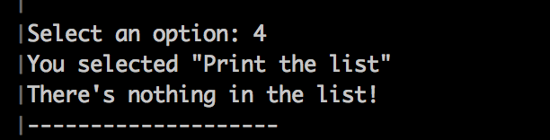

Option 1: Now, when the list is printed, it says the list is empty as expected.

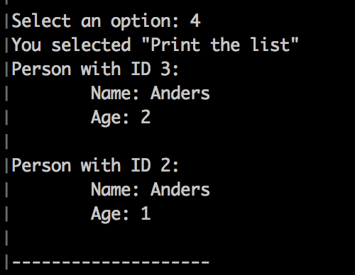

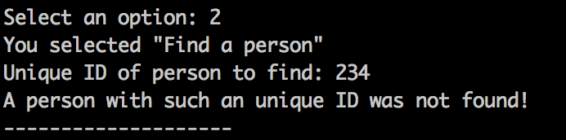

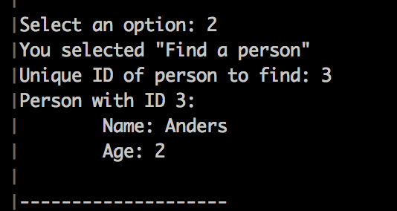

Option 2: If we try to find a person who does not exist, we get an error. Otherwise, it finds the person.
Assignment 4:
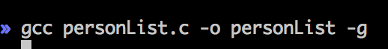

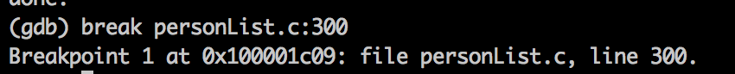

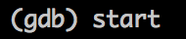

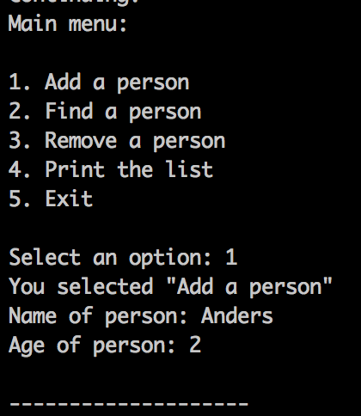

(gdb) print list
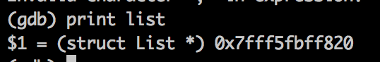

The command outputs the entire address stored in the pointer called list. It also describes what type of data the pointer points to, a List struct.

(gdb) print list.head
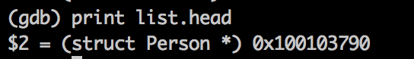

The command outputs the entire address of the head of the linked list. It also describes what type of data the pointer points to, a Person struct.

(gdb) print list.head->next
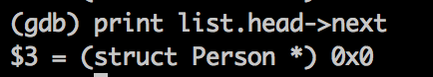

The command outputs the person after the head of the linked list. Since we only added one person, there is nothing after the head. The pointer points to NULL, 0x0, or nothing. It also describes what type of data the pointer should point to if a pointer existed, a person Struct.

Assignment 5:
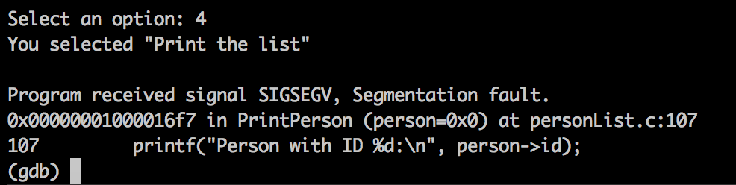

A segmentation fault here in indicates that the program was trying to read or write to an illegal memory location.
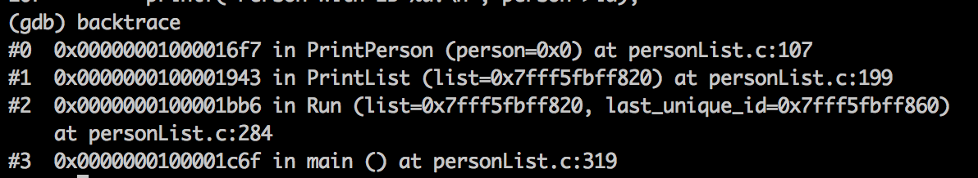
The backtrace (a trace going backwards) shows that the underlying issue occurs at personList.c:107. The person with address 0x0 seems to be having issues, obviously.
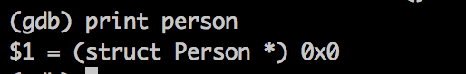

Print the person at this variable. Notice how the address is NULL.

After investigating the code at personList.c:107 the issue presents itself. We remove the line causing the error.

EXTRA CREDIT:
Extra Credit – Code:
In Run:
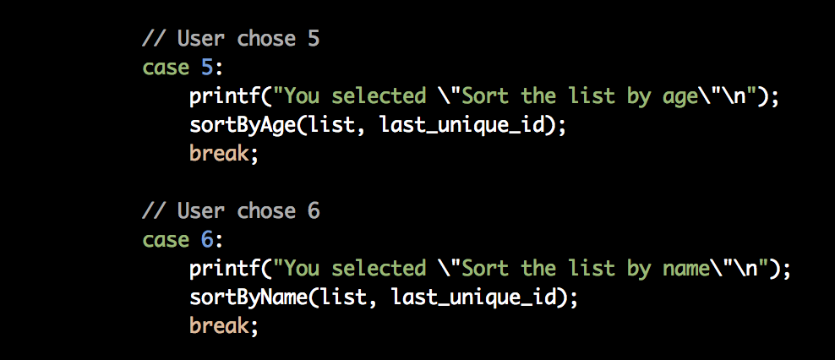
In PrintMenu:
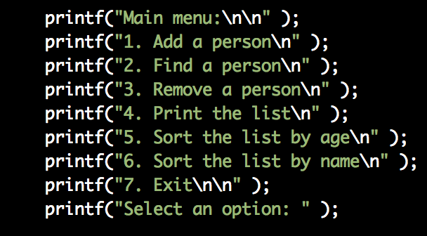

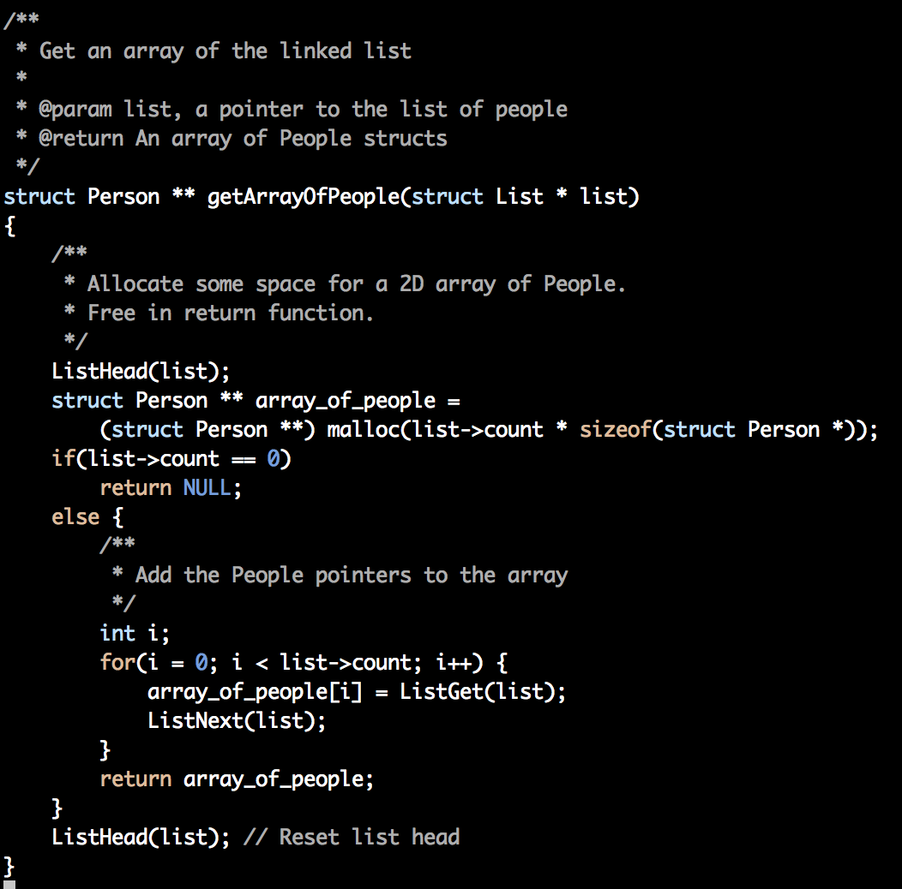

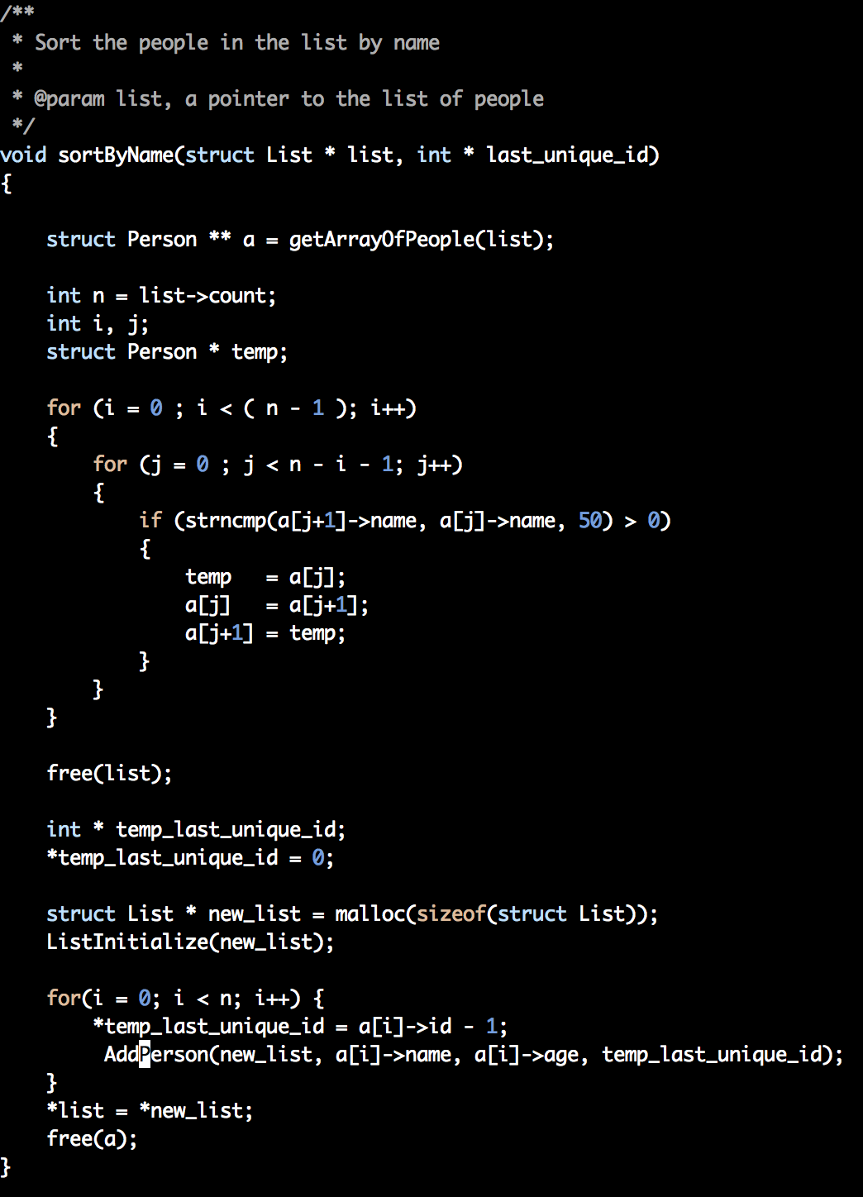
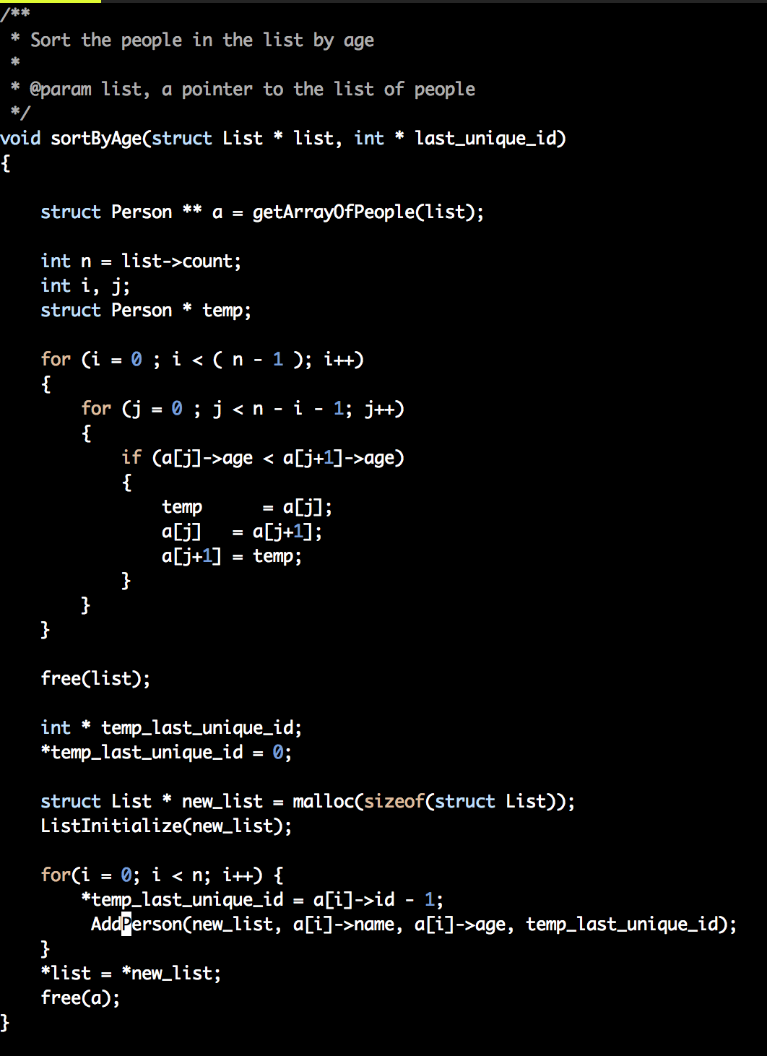
Extra Credit – Running the Code:
