Memory-Mapped I/O and Object-Oriented Programming

Patricia Gavelek, Anders Dahl
Gavelek.p@husky.neu.edu
dahl.a@husky.neu.edu

Submit date: Feb. 26, 2016
Due Date: Feb. 26, 2016

Abstract
This was the first lab using devices on the Zedboard. It introduced the concept of memory-mapped I/O to access devices available on the ZedBoard, including the LEDs, the switches, and buttons. We learned how to control these devices, first by writing a program that turned on the lights then by modifying the program to have the switches and buttons control the LEDs. In using the buttons, debouncing was a problem that had to be dealt with. Lastly, C++ was introduced, showing how the C++ classes could be used for abstraction when we changed our code to C++.

Introduction
In this lab we introduce the concept of memory-mapped I/O to access devices available on the ZedBoard, including the LEDs, the switches, and the push buttons. We learned how to control these devices, first by writing a program that turned on the lights then by modifying the program to have the switches and buttons control the LEDs. In using the buttons, debouncing was a problem that had to be dealt with. Lastly, C++ was introduced, showing how the C++ classes could be used for abstraction when we changed our code to C++. The lab also provided familiarity with the concept of a root user and access control. The root user was used to give a normal user sudo privileges on the ZedBoard. The ZedBoard offers a variety of tools to use. The LEDs, switches, and push buttons were all controllable through the use of code. The lab scratched the surface of the cool things one can accomplish with the ZedBoard.

Lab Discussion
In order to develop the programs, the C programming language, the gcc compiler, the gdb debugger, and the ZedBoard were all used. A variety of C libraries were needed – stdio, stdlib, fcntl, unistd, and sys/mman.
The pre-lab showed what would happen if the C program ran on a normal linux machine rather than the ZedBoard. It would not work. It also went through the functions seen in LedNumber.c, and the student had to describe what all the functions did. Here are the results:
a).

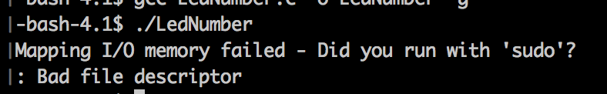

A file descriptor is an abstract indicator used to access an input/output source such as a file. The program fails during initialization. It tries to open "/dev/mem" for reading and writing, but it fails and returns -1 as the file descriptor. Next, the call to mmap exits with a perror message and the entire program shuts down.

b).

Initialize(): opens a file descriptor to “/dev/mem” with read and write access. It then returns an mmap which maps files or devices into memory. It wants to map the size of gpio_size, and each address should have an offset of gpio_address in the virtual address space. The allocated space should be readable, writable, and shared, and it should be linked to the file descriptor fd. The entire initialization returns the address to virtual memory which is mapped to physical or it gives an error.

Finalize(): closes previously open mappings and file descriptors. Removes the mapping previously allocated during initialize. Removes the entirety of it or the size of gpio_size. The finalize function then proceeds to close to opened file descriptor.

RegisterRead(): read a 4-byte value from the specified address in the virtual address space. You need to enter the base address returned from mmap and then the offset from that address.

RegisterWrite(): write a 4-byte value from the specified address in the virtual address space. You need to enter the base address returned from mmap and then the offset from that address. Now, at the correct location, write the value to that address space.

SetLedNumber(): Show the lower 8 bits of integer value on LEDs. This is done by writing to each address in control of the LEDs. The value of an individual bit can be calculated by utilizing modulus and division.

Results and Analysis
Assignment 2 – LedOnOff.c
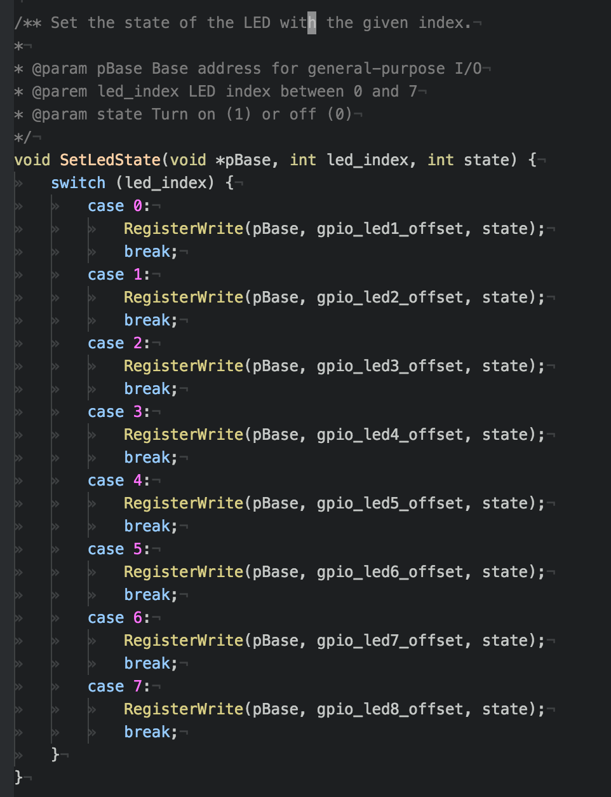

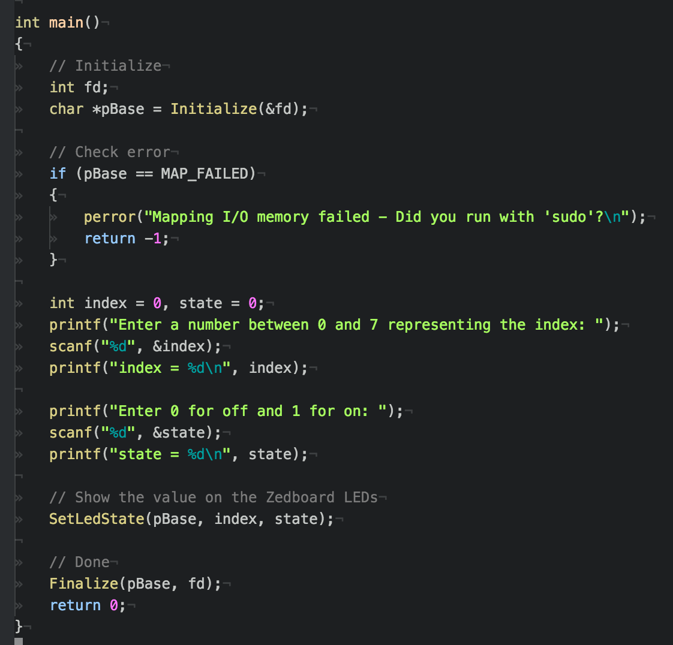

Assignment 2 – Running the Code
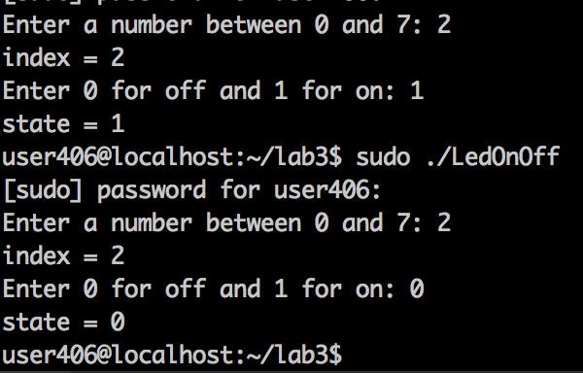

We tested on a variety of inputs, including the ones seen in the picture. We were able to turn individual LEDs on or off. We tried turning the same LED on twice. The expected behavior occurred – no change.

Assignment 3 – SwitchToLed.c:
a)

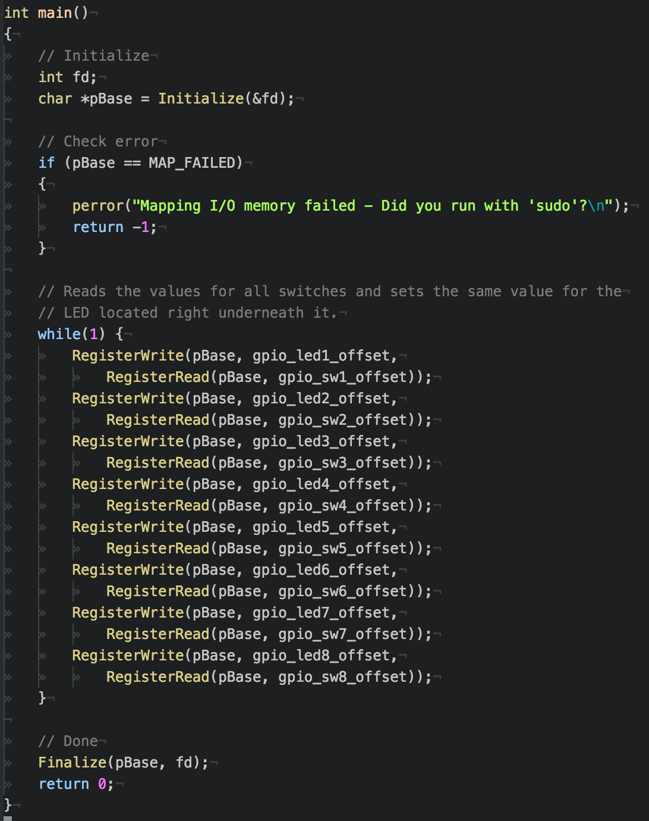
b)
The SwitchToLed.c along with all other programs were shown to the instructor or a TA.
Assignment 4 – PushButton.c:
a)
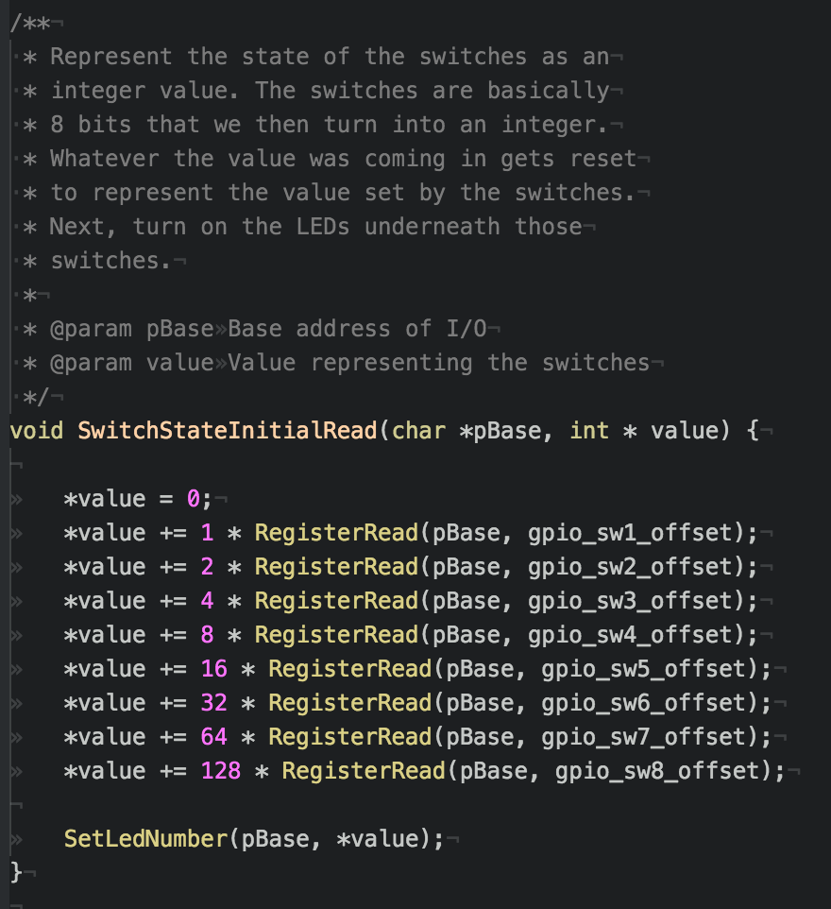

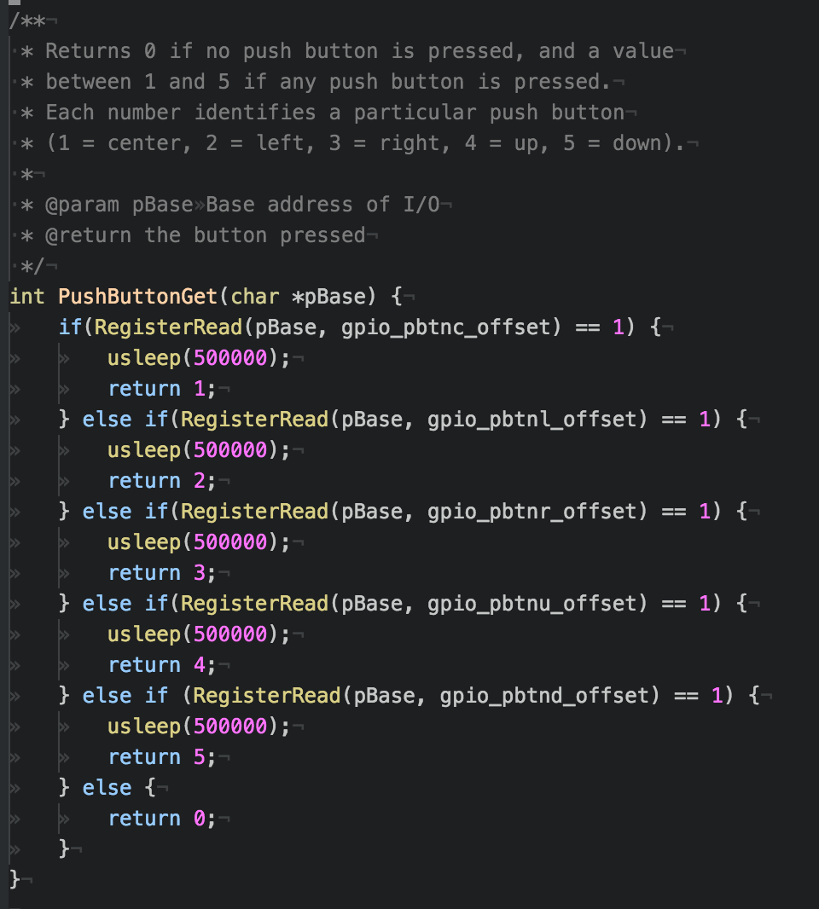

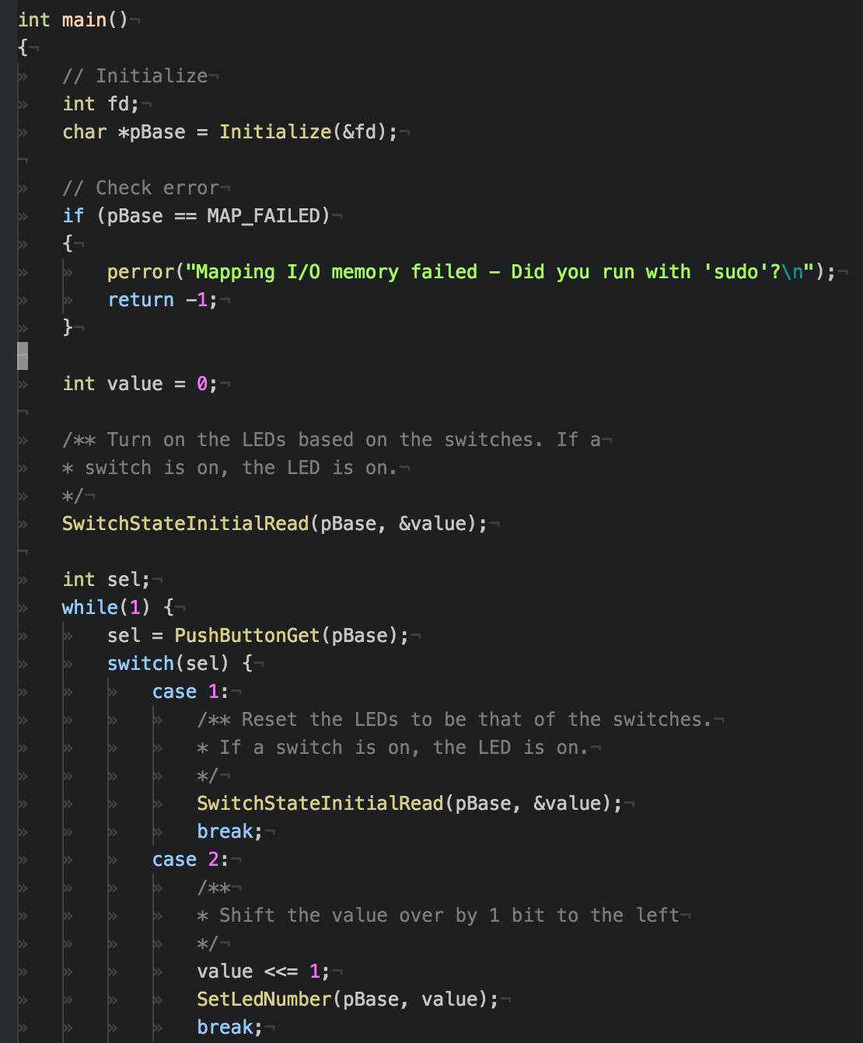

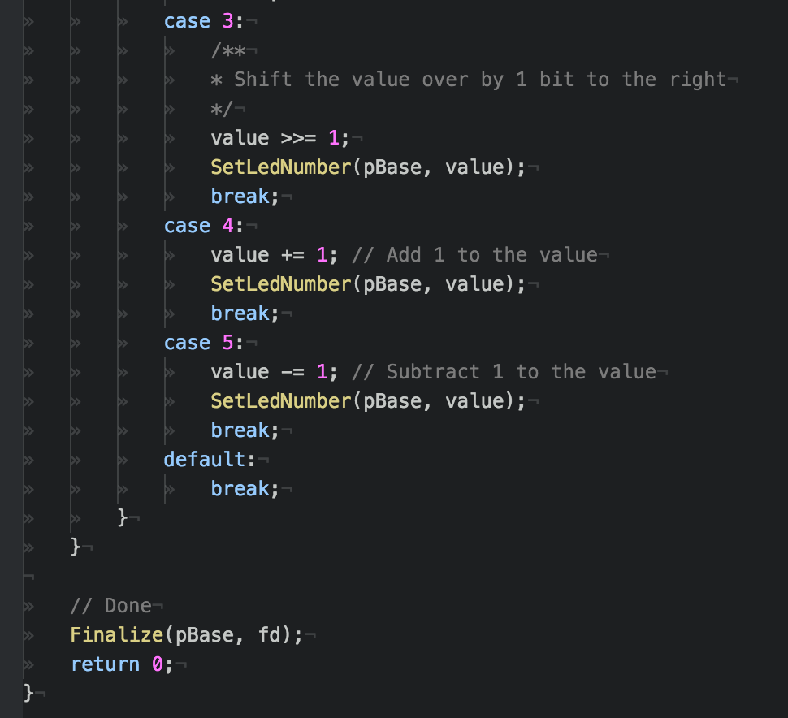

b)
The PushButton.c along with all other programs were shown to the instructor or a TA.

Assignment 5 – PushButtonCpp.cpp:
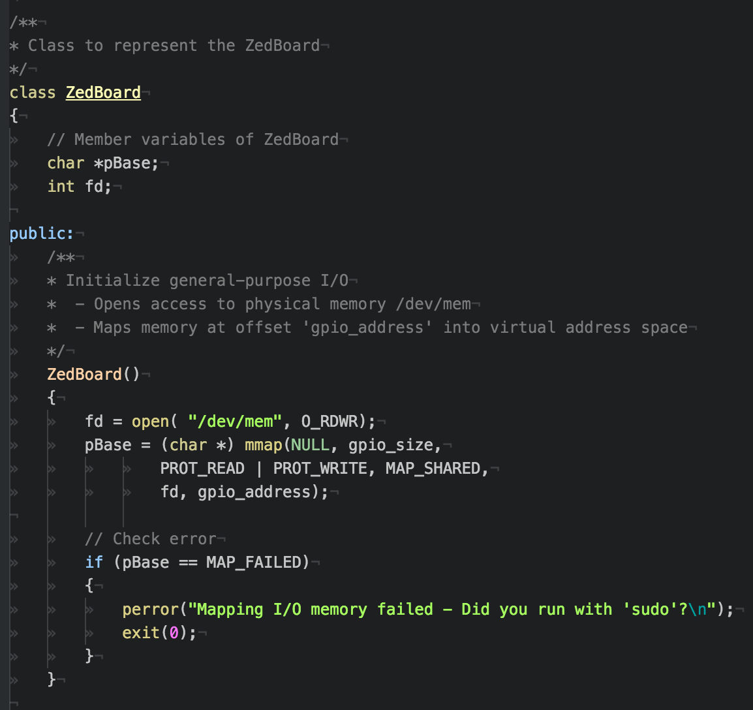
a)

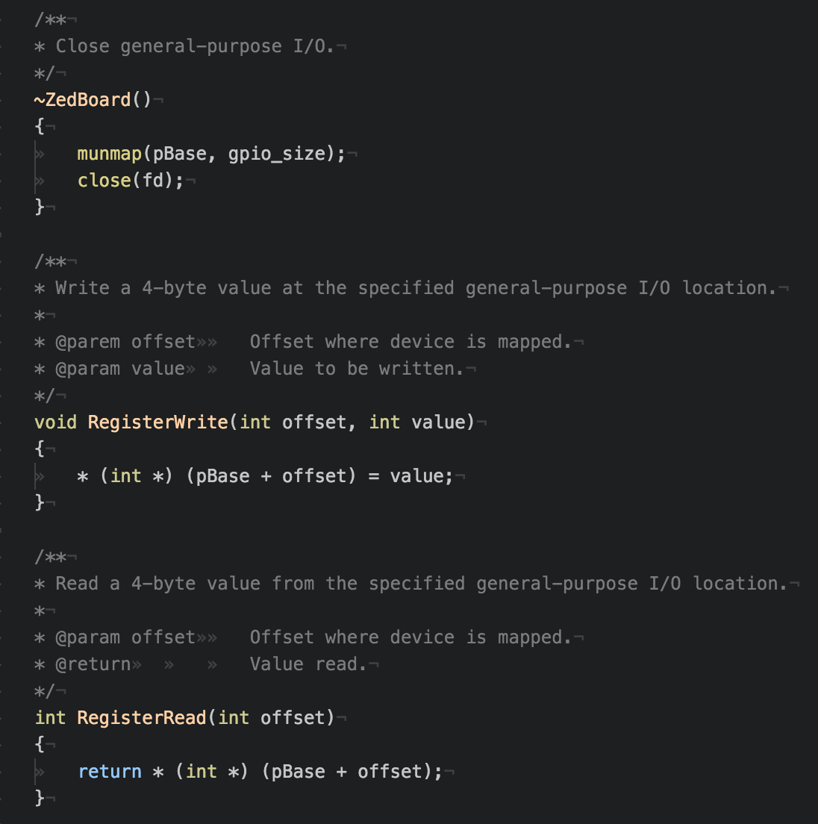

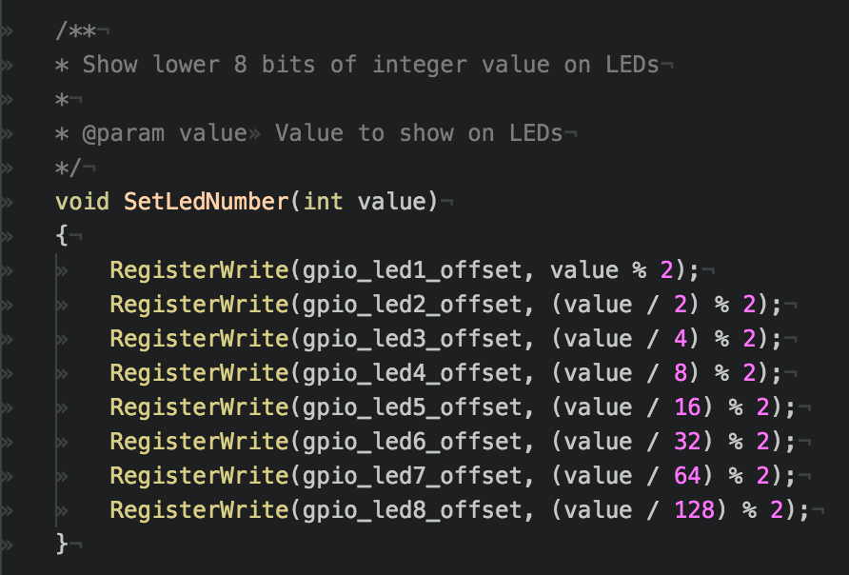

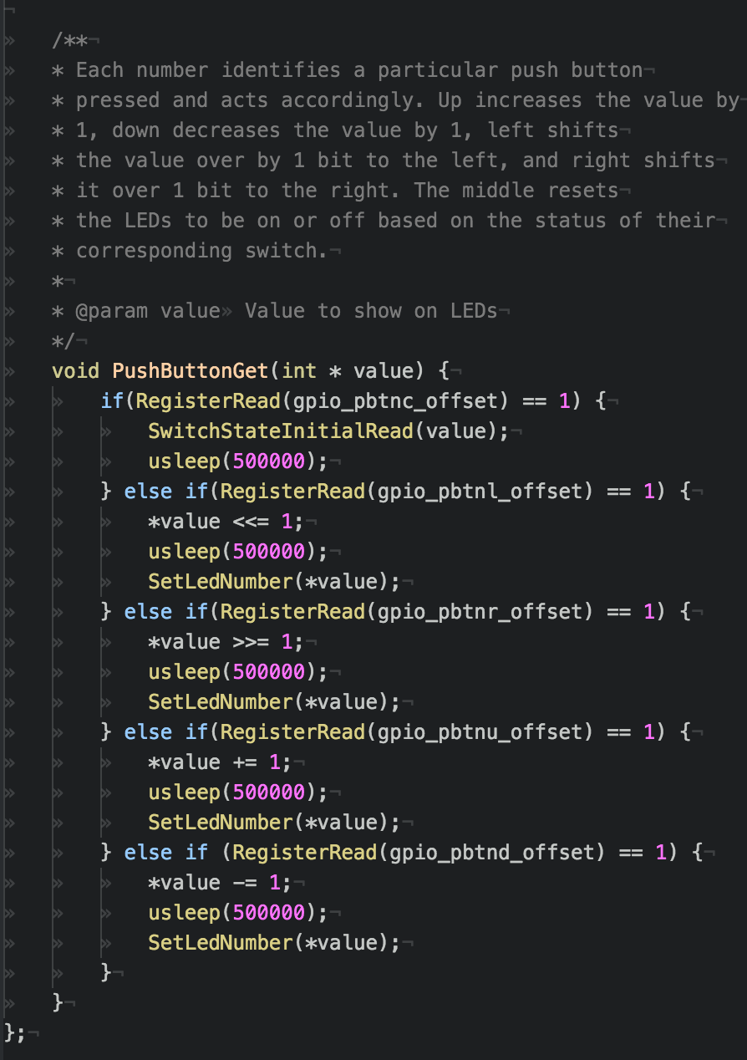

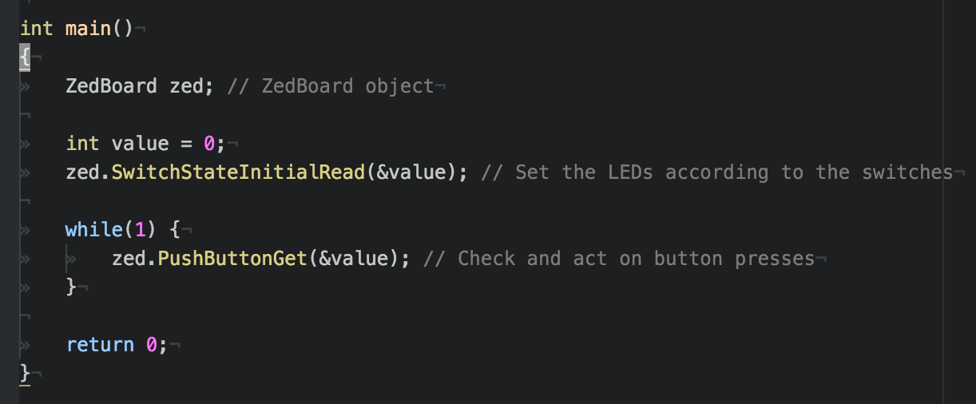

b)
The PushButtonCpp.cpp along with all other programs were shown to the instructor or a TA.

Extra Credit – CounterSpeed.cpp:
a)
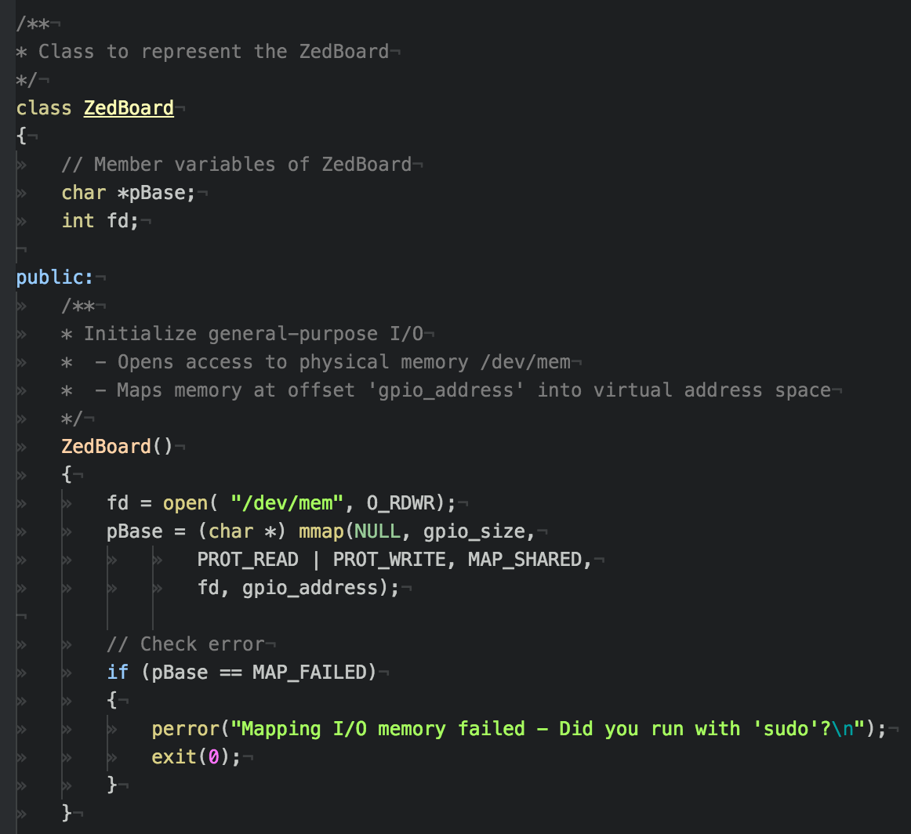

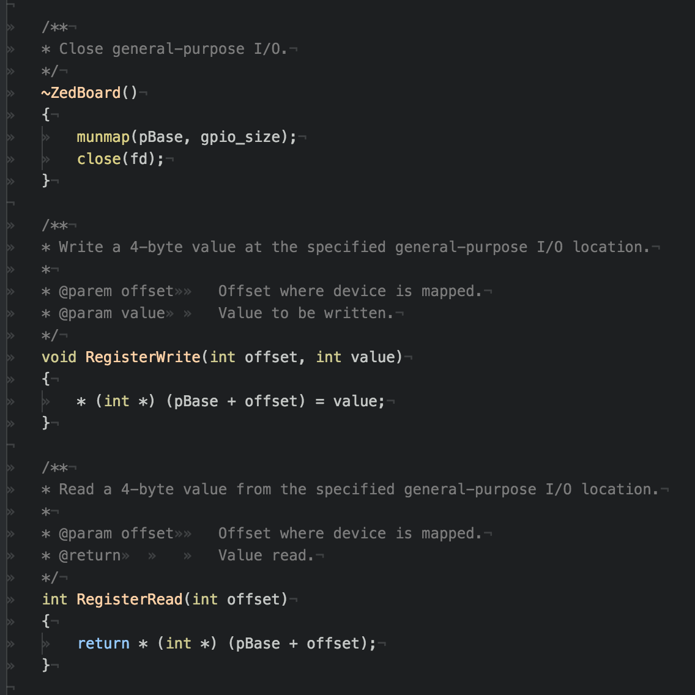

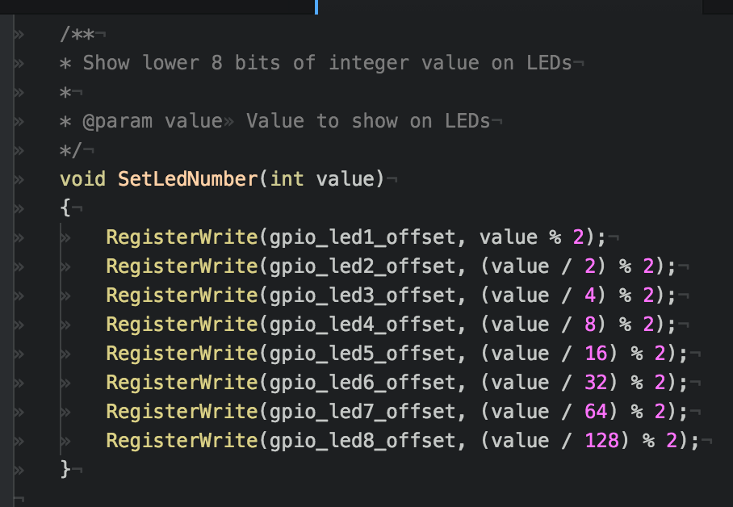

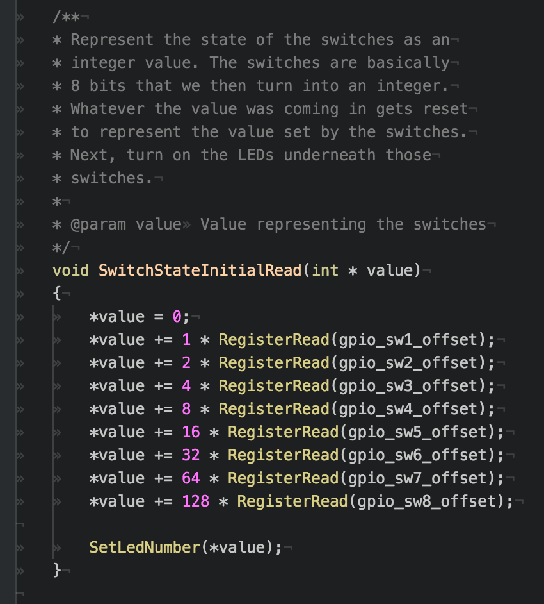

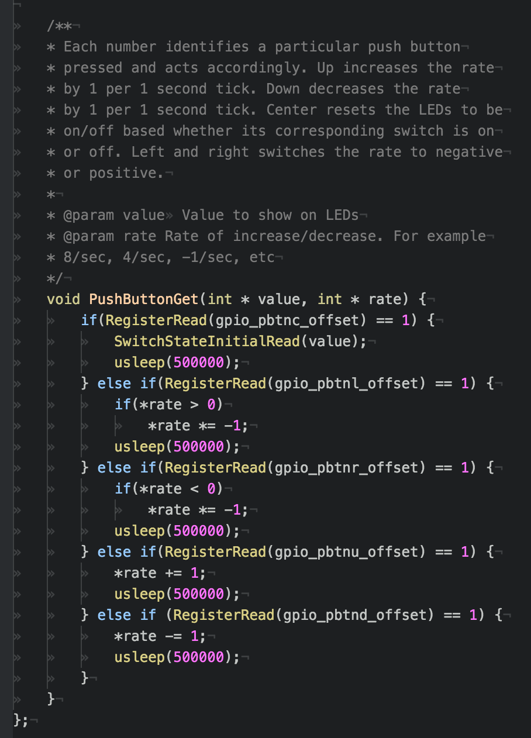

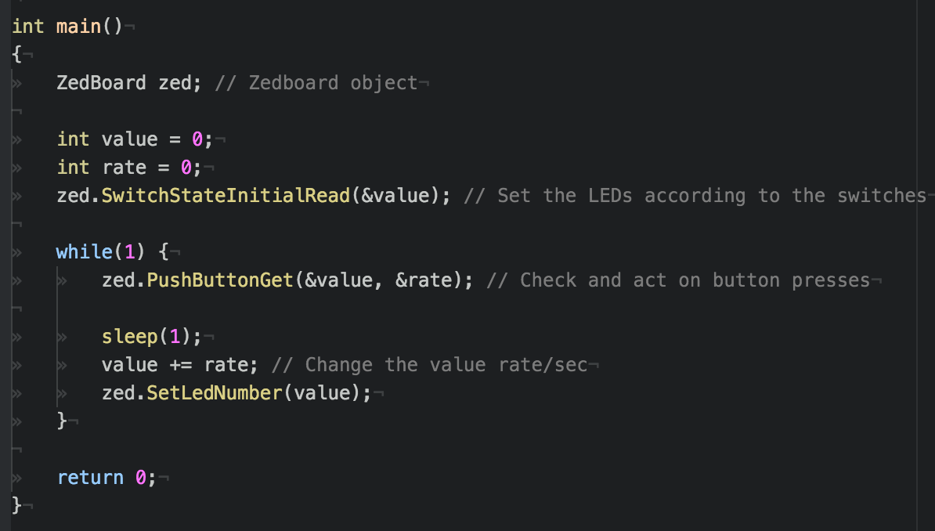
b)
The CounterSpeed.cpp along with all other programs were shown to the instructor or a TA.
Conclusion
Overall, in this lab we learned how to write code that controls the LEDs, buttons and switches on the Zedboard. Knowing how to use the memory-mapping IO and controlling the Zedboard devices will be useful later when we start using the Wii remote and robotic arm. For the buttons, we took care of debouncing by using usleep, so that it would only read one value when the button was pushed. This way, a button could be pushed twice in a row rather than using a state field that changed when a button was pushed. In general, knowing how to read and manipulate states and values critical to embedded design. In the future, more programs could be written to control the LEDs in different ways. The programs in the lab could also be rewritten. The files could be split up into proper C++ class files – makefiles, main.cpp, class.cpp, class.h, etc.
References
N/A

