Controlling the Wiimote with Object-Oriented Programming

Patricia Gavelek, Anders Dahl
Gavelek.p@husky.neu.edu
dahl.a@husky.neu.edu

Submit date: Feb. 29, 2016
Due Date: Feb. 29, 2016

Abstract
In this lab, the Wiimote will be used as an input device for the ZedBoard. The Wiimote gives values representing pressed buttons and device motion. These values will be used to display acceleration information on the LEDs of the ZedBoard, using an object-oriented approach. The position, acceleration, velocity, and time elapsed of the Wiimote were also recorded and displayed for the extra credit. Short shell scripts, allowing a user to connect to the Wiimote, will be written to aid in development.

Introduction
In this lab, the Wiimote will be used as an input device for the ZedBoard. The Wiimote gives values representing pressed buttons and device motion. These values will be used to display acceleration information on the LEDs of the ZedBoard, using an object-oriented approach. The position, acceleration, velocity, and time elapsed of the Wiimote were also recorded and displayed for the extra credit. Short shell scripts, allowing a user to connect to the Wiimote, will be written to aid in development.

Lab Discussion
In order to develop the programs, the C programming language, the gcc compiler, the gdb debugger, the ZedBoard, and Wiimote were all used. A variety of C libraries were needed – stdio, stdlib, fcntl, unistd, and iostream.
The pre-lab showed how to write simple bash scripts and how to lay out C++ programs. Here are the results:
a).
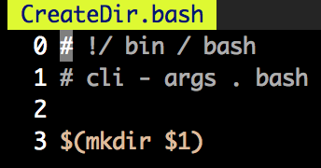

b).
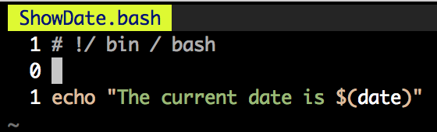

c), d), e).

Will be shown as part of this lab report.

Results and Analysis
Assignment 1:
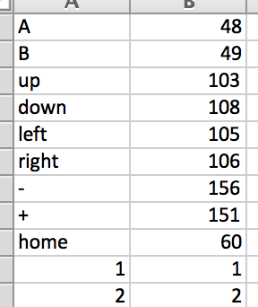

Assignment 2:
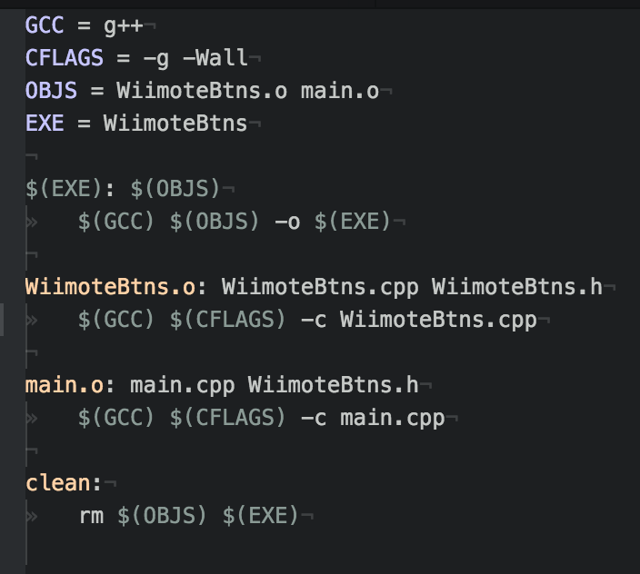

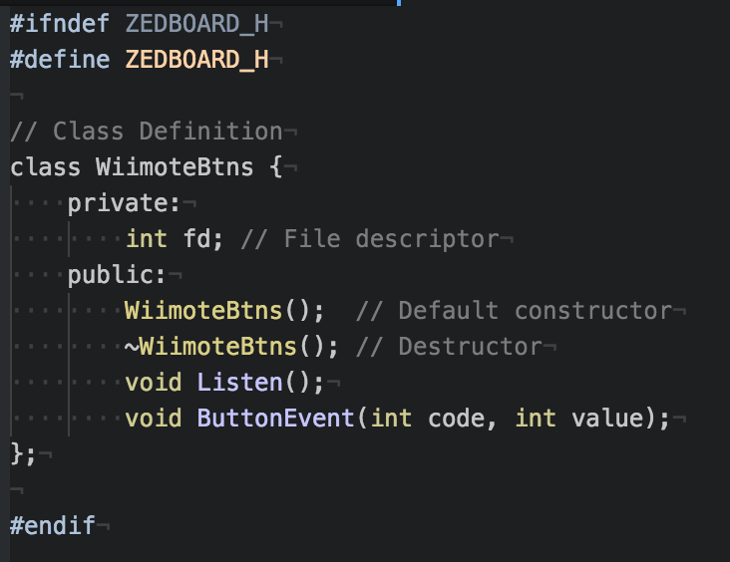

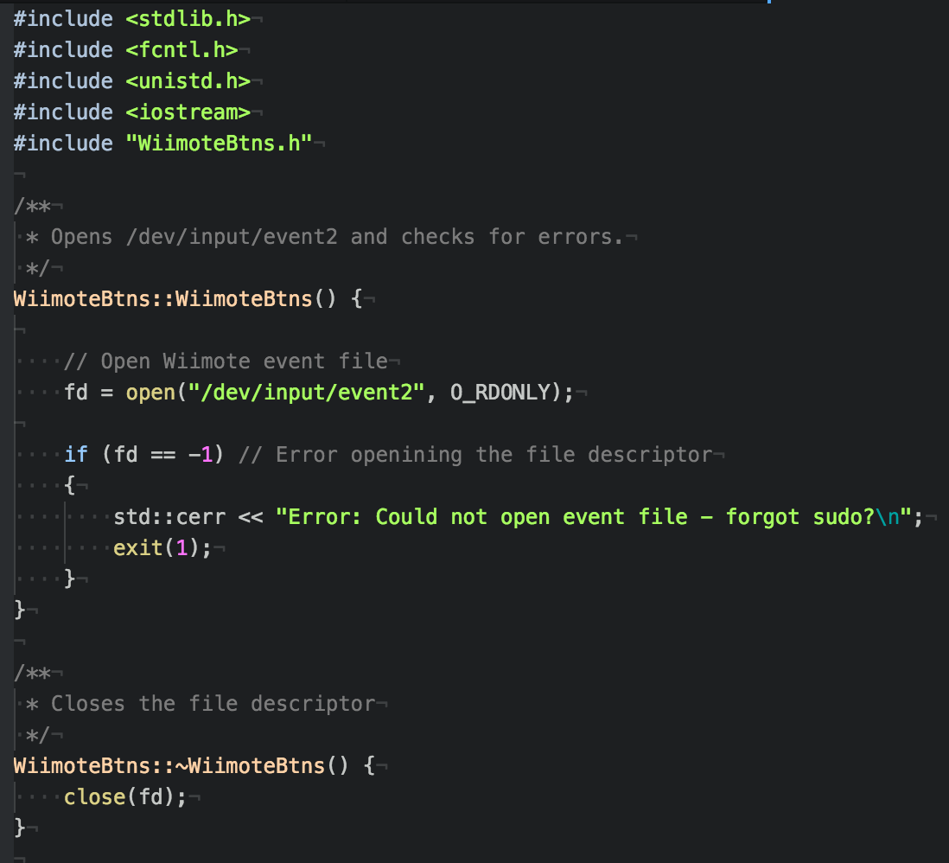

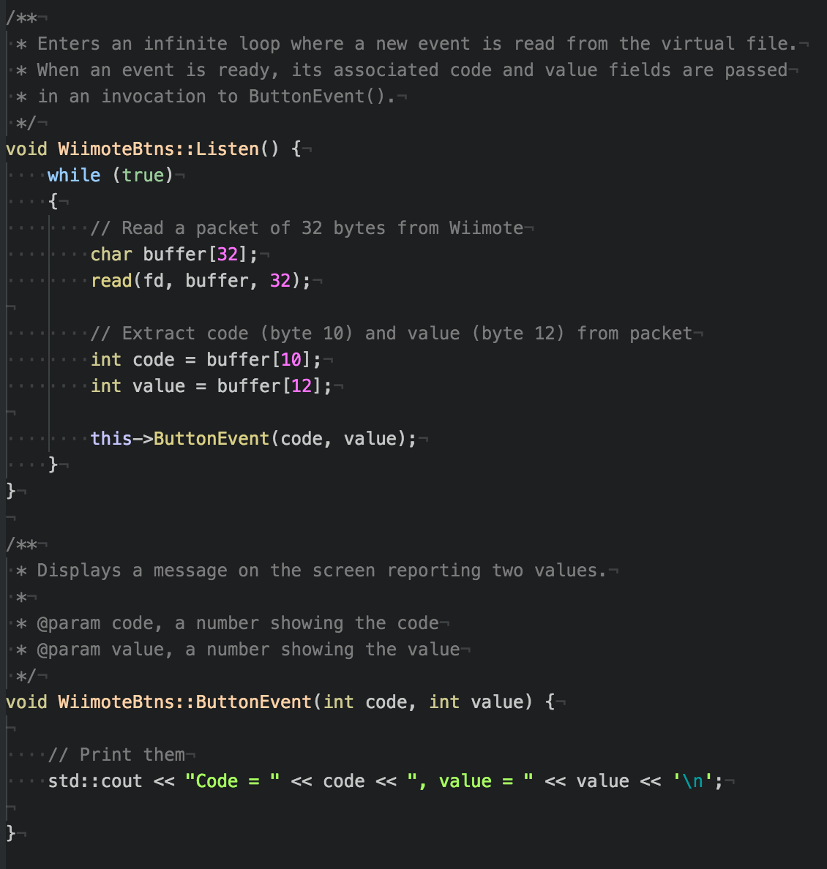

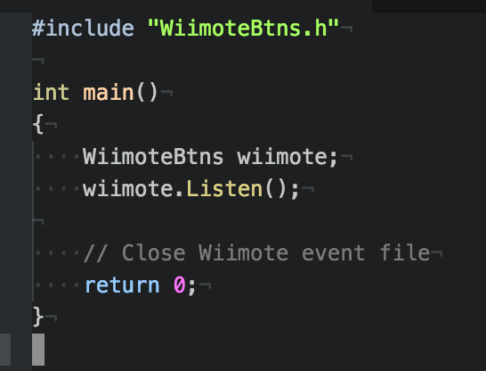

Assignment 3:

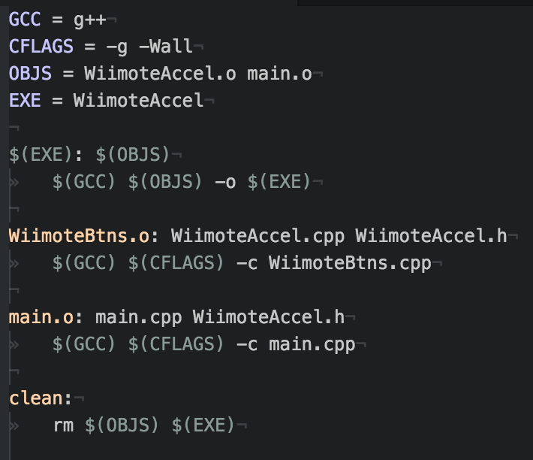

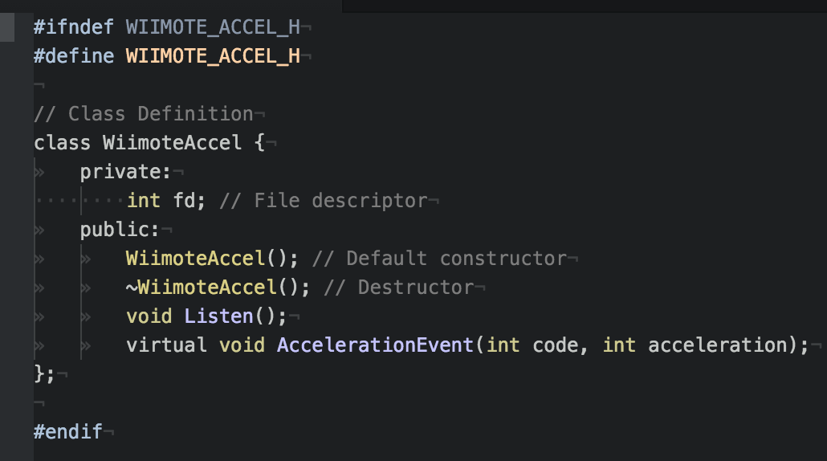

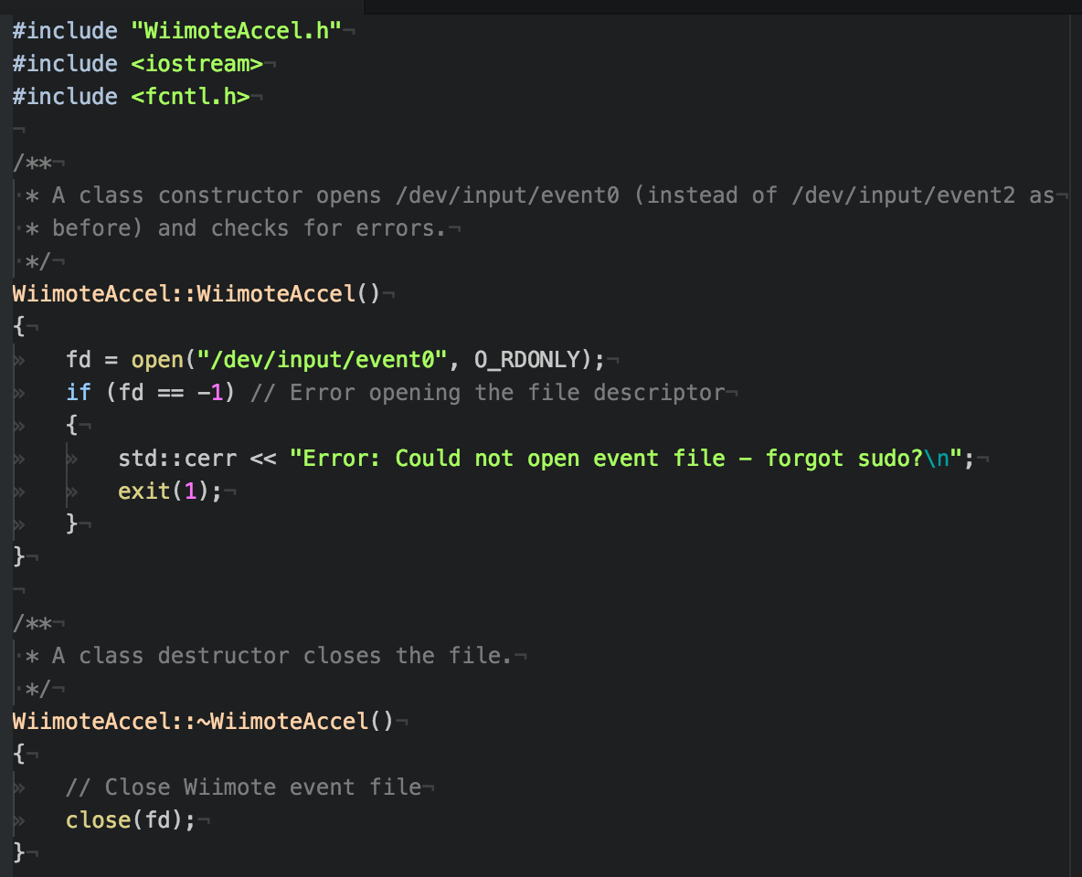

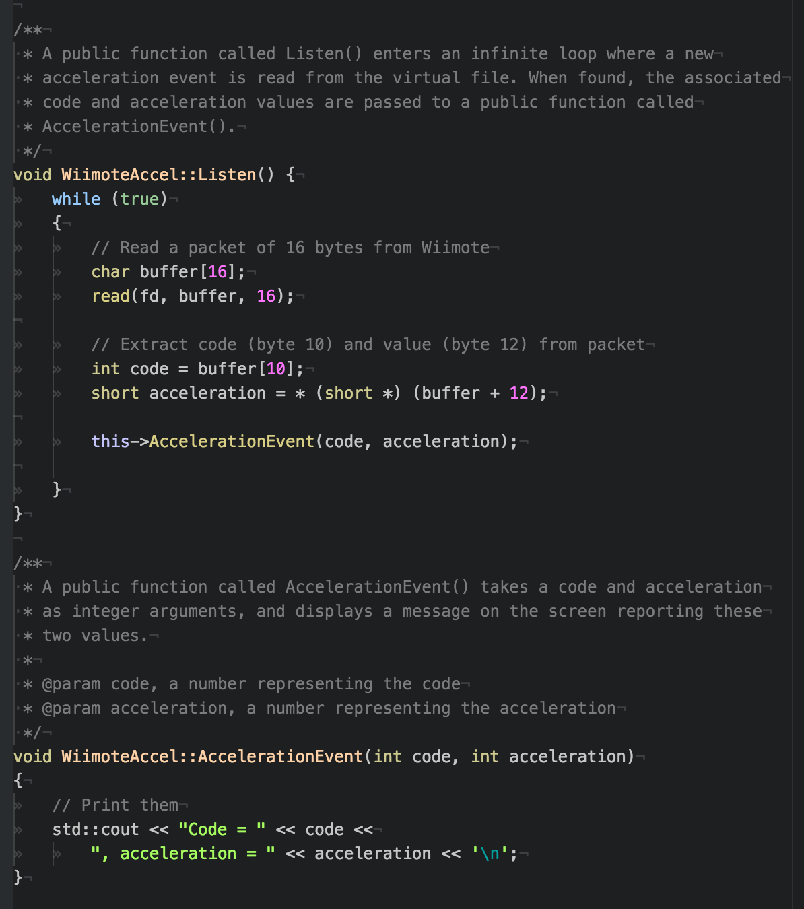

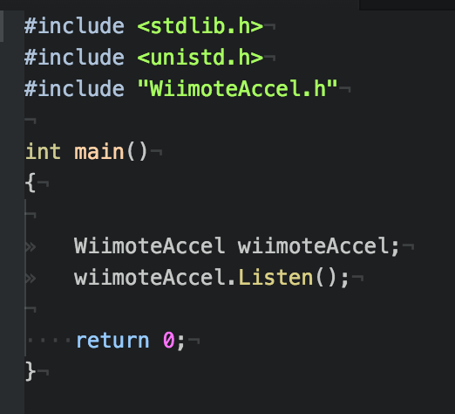

Assignment 4:

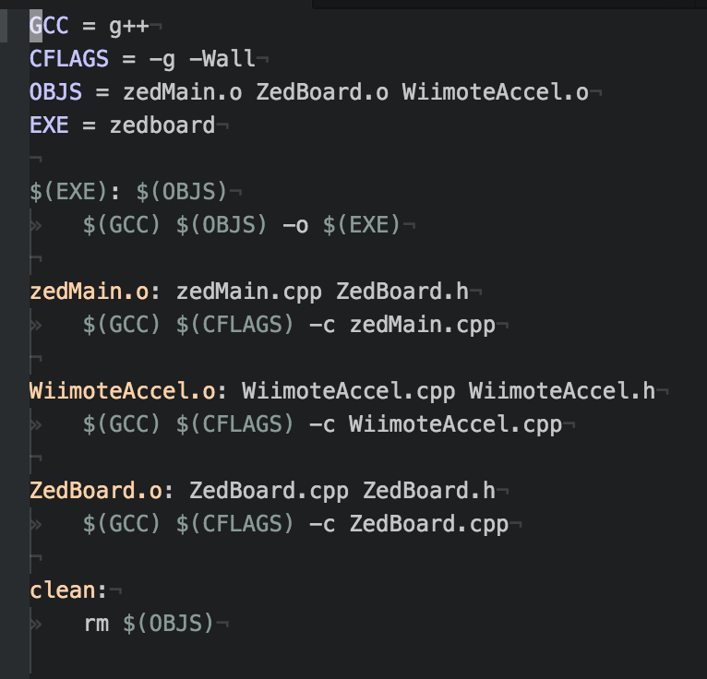

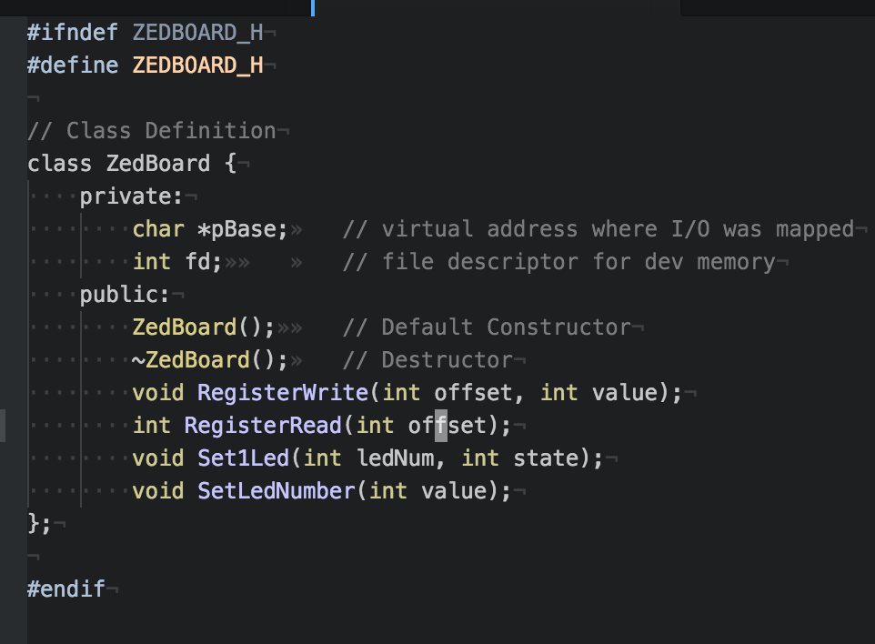

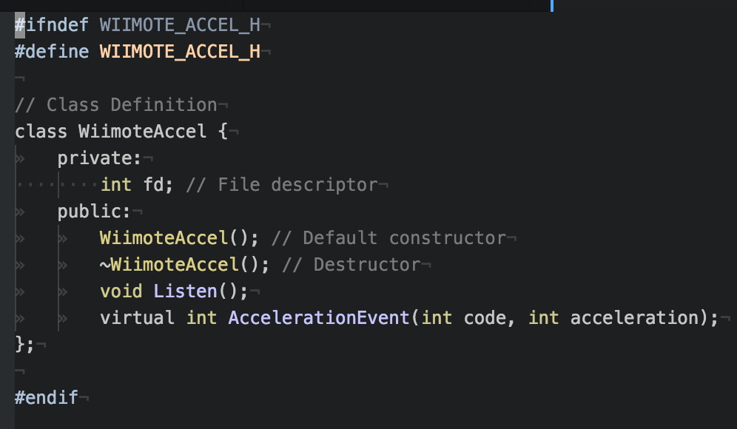
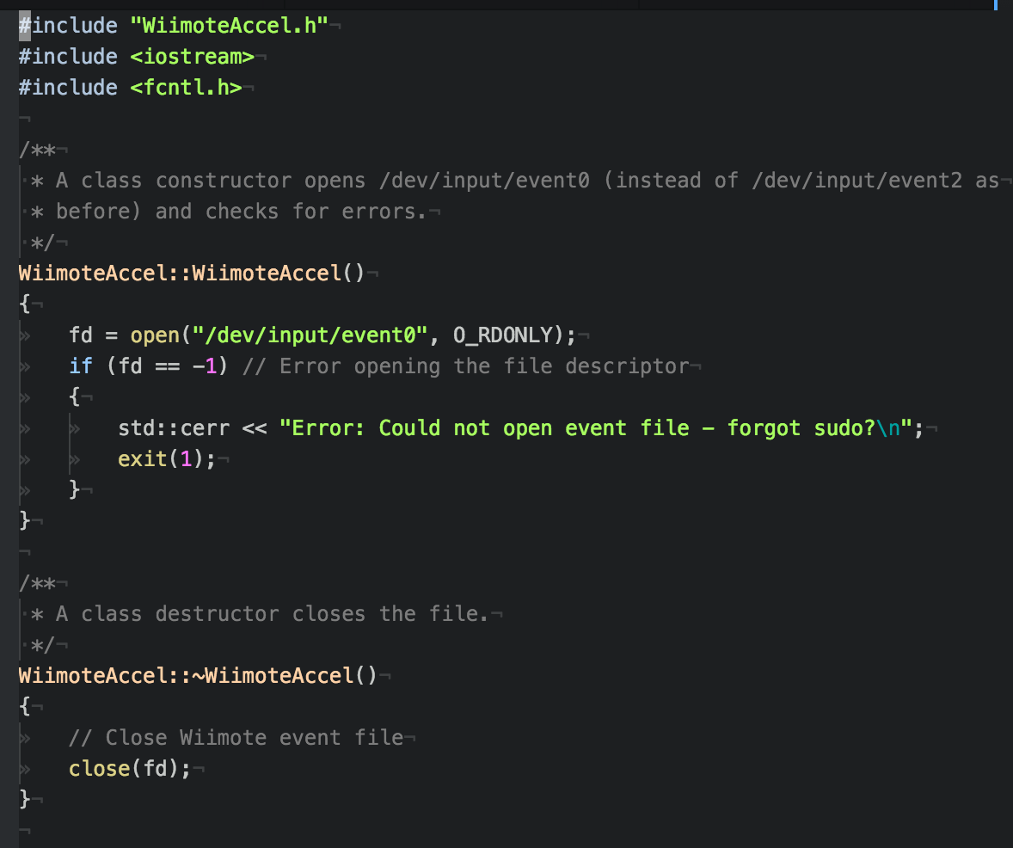

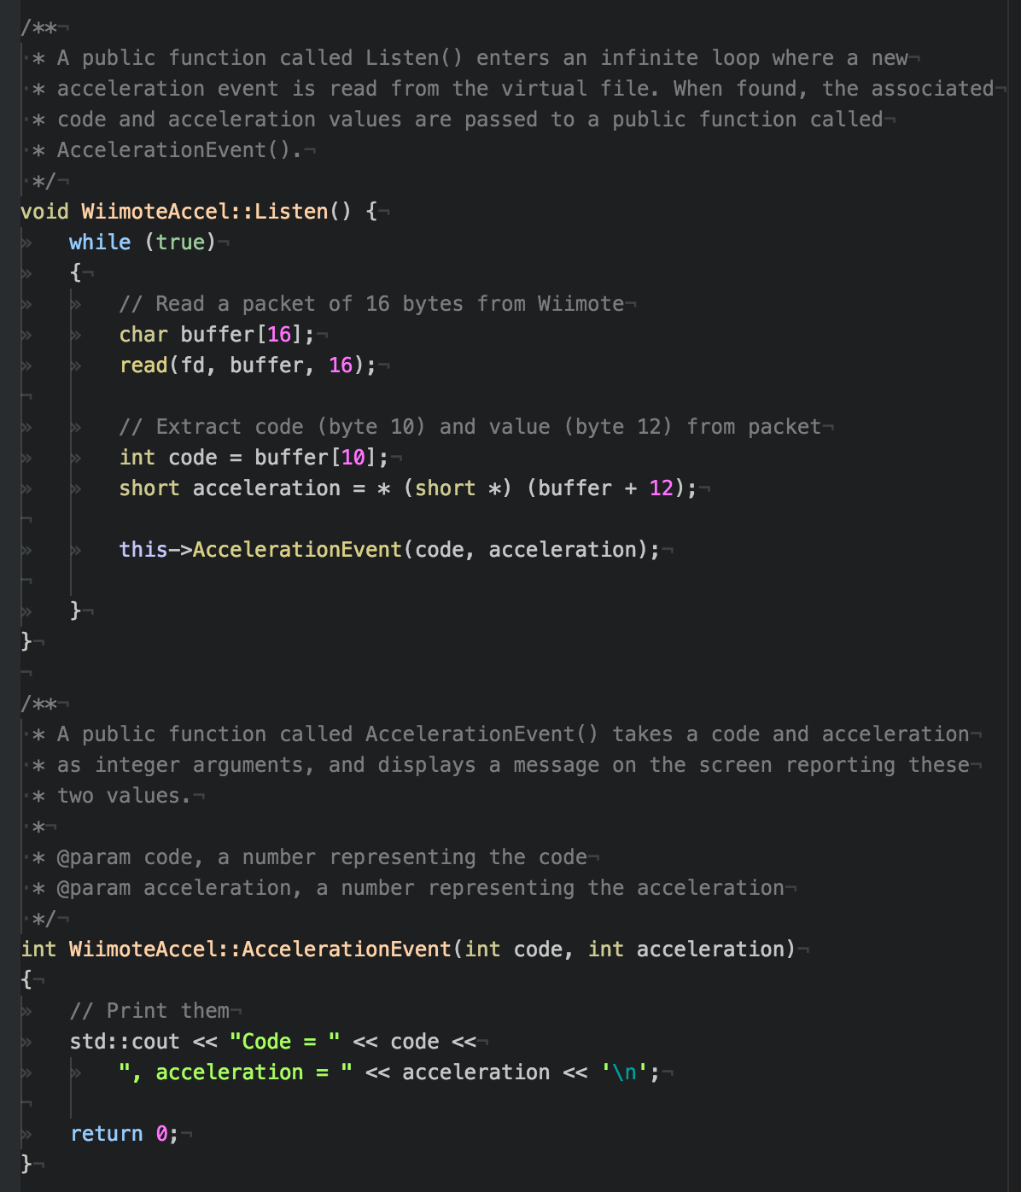
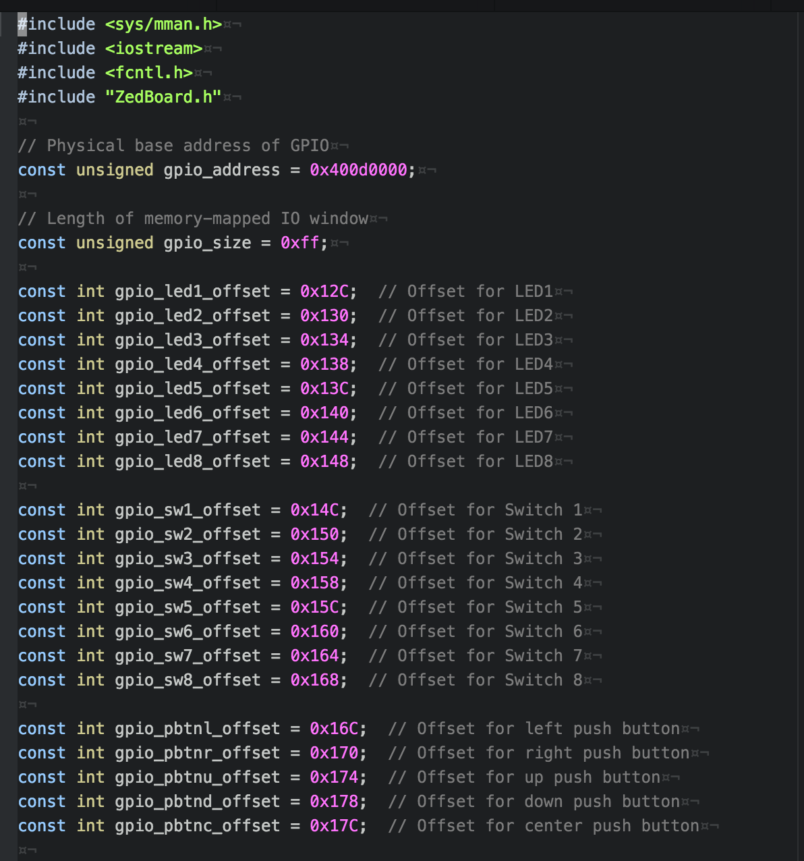

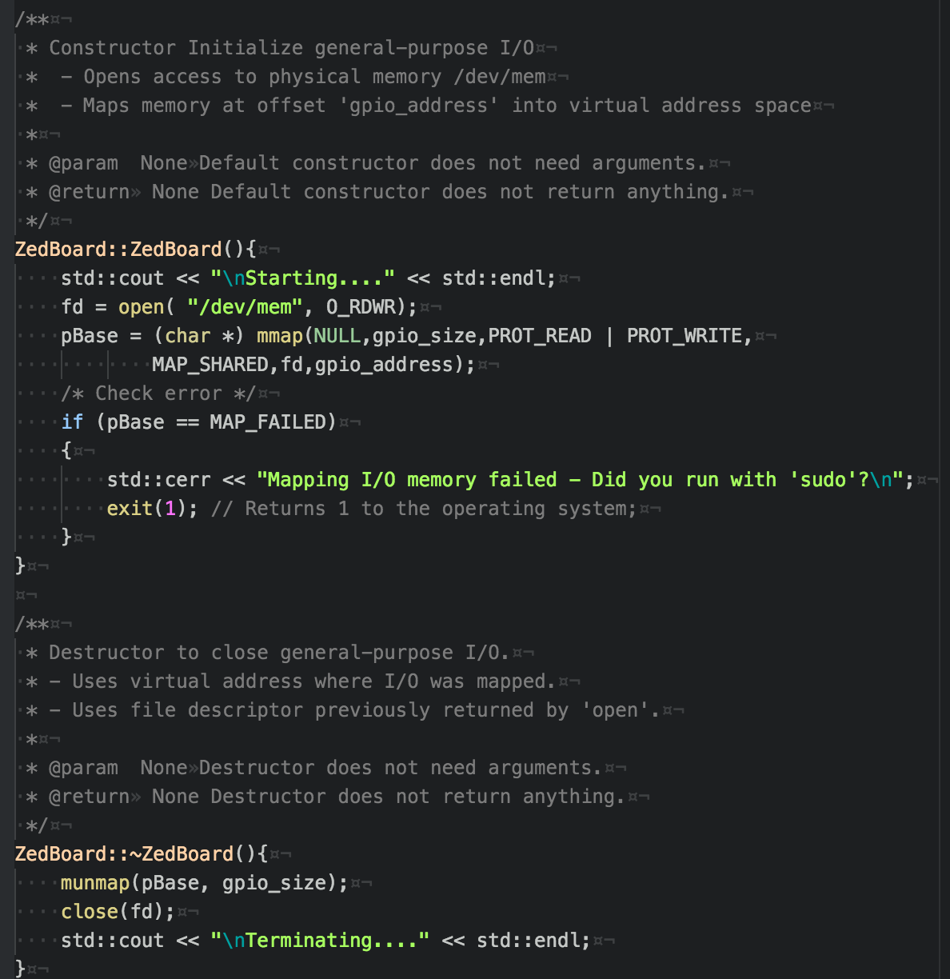

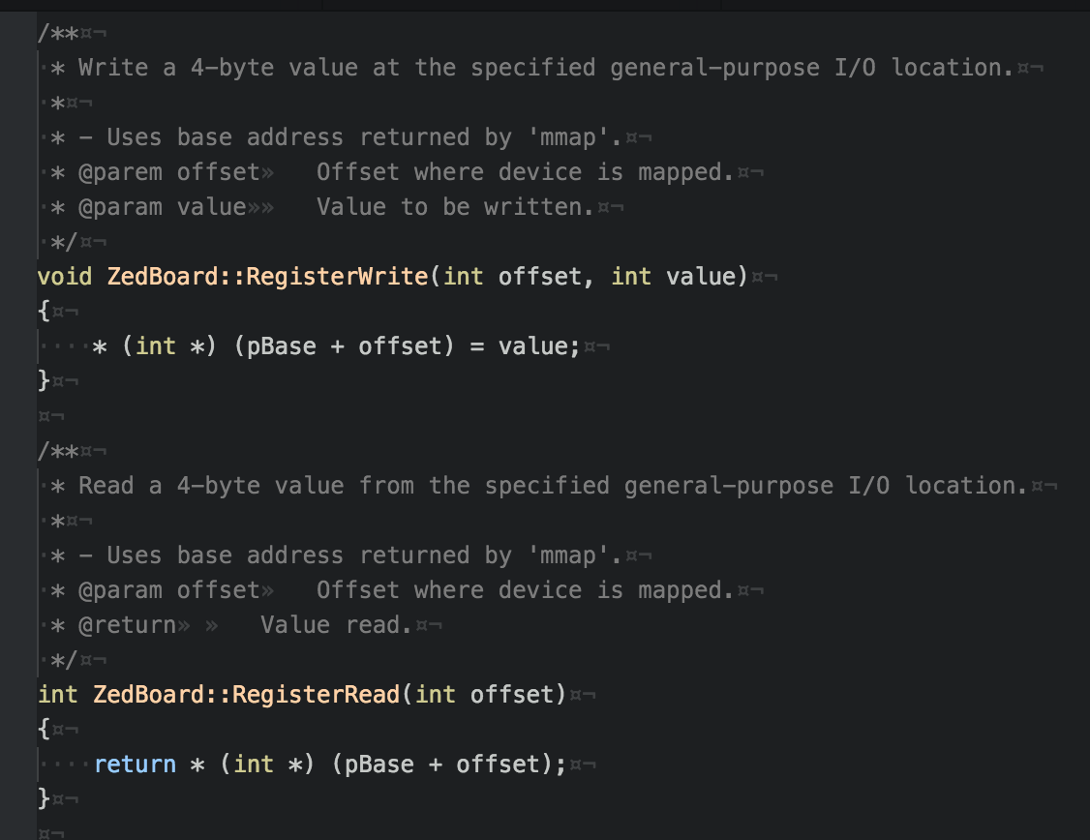

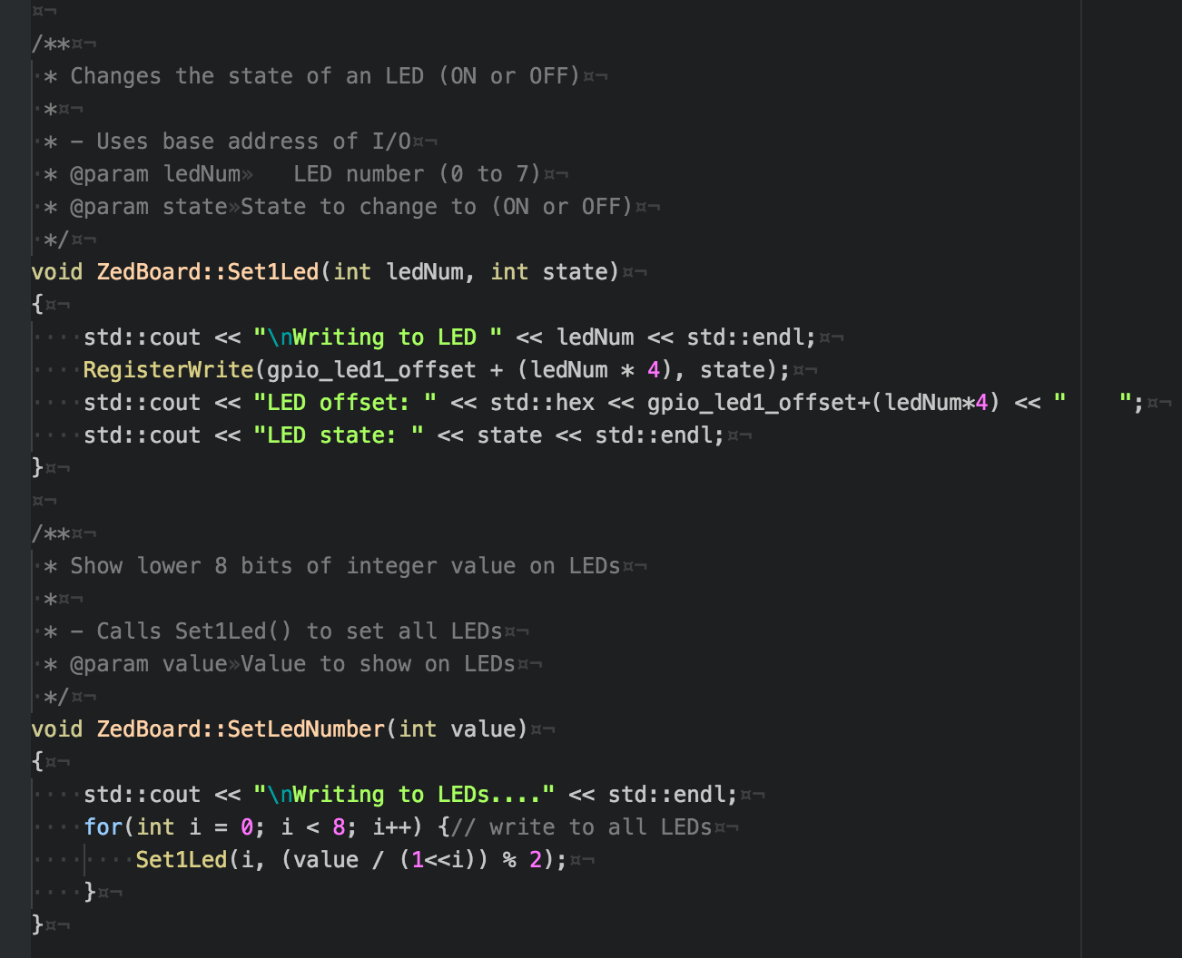

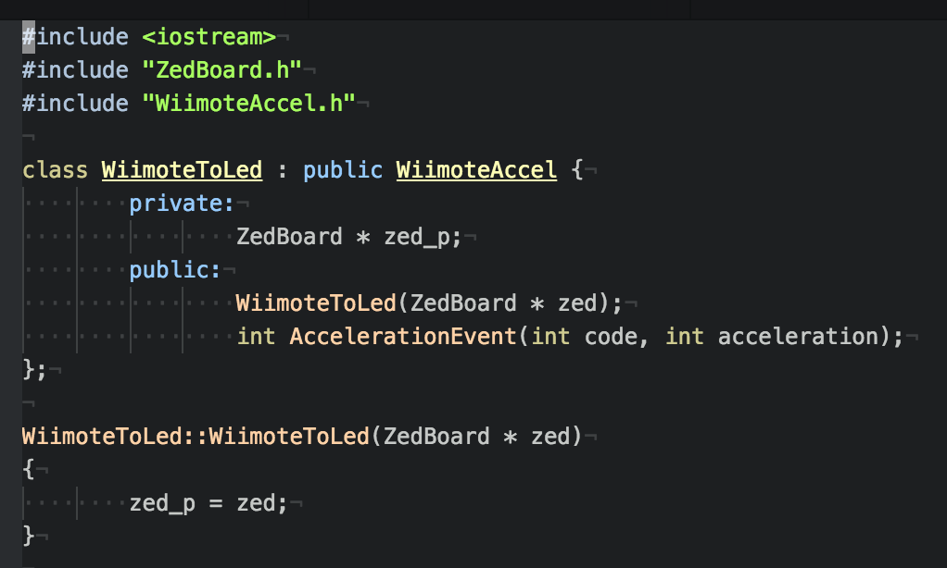
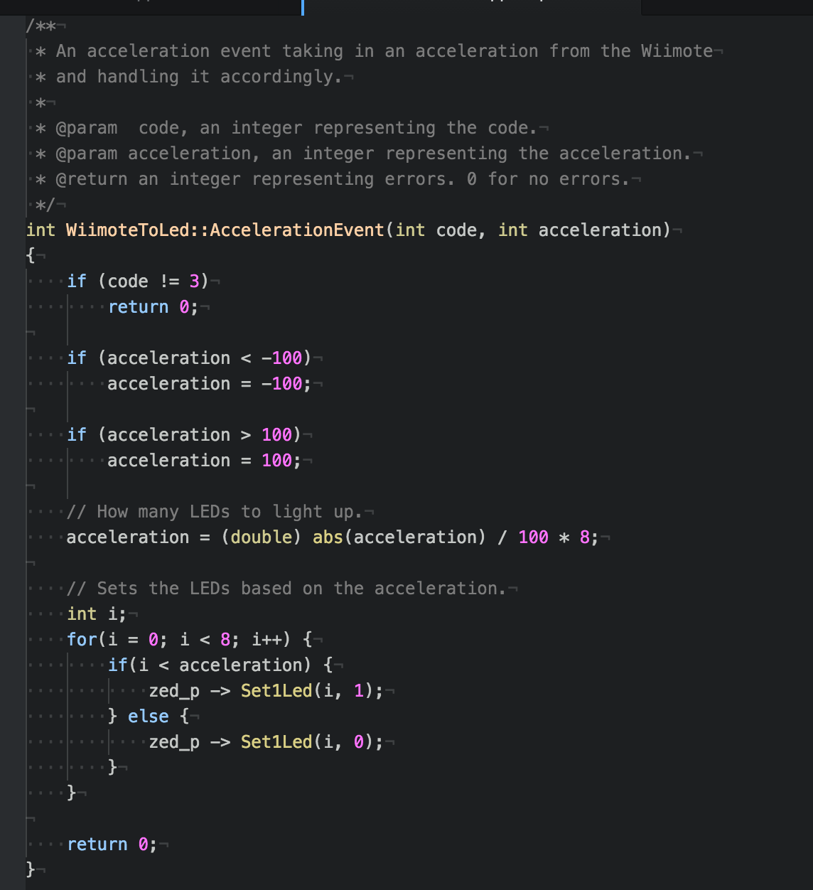

Assignment 5:

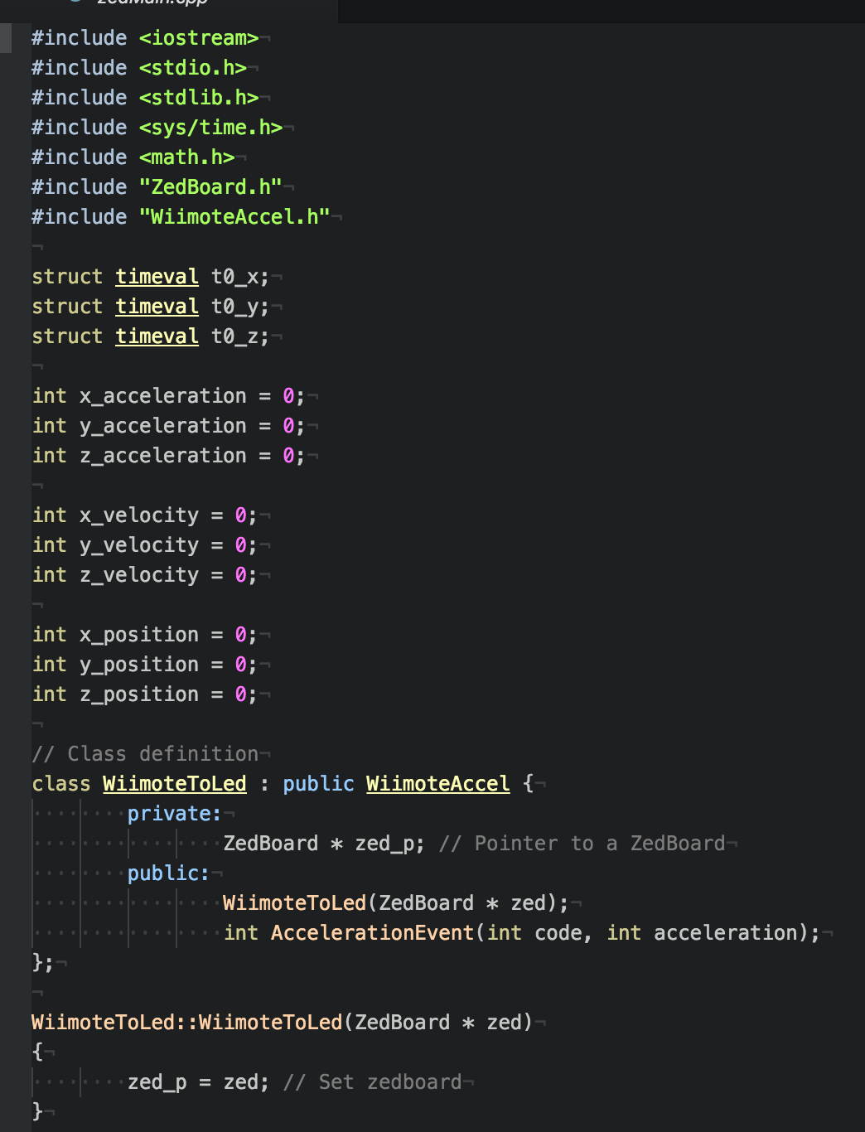
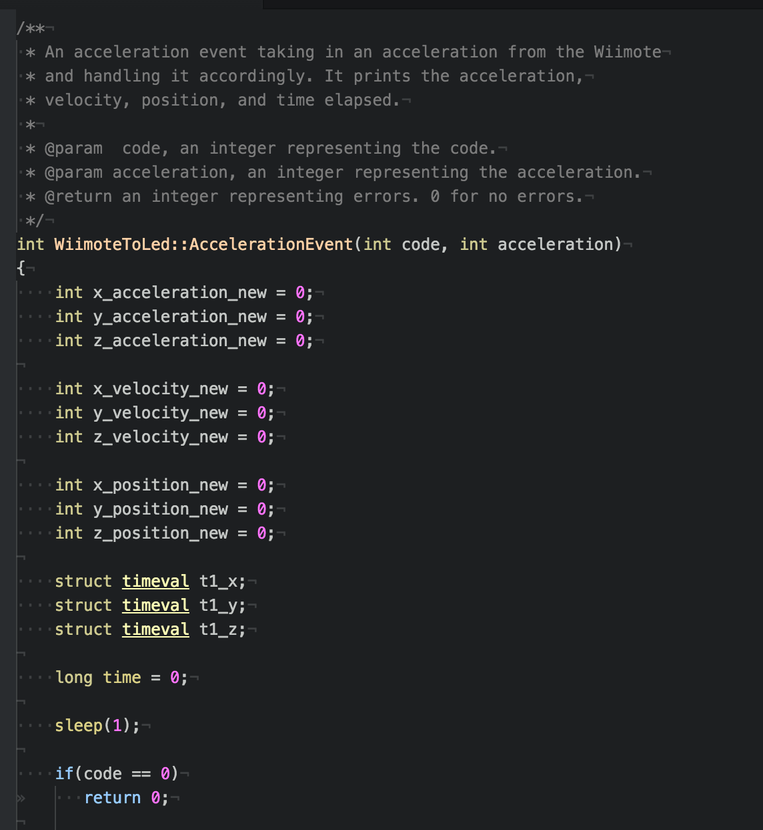

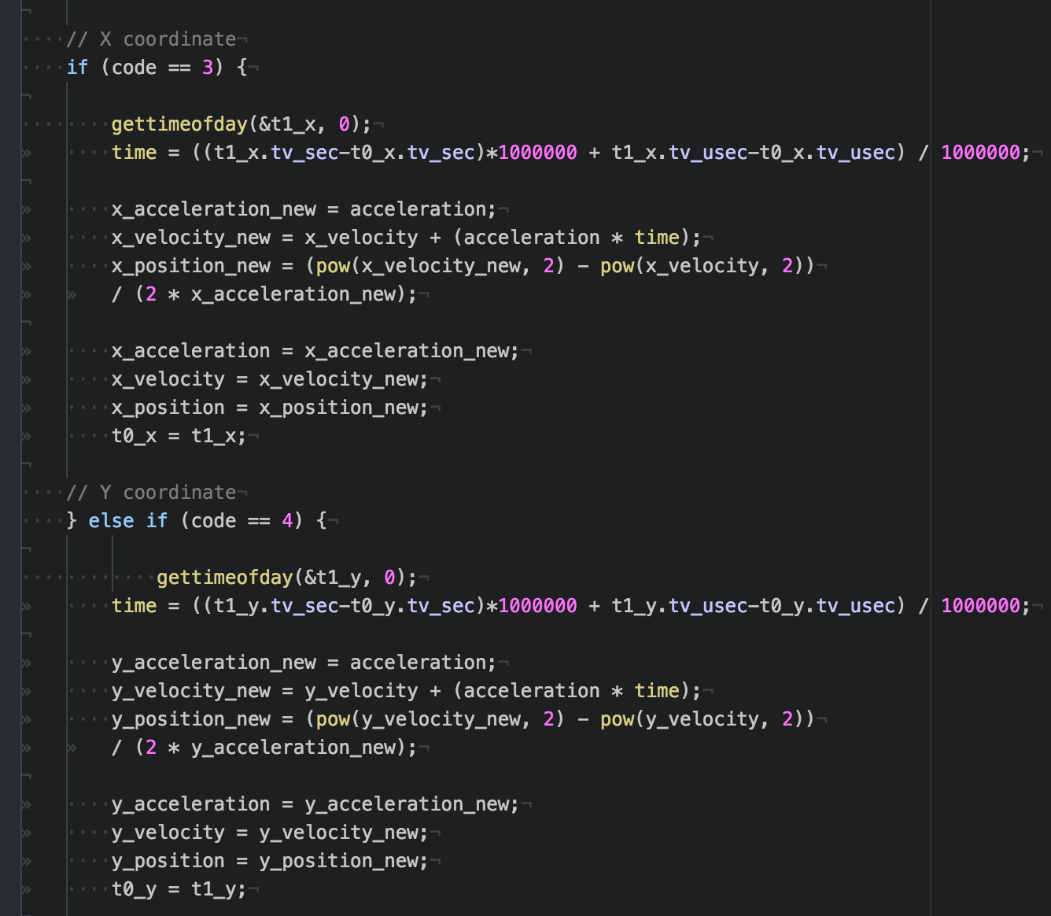

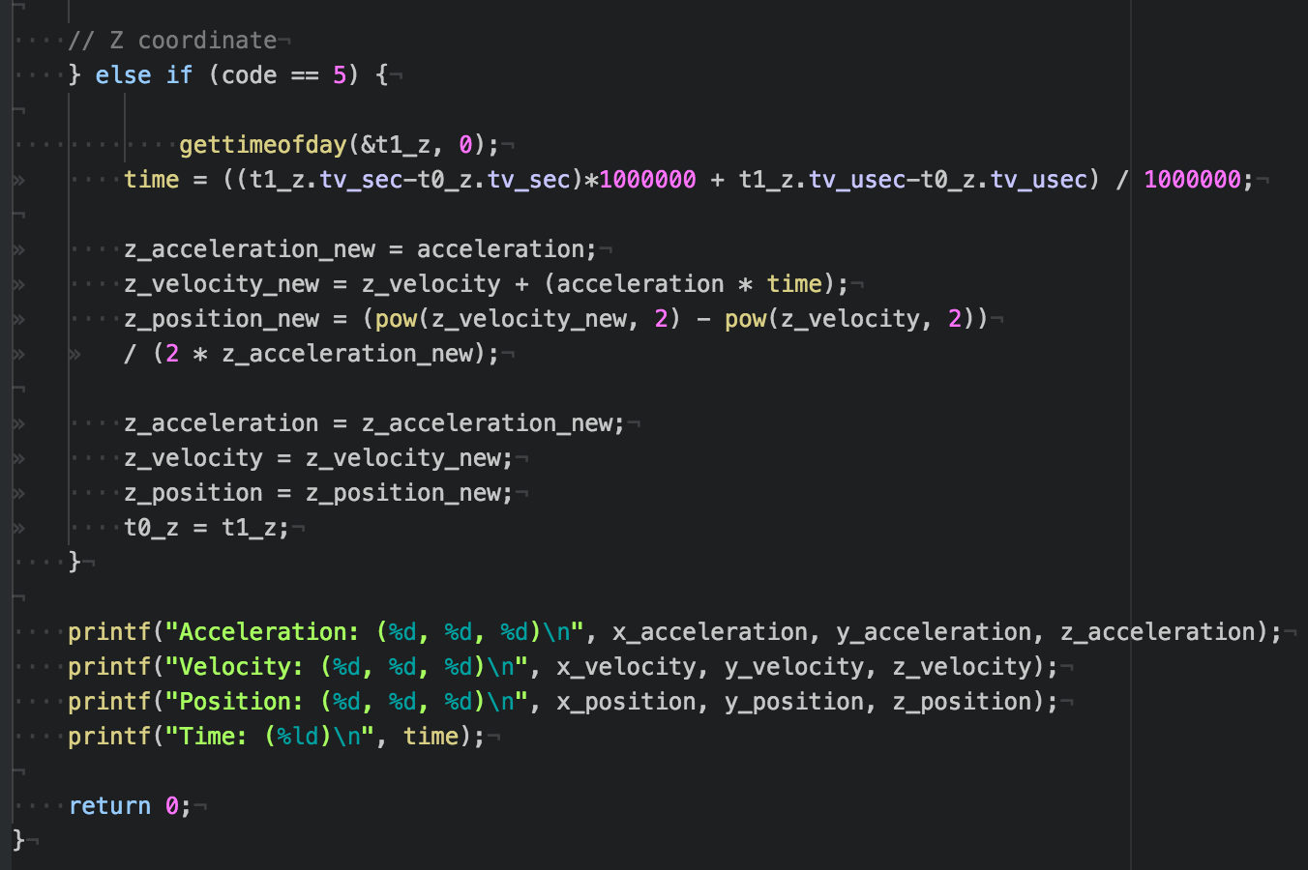
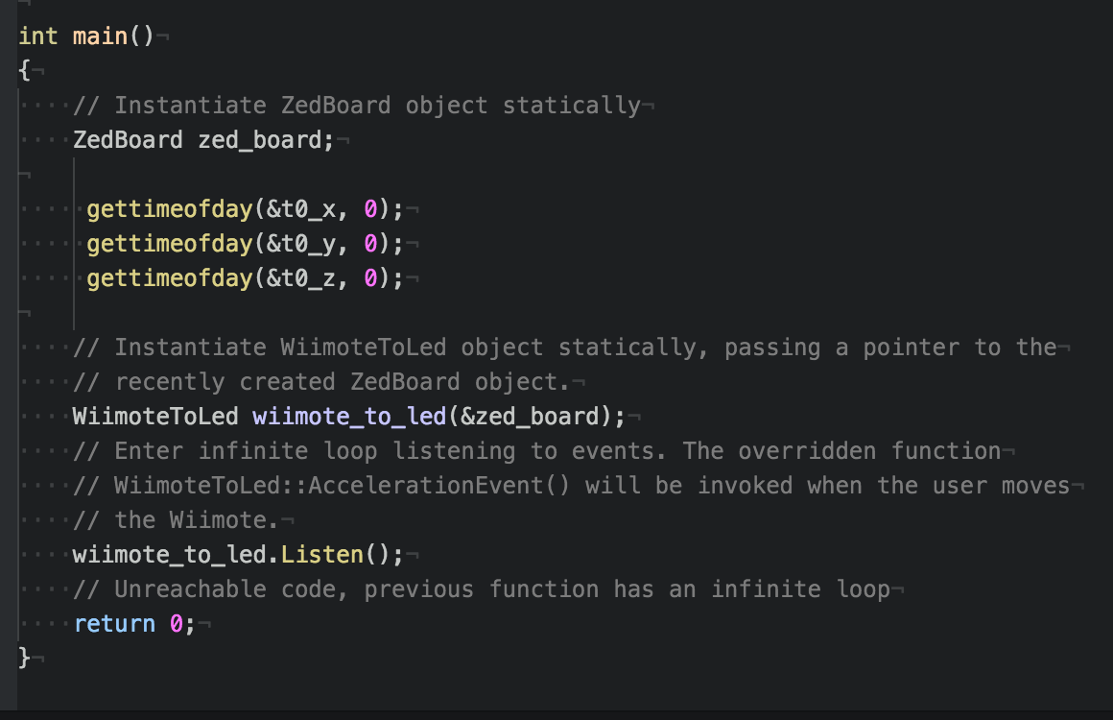
Conclusion
In this lab, values were used to display acceleration information on the LEDs of the ZedBoard, using an object-oriented approach. The position, acceleration, velocity, and time elapsed of the Wiimote were also recorded and displayed for the extra credit. In general, knowing how to read and manipulate states and values critical to embedded design. In the future, for more work, more programs could be written to control the LEDs in different ways. The programs in the lab could also be rewritten, tested, and debugged. We ran into a few issues on the extra credit with number arithmetic. It would be helpful to write tests for such code. This is something that could be accomplished in future work.
References
N/A

