1.)

PWM signal – Signal that oscillates between a high and low state to change the state of the circuit.
PWM duty cycle – A duty cycle describes the proportion of “ON” time versus “OFF” time over the period of the cycle. This is usually expressed as a percent, with 100% being fully on for the entire period.

2.)

a.
Period = 1 / frequency
Period = 1 / 50 Hz
Period = 1 / (50 cycles /sec)
Period = 20ms

b.
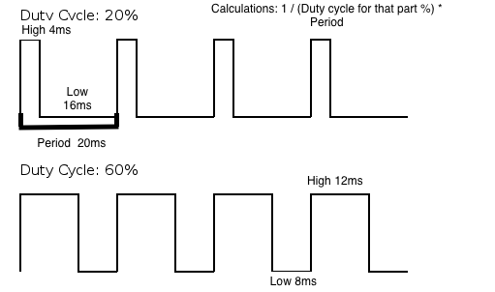

3.)
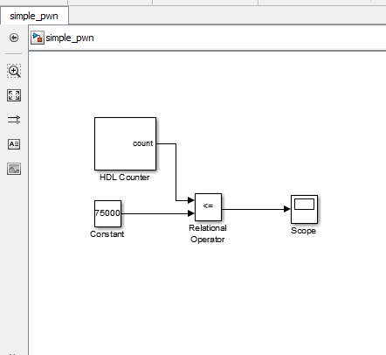

Calculations:

50MHz = 1 / 50M = .0002ms period
20ms / .0002 ms = 1M cycles for the HDL Counter
(1.5m/20ms) * 1M = 75000 cycles for the constant

4.)

a).
(.6 ms / 20 ms) * 1M counts = The count would be at 30000

b).
(1.5 ms / 20 ms) * 1M counts = The count would be at 75000
c).
(2.4 ms / 20 ms) * 1M counts = The count would be at 120000

