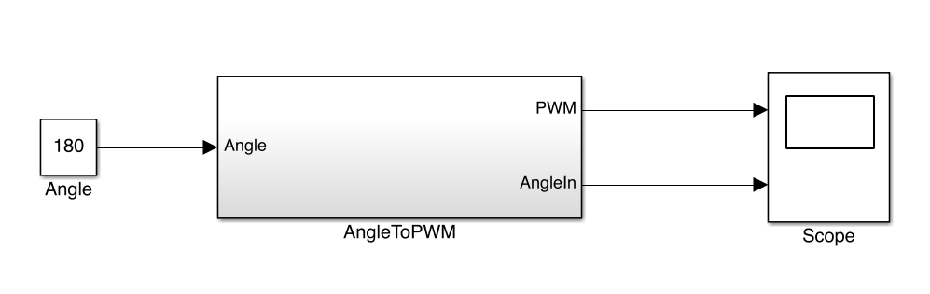

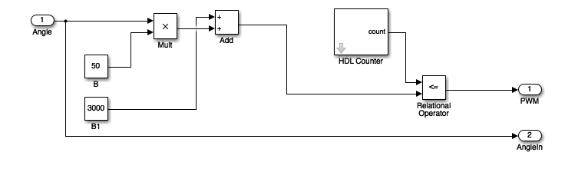

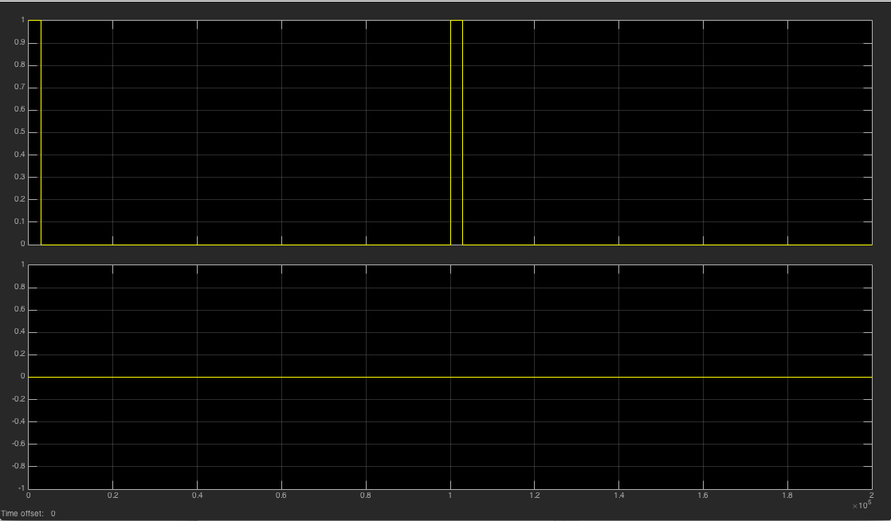

The pulse width for 0 degrees here is correct. It produces a pulse width of .6ms.

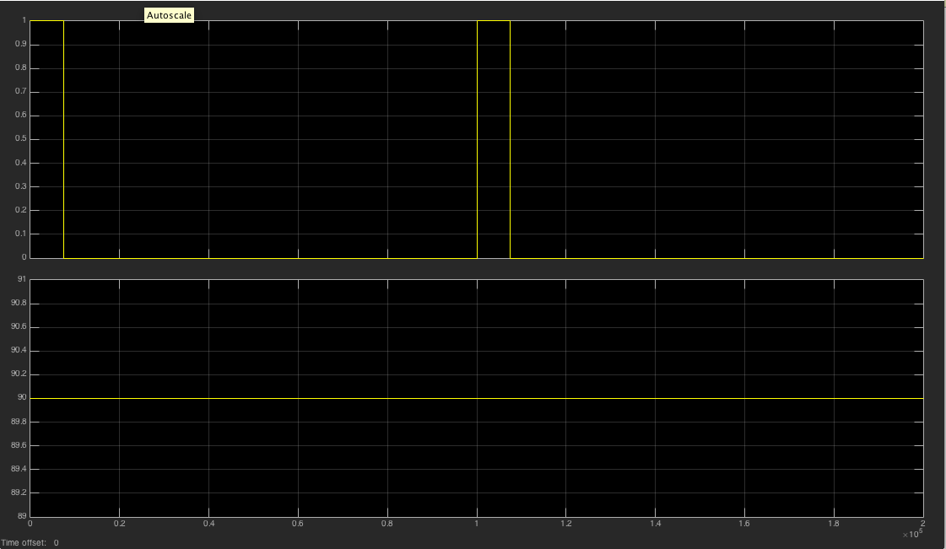

The pulse width for 90 degrees here is correct. It produces a pulse width of 1.5 ms.

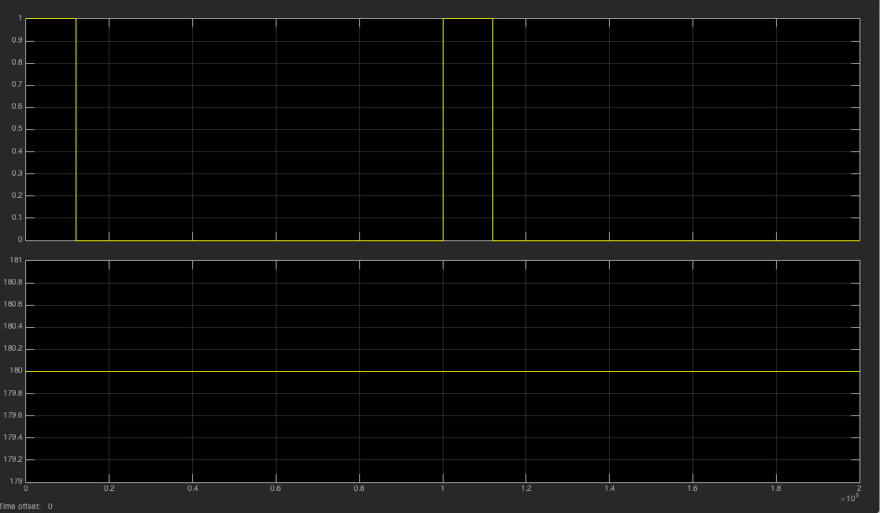

The pulse width for 0 degrees here is correct. It produces a pulse width of 2.4 ms.