**SmartSolenoid Developments**

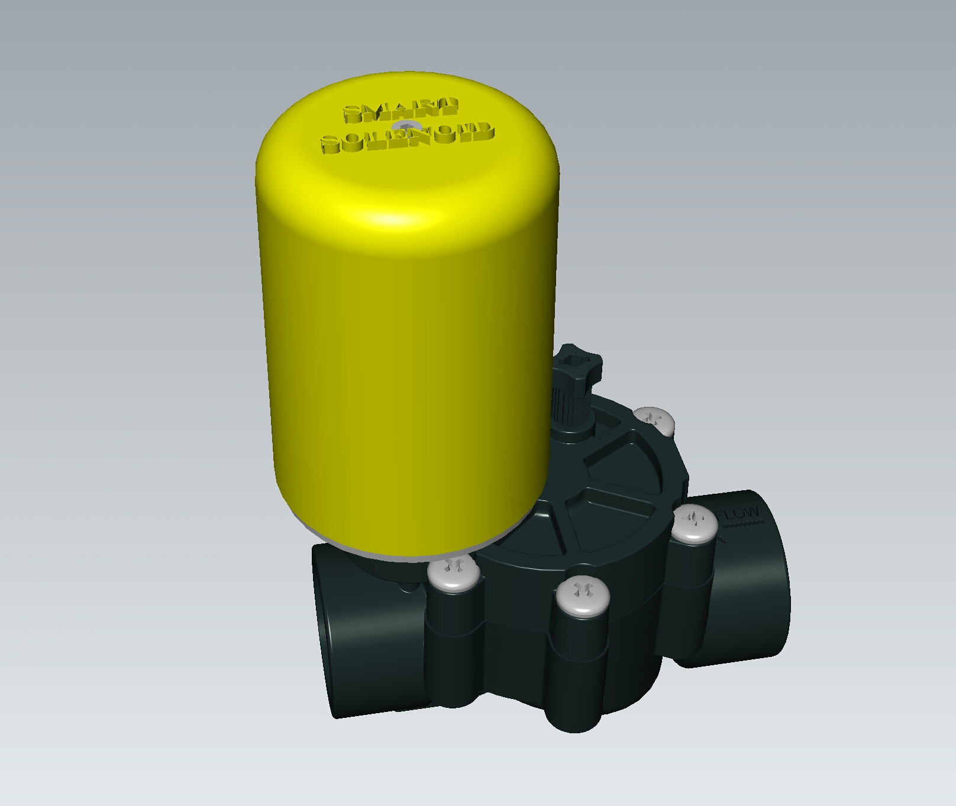

**The Idea**

To address the need of all people the have to irrigate where no power is available and do not like to run long wire to connect the controller to the irrigation valves, we got the ideas of embedding a small battery operated controller to a latching solenoid , and we name it SmartSolenoid.

**BLE SmartSolenoid**

Originally, when we started in September 2017, the unit was based on a long range BLE chip , with a very low current draw and an acceptable RF range . We have developed a code to be run on a nRF52 BLE 5.0 chip that could be RF connected to a Smartphone or to and OpenSprinkler running on a ESP32 processor. The Espressif ESP32 processor have an embedded BLE 4.0 unit capable to be connected to nRF52 units. Unfortunately the ESP32 BLE library are not yet fully developed and adding BLE to OpenSprinkler require functions and capabilities not available yet.

The SmartSolenoid code running on nRF52 is available on https://GitHub.com/pbecchi/SmartSolenoid and can be compiled with Arduino IDE.

We have used Fanstel Bt832 and BT832X modules.

The test we have performed with BT832 show expected range of 20 to 50 m and depend a lot on module position . Modules need to be in line of sight and any obstacle need to be avoided.

Current drawn by the module is very low, in average 50 to 120 uA , leading to a duration of 2500 h (100 day) with a small coin battery.

With BT832X module , than include a power amplifier, with have a substantial range increase up to about 500 m LOS.This may be more than enough for most of the user applications!

But since range is never really enough, recently we started a new SmartSolenoid development replacing Bluetooth link with a LoRa one.

**LoRa SmarSolenoid**

LoRa is a family of new spread spectrum RF transceiver working on 430 980 mHz bands.

Several low cost modules are today available on the market with 100mA RF (20 dB) Power transmission. For our SmartSolenoid nodes, we have selected a Semteck 1278 (433mHz) based module combined with an Atmel328p processor . This combination is supported by a wide choice of libraries (Arduino) and lead to a good low-power code.

Our prototype is based on a Electrodragon LoraArduino board and a small board to switch one or two latching solenoid.

http://www.electrodragon.com/product/wifi-lora-32-dev-board/

The power to the solenoid is provided by a 9v battery, while a small 1s lipo battery power LoraArduino. Our measurement of current consumption lead to a 2000mAh battery duration of 1 to 2 month, while the 9v battery should last more than 1000 actuations.

Using a 5000mA battery or adding a small solar panel , will be sufficient to increase the battery duration to 6 12 month.

We have performed several test to measure range of LoRa SmartSolenoids!

Range is far superior from the one of BLE units and span in open air from 300m to 2 km. Test has show that RSSI (receiver signal strength indicator) is highly dependent on antenna and his position. Most LoRa modules have a built-in helical dipole antenna and give his best if mounted vertical on a metallic structure at least 1mt over the ground surface. Obstacles can greatly limit the range and it is therefore better to locate antennas in LOS (line of sight). In order to allow a more free positioning of SmartSolenoid units we have developed a node mesh SW : remote units can be controlled thanks to other units relaying the commands to the unreachable devices. This way you can locate SmartSolenoids underground, inside building, or in any area out of controller sight.

SW is open source and available on GitHub.com/pbecchi/smartsolenoidsmall , the code is equivalent to the BLE version and use same API and is compatible to a modified version of OpenSprinkler code that can control remote LoRa units.

**Hardware**

HW details are available on github.com/pbecchi/SmartSolenoid .

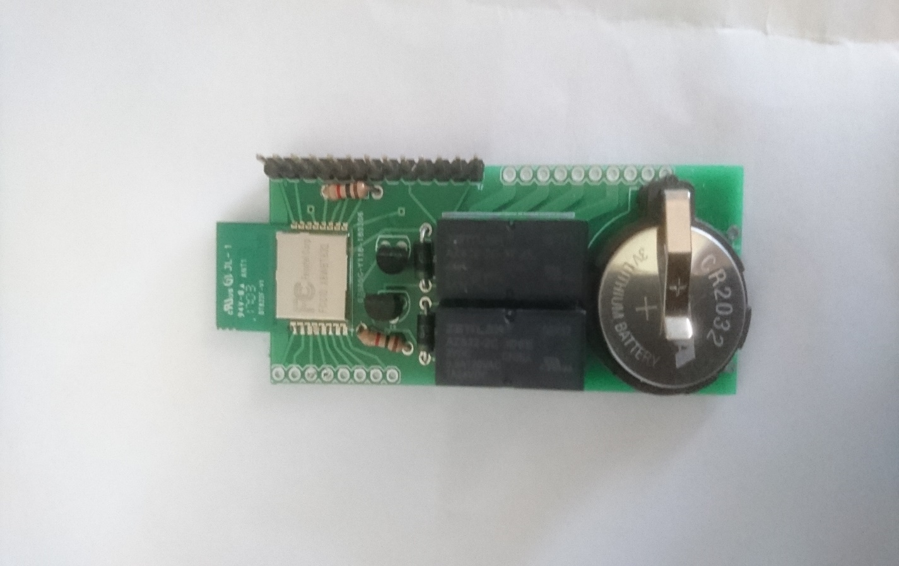

A set of prototype boards compatible to Fanstel modules and to ArduinoLora have been built and assembled. Recently using stereolitography we have built a proof of concept waterproof Smartsolenoid enclosure that contain in addition to the solenoid coil the PCB and the batteries.

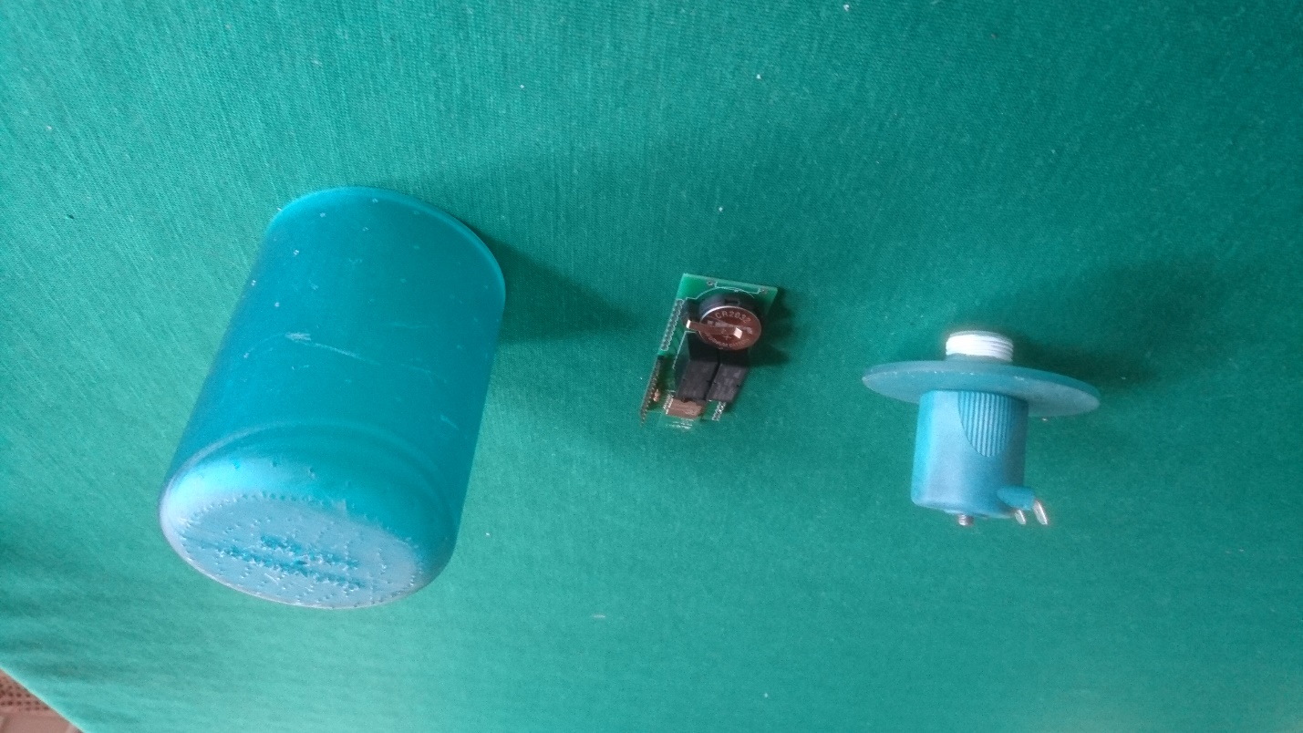

New production boards will be shortly available and will be integrated in the same waterproof containers. Production enclosures require a high initial investment due to tooling cost, production will be started when we will reach sufficient requests.

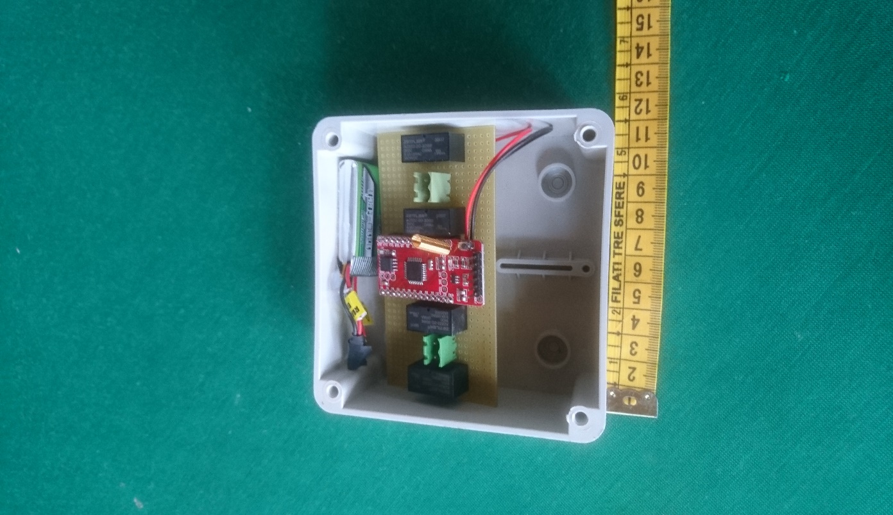

As simpler alternative, for 2+ solenoid units, a standard waterproof box with or without solarpanel is available. The Box will be mounted near to the existing latching valve and will be wired to it.

You can find information on SmartSolenoid units in smartgarden.cloud/SmartSolenoid.

SmartSolenoids will be controlled by a controller transmitter unit or by an Esp32 OpenSprinkler.

**OpenSprinkler**

OpenSprinkler 2.1.7 code has been ported to Esp32 MCU. This code is derived from Esp8266 version and use Oled 128x64 graphic LCD.

The capability to control LoRa SmartSolenoid has been added as an optional special RF stations. You can associate each OpenSprinkler station to a SmartSolenoid unit and without any wire you can operate, from inside your home , several Smartsolenoids located in your garden even 1000 m away. This way you can just get one Esp32 LoRa Oled unit and run a full featured OpenSprinkler controller only using remote LoraSmartsolenoid stations.

Two brand of Esp32 LoRa Oled modules are today available on the market Heltec and TTGO and can be found here:

<https://www.banggood.com/Wemos-TTGO-LORA-SX1278-ESP32-0_96OLED-16-Mt-Bytes-128-Mt-bit-433Mhz-For-Arduino-p-1205930.html>

Esp32 OpenSprinkler code can be found on GitHub.com/pbecchi/Esp32Opensprinkler/.