**E-Commerce Platform Backend Documentation**

**1. Introduction**

**Project Description**

This e-commerce platform is designed to manage products and orders efficiently, allowing users to browse a product catalog, place orders, and manage their customer information. The solution is built with a focus on scalability and ease of use.

**Technologies Used**

1. ASP.NET Core 8: Framework for building web applications and services.
2. Entity Framework Core: ORM used to interact with the database.
3. SQL Server: Relational database management system used to store the data.

**2. System Architecture**

**Architecture Diagram**

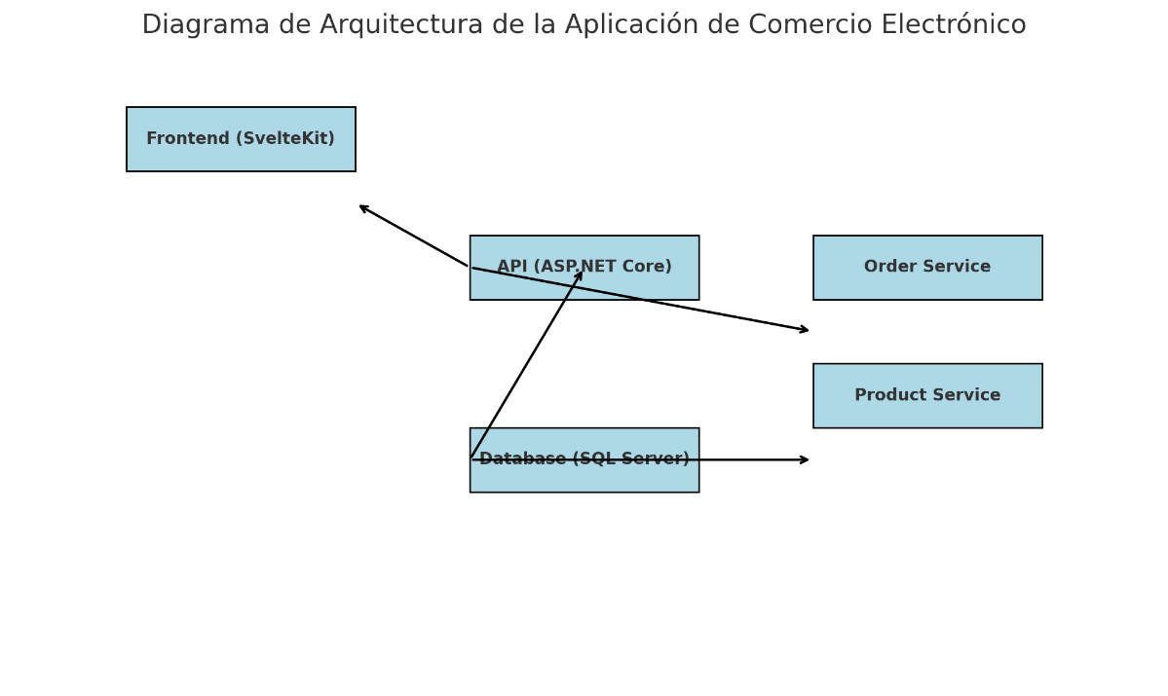

* **Frontend (SvelteKit):** The user interface where customers interact with the application.
* **API (ASP.NET Core):** The backend service that handles requests from the frontend and communicates with the database.
* **Database (SQL Server):** Where data related to products and orders is stored.
* **Order Service:** Handles logic related to order management.
* **Product Service:** Handles logic related to product management.

**Core Components**

**API:** Provides an interface to interact with the backend.

**Database:** Stores product information, orders, and order details.

**Services:** Contain the business logic to manage the application.

**3. Database Structure**

**Database Schema**

The database consists of the following tables:

* Products Table
* Orders Table
* Order Details Table

The DDL and DML can be found in the DB documentation

**4. Error Handling**

**HTTP Status Codes**

The API returns HTTP status codes to indicate the outcome of requests. Some common codes include:

* 200 OK: Request successful.
* 201 Created: Resource created successfully.
* 400 Bad Request: The request is invalid.
* 404 Not Found: The requested resource was not found.

**5. Installation and Configuration Guide**

**Prerequisites**

.NET SDK 8.0 or higher

SQL Server (local or cloud)

Installation Instructions

1. Clone the repository: <https://github.com/Anderson735/LinkTic_Test_Back.git>
2. Navigate to the project directory: cd LinkTic_Test_Back.
3. Restore the dependencias: dotnet restore.
4. Configure the database connection in appsettings.json.
5. Run the migrations: dotnet ef database update
6. Start the application: dotnet Run

**Database Configuration**

Make sure to configure the database connection string in the appsettings.json file according to your environment.

**6. Scalability and Maintenance**

**Scalability Strategies**

The application is designed to scale horizontally through the use of load balancers and separation of services.

**Maintenance**

It is recommended to perform regular database backups and monitor application performance.