Belt and Road Reboot: Beijing’s Bid to

De-Risk Its Global Infrastructure Initiative

# Chapter 2: The Road to Repayment for the World’s Largest Ofﬁcial Debt Collector

November 2023

Bradley C. Parks, Ammar A. Malik, Brooke Escobar, Sheng Zhang, Rory Fedorochko, Kyra Solomon, Fei Wang, Lydia Vlasto, Katherine Walsh, and Seth Goodman



# Chapter 2: The Road to Repayment for the World’s Largest Ofﬁcial Debt Collector

### Section 1: Debunking the myth that Beijing’s overseas lending program has collapsed

The conventional wisdom is that Beijing has responded to the deteriorating performance of its overseas lending program via retreat. Eric Olander,

co-founder of the China-Global South Project (CGSP), recently summarized the state of expert opinion, noting that “[t]here was a time when Chinese lending to developing countries rivaled the World Bank” but “[t]hose days are now long gone as Chinese overseas development lending has been on a steady downward trajectory” (Olander 2023). Scott Kennedy of the Center for Strategic and International Studies (CSIS) told *Foreign Policy* magazine earlier this year that the BRI was a “shadow of its former self” (Lu 2023).76 Elliot Wilson of *Euromoney* magazine claims that “Chinese overseas lending to the developing world has collapsed” (Wilson 2022).

However, the conventional wisdom is mostly wrong. The empirical evidence that we present in this chapter paints a different picture—one in which China is behaving more like an international crisis manager than a country admiring its problems and sticking its head in the sand. Beijing is rebalancing its overseas lending portfolio by adopting a wide-ranging set of de-risking measures. It is ramping down the provision of long-term, dollar-denominated bilateral loans to sovereign borrowers for public investment projects, while at the same time ramping up the provision of loans that are RMB-denominated, short- or

medium-term in nature, unrelated to public investment projects, and/or involving multiple Chinese and/or non-Chinese banks. It is ratcheting down its use of the policy banks (China Development Bank and China Eximbank), while at the same time ratcheting up its use of the central bank (People’s Bank of China), state-owned commercial banks (such as Industrial and Commercial Bank of China, Bank of China, and China Construction Bank), and syndicated loan

76 The same *Foreign Policy* magazine article notes that “experts say China's lending for BRI projects has plummeted” (Lu 2023).

arrangements with non-Chinese banks (such as Standard Chartered, BNP Paribas, the International Finance Corporation, and the European Bank of Reconstruction and Development). It is also putting in place stronger safeguards to protect itself from borrowers that present high levels of repayment risk. So, another way of reading the evidentiary record is that Beijing is behaving like a *yield-maximizing investment portfolio manager* (see Box 2b).

The de-risking measures that Beijing is implementing are poorly understood among those who make and shape policy in Western capitals, which means that Washington, London, and Brussels increasingly run the risk of competing with a version of the BRI that no longer exists—BRI 1.0 rather than BRI 2.0. Our aim in this chapter is to set the record straight. We do so by ﬁrst debunking the popular myth that China’s overseas lending program has experienced a total collapse. The rest of the chapter is focused on demystifying the purpose, nature, and scope of Beijing’s ongoing BRI reboot.

The “Beijing in retreat” storyline has gained traction because it is consistent with the topline Chinese lending commitment trends that are recorded in several publicly available databases, such as the China’s Overseas Development Finance Database, the Chinese Loans to Latin America and the Caribbean Database, the Chinese Loans to Africa Database, the China’s Global Energy Finance Database, the China Overseas Finance Inventory Database, and the World Bank’s International Debt Statistics (IDS). Consider the following claims that have been made based upon these data sources:

* In December 2020, Boston University’s Global Development Policy Center released the China’s Overseas Development Finance (CODF) Database, which provides data on China Eximbank and CDB lending commitments to governments, inter-governmental bodies, majority state-owned entities and minority state-owned entities with sovereign guarantees. The research team responsible for the database claimed at the time that it provided evidence of “China’s overseas development ﬁnance commitments” declining from $75 billion in 2016 to $3.9 billion in 2020 (Gallagher and Ray 2020). Then, in January 2023, the same research team used an updated version of the CODF database to argue that China’s

overseas development ﬁnance commitments remained at an exceptionally low level ($3.6 billion) in 2021 (Ray 2023).

* The World Bank’s International Debt Statistics (IDS) show a sharp decline in ofﬁcial sector loan commitments from China to public sector institutions in low-income and middle-income countries—from $31.5 billion in 2016 to $7 billion in 2021.
* According to the Chinese Loans to Latin America and the Caribbean Database jointly produced by Inter-American Dialogue and Boston University’s Global Development Policy Center, “the LAC region saw a precipitous decline in loans from CDB and Eximbank between 2015 and 2020, when lending ceased altogether” (Myers and Ray 2023: 1). They also concluded that Chinese development ﬁnance commitments to the LAC region remained stubbornly low in 2021, identifying only one ($204 million) CDB loan commitment in that year.77
* According to the Chinese Loans to Africa (CLA) database, which was initially developed by the China-Africa Research Initiative at the Johns Hopkins School of Advanced International Studies (SAIS-CARI) and is now maintained by Boston University’s Global Development Policy Center, Chinese lending commitments to African governments and state-owned entities plunged from a high of $28 billion in 2016 to a low of $1.9 billion in 2020. In a summary of their ﬁndings, the researchers responsible for the CLA database conclude that “[c]ompared to previous years, the number of loans and the total value of loan commitments decreased dramatically in 2020” (Hwang et al. (2022: 2).78

The latest (3.0) version of AidData’s Global Chinese Development Finance (GCDF) dataset paints a different picture of China’s overseas development

77 AidData has categorized this $204 million (EUR 175 million) CDB loan as an informal pledge of ﬁnancial support rather than a formal loan commitment, based on evidence that it gathered via direct correspondence with the Debt Management Division of Trinidad and Tobago's Ministry of Finance. See ID#95549 in the 3.0 version of AidData’s GCDF dataset for more details.

78 An update of the CLA database was published at the time that this report was going to press. It shows a continued decline in Chinese lending commitment—to $1.2 billion in 2021 and

$994.4 million in 2022 (Moses et al. 2023).

ﬁnance portfolio (see Figure 1.2 in Chapter 1). It demonstrates that Beijing is still the single largest source of international development ﬁnance in the world, with annual ODA and OOF commitments to LIC and MICs now hovering around $80 billion. Although it provides evidence of China’s annual international development ﬁnance commitments falling between 2016 and 2020, it also shows an increase in 2021 (returning to a level that is roughly comparable to the ﬁrst full year of BRI implementation).

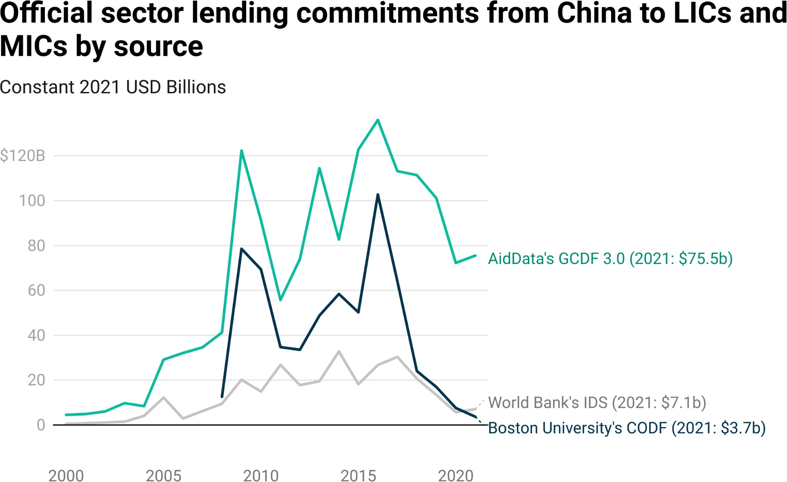

**Figure 2.1**

*Notes: Figure 2.1 compares the total size of ofﬁcial sector lending commitments from China to LICs and MICs across three datasets: the 3.0 version of AidData’s GCDF dataset, Boston University’s China’s Overseas Development Finance Database (CODF), and the World Bank’s International Debt Statistics (representing commitments to ofﬁcial creditors in China).*

Figure 2.1 provides a comparison of ofﬁcial lending commitments from China to borrowers in low-income and middle-income countries, as measured by three different sources: the 3.0 version of AidData’s GCDF dataset, the World Bank’s IDS, and the CODF database produced by Boston University's Global Development Policy Center.79 AidData captures lending commitments worth

79 To ensure comparability, we convert the IDS data series and the CODF data series into constant 2021 USD.

$1.28 trillion between 2000 and 2021, while CODF and IDS capture lending commitments worth $605 billion and $378 billion, respectively.80 Whereas AidData records a 45% decline in lending commitments between 2016 and 2021, CODF and IDS record substantially larger declines—96% and 78%, respectively. CODF and IDS record $3.7 billion and $7.1 billion, respectively, in new ofﬁcial lending commitments from China in 2021. AidData captures $75.5 billion in new ofﬁcial lending commitments from China in the same year.

There are several reasons why the estimates from AidData’s GCDF dataset, BU’s CODF dataset, and the World Bank’s IDS are widely divergent. First, although all three sources provide data on public and publicly guaranteed debt (PPG) debt from Chinese state-owned creditors,81 they provide different levels of geographical coverage.82 AidData’s GCDF dataset covers 126 countries, while BU’s CODF dataset covers 96 countries and the World Bank’s IDS covers 89 countries.83 Second, there are temporal coverage differences: whereas AidData’s GCDF dataset and the World Bank’s IDS provide data for 22 commitment years (2000-2021), BU’s CODF dataset provides data for 14 commitment years

(2008-2021). Third, in the subset of LICs and MICs for which CODF, IDS, and GCDF data are available, there are differences in how much PPG debt from Chinese state-owned creditors is captured. Table A15 demonstrates that, in the subset of LICs and MICs for which CODF or IDS data are available, AidData’s GCDF dataset captures $947 billion of lending commitments84 from ofﬁcial

80 The $1.28 trillion ﬁgure excludes short-term “rollover” facilities to reﬁnance maturing debts. When

short-term “rollover” facilities are included in the tally, AidData captures lending commitments from China worth $1.44 trillion between 2000 and 2021.

81 PPG debt consists of (a) long-term external obligations of public debtors, including the national government, a political subdivision (or an agency of either), and autonomous public bodies; and (b) long-term external obligations of private debtors that are guaranteed for repayment by a public entity (World Bank 2000).

82 The 3.0 version of AidData’s GCDF dataset provides comprehensive coverage of Chinese ODA and OOF commitments across 165 LICs and MICs between 2000 and 2021. However, only 134 of these countries secured loan commitments from ofﬁcial sector creditors in China over the same time period. An even smaller subset (126 countries) secured loan commitments between 2000 and 2021 from ofﬁcial sector creditors in China that qualify as PPG debt.

83 The IDS data capture ofﬁcial sector lending commitments from China to 89 low-income and

middle-income countries (excluding the People’s Republic of China) from 2000-2021. The IDS data do not allow users to differentiate between the People’s Republic of China (“China”) and the Republic of China (“Taiwan”). As such, we exclude all loan commitments that 9 additional countries reported during the years when they maintained diplomatic relations with Taiwan.

84 The $947 billion ﬁgure excludes short-term “rollover” facilities. When short-term “rollover” facilities are included in the tally, AidData captures lending commitments to LICs and MICs that qualify as PPG debt worth $1.09 trillion between 2000 and 2021.

sector institutions in China to LICs and MICs that qualify as PPG debt.85 In total, BU’s CODF dataset captures $605 billion and the World Bank’s IDS captures

$378 billion of lending from ofﬁcial sector institutions in China that qualiﬁes as PPG debt.86 These topline differences reﬂect widely varying levels of lending institution, borrowing institution, and debt instrument coverage (which we discuss at greater length below). Table A15 calls attention to the fourth and ﬁnal difference: neither BU’s CODF dataset nor the World Bank’s IDS provide any coverage of lending commitments from ofﬁcial sector institutions in China to LICs and MICs that qualify as non-PPG debt. AidData’s GCDF dataset, by contrast, captures $333 billion that does not (clearly) qualify as PPG debt: $67 billion of potential public sector debt (i.e., debt contracted by a minority

state-owned institution in the borrowing country without a public sector repayment guarantee), $216 billion of private sector debt, and $50 billion that is not allocable due to a lack of sufﬁcient information for categorization purposes.87

One additional source of information is worth considering: newly published data from the Bank of International Settlements (BIS) on total outstanding credit from Chinese banks to LICs and MICs from 2015 to 2021 (see Box 2a). These data are particularly valuable because they are based on direct reporting from Chinese banks about their cross-border claims. Although the BIS does not currently allow for its Chinese lending data to be disaggregated by borrower countries, one can derive lower-bound and upper-bound estimates of total outstanding credit from Chinese banks to LICs and MICs based on new research by Cerutti et al. (2023). As we describe at greater length in Box 2a, lower-bound estimates based on the BIS data indicate that total outstanding credit from Chinese banks to LICs and

85 In the 96 countries that are covered by the CODF dataset, BU captures $605 billion and AidData captures

$824 million of lending commitments (excluding short-term “rollover” facilities) between 2008 and 2021 from ofﬁcial sector institutions in China that qualiﬁes as PPG debt. When short-term “rollover” facilities are included in its tally, AidData captures $987 million in the same set of countries.

86 For a country-by-country comparison of AidData and IDS measures of PPG debt exposure to China (that are normalized by host country GDP), see Table A16.

87 The “Level of Public Liability” variable in the 3.0 version of AidData’s GCDF dataset captures the extent to which the host government may eventually be liable for debt repayment. Each loan record is assigned to one of six categories: (1) Central government debt, (2) Central government-guaranteed debt, (3) Other public sector debt, (4) Potential public sector debt, (5) Private debt, or (6) Unallocable. The sum of the ﬁrst three categories is equivalent to PPG debt. The fourth category captures loans to special purpose vehicles (SPV) or joint ventures (JV) that are minority-owned by one or more public sector institutions in the host country and that do not beneﬁt from a central government repayment guarantee or a repayment guarantee from a state-owned entity other than the central government in the host country. For more information about the “Level of Public Liability” variable, see Section A-5 in the Appendix.

MICs increased in nominal terms from $644 billion in 2015 to $1.16 trillion in 2021. Upper-bound estimates based on the BIS data indicate that total outstanding credit from Chinese banks to LICs and MICs increased in nominal terms from $878 billion in 2015 to $1.58 trillion in 2021. AidData’s estimates of the cumulative size of China’s overseas lending program in LICs and MICs are consistent with the more conservative (lower-bound) BIS-based estimates.88 According to the 3.0 version of the GCDF dataset, China’s cumulative overseas lending commitments increased from $620 billion in 2015 to $1.03 trillion in 2021 (in nominal USD).89 Neither AidData’s GCDF dataset nor the BIS-based estimates support the argument that China’s overseas lending program has experienced a total collapse.

**Box 2a: What is the true scale of China’s overseas lending program?**

The overall size of China’s overseas lending program is a subject of ongoing debate and controversy. Horn et al. (2019) conducted pioneering work, producing a $393 billion estimate of total outstanding cross-border credit from Chinese banks to LICs and MIC borrowers in 2017. At the time, their estimate was criticized by the IMF as being exaggerated (IMF 2020). Bräutigam and Acker (2020) also published a critique, concluding that they “agree[d] with the IMF.” Horn et al. (2020a) then issued a response to their critics, arguing that “our numbers are substantially below comparison ﬁgures [from the PBOC and other ofﬁcial sources] and likely a lower bound estimate of the true extent of Chinese overseas lending.”90 They explained that “[d]espite our best efforts to merge data from multiple sources, we still miss substantial amounts of Chinese overseas lending.”

There was also an important development around the time that the Horn et al. (2019) study was published: China began reporting to the Bank of International Settlements (BIS) on the

cross-border claims of its banks.91 At the time, the Locational Banking Statistics (LBS) published by the BIS indicated that total outstanding credit from Chinese banks to overseas borrowers was

88 A key caveat, as we explain in Section A-4, is that the BIS data are represented as amounts outstanding, which is effectively equivalent to cumulative disbursements minus cumulative repayments (i.e., credit stocks rather than credit ﬂows). Consequently, cumulative lending commitments usually *exceed* amounts outstanding.

89 These nominal USD ﬁgures exclude short-term “rollover” facilities to reﬁnance maturing debts. If

short-term “rollover” facilities are included in the tally, China’s cumulative overseas lending commitments increased from $630 billion in 2015 to $1.17 trillion in 2021 (in nominal USD). In general, we prefer to report China’s overseas lending commitments in constant 2021 USD. However, since the BIS data are recorded in nominal USD, an apples-to-apples comparison with the 3.0 version of AidData’s GCDF dataset requires use of nominal USD. In Table 2.1, we report China’s cumulative overseas lending commitments to LICs and MICs from 2015-2021 in both nominal and constant 2021 USD.

90 At the time, China’s State Administration of Foreign Exchange (SAFE) had published (2017) data on “China’s International Investment Position” that identiﬁed $637 billion of total outstanding cross-border credit. By 2021, this ﬁgure rose to $988 billion. See <https://www.safe.gov.cn/en/2018/0928/1459.html>.

91 Although China has joined the list of countries reporting to the BIS, its data (unlike the data of many of other BIS reporting countries) are not made publicly available on a bilateral basis.

more than double ($919 million) the size of the Horn et al. (2019) estimate.92 Since then, additional BIS reporting by China and new research by Cerutti et al. (2023) has made it possible to generate updated estimates of total outstanding credit from Chinese banks to borrowers in LICs, MICs, high-income countries (HICs), and other overseas jurisdictions.93 In Section A-4, we provide a step-by-step description of how these BIS-based measures of total outstanding credit from Chinese banks to overseas borrowers are derived. We also discuss a number of important caveats and considerations regarding the BIS cross-border lending data.

The estimates, which we report in Table 2.1, demonstrate that China’s total outstanding credit—measured in nominal terms—to borrowers in LICs, MICs, HICs, and other overseas jurisdictions soared from $1.45 trillion in 2015 to $2.63 trillion in 2021. Conservative,

lower-bound estimates based on BIS reporting also indicate that *total outstanding credit from Chinese banks to LIC and MIC borrowers effectively doubled in nominal terms between 2015 and 2021—from $644 billion to $1.16 trillion.* This measure of the stock of LIC and MIC debt to Chinese banks is remarkably similar to our own measure of the stock of LIC and MIC debt to Chinese banks.94 According to the 3.0 version of AidData’s GCDF dataset, China’s cumulative overseas lending commitments to LIC and MICs increased in nominal terms from $620 billion in 2015 to $1.03 trillion in 2021.95

Table 2.1 provides several additional insights. One is that China’s total outstanding credit to LICs, MICs, and HICs soared from $1.45 trillion in 2015 to $2.63 trillion in 2021. Another is that total outstanding credit from Chinese banks to HIC borrowers effectively doubled over the same six-year period. Between 2015 and 2021, this ﬁgure rose from approximately $330 billion to

$600 billion. A third is that total outstanding credit from Chinese banks to “other” borrowers increased from $314.3 billion in 2015 to $568.3 billion in 2021.

While the LBS data from the BIS are extremely valuable for cross-validation purposes (since they provide credible estimates of total outstanding credit from Chinese banks to LIC, MICs, and HICs), they do not make it possible to track disbursements, repayments, and amounts outstanding on a loan-by-loan basis. AidData recently launched a new data collection initiative and research program to address this major evidentiary gap. For the time being, in the 3.0 version of the GCDF dataset, we have documented disbursements, repayments, and amounts outstanding in the “description” ﬁeld for a subset of countries. However, in the future, we intend to publish loan-level data on disbursements, repayments, and amounts outstanding for a more complete set of countries. We also intend to make these data available in a more user-friendly format.

92 On this point, see Zhou and Cerutti 2018.

93 BIS classiﬁes most HICs as “Advanced Economies” (AEs) and most LICs and MICs as Emerging Market and Developing Economies (EMDEs). For the sake of clarity and consistency, we use the LIC, MIC, and HIC acronyms. For more on the BIS country classiﬁcation system, see Cerutti et al. (2023).

94 This BIS-based measure of China’s lending portfolio in LICs and MICs is based on amounts outstanding. AidData’s measure of China’s lending portfolio in LICs and MICs is based on cumulative lending commitments, which usually exceed amounts outstanding. See Section A-4.

95 According to BU’s CODF dataset, China’s cumulative overseas lending commitments to LIC and MICs increased in nominal terms from $308 billion in 2015 to $498 billion in 2021. According to the World Bank’s IDS, China’s cumulative overseas lending commitments to LIC and MICs increased in nominal terms from

$188 billion in 2015 to $293 billion in 2021.

## Comparison of AidData- and BIS-based estimates of China’s international lending portfolio

**Table 2.1**

|  |  |  |  |  |  |  |  |  |
| --- | --- | --- | --- | --- | --- | --- | --- | --- |
| **Year** | **BIS Total to LICs and MICs (Based on 60.4%**  **Assumption)** | **BIS Total to LICs and MICs (Based on 44.31%**  **Assumption)** | **AidData Total to LICs and MICs**  **Nominal USD (Constant 2021 USD)** | **BIS Total to HICs (Based on 22.6%**  **Assumption)** | **BIS Total to HICs (Based on 22.8%**  **Assumption)** | **BIS Total to "Other" Borrowers (Based on 21.6%**  **Assumption)** | **BIS Total to OFC**  **Borrowers (Based on 30.33%**  **Assumption)** | **BIS Total to LICs, MICs,**  **HICs, and “Other” Borrowers** |
| 2015 | 878.7 | 644.7 | 620.7  (823.4) | 328.8 | 331.7 | 314.3 | 441.3 | 1,454.9 |
| 2016 | 1,046.1 | 767.4 | 721.4  (942.2) | 391.4 | 394.9 | 374.1 | 525.3 | 1,731.9 |
| 2017 | 1,197.7 | 878.7 | 805.7  (1,039.3) | 448.2 | 452.1 | 428.3 | 601.4 | 1,983.0 |
| 2018 | 1,348.3 | 989.1 | 889.4  (1,130.6) | 504.5 | 509.0 | 482.2 | 677.1 | 2,232.3 |
| 2019 | 1,367.0 | 1,002.8 | 951.0  (1,199.8) | 511.5 | 516.0 | 488.8 | 686.4 | 2,263.2 |
| 2020 | 1,492.7 | 1,095.1 | 986.8  (1,239.8) | 558.5 | 563.5 | 533.8 | 749.6 | 2,471.4 |
| 2021 | 1,589.2 | 1,165.9 | 1,027.1  (1,280.1) | 594.6 | 599.9 | 568.3 | 798.0 | 2,631.1 |

*Notes: The BIS data are reported in current (nominal) USD. For the sake of comparability, the amounts recorded in the “AidData Total to LICs and MICs” column are also reported in current (nominal) USD, though the constant 2021 USD amounts are reported in parenthesis. The totals from AidData exclude short-term “rollover” facilities (see Box 2c and Section A-3 in the Appendix).*

There are three main reasons why AidData’s GCDF dataset challenges the conventional wisdom about the total collapse of China’s overseas lending program.

1. **Lending institution coverage:** Unlike other publicly available datasets that measure Chinese development ﬁnance, the 3.0 version of AidData’s GCDF dataset does not exclusively track the overseas lending activities of China’s government agencies (MOFCOM and CIDCA) and its state-owned

policy banks (China Eximbank and CDB).96 Based on OECD-DAC reporting directives, it tracks the overseas lending activities of *all* government and state-owned creditors in China, including state-owned commercial banks (such as Bank of China, ICBC, China Construction Bank, Bank of Communications, China CITIC Bank, Bank of Shanghai, Postal Savings Bank of China, China Merchants Bank, and Harbin Bank),

state-owned companies (such as CNPC, CMEC, Poly Technologies, NORINCO, and AVIC), state-owned funds (such as the Silk Road Fund and China Investment Corporation), state-owned policy banks (CDB and China Eximbank), and government agencies (such as MOFCOM, PBOC, and SAFE). In total, 180 Chinese lending institutions are included in the

3.0 version of AidData’s GCDF dataset. By way of comparison, two Chinese lending institutions are included in Boston University’s CODF database (China Eximbank and CDB) and only a handful of Chinese lending institutions are included in the IDS.97 The breadth of AidData’s lending institution coverage is particularly consequential because, in recent years, the LIC and MIC lending operations of China’s central bank (PBOC) and state-owned commercial banks have expanded while those of CDB and China Eximbank have contracted (see Figure 2.7).98

96 The China’s Overseas Development Finance Database, the Chinese Loans to Latin America and the Caribbean Database, and China’s Global Energy Finance Database track the overseas lending activities of two state-owned policy banks (CDB and China Eximbank). They do not track the overseas lending activities of China’s state-owned commercial banks. Nor do the World Bank IDS data capture loans from Chinese state-owned commercial banks. As explained by Horn et al. (2021: 15), “the World Bank's deﬁnition [of ofﬁcial sector lending] does not cover lending by commercial banks such as the Industrial and Commercial Bank of China (ICBC) or the Bank of China (BoC), despite the fact that they are state-owned. These banks are ofﬁcial creditors according to our (OECD) deﬁnition (they are owned and controlled by the Chinese government), but they are not bilateral creditors according to the World Bank’s deﬁnition, because they are not a ‘public enterprise’ in a narrow sense, in contrast to the policy banks such as China Ex-Im Bank or CDB.”

97 IDS includes loan commitments from government agencies (such as MOFCOM and CIDCA) and state-owned policy banks (such as China Eximbank and CDB), but excludes loan commitments from

state-owned companies, state-owned funds, and state-owned commercial banks (Horn et al. 2021: 15). For the most part, IDS also appears to exclude loan commitments from the PBOC and SAFE, which is a PBOC subsidiary (see Box 2c). This is true despite the fact that IDS seeks to capture all loans from “the general government, central government; state and local government; [and] central bank and public enterprise” (World Bank 2020b: 4).

98 On average, during the pre-BRI period (2000-2013), Beijing channeled 15% of its annual lending commitments to low- and middle-income countries through its state-owned commercial banks. This ﬁgure increased to 18% during the early BRI (2014-2017) period and 22% during the late BRI period (2018-2021). On average, Beijing channeled 70% of its annual lending commitments to low- and middle-income countries through its policy banks during the pre-BRI period. This ﬁgure dropped to 60% during the early BRI period and 30% during the late BRI period. On average, during the pre-BRI period, Beijing channeled only 3% of its annual lending commitments to low- and middle-income countries through PBOC/SAFE. This ﬁgure increased to 14% during the early BRI period and 43% during the late BRI period. See Figure 2.7 for more details.

1. **Borrowing institution coverage:** OECD-DAC reporting guidelines specify that ODA and OOF are designed to capture ofﬁcial sector ﬁnancial ﬂows, where the “ofﬁcial sector” refers to the sources rather than the destinations of such ﬂows (Horn et al. 2021: 23). AidData adheres to this reporting standard to ensure that its measures of Chinese development ﬁnance are comparable to OECD-DAC sources of international development ﬁnance. As such, the 3.0 version of AidData’s GCDF dataset captures lending from all Chinese government and state-owned creditors to all public sector and private sector borrowers in low-income and middle-income countries, regardless of whether they secured sovereign repayment guarantees. By contrast, other publicly available datasets—such as Boston University’s CODF dataset and the World Bank’s IDS—exclusively track Chinese loans to government institutions, majority state-owned entities, and borrowing institutions that beneﬁt from sovereign repayment guarantees (i.e., public and publicly guaranteed debt owed to China). This coverage difference is consequential because a signiﬁcant percentage of China’s overseas lending portfolio is channeled to special purpose vehicles, joint ventures, private sector institutions, and minority state-owned entities (see Figures 2.18 and A10). While these loans typically do not appear on government balance sheets in

low-income and middle-income countries, many of them beneﬁt from implicit host government liability protection, which has blurred the distinction between public debt and private debt.99 In total, the 3.0 version of the GCDF dataset captures $525 billion of lending commitments to 661 borrowing institutions that qualify as central government or central government-guaranteed debt, $421 billion of lending commitments to 455 borrowing institutions that qualify as another type of public sector debt, $67 billion of lending commitments to 85 borrowing institutions that qualify as potential public sector debt, $216 billion of lending commitments to 724 borrowing institutions that qualify as private sector debt, and $50 billion that is not allocable due to a lack

99 As Horn et al. (2021: 4) explain, "[w]hile the distinction between private and public sector recipients is clear in principle, it tends to be blurry in practice, in particular in developing countries and during ﬁnancial crises. Private debt often turns into public debt once a crisis hits and many of the loans [to private sector borrowers] might have explicit or implicit government guarantees.” On this point, also see Malik et al. (2021) and Malik and Parks (2021).

of sufﬁcient information for categorization purposes.100 By contrast, BU’s CODF dataset captures $605 billion of lending commitments from ofﬁcial sector institutions in China to 150 borrowing institutions that qualify either as central government debt, central government-guaranteed debt or another type of public sector debt.101

1. **Debt instrument coverage:** For the most part, existing Chinese development ﬁnance datasets—such as BU’s CODF dataset and the World Bank’s IDS—track long-term, dollar-denominated bilateral loans for public investment projects. However, China’s overseas lending program is supported by a more diverse set of ﬁnancing instruments, some of which are RMB-denominated, short- or medium-term in nature, unrelated to public investment projects, and/or involving multiple Chinese and/or

non-Chinese banks. They include syndicated loans with multiple Chinese and/or non-Chinese bank participants, loans entrusted to multilateral administrators, short- or medium-term liquidity support facilities (LSFs) to provide balance of payments (BOP) support, currency swap facilities, foreign currency deposit loans, pre-export ﬁnancing (PxF) facilities, deferred payment facilities, EPCF arrangements, interbank loan agreements, and revolving credit facilities, among other things.

Consistent with OECD-DAC measurement standards, the 3.0 version of AidData’s GCDF dataset tracks the full set of debt instruments used by Chinese state-owned entities in low-income and middle-income countries.102 Here again, the breadth of instrument coverage is becoming increasingly important, as Chinese state-owned creditors pivot away from the traditional approach of issuing long-term, dollar-denominated

100 These ﬁgures exclude the short-term “rollover” facilities that are described in Box 2c and Section A-3. When such facilities are included, the 3.0 version of the GCDF dataset captures the following lending commitment amounts: central government or central government guaranteed debt ($687 billion), other public sector debt ($422 billion), potential public sector debt ($67 billion) and private sector debt ($216 billion). There is an additional $50 billion in debt that is not allocable due to a lack of sufﬁcient information for categorization purposes.

101 For its part, IDS captures $378 billion of lending from ofﬁcial sector institutions in China to borrowing institutions that qualiﬁes either as central government debt, central government-guaranteed debt or another type of public sector debt (i.e., PPG debt). However, the publicly available IDS data cannot be disaggregated by borrowing institution. For a country-by-country comparison of AidData and IDS measures of PPG and non-PPG debt exposure to China, see Table A16

102 The OECD-DAC uses a broad deﬁnition of what qualiﬁes as a debt instrument. According to the latest version of its Converged Statistical Reporting Directives for the Creditor Reporting System (CRS) and the Annual DAC Questionnaire, "[d]ebt instruments require the payment of principal and/or interest at some point(s) in the future” (OECD 2023b: 12).

bilateral buyer’s credits and concessional loans for public investment projects (see Figures A11, A12, and A13) and toward short- and medium-term bilateral emergency rescue loans as well as long-term syndicated loans and loans entrusted to multilateral administrators.103

The “scope parameter” differences between the GCDF dataset and other publicly available datasets matter for a simple but important reason: exclusively tracking the lending activities of China Eximbank and CDB and the subset of loans from these two policy banks that qualify as PPG debt is not a useful way to monitor the changing scale and composition of Beijing’s overseas lending portfolio if the portfolio has shifted toward new creditors, new borrowers, and new lending instruments. In this chapter, we demonstrate that such changes have already taken place, which means that a continued focus on PPG debt from China Eximbank and China Development Bank would be analogous to the proverbial drunkard who insists upon searching for his keys beneath the lamppost “because that’s where the light is.”104

There are several supply-side factors that have likely prevented China’s overseas lending program from collapsing. First, Beijing’s state-owned banks have high levels of international exposure to default risk, which means they have an interest in ensuring that their biggest borrowers are sufﬁciently liquid to continue servicing their existing debts. One way of providing liquidity relief to borrowers is via short- or medium-term bridge loans.105 Second, even though Chinese banks are increasingly reluctant to issue long-term infrastructure project loans to government borrowers due to the rising tide of sovereign debt distress, Chinese companies with signiﬁcant international operations have an interest in securing

103 During the early BRI period (2014-2017) and late BRI period (2018-2021), an increasing proportion of China's ofﬁcial sector lending to LICs and MICs consisted of emergency rescue loans, including those of the “rollover” variety (see Figures 2.6 and A14 and Box 2c). The percentage of China’s non-emergency lending program in LICs and MICs that was channeled via multilateral institutions or syndicated loan arrangements increased from 33.7% in 2014 to 51.5% in 2021 (see Figure 2.23).

104 According to the 3.0 version of AidData’s GCDF dataset, the percentage of ofﬁcial sector lending commitments from China to LICs and MICs that were channeled through the policy banks (CDB and China Eximbank) plummeted from 87% in 2009 to 22% in 2021 (see Figure A27). As Mingey and Kratz (2021) put it “[t]he issue ultimately is one of scope. The [...] focus on policy bank loans obscures changes in China’s lending patterns—whether a shift in the source of loans to emerging market governments from policy commercial banks, or shifts in the destination of loans from governments to private infrastructure vehicles and corporates.”

105 Other options include grace period extensions, maturity extensions, and interest rate reductions. For more on this topic, see Horn et al. (2023a, 2023b).

new business and preserving market share in the countries where they operate. They therefore have incentives to ensure that new sources and types of ﬁnancing—such as syndicated loans that pool credit risk across Chinese and non-Chinese lenders, loans to special purpose vehicles and joint ventures rather than sovereigns, and deferred payment or EPCF agreements that involve more

risk-sharing between Chinese companies and their overseas clients—are brought to bear in support of new infrastructure projects in overseas markets. Third, to sustain high levels of domestic economic growth, China has a long-run need to secure natural resources that it lacks in sufﬁcient quantities at home, which is an important reason why Beijing allows its overseas borrowers to collateralize and repay loans with the money they earn from natural resource exports to China.

Fourth, China is seeking to position itself as a major world power and project inﬂuence around the globe, which serves as a counterweight to ﬁnancial pressures for retrenchment.

However, there is probably no factor more important than the overall size of China’s foreign exchange reserves. China would not have become the world’s largest ofﬁcial creditor to the developing world—larger than the World Bank, the IMF, and all Paris Club creditors combined—if not for its massive stockpile of foreign exchange reserves (Dreher et al. 2021, 2022). When Beijing adopted the “Going Out” strategy at the turn of the century, it prioritized

dollar-denominated lending to overseas borrowers to deal with a foreign currency oversupply challenge: annual trade surpluses led to a rapid accumulation of dollar reserves, which created a risk of currency (RMB) appreciation and prompted China’s State Administration of Foreign Exchange (SAFE) to search for international assets where it could invest its surplus dollar reserves and get a good return.106 SAFE used these funds in the early 2000s to recapitalize several state-owned banks, which in turn ramped up

dollar-denominated lending to overseas borrowers (see Figure 2.2 and Box 2b). However, until the 2008 Global Financial Crisis, SAFE parked the lion’s share of its surplus dollar reserves in U.S. government securities. Then, in 2008 and 2009, international asset prices plummeted and the U.S. Federal Reserve weakened the dollar via quantitative easing. Beijing’s traditional investment strategy of

106 For decades, China has sought to avoid a rapid appreciation of its currency in order to sustain high levels of export growth, which it regards as essential to achieve high-income country status.

parking surplus dollar reserves in U.S. government securities became less attractive and it launched a search for higher-yield (undervalued) overseas assets. SAFE entrusted a larger proportion of its surplus dollar reserves to the country’s state-owned policy banks, state-owned commercial banks, and state-owned investment funds and tasked them with the pursuit of higher

investment returns via dollar-denominated international lending (see Box 2b).107

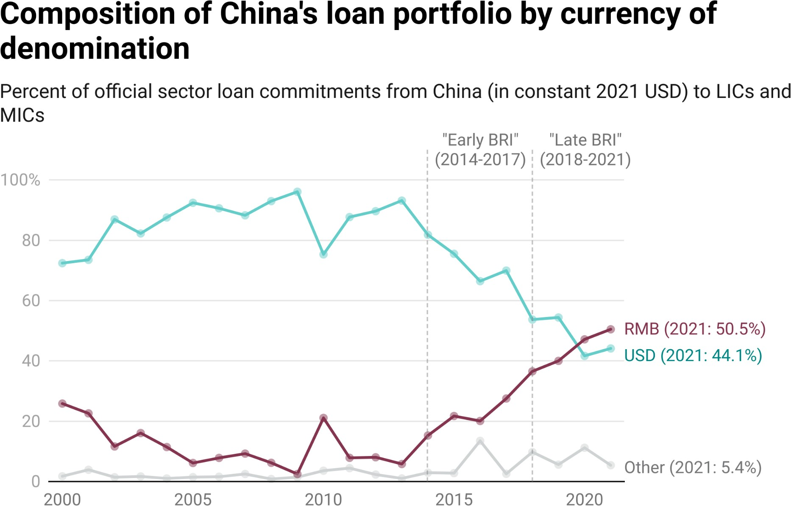

**Figure 2.2**

*Notes: The “Other” category includes all other currencies of denomination, including EUR, GBP, and local currencies in low-income and middle-income countries.*

The central role that foreign exchange reserves have played in the dramatic expansion of China’s 21st century overseas lending program raises several important questions. Are China’s foreign exchange reserves rising or falling? If they are rising, how are they being invested? Are Chinese state-owned lenders being recapitalized with these reserves and tasked with using these reserves to extend foreign currency-denominated loans to overseas borrowers?

107 However, SAFE is not the only source of foreign exchange that China's state-owned commercial banks have drawn upon to support foreign exchange-denominated overseas lending activities. Their balance sheet data demonstrates that they also have access to domestic foreign exchange deposits (Setser 2023a).

China’s foreign currency reserves remain vast—approximately $3.1 trillion as of 2023. However, this ﬁgure only refers to the ofﬁcial, foreign currency reserve holdings of China’s central bank (the PBOC). It does not account for the country’s so-called “hidden reserves,” which include foreign currency that the PBOC has moved out of its ofﬁcial reserve holdings (and off of its balance sheet) by entrusting them to Chinese state-owned policy banks (like CDB and China Eximbank), state-owned commercial banks (like BOC, ICBC, and China Construction Bank), and state-owned funds (like the Silk Road Fund and CIC).

Brad Setser of the Council on Foreign Relations argues that the country’s “hidden reserves” may be worth an additional $3 trillion.108 He also provides evidence that these additional reserves have rapidly increased over the last decade, which may explain why the 3.0 version of the GCDF dataset does not show a major contraction in the overall size of China’s overseas lending program in LICs and MICs.109 Additionally, it may explain why China’s overseas lending program in high-income countries (HICs) and offshore ﬁnancial centers (OFCs) nearly doubled between 2015 and 2021 (see Box 2a and Table 2.1).

**Box 2b: The investment agency behind the curtain—China’s State Administration of Foreign Exchange (SAFE)**

China’s State Administration of Foreign Exchange (SAFE) is a vice ministry-level institution and a subsidiary of the PBOC; its original mandate in 1955 was to act as the country’s foreign exchange regulatory authority. However, prior to the opening up of China’s economy in the late 1970s, the country had limited foreign exchange reserves and the PBOC had limited central bank responsibilities.110

Despite its inauspicious beginnings, SAFE was eventually made responsible for the management of the world’s largest stockpile of foreign exchange reserves. It also became one of the most important investors in the world.111 Due to recurring current account surpluses and capital account surpluses, China’s stock of foreign exchange reserves skyrocketed from from $200 billion in 2000 to $1 trillion in 2006, $2 trillion in 2009, and $3 trillion in 2011. Keeping all of these reserves (mostly USD) onshore posed a currency appreciation risk and threatened to undermine

108 Setser (2023a) argues that China’s “hidden reserves” consist of (a) non-reserve foreign exchange assets that SAFE has provided to the policy banks, state-owned commercial banks, and state-owned investment funds to lend and invest abroad; (b) foreign assets that state-owned commercial banks have purchased to match their domestic foreign currency deposit base; and (c) foreign exchange that CIC purchased off the balance sheet of SAFE.

109 See Setser 2023a, 2023c.

110 At that time, the PBOC was a state-owned commercial bank operating under the supervision of the Ministry of Finance. The PBOC did not ofﬁcially become China’s central bank until 1983.

111 Wei 2013; Liu 2023.

the country’s export-led economic growth strategy, so SAFE was tasked with investing surplus dollars in overseas assets that would yield attractive returns within acceptable risk levels.112

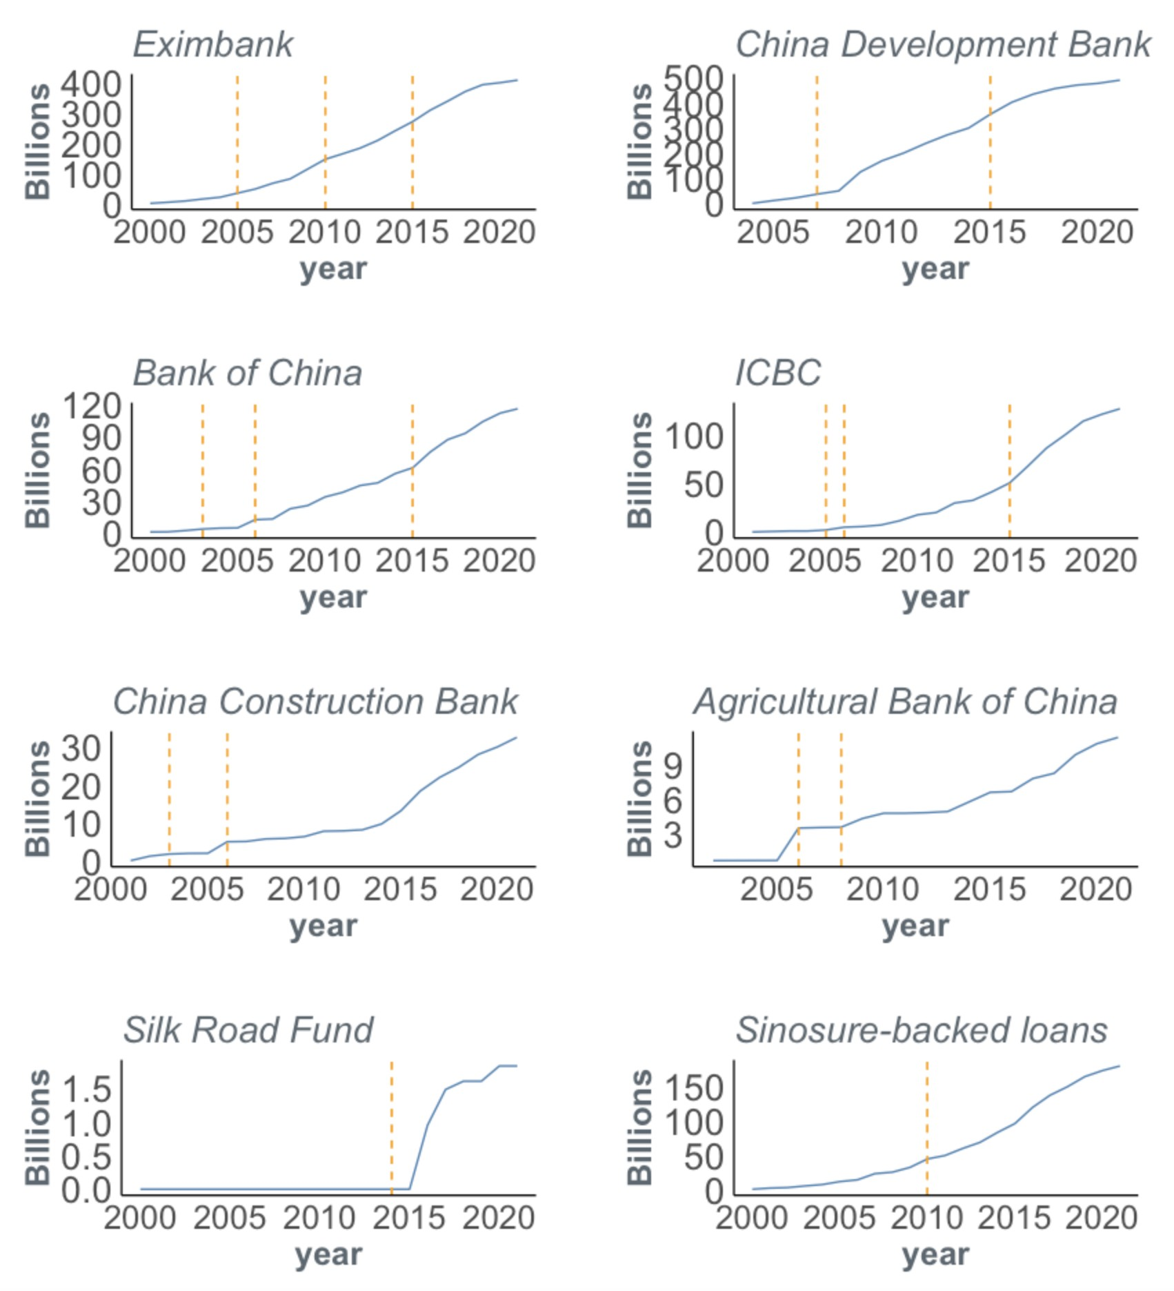

Figure 2.3 below presents *cumulative* lending commitments of China’s state-owned policy banks, state-owned commercial banks, and the Silk Road Fund to LICs and MICs, in relation to the timing of SAFE’s investments in these organizations. It does the same for Sinosure-backed lending commitments to LICs and MICs. One can see that *large cash injections from SAFE have generally preceded increases in the overseas lending activities of China’s state-owned policy banks, state-owned commercial banks, and the Silk Road Fund*. An increase in Sinosure-backed lending to overseas borrowers also followed SAFE’s recapitalization of the state-owned credit insurance agency in 2010.

##### Figure 2.3

**Cumulative loan commitments to LICs and MICs by ﬁnancial institution and capital injections from SAFE, 2000-2021**

112 China’s foreign exchange management law requires that the country’s ofﬁcial reserves be invested in highly liquid and low-risk assets that can be used to address balance of payment needs. However, foreign exchange reserves that are entrusted to a state-owned entity for investment purposes fall outside the ofﬁcial (IMF) deﬁnition of foreign exchange reserves. They can therefore be invested in higher-risk, illiquid assets (Liu 2023).

*Notes: This table presents cumulative lending commitments to LICs and MICs (in constant 2021 USD) from selected Chinese state-owned policy banks, state-owned commercial banks, and state-owned funds. It also presents cumulative lending commitments to LICs and MICs (in constant 2021 USD) that are backed by credit insurance from Sinosure. The vertical dashed lines represent years in which a SAFE capital injection is known to have taken place. These ﬁgures exclude short-term "rollover" facilities to reﬁnance maturing debts (see Box 2c and Section A-3 in the Appendix).*

SAFE’s ﬁrst major investment came in December 2003, when it capitalized the Central Huijin Investment Corporation (Central Huijin) with $45 billion, which in turn bought equity stakes in two state-owned commercial banks: Bank of China ($22.5 billion) and China Construction Bank ($22.5 billion). In April 2005, Central Huijin also bought an equity stake in ICBC for $15 billion. SAFE injected an additional $150 billion into China’s state-owned commercial banks—by swapping USD for RMB held by the banks—in late 2005 and 2006.113 The ﬁrst known recapitalization of a state-owned policy bank came in July 2005, when SAFE injected $5 billion into China Eximbank. Then, in December 2007, Central Huijin—a wholly-owned subsidiary of SAFE—injected $20 billion into CDB. Six months later, SAFE agreed to provide additional funding (worth an estimated $166.5 billion) to CDB via entrusted loan agreements to support the overseas activities of Chinese companies.114 Under these agreements, CDB acted as a custodian of funds for SAFE, disbursing loans to borrowers, supervising the use of the funds, and managing repayments.115 SAFE eventually expanded its use of entrusted loan agreements to other state-owned banks.116 By 2010, it had “taken initial steps toward giving policy and commercial banks authority to handle loans for intergovernmental cooperation projects” and moved “beyond its traditional role of managing foreign exchange reserves, effectively [becoming] a foreign-currency lender” (Yuzhe 2010).117

Then, in April 2010, Central Huijin injected $11.7 billion (RMB 80 billion) into China Eximbank and Sinosure to help them clean up bad loans on their balance sheets. Fourteen months later, in June 2011, China Investment Corporation—another state-owned entity responsible for investing the country's foreign exchange reserves—injected an additional $3.15 billion (RMB 20 billion) into Sinosure. Then, in December 2014, SAFE injected $40 billion into the Silk Road Fund through a subsidiary known as Buttonwood Investment Holding Company Ltd.118 SAFE injected

$48 billion into CDB and $45 billion into China Eximbank in July 2015 through wholly-owned subsidiaries (known as Wutongshu Investment Platform Co. Ltd, Sycamore Tree Investment Platform, and Buttonwood Investment Holding Company Ltd.). SAFE also purchased equity

113 Central Huijin injected RMB 130 billion ($19 billion) into the Agricultural Bank of China in November 2008. However, it was no longer a wholly-owned subsidiary of SAFE at the time.

114 Nine foreign reserve entrusted loan agreements were signed by SAFE and CDB in May 2010.

115 However, as a ﬁduciary acting on behalf of SAFE (in exchange for a commission), it does not assume any of the risks or rewards of the entrusted loans. As such, CDB records entrusted loans as off-balance sheet items.

116 According to Liu (2023: 174), “SAFE does have a minimum return target for the foreign exchange entrusted loans of about 2.5 percent, calculated as a spread of several basis points above the international benchmark bank-lending rate, LIBOR. In 2012 and 2013, an interest rate of 2.5 percent was not particularly low in an environment of quantitative easing in the EU and the United States; at the end of 2012 the US ten-year Treasury note, a proxy for the risk-free rate, was only 1.5 percent.”

117 At that time, SAFE also agreed to "act as the organizer and primary arranger of syndicated loans under entrust agreements” (Yuzhe 2010).

118 In May 2017, the Chinese Government announced that it would inject another RMB 100 billion into the Silk Road Fund. The entity responsible for the injection is unknown.

stakes in ICBC and Bank of China—via Wutongshu Investment Platform Co. Ltd—during the last quarter of 2015.119

Since 2015, SAFE has not publicly announced any additional cash infusions into China’s

state-owned policy banks, state-owned commercial banks, or its state-owned credit insurance agency. An ongoing source of speculation and debate is whether SAFE is worried about “throwing good money after bad.”120 There are some indications that the country’s largest state-owned banks and Sinosure, which are stewarding foreign exchange reserves from SAFE,

may have high levels of cross-border exposure to non-performing loans on the balance sheets of Chinese banks.121 In November 2017, China Banking Regulatory Commission (CBRC)—the country's top banking regulator—publicly called upon CDB and China Eximbank to put in place more robust risk management procedures (Xueqing 2017).122 Then, in 2018, Sinosure’s Chief Economist took the extraordinary step of publicly admonishing China’s policy banks for their “downright inadequate” due diligence procedures (Pilling and Feng 2018). Another sign of potential peril is the fact that the *annual* overseas lending commitments of CDB, China Eximbank, Bank of China, and ICBC sharply declined *after* they received large cash infusions from SAFE in 2015 (see Figure A31). One potential explanation for this unusual pattern is that SAFE’s money was used to clean up bad debts on the balance sheets of these banks instead of supporting new overseas lending commitments.

SAFE is discreet about the returns that it has earned via overseas investments, due to domestic political concerns about whether China’s “xuè hàn qián” (the hard-earned money of Chinese workers) is being effectively stewarded. It “tries to limit its investments outside [U.S. government securities] to amounts small enough to hide from the public in case the bets go bad” (Wei 2013). However, in 2021, SAFE disclosed that it had earned an average annual return on its foreign exchange reserve portfolio of 3.35% between 2008 and 2017 and 4.11% between 1998 and

119 The bank (re)capitalization information in Box 2b was drawn from SAFE 2004, 2017a, 2017b; Ma 2006; PBOC 2007, 2012; Ying 2008; China Daily 2009; Reuters 2009, 2010a, 2010b, 2016; Parson 2010; Shan

2011; Yuan 2014; Tangjun et al. 2014; Jia 2015; Xinhua 2015; Xiao 2016; Xie and Lamar 2016; Chen 2014; Kong and Gallagher 2017; Ofﬁce of the Leading Group for Promoting the Belt and Road Initiative 2019; Embassy of the People's Republic of China in the Republic of the Philippines 2019; Liu 2023; and Setser 2023a.

120 SAFE has a particularly high level of exposure to non-performing loans on China Eximbank’s balance sheet. According to a bond prospectus that China Eximbank issued in March 2017, “the ownership of the Ministry of Finance in China Eximbank is approximately 10.7% while [...] SAFE owns approximately 89.3% of China Eximbank through its investment platform” (Export-Import Bank of China 2017: 20). SAFE is also exposed to non-performing CDB loans, but its exposure is related to its use of CDB as a ﬁduciary for entrusted loans and CDB’s own balance sheet. SAFE holds a 27.1% ownership stake in CDB through Buttonwood Investment Holding Company Ltd. It purchased this stake on July 15, 2015, when Buttonwood Investment Holding Company Ltd. injected $48 billion of share capital into CDB (CDB 2020).

121 During the primary data collection effort for the 3.0 version of the GCDF dataset, AidData uncovered evidence of Sinosure in recent years providing credit insurance for loans issued by *non-Chinese banks* for projects being implemented by Chinese contractors. These loan commitments are not included in the 3.0 version of AidData’s GCDF dataset.

122 Zhou Minyuan, the head of CBRC's policy banks supervision department, announced at the time that it “required both banks to fully identify overseas business risks, step up compliance management, completely understand the operational and ﬁnancial status of their clients as well as the laws and regulations of host countries, strictly observe the local environmental and industrial regulations, and strengthen communication with local regulators” (Xueqing 2017). CBRC also “demanded the banks enhance capital supervision via

on-site inspections and investigations, effectively prevent and control overseas business risks by taking

risk-sharing measures, prudentially evaluate the feasibility and compliance of relevant guarantee measures, and improve their emergency response mechanism” (Xueqing 2017).

2017 (SAFE 2021: 53). At the time, it characterized the rate of return as being at a “relatively good level” (SAFE 2021: 53). SAFE has not released any data on average annual returns for 2018 or any subsequent years.

Another important question that remains unanswered is the extent to which SAFE owns the bonded debt of the LIC and MIC governments of Emerging Market and Developing Economies (EMDEs)—either through direct purchases or secondary market purchases (i.e., via investment funds like PIMCO, Blackrock, AllianceBernstein, Fidelity Investments, and Amundi Asset Management). There are several reasons to believe that SAFE’s holdings of bonded EMDE sovereign debt may be signiﬁcant. First, when SAFE agreed to buy $300 million of bonded debt from the Government of Costa Rica in 2008, it attempted to hide the purchase (Anderlini 2008). The Deputy Administrator of SAFE, Fang Shangpu, sought and secured a written assurance from the Government of Costa Rica that it would “take necessary measures to prevent the disclosure of the ﬁnancial terms of this operation and of SAFE as a purchaser of the bonds” (SAFE 2008).123 The purchase was only made public because of a court order. When SAFE was asked to comment on the matter, it said that there was nothing unusual about the purchase because it “owns bonds issued by many other governments” (Batson 2008). Second, SAFE’s Chief Investment Ofﬁcer from 2010 to 2014 was a bond trader at PIMCO (and right-hand man of PIMCO co-founder Bill Gross) from 2006 to 2009 (Wei 2013). Third, SAFE opened an ofﬁce on Fifth Avenue in New York City in 2013, and shortly thereafter it became an open secret among the world’s largest asset managers—like PIMCO and BlackRock—that SAFE was one of their most important conﬁdential clients.

### Section 2: Major changes in Beijing’s overseas lending portfolio during the BRI 2.0 era

Our goal in the remainder of this chapter is to explain how China is responding to the rising tide of debt distress in the developing world and identify the measures it is taking to de-risk its overseas lending portfolio. However, before we do so, it is important to understand some of the major changes in Beijing’s overseas lending portfolio that have recently transpired. Three changes, which have become hallmarks of the BRI 2.0 era, merit special attention:

1. China’s new and unfamiliar role as the world’s largest ofﬁcial debt collector

123 Also see Government of Costa Rica (2007, 2008). We have made the ofﬁcial correspondence between SAFE and Costa Rica’s Ministry of Finance in January 2008 accessible via [https://www.dropbox.com/scl/ﬁ/a20fdxb2lecowt8tp5lym/2-January-2008-SAFE-Letter-to-Minister-of-Financ](https://www.dropbox.com/scl/fi/a20fdxb2lecowt8tp5lym/2-January-2008-SAFE-Letter-to-Minister-of-Finance-of-Costa-Rica.pdf?rlkey=y9ywdrrhap4rdkt0cyqj4mj4y&dl=0) [e-of-Costa-Rica.pdf?rlkey=y9ywdrrhap4rdkt0cyqj4mj4y&dl=0](https://www.dropbox.com/scl/fi/a20fdxb2lecowt8tp5lym/2-January-2008-SAFE-Letter-to-Minister-of-Finance-of-Costa-Rica.pdf?rlkey=y9ywdrrhap4rdkt0cyqj4mj4y&dl=0) and [https://www.dropbox.com/scl/ﬁ/48qdeslzwim9t6dqhyk0m/7-January-2008-Letter-from-Minister-of-Finance-](https://www.dropbox.com/scl/fi/48qdeslzwim9t6dqhyk0m/7-January-2008-Letter-from-Minister-of-Finance-of-Costa-Rica-to-SAFE.pdf?rlkey=pr3p4advi1wfzzwjr5t8gva5m&dl=0) [of-Costa-Rica-to-SAFE.pdf?rlkey=pr3p4advi1wfzzwjr5t8gva5m&dl=0](https://www.dropbox.com/scl/fi/48qdeslzwim9t6dqhyk0m/7-January-2008-Letter-from-Minister-of-Finance-of-Costa-Rica-to-SAFE.pdf?rlkey=pr3p4advi1wfzzwjr5t8gva5m&dl=0).

1. The rise of emergency rescue lending and the fall of infrastructure project lending
2. A strategic pivot from USD-denominated bilateral lending to RMB-denominated bilateral lending

#### China’s new and unfamiliar role as the world’s largest ofﬁcial debt collector

When the BRI was initially launched, Beijing differentiated itself from its peers and competitors by ﬁnancing big-ticket infrastructure projects—like high-speed railways and next-generation telecommunication networks—that virtually no one else was willing to bankroll. Many of the loans that were issued for these projects included lengthy grace periods, so most borrowers didn’t need to worry about making large debt service payments for ﬁve, six, or seven years. With a lot of “easy money” sloshing around, many borrower countries saw their economic growth rates soar (Dreher et al. 2021, 2022). China’s popularity around the globe also soared: the high-water mark of public support for China in the developing world—after the introduction of the BRI—was in 2019.124

However, as Figure 2.4 demonstrates, the age of easy money is in the rear-view mirror for an expanding set of borrowers. By 2020, 40% of ofﬁcial sector loans from China to low-income and middle-income countries had entered their principal repayment periods (following the expiration of their grace periods).

This ﬁgure increased to 55% in 2023, and we expect it will reach approximately 75% by 2030 and 100% by 2049.

Another way of thinking about the looming repayment challenge is to track the percentage of loans in China’s LIC and MIC portfolio that have already reached their (originally scheduled) ﬁnal repayment dates. In 2014 (the ﬁrst full year of BRI implementation), this ﬁgure stood at only 17% (see Figure 2.5). By 2023 (the tenth full year of BRI implementation), it had increased to 44%. We expect this

124 At that time, the population-weighted average level of public support for China in the developing world was 55.66%. On the causal relationship between the receipt of Chinese aid and credit and public support for China, see Wellner et al. (forthcoming, 2023).

ﬁgure to rise to 52% by 2025 and approach nearly 100% by 2040 (see Figure 2.5).

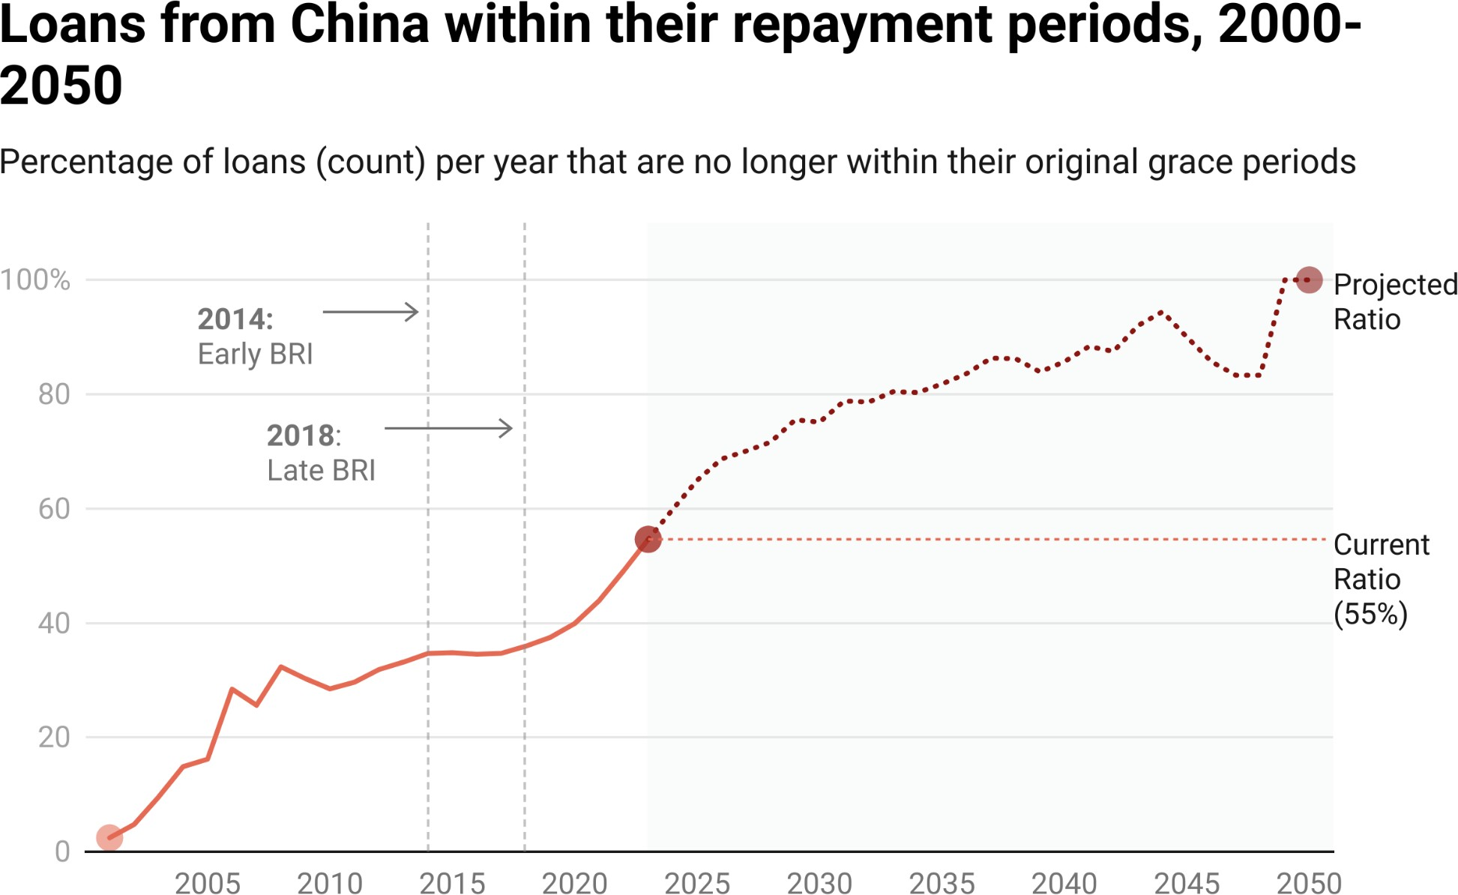

**Figure 2.4**

*Notes: This graph shows the cumulative percentage of ofﬁcial sector loans from China to LICs and MICs (as measured by the number of loans) that are within their repayment periods). To determine when each loan will enter repayment, each loan’s grace period is added to its commitment date. This ﬁgure represents when loans will reach their repayment period according to their original borrowing terms, although many loans have been rescheduled (often involving an extension of the loan’s grace period and/or maturity).*

*MOFCOM interest-free loan commitments (which are typically issued without a credible expectation of repayment) are excluded from the calculation.*

**Figure 2.5**

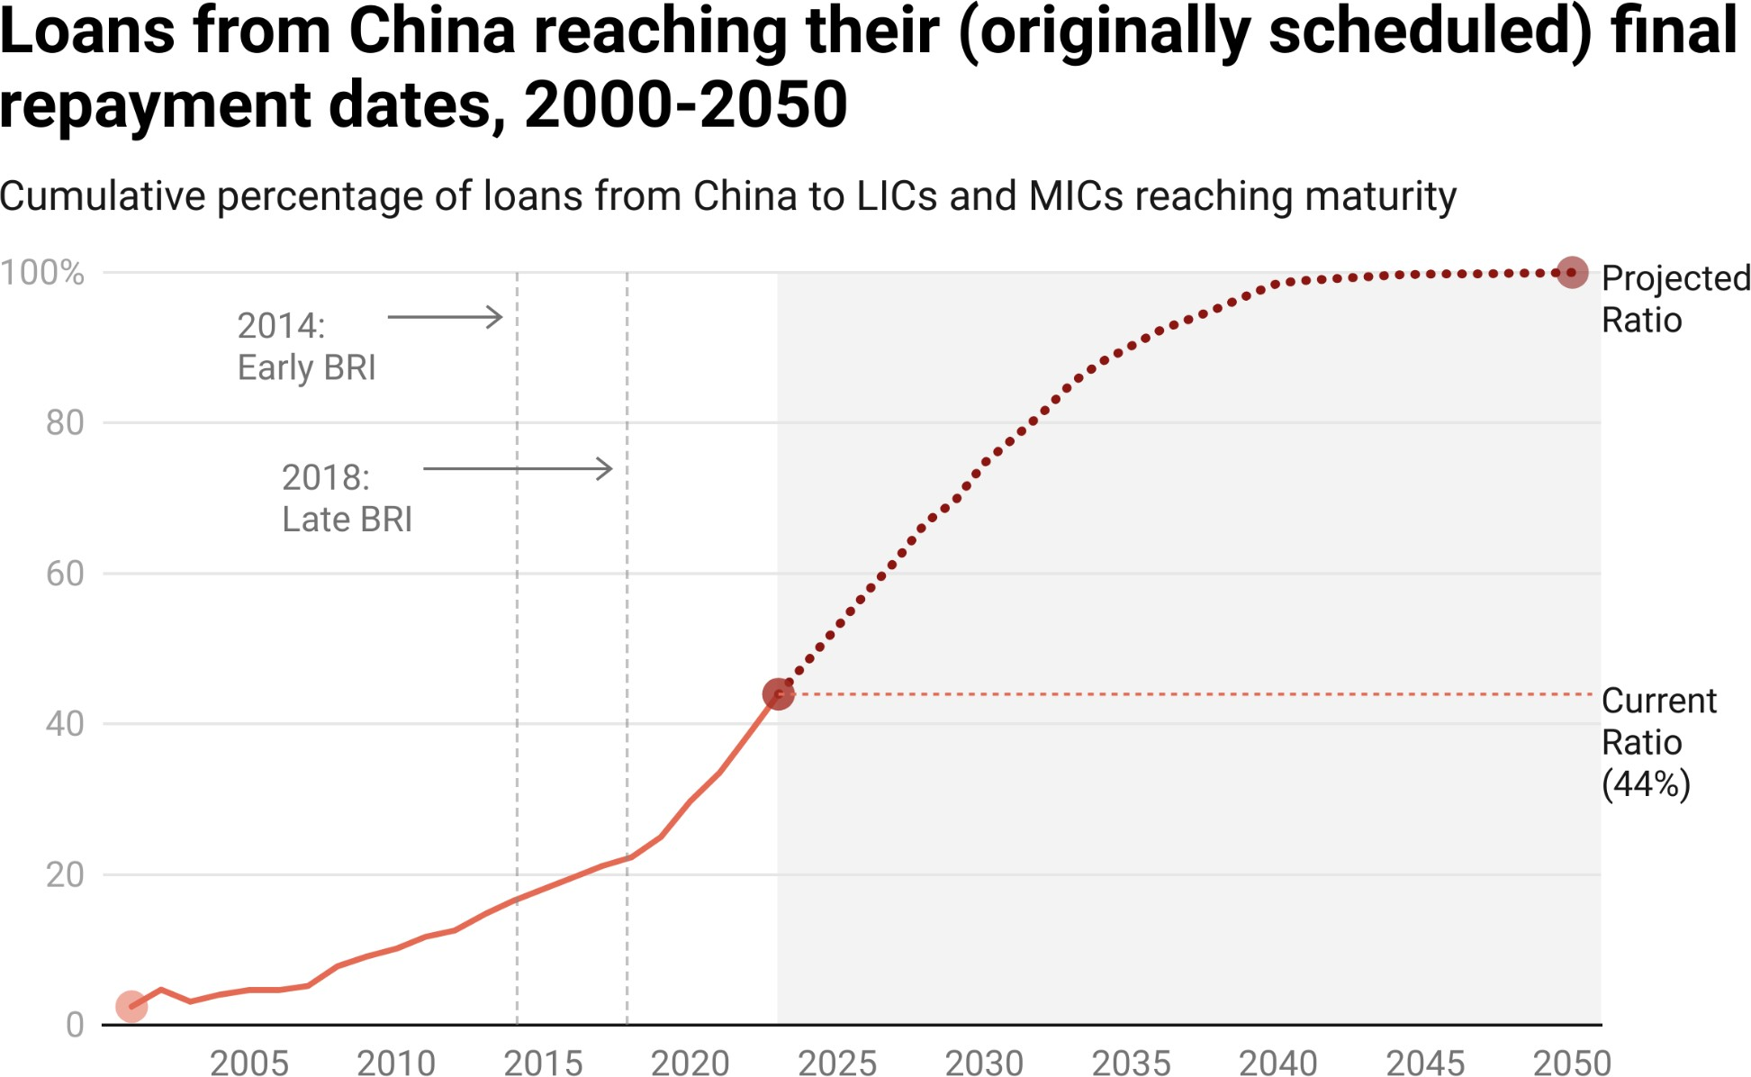

*Notes: This graph shows the cumulative percentage of ofﬁcial sector loans from China to LICs and MICs (as measured by the number of loans) that have reached maturity. To determine when each loan will reach maturity, each loan’s maturity period is added to its commitment date. This ﬁgure represents when loans will reach their maturity according to the original borrowing terms, although many loans have been rescheduled (often involving an extension of the loan’s grace period and/or maturity). MOFCOM*

*interest-free loan commitments (which are typically issued without a credible expectation of repayment) are excluded from the calculation.*

What does all of this mean in practical terms? It means that a rapidly growing percentage of borrowers in the Global South are making large debt service payments (that are for the most part denominated in U.S. dollars) to Beijing at a time when interest rates are rising, the U.S. dollar is strengthening, local currencies are weakening, and global growth is slowing. Many borrowers do not have enough hard currency on hand to meet their repayment obligations—especially on loans with LIBOR-based interest rates that increased by ﬁve-and-a-half percentage points between January 2022 and September 2023.125

125 Average 6-month LIBOR skyrocketed from 0.426% in January 2022 to 5.892% in September 2023.

It also means that Beijing ﬁnds itself in an unfamiliar and uncomfortable role—as the world’s largest ofﬁcial debt collector. Some of China’s state-sponsored tabloids and research institutions are attempting to deﬂect criticism by blaming the U.S. Federal Reserve for the sharp increase in LIBOR-based interest rates (e.g., Xueqing 2022; Qing 2023).126 However, this position will be difﬁcult to defend. When Beijing decided to make LIBOR central to its dollar-denominated overseas lending program (see Figure 2.14), it did not do so at the behest of the

U.S. or any other foreign power.127 It did so on its own—and for its own

proﬁt-making purposes (see Box 2b). Now, the grace periods on most of China’s LIBOR-based loans are expiring, and Beijing is learning a difﬁcult lesson: *it’s easier for great powers to behave like commercial creditors in times of plenty than in times of want*. If China was a commercial bank, it would be easier to demand that ﬁnancially-distressed LIC and MIC borrowers draw upon their limited U.S. dollar reserves to make increasingly large debt service payments.

However, China is a global superpower that has to balance a wide range of competing equities, including reputational risk and repayment risk (see Chapter 4 for more on this key tension and tradeoff).

#### The rise of emergency rescue lending and the fall of infrastructure project lending

China’s overseas lending program has become synonymous with the BRI—an overland “Belt” of road, rail, port, and pipeline projects that seeks to create an infrastructure corridor from China to Central Asia and Europe, and a “Maritime Silk Road” that seeks to link China to South and Southeast Asia, the Middle East, and Africa through deep-water seaport construction projects along the littoral areas of the Indian Ocean. However the 3.0 version of AidData’s GCDF dataset

126 For example, in April 2023, China’s state-owned tabloid, *Global Times*, published an op-ed identifying “the US’ irresponsible monetary policy [as] the root of African debt problems.” It argued that “[r]elying on dollar hegemony, the US has implemented three rounds of quantitative easing, cut interest rates to near zero, and ﬂooded Africa and emerging markets with low-interest dollars. It then arbitrarily and aggressively raised interest rates, boosted the U.S. dollar exchange rate, attracted the return of dollars, as a result, African countries have to face liquidity shortages, broken funding chains, currency depreciation, skyrocketing debt repayment costs denominated in dollars, a surge in sovereign debt, and exacerbated debt problems. The unfair ﬁnancial system led by the US is the root of Africa’s debt problems.” (Qing 2023).

127 According to the 3.0 version of AidData’s GCDF dataset, 45% of China’s dollar-denominated ofﬁcial sector lending to LICs and MICs is based on 6-month LIBOR or another LIBOR-based interest rate and 67% of China's variable interest rate ofﬁcial sector lending to LICs and MICs is based on 6-month LIBOR or another LIBOR-based interest rate (see Figure 2.14).

highlights the importance of not conﬂating China’s ﬂagship, global infrastructure initiative with its overseas lending program.128

During the pre-BRI period (2000-2013), Beijing provided an extraordinary amount of credit for infrastructure projects in LICs and MICs.129 In total, the 3.0 version of AidData’s GCDF dataset identiﬁes 2,217 loan-ﬁnanced projects worth

$628 billion during this fourteen-year period.130 66% of these projects (worth

$412 billion) sought to construct, rehabilitate, expand, or maintain physical infrastructure.131 However, Figures 2.6 and A13 provide evidence that, since the BRI was launched, a rapidly *shrinking* proportion of China’s overseas lending to LICs and MICs has supported infrastructure projects.132 This was true during the early BRI period (2014-2017) and during the late BRI (2018-2021) period.

Infrastructure project lending commitments as a share of total lending commitments to LICs and MICs fell from 65% in 2014, to 50% in 2017, 49% in

2018, and 31% in 2021.

128 Table 2.1 also calls attention to this point by spotlighting the vast scale of China’s overseas lending to high-income countries (HICs) and offshore ﬁnancial centers (OFCs).

129 84% of China’s infrastructure project lending from 2000-2014 was provided by CDB and China Eximbank, and 32% was provided via buyer’s credits. However, Figures A11 and 2.7 demonstrate that a rapidly shrinking percentage of China’s overseas lending program in the developing world is provided via the country’s policy banks and buyer’s credits.

130 To generate this estimate, we identify all loans in the 3.0 version of the GCDF dataset that are categorized as “investment project loans.” For more on the deﬁnition and measurement of the investment project loan variable, see Custer et al. (2023).

131 To generate this estimate, we identify all loans in the 3.0 version of the GCDF dataset that are categorized as “investment project loans” *and* that involve the construction, rehabilitation, expansion, or maintenance of physical infrastructure. For more on the deﬁnition and measurement of the infrastructure variable and the investment project loan variable, see Custer et al. (2023).

132 Figure A26 in the Appendix provides another version of this graph that presents project lending rather than infrastructure project lending over time. It shows a very similar pattern: project lending commitments as a share of total lending commitments fell from 78% in 2014 to 56% in 2017, and then from 50% in 2018 to 32% in 2021.

**Figure 2.6**

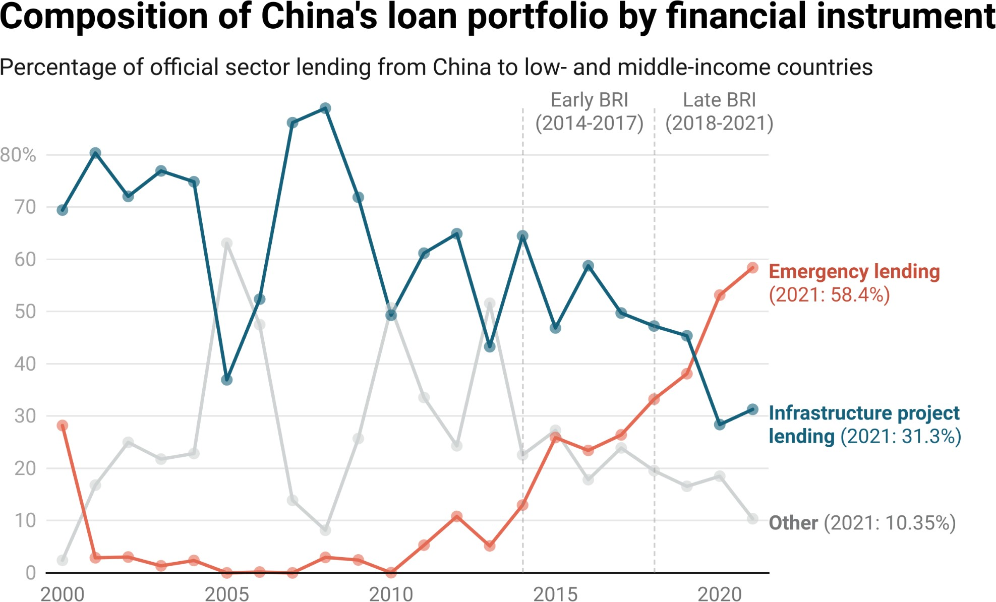

*Notes: For details on how infrastructure project lending is measured, see footnote 131.*

Given that Beijing did not dramatically scale back the overall size of its overseas lending program in LICs and MICs, how and why did it continue to lend record amounts to developing countries at a time when it was ratcheting down Belt and Road project lending? Figure 2.6 provides a clear answer: Beijing was ramping up its emergency rescue lending activities while it was ramping down its infrastructure project lending activities.133 In 2013, one year before the ﬁrst full year of BRI implementation, emergency rescue lending represented only 5% of China’s overseas lending to LICs and MICs. By 2021, 58% of China’s overseas lending to LICs and MICs consisted of emergency rescue lending. The People’s Bank of China (PBOC)—China’s central bank—is by far the most important ﬁnancier of international emergency rescue lending operations, which explains

133 Consistent with Horn et al. (2023a, 2023b), we deﬁne emergency rescue loans as all loans from Chinese state-owned entities to government borrowing institutions in low-income and middle-income countries that can be used for at least one of three purposes: repaying existing debts, ﬁnancing general public expenditures, or shoring up foreign exchange reserves. Such loans include borrowings via currency swap agreements, liquidity support facilities, foreign currency term ﬁnancing facility agreements, deposit loans, commodity prepayment facilities, and so-called “sovereign loans” (主权贷).

why it had assumed a dominant role in Beijing’s LIC and MIC lending portfolio by 2020 (see Figure 2.7).134

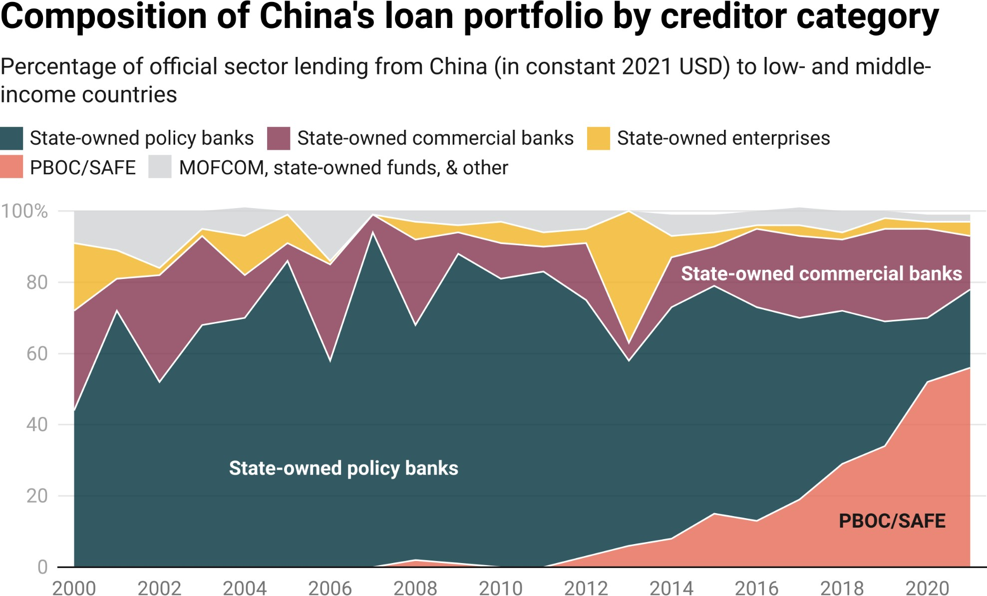

**Figure 2.7**

In March 2023, a team of researchers from AidData, the World Bank, the Harvard Kennedy School, and the Kiel Institute for the World Economy published a study that explains why Beijing has undertaken rescue lending operations worth nearly

$250 billion in 22 countries (Horn et al. 2023a).135 They ﬁnd that most of these operations have taken place in BRI participant countries with high levels of outstanding (infrastructure project) debt to Chinese banks and companies. They also ﬁnd that bailouts from Beijing are directed to distressed government borrowers at times when their foreign exchange reserve levels are low and their credit ratings are weak.

134 In 2013, the PBOC and SAFE (its subsidiary) were responsible for only 6% of China’s ofﬁcial sector lending commitments to LICs and MICs. By 2021, that ﬁgure reached 54% (see Figure 2.7 and Figure A37). 135 The authors of the study include Sebastian Horn of the World Bank; Brad Parks, Executive Director of AidData and Research Professor at William & Mary’s Global Research Institute; Carmen Reinhart, former World Bank Group Chief Economist and current Professor at the Harvard Kennedy School; and Christoph Trebesch, Director at the Kiel Institute for the World Economy.

**Figure 2.8**

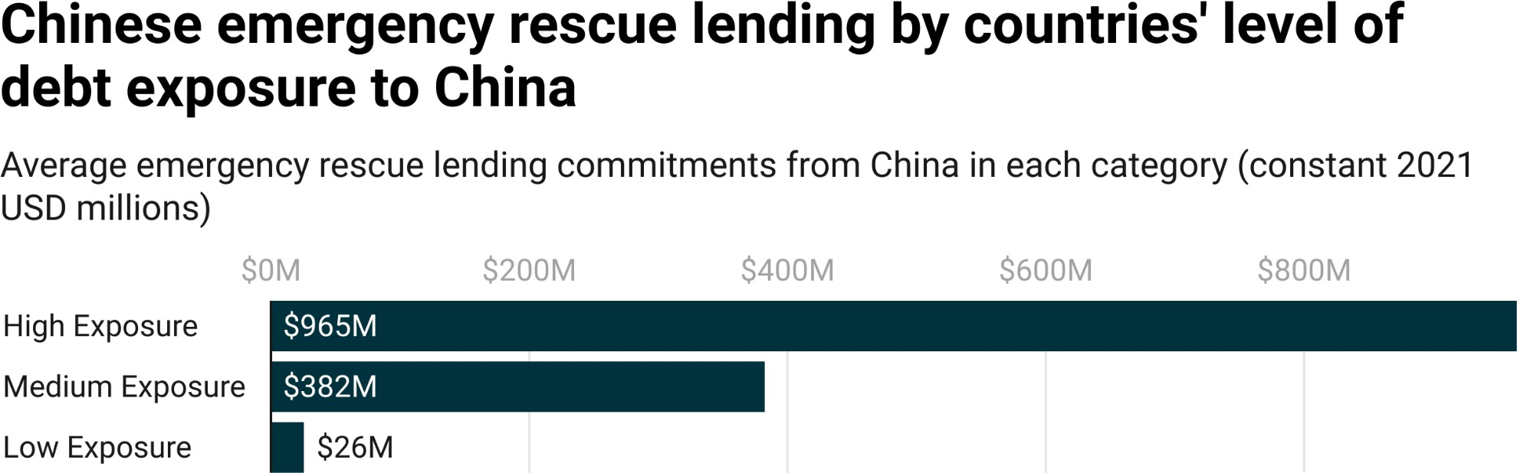

*Notes: The three categories (high, medium, or low debt exposure to China) are constructed by ranking countries according to total non-emergency lending commitments from ofﬁcial sector institutions in China between 2000 and 2021. Countries that did not receive any non-emergency lending commitments are excluded from the calculation. The calculation of average emergency rescue loan commitments excludes short-term "rollover" facilities to reﬁnance maturing debts (see Box 2c and Section A-3 in the Appendix).*

The 3.0 version of AidData’s GCDF dataset provides an opportunity to conduct a basic replication exercise with four years of additional data (2018-2021), substantially revised data for 2000-2017, and more precise measurements of China’s project, infrastructure project, and non-emergency lending activities. In Figure 2.8, we reproduce Figure 5 from the Horn et al. (2023a) study with updated data on emergency and non-emergency lending commitments and conﬁrm that China’s international emergency lending operations are concentrated in countries that accumulated large amounts of debt to China for non-emergency purposes between 2000 and 2021.136 We can also conﬁrm that every country that received an emergency rescue loan from China is a participant in the BRI.137 In Table 2.2, we replicate Table A4 from the Horn et al. (2023a) study and conﬁrm that Chinese emergency rescue loans are issued to sovereigns at times when reserves are low and at times when borrowers have

136 Figure 2.8 uses a new dummy variable (“rescue”) in the 3.0 version of the GCDF dataset for emergency rescue loans, which captures any loan that allows a sovereign debtor to (1) service existing debts, (2) ﬁnance general budgetary expenditures and/or (3) shore up foreign reserves.

137 As of 2021, this was true of all emergency rescue loan recipients other than Argentina and Malawi. Then, in 2022, Argentina and Malawi joined the BRI.

very weak credit ratings.138 By contrast, we ﬁnd that Chinese project loans and Chinese infrastructure project loans are issued to borrowers at times when they have relatively strong credit ratings and reserve adequacy ratios.139 All of these ﬁndings are consistent with those of Horn et al. (2023a) and support their characterization of Beijing’s crisis management response as one of “Bailouts on the Belt and Road.”140

**Table 2.2**

## Average sovereign risk ratings and gross reserves for recipients of different Chinese loan types

**Type of Loan**

**Average Sovereign**

**Moody’s Rating Fitch Rating S&P Rating**

**Gross Reserves (in Months of Imports)**

**Risk Rating**

|  |  |  |  |  |  |
| --- | --- | --- | --- | --- | --- |
| Rescue Loans | 5.7 | Caa1 | CCC | CCC+ | 4.7 |
| Project Loans | 9.4 | Ba3 | BB- | BB- | 6.2 |
| Infrastructure Project Loans | 9.2 | Ba3 | BB- | BB- | 5.9 |

*Notes: This table presents the average sovereign risk rating and level of gross reserves (in months of import cover) for countries that received emergency rescue loans, project loans and infrastructure project loans from China between 2000 and 2021. The averages are weighted by the commitment amounts of the emergency rescue, project, and infrastructure project loans from the 3.0 version of AidData’s GCDF dataset. The data on gross reserves in months of imports are drawn from the World Bank’s World Development Indicators. The sovereign risk ratings data are derived from the World Bank’s sovrate index using the conversion scale in Séri (2021). Sovrate is a measure of repayment risk that varies from 0 to 21, with higher scores indicating lower levels of sovereign credit risk (Kose et al. 2022).*

138 The sovereign risk ratings produced by Moody’s take one of 21 categorical values, where Aaa represents the lowest level of risk and C represents the highest level of risk. The sovereign risk ratings produced by Fitch take one of 21 categorical values, where AAA represents the lowest level of risk and D represents the highest level of risk. The sovereign risk ratings produced by S&P take one of 21 categorical values, where AAA represents the lowest level of risk and C/D represents the highest level of risk. For more details, see Séri (2021).

139 Horn et al. (2023a) uses loan commitments for non-emergency purposes as a proxy for “project loans” and relies on the 2.0 version of AidData’s GCDF dataset. Table 2.2 uses the 3.0 version of AidData’s GCDF dataset, which allows for more precise measurement of project loans and infrastructure project loans. For more on these measurements, see footnote 130 and footnote 131.

140 Emergency rescue loans and debt reschedulings are similar in that they both provide cash ﬂow relief to insufﬁciently liquid borrowers. In this way, they can both be used to “bail out” a borrower (Horn et al.

2023b).

In Figure 2.9, we take the analysis one step further. We ﬁrst use the country-year level measure of ﬁnancial distress (that we introduced in Chapter 1) to identify Beijing’s 50 largest LIC and MIC borrowers that experienced ﬁnancial distress at some point between 2000 and 2021.141 We then identify the timing of bailouts (emergency rescue loans) and debt reschedulings (cash ﬂow relief) from Beijing in relation to the onset and duration of ﬁnancial distress episodes.

141 In order to differentiate between repayment risks and repayment risk mitigation efforts, we modify the criteria for the ﬁnancial distress measure. Instead of using all loan records where the description ﬁeld in the

3.0 GCDF dataset indicates that the borrower had difﬁculty making repayments or experienced ﬁnancial distress, we exclude all observations for which the only source of evidence of the borrower having difﬁculty making repayments or experiencing ﬁnancial distress is an attempted or actual debt rescheduling.

## Rescue lending and debt rescheduling events for the top 50 borrowers in ﬁnancial distress, 2000-2021

**Figure 2.9**

*Notes: This ﬁgure provides an overview of the timeline of when countries experienced ﬁnancial distress (blue shading), when China provided rescue lending (circles), and when China rescheduled existing loan repayments (X’s). A circle indicates that at least one rescue loan was provided by China to the respective country that year, and an X indicates that at least one loan was rescheduled by China for the respective country that year. Countries included in this list represent the top 50 borrowers in distress, ordered by the*

*size of their cumulative lending portfolio as of 2021. See footnote 141 for details on how the ﬁnancial distress index was modiﬁed to differentiate between repayment risks and repayment risk mitigation efforts.*

Figure 2.9 demonstrates that 83% of China’s emergency rescue loans (including short-term “rollover” facilities) were issued in years when the recipients of these loans were in ﬁnancial distress.142 Similarly, 80% of China’s debt reschedulings took place in years when borrowers in the participating countries experienced ﬁnancial distress.143 Figure 2.9 also provides evidence of Beijing repeatedly targeting debt reschedulings and emergency rescue loans to the same BRI participant countries with high levels of debt exposure to China.144 The serial nature of these cash ﬂow relief efforts suggests that Beijing’s biggest borrowers may not only have short-term liquidity problems, but also long-term solvency problems.

Another important implication of these results is that China is increasingly behaving like an international crisis manager. It has effectively created a safety net for ﬁnancially distressed sovereigns that are participating in the BRI—and, by extension, their highly exposed Chinese creditors.145 It has also taken a differentiated approach across countries that present varying levels of risk to the Chinese banking sector, whereby countries that present a high level of balance sheet exposure get new money (via balance of payments support) and countries that present a low level of balance sheet exposure get cash ﬂow relief (via debt reschedulings) but no new money (Horn et al. 2023a, 2023b).146 These actions

142 By comparison, 49% of China’s non-emergency loans were issued in years when the recipients of these loans were in ﬁnancial distress. This difference is also observable during the BRI era (2014-2021). Over this eight-year period, 83% of China’s emergency rescue loans (representing 86% of China’s emergency rescue lending portfolio in monetary terms) were issued in years when the recipients of these loans were in ﬁnancial distress. During the BRI era (2014-2021), 63% of China’s non-emergency loans (representing 67% of China’s non-emergency rescue lending portfolio in monetary terms) were issued in years when the recipients of these loans were in ﬁnancial distress. These percentages reﬂect the distress marker that was modiﬁed to differentiate between repayment risks and repayment risk mitigation efforts (see footnote 141).

143 This ﬁnding is also consistent with Horn et al. (2023a) and Horn et al. (2023b).

144 According to the underlying data that was used to construct Figure 2.9, 100% of the countries that received serial debt reschedulings and 100% of the countries that received serial emergency rescue loans are formal participants in the BRI. All of these countries rank among Beijing’s 50 largest LIC and MIC borrowers and either beneﬁted from debt reschedulings in two or more consecutive years or emergency rescue loans in two or more consecutive years.

145 It is important to keep in mind that, from a historical perspective, countercyclical ofﬁcial lending is the norm rather than the exception. As Horn et al. (2020b) explain, “[d]uring the course of the 1930s, the United States joined European states in extending ofﬁcial loans to states with balance-of-payments problems, in particular through the US Export-Import Bank and the US Treasury’s Exchange Stabilization Fund, which was established in 1934” (Horn et al. 2020b: 7).

146 For more on this point, see Horn et al. (2023a) and Horn et al. (2023b).

are difﬁcult to reconcile with the increasingly popular “Beijing in retreat” narrative that we previously described.

#### A strategic pivot from USD-denominated bilateral lending to RMB-denominated bilateral lending

As we noted in Section 1 of Chapter 2, China dramatically increased its foreign, dollar-denominated lending activities in the immediate aftermath of the 2008 Global Financial Crisis. Figure 1.2 in Chapter 1 demonstrates that the single largest year-on-year increase in ofﬁcial sector lending commitments from China to LICs and MICs was between 2008 and 2009, and Figure 2.2 provides evidence that nearly all of these commitments were denominated in dollars.

But the 3.0 version of AidData’s GCDF dataset also calls attention to three additional changes that took place after the 2008 Global Financial Crisis. First, Chinese state-owned creditors were already holding a substantial amount of distressed, dollar-denominated debt by the time the BRI was announced in 2013 (see Figures 1.8 and A4). Second, from 2013 onward, the dollar’s importance in China’s overseas lending portfolio steadily declined: the share of new lending commitments denominated in dollars fell sharply, from 93% in 2013 to 44% in 2021 (see Figure 2.2). Dollar-denominated loans were replaced by

RMB-denominated loans: the share of new lending commitments denominated in RMB soared from 6% in 2013 to 50% in 2021 (see Figure 2.2). Third, the RMB-denominated loans that Beijing issued were predominantly emergency rescue loans to countries in ﬁnancial distress (see Figures 2.9, 2.10, and A15).147

147 In the Appendix, we replicate Figure 2.2 for two different cohorts: one for countries in ﬁnancial distress and another for countries not in ﬁnancial distress (see Figures A16 and A17). One can see an increase in RMB-denominated lending across both cohorts, but the increase is more substantial for countries in ﬁnancial distress. Figure 2.10, which includes short-term, roll-over loan amounts, shows a similar pattern in China’s RMB-denominated rescue lending portfolio.

**Figure 2.10**

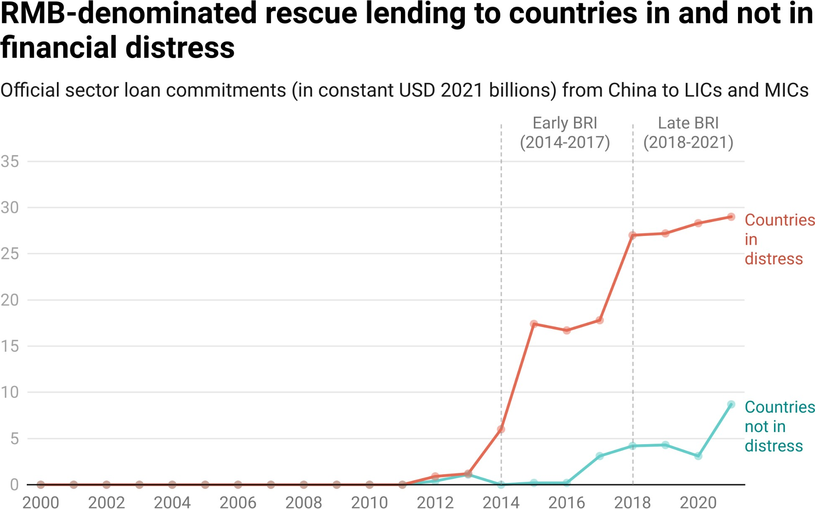

*Notes: To determine if a country experienced ﬁnancial distress in a given year, we use the binary measure that is described in Box 1a in Chapter 1.*

On one hand, this strategy makes sense. During the 1930s and after World War II, the U.S. became a major international lender of last resort, providing

dollar-denominated emergency rescue loans to borrowers with large outstanding dollar-denominated debts to U.S. companies and banks through the

U.S. Federal Reserve, the U.S. Treasury’s Exchange Stabilization Fund, and the

U.S. Ex-Im Bank (Horn et al. 2020b). These activities helped the dollar eventually become a dominant currency for reserve holdings and international ﬁnancial transactions. Now, Chinese state-owned policy banks, state-owned commercial banks, and state-owned enterprises have high levels of exposure to overseas borrowers that are in default or teetering on the edge of default, and the institution with a mandate to protect the health of China’s ﬁnancial sector and internationalize the RMB (the PBOC) is ramping up the provision of emergency rescue loans to ensure that its overseas borrowers are sufﬁciently liquid to continue servicing their outstanding debts to Chinese creditors.

On the other hand, the PBOC’s decision to provide RMB-denominated rescue loans is puzzling because the borrowers being bailed out need USD more than RMB to repay their outstanding debts to Chinese creditors. One potential explanation is that the PBOC is heeding Winston’s Churchill's advice to “never let a good crisis go to waste.” For many years, it sought to internationalize the RMB—without achieving much progress due to tight capital controls and an insufﬁciently deep and liquid RMB bond market outside of mainland China.148 However, the rising tide of debt distress in the Global South has made two groups of countries more willing to increase their RMB reserve holdings: (1) countries facing severe liquidity and/or solvency problems that would like to avoid borrowing from the traditional lender of the last resort (the IMF) because of concerns about onerous policy conditionalities (like Venezuela, Belarus, and Laos); and (2) countries facing severe liquidity and/or solvency problems that have decided to seek IMF support but need additional support in order to stay aﬂoat (like Argentina, Mongolia, and Sri Lanka).149

Why has the PBOC channeled RMB-denominated emergency rescue loans to both groups of countries since 2013? The logic of doing so in the ﬁrst country cohort seems relatively straightforward: the proceeds from an

RMB-denominated emergency loan can be used to service previously contracted loans from Chinese creditors that were denominated in RMB. For the second cohort of countries, Beijing’s intentions are opaque and poorly-understood. But recent events in Argentina may provide a clue. In mid-2023, the dollar reserve holdings of the country’s central bank (BCRA) were perilously low, and it was urgently seeking bridge funding to avoid defaulting on its repayment obligations under a $44 billion loan agreement with the IMF. The PBOC stepped into the breach, helping BCRA make three large debt service payments to the IMF in June 2023, July 2023, and October 2023 (Nugent 2023a, 2023b; Do Rosario 2023b; Do Rosario and Strohecker 2023). It did so by allowing BCRA to use RMB drawings under a swap line between the two central banks worth approximately $9.3 billion. BCRA was able to use short-term RMB swap debt

148 As of 2022, the RMB accounted for less than 3% of global currency reserves and less than 2.5% of global payments. Key impediments to RMB internationalization include tight capital controls that inhibit the free movement of the currency and the absence of a large offshore market for investors to purchase safe,

RMB-denominated assets that are comparable to U.S. Treasury bonds (Bertaut et al. 2023).

149 See Horn et al. (2023a, 2023b).

from the PBOC to repay the IMF “without touching [its] dollar reserves” (do Rosario and Otaola 2023) for two reasons: (1) money is fungible, and (2) IMF loans can be repaid with multiple currencies (including USD, EUR, RMB, JPY, GBP, and SDR). In other words, BCRA repaid its debt to the IMF in RMB, which allowed it to preserve its dollar reserve holdings.150 The case of Argentina also calls attention to a separate, but closely related, point: Beijing has an encompassing interest in ensuring that its largest borrowers with

dollar-denominated debts to Chinese creditors do not exhaust their dollar reserve holdings.151

In this way, the PBOC’s willingness to serve as an international lender of last resort suggests that it may be seeking to kill several birds with one stone: preserving the dollar reserve holdings of its biggest borrowers, encouraging greater use of the RMB in cross-border transactions, and laying the groundwork for the RMB to eventually achieve global reserve currency status.152 The fact that the PBOC played an instrumental role in helping the IMF’s single largest borrower meet its repayment obligations with RMB also suggests that former

U.S. Treasury Secretary Larry Summers may have been overly optimistic when he was asked about the risk of de-dollarization and responded that: “you cannot replace something with nothing. […] Europe’s a museum, Japan’s a nursing home, and China’s a jail. We don’t need to worry about those currencies being some kind of major threat to us.”153

150 In August 2023, Argentina’s central bank (BCRA) decided to repay some of its outstanding swap debt to the PBOC with the proceeds from an IMF loan disbursement (Do Rosario 2023a).

151 There is also a potential demand-side explanation for why sovereigns in ﬁnancial distress—like Argentina and Sri Lanka—are willing to contract RMB-denominated swap debt from the PBOC. Despite signiﬁcant restrictions on the free and ﬂexible use of PBOC swap drawings, central banks can use these RMB drawings as a “window dressing” device to temporarily inﬂate their gross international reserves (Horn et al. 2023a). This approach might help avert credit rating downgrades and borrowing cost increases. However, it can also free up otherwise encumbered foreign exchange reserves to facilitate dollar-denominated debt service to Chinese creditors (other than PBOC) and non-Chinese creditors. For example, Brad Setser has argued (see <https://twitter.com/Brad_Setser/status/1602151579150438401>) that the receipt of PBOC swap debt in Sri Lanka freed up foreign exchange reserves to facilitate a $400 million payment on a maturing Eurobond and dollar-denominated debt service to China Eximbank.

152 It is also noteworthy that Beijing has changed its public messaging about the advisability of dollar-denominated overseas lending and borrowing (e.g., Qing 2023).

153 Indeed, there is evidence that signing a currency swap agreement with the PBOC results in a 14% increase in the probability of a country using the RMB for international payments (Bahaj and Reis 2022). Large-scale borrowing via PBOC swap lines can also have the direct effect of changing the currency composition of a country’s reserve holdings. After nearly a decade of RMB drawdowns through its swap line with PBOC, approximately 50% of Argentina’s reserve holdings consisted of RMB (Douglas 2022).

### Section 3: Beijing’s crisis-time approach to repayment risk mitigation—Fool me once, shame on you. Fool me twice, shame on me.

In the next section of this chapter, we analyze the 3.0 version of AidData’s GCDF dataset to better understand how Beijing is seeking to de-risk its overseas loan portfolio. We see evidence of Chinese state-owned lenders taking the following risk mitigation efforts:

1. Sweeping cash out of escrow accounts
2. Providing short-term cash ﬂow relief in exchange for escrow account replenishment
3. Lending with higher interest rates, shorter repayment periods, more safeguards, and more severe penalties for default
4. Taking a differentiated approach with borrowers that present high and low levels of repayment risk
5. Scaling down bilateral lending operations and scaling up lending operations via syndication and multilateralization

#### Risk mitigation strategy #1: Sweeping cash out of escrow accounts

In March 2021, a team of researchers from AidData, the Center for Global Development (CGD), the Kiel Institute for the World Economy, and the Peterson Institute for International Economics (PIIE) published a study entitled “How China Lends,” which demonstrated that Chinese state-owned lenders have a preference for sources of collateral that do not require liquidation through a costly, time-consuming, and uncertain judicial process (Gelpern et al. 2021, 2022). More speciﬁcally, the study found that Chinese state-owned lenders prefer to collateralize on foreign currency deposits in escrow accounts that they control and can unilaterally debit (without having to initiate judicial proceedings to try to recover an overdue debt by seizing or liquidating a physical asset). It also found that borrowers are typically required to maintain a minimum cash

balance in a special type of escrow account—known as a “Repayment Reserve Account” or “Debt Service Reserve Account” (DSRA)—equivalent to one year’s worth of principal and interest repayments.

At the time that the study was published, there was no hard evidence of borrowers complying with these escrow account conditions. Nor was there any hard evidence of Chinese lenders sweeping cash out of these escrow accounts in order to deal with nonpayment or late payment by overseas borrowers. The

3.0 version of the GCDF dataset provides such evidence.154

**Table 2.3**

## Illustrative escrow account balances linked to loans from China Eximbank, CDB, and ICBC

**Aggregate Cash Balance**

|  |  |  |  |  |
| --- | --- | --- | --- | --- |
| **Country** | **Lender** | **Borrower** | **of Escrow Accounts**  **(Maximum)** | **Corresponding Loan(s)** |
| Tanzania | China | Ministry of | $60.3 million | $920 million (2012), $275 million |
|  | Eximbank | Finance, TPDC |  | (2012) |
| Guinea | ICBC | Central | €76.35 million | €559.4 million (2018) |
|  |  | Government |  |  |
| Republic of | China | Central | $338 million | ~20 loans under $1.6 billion (2006) |
| Congo | Eximbank | Government |  | and $1 billion (2012) framework |
|  |  |  |  | agreements |
| Suriname | China | Central | $9.3 million | $98.4 million (2016) |
|  | Eximbank | Government, |  |  |
|  |  | Telesur |  |  |
| Ghana | CDB | Central | $71.2 million | $850 million (2012), $150 million |
|  |  | Government |  | (2013), $210.6 million (2019), $185.5 |
|  |  |  |  | million (2019) |
| Malawi | ICBC | Reserve Bank of | $32 million | $66 million (2021) |
|  |  | Malawi |  |  |
| Myanmar | CDB | Myanmar Oil | $77.1 million (in € | €452.7 million (2010) |
|  |  | and Gas | equivalent) |  |
|  |  | Enterprise |  |  |
| Zimbabwe | China | Ministry of | $17.2 million | $319 million (2013) |
|  | Eximbank | Finance, KHPC |  |  |
| Angola | CDB | Ministry of | $1.5 billion | $15 billion (2015) |
|  |  | Finance |  |  |
| Kenya | China | National | $250 million | $1.9 billion (2014), $1.6 billion (2014) |
|  | Eximbank | Treasury, KRC |  |  |

154 Escrow account cash balances are recorded in the 3.0 version of the GCDF dataset’s “collateral” and “description” ﬁelds. Cash sweeps out of escrow accounts recorded in the GCDF dataset’s “description” ﬁeld.

**Country Lender Borrower**

**Aggregate Cash Balance of Escrow Accounts (Maximum)**

**Corresponding Loan(s)**

|  |  |  |  |  |
| --- | --- | --- | --- | --- |
| Ecuador | CDB | Ministry of Finance | $113 million | $1 billion (2010) |
| Ghana | China Eximbank | Central Government | $27.2 million | $293.5 million (2007) |
| Zimbabwe | CDB | Econet Wireless Zimbabwe | $12.4 million | $93 million (2014) |
| Botswana | ICBC | BPC | $33 million | $825 million (2009) |
| Zambia | CDB | DBZ | $6 million | $30 million (2015) |

*Notes: This table provides examples of escrow account cash balances linked to loans from Eximbank, CDB, and ICBC (project ID#59752, 59733, 65116, 65115, 60219, 59273, 55437, 73140, 30578, 58586, 60039,*

*98520, 34468, 62674, 66847, 31777, 37103, 35865, 183, 62601, 40, 52190 in the 3.0 version of AidData’s*

*GCDF dataset). The escrow account balance information is drawn from the collateral ﬁeld and description ﬁeld. Escrow account balances vary over time. This table records the maximum observed account balances.*

Table 2.3 provides an illustrative set of escrow account cash balances linked to China Eximbank, CDB, and ICBC loans in 15 countries. There are several important points to keep in mind about these balances. First, although there is some evidence of borrower noncompliance with the escrow account conditions in their Chinese loan agreements, compliance seems to be the norm rather than the exception. Borrowers subject to such conditions typically maintain escrow account cash balances that are sufﬁcient to cover the cost of 1 to 3 semi-annual principal and interest payments. These amounts are usually equivalent to 5-10% of the face value of the loan supported by the escrow account. Second, it is not uncommon for minimum cash balances—and minimum cash balance requirements—to change based on a loan’s actual or expected amount outstanding at different points in time over the lifetime of the loan. The cash balance (requirement) is usually at its lowest point during the grace period when the loan has not fully disbursed and at its highest point when the loan has fully disbursed but no repayments have been made. Some, but not all, Chinese lenders allow borrowers to incrementally reduce the amount of cash in their escrow accounts as repayments are made and the total amounts outstanding shrink.155

155 In the 3.0 version of AidData’s GCDF dataset, there is more evidence that CDB follows this practice than China Eximbank. See, for example, project ID#37103, 55437, 58839, and 58842.

Third, notwithstanding the “1 to 3 semi-annual debt service payments” rule of thumb, minimum cash balance requirements can be adjusted based on the borrower’s risk proﬁle and/or the lender’s level of exposure.156 Chinese

state-owned creditors may, for example, use a “portfolio-wide approach” to compensate for a high level of exposure to a risky borrower. China Eximbank’s collateralized lending arrangement with the Government of Congo-Brazzaville is a case in point. The borrower is required to keep a minimum cash balance equivalent to 20% of its total outstanding debt under multiple China Eximbank loan agreements in an offshore, lender-controlled escrow account (République du Congo 2018). The 3.0 version of AidData’s GCDF dataset demonstrates that the Congolese authorities have for the most part complied with this requirement: the cash balances in their China Eximbank-controlled escrow account were $338 million in 2017 and $266.6 million in 2020.157 Fourth, while the amounts of foreign currency that Chinese state-owned creditors ask borrowers to ring-fence in escrow accounts are not necessarily large enough to be consequential during normal times, the signiﬁcance of these funds can increase during periods of ﬁnancial distress, when borrowers are strapped for hard currency and seeking a coordinated debt restructuring with multiple creditors. Non-Chinese creditors often lack access to foreign currency that is ring-fenced for their exclusive use and they fear—with some justiﬁcation—that Chinese creditors have positioned themselves at the front of the repayment line by demanding that borrowers grant them access to cash collateral that other creditors lack (and that can be unilaterally debited in a moment’s notice).

Consequently, they may not be willing to participate in a coordinated debt rescheduling unless all creditors agree to abide by the so-called “comparable treatment” principle—i.e., ensure that there is reasonable burden sharing in the

156 Gelpern et al. (2021, 2022) analyze the terms and conditions in 100 loan contracts issued by Chinese state-owned creditors and 142 foreign loan contracts issued by 28 non-Chinese (commercial, bilateral, and multilateral) creditors to government borrowers in LICs and MICs. They ﬁnd that 30% of the Chinese loan contracts include escrow or revenue account provisions, but only 2% of the non-Chinese loan contracts (one from AfDB, one from Commerzbank, and one from Agence Française de Développement) include such provisions. In the rare cases when non-Chinese creditors require government borrowers to maintain minimum cash balances in escrow accounts, the amounts that they require are similar to the amounts required by Chinese creditors. There is only one contract in the sample of 142 non-Chinese loan contracts analyzed by Gelpern et al. (2021, 2022) that clearly speciﬁes a minimum cash balance requirement: a $56.6 million loan agreement between Commerzbank AG Paris Branch and the Government of Cameroon that requires the borrower to (initially) maintain a escrow account cash balance equivalent to one year’s worth of principal and interest payments (i.e., two semi-annual debt service payments). The unredacted loan agreement can be accessed in its entirety via <https://docs.aiddata.org/ad4/pdfs/how_china_lends/CMR_2015_121.pdf>.

157 See ID#60219 and #59273 in the 3.0 version of the GCDF dataset.

way that ﬁnancial losses are distributed across creditors (Buchheit and Gulati 2023).158

During our review of the primary sources that underpin the dataset (including escrow account agreements, repayment mechanism agreements, and the audited ﬁnancial statements of borrowing institutions), we also discovered that Chinese lenders have put in place several different safeguards (or “lines of defense”) to minimize the risk that these escrow accounts will not fulﬁll their intended risk mitigation purposes. The ﬁrst safeguard is a requirement that the borrowers initially meet their minimum cash balance requirements by depositing funds into the repayment reserve (or DSRA) accounts with revenues that are already at their disposal (rather than project revenues, which are typically minimal or nonexistent when project loans are ﬁrst issued). The second safeguard is automaticity in the way that the repayment reserve (or DSRA) accounts are replenished after withdrawals have taken place. In a typical escrow account agreement between a Chinese lender, borrower, and escrow account bank, if the borrower misses a principal and/or interest payment and the lender sweeps cash out of the repayment reserve account (in order to satisfy its desire to be repaid in a timely manner), the escrow account bank is responsible for immediately replenishing the repayment reserve account with cash from another escrow account that is often referred to as the “revenue account” or “sales collection account.” Chinese lenders typically require that their borrowers deposit all project revenues—or all of the revenues generated by the underlying infrastructure asset (e.g., a toll road, an airport, a telecommunications network) supported by the project—into this additional escrow account.159 In some cases, Chinese lenders will go one step further and require that a ﬁxed percentage of all revenues of the borrowing institution be deposited in the revenue account.160 The third safeguard is that Chinese lenders usually possess exclusive authority to freeze the revenue account (without the consent of the borrower) and prevent

158 If there is a perception that China wants to be treated as a senior creditor whose debts need to be given ﬁrst priority and other creditors are being pushed to the back of the repayment line, a collective action failure among creditors (i.e., no coordinated debt rescheduling) becomes more likely (Wigglesworth and Yu 2023; Ferry and Zeitz 2023).

159 See, for example, ID#59753 in the 3.0 version of AidData’s GCDF dataset. Alternatively, the borrower may be required to deposit into this account cash proceeds from sales under a long-term commodity purchase agreement. See, for example, ID#35865 in the 3.0 version of AidData’s GCDF dataset.

160 See, for example, ID#55437 in the 3.0 version of AidData’s GCDF dataset.

the borrower from making withdrawals from the account.161 The fourth safeguard is that, in the event of a missed interest or principal payment, Chinese lenders are entitled under the terms of most escrow account agreements to “pay themselves” by withdrawing an equivalent amount of cash out of the repayment reserve account and/or the revenue account (without borrower consent).162

The latest version of the GCDF dataset also provides evidence that, when borrowers default on their repayment obligations, Chinese lenders do in fact “pay themselves” by unilaterally making cash withdrawals from the escrow accounts that they established for risk mitigation purposes. Consider, for example, the $98.4 million loan that China Eximbank issued to the Government of Suriname and Telesur—the state-owned telecommunications company of Suriname—in 2016 for a National Broadband Network Project.163 As a source of cash collateral, the lender asked its borrower to maintain a minimum balance in a USD repayment reserve account of $2.9 million (equivalent to total payable interest for one year or two semi-annual interest payments) during the loan’s grace period and $9.3 million (equivalent to total payable principal for one year or two semi-annual principal payments) during the loan’s repayment period. It also required that Telesur deposit at least 50% of its organizational funding (including broadband user revenues from the National Broadband Network Project) in a local currency revenue account. Then, during the COVID-19 pandemic, the Government of Suriname defaulted on its sovereign debt obligations multiple times in 2020 and 2021. By the end of 2021, the Government of Suriname had accumulated principal and interest arrears to China Eximbank worth approximately $61 million (IMF 2021). Then, in February 2022, the Government of Suriname and Telesur missed a scheduled interest payment on the China Eximbank loan for the National Broadband Network

161 More precisely, Chinese lenders typically possess the exclusive authority to instruct the escrow account bank to freeze the revenue account and prevent borrower withdrawals. See, for example, ID#59753 in the

3.0 version of AidData’s GCDF dataset

162 By way of example, see ID#37103, #31777, #59753, and #35865 in the 3.0 version of AidData’s GCDF dataset.

163 On December 30, 2016, China Eximbank and the Government of the Republic of Suriname signed a

$98.4 million preferential buyer’s credit (PBC) agreement for the Suriname National Broadband Network Project. The loan ofﬁcially went into effect in November 2017 after several preconditions (so-called “conditions precedent”) were met by the borrower, including but not limited to the signing of a repayment mechanism (escrow account) agreement. The loan carries the following borrowing terms: a 15-year maturity, a 5-year grace period, a 3% interest rate, a 0.4% management fee, and a 0.4% commitment fee. The Government of Suriname on-lent the proceeds of the loan to Telesur on May 12, 2017. For more details, see ID#55437 in the 3.0 version of AidData’s GCDF dataset.

Project. The lender responded by immediately withdrawing $1.47 million (the monetary value of one semi-annual interest payment) from the repayment reserve account in order to cover the cost of the missed interest payment. It also instructed a local Surinamese escrow account bank (FinaBank N.V) to immediately (a) block Telesur’s access to the local currency revenue account, and

(b) replenish the repayment reserve account with funds in the revenue account.164 These actions proved consequential for domestic and international reasons. The decision to deny the state-owned telecommunications company access to at least 50% of its organizational funding instigated questions among local stakeholders about why a foreign lender possessed such extraordinary authority. The revelation that China Eximbank paid itself by executing a cash sweep out of an offshore, lender-controlled escrow account also proved controversial because the Government of Suriname was pursuing a coordinated debt rescheduling with all of its major external creditors at the time, many of whom were unaware that China Eximbank had recourse to ring-fenced foreign currency reserves (and under the impression that the Government of Suriname was cash-strapped and unable to make loan repayments to any external creditors).165

Most of these cash sweeps are done in secret. These are exceptionally difﬁcult to monitor because the lender is debiting cash from an escrow account that is typically domiciled outside of the borrower country or inside the borrower country but beyond the immediate reach of domestic oversight institutions—such as the auditor general and the public accounts committee within parliament.166 Also, the legal agreements that grant Chinese lenders the authority to conduct these cash sweeps effectively represent “side agreements.”

164 Under the original escrow account arrangement that was ﬁnalized in 2017, Telesur was required to deposit at least 50% of its funding (including broadband user revenues from the National Broadband Network Project) in the local currency-denominated revenue account. See ID#55437 in the 3.0 version of AidData’s GCDF dataset.

165 In March 2022, the IMF reported that the February 2022 “[p]ayment from the repayment reserve account for the Telesur loan will be reﬂected in the eventual debt restructuring with [China Eximbank] to ensure there is comparability of treatment with other ofﬁcial creditors” (IMF 2022).

166 In most sovereign debt transactions, ﬁnance ministries are the borrower country counterparts to escrow account agreements with Chinese creditors. These agreements typically impose expansive conﬁdentiality obligations on borrowers (ﬁnance ministries). By way of illustration, the escrow account agreement for the China Eximbank loan captured in Project ID#59753 of AidData’s GCDF dataset (Version 3.0) says that “[t]he obligation of conﬁdentiality shall endure in perpetuity. […] The Parties [to the escrow account agreement] shall not at any time during the terms of this Deed release any statement to the press or make any other public statement of any nature which could reasonably be expected to be published in any media regarding the relationship or the subject matter of this Deed […].”

The authority to conduct a cash sweep is almost never identiﬁed in loan agreements between Chinese lenders and their overseas borrowers, which are more readily accessible to domestic oversight institutions. Instead, loan agreements with Chinese state-owned creditors typically cross-reference another agreement—often known as an “account management agreement,” an “escrow account agreement,” or a “repayment mechanism agreement”—that grants the lender such authority. Finance ministries rarely disclose these side agreements to auditors in the executive branch, overseers in the legislative branch, or international organizations (like the IMF) with surveillance responsibilities unless they are pressed to do so. These agreements are shrouded in secrecy for a purpose: collateralizing on cash deposits in lender-controlled escrow accounts is rare among ofﬁcial creditors, so (sovereign) borrowers are reluctant to disclose that they have granted these sources of leverage (debt seniority) to Chinese state-owned creditors but not other ofﬁcial creditors. In the vanishingly rare instances in which cash sweeps are discovered, it can become more difﬁcult for a distressed sovereign to get all major creditors to participate in a coordinated debt rescheduling governed by the “comparable treatment” principle. If some creditors have recourse to ring-fenced sources of foreign currency and others do not, any promise by the sovereign borrower to abide by the “comparable treatment” principle is rendered less credible.167

#### Risk mitigation strategy #2: Providing short-term cash ﬂow relief in exchange for escrow account replenishment

Figure 2.11 demonstrates that we have entered a new era of “reschedulings galore.” The 3.0 version of the GCDF dataset records 98 Chinese debt reschedulings in 2020 and 2021, which is more than double the number of Chinese debt restructurings recorded in the Rhodium Group database over the same time period (Mingey and Wright 2023). Chinese debt reschedulings for LICs and MICs have increased in tandem with the percentage of loans in China’s LIC and MIC portfolio that have already reached their (originally scheduled) ﬁnal repayment dates (see Figure 2.11). They have also for the most part taken place in ﬁnancially distressed countries (see Figures 2.9 and 2.12).

167 Suriname is a case in point.

**Figure 2.11**

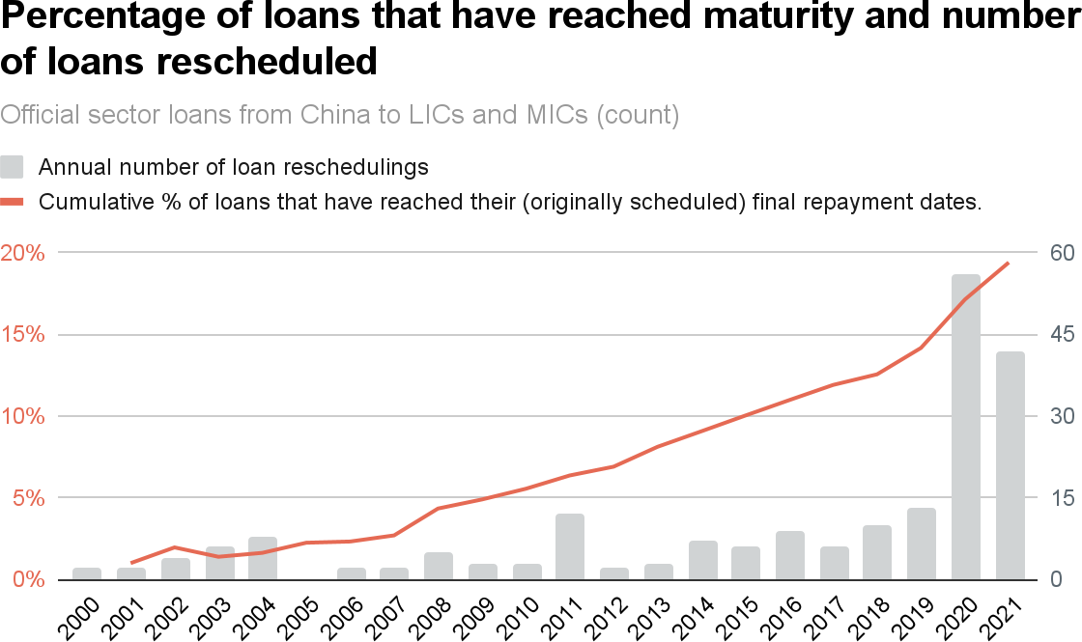

*Notes: To determine when each loan will reach maturity, each loan’s maturity period is added to its commitment date. This ﬁgure represents when loans reached their ﬁnal maturity dates according to the original borrowing terms, although many loans have been rescheduled (often involving an extension of the loan’s grace period and/or maturity). MOFCOM interest-free loan commitments (which are typically issued without a credible expectation of repayment) are excluded from the calculation.*

**Figure 2.12**

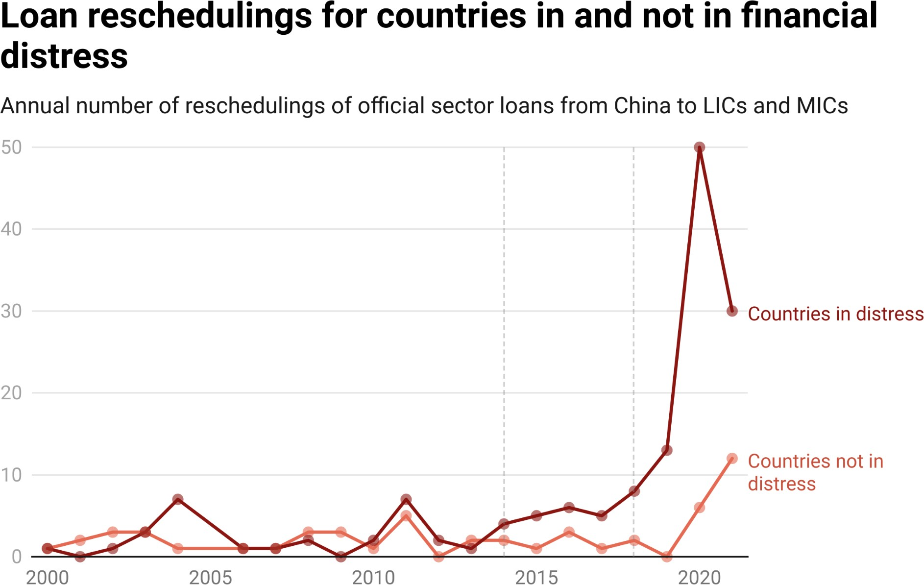

*Notes:To determine if a country experienced ﬁnancial distress in a given year, we use the binary measure that is described in Box 1a in Chapter 1. See footnote 141 for details on how the ﬁnancial distress index was modiﬁed to differentiate between repayment risks and repayment risk mitigation efforts.*

These empirical patterns underline the fact that many of China’s overseas borrowers are insufﬁciently liquid to meet their repayment obligations and in need of debt relief. How is Beijing responding to this challenge? The 3.0 version of AidData’s GCDF dataset demonstrates that Chinese lenders are generally willing to defer principal and/or interest payments for several years, thereby providing short-term cash ﬂow relief (i.e., “breathing room”) to their borrowers.168 However, as yield-maximizing surrogates of the state, Chinese lenders are ultimately focused on protecting the bottom line (Chen 2020a,

168 There is an important distinction between cash ﬂow relief and debt relief. Chinese state-owned creditors are substantially more willing to provide cash ﬂow relief than debt relief, which is traditionally deﬁned in the academic literature as “the reduction in the net present value of the debtor’s outstanding obligations due to the restructuring agreement” (Horn et al. 2022a: 14). The importance of this distinction came into sharper resolution after China agreed to participate in the G20’s Debt Service Suspension Initiative (DSSI). In April 2021, the President of China Eximbank publicly clariﬁed that “debt suspension [...] is neither debt reduction nor debt forgiveness. One should not take the opportunity [of the Covid-19 pandemic] to harm China’s interests and take advantage of China” (The Export-Import Bank of China 2021).

2020b, 2023; Dreher et al. 2021, 2022).169 As such, they are generally unwilling to accept signiﬁcant ﬁnancial losses in net present value (NPV) terms (Ministry of Finance of the People's Republic of China 2020; Bon and Cheng 2021; Gardner et al. 2021; Horn et al. 2022b).170

The 3.0 version of AidData’s GCDF dataset also sheds light on the key role that escrow account *replenishment* plays in debt rescheduling negotiations with Chinese creditors. Once a borrower has defaulted on its repayment obligations and its Chinese lender has exhausted the funds in a repayment reserve account (DSRA), the Chinese lender will typically instruct the escrow bank to (a) immediately replenish the account with funds from the revenue (sales collection) account, and (b) block the borrower from making any withdrawals from the revenue (sales collection) account. However, this approach is not foolproof, since a ﬁnancially distressed borrower can stop making deposits into the revenue (sales collection) account, thereby eliminating the Chinese lender’s second line of defense. Consequently, as more borrowers seek debt relief, Chinese lenders are demanding a credible protection against (another) default in exchange for short-term cash ﬂow relief.

The Government of Angola’s 2020 debt rescheduling with China Development Bank is a case in point.171 In late 2015, CDB issued a $15 billion loan to the Government of Angola and required that the borrower maintain a minimum balance of $1.5 billion in an escrow account as a source of cash collateral. Then, the Angolan Government faced a cash crunch—due to a sharp decline in oil prices—and had difﬁculty servicing its dollar-denominated debts. CDB agreed to defer principal payments as part of a debt reproﬁling agreement in 2020 and

169 During debt rescheduling negotiations, Chinese lenders have traditionally provided cash ﬂow relief to borrowers so long as there was no signiﬁcant net present value (NPV) reduction in total repayments to the lender over the lifetime of the loan (i.e., the NPV of debt service payments after rescheduling was not lower than the NPV of debt service payments before rescheduling). However, change may be afoot. In January 2023, IMF Managing Director Kristalina Georgieva announced that "[w]e have reached an understanding in principle that China will de facto accept NPV reduction on the basis of signiﬁcant stretching of the maturities and reduction of interest. [...] In China there is not yet a consensus to take upfront haircuts” (Mfula 2023). Reductions in a loan’s NPV can be achieved via substantial interest rate reductions, lengthy maturity/grace period extensions, and/or face value reductions to loan principal (so-called “face value haircuts” or “principal haircuts”).

170 Reinhart and Trebesch (2016) study debt relief operations during two periods—1920-1939 and

1978-2010—and ﬁnd that economic growth generally increased following debt *stock* reductions (face value reductions to loan principal) but not debt *ﬂow* reductions (cash ﬂow relief via maturity/grace period extensions and interest rate reductions).

171 See ID#95415 and ID#53063 in the 3.0 version of AidData’s GCDF dataset.

use the cash in the escrow account to satisfy the borrower’s interest payment obligations from 2020 to 2022. However, in anticipation of the escrow account balance being depleted to nearly zero by mid-2022, CDB demanded that the borrower replenish the account to $1.5 billion by 2023.

#### Risk mitigation strategy #3: Lending with higher interest rates, shorter repayment periods, more safeguards, and more severe penalties for default

One way to go about de-risking an overseas lending portfolio—on a going forward basis (“future-prooﬁng”)—is to reduce the provision of concessional credit. Lending on below-market terms is risky from a creditor perspective for multiple reasons.172 First, any subsidy from a creditor to a borrower implies that the creditor will achieve a smaller investment return than it would in the absence of the subsidy. Second, most concessional loans carry low interest rates that are ﬁxed rather than ﬂoating, so a creditor that provides such loans must bear all of the risk associated with its “cost of funds” increasing over time.173 As the “cost of funds” increases (for example, due to an increase in interbank lending rates or an increase in the cost of borrowing via bonds issued on capital markets), the creditor’s incentive to offer concessional loans with low, ﬁxed interest rates weakens. Third, concessional loans from ofﬁcial creditors are subject to substantially larger haircuts (investor losses) than loans from commercial creditors.174 Therefore, if SAFE—a central government institution with discretionary authority to entrust surplus foreign exchange to “ofﬁcial creditors” like China Eximbank or “commercial creditors” like Bank of China (see Box 2b for more on SAFE’s role)—wanted to de-risk the country’s overseas loan portfolio, it might seek to minimize future losses (i.e., future-proof the portfolio)

172 If a creditor issues a loan to a borrower at an interest rate that is lower than its own borrowing terms (i.e., “cost of funds”) at the time the loan is issued, the creditor is lending to the borrower at a “below-market” rate. There is signiﬁcant “cost of funds” variation across Chinese banks and loans denominated in different currencies (Chen 2020a). With respect to RMB-denominated loans, the state-owned commercial banks mobilize funds by accepting deposits (with the deposit rate at 1-2%), while the state-owned policy banks mobilize funds by issuing bonds with yields of 3-5%. With respect to foreign currency-denominated loans, the state-owned policy banks can borrow from PBOC at a 2-3% interest rate.

173 Relatedly, the bank bears all of the downside risk associated with an increase in the *opportunity* cost of funds.

174 Depending on the discounting approach that is used, there is a 19.4 percentage point minimum difference and 38.6 percentage point maximum difference in average haircuts (investor losses) for ofﬁcial creditors versus commercial creditors (Schlegl et al. 2019).

by reining in the amount of concessional credit provided via ofﬁcial creditors and prioritizing the provision of non-concessional credit via commercial creditors.175

The 3.0 version of AidData’s GCDF dataset provides evidence that Beijing is indeed moving in this direction. Figure A18 demonstrates that the weighted average interest rate of ofﬁcial sector lending from China to LICs and MICs increased from 4.5% during the early BRI period to 5% during the late BRI period. Consistent with this shift toward harder lending terms, the weighted average repayment period (maturity) declined from 11 years during the early BRI period to 6 years during the late BRI period (see Figure A19). The weighted average grant element—a summary measure of ﬁnancial concessionality (discussed at greater length in Section A-2 in the Appendix)—fell by 9 percentage points between the early BRI period and the late BRI period: from 25% to 16% (see Figure A20).176

In order to gauge whether Beijing is making a concerted effort to rein in the provision of concessional cross-border credit, it is also worth considering if it has increased or reduced use of the two primary instruments that it has established for concessional lending to overseas borrowers: government concessional loans (GCLs) and preferential buyer’s credits (PBCs) from China Eximbank.177 Figure A12 provides evidence that GCLs and PBCs have indeed fallen out of favor, as they represent a rapidly dwindling percentage of new overseas lending commitments from China to LICs and MICs (18% in 2014 and 3% in 2021).178

175 Some Chinese state-owned lenders participate in debt restructurings that are (loosely) coordinated with ofﬁcial creditors from other countries, while others do not and wish to be treated as commercial creditors (Gardner et al. 2021; Horn et al. 2022b). Recent events in Zambia suggest that Beijing considers the claims of its ofﬁcial creditors to include those of China Eximbank and those of other Chinese state-owned creditors that are insured (“guaranteed”) by Sinosure. Beijing evidently considers CDB debts that are not backed by a Sinosure credit insurance policy to be the claims of a commercial creditor (Setser 2023b).

176 The weighted average grant element of Chinese lending to overseas borrowers declined by 19 percentage points—from 30% in 2014 to 11% in 2021 (see Figure A21).

177 GCLs are RMB-denominated loans that are issued to government institutions and provided on below-market terms (usually 20-year maturities, 5-year grace periods, and 2% interest rates). PBCs are

USD-denominated loans that are issued to government institutions on terms that are more generous than prevailing market terms, but slightly more expensive (higher interest rates, shorter maturities, and shorter grace periods) than GCLs (Morris et al. 2020; Horn et al. 2021; Dreher et al. 2022).

178 The fact that these two concessional lending windows are increasingly inaccessible has signiﬁcant implications for sovereign borrowers. The terms and conditions in PBC and GCL contracts are fairly standardized (Gelpern et al. 2022) and reasonably well-understood among debt management ofﬁcers and transaction lawyers in LIC and MIC ﬁnance ministries (e.g., Banco Central de Bolivia 2016; NEDA 2017; Economic Relations Division of the Government of the People's Republic of Bangladesh 2023). They include low (ﬁxed) interest rates, long maturities, generous grace periods, no penalty interest provisions, and strict requirements to use Chinese contractors and keep all terms and conditions conﬁdential, among

During the pre-BRI and early BRI era, GCLs and PBCs were Beijing’s “workhorse” lending instruments. China Eximbank issued 669 GCLs and PBCs worth $121 billion from 2000 to 2017.179 All of these loans carry low, ﬁxed interest rates and nearly 100% of them qualify as concessional loans under OECD-DAC measurement standards.180 However, Figure 2.13 provides evidence of a shift away from ﬁxed interest rate lending and toward variable interest rate lending: whereas 60% of new lending commitments from China to LIC and MIC borrowers carried variable interest rates in 2014, this ﬁgure increased to 90% by 2021. These portfolio-level summary statistics suggest that an effort is underway to transfer more risk from lenders to borrowers. Risk-based loan pricing models usually rely on a variable interest rate, which in turn is based on a ﬂoating market reference rate—such as the London Interbank Offered Rate (LIBOR) or Euro Interbank Offered Rate (EURIBOR)—and a premium that accounts for the risk proﬁle of the borrower. It is also important to keep in mind that SAFE has tasked Chinese state-owned lenders with maximizing investment returns within acceptable risk levels, which is more difﬁcult to do via ﬁxed interest lending when variable (ﬂoating market) interest rates are increasing and pushing up the opportunity cost of funds for lenders (see Box 2b).

other things. However, the terms and conditions that are included in more “exotic” Chinese lending instruments (like PBOC swap contracts, CDB liquidity support facilities, and accounts receivable ﬁnancing arrangements with Chinese state-owned commercial banks) are not well-understood.

179 Between 2018 and 2021, China Eximbank issued 49 GCLs worth $9 billion and 40 PBCs worth $22 billion.

180 99.6% (260 of 261) of the GCLs that were issued between 2000 and 2017 with grant element observations met the OECD’s 25% grant element threshold of concessionality. 99.6% (247 of 248) of the PBCs that were issued between 2000 and 2017 with grant element observations met the OECD's 25% grant element threshold of concessionality.

**Figure 2.13**

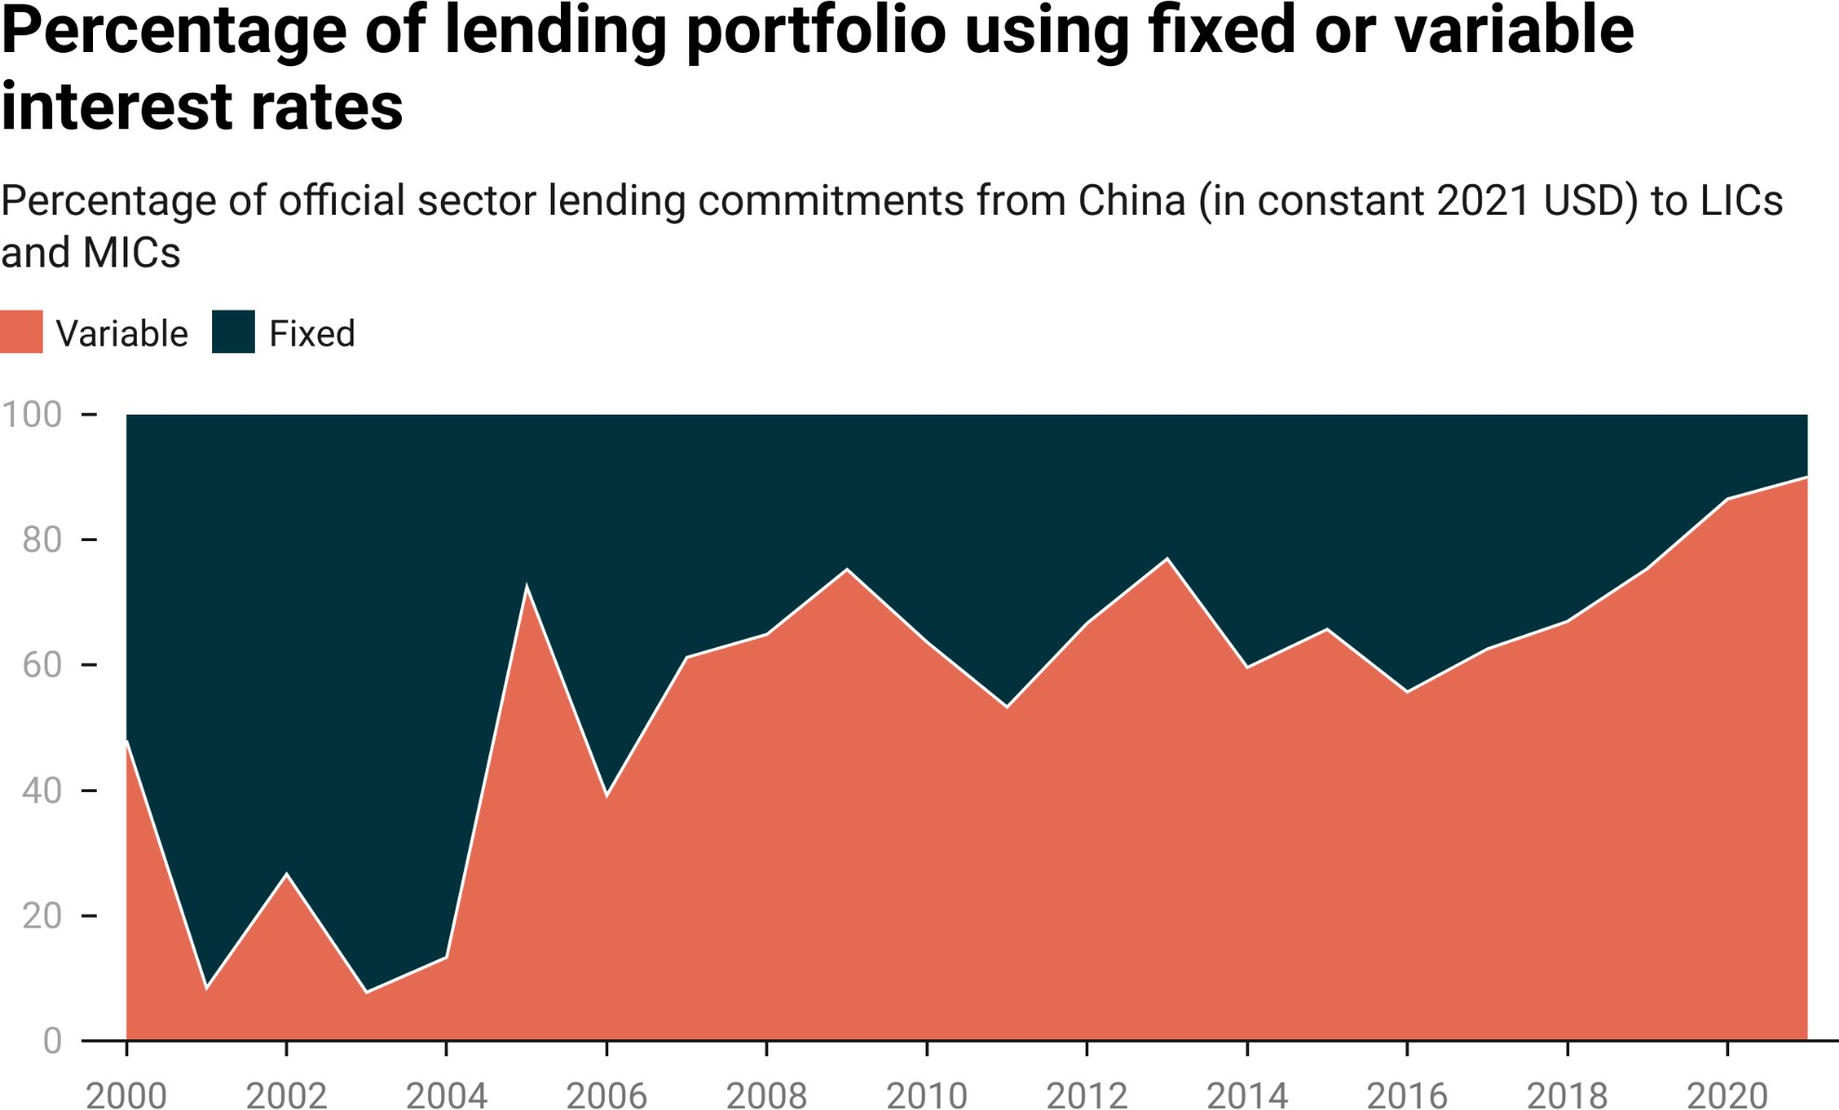

*Notes: Variable interest rates that Chinese state-owned creditors use as benchmarks include LIBOR, EURIBOR, SHIBOR, BADLAR, CIRR, JIBOR, LPR and BADCOR. We exclude all loans for which we cannot determine if a ﬁxed or variable interest rate was applied.*

Together, the shift from dollar-denominated lending to RMB-denominated lending and the shift from ﬁxed interest rate lending to variable interest rate lending have resulted in a dramatic turn away from LIBOR-based lending and toward SHIBOR-based lending. Figure 2.14 demonstrates that the percentage of China’s variable interest rate lending to LICs and MICs based on LIBOR sharply declined from 100% in 2008 to 29% in 2021.181 The fall of LIBOR was accompanied by the rise of SHIBOR. The percentage of China’s variable interest rate lending to LICs and MICs based on SHIBOR soared from 0% in 2008 to 70% in 2021.182

181 China's LIC and MIC lending program was almost exclusively dollar-denominated in 2009 (see Figure 2.2).

182 SHIBOR and LPR are both variable interest rates set by the PBOC. Figure 2.14 combines all loans with SHIBOR- and LPR- based interest rates into a single category. However, LPR is not yet widely used in China’s overseas lending portfolio. There are only 2 LPR-based loan records in the 3.0 version of the GCDF dataset. The shift that has taken place is largely a shift from LIBOR to SHIBOR.

**Figure 2.14**

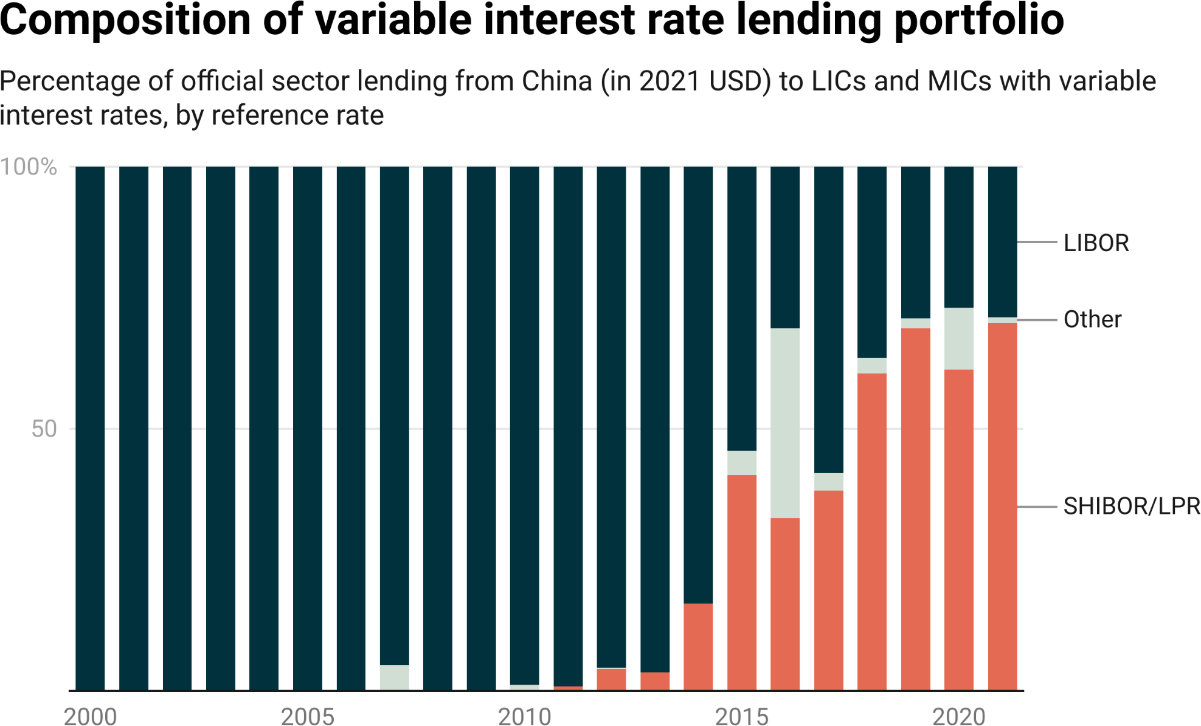

*Notes: LIBOR refers to the London Interbank Offered Rate. SHIBOR refers to the Shanghai Interbank Offered Rate. LPR refers to the China Loan Prime Rate. The “other” category includes loans with variable interest rates, such as EURIBOR, BADLAR, CIRR, JIBOR, and BADCOR.*

Another important reason why concessionality at the portfolio level has fallen over time is that some of Beijing’s biggest sovereign borrowers have swapped less expensive debt for more expensive debt. Horn et al. (2023a) provide evidence that the interest rates on China’s emergency rescue loans exceed the interest rates on the existing debt stocks of the borrowers. They also provide evidence that China’s emergency loans have very short maturities (in many cases, 1 year or less), although it is not unusual for such loans to be “rolled over” when they reach their ofﬁcial maturity dates (see Box 2c for more on this issue).183 As such, reﬁnancing with bailouts from Beijing typically does not reduce the net present value of a borrower’s debt stock, which highlights an emerging tension between those providing and those receiving new loans:

183 Rollover debt comes in two varieties: (1) loans that reach their original contractual maturity dates and secure ﬁnal maturity date extensions; and (2) loans that are repaid on their original contractual maturity dates and reissued (with similar or different face values and borrowing terms) and assigned new maturity dates.

ﬁnancially distressed borrowers want cheap credit that will help them “ride out the storm,” but Chinese state-owned creditors are unsure if their biggest Belt and Road borrowers are illiquid or insolvent, so they are pricing in a higher risk of default when they provide additional credit.

##### Box 2c: Should emergency liquidity support from PBOC swap lines be treated as short-term or long-term debt?

Between 2016 and 2021, the PBOC used its swap line network to provide nearly $150 billion in emergency liquidity support to central banks in LICs and MICs (Horn et al. 2023a). These borrowings have created a new measurement challenge for organizations that (a) track the international lending activities of external creditors, and (b) monitor levels of public debt exposure in the developing world.

The reporting directives of the OECD’s Creditor Reporting System (CRS) specify that “[l]oans with a maturity of one year or less are not reportable in DAC statistics” (OECD 2021: 51).184 Similarly, governments that participate in the World Bank’s Debtor Reporting System (DRS) are asked to report their long-term debt repayment obligations to external creditors on an annual basis.185 Long-term debt is deﬁned in the DRS reporting manual as debt “with an original contractual or extended maturity of more than one year […]” (World Bank 2000: 4).

Based on a narrow interpretation of the prevailing international reporting rules, PBOC swap line borrowings should not be reported to the DRS or the CRS. Nearly all of these borrowings carry de jure maturities of one year or less (i.e., they are initially scheduled for repayment in 12 months or less). However, central banks that borrow from the PBOC frequently see their ﬁnal maturity dates extended—or they repeatedly receive short-term loans to reﬁnance maturing debts. Horn et al. (2023a) provide evidence that the de facto maturity of the average PBOC swap line borrowing is 3.5 years.

The custodians of the DRS are aware of the gap between the de jure and de facto maturities of PBOC swap line borrowings and the underreporting of PBOC swap debt. In October 2020, they sounded the alarm, questioning whether “currency swap arrangements that represent loans from other central banks are reﬂected in external debt stocks of low- and middle-income countries” (World Bank 2020a: 13). At that time, they clariﬁed that “[t]he DRS […] considers one-year [central bank] deposits that are consistently rolled over (de facto) to be long-term debt” (World Bank 2020a: 13). They also emphasized that “[t]he transparency of data on debt must evolve to keep pace with an ever-changing creditor landscape and with new and increasingly complex debt-like instruments and data requirements,” and that one of their top priorities is

184 Since 1973, the OECD’s Creditor Reporting System (CRS) has collected and published data on ofﬁcial sector ﬁnancial ﬂows (ODA and OOF) from DAC and non-DAC countries.

185 The World Bank’s Debtor Reporting System (DRS) has served as the primary international reporting system for public debt since 1951. It supports the publication of a widely used data source: the World Bank’s International Debt Statistics (IDS).

“incorporating Central Bank deposits and currency swaps lines into the DRS dataset” (World Bank 2021: 29).186

The 3.0 version of AidData’s GCDF dataset captures the full range of China’s international rescue lending operations. Figure A14 demonstrates that an increasing proportion of China’s ofﬁcial sector lending to LICs and MICs consisted of “rollover” emergency rescue loans during the early BRI period (8%) and the late BRI period (34%).

Another way of mitigating elevated levels of default risk is to attach stronger repayment safeguards to new loans. Beijing appears to be following this strategy. Figure 2.15 demonstrates that the percentage of China’s overseas lending portfolio supported by collateral increased from 42% during the pre-BRI and early BRI period (2000-2017) to 56% in the late BRI period (2018-2021). By 2021, nearly three-quarters (72%) of China’s overseas lending to LICs and MICs was collateralized.

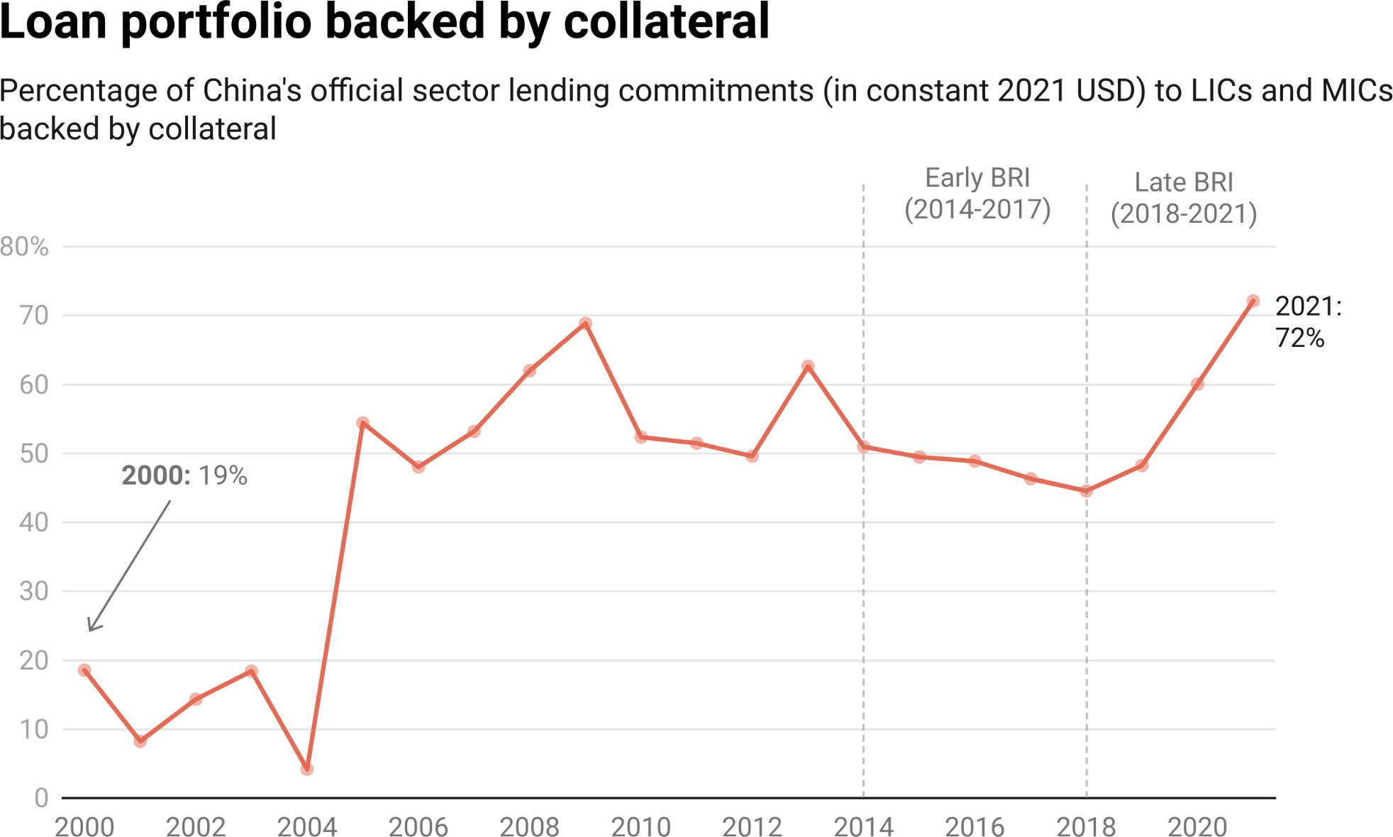

**Figure 2.15**

*Notes: Collateralized lending commitments are identiﬁed with the “collateralized” ﬁeld in the*

*3.0 version of the AidData’s GCDF dataset.*

186 The custodians of the CRS, by contrast, have not addressed this issue—most likely because China does not participate in its reporting system.

There is also some evidence that, in order to reduce the likelihood of default and/or minimize post-default losses, Chinese state-owned creditors are including stiffer penalties for default in their contracts with borrowers. The 3.0 version of AidData’s GCDF dataset includes a new variable that measures the default (penalty) interest rates that apply to individual loans from Chinese

state-owned entities. Figure 2.16, which draws upon the data, demonstrates that the average default (penalty) interest rate more than doubled between the early BRI period and the late BRI period (0.584% from 2014-2017 and 1.175% from 2018-2021).187 The maximum (observed) default (penalty) interest rate also increased—from 3% during the early BRI period to 8.7% during the late BRI period.188 These ﬁndings are difﬁcult to reconcile with those of SAIS-CARI, which has concluded that they “see no evidence of penalty interest rates” in China’s overseas lending to developing countries (Acker et al. 2020: 31).189

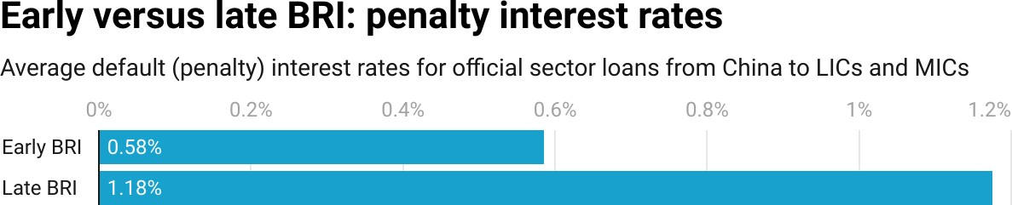

**Figure 2.16**

*Notes: Default (penalty) interest rates are identiﬁed with the “Default Interest Rate” ﬁeld in the 3.0 version of the AidData’s GCDF dataset.*

187 In most Chinese loan agreements that include such provisions, the default (penalty) interest rate applies to overdue principal and/or overdue interest amounts. See, for example, Section 6.9 of the China Eximbank buyer’s credit loan agreement for Phase 1 of the Standard Gauge Railway Project (accessible via <https://www.dropbox.com/s/5j3alwun2tv8wk2/SGR%20BCL%202014.pdf>).

188 It is also important to keep in mind that the creditor composition of China’s overseas lending portfolio is shifting away from ﬁnanciers that use no or low penalty interest rates. Interest-free loans from MOFCOM, government concessional loans from China Eximbank, and preferential buyer’s credits from China Eximbank do not carry penalty interest rates—and they are all on the decline (see Figures 2.7 and A12). However, lending from Chinese state-owned commercial banks carries penalty interest rates in the 0.5% to 3% range—and it is on the rise (see Figure 2.7).

189 Lest there be any confusion about whether sovereign borrowers are responsible for making penalty interest payments to their Chinese creditors, the Government of Sudan disclosed that it owed $127 million of penalty interest to Chinese creditors as of March 31, 2022 (CBOS 2023). The Government of Zimbabwe and the Government of Serbia have also acknowledged incurring penalty interest under their loan agreements with China Eximbank (NBS 2007; MOFED 2022).

Figure 2.17 zooms in on four sovereign borrowers—Ghana, Uganda, Guyana, and Serbia—for whom we have reasonably complete data over time on the default (penalty) interest rates attached to loans from Chinese state-owned creditors. One can see that, in all of these countries, default (penalty) interest rates varied between 0-0.33% until 2015. These rates remained mostly stable from 2016 to 2020, although there was a slight uptick in two countries. However, by 2021 or 2022, default (penalty) interest rates reached 2% in Serbia, 2% in Uganda, 3.5% in Guyana, and 4.8% in Ghana. These new risk mitigation measures by Beijing pose a challenge to borrowers in the developing world that is rarely taken into consideration: those who continue to contract new debt from Beijing must be aware of the danger of compounding arrears due to penalty interest.

**Figure 2.17**

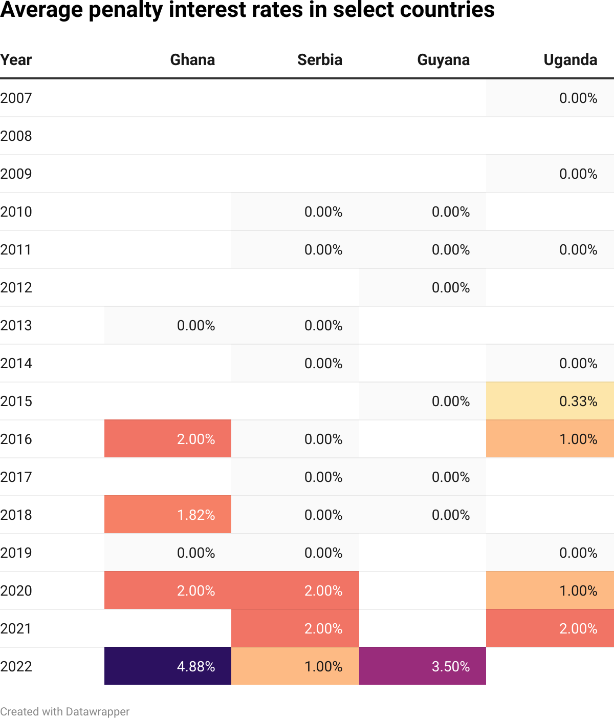

*Notes: This chart shows unweighted average default (penalty) interest rates on loans from ofﬁcial sector institutions in China to government and state-owned borrowing institutions in Ghana, Serbia, Guyana and Uganda. The absence of a value in a given country-year indicates missing penalty interest rate data.*

*Observations are drawn from 2000-2021 GCDF (Version 3.0) data and preliminary 2022 GCDF data. In addition to loan commitments, pledged loans and suspended/canceled loan commitments are included since borrowers may be more likely to reject loan offers with high penalty interest rates and suspend or cancel loan commitments with terms that they perceive to be onerous.*

The 3.0 version of AidData’s GCDF dataset also provides evidence that when borrowers fail to honor their repayment obligations, Chinese lenders will seek to recover the penalty interest that they are owed by sweeping cash out of escrow accounts (when they have recourse to such collateral). By way of illustration, consider how China Eximbank responded to an overdue debt repayment from Tanzania Petroleum Development Corporation (TPDC)—a parastatal that is wholly-owned by the Government of Tanzania—for the Songo Songo to Dar Es Salaam Gas Pipeline and Natural Gas Processing Plants at Mnazi Bay and Songo Songo Project. As a source of collateral for a $275 million buyer's credit loan (BCL) that China Eximbank issued in 2012, TPDC deposited approximately $60 million in escrow accounts accessible to the lender.190 However, by the ﬁrst half of 2017, TPDC had accumulated arrears to China Eximbank. The lender responded by sweeping cash out of one of the escrow accounts between July 2017 and June 2018. According to TPDC’s audited ﬁnancial statements, it withdrew the funds “as a penalty for [the borrower’s] late repayment of due installment” (The Controller and Auditor General of the National Audit Ofﬁce of Tanzania 2018: 76).191

#### Risk mitigation strategy #4: Taking a differentiated approach with borrowers that present high and low levels of repayment risk

Previous research indicates that when creditors are confronted with a sudden wave of defaults or a sharp increase in non-performing loans, they may seek to rebalance the risk proﬁles of their asset portfolios by issuing fewer loans to potentially risky borrowers—or by pulling back from an entire asset class with a new risk proﬁle (Kaminsky and Reinhart 2000; Longstaff et al. 2011; Brooks et al. 2015; Gilchrist et al. 2022). Consistent with this expectation, the 3.0 version of AidData’s GCDF dataset provides evidence of a compositional shift in

190 According to TPDC’s audited ﬁnancial statements, the escrow accounts “were opened to secure repayment of principal and payment of interest and fees under the loan agreements” and the minimum cash balances in these accounts functioned as sources of “collateral.”

191 In June 20, 2012, China Eximbank and Tanzania’s Ministry of Finance signed a $1,225,327,000 ﬁnancing agreement for the Songo Songo to Dar Es Salaam Gas Pipeline and Natural Gas Processing Plants at Mnazi Bay and Songo Songo Project. Two loans were issued to Tanzania’s Ministry of Finance: (1) a $275 million buyer’s credit loan (BCL) with an interest rate of 6-month LIBOR plus 430 basis points, a 1.83-year

(22-month) grace period, and a 12.83-year (154-month) maturity, and (2) a $920 million preferential buyer’s credit (PBC) with a 20-year maturity, a 7-year grace period, and a 2% interest rate. The BCL and PBC proceeds were then on-lent from Tanzania’s Ministry of Finance to the Tanzania Petroleum Development Corporation (TPDC). See ID#59733 and 59752 in the 3.0 version of AidData’s GCDF dataset.

non-emergency lending from public sector to private sector borrowers. This move away from the sovereign debt “asset class” is particularly noticeable between 2020 and 2021—when the effects of the COVID-19 pandemic were most acute. The share of China’s non-emergency lending commitments to private sector borrowers in LICs and MICs soared from 21% in 2020 to 54% in 2021, while the share devoted to public sector borrowers shrank from 67% in 2020 to 43% in 2021 (see Figure 2.18).192

192 Here we deﬁne public sector loans as the sum of central government debt, central government-guaranteed debt, and other public sector debt (as described in Section A-5 in the Appendix), which is consistent with the IDS deﬁnition of PPG debt. In the Appendix, we replicate this graph for China’s total (emergency and non-emergency) lending commitments to borrowers in LIC and MICs (see Figure A10). The incorporation of China’s emergency lending commitments disguises the pivot away from public sector lending and toward private sector lending (as emergency lending commitments are large and exclusively channeled to sovereign borrowers).

**Figure 2.18**

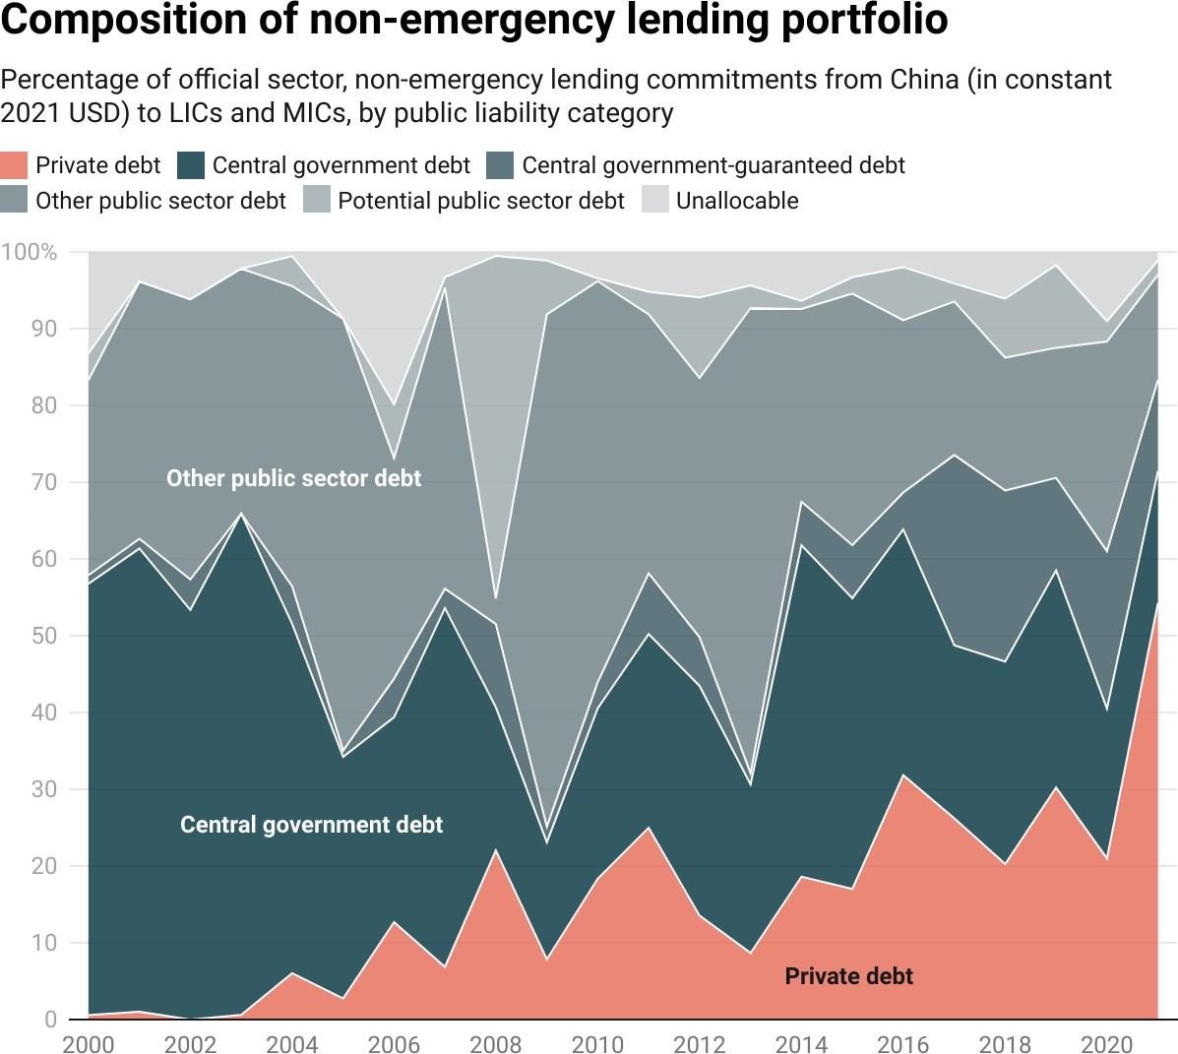

*Notes: This graph shows the composition of China’s non-emergency lending portfolio (as measured in 2021 constant USD) in LICs and MICs according to the extent to which host governments may eventually be liable for debt repayment. Central government debt and other public sector debt represent loans where the borrower is a government agency or a wholly- or majority-owned state entity. Central government debt represents loans that have a sovereign guarantee from the host government. Potential public debt represents loans to entities (including special purpose vehicles or joint ventures) where the host government has a minority stake. Private debt captures loans to private entities.*

Another potential de-risking strategy is to take a differentiated approach across borrower countries that present varying levels of repayment risk. Figures A22 and A23 provide evidence that suggests Beijing is adopting this approach: Chinese state-owned creditors have lent to ﬁnancially distressed countries at higher interest rates and with shorter repayment periods than countries that are

not in ﬁnancial distress. Consequently, the concessionality level (weighted average grant element) of ofﬁcial sector lending from China is consistently lower in countries experiencing ﬁnancial distress than in countries not experiencing ﬁnancial distress (see Figure A24).193

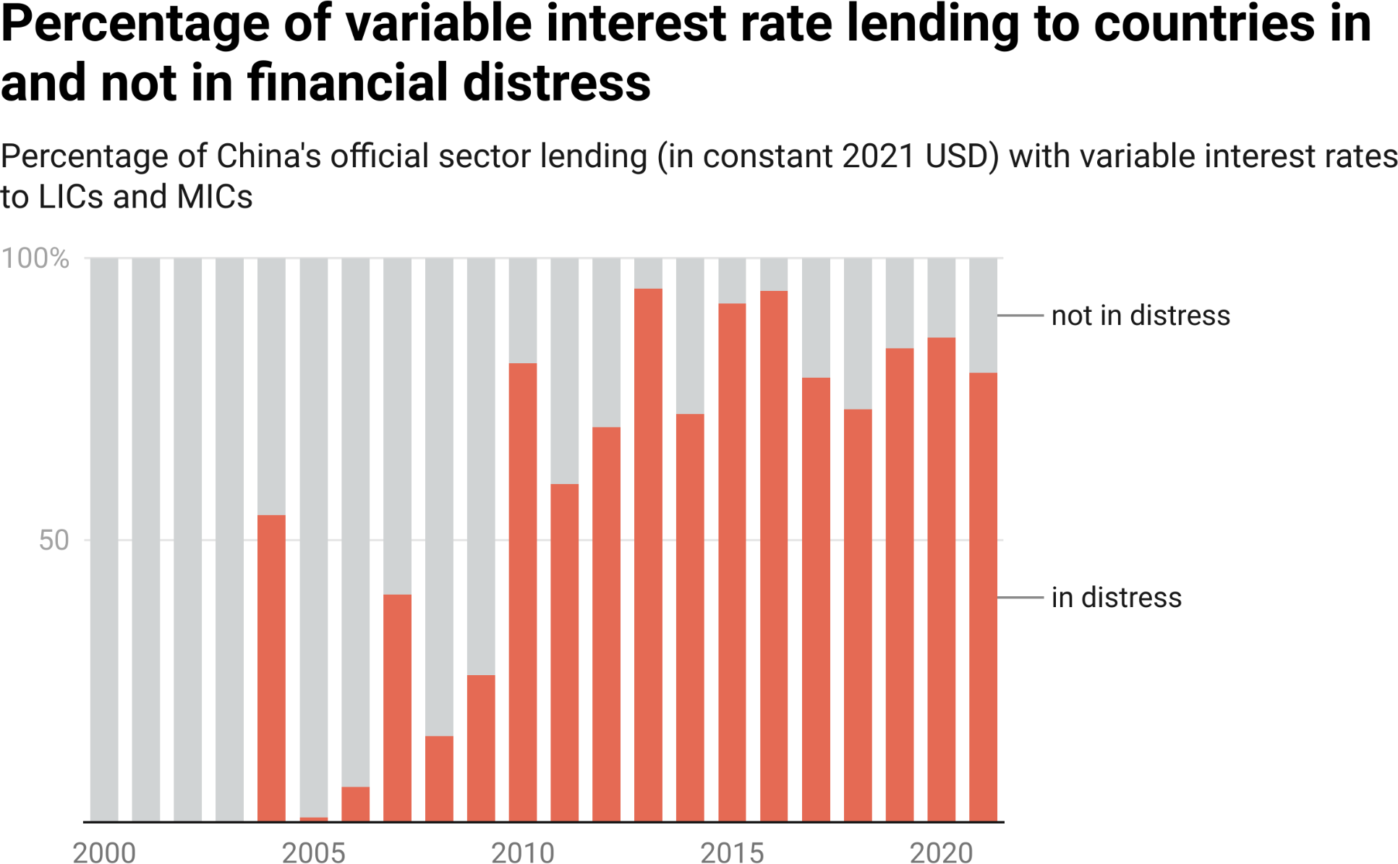

**Figure 2.19**

*Notes: Variable interest rates include LIBOR, EURIBOR, SHIBOR, BADLAR, CIRR, JIBOR, LPR and BADCOR. To determine if a country experienced ﬁnancial distress in a given year, we use the binary measure that is described in Box 1a.*

Chinese state-owned creditors have also changed the way that they lend to ﬁnancially distressed countries over time by shifting toward variable interest rate lending (see Figure 2.19). This approach to lending follows a risk-based pricing model by adding a borrower-speciﬁc margin—that accounts for the credit proﬁle characteristics of the borrower—to a market-based reference interest rate.194 In

193 Between 2000 and 2021, the weighted average grant element of ofﬁcial sector lending from China to countries experiencing ﬁnancial distress was ten percentage points lower than in countries not experiencing ﬁnancial distress (see Figure A25 in the Appendix).

194 Risk-based loan pricing models (a) charge risky borrowers higher prices (i.e., attach larger risk premia to borrowers that present a high probability of default), and (b) account for the expected magnitude of

post-default losses (i.e., how much money the creditor expects to lose if the borrower defaults).

the early 2000s, there was no evidence whatsoever of any variable interest rate lending by Chinese state-owned creditors to LICs or MICs in ﬁnancial distress. However, by 2021, more than 80% of China’s variable interest rate lending was directed to countries in ﬁnancial distress.

The 3.0 version of AidData’s GCDF dataset also reveals that China is increasingly collateralizing loans to countries in dire ﬁnancial straits: the share of China’s collateralized lending portfolio directed to countries in ﬁnancial distress increased from zero at the turn of the century to 74% by 2021 (see Figure 2.20).195 This change is part of a broader pattern in China’s use of credit enhancements, which AidData deﬁnes as lending backed by a credit insurance policy, a third-party repayment guarantee, and/or collateral. Figure A29 divides China’s LIC and MIC lending portfolio into three categories: (1) credit-enhanced lending to countries in ﬁnancial distress; (2) credit-enhanced lending to countries not in ﬁnancial distress; and (3) lending that is not credit-enhanced. It shows almost no proportional increase in credit-enhanced lending to countries that are not in ﬁnancial distress, but a large proportional increase in credit-enhanced lending to countries that are in ﬁnancial distress.

195 Figure 2.20 shows the proportion of ofﬁcial sector lending commitments from China (in constant 2021 USD) to LICs and MICs that falls into three categories: (1) loans that are collateralized and are going to a borrowing country that is in distress at the time of the loan commitment, (2) loans that are collateralized but are going to a borrowing country that is not experiencing ﬁnancial distress at the time of the loan commitment, and (3) loans that are not collateralized at the time of commitment. The underlying data from Figure 2.20 demonstrate that, while 51% of China's collateralized lending commitments to LICs and MICs were directed to developing countries in ﬁnancial distress during the pre-BRI period (2000-2013), this ﬁgure increased to 82% in the early and late BRI periods (2014-2021).

**Figure 2.20**

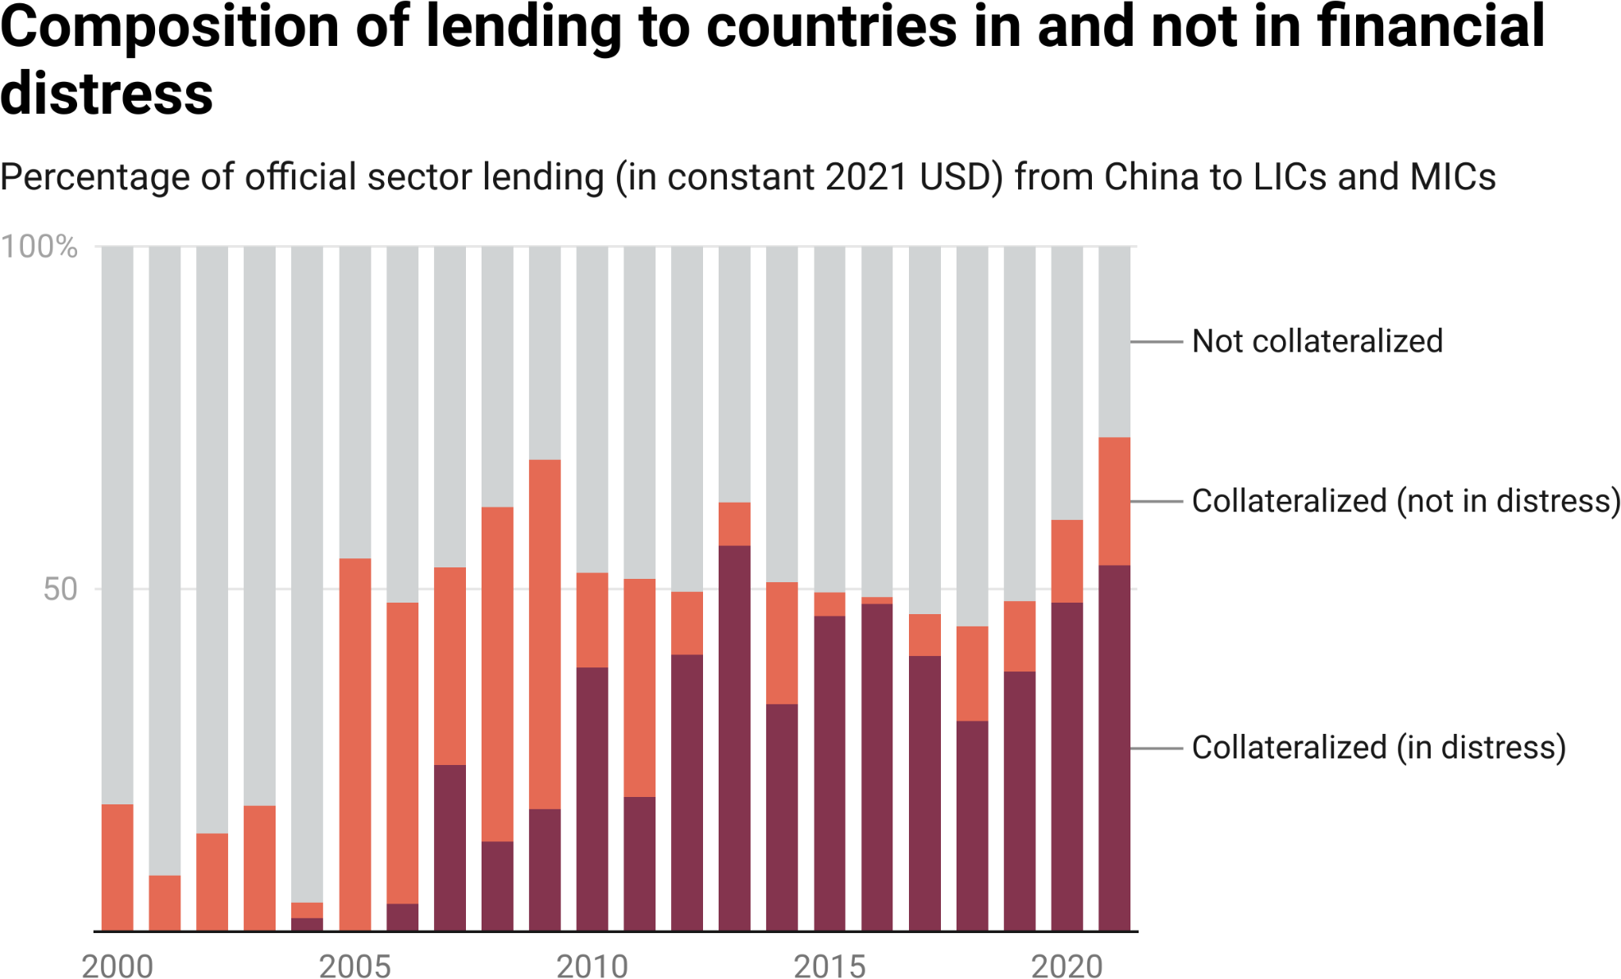

*Notes: To determine if a country experienced ﬁnancial distress in a given year, we use the binary measure that is described in Box 1a.*

Given that the large-scale provision of emergency rescue loans to ﬁnancially distressed borrowers has increased Chinese bank exposure to repayment risk, another potential portfolio rebalancing strategy is to direct project (or nonemergency) loans to less risky borrowers. As a preliminary test of whether Chinese state-owned creditors may be responding in this way, we ﬁrst measure the percentage of China’s emergency rescue loan portfolio supporting borrower countries with credit ratings in “C and D territory”—i.e., countries that Moody’s, Standard & Poor’s, and Fitch identify as in default or presenting a high risk of default. We then measure the percentage of China’s project loan portfolio supporting borrower countries with credit ratings in C and D territory. Figure

2.21 provides these summary statistics, which demonstrate that the overall credit quality of China’s project loan portfolio is substantially better than that of its emergency rescue loan portfolio.196

196 Project loans are deﬁned as those in the 3.0 version of AidData’s GCDF dataset that are categorized as investment project loans (IPLs).

**Figure 2.21**

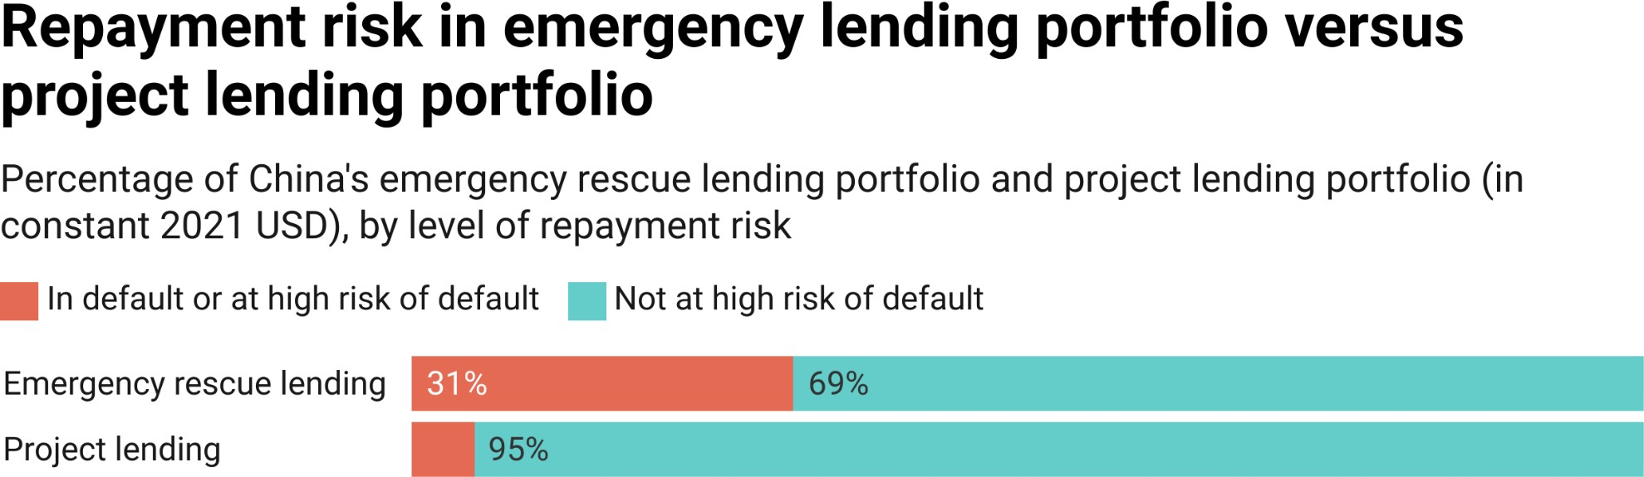

*Notes: Countries in default or at a high risk of default represent LICs and MICs with scores of 5 or less on the sovrate index (see Box 1a). Countries not at a high risk of default represent LICs and MICs with scores above 5 on the sovrate index. The World Bank’s sovrate index is a measure of repayment risk that varies from 0 to 21, with higher scores indicating lower levels of sovereign credit risk (Kose et al. 2022).*

*Country-year observations without ofﬁcial sector Chinese lending commitments or sovrate scores are excluded from the ﬁgure. MOFCOM interest-free loan commitments (which are typically issued without a credible expectation of repayment) are excluded from the calculation.*

We also ﬁnd evidence of portfolio rebalancing over time. According to Figure A30, China reduced the percentage of its non-emergency loan portfolio supporting borrower countries with credit ratings in C and D territory—from 7.9% during the early BRI period to 0.8% during the late BRI period. One potential way of shifting the non-emergency (and project) lending portfolio away from countries that present high levels of repayment risk is via syndication and multilateralization. Figure 2.22 demonstrates that when Beijing outsources risk management (including the loan origination process), less credit is channeled to countries that are in default or present a high probability of default. However, is there any evidence that Beijing is actually pivoting away from its bilateral lending institutions and toward multilateral lending institutions and syndicated loan arrangements? This is the next question that we attempt to answer.

**Figure 2.22**

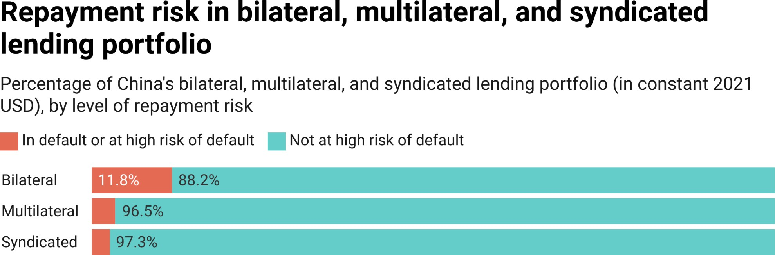

*Notes: Countries in default or at a high risk of default represent LICs and MICs with scores of 5 or less on the sovrate index (see Box 1a). Countries not at a high risk of default represent LICs and MICs with scores above 5 on the sovrate index. The World Bank’s sovrate index is a measure of repayment risk that varies from 0 to 21, with higher scores indicating lower levels of sovereign credit risk (Kose et al. 2022).*

*Country-year observations without ofﬁcial sector Chinese lending commitments or sovrate scores are excluded from the ﬁgure. MOFCOM interest-free loan commitments (which are typically issued without a credible expectation of repayment) are excluded from the calculation.*

#### Risk mitigation strategy #5: Scaling down bilateral lending operations and scaling up lending operations via syndication and multilateralization

If China’s bilateral development ﬁnance institutions do not have sufﬁciently strong risk management guardrails in place, one option is to reform these institutions from within. However, these institutions are politically powerful and slow to change (Chen 2020a, 2020b, 2023). Another option to improve the risk proﬁle of the country’s overseas lending program is to dial down the provision of credit through bilateral channels and dial up the provision of credit through syndicated and multilateral lending channels.

Syndicated loans allow a group of lenders (a “syndicate”) to pool their funds and share credit risk. When a transaction is ﬁnanced through a syndicated arrangement, all members of the syndicate must agree to a common set of contractual terms and conditions, including the standards and safeguards that will govern the transaction. Given that each lender has its own standards and safeguards, the members of a syndicate can seek to reconcile (hybridize) their

respective standards and safeguards. However, it is more common for the members of the syndicate to defer to the standards and safeguards of one member of the syndicate. In most syndicated loan arrangements, a “lead arranger”—sometimes referred to as the “arranging lender” “lead lender,” “lead manager,” or “underwriter”—establishes the transaction’s key terms and conditions, which cannot be amended without the consent of all members of the syndicate.197 It is also customary for all members of the syndicate to use a common set of due diligence standards to vet the borrowing institution and the proposed transaction.198 Here again, the lead arranger is usually responsible for identifying and applying the due diligence standards (Dennis and Mullineaux 2000; Ivashina 2009).

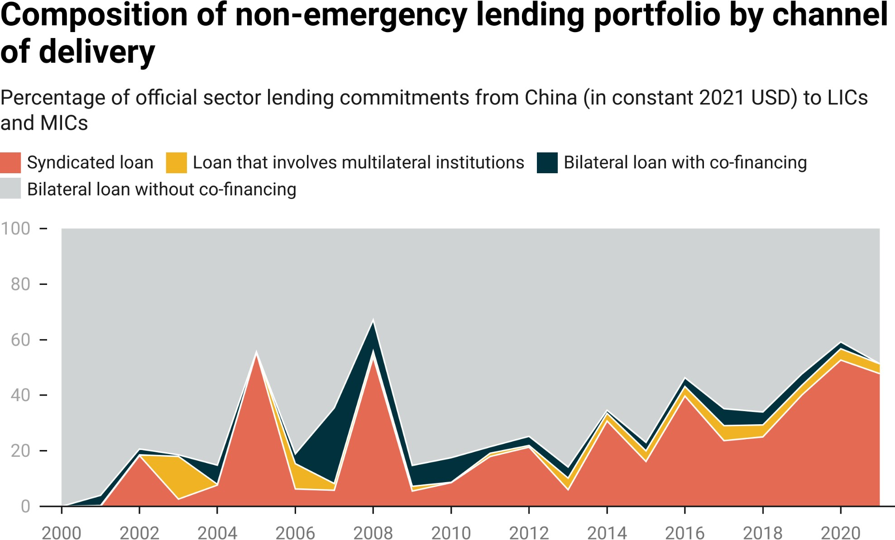

**Figure 2.23**

*Notes: All emergency rescue loans are excluded. The “loans that involve multilateral institutions” category include loans where a multilateral agency has some formal role, such as an entrusted loan agreement or a co-ﬁnancing arrangement.*

197 However, other terms and conditions can usually be amended with the consent of the “majority lenders.”

198 Suﬁ (2007) demonstrates that lead arrangers reduce the costs of due diligence for all other syndicate participants.

Figure 2.23 provides evidence that, at the turn of the century, China’s

non-emergency lending program in LICs and MICs exclusively consisted of bilateral loans—i.e., loans issued by a single lender to a single borrower.

However, over time, Beijing has moved away from this approach, ramping up its use of syndicated loan arrangements. It began experimenting with this more collaborative way of issuing credit during the pre-BRI period and early BRI period, but made syndication central to the country’s overseas lending strategy during the late BRI period. By 2021, 50% of China’s non-emergency lending program in LICs and MICs consisted of syndicated loan commitments.199

This empirical pattern ﬂies in the face of the conventional wisdom that “[e]merging economies’ debt to China is [...] non-marketable” (Kondo et al. 2022).200 That was certainly true 25 years ago, but it is no longer the case: half of China’s non-emergency lending portfolio in the developing world now consists of syndicated loans (Figure 2.23).

China's state-owned commercial banks are particularly focused on this approach to cross-border lending. The 3.0 version of AidData’s GCDF dataset demonstrates that they are more heavily engaged than the country’s policy banks in syndicated lending to LICs and MICs. In 2021, 84% of China’s

state-owned commercial bank lending to LICs and MICs relied on syndicated loan instruments and the remaining 16% relied on bilateral loan instruments. By comparison, only 36% of China’s policy bank lending to LICs and MICs relied on syndicated loan instruments and the remaining 64% relied on bilateral loan instruments.

Another important aspect of the country’s pivot from bilateral lending to syndicated loans is the growing involvement of non-Chinese banks and multilateral institutions in the syndicates that are being established. Figure A32 demonstrates that roughly 80% of the syndicated loans from ofﬁcial sector

199 49% of China’s non-emergency lending program in LICs and MICs consisted of bilateral loan commitments in 2021. Beijing’s pivot toward lending via syndicated loans is especially noticeable in the project lending portfolio (see Figure A36 for supplementary evidence).

200 A syndicated loan constitutes marketable debt in that the arranging lender responsible for originating and structuring the transaction can distribute/sell part of the loan to other banks and nonbank institutions through a marketing and syndication process and the loan can be traded on secondary markets.

creditors in China to LICs and MICs involve non-Chinese bank participants.201 A non-trivial percentage of these loans also involve multilateral institutions (see Figure A33).202 Multilateral and non-Chinese bank participation could have

far-reaching consequences if their standards and safeguards prevail as the ones that all other syndicate members must follow.203 In Table 2.4, we provide metadata for an illustrative set of syndicated loan agreements involving Chinese state-owned creditors and non-Chinese creditors. One can see that syndicated loans with Chinese and non-Chinese participants frequently rely on Western commercial banks and multilateral institutions to serve as lead arrangers, which is consistent with the notion that Beijing is de-risking its overseas loan portfolio by outsourcing risk management.204 In Chapter 4, where we address this issue at greater length, we ﬁnd that Chinese participation in syndicated loan agreements with non-Chinese banks and multilateral institutions consistently results in stronger rather than weaker risk management standards and safeguards.

**Table 2.4**

## Illustrative set of syndicated loan agreements with Chinese and non-Chinese bank participants

**Country Project Year**

**Value of Lead Arranger Loan**

**Chinese Participants**

**Total Number of Participants**

Sierra Leone Port Elizabeth II

Upgrading and

2017 $659

million

ICBC ICBC, China 2

Eximbank

Expansion Project

201 Although there are more syndicated loans with Chinese and non-Chinese participants (833) than there are syndicated loans with exclusively Chinese participants (312), syndicated loans with Chinese and

non-Chinese participants tend to be smaller ($138.8 million on average) than syndicated loans with exclusively Chinese participants ($545.5 million on average). These summary statistics are drawn from Figures A34 and A35.

202 When one accounts for multilateral participation in syndicated loans *and* entrusted loan agreements with multilateral institutions, the multilateralization of China’s LIC and MIC lending portfolio comes into sharper resolution (see Figure A28).

203 We provide evidence that suggests this is indeed the case in Chapter 3.

204 With an earlier vintage of the GCDF dataset, Joosse et al. (2023) use social network analysis to map the international network of non-Chinese ﬁnanciers that facilitate the participation of Chinese state-owned creditors in syndicated loan agreements. They conclude that the ten most important network “brokers” include two multilateral institutions (Inter-American Development Bank and African Development Bank) and eight Western commercial banks (BNP Paribas, Standard Chartered, Sumitomo Mitsui, MUFG, Citibank, ING, Deutsche Bank, and HSBC).

**Country Project Year**

**Value of Lead Arranger Loan**

**Chinese Participants**

**Total Number of Participants**

Iraq Basrah Natural Gas Liquids Facility Construction Project

2021 $260

million

International Finance Corporation (IFC)

ICBC, Bank of 9

China

Kazakhstan Almaty Ring Road

Project

2020 $585

million

European Bank for Reconstruction and Development (EBRD)

Bank of China 5

Argentina La Castellana Wind

Power Project

2017 $64.05

million

International Finance Corporation (IFC)

SAFE through 2

the Managed Co-lending Portfolio Program

Bangladesh Unit 3 of 220 MW

Sirajganj Combined Cycle Power Plant Project

2017 $196.7

million

Standard Chartered Bank of China 4

Bank

*Notes: This table provides examples of syndicated loans with Chinese state-owned participants (ID#62223, 62224, 95921, 92613, 98022, and 69033 in the 3.0 version of AidData’s GCDF dataset). The “Year” column captures the ﬁnancial commitment year. The “Value of Loan” column captures the aggregate monetary value of all syndicated loan tranches/contributions. The “Chinese Participants” column captures all ofﬁcial sector Chinese participants in the syndicate. The “Total Number of Participants” column captures the total number of Chinese and non-Chinese creditors that participated in the syndicate.*

Figure 2.23 above highlights another interesting trend: a modest increase in Chinese lending that is channeled via multilateral institutions during the BRI era (2014-2021). During the ﬁve year period that preceded the BRI (2009-2013), 2% of China’s non-emergency lending to LICs and MICs was channeled via multilateral institutions. This ﬁgure doubled (to 4%) during the ﬁrst eight years of BRI implementation (2014-2021).205

One of China’s initial forays into entrusted lending via multilateral institutions began in 2013 and 2014, with the creation of the Africa Growing Together Fund (AGTF) at the African Development Bank, the China Co-ﬁnancing Fund for Latin America and the Caribbean at the Inter-American Development Bank, and the Managed Co-Lending Portfolio Program (MCPP) at the International Finance Corporation (IFC). The MCPP, which was launched by the IFC in partnership with China’s State Administration for Foreign Exchange (SAFE), helps illustrate the logic of an entrusted loan agreement with a multilateral institution. Rather than directly lending to borrowers in developing countries, SAFE entrusted $3 billion to the IFC and “leverage[d] IFC’s project pipeline and due diligence skills to [...]

205 Figure 2.23 excludes emergency loans since they are exclusively provided via bilateral channels.

co-lend to projects or groups of projects alongside IFC on commercial terms” (World Bank Group 2020: 35). Beijing’s decision to outsource loan management to a multilateral institution was evidently motivated by a desire for stronger safeguards and attractive investment returns (see Box 2b for more on SAFE’s mandate to maximize investment returns on the country’s surplus foreign exchange reserves). An ex-post evaluation of the MCPP concluded that “[m]ost of these borrowers [had] the capacity to meet their ﬁnancial commitments and [were] less vulnerable to nonpayment than other speculative projects" (World Bank Group 2020: 36).

Think tanks, research institutions, and media outlets in G7 countries have in recent years trained their sights on China’s *bilateral* lending activities—in particular, infrastructure projects ﬁnanced by China Eximbank and China Development Bank (e.g., Dyer et al. 2011; Sanderson and Forsythe 2013; Gallagher and Ray 2020; Myers and Ray 2023; Ray 2023; Do Rosario and Savage 2023). Yet there has been virtually no discussion about Beijing’s strategic pivot away from bilateral lending and toward collaborative lending arrangements involving Chinese and non-Chinese banks. The reason why this change in China’s overseas lending portfolio has not received serious attention is simple: Chinese bank participation in syndicated loans (with non-Chinese participants) and loans entrusted to multilateral institutions have gone undetected because they are mostly excluded from other publicly available Chinese development ﬁnance datasets.206 Beijing has not been especially secretive about this change in the composition of its overseas lending strategy. It was hiding in plain sight; those seeking to track China’s overseas lending activities either did not detect it or did not think it was important enough to track.

206 Here again, one is reminded of the proverbial drunkard who insists upon searching for his keys beneath the lamppost “because that’s where the light is.” Chinese creditor contributions to syndicated loans are not systematically tracked in the China’s Overseas Development Finance Database, the Chinese Loans to Latin America and the Caribbean Database, the Chinese Loans to Africa Database, the China’s Global Energy Finance Database, the China Overseas Finance Inventory Database, or the World Bank’s International Debt Statistics (IDS). However, Figure A32 demonstrates that ofﬁcial sector lending from China is increasingly channeled via bank syndicates that include Chinese and non-Chinese banks.

There are several reasons why Beijing’s pivot away from bilateral lending instruments is crucial to understand its de-risking strategy.207 First, since most of the syndicated loans in question involve non-Chinese bank participants (see Figure A32), Beijing is increasingly able to outsource risk management to lending institutions with stronger rules and standards.208 Second, multilateral institutions have particularly strong risk management guardrails in place (see Chapter 3), so the use of entrusted loan agreements with multilateral institutions necessarily involves the application of a more stringent set of safeguards. These are effectively de-risking “shortcuts.” Bilateral development ﬁnance institutions have rules and standards that have evolved over decades via accretion. It is unlikely that these institutions are going to dispense with these safeguards or dramatically change them in the short-run. So, delegating borrower selection and loan preparation to a credible third party is an attractive shortcut to de-risk a loan portfolio (on a going forward basis).209 Second, participation in a syndicated loan agreement or an entrusted loan agreement with a multilateral development bank (MDB) is a rapid and reliable de-risking strategy because MDBs enjoy de facto preferred creditor status (Schlegl et al. 2019) and confer this beneﬁt to all other lenders that participate in their syndicated loan agreements and entrusted loan agreements (Gurara et al. 2020).210 An added beneﬁt of this approach is that loans involving MDBs are generally exempt from rescheduling and shielded from large haircuts (investor losses).211 From a risk mitigation perspective, syndicated loan agreements also have two perversely attractive features to ofﬁcial creditors: (1) unanimous consent requirements can make them more difﬁcult and time-consuming to reschedule (Buchheit 1985, 1991; Gelpern

207 As we explain at greater length in Chapter 3, Beijing has positioned its bilateral lending institutions as alternative sources of ﬁnancing for LICs and MICs that would prefer not to deal with OECD-DAC donors or multilateral development banks (Parks 2019; Malik et al. 2021; Dreher et al. 2022). Therefore, the pivot toward syndication and multilateralization represents a major departure.

208 In November 2017, the country's top banking regulator—the China Banking Regulatory Commission (CBRC)—called upon Chinese state-owned banks to “prevent and control overseas business risks *by taking risk-sharing measures*” (Xueqing 2017, emphasis added). The shift toward syndication and multilateralization during the late BRI period (highlighted above in Figure 2.23) may constitute evidence of bank responsiveness to CBRC’s policy guidance.

209 On this point, see Dennis and Mullineaux (2000).

210 In a typical A/B syndicated loan arrangement involving an MDB, the lender-of-record is the MDB; it keeps a part of the loan for its own account (the “A-loan”) and it sells participation in the remainder of the loan (the “B-loan”). As the lender-of-record, the MDB confers its status as a de facto preferred creditor to all B-loan participants.

211 On this point, see Cordella and Powell (2021).

2016); and (2) they are generally subject to smaller haircuts (ﬁnancial losses) than bilateral loans (Cruces and Trebesch 2013; Schlegl et al. 2019).212

### Section 4: What have we learned about Beijing’s bid to reboot its overseas lending program?

In this chapter, we have presented evidence that challenges the conventional wisdom about the total collapse of China’s overseas lending program. With more complete data on the full range of China’s lending activities in LICs and MICs, we have shown that Beijing remains the world’s largest ofﬁcial creditor: in nominal terms, the world owes China about $2.6 trillion and the developing world owes China at least $1.1 trillion and perhaps as much as $1.5 trillion. We have also shed light on the ways in which Beijing is rebalancing its cross-border credit portfolio—much like a yield-maximizing investment portfolio manager that is navigating an environment in which a growing number of borrowers are illiquid or insolvent. Beijing has ramped down the provision of long-term,

dollar-denominated bilateral loans to sovereign borrowers for public investment projects, while at the same time ramping up the provision of RMB-denominated emergency rescue loans that are short- or medium-term in nature. It has reduced its reliance upon the policy banks, while making greater use of state-owned commercial banks, the central bank, syndicated loan arrangements with

non-Chinese banks, and multilateral administrators.

What can we say, by way of conclusion, about Beijing’s efforts to de-risk its overseas lending portfolio and its determination to ensure that LIC and MIC borrowers repay their debts? The evidence at hand does not suggest that it is ready to take ﬁnancial losses in order to minimize diplomatic blowback and reputational damage.213 Quite the opposite: Beijing appears to be stiffening its resolve and preparing for a long and difﬁcult slog. It is sweeping cash out of the escrow accounts of its overseas borrowers, requiring that borrowers replenish

212 Bilateral loans from ofﬁcial creditors are typically rescheduled through the Paris Club, while syndicated loans are typically rescheduled through London Club reschedulings (regardless of whether the syndicate members include ofﬁcial creditors or commercial creditors).

213 Gong Chen, the founder of Anbound (a Beijing-based think tank) and a BRI adviser to the central government, recently told Nikkei Asia that “widespread debt evasion and avoidance [by BRI participants] would have a signiﬁcant impact on China's ﬁnancial stability” and “we are concerned that some countries may try to avoid paying back their debt by utilizing geopolitics and the ideological competition between East and West” (Aamir et al. 2022).

escrow accounts in exchange for short-term cash ﬂow relief, introducing stronger penalties for late repayments, and channeling emergency rescue loans with high interest rates and short repayment periods to ﬁnancially distressed borrowers (to make sure they have enough cash on hand to service their existing infrastructure project debts). Only time will tell if Beijing has enough “steel in its spine” to stay the course, but its actions to date suggest that it intends to do whatever it takes to protect the bottom line.

A ﬁnal point bears emphasis. We freely concede that this chapter has only scratched the surface of what can be done with the 3.0 version of AidData’s GCDF dataset to uncover new insights about Beijing’s contemporary lending activities and practices in the Global South. The dataset can—and should—be used to answer an array of additional questions, such as:

* How have the terms and conditions in Chinese loan contracts changed (or not) since Beijing endorsed the Common Framework in November 2020?
* What are the consequences of borrower non-compliance with escrow account conditions?
* How do Chinese creditors select their preferred partners in syndicated loan agreements?
* Why does Beijing prefer to channel loans through some multilateral institutions rather than others?
* What are the supply-side and demand-side drivers of China’s emergency lending program? Has this changed over time, and if so, how and why?
* What are the supply-side and demand-side drivers of China’s

non-emergency lending program? Has this changed over time, and if so, how and why?

Although there are commercial incentives to put the GCDF dataset behind a paywall and professional incentives to withhold release until it is introduced in leading, peer-reviewed academic journals, we remain fully committed to the

principle that all past, present, and future versions of the GCDF dataset should be treated as public goods rather than private goods.214 Our hope is that the dataset will catalyze a knowledge multiplier effect and facilitate evidence-based decision-making.215

214 In this respect, we are carrying forward the “open research” tradition of the original, interdisciplinary group of researchers who developed the Tracking Underreported Financial Flows (TUFF) methodology that underpins AidData’s GCDF dataset. See Chapter 3 of Dreher et al. (2022).

215 If past is prologue, we expect that this approach will deliver a signiﬁcant payoff. To date, the GCDF dataset has been used in more than 500 research publications (Wooley 2023).

# References

Aamir, Adnan, Marwaan Macan-Markar, Shaun Turton, Cissy Zhou and Grace Li. 2022. Road to nowhere: China’s Belt and Road Initiative at tipping point. 10 August 2022. *Nikkei Asia*.

Accessed on 13 August 2023 at

[https://asia.nikkei.com/Spotlight/The-Big-Story/Road-to-nowhere-China-s-Belt-and-Road-Initiati](https://asia.nikkei.com/Spotlight/The-Big-Story/Road-to-nowhere-China-s-Belt-and-Road-Initiative-at-tipping-point) [ve-at-tipping-point](https://asia.nikkei.com/Spotlight/The-Big-Story/Road-to-nowhere-China-s-Belt-and-Road-Initiative-at-tipping-point)

Acker, Kevin, Deborah Brautigam, and Yufan Huang. 2020. Debt Relief with Chinese Characteristics. SAIS-CARI Working Paper No. 2020/39. Washington DC: Johns Hopkins University.

Anderlini, Jamil. 2008. Beijing uses forex reserves to target Taiwan. 12 September 2008.

*Financial Times*. Accessed on 1 August 2023 at <https://www.ft.com/content/22fe798e-802c-11dd-99a9-000077b07658>

Bahaj, Saleem, and Ricardo Reis. 2022. Jumpstarting an International Currency. CEPR Discussion Paper DP14793. London: Centre for Economic Policy Research (CEPR).

Batson, Andrew. 2008. China Used Reserves To Sway Costa Rica. 13 September 2008. *Wall Street Journal.* Accessed on 2 August 2023 at <https://www.wsj.com/articles/SB122121919505927749>

Bertaut, Carol, Bastian von Beschwitz, Stephanie Curcuru. 2023. ‘The International Role of the

U.S. Dollar’ Post-COVID Edition. FEDS Notes. Washington: Board of Governors of the Federal Reserve System.

Bon, Gatien and Gong Cheng. 2021. Understanding China's role in recent debt relief operations: A case study analysis. *International Economics* 166 (C): 23-41.

Bräutigam, Deborah and Kevin Acker. 2020. Is China Hiding its Overseas Lending? Horn, Reinhart and Trebesch's Hidden Loans and Hidden Data. SAIS-CARI Blog. Accessed on 19 July 2023 at [www.chinaafricarealstory.com/2020/04/is-china-hiding-its-overseas-lending.html](http://www.chinaafricarealstory.com/2020/04/is-china-hiding-its-overseas-lending.html)

Brooks, Sarah M., Raphael Cunha, and Layna Mosley. 2015. Categories, Creditworthiness, and Contagion: How Investors' Shortcuts Affect Sovereign Debt Markets. *International Studies Quarterly* 59 (3): 587–601.

Buchheit, Lee C. 1985. Is Syndicated Lending a Joint Venture? *International Financial Law Review* 4: 12-14.

Buchheit, Lee C. 1991. Making Amends for Amendments. *International Financial Law Review*

10: 11.

Buchheit, Lee C. and Mitu Gulati. 2023. Enforcing comparable treatment in sovereign debt workouts. *Capital Markets Law Journal* 18 (1): 71-77.

Central Bank of Sudan (CBOS). 2023. Sudan External Debt Position First Quarter as at 31st of March 2022. Khartoum: CBOS. Accessed on 19 July 2023 at https://web.archive.org/web/20230208195131/https:/cbos.gov.sd/sites/default/ﬁles/Quarter%2 01%20Report%20%202022%20.pdf

Cerutti, Eugenio, Catherine Casanova, and Swapan-Kumar Pradhan. 2023. Banking Across Borders: Are Chinese Banks Different? *Journal of Banking & Finance* 154: 106920.

Cerutti, Eugenio, Catherine Koch, and Swapan-Kumar Pradhan. 2018. The growing footprint of EME banks in the international banking system. *BIS Quarterly Review*. Accessed on 19 July 2023 at https://[www.bis.org/publ/qtrpdf/r_qt1812e.htm](http://www.bis.org/publ/qtrpdf/r_qt1812e.htm)

Chen, Xiaoyi. 2014. 揭开外储委托贷款的神秘面纱 (Unveil the Mysteries of the Entrust Loans of the Foreign Exchange Reserves in China). 21 August 2014. Accessed on 15 September 2023 at [https://www.dropbox.com/scl/ﬁ/r5idp65hfybugsmc5v7b3/.pdf?rlkey=xr8jqe079moeb50pybrjh9](https://www.dropbox.com/scl/fi/r5idp65hfybugsmc5v7b3/.pdf?rlkey=xr8jqe079moeb50pybrjh90bx&dl=0) [0bx&dl=0](https://www.dropbox.com/scl/fi/r5idp65hfybugsmc5v7b3/.pdf?rlkey=xr8jqe079moeb50pybrjh90bx&dl=0)

Chen, Muyang. 2020a. Beyond Donation: China’s Policy Banks and the Reshaping of Development Finance. *Studies in Comparative International Development* 55: 436–459.

Chen, Muyang. 2020b. State Actors, Market Games: Credit Guarantees and the Funding of China Development Bank. *New Political Economy* 25 (3): 453-468.

Chen, Muyang. 2023. China’s rise and the reshaping of sovereign debt relief. *International Affairs* 99 (4): 1755-1775.

China Daily. 2009. Huijin to fund Exim, Sinosure. 17 September 2009. *China Daily* Accessed on 1 August 2023 at [www.chinadaily.com.cn/business/2009-09/17/content_8701521.htm](http://www.chinadaily.com.cn/business/2009-09/17/content_8701521.htm)

China Development Bank (CDB). 2020. Pricing Supplement. 19 November 2020. Accessed at https:// secure.fundsupermart.com/fsm/bond/relatedBondDocument/XS2263032786/ China%20Development%20Bank_Pricing%20Supplement%20_%20Programme%20OC_Issue% 20of%20CNY2,800,000, 000%203.03%20per%20cent.%20Notes%20due%202023.pdf

Cordella, Tito and Powell, Andrew. 2021. Preferred and non-preferred creditors. *Journal of International Economics* 132(C): 103491

Cruces, Juan J, and Christoph Trebesch. 2013. Sovereign Defaults: The Price of Haircuts.

*American Economic Journal: Macroeconomics* 5 (3): 85–117.

Custer, Samantha, Axel Dreher, Thai-Binh Elston, Brooke Escobar, Rory Fedorochko, Andreas Fuchs, Siddhartha Ghose, Joyce Jiahui Lin, Ammar Malik, Bradley C. Parks, Kyra Solomon, Austin Strange, Michael J. Tierney, Lydia Vlasto, Katherine Walsh, Fei Wang, Lincoln Zaleski, and Sheng Zhang. 2023. Tracking Chinese Development Finance: An Application of AidData’s TUFF 3.0 Methodology. Williamsburg, VA: AidData at William & Mary.

Dennis, Steven A. and Donald J. Mullineaux. 2000. Syndicated loans. *Journal of Financial Intermediation* 9(4): 404-426.

Do Rosario, Jorgelina and Karin Strohecker. 2023. Analysis: China holds the key to avoiding Argentina's IMF default. The price tag is unknown. *Reuters*. 2 August 2023 Accessed on 2 August 2023 at

[https://www.reuters.com/markets/china-holds-key-avoiding-argentinas-imf-default-price-tag-is-](https://www.reuters.com/markets/china-holds-key-avoiding-argentinas-imf-default-price-tag-is-unknown-2023-08-02/) [unknown-2023-08-02/](https://www.reuters.com/markets/china-holds-key-avoiding-argentinas-imf-default-price-tag-is-unknown-2023-08-02/)

Do Rosario, Jorgelina and Rachel Savage. 2023. China development loans to emerging economies hit 13-year low in 2021. *Reuters*. 24 January 2023, Accessed on 17 July 2023 at [https://www.reuters.com/markets/asia/china-development-loans-emerging-economies-hit-13-y](https://www.reuters.com/markets/asia/china-development-loans-emerging-economies-hit-13-year-low-2021-study-2023-01-24/) [ear-low-2021-study-2023-01-24/](https://www.reuters.com/markets/asia/china-development-loans-emerging-economies-hit-13-year-low-2021-study-2023-01-24/)

Do Rosario, Jorgelina. 2023. Exclusive: Argentina to use IMF money to pay back part of a currency swap with China, sources say. *Reuters*. 24 August 2023. Accessed on 24 August 2023 at

[https://www.reuters.com/world/americas/argentina-use-imf-money-pay-back-part-currency-swa](https://www.reuters.com/world/americas/argentina-use-imf-money-pay-back-part-currency-swap-with-china-sources-2023-08-23/) [p-with-china-sources-2023-08-23/](https://www.reuters.com/world/americas/argentina-use-imf-money-pay-back-part-currency-swap-with-china-sources-2023-08-23/)

Douglas, Jason. 2022. China Props Up Belt-and-Road Borrowers Via Unusual Channel. 11 December 2022. *Wall Street Journal*. Accessed on 1 August 2023 at [https://www.wsj.com/articles/china-props-up-belt-and-road-borrowers-via-unusual-channel-116](https://www.wsj.com/articles/china-props-up-belt-and-road-borrowers-via-unusual-channel-11670727153) [70727153](https://www.wsj.com/articles/china-props-up-belt-and-road-borrowers-via-unusual-channel-11670727153)

Dreher, Axel, Andreas Fuchs, Bradley Parks, Austin Strange, and Michael J. Tierney. 2021. Aid, China, and Growth: Evidence from a New Global Development Finance Dataset. *American Economic Journal: Economic Policy* 13 (2): 135-174.

Dreher, Axel, Andreas Fuchs, Bradley Parks, Austin Strange, and Michael J. Tierney. 2022.

*Banking on Beijing: The Aims and Impacts of China’s Overseas Development Program.*

Cambridge, UK: Cambridge University Press.

Dyer, Geoff, Jamil Anderlini, and Henny Sender. 2011. China’s lending hits new heights. 17 January 2011. *Financial Times.* Accessed on 3 August 2023 at <https://www.ft.com/content/488c60f4-2281-11e0-b6a2-00144feab49a>

Embassy of the People's Republic of China in the Republic of the Philippines. 2019. Belt and Road Primer. Accessed on 1 July 2023 at

ph.china-embassy.gov.cn/eng/sgdt/201904/t20190411_1182334.htm

Ferry, Lauren and Alexandra Zeitz. 2023. China, the IMF, and Sovereign Debt Crisis. Paper presented at the 6th Interdisciplinary Sovereign Debt Research and Management Conference (DebtCon6) at Princeton University from 27-29 April 2023. Accessed on 1 August 2023 at [https://debtcon6.princeton.edu/sites/g/ﬁles/toruqf3611/ﬁles/documents/ferry.pdf](https://debtcon6.princeton.edu/sites/g/files/toruqf3611/files/documents/ferry.pdf)

Gallagher, Kevin P. and Rebecca Ray. 2020. Scope and Findings: China’s Overseas Development Finance Database. BU Global Development Policy Center. Accessed on 17 July 2023 at

[https://www.bu.edu/gdp/2020/12/13/scope-and-ﬁndings-chinas-overseas-development-ﬁnanc](https://www.bu.edu/gdp/2020/12/13/scope-and-findings-chinas-overseas-development-finance-database/) [e-database/](https://www.bu.edu/gdp/2020/12/13/scope-and-findings-chinas-overseas-development-finance-database/)

Gardner, Alysha, Joyce Lin, Scott Morris, and Bradley Parks. 2021. Bargaining with Beijing: A Tale of Two Borrowers. Center for Global Development and AidData at William & Mary.

Gelpern, Anna, Sebastian Horn, Scott Morris, Brad Parks, Christoph Trebesch. 2021. How China Lends: A Rare Look into 100 Debt Contracts with Foreign Governments. Peterson Institute for International Economics, Kiel Institute for the World Economy, Center for Global Development, and AidData at William & Mary.

Gelpern, Anna, Sebastian Horn, Scott Morris, Brad Parks, Christoph Trebesch. 2022. How China Lends: A Rare Look into 100 Debt Contracts with Foreign Governments. *Economic Policy* eiac054.

Gelpern, Anna. 2016. Sovereign debt: now what? *Yale Journal of International Law* 41 (2): 45-96.

Gilchrist, Simon, Bin Wei, Vivian Z. Yue, and Egon Zakrajšek. 2022. Sovereign risk and ﬁnancial risk. *Journal of International Economics* 136 (C): 103603.

Government of Costa Rica. 2007. Establecimiento de relaciones diplomáticas con la República Popular China ha resultado beneﬁcioso para el país. 10 September 2007. San Jose: Ministerio de Relaciones Exteriores y Culto Dirección de Comunicación Institucional. Accessed on 2 August 2023 at

[https://www.dropbox.com/scl/ﬁ/g8kkmicps7o8z9vdxcn5d/1243-RPCH-beneﬁcios.pdf?rlkey=3u](https://www.dropbox.com/scl/fi/g8kkmicps7o8z9vdxcn5d/1243-RPCH-beneficios.pdf?rlkey=3u5afpnqeeg6myy358wxj2kn9&dl=0) [5afpnqeeg6myy358wxj2kn9&dl=0](https://www.dropbox.com/scl/fi/g8kkmicps7o8z9vdxcn5d/1243-RPCH-beneficios.pdf?rlkey=3u5afpnqeeg6myy358wxj2kn9&dl=0)

Government of Costa Rica. 2008. Letter from Costa Rican Minister of Finance Guillermo E. Zúñiga to SAFE Deputy Administrator Fang Shangpu. 7 January 2008. Accessed on 13 August 2023 at

[https://www.dropbox.com/scl/ﬁ/48qdeslzwim9t6dqhyk0m/7-January-2008-Letter-from-Minister](https://www.dropbox.com/scl/fi/48qdeslzwim9t6dqhyk0m/7-January-2008-Letter-from-Minister-of-Finance-of-Costa-Rica-to-SAFE.pdf?rlkey=pr3p4advi1wfzzwjr5t8gva5m&dl=0)

[-of-Finance-of-Costa-Rica-to-SAFE.pdf?rlkey=pr3p4advi1wfzzwjr5t8gva5m&dl=0](https://www.dropbox.com/scl/fi/48qdeslzwim9t6dqhyk0m/7-January-2008-Letter-from-Minister-of-Finance-of-Costa-Rica-to-SAFE.pdf?rlkey=pr3p4advi1wfzzwjr5t8gva5m&dl=0)

Gurara, Daniel, Andrea Presbitero, and Miguel Sarmiento. 2020. Borrowing costs and the role of multilateral development banks: Evidence from cross-border bank syndicated lending.

*Journal of International Money and Finance* 100: 102090.

Horn, Sebastian, Bradley C. Parks, Carmen M. Reinhart, and Christoph Trebesch. 2023a. China as an International Lender of Last Resort. NBER Working Paper #31105. Cambridge, MA: NBER.

Horn, Sebastian, Bradley C. Parks, Carmen M. Reinhart, and Christoph Trebesch. 2023b. Debt Distress on China’s Belt and Road. *American Economic Association Papers & Proceedings* 113: 131-34.

Horn, Sebastian, Carmen M. Reinhart, and Christoph Trebesch. 2019. China’s Overseas Lending. NBER Working Paper No. 26050. Cambridge, MA: National Bureau of Economic Research.

Horn, Sebastian, Carmen M. Reinhart, and Christoph Trebesch. 2020a. China’s Overseas Lending: A Response to Our Critics. CGD Note. Washington DC: Center for Global Development (CGD). Accessed on 19 July 2023 at [https://www.cgdev.org/sites/default/ﬁles/chinas-overseas-lending-response-our-critics.pdf](https://www.cgdev.org/sites/default/files/chinas-overseas-lending-response-our-critics.pdf)

Horn, Sebastian, Carmen M. Reinhart, and Christoph Trebesch. 2020b. Coping with Disasters: Two Centuries of International Ofﬁcial Lending. NBER Working Paper No. 27343.

Horn, Sebastian, Carmen M. Reinhart, and Christoph Trebesch. 2021. China’s Overseas Lending. *Journal of International Economics* 133: 103539.

Horn, Sebastian, Carmen M. Reinhart, and Christoph Trebesch. 2022a. Hidden Defaults. World Bank Policy Research Working Paper Series 9925. Washington DC: World Bank.

Horn, Sebastian, Carmen M. Reinhart, and Christoph Trebesch. 2022b. Hidden Defaults. *AEA Papers and Proceedings* 112: 531–35.

Hwang, Jyhjong,, Oyintarelado Moses, Lucas Engel, and Sobia Shadbar. 2022. Chinese Loans to Africa During the COVID-19 Pandemic. BU Global Development Policy Center. GCI Policy Brief 012. Accessed on 17 July 2023 at [https://www.bu.edu/gdp/ﬁles/2022/11/GCI_PB_012_EN_FIN.pdf](https://www.bu.edu/gdp/files/2022/11/GCI_PB_012_EN_FIN.pdf)

International Monetary Fund (IMF). 2020. IMF Policy Paper: The Evolution of Public Debt Vulnerabilities in Lower Income Economies. Washington DC: IMF.

International Monetary Fund (IMF). 2021. Request for an Extended Arrangement Under the Extended Fund Facility -- Press Release; Staff Report; Staff Statement; and Statement by the Executive Director for Suriname. IMF Country Report No. 21/280. Washington DC: IMF.

Accessed at

<https://www.imf.org/-/media/Files/Publications/CR/2021/English/1SUREA2021001.ashx>

Ivashina, Victoria. 2009. Asymmetric information effects on loan spreads. *Journal of Financial Economics* 92 (2): 300–319.

Jia, Chen. 2015. Policy banks get $90b cash infusion. 19 August 2015. *China Daily.* Accessed on 10 July 2023 at <https://www.chinadaily.com.cn/business/2015-08/19/content_21643373.htm>

Joosse, Alexandra, Ammar A. Malik, Sheng Zhang, and Thai-Binh Elston. 2023. Networks of the Belt & Road: The Hidden Role of Financial Brokers. Mimeo.

Kaminsky, Graciela and Carmen M. Reinhart. 2000. On Crises, Contagion and Confusion.

*Journal of International Economics* 51 (1): 145-168.

Kondo, Illenin O., Astghik Mkhitaryan, and Cesar Sosa-Padilla. 2022. Borrowing in the Shadow of China. Mimeo.

Kong, Bo, and Kevin P. Gallagher. 2017. Globalizing Chinese Energy Finance: The Role of Policy Banks. *Journal of Contemporary China* 26 (108): 834–851.

Kose, M. Ayhan, Sergio Kurlat, Franziska Ohnsorge, and Naotaka Sugawara. 2022. A Cross-Country Database of Fiscal Space. *Journal of International Money and Finance* 128 (November): 102682.

Liu, Zongyuan Zoe. 2023. *Sovereign Funds: How the Communist Party of China Finances Its Global Ambitions*. Cambridge, MA: Harvard University Press.

Longstaff, Francis A., Pan, Jun, Pedersen, Lasse H. and Singleton, Kenneth J. 2011. How Sovereign Is Sovereign Credit Risk? *American Economic Journal: Macroeconomics* 3 (2): 75-103.

Lu, Christina. 2023. China’s Belt and Road to Nowhere. *Foreign Policy.* 13 February 2023.

Accessed on 10 July 2023 at

[https://foreignpolicy.com/2023/02/13/china-belt-and-road-initiative-infrastructure-development](https://foreignpolicy.com/2023/02/13/china-belt-and-road-initiative-infrastructure-development-geopolitics/)

[-geopolitics/](https://foreignpolicy.com/2023/02/13/china-belt-and-road-initiative-infrastructure-development-geopolitics/)

Ma, Guonan. 2006. Sharing China’s Bank Restructuring Bill. *China & World Economy* 14 (3): 19-37.

Malik, Ammar A. and Bradley C. Parks. 2021. Hidden debt exposure to China: What is it, where is it, and should we be concerned? Williamsburg, VA: AidData at William & Mary.

Malik, Ammar A., Bradley C. Parks, Brooke Russell, Joyce Lin, Katherine Walsh, Kyra Solomon, Sheng Zhang, Thai-Binh Elston, and Seth Goodman. 2021. Banking on the Belt and Road: Insights from a New Global Dataset of 13,427 Chinese Development Projects. Williamsburg, VA: AidData at William & Mary.

Mfula, Chris. IMF's Georgieva sees broad deal with China on debt restructurings. *Reuters*. 24 January 2023. Accessed on 30 July 2023 at

[https://www.reuters.com/world/africa/imf-chief-says-its-time-creditors-restructure-zambias-debt](https://www.reuters.com/world/africa/imf-chief-says-its-time-creditors-restructure-zambias-debt-2023-01-24/)

[-2023-01-24/](https://www.reuters.com/world/africa/imf-chief-says-its-time-creditors-restructure-zambias-debt-2023-01-24/)

Mingey, Matthew and Agatha Kratz. 2021. China’s Belt and Road: Down but not Out. Rhodium Group Note. Accessed on 21 July 2023 at <https://rhg.com/research/bri-down-out/>

Mingey, Matthew and Logan Wright. 2023 China’s External Debt Renegotiations After Zambia.

Rhodium Group Note. Accessed on 1 August 2023 at <https://rhg.com/research/chinas-external-debt-renegotiations-after-zambia/>

Ministry of Finance and Economic Development (MOFED). 2022. Annual Public Debt Bulletin 2021 Financial Year. Harare, Zimbabwe: Ministry of Finance and Economic Development (MOFED). Accessed on 20 July 2023 at [https://veritaszim.net/sites/veritas_d/ﬁles/2021%20Annual%20Public%20Debt%20Bulletin.pdf](https://veritaszim.net/sites/veritas_d/files/2021%20Annual%20Public%20Debt%20Bulletin.pdf)

Ministry of Finance of the People's Republic of China. 2020. Written Interview with Finance Minister Liu Kun on G20 Debt Agenda. Beijing: Ministry of Finance of the People's Republic of China. Accessed on 1 August 2023 [atwww.mof.gov.cn/en/news/spe/202011/t20201120_3626593.htm](http://atwww.mof.gov.cn/en/news/spe/202011/t20201120_3626593.htm)

Morris, Scott, Brad Parks, and Alysha Gardner. 2020. Chinese and World Bank Lending Terms: A Systematic Comparison across 157 Countries and 15 Years. CGD Policy Paper 170.

Washington, DC: Center for Global Development.

Moses, Oyintarelado Jyhjong Hwang, Lucas Engel, and Victoria Yvonne Bien-Aimé. 2023. A New State of Lending: Chinese Loans to Africa. GCI Policy Brief 019. Boston, MA: Boston University's Global Development Policy Center.

Myers, Margaret and Rebecca Ray. 2023. At a Crossroads: Chinese Development Finance to Latin America and the Caribbean, 2022. InterAmerican Dialogue and BU Global Development Policy Center. Accessed on 17 July 2023 at

[https://www.thedialogue.org/wp-content/uploads/2023/03/Chinese-Development-Finance-202](https://www.thedialogue.org/wp-content/uploads/2023/03/Chinese-Development-Finance-2023-FINAL.pdf) [3-FINAL.pdf](https://www.thedialogue.org/wp-content/uploads/2023/03/Chinese-Development-Finance-2023-FINAL.pdf)

National Bank of Serbia (NBS). 2007. Financial Statements prepared in accordance with International Financial Reporting Standards for the year ended 31 December 2006 with Independent Auditor's Report. Belgrade, Serbia: NBS. Accessed on 1 July 2023 at [https://nbs.rs/export/sites/NBS_site/documents-eng/onbs-poslovanje/NBS_IAS_Report_2006.p](https://nbs.rs/export/sites/NBS_site/documents-eng/onbs-poslovanje/NBS_IAS_Report_2006.pdf) [df](https://nbs.rs/export/sites/NBS_site/documents-eng/onbs-poslovanje/NBS_IAS_Report_2006.pdf)

Nugent, Clara. 2023a. Argentina reaches last-minute deal with IMF to avoid default. *Financial Times*. 28 July 2023. Accessed on 2 August 2023 at

<https://www.ft.com/content/42c509a8-d75e-4350-b448-b6b8db13942a>

Nugent, Ciara. 2023b. Argentina taps Chinese credit line to keep economy aﬂoat during elections. *Financial Times*. 18 October 2023. Accessed on 19 October 2023 at <https://www.ft.com/content/c92e56b7-e619-4cbb-b615-e401140c10cc>

Organisation for Economic Co-operation and Development (OECD). 2023b. Converged Statistical Reporting Directives for the Creditor Reporting System (CRS) and the Annual DAC Questionnaire, Chapter 1-6. 27 April 2023. Paris: OECD. Accessed on 14 September 2023 at https://one.oecd.org/document/DCD/DAC/STAT(2023)9/FINAL/en/pdf

Ofﬁce of the Leading Group for Promoting the Belt and Road Initiative. 2019. The Belt and Road Initiative Progress, Contributions and Prospects. Beijing: Ofﬁce of the Leading Group for Promoting the Belt and Road Initiative. Accessed on 1 July 2023 at <https://eng.yidaiyilu.gov.cn/p/86739.html>

Olander, Eric. 2023. What’s Driving the Steady Decline in Chinese Overseas Development Lending? China Global South Project. Accesed on 01 July 223 at [https://chinaglobalsouth.com/podcasts/whats-driving-the-steady-decline-in-chinese-overseas-d](https://chinaglobalsouth.com/podcasts/whats-driving-the-steady-decline-in-chinese-overseas-development-lending/) [evelopment-lending/](https://chinaglobalsouth.com/podcasts/whats-driving-the-steady-decline-in-chinese-overseas-development-lending/)

Organisation for Economic Co-operation and Development (OECD). 2021. Converged Statistical Reporting Directives for the Creditor Reporting System (CRS) and the Annual DAC Questionnaire. Paris: OECD. Accessed on 1 August 2023 at <https://one.oecd.org/document/DCD/DAC/STAT(2020)44/FINAL/en/pdf>

Parks, Bradley. 2019. Chinese Leadership and the Future of BRI: What Key Decisions Lie Ahead? CGD Note. Washington, DC: Center for Global Development.

Parsons, Nick. 2010. CIC bonds: The good, the bad and the ugly. *The Asset.* 23 April 2010.

Accessed on 15 July 2023 at

<https://theasset.com/article/17866/cic-bonds-the-good-the-bad-and-the-ugly>

Pilling, David, and Emily Feng. 2018. Chinese Investments in Africa Go Off the Rails. *Financial Times*. 5 December 2018. Accessed on 1 August 2023 at https://[www.ft.com/content/82e77d8a-e716-11e8-8a85-](http://www.ft.com/content/82e77d8a-e716-11e8-8a85-) 04b8afea6ea3.

Qing, Shi. 2023. Dollar Hegemony is the true cause of Africa’s debt problems, not China. 19 April 2023. *Global Times.* Accessed on 1 October 2023 at <https://www.globaltimes.cn/page/202304/1289429.shtml>

Ray, Rebecca. 2023. Small is Beautiful: A New Era in China’s Overseas Development Finance?. GCI Policy Brief 017. BU Global Development Policy Center. Accessed on 17 December 2023 at [https://www.bu.edu/gdp/ﬁles/2023/01/GCI_PB_017_CODF_EN_FIN.pdf](https://www.bu.edu/gdp/files/2023/01/GCI_PB_017_CODF_EN_FIN.pdf)

Reinhart, Carmen M. and Christoph Trebesch. 2016. Sovereign debt relief and its aftermath.

*Journal of the European Economic Association* 14 (1): 215–251.

République du Congo. 2018. Annexe Opérationnelle N°2, Document Cadre de Politiques et de Programmation Macroéconomiques et Budgétaires (DPPMB) 2018-2022, Plan National de Développement (PND) 2018-2022. Brazzaville: République du Congo. Accessed on 31 July 2023 at

https://web.archive.org/web/20200722130921/https://pnd.plan.gouv.cg/wp-content/uploads/2 018/07/Parlement-CMEB-24-07-18.pdf

Reuters. 2009. China Huijin to recapitalise Exim Bank soon-media. 12 November 2009. *Reuters*.

Accessed on 15 July 2023 at

[https://www.reuters.com/article/china-exim-huijin/china-huijin-to-recapitalise-exim-bank-soon-](https://www.reuters.com/article/china-exim-huijin/china-huijin-to-recapitalise-exim-bank-soon-media-idUSPEK13684620091112) [media-idUSPEK13684620091112](https://www.reuters.com/article/china-exim-huijin/china-huijin-to-recapitalise-exim-bank-soon-media-idUSPEK13684620091112)

Reuters. 2010a. SAFE intends to change policy-oriented foreign exchange loans to entrusted banks to handle them--Media (外管局拟将政策性外汇贷款改为委托银行办理形式--媒体). 17 May 2010. *Reuters*. Accessed on 15 July 2023

<https://www.reuters.com/article/idCNCHINA-230572>

Reuters. 2010b. Huijin to invest 100 bln yuan in China banks -report. 19 August 2010. *Reuters*.

Accessed on 5 June 2023 at

https://[www.reuters.com/article/china-economy-huijin/huijin-to-invest-100-bln-yuan-in-china-ba](http://www.reuters.com/article/china-economy-huijin/huijin-to-invest-100-bln-yuan-in-china-ba) nks-report-idINTOE67J02720100820

Reuters. 2016. China forex regulator buys $4.2 bln in stocks via new platform - media. 31 March 2016. *Reuters*. Accessed on 15 July 2023 at

[https://www.reuters.com/article/china-markets-regulator-stocks/china-forex-regulator-buys-4-2-](https://www.reuters.com/article/china-markets-regulator-stocks/china-forex-regulator-buys-4-2-bln-in-stocks-via-new-platform-media-idUSL3N1731HH) [bln-in-stocks-via-new-platform-media-idUSL3N1731HH](https://www.reuters.com/article/china-markets-regulator-stocks/china-forex-regulator-buys-4-2-bln-in-stocks-via-new-platform-media-idUSL3N1731HH)

Sanderson, Henry and Michael Forsythe. 2013. *China’s Superbank: Debt, Oil and Inﬂuence - How China Development Bank is Rewriting the Rules of Finance.* New York, NY: Wiley.

Séri, Regina Stéphanie. 2021. How giant discoveries of natural resources impact sovereign debt ratings in developing and emerging countries? Études et Documents n°10. Paris: CERDI.

Setser, Brad W. 2023a. Shadow reserves — how China hides trillions of dollars of hard currency. *The China Project.* Accessed on 1 July 2023 at [https://thechinaproject.com/2023/06/29/shadow-reserves-how-china-hides-trillions-of-dollars-o](https://thechinaproject.com/2023/06/29/shadow-reserves-how-china-hides-trillions-of-dollars-of-hard-currency/) [f-hard-currency/](https://thechinaproject.com/2023/06/29/shadow-reserves-how-china-hides-trillions-of-dollars-of-hard-currency/)

Setser, Brad W. 2023b. The Common Framework and Its Discontents. 26 March 2023. New York: Council on Foreign Relations. Accessed on 1 August 2023 at <https://www.cfr.org/blog/common-framework-and-its-discontents>

Setser, Brad W. 2023c. How to Hide Your Foreign Exchange Reserves—A User’s Guide. 29 June 2023. New York, NY: Council on Foreign Relations. Accessed on 1 September 2023 at <https://www.cfr.org/blog/how-hide-your-foreign-exchange-reserves-users-guide>

Shan, He. 2011. CIC injects 20 bln yuan into Sinosure. Accessed on 1 June 2023 at [www.china.org.cn/business/2011-11/17/content_23944979.htm](http://www.china.org.cn/business/2011-11/17/content_23944979.htm)

State Administration of Foreign Exchange (SAFE). 2004. Annual Report of the State Administration of Foreign Exchange (2004). Beijing: SAFE. Accessed on 1 August 2023 at <https://www.safe.gov.cn/en/2004/0726/1272.html>

State Administration of Foreign Exchange (SAFE). 2008. Letter from SAFE Deputy Administrator Fang Shangpu to Costa Rican Minister of Finance Guillermo E. Zúñiga . 2 January 2008. Accessed on 13 August 2023 at [https://www.dropbox.com/scl/ﬁ/a20fdxb2lecowt8tp5lym/2-January-2008-SAFE-Letter-to-Minist](https://www.dropbox.com/scl/fi/a20fdxb2lecowt8tp5lym/2-January-2008-SAFE-Letter-to-Minister-of-Finance-of-Costa-Rica.pdf?rlkey=y9ywdrrhap4rdkt0cyqj4mj4y&dl=0) [er-of-Finance-of-Costa-Rica.pdf?rlkey=y9ywdrrhap4rdkt0cyqj4mj4y&dl=0](https://www.dropbox.com/scl/fi/a20fdxb2lecowt8tp5lym/2-January-2008-SAFE-Letter-to-Minister-of-Finance-of-Costa-Rica.pdf?rlkey=y9ywdrrhap4rdkt0cyqj4mj4y&dl=0)

State Administration of Foreign Exchange (SAFE). 2017a. Pan Gongsheng: Foreign Exchange Administration Supports the Belt and Road Initiative. Beijing: SAFE. Accessed on 1 July 2023 at <https://www.safe.gov.cn/en/2017/0505/1263.html>

State Administration of Foreign Exchange (SAFE). 2017b. Annual Report of the State Administration of Foreign Exchange 2017. Beijing: SAFE. Accessed on 1 July 2023 at

https://[www.safe.gov.cn/en/ﬁle/ﬁle/20180822/2f5f632ccd964e02876b7455883e0449.pdf?n=A](http://www.safe.gov.cn/en/ﬁle/ﬁle/20180822/2f5f632ccd964e02876b7455883e0449.pdf?n=A) nnual%20Report%20of%20the%20State%20Administration%20of%20Foreign%20Exchange%2 0(2017)

State Administration of Foreign Exchange (SAFE). 2021. State Administration of Foreign Exchange 2021 Annual Report. Beijing: SAFE. Accessed on 1 August 2023 at https://[www.safe.gov.cn/en/ﬁle/ﬁle/20221226/9186b372d33e4a6b9d156ab154cc2979.pdf?n=](http://www.safe.gov.cn/en/ﬁle/ﬁle/20221226/9186b372d33e4a6b9d156ab154cc2979.pdf?n) Annual%20Report%20of%20the%20State%20Administration%20of%20Foreign%20Exchange% 20(2021)

Suﬁ, Amir, 2007. Information asymmetry and ﬁnancing arrangements: Evidence from syndicated loans. *The Journal of Finance* 62: 629–668.

Tangjun, Song, Zhang Jianguang, and Wang Lin. 2016. Research on State-owned Assets Management of Administrative Units (行政单位国有资产管理研究). Beijing: China Financial and Economic Publishing House

The Controller and Auditor General of the National Audit Ofﬁce of Tanzania. 2018. Report of the Controller and Auditor General on the Consolidated and Separate Financial Statements of Tanzania Petroleum Development Corporation for the Year Ended 30 June 2018. Dar es Salaam: The Controller and Auditor General of the National Audit Ofﬁce of Tanzania. Accessed at [https://www.dropbox.com/s/dyt43g53m2btrmz/TPDC%20Financial%20Statements%2030%20J](https://www.dropbox.com/s/dyt43g53m2btrmz/TPDC%20Financial%20Statements%2030%20June%202018.pdf?dl=0) [une%202018.pdf?dl=0](https://www.dropbox.com/s/dyt43g53m2btrmz/TPDC%20Financial%20Statements%2030%20June%202018.pdf?dl=0)

The Export-Import Bank of China. 2017. Offering Memorandum. 7 March 2017. Accessed on 4 August 2023 at [https://links.sgx.com/FileOpen/China%20EximBank_USD%20Bonds%20Offering%20Memoran](https://links.sgx.com/FileOpen/China%20EximBank_USD%20Bonds%20Offering%20Memorandum%20dated%207%20March%202017.ashx?App=Prospectus&FileID=30816) [dum%20dated%207%20March%202017.ashx?App=Prospectus&FileID=30816](https://links.sgx.com/FileOpen/China%20EximBank_USD%20Bonds%20Offering%20Memorandum%20dated%207%20March%202017.ashx?App=Prospectus&FileID=30816)

The Export-Import Bank of China. 2021. The Party Secretary and President of the Export-Import Bank of China Hu Xiaolian attends events at the 2021 Boao Asia Forum. 20 April 2021.

Accessed on 1 October 2023 at [www.eximbank.gov.cn/info/news/202104/t20210420_30419.html](http://www.eximbank.gov.cn/info/news/202104/t20210420_30419.html)

The People's Bank of China (PBOC). 2007. China Development Bank to Receive US$20 billion as Capital Injection. 31 December 2007. Beijing: PBOC. Accessed on 2 June 2023 at [www.pbc.gov.cn/en/3688110/3688172/4048344/3715513/index.html](http://www.pbc.gov.cn/en/3688110/3688172/4048344/3715513/index.html)

The People's Bank of China (PBOC). 2012. China Financial Stability Report 2012. eijing: PBOC. Accessed on 1 June 2023 at [www.pbc.gov.cn/eportal/ﬁleDir/image_public/UserFiles/english/upload/File/China%20Financial](http://www.pbc.gov.cn/eportal/fileDir/image_public/UserFiles/english/upload/File/China%20Financial%20%20Stability%20Report(1).pdf)

[%20%20Stability%20Report(1).pdf](http://www.pbc.gov.cn/eportal/fileDir/image_public/UserFiles/english/upload/File/China%20Financial%20%20Stability%20Report(1).pdf)

Wei, Lingling. 2013. China's Zhu Changhong Helps Steer Nation's Currency Reserves. 16 July 2013. *Wall Street Journal*. Accessed on 1 August 2023 at <https://www.wsj.com/articles/SB10001424127887323664204578606301739504368>

Wellner, Lukas, Axel Dreher, Andreas Fuchs, Bradley C. Parks, and Austin Strange. Forthcoming. Can Aid Buy Foreign Public Support? Evidence from Chinese Development Finance. *Economic Development and Cultural Change*.

Wigglesworth, Robin and Sun Yu. 2023. How China changed the game for countries in default. 13 April 2023. *Financial Times*. Accessed on 14 August 2023 at <https://www.ft.com/content/19add278-aa83-45f8-a84f-12750f32258f>

Wilson, Elliot. 2022. BRI: Have we passed peak China? 16 February 2022. Euromoney. Accessed on 3 August 2023 at [https://www.euromoney.com/article/29ppq3xrh5p5bxgoh9dz4/opinion/bri-have-we-passed-pe](https://www.euromoney.com/article/29ppq3xrh5p5bxgoh9dz4/opinion/bri-have-we-passed-peak-china) [ak-china](https://www.euromoney.com/article/29ppq3xrh5p5bxgoh9dz4/opinion/bri-have-we-passed-peak-china)

Wooley, Alex. 2023. AidData’s China data wins 2023 Best Dataset Award from IPES. *The First Tranche.* 29 August 2023. Accessed on 10 September 2023 at <https://www.aiddata.org/blog/aiddatas-china-data-wins-2023-best-dataset-award-from-ipes>

World Bank Group. 2020. World Bank Group Approaches to Mobilize Private Capital for Development: An Independent Evaluation. Washington DC: World Bank [https://ieg.worldbankgroup.org/sites/default/ﬁles/Data/Evaluation/ﬁles/PrivateCapitalMobilizat](https://ieg.worldbankgroup.org/sites/default/files/Data/Evaluation/files/PrivateCapitalMobilization.pdf) [ion.pdf](https://ieg.worldbankgroup.org/sites/default/files/Data/Evaluation/files/PrivateCapitalMobilization.pdf)

World Bank. 2000. World Bank Debtor Reporting System Manual. Washington DC: World Bank. Accessed on 20 February 2023 via https://web.archive.org/web/20220901043448/https://databankﬁles.worldbank.org/data/downl oad/debt/DRS%20Manual%202013.pdf

World Bank. 2020a. International Debt Statistics 2021. Washington DC: World Bank. Accessed on 20 February 2023 via https://openknowledge.worldbank.org/handle/10986/34588

World Bank. 2020b. World Bank Debtor Reporting System – What it Measures. World Bank Development Economics Data Group. Washington DC: World Bank. Accessed on 15 September 2023 at

<https://pubdocs.worldbank.org/en/951771586884732835/pdf/DRS-What-it-Measures.pdf>

World Bank. 2021. International Debt Statistics 2022. Washington DC: World Bank. Accessed on 20 February 2023 via <https://openknowledge.worldbank.org/handle/10986/36289>

Xiao, Cai. 2016. SAFE buys into A-share market. 1 April 2016. *China Daily.* Accessed on 1 June 2023 at <https://www.chinadaily.com.cn/cndy/2016-04/01/content_24224169.htm>

Xie, Yifan and Mia Lamar. 2016. China Currency Regulator Invests in Bank Stocks. 4 April 2016.

*Wall Street Journal.* Accessed on 5 July 2023 at

<https://www.wsj.com/articles/chinas-foreign-exchange-regulator-dips-into-stocks-1459523466>

Xinhua. 2015 China raises capital base of development bank. 18 August 2015. *Xinhua*.

Accessed on 5 June 2023 at

<https://www.chinadaily.com.cn/business/2015-08/18/content_21640311.htm>

Xueqing, Jiang. 2017. CBRC Tells Policy Banks to Beef up Risk Management. 16 November 2017. *China Daily.* Accessed on 1 August 2023 at <https://www.chinadaily.com.cn/business/2017-11/16/content_34591397.htm>

Xueqing, Jiang. 2022. Tsinghua report exposes Africa's bond crises. 5 August 2022. *China Daily*. Accessed on 5 August 2022 at <https://www.chinadaily.com.cn/a/202208/05/WS62ec70d1a310fd2b29e706f6.html>

Ying, Diao. 2008. Policy bank to gradually go commercial. 3 March 2008. *China Daily.* Accessed on 15 June 2023 at <https://www.chinadaily.com.cn/china/2008-03/03/content_6500728.htm>

Yuan, Yao. 2014. Global Investment M&A Newsletter: Revealing the Mystery of Foreign Exchange Reserve Entrusted Loans. Accessed on 1 July 2023 at <https://m.gaodun.com/caiwu/379542.html>

Yuzhe, Zhang. 2010. China ﬁnds policy job for forex reserves. 23 May 2010. *Caixin Online.* Accessed on 1 August 2023 at https://web.archive.org/web/20100523082852/<http://english.caing.com/2010-05-20/10014574> 3.html

Zhou, Haonan and Eugenio Cerutti 2018. The Chinese banking system: Much more than a domestic giant. VoxEU Blog. Accessed on 19 July 2023 at <https://cepr.org/voxeu/columns/chinese-banking-system-much-more-domestic-giant>