<https://tinyurl.com/ynhtf7x6>

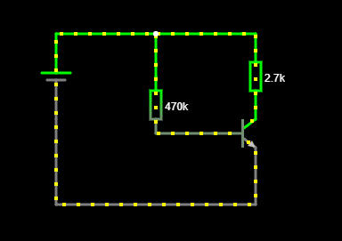

https://tinyurl.com/yr74kod2

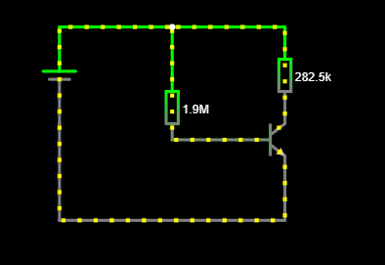

<https://tinyurl.com/ym7q69rx>

