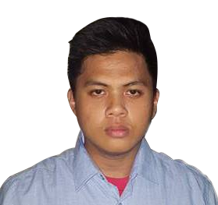**Adrian B. Guevarra**

Contact Number: Smart: 0949-669-8591

Email: Adrian.guevarra7788@gmail.com

Address: Blk3 lot 182 Northville 3 Bayugo Meycauayan city of Bulacan

**Personal Information:**

Gender: Male Age: 18

Date of Birth: August 8, 1998 Civil Status: Single

Religion: Roman Catholic Nationality: Filipino

Language can speak/s: English and Filipino

**Skills:**

* Computer Literate(VB.net, Turbo C, Java, HTML, Photoshop)
* Fast learner
* Hard working
* Work efficiently in team or individually.

**Objective:** To test and practice my knowledge and skill, and also learn and to have unforgettable memory and experience during the On-the-Job training.

**Educational Background:**

* **Meycauayan West Central School (Elementary 2004-2010)**

Hulo Meycauayan, Bulacan

* **Meycauayan College (High school 2010-2014)**

Malhacan Meycauayan, Bulacan

**Seminars Attended:**

* **Mathsama-samaTayo 2017: United by Math, United as One**

Valencia Hall, Bulacan State University (March 21, 2017)

* **Internship Orientation Seminar**

CS Audio Visual Room, Federizo Hall, Bulacan State University

(April 10, 2017)

* **Pandayang Plaridel VIII(Campus Journalism Seminar)**

Valencia Hall, Bulacan State University (March 30, 2017)

* **GMA News TV Learniversity: A Day of career talks & Learning Exhibits**

Valencia Hall, Bulacan State University (September 20, 2016)

* **Mathsama-samaTayo 2016: United by Math, United as One**

Valencia Hall, Bulacan State University (January 8, 2016)

**Reference Person:**

**Irish Baldevarona**

Internship Coordinator & Instructor – Bulacan State University

Contact: 0918-575-3526

**Marcus Louis Marcos**

Web Development Instructor – Bulacan State University

Contact: 0933-540-3005

Adrian B. Guevarra