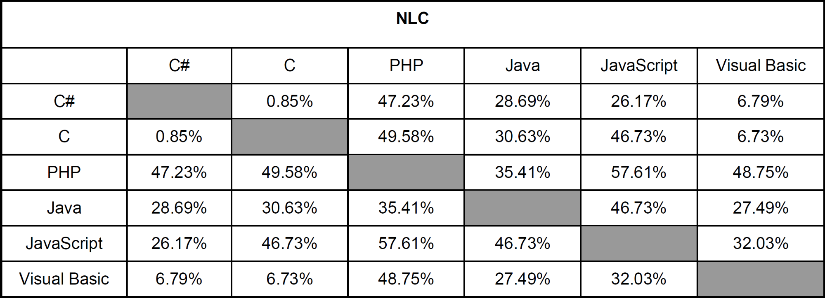

**NLC**

*C#*

PHP

Java

JavaScript

Visual Basic

***C#***

0.85%

47.23%

28.69%

26.17%

6.79%

C

0.85%

49.58%

30.63%

46.73%

6.73%

PHP

47.23%

49.58%

35.41%

57.61%

48.75%

Java

28.69%

30.63%

35.41%

46.73%

27.49%

JavaScript

26.17%

46.73%

57.61%

46.73%

32.03%

Visual Basic

6.79%

6.73%

48.75%

27.49%

32.03%