
Non-Invasive Prenatal Screening (NIPS)
Patient name | : Mrs. Kavitha Sathish (00389994) | Specimen | : Peripheral Blood
Date of Birth | : 01-02-1993 | PIN | : ADB0000037137
Gestational Age | : 16 Weeks | Sample Number | : 260552798
Pregnancy Type; status | : Natural Pregnancy; Singleton | Sample collection date | : 12-05-2026
Referring Clinician | : Dr. Ashwini | Sample received date | : 13-05-2026
Hospital/Clinic | : Tma Pai Hospital - Udupi | Report date | : 02-06-2026
This test does not reveal sex of the fetus & confers to PNDT act, 1994
Test Indication
Maternal serum marker risk
Test Performed
NIPS for 23 pairs of chromosomes (including sex chromosomal aneuploidies)
Result Summary
Screen result: Low risk | Fetal fraction: 12.87%
Aneuploidies | Results
Chromosome 21 | Low risk
Chromosome 18 | Low risk
Chromosome 13 | Low risk
Sex Chromosomes* | Low risk
Other Autosomes | Low risk



Chromosome tested | Z Score | Test result | Reference interval
Chromosome 1 | -1.06 | Low risk | -6<Z score<6
Chromosome 2 | -2.06 | Low risk | -6<Z score<6
Chromosome 3 | 0.45 | Low risk | -6<Z score<6
Chromosome 4 | -1.67 | Low risk | -6<Z score<6
Chromosome 5 | -1.36 | Low risk | -6<Z score<6
Chromosome 6 | 1.44 | Low risk | -6<Z score<6
Chromosome 7 | -2.69 | Low risk | -6<Z score<6
Chromosome 8 | 0.53 | Low risk | -6<Z score<6
Chromosome 9 | 1.46 | Low risk | -6<Z score<6
Chromosome 10 | -0.60 | Low risk | -6<Z score<6
Chromosome 11 | 1.37 | Low risk | -6<Z score<6
Chromosome 12 | -0.83 | Low risk | -6<Z score<6
Chromosome 13 | 0.04 | Low risk | -6<Z score<2.8
Chromosome 14 | -0.68 | Low risk | -6<Z score<6
Chromosome 15 | 1.27 | Low risk | -6<Z score<6
Chromosome 16 | 1.66 | Low risk | -6<Z score<6
Chromosome 17 | -1.39 | Low risk | -6<Z score<6
Chromosome 18 | 0.94 | Low risk | -6<Z score<2.8
Chromosome 19 | -0.70 | Low risk | -6<Z score<6
Chromosome 20 | 1.61 | Low risk | -6<Z score<6
Chromosome 21 | -0.21 | Low risk | -6<Z score<2.8
Chromosome 22 | 1.58 | Low risk | -6<Z score<6
*As per PCPNDT act, the reference Z scores for sex chromosomal aneuploidies will not be provided.


Interpretation and follow-up
• The results show low risk for all the autosomes and sex chromosomes.
• The fetal fraction was sufficient for analysis.
• A low risk result means that the baby has a low probability of having the condition listed in the report. The results should be communicated by the clinician with appropriate counseling.
• A low-risk result does not eliminate the possibility of aneuploidy or other genetic disorders.
• All results must be correlated with clinical findings, ultrasound, and maternal risk factors.
Diagnostic confirmation is strongly recommended if any of the below are:
Positive/high-risk NIPT
Ultrasound abnormalities
High-risk maternal age or prior affected pregnancy
No-call/low fetal fraction samples
Recommendation
• Genetic counseling is recommended.
• If ultrasound/NT scan shows any abnormality or serum markers indicate high risk, invasive testing by amniocentesis with chromosomal microarray is mandated even if NIPS is low risk.
Test Method
Maternal whole blood sample was taken from the pregnant mother after 10-week gestation with no risk to the fetus. The circulating cell-free placental DNA was isolated and purified, which was then converted into genomic DNA library using Yourgene cfDNA Library prep kit. This was followed by automated size selection of fragment lengths by QS250 for enriching fetal fraction. The enriched sample pool was subjected to high throughput sequencing using Ion GeneStudio S5 Plus™ System. Finally, analysis was performed using Sage Link V2.
Test Limitations
Test performance is valid only for full chromosomal aneuploidies involving all the autosomes and sex chromosomes with an accuracy of up to 99% for aneuploidies pertaining to chromosomes 13, 18 and 21. The method is intended for use in pregnant women who are at least 10+ weeks pregnant. The method is suitable for both singleton and twin pregnancies. The accuracy may be slightly lower in twin pregnancies due to multiple sources of fetal DNA. Patients with malignancy or a history of malignancy, patients with bone marrow or organ transplant, patients pregnant with more than 2 fetuses are not eligible for the test.
For vanishing twins, sampling must be performed 8 weeks after vanishing event. The test is not intended and not validated for mosaicism, triploidy, partial trisomy/monosomy, uniparental disomy or translocations. Other genomic abnormalities not covered by this assay may impact the phenotype.


A high risk result for twin pregnancies indicates high probability for the presence of at least one affected fetus.
Pregnant women with a low risk test result do not ensure an unaffected pregnancy as this is a screening test. Although this test is accurate, there is still a small possibility for false positive or false negative results. This may be caused by technical and/or biological limitations, including but not limited to confined placental mosaicism (CPM) or other types of mosaicism, maternal constitutional or somatic chromosomal abnormalities, residual cfDNA from a vanished twin or other rare molecular events.
This test is not a diagnostic but a screening test and results should be considered in the context of other clinical criteria. Clinical correlation with ultrasound findings, and other clinical data and tests is recommended.
If definitive diagnosis is desired, invasive prenatal testing by chorionic villus biopsy (CVS) or amniocentesis is necessary. The referral clinician is responsible for counselling before and after the test including the provision of advice regarding the need for additional invasive genetic testing.
Regulatory & Validation Notes
Test performance is based on laboratory-validated parameters; results may vary across populations and platforms. Not intended for use in multi-fetal reduction, mosaic embryo transfer, or post-transplant pregnancies.
Disclaimer
No irreversible actions should be taken based solely upon the results of this screening test. The manner in which this information is used to guide patient care is the responsibility of the health care provider, including advising for the need for genetic counseling or diagnostic testing. Any test should be interpreted in the context of all available clinical findings. As with any screening test, any positive result should be confirmed with diagnostic testing.


Test specifications
Table 1: Performance of Sage 32 NIPT workflow in singleton pregnancies
Condition | Sensitivity | Specificity | PPV | NPV | FPR | FNR
Trisomy 21 | 99% 95%CI:99.49-100% | >99% 95%CI:99.99-100% | >99.99% | 99.99% | <0.1% | 0.1%
Trisomy 18 | 99% 95%CI:96.82-99.99% | >99% 95%CI:99.99-100% | >99.99% | 99.99% | <0.1% | 0.58%
Trisomy 13 | >99% 95%CI:96.87-100% | >99% 95%CI:99.99-100% | >99.99% | >99.99% | <0.1% | <0.1%
Sex chromosomal aneuploidies | >98 % 95%CI:99.31-100% | >98% 95%CI:99.99-100% | 99.81% | >99.99% | 0.0014% | <0.01%
Other autosomal aneuploidies | >90% 95%CI:98.03-100% | >90% 95%CI:99.99-100% | >99.99% | >99.99% | <0.01% | <0.01%

PPV – Positive predictive value; NPV – Negative predictive value; FPR – False positive rate; FNR – False negative rate

Table 2: Performance of Sage 32 NIPT workflow in twin pregnancies
Condition | Sensitivity | Specificity | PPV | NPV | FPR | FNR
Trisomy 21 | >98% | >98% | >99.99% | >99.99% | <0.01% | <0.01%
Trisomy 18 | >98% | >98% | >98% | >99.99% | <0.01% | <0.01%
Trisomy 13 | >98% | >98% | >98% | >99.99% | <0.01% | <0.01%
Sex chromosomal  aneuploidies | >97% | >97% | >97% | >99.99% | 0.0014% | <0.01%
Other autosomal  aneuploidies | >95% | >95% | >95% | >99.99% | <0.01% | <0.01%

PPV – Positive predictive value; NPV – Negative predictive value; FPR – False positive rate; FNR – False negative rate


Prenatal Testing Algorithm
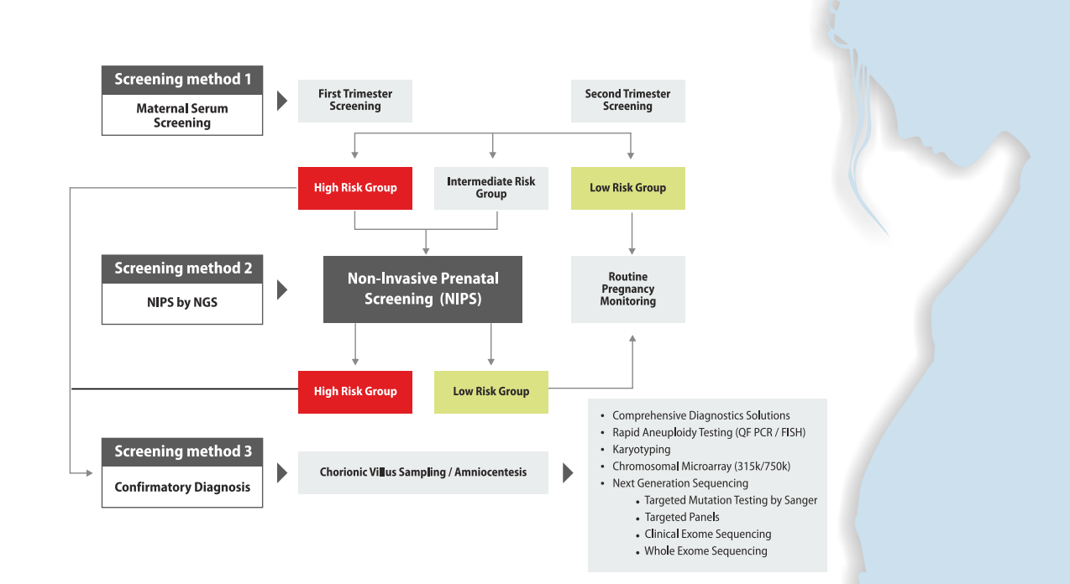
References
1. Bianchi DW, Platt LD, Goldberg JD, Abuhamad AZ, Sehnert AJ, Rava RP. Genome-wide fetal aneuploidy detection by maternal plasma DNA sequencing. Obstetrics & Gynecology. 2012 May 1;119(5):890-901.
2. Chiu RW, Akolekar R, Zheng YW, Leung TY, Sun H, Chan KA, Lun FM, Go AT, Lau ET, To WW, Leung WC. Non-invasive prenatal assessment of trisomy 21 by multiplexed maternal plasma DNA sequencing: large scale validity study. Bmj. 2011 Jan 11;342:c7401.
3. Chiu RW, Lo YM. Noninvasive prenatal diagnosis empowered by high‐throughput sequencing. Prenatal diagnosis. 2012 Apr 1;32(4):401-6.
4. Dugoff L. Cell-Free DNA Screening for Fetal Aneuploidy. Topics in Obstetrics & Gynecology. 2017 Jan 15;37(1):1-7.
This report has been reviewed and approved by:
 | 
Dr. Sachin D. Honguntikar | Dr. Suriyakumar.G
Head – Anderson Clinical Genetics | Director

