PARCIAL FINAL TEORICO

PRESENTADO POR:

JUAN CAMILO BAZURTO ARIAS

PRESENTADO A:

SEBASTIAN CAMILO MARTINEZ REYES

ESCUELA COLOMBIANA DE INGENIERÍA JULIO GARAVITO

ALGORITMOS Y ESTRUCTURAS DE DATOS

PROGRAMA DE INGENIERÍA DE SISTEMAS

BOGOTÁ D.C.

2021 – 1

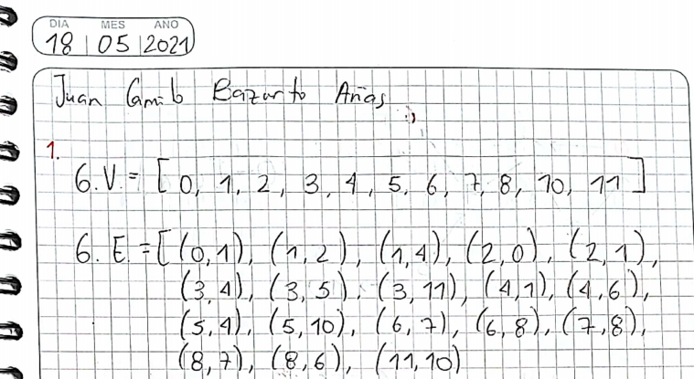

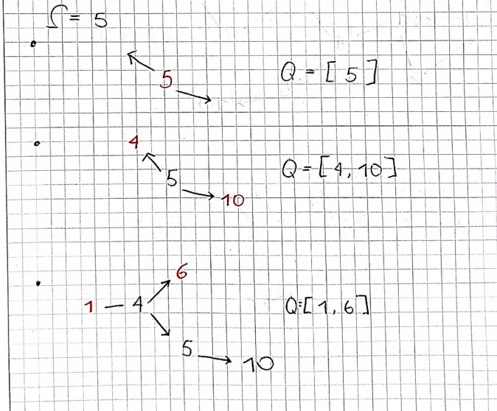

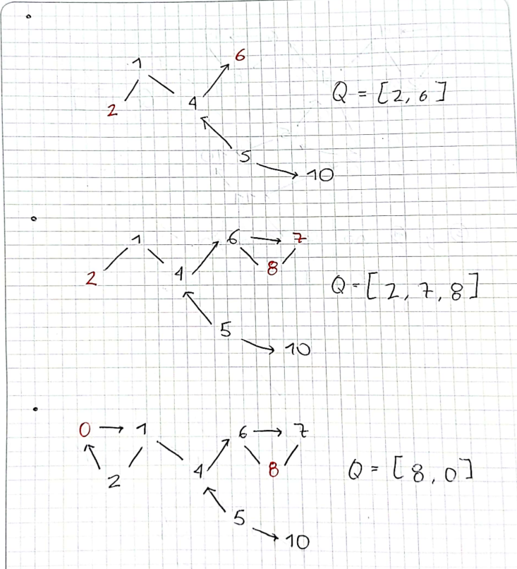

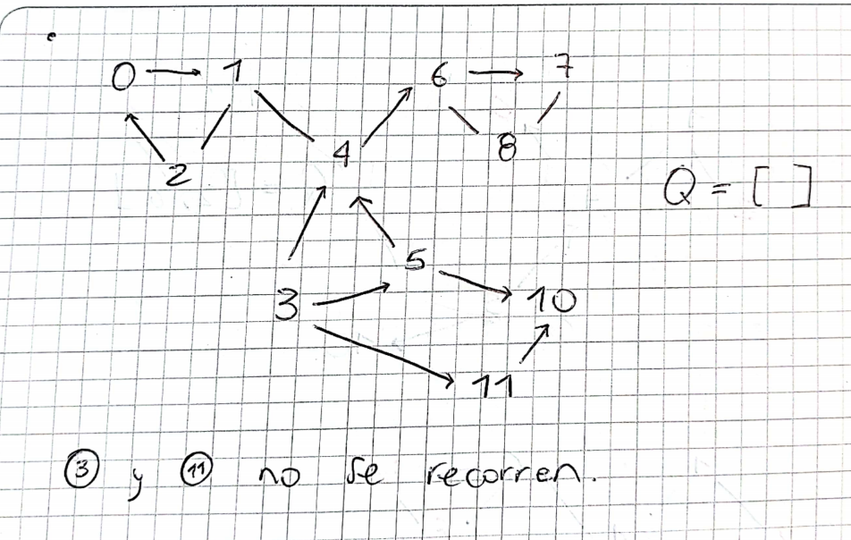

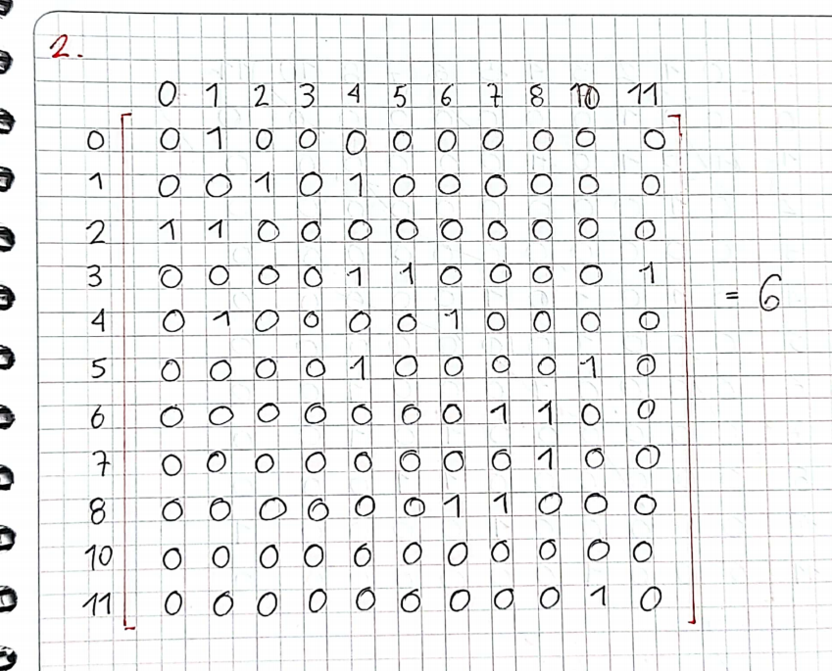

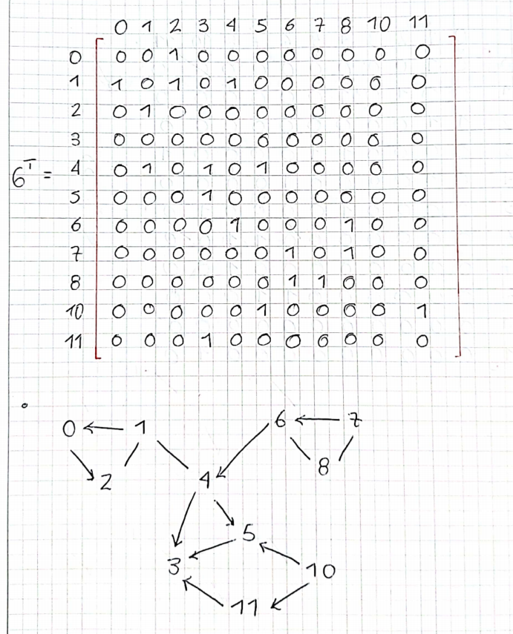

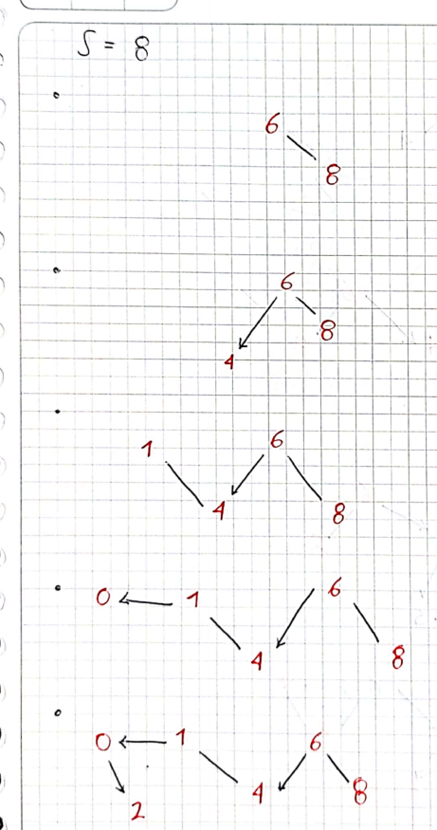

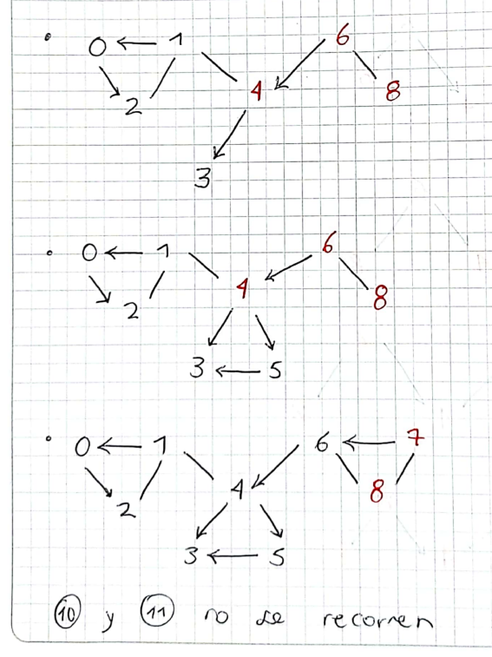

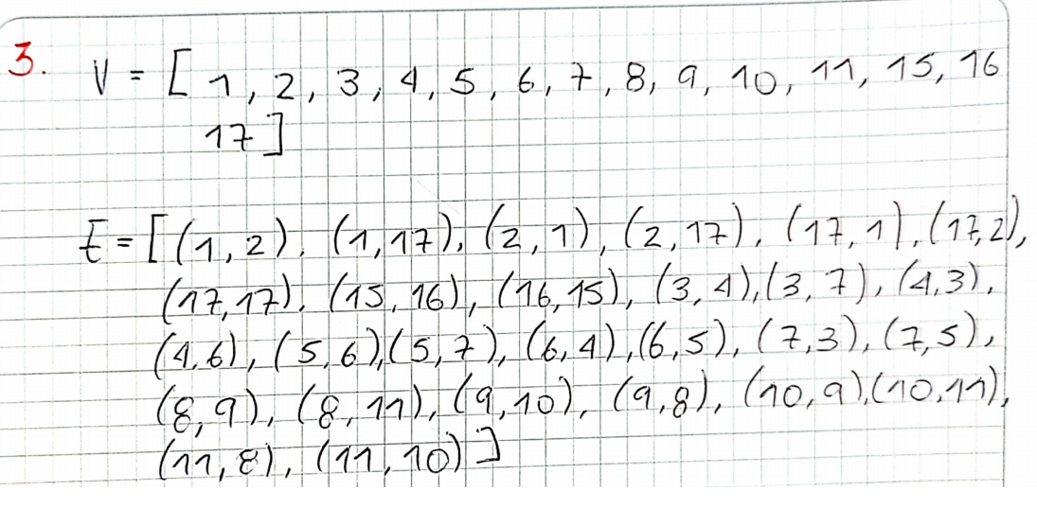

* {1}{2}{3}{4}{5}{6}{7}{8}{9}{10}{11}{15}{16}{17}

(15,16)

* {1}{2}{3}{4}{5}{6}{7}{8}{9}{10}{11}{15, 16}{17}

(1, 17)

* {1, 17}{2}{3}{4}{5}{6}{7}{8}{9}{10}{11}{15, 16}

(1, 2) (17, 2)

* {1, 2, 17}{3}{4}{5}{6}{7}{8}{9}{10}{11}{15, 16}

(3, 4)

* {1, 2, 17}{3, 4}{5}{6}{7}{8}{9}{10}{11}{15, 16}

(4, 6)

* {1, 2, 17}{3, 4, 6}{5}{7}{8}{9}{10}{11}{15, 16}

(6, 5)

* {1, 2, 17}{3, 4, 5, 6}{7}{8}{9}{10}{11}{15, 16}

(3, 7) (5, 7)

* {1, 2, 17}{3, 4, 5, 6, 7}{8}{9}{10}{11}{15, 16}

(8, 9)

* {1, 2, 17}{3, 4, 5, 6, 7}{8, 9}{10}{11}{15, 16}

(9, 10)

* {1, 2, 17}{3, 4, 5, 6, 7}{8, 9, 10}{11}{15, 16}

(8, 11) (10, 11)

* {1, 2, 17}{3, 4, 5, 6, 7}{8, 9, 10, 11}{15, 16}

1. CAMINOS MINIMOS.

* S a T:

[S, Y, T]

Peso: 8

* S a X:

[S, Y, T, X]

Peso: 9

* S a Y:

[S, Y]

Peso: 5

* S a Z:

[S, Y, Z]

Peso: 7

1. CAMINOS MINIMOS DESDE S = 0.

* 0 a 1:  
  [0, 1]  
  Peso: 5
* 0 a 2:  
  [0, 1, 2]  
  Peso: 6
* 0 a 3:  
  [0, 1, 6, 5, 3]  
  Peso: 9
* 0 a 4:  
  [0, 1, 6, 5, 4]  
  Peso: 9
* 0 a 5:  
  [0, 1, 6, 5]  
  Peso: 7
* 0 a 6:  
  [0, 1, 6]  
  Peso: 7