Nombre: Juan Camilo Bazurto Arias

Ejercicios Iteración.

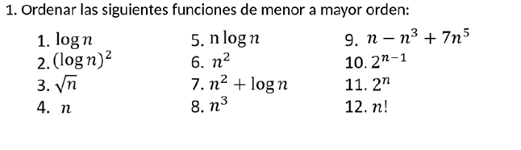

2.

Function mystery(n) # Cost Times  
 r := 0 # C1 1  
 for i := 1 to n – 1 do # C2 n-1  
 for j := i + 1 to n do # C3 n  
 for k := 1 to j do # C4 n  
 r := r + 1 # C5 n-1  
 return r # C6 1

#n^3-n^2+n-1 ---> O(n^3)

Function pesky(n) # Cost Times  
 r := 0 # C1 1  
 for i := 1 to n do # C2 n  
 for j := 1 to i do # C3 n  
 for k := j to i + j do # C4 n  
 r := r + 1 # C5 n-1  
 return r # C6 1  
  
# n ^ 3 + n + 1 ---> O(n^3)

Function prestiferous(n) # Cost Times  
 r := 0 # C1 1  
 for i := 1 to n do # C2 n  
 for j := 1 to i do # C3 n  
 for k := 1 to i + j do # C4 2n  
 for l := 1 to i + j – k do# C5 n  
 r := r + 1 # C6 n-1  
 return r # C7 1  
  
#2n^4 + n + 1 ---> O(n^4)

3.