**ELC (Estée Lauder Companies) – Azure Policy Integration with Azure DevOps - Proof of Concept (POC)**

**Submitted to**

**By**

**Wipro Technologies**

**1-10-2024**

**Revision History**

|  |  |  |  |  |
| --- | --- | --- | --- | --- |
| **Version** | **Date of Revision** | **Description of Change** | **Reason for Change** | **Reviewed By** |
| 1.1 |  | Initial Draft | NA | Siva ande |
|  |  |  |  |  |
|  |  |  |  |  |

**Author/Reviewer/Approvals**

|  |  |  |  |
| --- | --- | --- | --- |
| **Name** | **Designation** | **Responsibility** | **Date** |
|  |  |  |  |
|  |  |  |  |
|  |  |  |  |
|  |  |  |  |

**Git Summary: -**

Git is a distributed version control system designed to handle everything from small to very large projects with speed and efficiency. It helps you keep track of code changes, collaborate with other developers, and manage different versions of your codebase.

By following below link we can login into Git by mentioning our Credentials.

[Sign in to Estee Lauder](https://github.com/elc-digital)

After login we can check our repositories by following below page,

Please refer, below screenshot to check cloud security team repositories,

We can refer multiple branches by following below page,

We can Create a new repository and push the source code files and folders into Azure Repos also by below link, [ELC-CloudSecurityTeam Project - Repos](https://elcdevops.visualstudio.com/_git/ELC-CloudSecurityTeam%20Project)

We can login by using azure repos into GitHub by following below page,

Create a new Project under new organization,

**By following below link we can see the policy definition code,** [**assign-policyDef.ps1 - Repos**](https://elcdevops.visualstudio.com/_git/ELC-CloudSecurityTeam%20Project?path=/scripts/assign-policyDef.ps1&version=GBPolicy_definition&_a=contents)

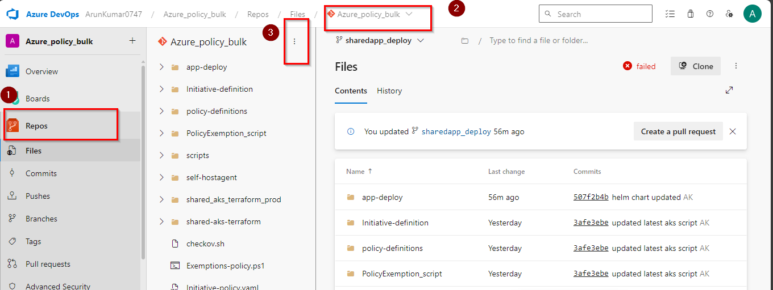

Click on new option for to create the pipeline.

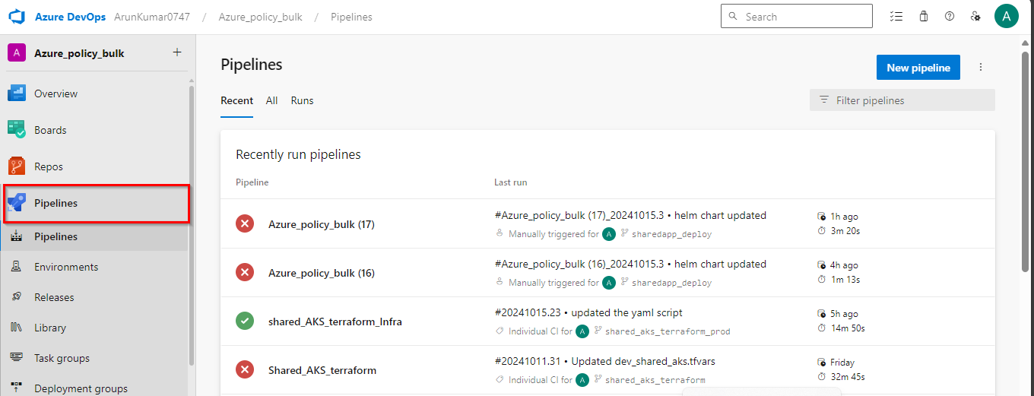

We can see the policy definitions pipelines,

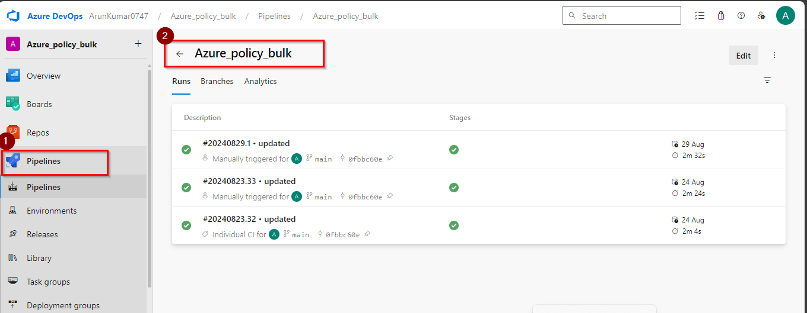

**Service Principle in Azure & Service Principle in Azure DevOps**

Azure service principal is a security identity used by user-created apps, services, and automation tools to access specific Azure resources. Think of it as a 'user identity' (login and password or certificate) with a specific role, and tightly controlled permissions to access your resources. It only needs to be able to do specific things, unlike a general user identity. It improves security if you only grant it the minimum permissions level needed to perform its management tasks.

To make the integration between Azure Pipelines and Azure cloud, we need to setup what is called service connection. there are multiple service connections available on Azure DevOps, but for our purpose we are talking about the Azure Resource Manager (ARM) Service Connection. We need Service principal details from azure like Client ID, App ID, Tenant ID, to establish a connection from Azure DevOps Pipelines to Azure.

1. **Steps to create the Service Principle in Azure and Azure DevOps**
2. Login into Azure Portal <https://portal.azure.com/>
3. Click on Azure Cloud Shell and execute the command “az ad sp create-for-rbac -n “your app name””.

1. Copy and paste all the Credentials at one place.

1. Open azure devops portal and select the project to create the service principle to establish a service connection between azure devops and azure portal.

V. Click on service connection under the project settings.

Vi . Please fill the details service connection details below.

