Replication:
Stopping MongoDB service on Port:27017
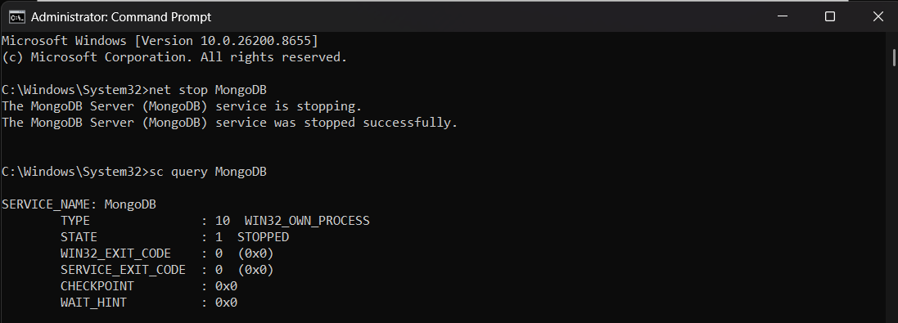
Creating the data folder which db0, db1, db2 folders
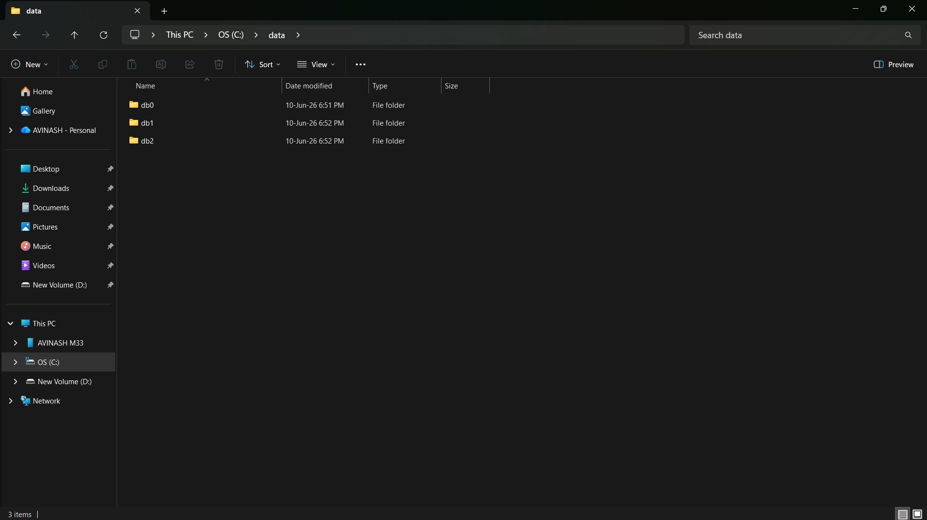

Running three MongoDB instances db0, db1, db2 on separate cmd
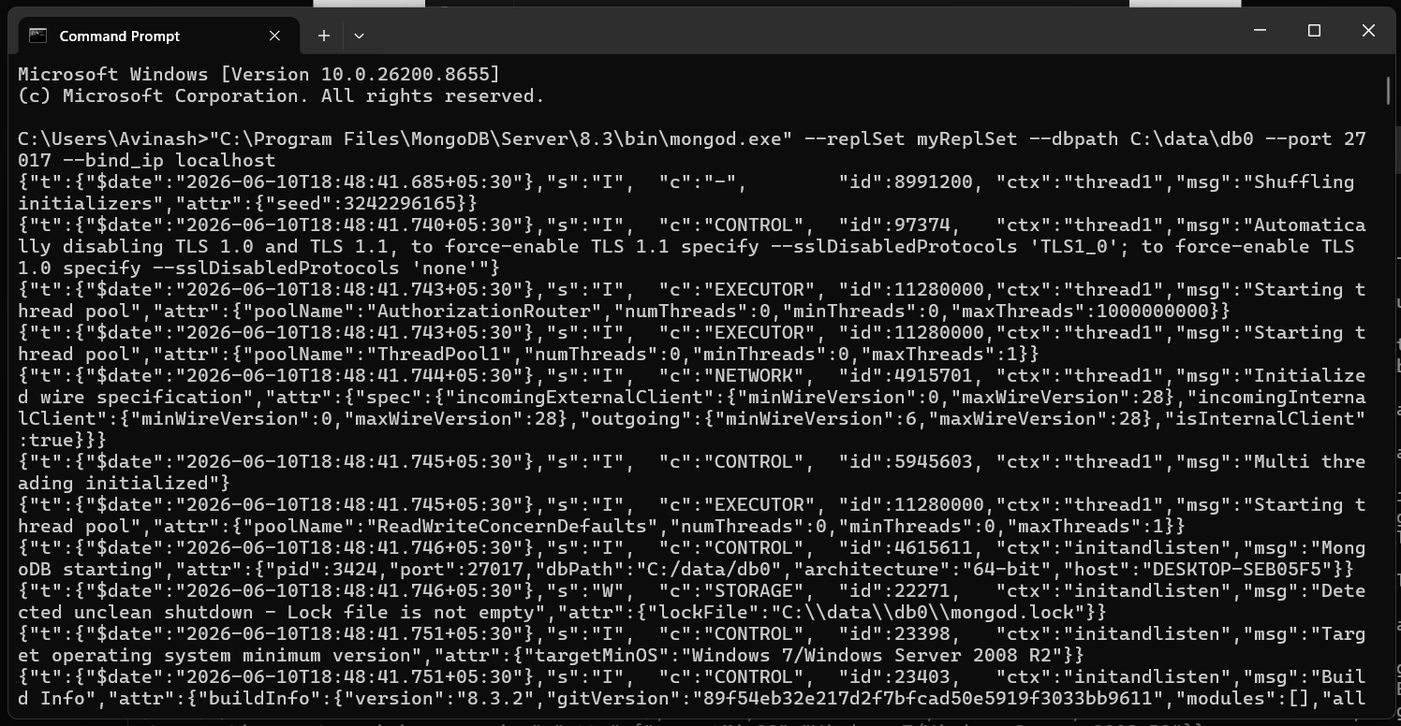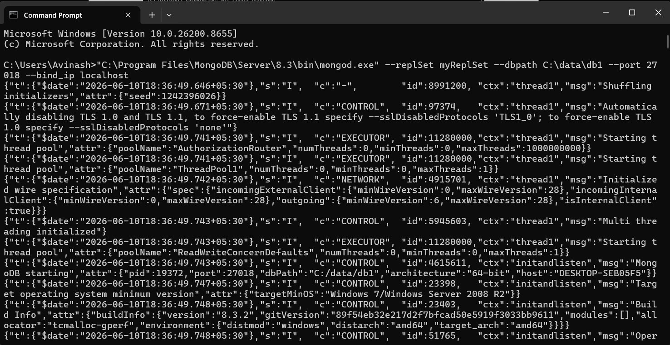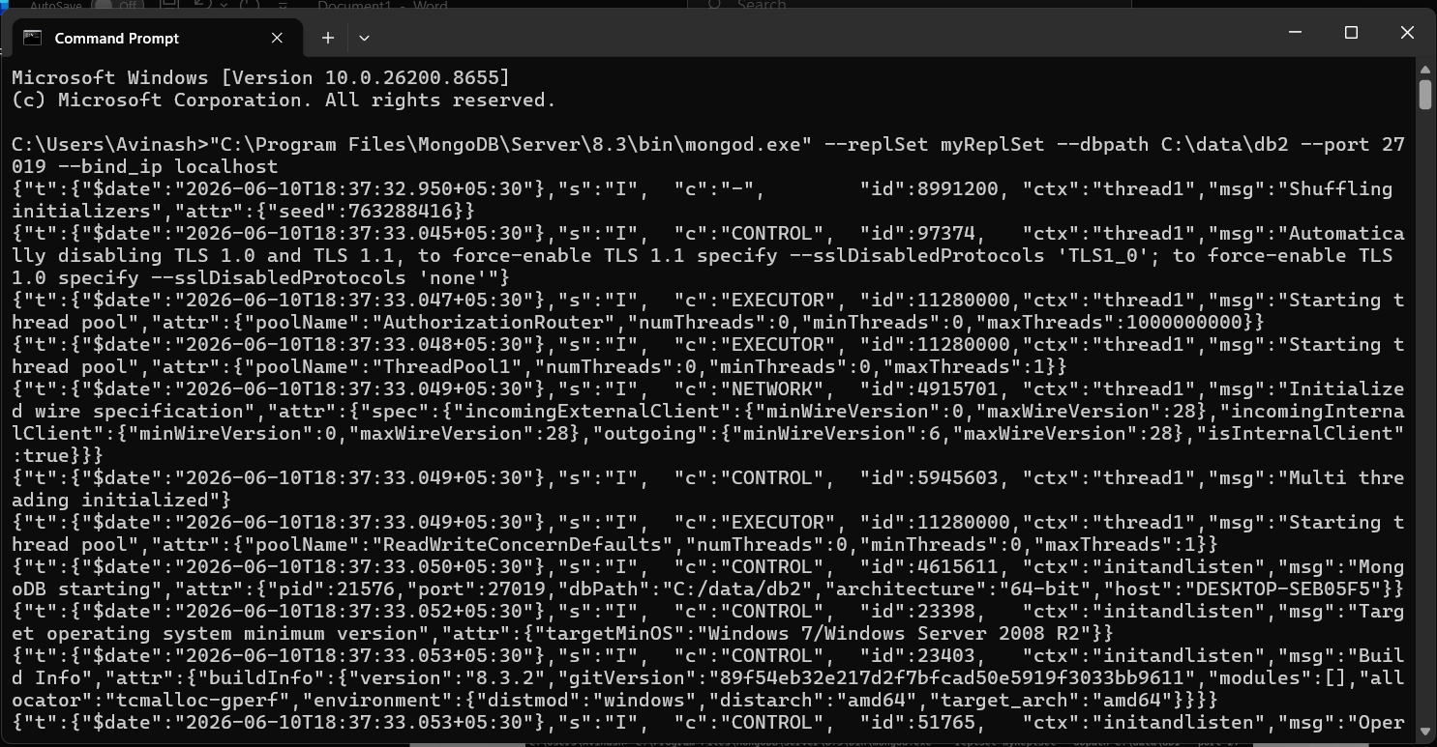
Setting up the MongoDB connection at port:27017
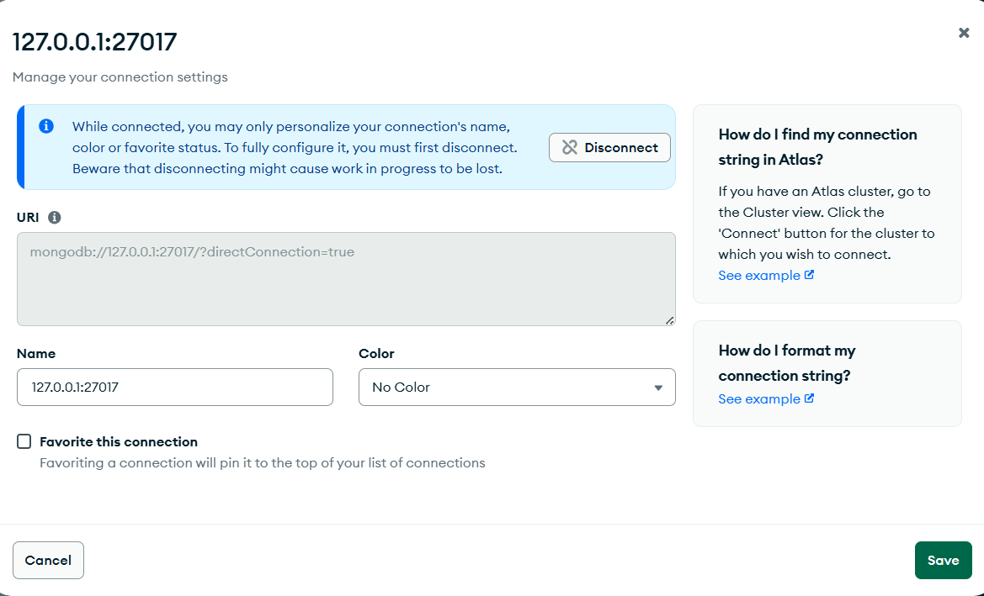
Creating the replicas
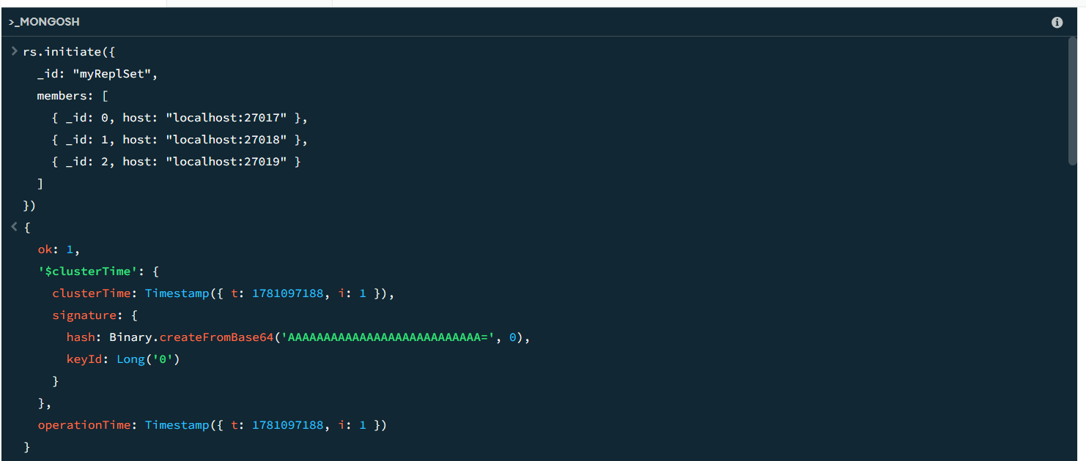

Checking the status of the replicas
{
configVersion: 1,
configTerm: 1,
self: true,
lastHeartbeatMessage: ''
},
{
_id: 1,
name: 'localhost:27018',
health: 1,
state: 2,
stateStr: 'SECONDARY',
uptime: 16,
optime: { ts: Timestamp({ t: 1781097200, i: 17 }), t: Long('1') },
optimeDurable: { ts: Timestamp({ t: 1781097200, i: 17 }), t: Long('1') },
optimeWritten: { ts: Timestamp({ t: 1781097200, i: 17 }), t: Long('1') },
optimeDate: 2026-06-10T13:13:20.000Z,
optimeDurableDate: 2026-06-10T13:13:20.000Z,
optimeWrittenDate: 2026-06-10T13:13:20.000Z,
lastAppliedWallTime: 2026-06-10T13:13:20.448Z,
lastDurableWallTime: 2026-06-10T13:13:20.448Z,
lastWrittenWallTime: 2026-06-10T13:13:20.448Z,
lastHeartbeat: 2026-06-10T13:13:24.243Z,
lastHeartbeatRecv: 2026-06-10T13:13:25.272Z,
pingMs: Long('0'),
lastHeartbeatMessage: '',
syncSourceHost: 'localhost:27017',
syncSourceId: 0,
infoMessage: '',
configVersion: 1,
configTerm: 1
},
{
_id: 2,
name: 'localhost:27019',
health: 1,
state: 2,
stateStr: 'SECONDARY',
uptime: 16,
optime: { ts: Timestamp({ t: 1781097200, i: 17 }), t: Long('1') },
optimeDurable: { ts: Timestamp({ t: 1781097200, i: 17 }), t: Long('1') },
optimeWritten: { ts: Timestamp({ t: 1781097200, i: 17 }), t: Long('1') },
optimeDate: 2026-06-10T13:13:20.000Z,
optimeDurableDate: 2026-06-10T13:13:20.000Z,
optimeWrittenDate: 2026-06-10T13:13:20.000Z,
lastAppliedWallTime: 2026-06-10T13:13:20.448Z,
lastDurableWallTime: 2026-06-10T13:13:20.448Z,
lastWrittenWallTime: 2026-06-10T13:13:20.448Z,
lastHeartbeat: 2026-06-10T13:13:24.256Z,
lastHeartbeatRecv: 2026-06-10T13:13:25.290Z,
pingMs: Long('0'),
lastHeartbeatMessage: '',
syncSourceHost: 'localhost:27017',
syncSourceId: 0,
infoMessage: '',
configVersion: 1,
configTerm: 1
}
],
ok: 1,
'$clusterTime': {
clusterTime: Timestamp({ t: 1781097200, i: 17 }),
signature: {
hash: Binary.createFromBase64('AAAAAAAAAAAAAAAAAAAAAAAAAAA=', 0),
keyId: Long('0')
}
},
operationTime: Timestamp({ t: 1781097200, i: 17 })
}

Testing replication
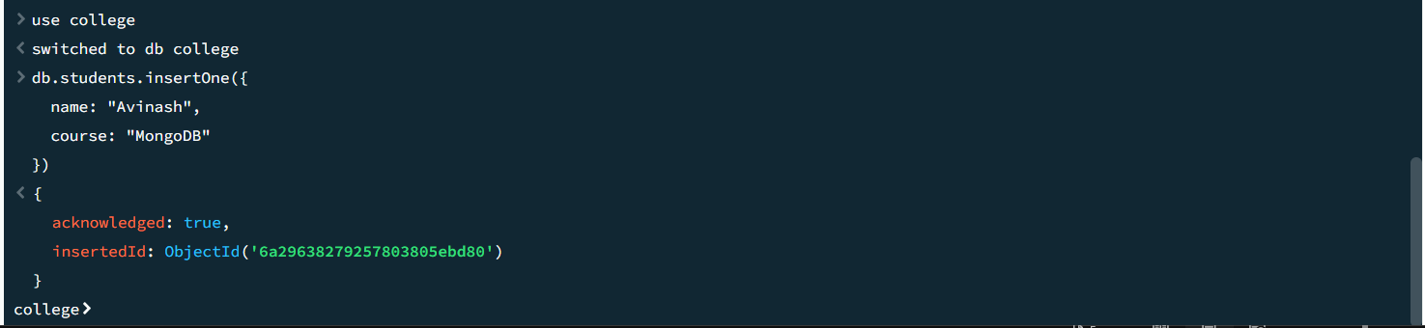

Verifying on Secondary
First connecting to compass
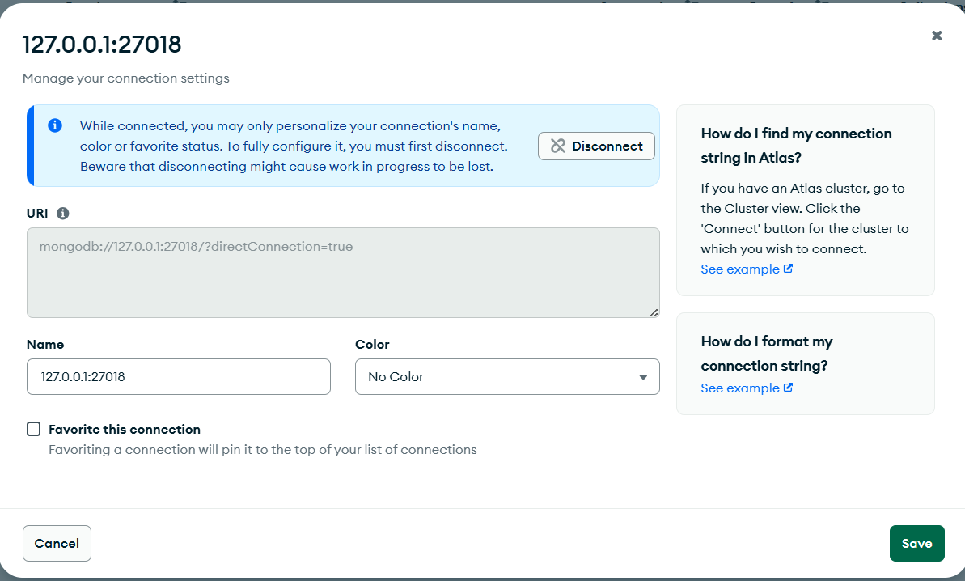

Checking for the data in replica Set
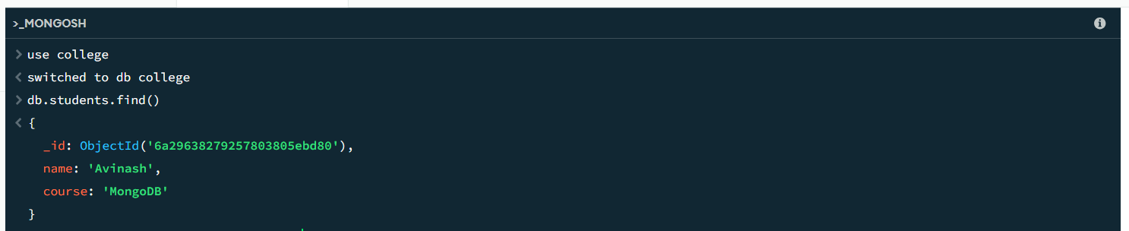
Killing the primary Window by closing it. Then, running re.status()
The primary’ health becomes and one of the secondary becomes the primary

{
set: 'myReplSet',
date: 2026-06-10T13:44:06.394Z,
myState: 1,
term: Long('4'),
syncSourceHost: '',
syncSourceId: -1,
heartbeatIntervalMillis: Long('2000'),
majorityVoteCount: 2,
writeMajorityCount: 2,
votingMembersCount: 3,
writableVotingMembersCount: 3,
optimes: {
lastCommittedOpTime: { ts: Timestamp({ t: 1781099046, i: 1 }), t: Long('4') },
lastCommittedWallTime: 2026-06-10T13:44:06.051Z,
readConcernMajorityOpTime: { ts: Timestamp({ t: 1781099046, i: 1 }), t: Long('4') },
appliedOpTime: { ts: Timestamp({ t: 1781099046, i: 1 }), t: Long('4') },
durableOpTime: { ts: Timestamp({ t: 1781099046, i: 1 }), t: Long('4') },
writtenOpTime: { ts: Timestamp({ t: 1781099046, i: 1 }), t: Long('4') },
lastAppliedWallTime: 2026-06-10T13:44:06.051Z,
lastDurableWallTime: 2026-06-10T13:44:06.051Z,
lastWrittenWallTime: 2026-06-10T13:44:06.051Z
},
lastStableRecoveryTimestamp: Timestamp({ t: 1781099016, i: 1 }),
electionCandidateMetrics: {
lastElectionReason: 'stepUpRequestSkipDryRun',
lastElectionDate: 2026-06-10T13:42:55.972Z,
electionTerm: Long('4'),
lastCommittedOpTimeAtElection: { ts: Timestamp({ t: 1781098966, i: 1 }), t: Long('3') },
lastSeenWrittenOpTimeAtElection: { ts: Timestamp({ t: 1781098966, i: 1 }), t: Long('3') },
lastSeenOpTimeAtElection: { ts: Timestamp({ t: 1781098966, i: 1 }), t: Long('3') },
numVotesNeeded: 2,
priorityAtElection: 1,
electionTimeoutMillis: Long('10000'),
priorPrimaryMemberId: 0,
numCatchUpOps: Long('0'),
newTermStartDate: 2026-06-10T13:42:55.997Z,
wMajorityWriteAvailabilityDate: 2026-06-10T13:42:56.027Z
},
electionParticipantMetrics: {
votedForCandidate: true,
electionTerm: Long('3'),
lastVoteDate: 2026-06-10T13:39:44.493Z,
electionCandidateMemberId: 0,
voteReason: '',
lastWrittenOpTimeAtElection: { ts: Timestamp({ t: 1781097722, i: 1 }), t: Long('2') },
maxWrittenOpTimeInSet: { ts: Timestamp({ t: 1781097722, i: 1 }), t: Long('2') },
lastAppliedOpTimeAtElection: { ts: Timestamp({ t: 1781097722, i: 1 }), t: Long('2') },
maxAppliedOpTimeInSet: { ts: Timestamp({ t: 1781097722, i: 1 }), t: Long('2') },
priorityAtElection: 1
},
members: [
{
_id: 0,
name: 'localhost:27017',
health: 0,
state: 8,
stateStr: '(not reachable/healthy)',
uptime: 0,
optime: { ts: Timestamp({ t: 0, i: 0 }), t: Long('-1') },
optimeDurable: { ts: Timestamp({ t: 0, i: 0 }), t: Long('-1') },
optimeWritten: { ts: Timestamp({ t: 0, i: 0 }), t: Long('-1') },
optimeDate: 1970-01-01T00:00:00.000Z,
optimeDurableDate: 1970-01-01T00:00:00.000Z,
optimeWrittenDate: 1970-01-01T00:00:00.000Z,
lastAppliedWallTime: 2026-06-10T13:42:55.997Z,
lastDurableWallTime: 2026-06-10T13:42:55.997Z,
lastWrittenWallTime: 2026-06-10T13:42:55.997Z,
lastHeartbeat: 2026-06-10T13:44:05.442Z,
lastHeartbeatRecv: 2026-06-10T13:43:00.509Z,
pingMs: Long('0'),
lastHeartbeatMessage: 'Error connecting to localhost:27017 (127.0.0.1:27017) :: caused by :: onInvoke :: caused by :: No connection could be made because the target machine actively refused it.',
syncSourceHost: '',
syncSourceId: -1,
infoMessage: '',
configVersion: 1,
configTerm: 4
},
{
_id: 1,
name: 'localhost:27018',
health: 1,
state: 1,
stateStr: 'PRIMARY',
uptime: 268,
optime: { ts: Timestamp({ t: 1781099046, i: 1 }), t: Long('4') },
optimeDate: 2026-06-10T13:44:06.000Z,
optimeWritten: { ts: Timestamp({ t: 1781099046, i: 1 }), t: Long('4') },
optimeWrittenDate: 2026-06-10T13:44:06.000Z,
lastAppliedWallTime: 2026-06-10T13:44:06.051Z,
lastDurableWallTime: 2026-06-10T13:44:06.051Z,
lastWrittenWallTime: 2026-06-10T13:44:06.051Z,
syncSourceHost: '',
syncSourceId: -1,
infoMessage: '',
electionTime: Timestamp({ t: 1781098975, i: 1 }),
electionDate: 2026-06-10T13:42:55.000Z,
configVersion: 1,
configTerm: 4,
self: true,
lastHeartbeatMessage: ''
},
{
_id: 2,
name: 'localhost:27019',
health: 1,
state: 2,
stateStr: 'SECONDARY',
uptime: 258,
optime: { ts: Timestamp({ t: 1781099046, i: 1 }), t: Long('4') },
optimeDurable: { ts: Timestamp({ t: 1781099046, i: 1 }), t: Long('4') },
optimeWritten: { ts: Timestamp({ t: 1781099046, i: 1 }), t: Long('4') },
optimeDate: 2026-06-10T13:44:06.000Z,
optimeDurableDate: 2026-06-10T13:44:06.000Z,
optimeWrittenDate: 2026-06-10T13:44:06.000Z,
lastAppliedWallTime: 2026-06-10T13:44:06.051Z,
lastDurableWallTime: 2026-06-10T13:44:06.051Z,
lastWrittenWallTime: 2026-06-10T13:44:06.051Z,
lastHeartbeat: 2026-06-10T13:44:06.349Z,
lastHeartbeatRecv: 2026-06-10T13:44:04.881Z,
pingMs: Long('0'),
lastHeartbeatMessage: '',
syncSourceHost: 'localhost:27018',
syncSourceId: 1,
infoMessage: '',
configVersion: 1,
configTerm: 4
}
],
ok: 1,
'$clusterTime': {
clusterTime: Timestamp({ t: 1781099046, i: 1 }),
signature: {
hash: Binary.createFromBase64('AAAAAAAAAAAAAAAAAAAAAAAAAAA=', 0),
keyId: Long('0')
}
},
operationTime: Timestamp({ t: 1781099046, i: 1 })
}

Restarting the old primary with the same command and running rs.status()
The old primary becomes secondary and the current primary remains the same

{
set: 'myReplSet',
date: 2026-06-10T13:47:33.096Z,
myState: 1,
term: Long('4'),
syncSourceHost: '',
syncSourceId: -1,
heartbeatIntervalMillis: Long('2000'),
majorityVoteCount: 2,
writeMajorityCount: 2,
votingMembersCount: 3,
writableVotingMembersCount: 3,
optimes: {
lastCommittedOpTime: { ts: Timestamp({ t: 1781099246, i: 1 }), t: Long('4') },
lastCommittedWallTime: 2026-06-10T13:47:26.226Z,
readConcernMajorityOpTime: { ts: Timestamp({ t: 1781099246, i: 1 }), t: Long('4') },
appliedOpTime: { ts: Timestamp({ t: 1781099246, i: 1 }), t: Long('4') },
durableOpTime: { ts: Timestamp({ t: 1781099246, i: 1 }), t: Long('4') },
writtenOpTime: { ts: Timestamp({ t: 1781099246, i: 1 }), t: Long('4') },
lastAppliedWallTime: 2026-06-10T13:47:26.226Z,
lastDurableWallTime: 2026-06-10T13:47:26.226Z,
lastWrittenWallTime: 2026-06-10T13:47:26.226Z
},
lastStableRecoveryTimestamp: Timestamp({ t: 1781099196, i: 1 }),
electionCandidateMetrics: {
lastElectionReason: 'stepUpRequestSkipDryRun',
lastElectionDate: 2026-06-10T13:42:55.972Z,
electionTerm: Long('4'),
lastCommittedOpTimeAtElection: { ts: Timestamp({ t: 1781098966, i: 1 }), t: Long('3') },
lastSeenWrittenOpTimeAtElection: { ts: Timestamp({ t: 1781098966, i: 1 }), t: Long('3') },
lastSeenOpTimeAtElection: { ts: Timestamp({ t: 1781098966, i: 1 }), t: Long('3') },
numVotesNeeded: 2,
priorityAtElection: 1,
electionTimeoutMillis: Long('10000'),
priorPrimaryMemberId: 0,
numCatchUpOps: Long('0'),
newTermStartDate: 2026-06-10T13:42:55.997Z,
wMajorityWriteAvailabilityDate: 2026-06-10T13:42:56.027Z
},
electionParticipantMetrics: {
votedForCandidate: true,
electionTerm: Long('3'),
lastVoteDate: 2026-06-10T13:39:44.493Z,
electionCandidateMemberId: 0,
voteReason: '',
lastWrittenOpTimeAtElection: { ts: Timestamp({ t: 1781097722, i: 1 }), t: Long('2') },
maxWrittenOpTimeInSet: { ts: Timestamp({ t: 1781097722, i: 1 }), t: Long('2') },
lastAppliedOpTimeAtElection: { ts: Timestamp({ t: 1781097722, i: 1 }), t: Long('2') },
maxAppliedOpTimeInSet: { ts: Timestamp({ t: 1781097722, i: 1 }), t: Long('2') },
priorityAtElection: 1
},
members: [
{
_id: 0,
name: 'localhost:27017',
health: 1,
state: 2,
stateStr: 'SECONDARY',
uptime: 12,
optime: { ts: Timestamp({ t: 1781099246, i: 1 }), t: Long('4') },
optimeDurable: { ts: Timestamp({ t: 1781099246, i: 1 }), t: Long('4') },
optimeWritten: { ts: Timestamp({ t: 1781099246, i: 1 }), t: Long('4') },
optimeDate: 2026-06-10T13:47:26.000Z,
optimeDurableDate: 2026-06-10T13:47:26.000Z,
optimeWrittenDate: 2026-06-10T13:47:26.000Z,
lastAppliedWallTime: 2026-06-10T13:47:26.226Z,
lastDurableWallTime: 2026-06-10T13:47:26.226Z,
lastWrittenWallTime: 2026-06-10T13:47:26.226Z,
lastHeartbeat: 2026-06-10T13:47:32.304Z,
lastHeartbeatRecv: 2026-06-10T13:47:31.606Z,
pingMs: Long('0'),
lastHeartbeatMessage: '',
syncSourceHost: 'localhost:27018',
syncSourceId: 1,
infoMessage: '',
configVersion: 1,
configTerm: 4
},
{
_id: 1,
name: 'localhost:27018',
health: 1,
state: 1,
stateStr: 'PRIMARY',
uptime: 475,
optime: { ts: Timestamp({ t: 1781099246, i: 1 }), t: Long('4') },
optimeDate: 2026-06-10T13:47:26.000Z,
optimeWritten: { ts: Timestamp({ t: 1781099246, i: 1 }), t: Long('4') },
optimeWrittenDate: 2026-06-10T13:47:26.000Z,
lastAppliedWallTime: 2026-06-10T13:47:26.226Z,
lastDurableWallTime: 2026-06-10T13:47:26.226Z,
lastWrittenWallTime: 2026-06-10T13:47:26.226Z,
syncSourceHost: '',
syncSourceId: -1,
infoMessage: '',
electionTime: Timestamp({ t: 1781098975, i: 1 }),
electionDate: 2026-06-10T13:42:55.000Z,
configVersion: 1,
configTerm: 4,
self: true,
lastHeartbeatMessage: ''
},
{
_id: 2,
name: 'localhost:27019',
health: 1,
state: 2,
stateStr: 'SECONDARY',
uptime: 465,
optime: { ts: Timestamp({ t: 1781099246, i: 1 }), t: Long('4') },
optimeDurable: { ts: Timestamp({ t: 1781099246, i: 1 }), t: Long('4') },
optimeWritten: { ts: Timestamp({ t: 1781099246, i: 1 }), t: Long('4') },
optimeDate: 2026-06-10T13:47:26.000Z,
optimeDurableDate: 2026-06-10T13:47:26.000Z,
optimeWrittenDate: 2026-06-10T13:47:26.000Z,
lastAppliedWallTime: 2026-06-10T13:47:26.226Z,
lastDurableWallTime: 2026-06-10T13:47:26.226Z,
lastWrittenWallTime: 2026-06-10T13:47:26.226Z,
lastHeartbeat: 2026-06-10T13:47:31.305Z,
lastHeartbeatRecv: 2026-06-10T13:47:31.775Z,
pingMs: Long('0'),
lastHeartbeatMessage: '',
syncSourceHost: 'localhost:27018',
syncSourceId: 1,
infoMessage: '',
configVersion: 1,
configTerm: 4
}
],
ok: 1,
'$clusterTime': {
clusterTime: Timestamp({ t: 1781099246, i: 1 }),
signature: {
hash: Binary.createFromBase64('AAAAAAAAAAAAAAAAAAAAAAAAAAA=', 0),
keyId: Long('0')
}
},
operationTime: Timestamp({ t: 1781099246, i: 1 })
Clean Shutdown
In each mongod window:
Ctrl + C

After all three stop:
net start MongoDB

to return to your normal MongoDB setup.
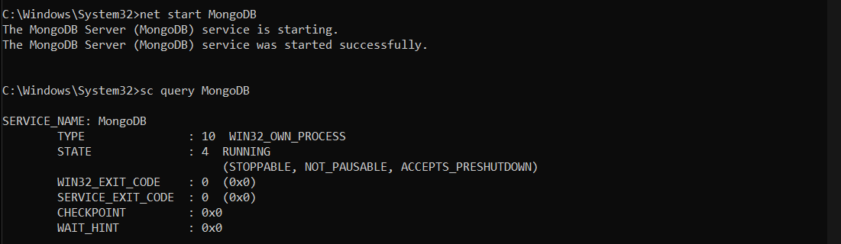
Sharding:
Stop MongoDB service:
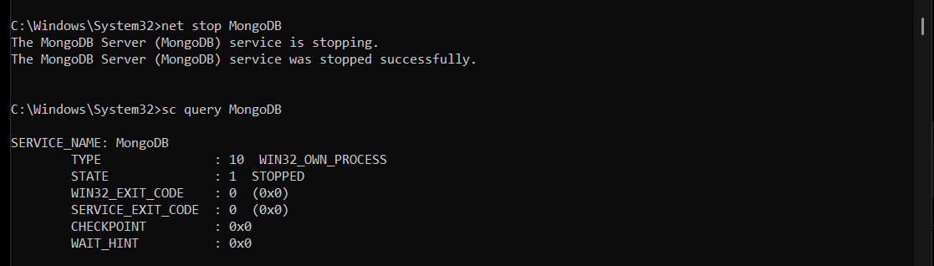
Then create data folder and in that create config, shard1, shard2
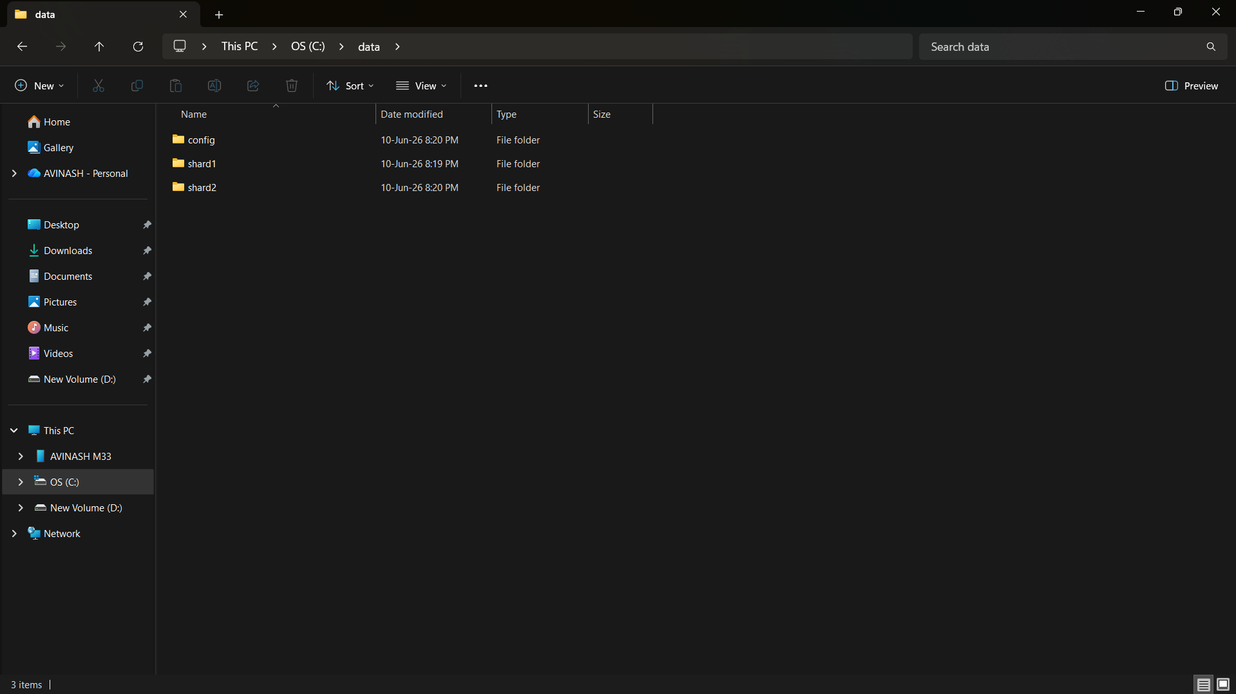
Start Config Server
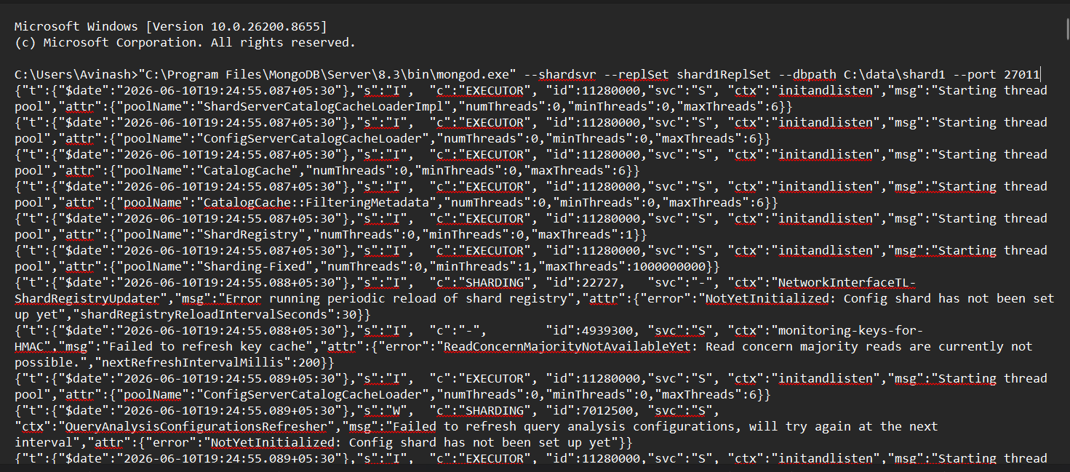
Connect to MongoDB and run the initialize command in the shell
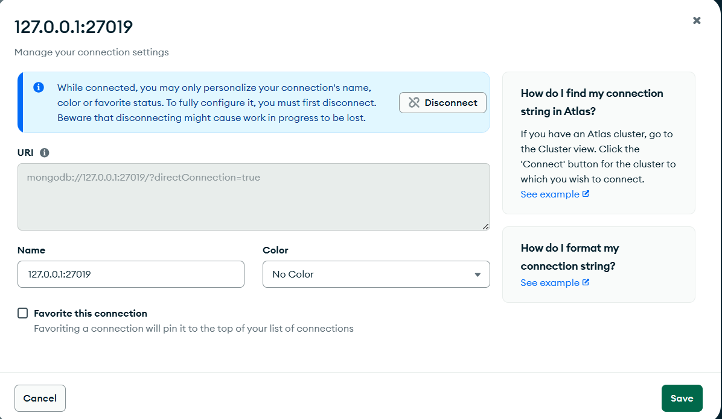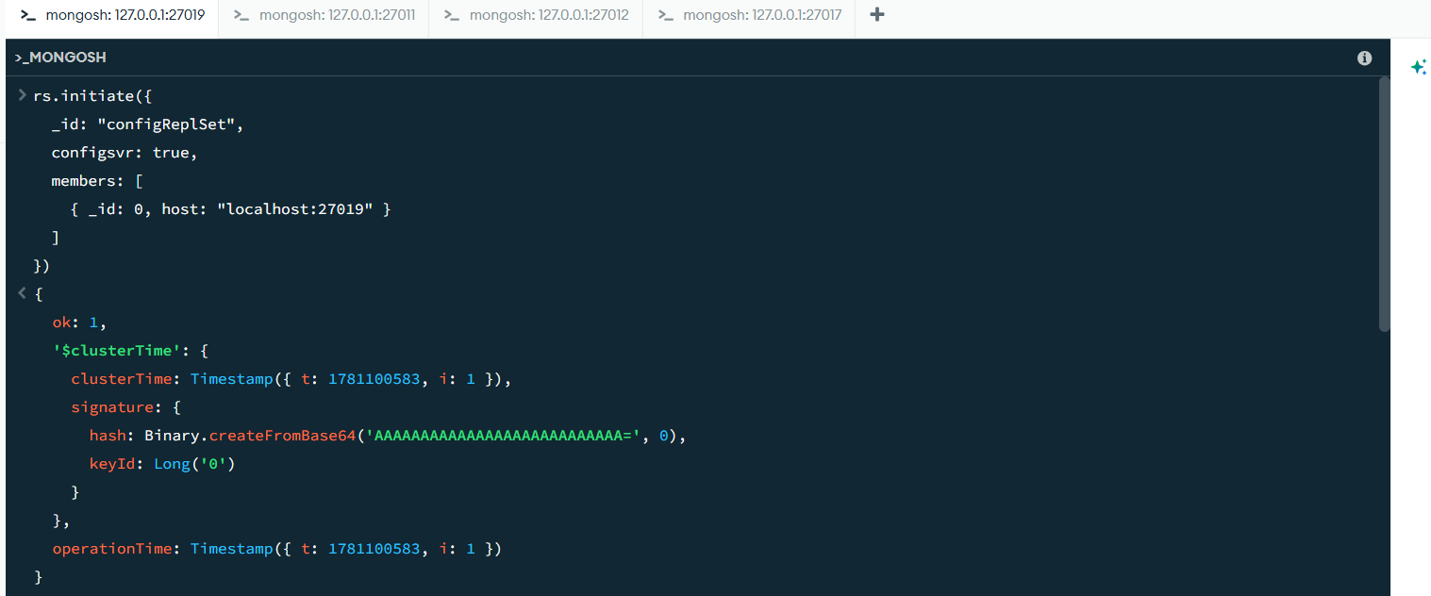
Run rs.status()
{
set: 'configReplSet',
date: 2026-06-10T14:10:41.088Z,
myState: 1,
term: Long('1'),
syncSourceHost: '',
syncSourceId: -1,
configsvr: true,
heartbeatIntervalMillis: Long('2000'),
majorityVoteCount: 1,
writeMajorityCount: 1,
votingMembersCount: 1,
writableVotingMembersCount: 1,
optimes: {
lastCommittedOpTime: { ts: Timestamp({ t: 1781100640, i: 1 }), t: Long('1') },
lastCommittedWallTime: 2026-06-10T14:10:40.512Z,
readConcernMajorityOpTime: { ts: Timestamp({ t: 1781100640, i: 1 }), t: Long('1') },
appliedOpTime: { ts: Timestamp({ t: 1781100640, i: 1 }), t: Long('1') },
durableOpTime: { ts: Timestamp({ t: 1781100640, i: 1 }), t: Long('1') },
writtenOpTime: { ts: Timestamp({ t: 1781100640, i: 1 }), t: Long('1') },
lastAppliedWallTime: 2026-06-10T14:10:40.512Z,
lastDurableWallTime: 2026-06-10T14:10:40.512Z,
lastWrittenWallTime: 2026-06-10T14:10:40.512Z
},
lastStableRecoveryTimestamp: Timestamp({ t: 1781100583, i: 1 }),
electionCandidateMetrics: {
lastElectionReason: 'electionTimeout',
lastElectionDate: 2026-06-10T14:09:43.671Z,
electionTerm: Long('1'),
lastCommittedOpTimeAtElection: { ts: Timestamp({ t: 1781100583, i: 1 }), t: Long('-1') },
lastSeenWrittenOpTimeAtElection: { ts: Timestamp({ t: 1781100583, i: 1 }), t: Long('-1') },
lastSeenOpTimeAtElection: { ts: Timestamp({ t: 1781100583, i: 1 }), t: Long('-1') },
numVotesNeeded: 1,
priorityAtElection: 1,
electionTimeoutMillis: Long('10000'),
newTermStartDate: 2026-06-10T14:09:43.736Z,
wMajorityWriteAvailabilityDate: 2026-06-10T14:09:44.139Z
},
members: [
{
_id: 0,
name: 'localhost:27019',
health: 1,
state: 1,
stateStr: 'PRIMARY',
uptime: 947,
optime: { ts: Timestamp({ t: 1781100640, i: 1 }), t: Long('1') },
optimeDate: 2026-06-10T14:10:40.000Z,
optimeWritten: { ts: Timestamp({ t: 1781100640, i: 1 }), t: Long('1') },
optimeWrittenDate: 2026-06-10T14:10:40.000Z,
lastAppliedWallTime: 2026-06-10T14:10:40.512Z,
lastDurableWallTime: 2026-06-10T14:10:40.512Z,
lastWrittenWallTime: 2026-06-10T14:10:40.512Z,
syncSourceHost: '',
syncSourceId: -1,
infoMessage: 'Could not find member to sync from',
electionTime: Timestamp({ t: 1781100583, i: 2 }),
electionDate: 2026-06-10T14:09:43.000Z,
configVersion: 1,
configTerm: 1,
self: true,
lastHeartbeatMessage: ''
}
],
ok: 1,
'$clusterTime': {
clusterTime: Timestamp({ t: 1781100640, i: 1 }),
signature: {
hash: Binary.createFromBase64('AAAAAAAAAAAAAAAAAAAAAAAAAAA=', 0),
keyId: Long('0')
}
},
operationTime: Timestamp({ t: 1781100640, i: 1 })
}

Start Shard1
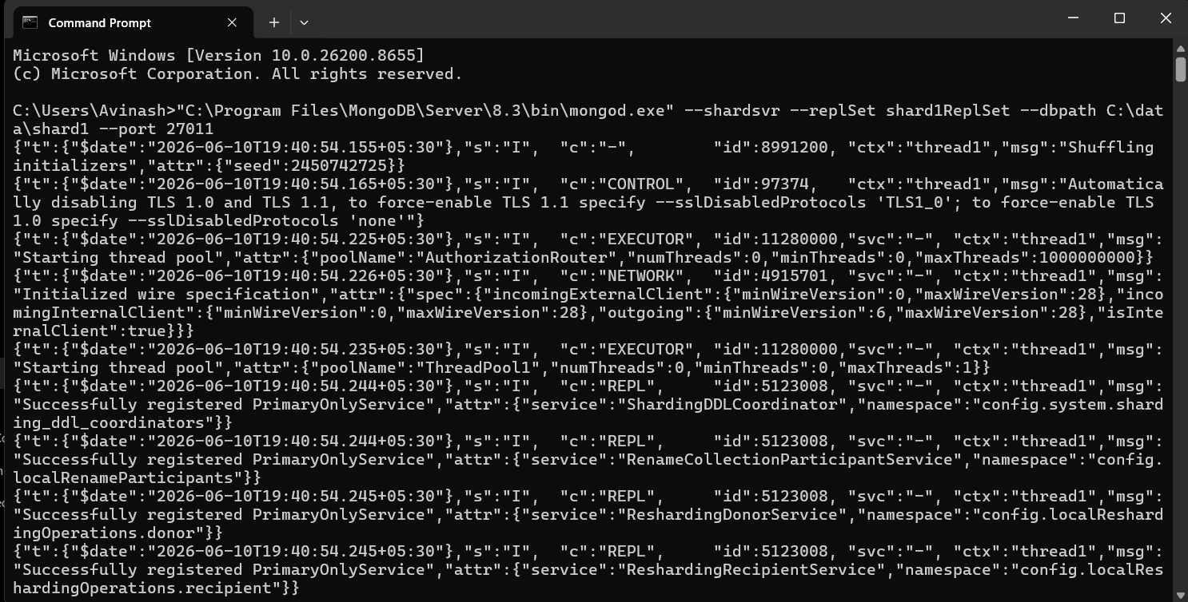
Connect to MongoDB and run the initialize command in the shell
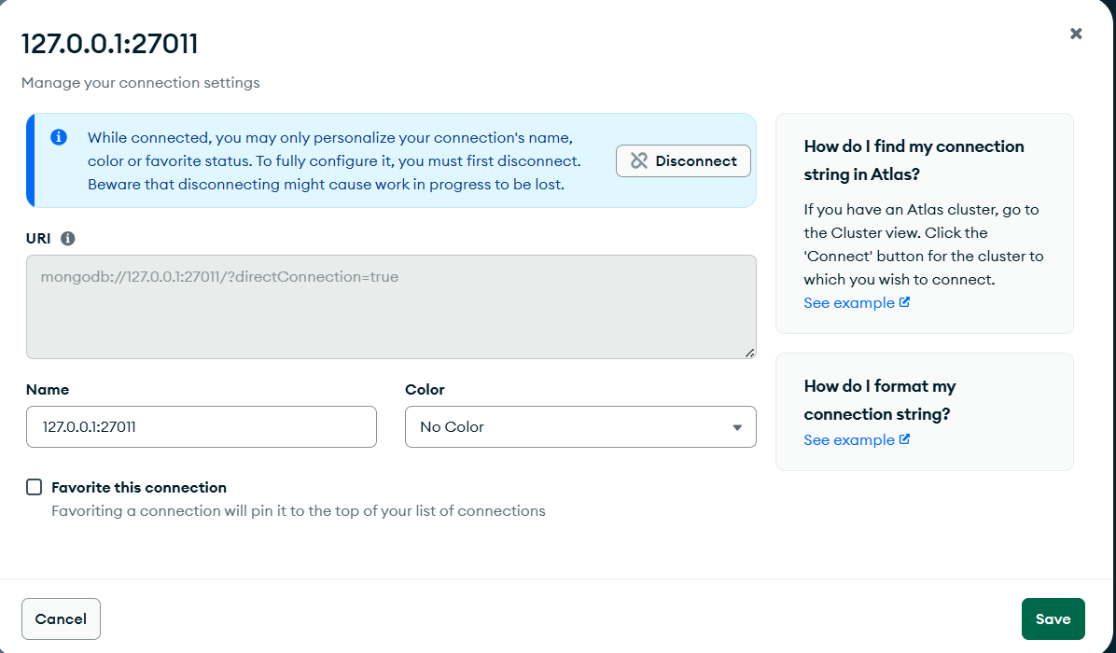
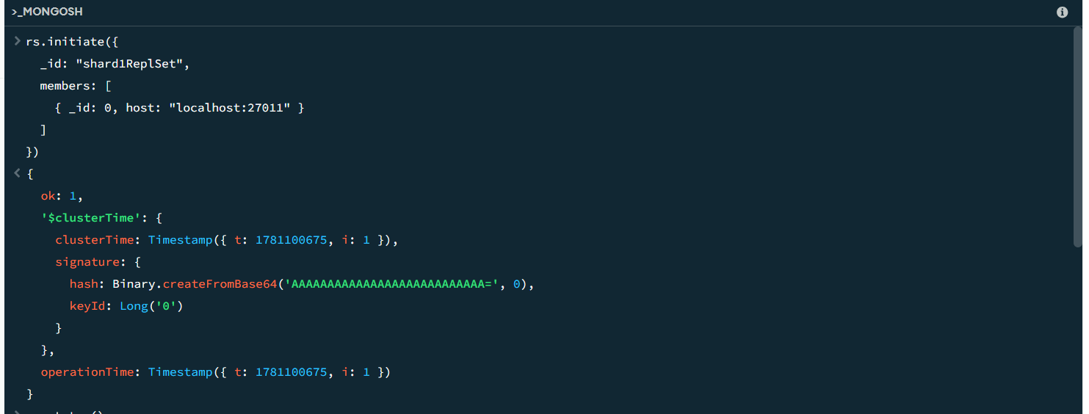
Run rs.status()
{
set: 'shard1ReplSet',
date: 2026-06-10T14:11:21.923Z,
myState: 1,
term: Long('1'),
syncSourceHost: '',
syncSourceId: -1,
heartbeatIntervalMillis: Long('2000'),
majorityVoteCount: 1,
writeMajorityCount: 1,
votingMembersCount: 1,
writableVotingMembersCount: 1,
optimes: {
lastCommittedOpTime: { ts: Timestamp({ t: 1781100676, i: 11 }), t: Long('1') },
lastCommittedWallTime: 2026-06-10T14:11:16.192Z,
readConcernMajorityOpTime: { ts: Timestamp({ t: 1781100676, i: 11 }), t: Long('1') },
appliedOpTime: { ts: Timestamp({ t: 1781100676, i: 11 }), t: Long('1') },
durableOpTime: { ts: Timestamp({ t: 1781100676, i: 11 }), t: Long('1') },
writtenOpTime: { ts: Timestamp({ t: 1781100676, i: 11 }), t: Long('1') },
lastAppliedWallTime: 2026-06-10T14:11:16.192Z,
lastDurableWallTime: 2026-06-10T14:11:16.192Z,
lastWrittenWallTime: 2026-06-10T14:11:16.192Z
},
lastStableRecoveryTimestamp: Timestamp({ t: 1781100675, i: 1 }),
electionCandidateMetrics: {
lastElectionReason: 'electionTimeout',
lastElectionDate: 2026-06-10T14:11:15.944Z,
electionTerm: Long('1'),
lastCommittedOpTimeAtElection: { ts: Timestamp({ t: 1781100675, i: 1 }), t: Long('-1') },
lastSeenWrittenOpTimeAtElection: { ts: Timestamp({ t: 1781100675, i: 1 }), t: Long('-1') },
lastSeenOpTimeAtElection: { ts: Timestamp({ t: 1781100675, i: 1 }), t: Long('-1') },
numVotesNeeded: 1,
priorityAtElection: 1,
electionTimeoutMillis: Long('10000'),
newTermStartDate: 2026-06-10T14:11:16.030Z,
wMajorityWriteAvailabilityDate: 2026-06-10T14:11:16.094Z
},
members: [
{
_id: 0,
name: 'localhost:27011',
health: 1,
state: 1,
stateStr: 'PRIMARY',
uptime: 27,
optime: { ts: Timestamp({ t: 1781100676, i: 11 }), t: Long('1') },
optimeDate: 2026-06-10T14:11:16.000Z,
optimeWritten: { ts: Timestamp({ t: 1781100676, i: 11 }), t: Long('1') },
optimeWrittenDate: 2026-06-10T14:11:16.000Z,
lastAppliedWallTime: 2026-06-10T14:11:16.192Z,
lastDurableWallTime: 2026-06-10T14:11:16.192Z,
lastWrittenWallTime: 2026-06-10T14:11:16.192Z,
syncSourceHost: '',
syncSourceId: -1,
infoMessage: 'Could not find member to sync from',
electionTime: Timestamp({ t: 1781100675, i: 2 }),
electionDate: 2026-06-10T14:11:15.000Z,
configVersion: 1,
configTerm: 1,
self: true,
lastHeartbeatMessage: ''
}
],
ok: 1,
'$clusterTime': {
clusterTime: Timestamp({ t: 1781100676, i: 11 }),
signature: {
hash: Binary.createFromBase64('AAAAAAAAAAAAAAAAAAAAAAAAAAA=', 0),
keyId: Long('0')
}
},
operationTime: Timestamp({ t: 1781100676, i: 11 })
}

Start Shard2
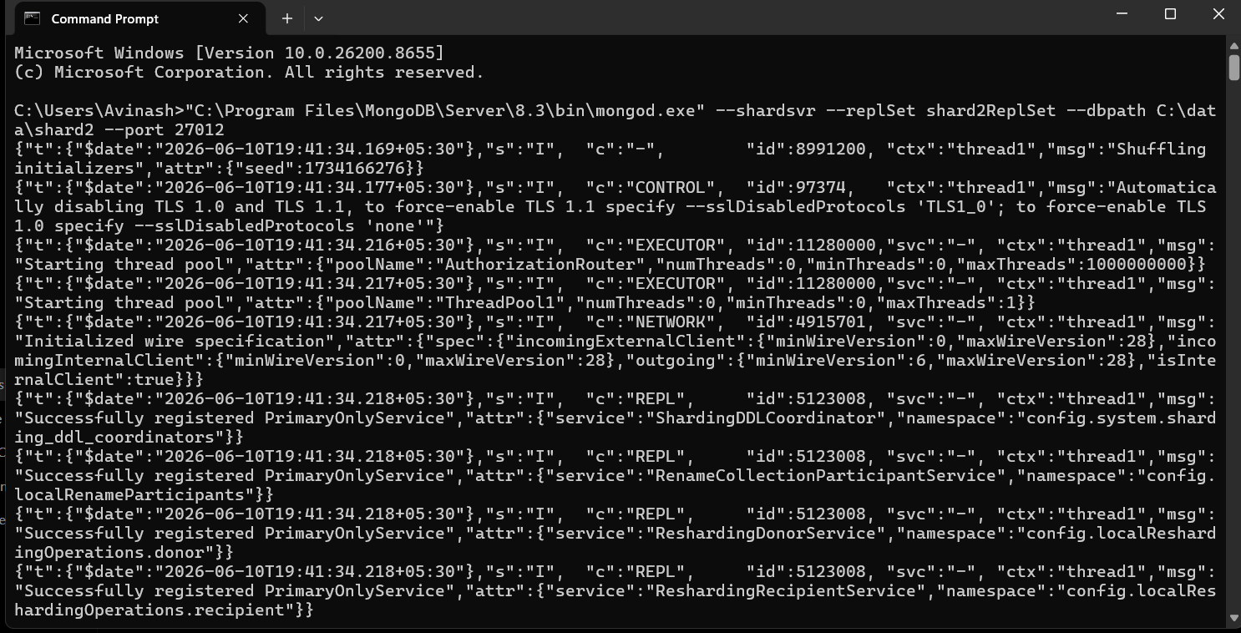
Connect to MongoDB and run the initialize command in the shell
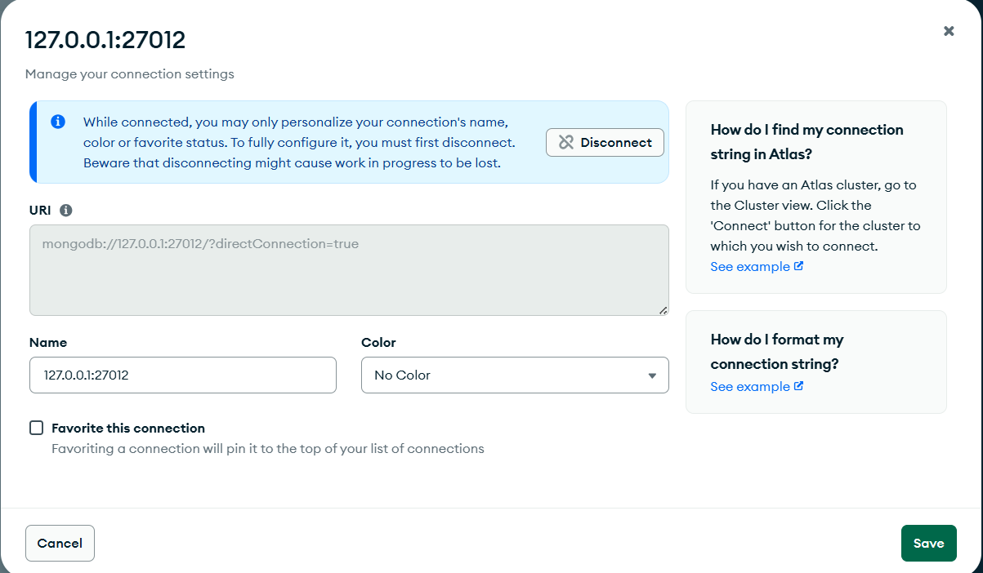
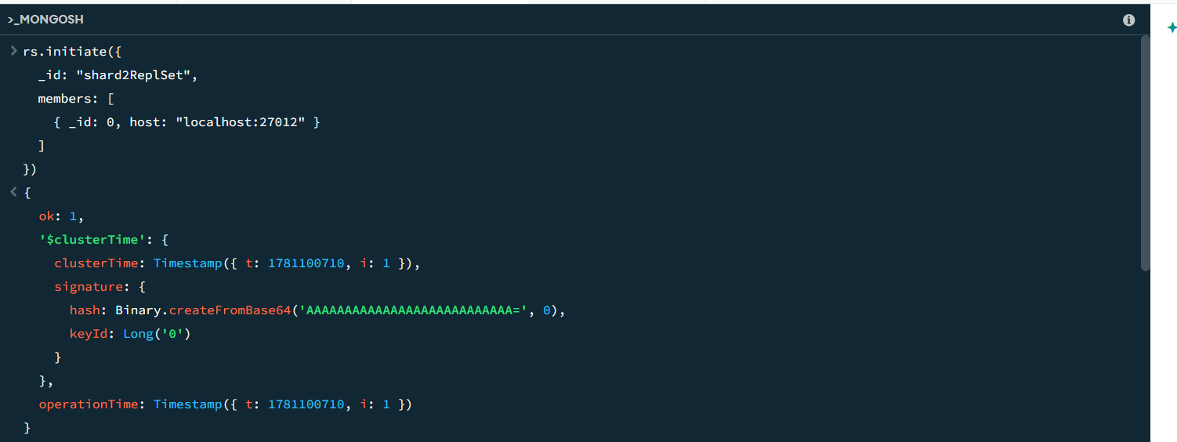
Run rs.status()
{
set: 'shard2ReplSet',
date: 2026-06-10T14:11:54.672Z,
myState: 1,
term: Long('1'),
syncSourceHost: '',
syncSourceId: -1,
heartbeatIntervalMillis: Long('2000'),
majorityVoteCount: 1,
writeMajorityCount: 1,
votingMembersCount: 1,
writableVotingMembersCount: 1,
optimes: {
lastCommittedOpTime: { ts: Timestamp({ t: 1781100710, i: 16 }), t: Long('1') },
lastCommittedWallTime: 2026-06-10T14:11:50.834Z,
readConcernMajorityOpTime: { ts: Timestamp({ t: 1781100710, i: 16 }), t: Long('1') },
appliedOpTime: { ts: Timestamp({ t: 1781100710, i: 16 }), t: Long('1') },
durableOpTime: { ts: Timestamp({ t: 1781100710, i: 16 }), t: Long('1') },
writtenOpTime: { ts: Timestamp({ t: 1781100710, i: 16 }), t: Long('1') },
lastAppliedWallTime: 2026-06-10T14:11:50.834Z,
lastDurableWallTime: 2026-06-10T14:11:50.834Z,
lastWrittenWallTime: 2026-06-10T14:11:50.834Z
},
lastStableRecoveryTimestamp: Timestamp({ t: 1781100710, i: 1 }),
electionCandidateMetrics: {
lastElectionReason: 'electionTimeout',
lastElectionDate: 2026-06-10T14:11:50.621Z,
electionTerm: Long('1'),
lastCommittedOpTimeAtElection: { ts: Timestamp({ t: 1781100710, i: 1 }), t: Long('-1') },
lastSeenWrittenOpTimeAtElection: { ts: Timestamp({ t: 1781100710, i: 1 }), t: Long('-1') },
lastSeenOpTimeAtElection: { ts: Timestamp({ t: 1781100710, i: 1 }), t: Long('-1') },
numVotesNeeded: 1,
priorityAtElection: 1,
electionTimeoutMillis: Long('10000'),
newTermStartDate: 2026-06-10T14:11:50.691Z,
wMajorityWriteAvailabilityDate: 2026-06-10T14:11:50.758Z
},
members: [
{
_id: 0,
name: 'localhost:27012',
health: 1,
state: 1,
stateStr: 'PRIMARY',
uptime: 20,
optime: { ts: Timestamp({ t: 1781100710, i: 16 }), t: Long('1') },
optimeDate: 2026-06-10T14:11:50.000Z,
optimeWritten: { ts: Timestamp({ t: 1781100710, i: 16 }), t: Long('1') },
optimeWrittenDate: 2026-06-10T14:11:50.000Z,
lastAppliedWallTime: 2026-06-10T14:11:50.834Z,
lastDurableWallTime: 2026-06-10T14:11:50.834Z,
lastWrittenWallTime: 2026-06-10T14:11:50.834Z,
syncSourceHost: '',
syncSourceId: -1,
infoMessage: 'Could not find member to sync from',
electionTime: Timestamp({ t: 1781100710, i: 2 }),
electionDate: 2026-06-10T14:11:50.000Z,
configVersion: 1,
configTerm: 1,
self: true,
lastHeartbeatMessage: ''
}
],
ok: 1,
'$clusterTime': {
clusterTime: Timestamp({ t: 1781100710, i: 16 }),
signature: {
hash: Binary.createFromBase64('AAAAAAAAAAAAAAAAAAAAAAAAAAA=', 0),
keyId: Long('0')
}
},
operationTime: Timestamp({ t: 1781100710, i: 16 })
}
Start the Config Server
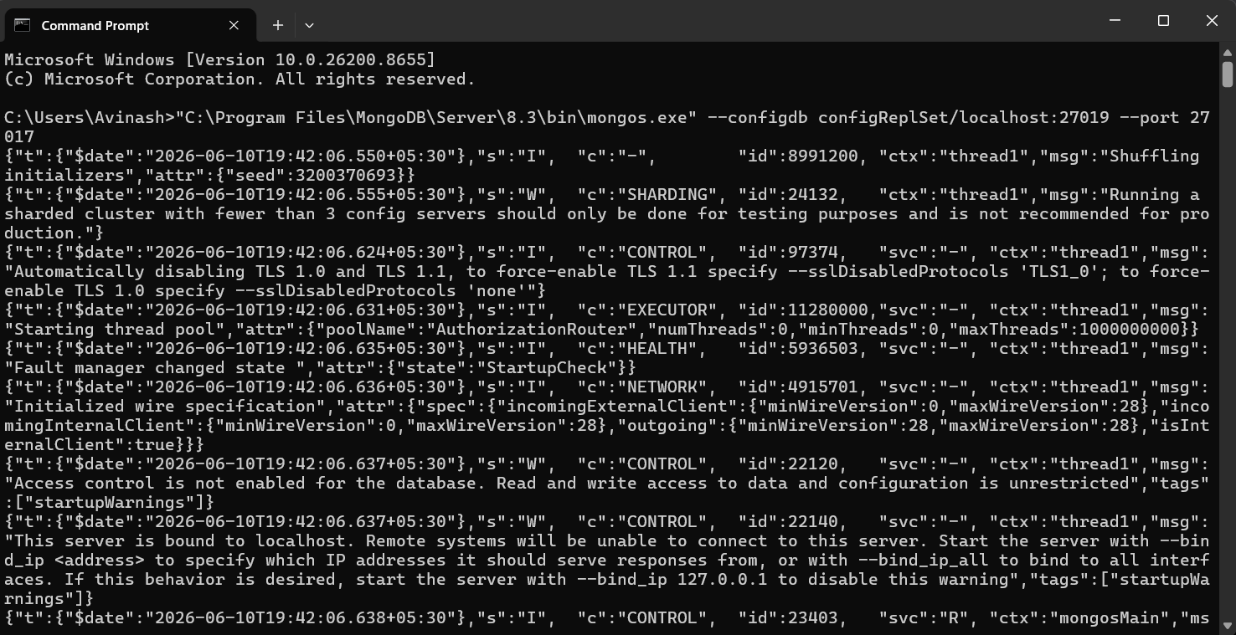

Connect to MongoDB and Shards
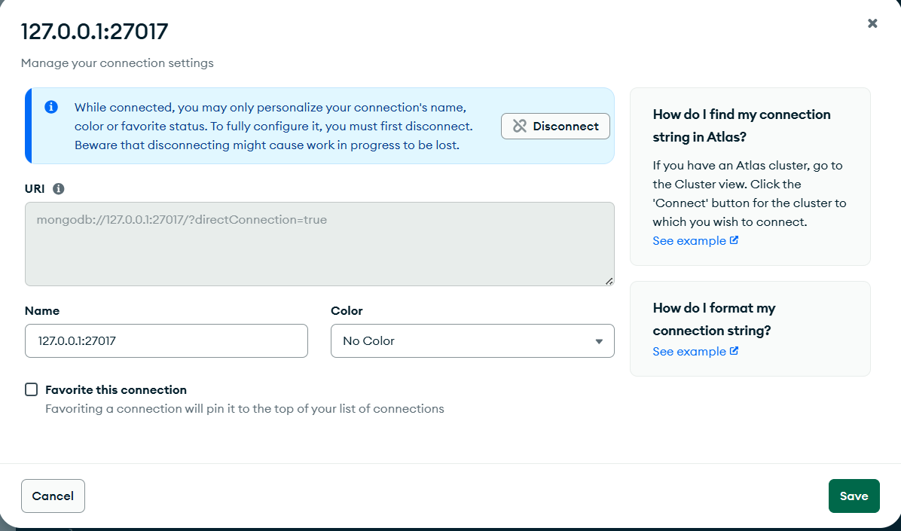
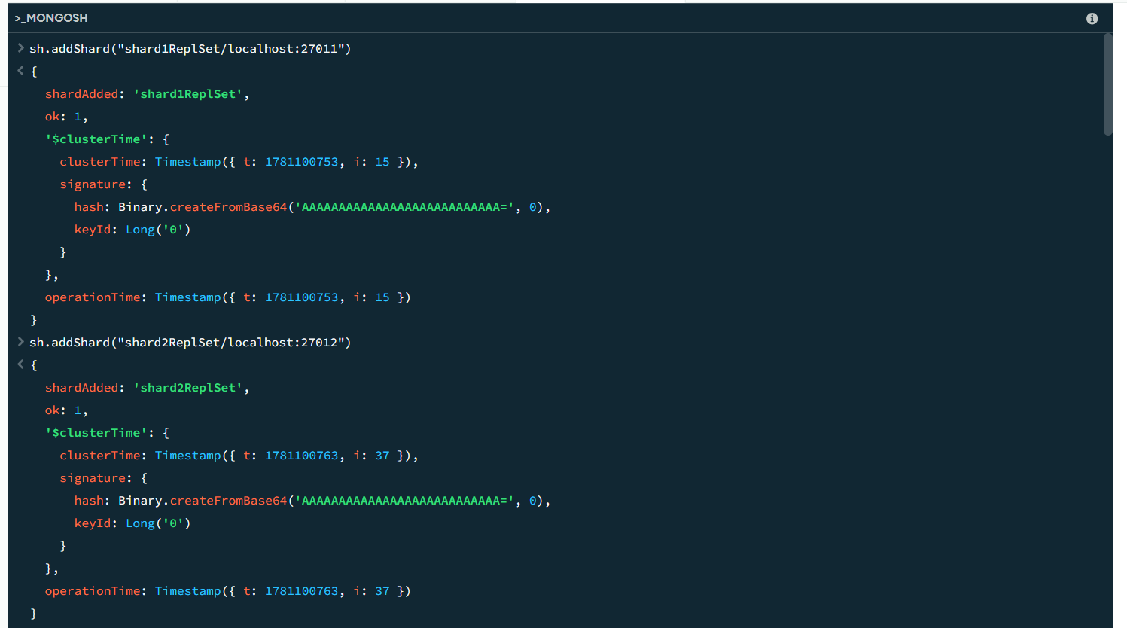

Enable Sharding
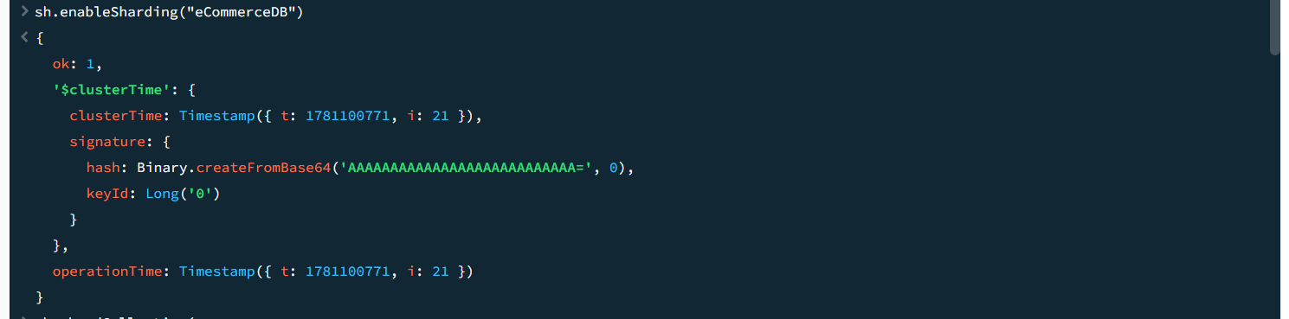
Shard Collection 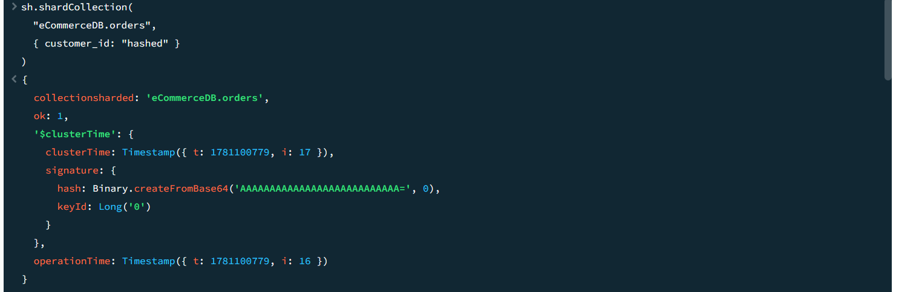
Insert Data
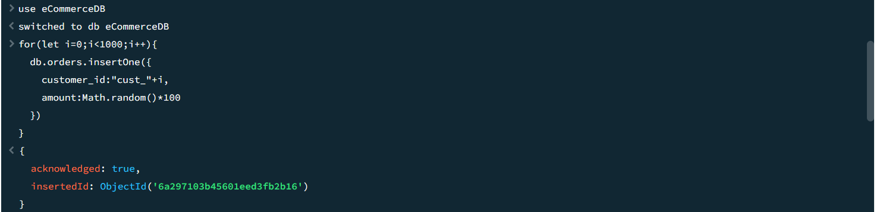

Verifying Sharding
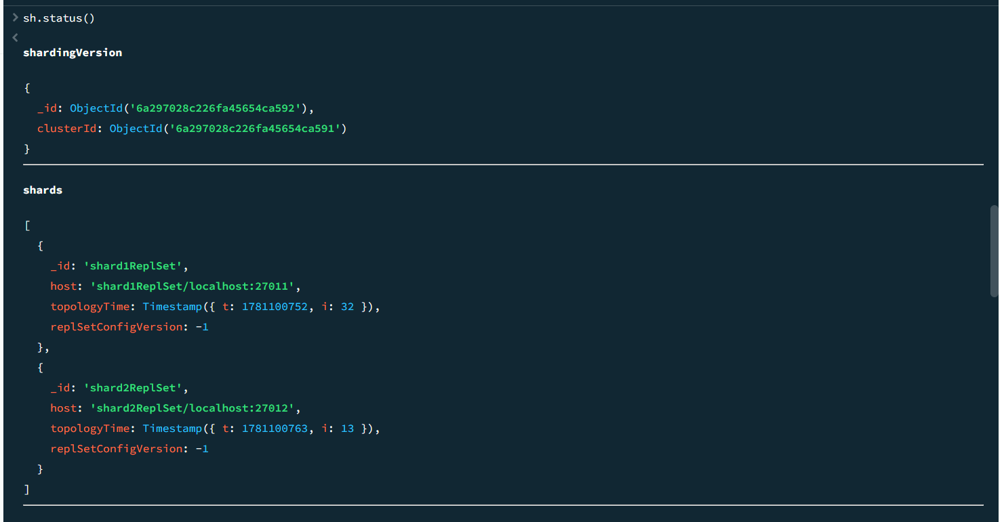 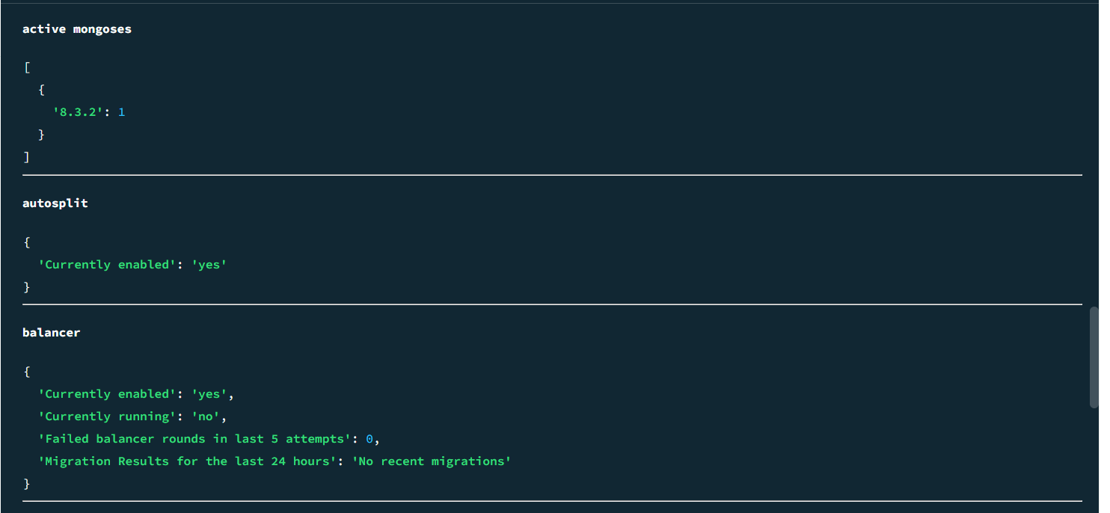 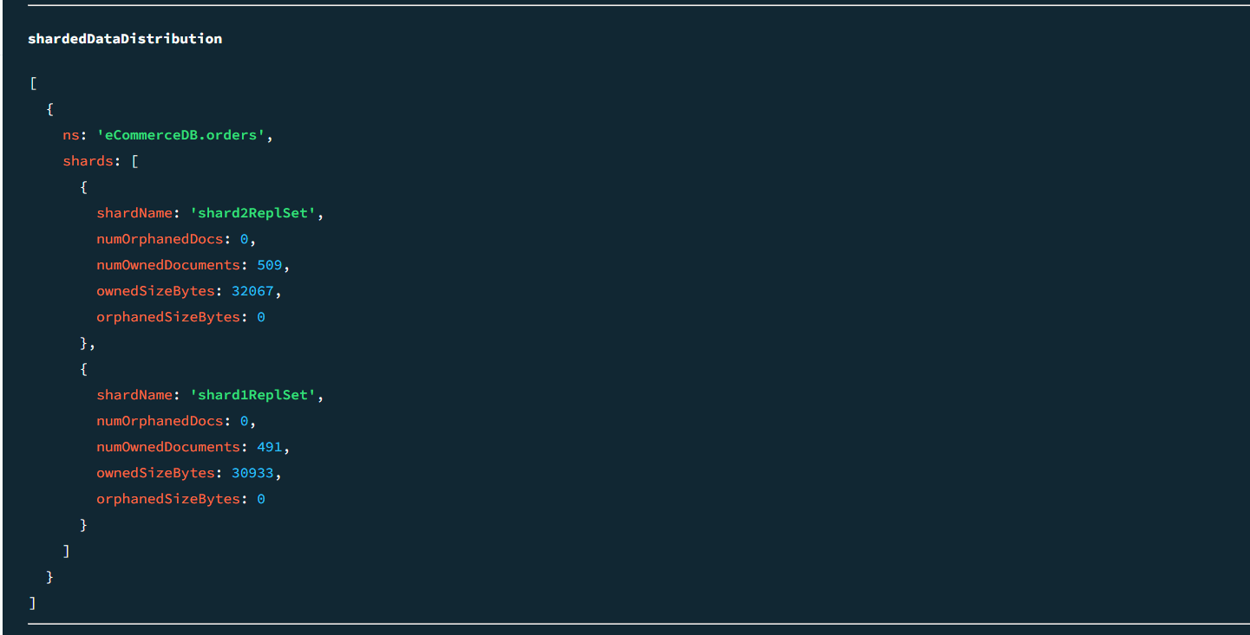 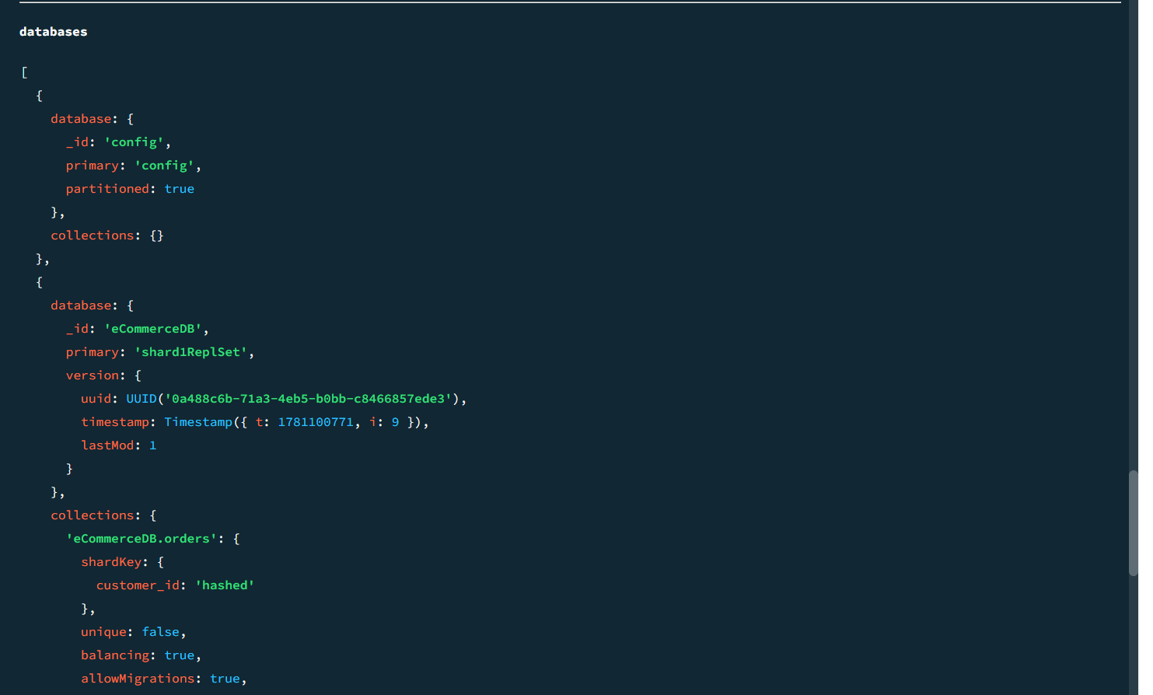 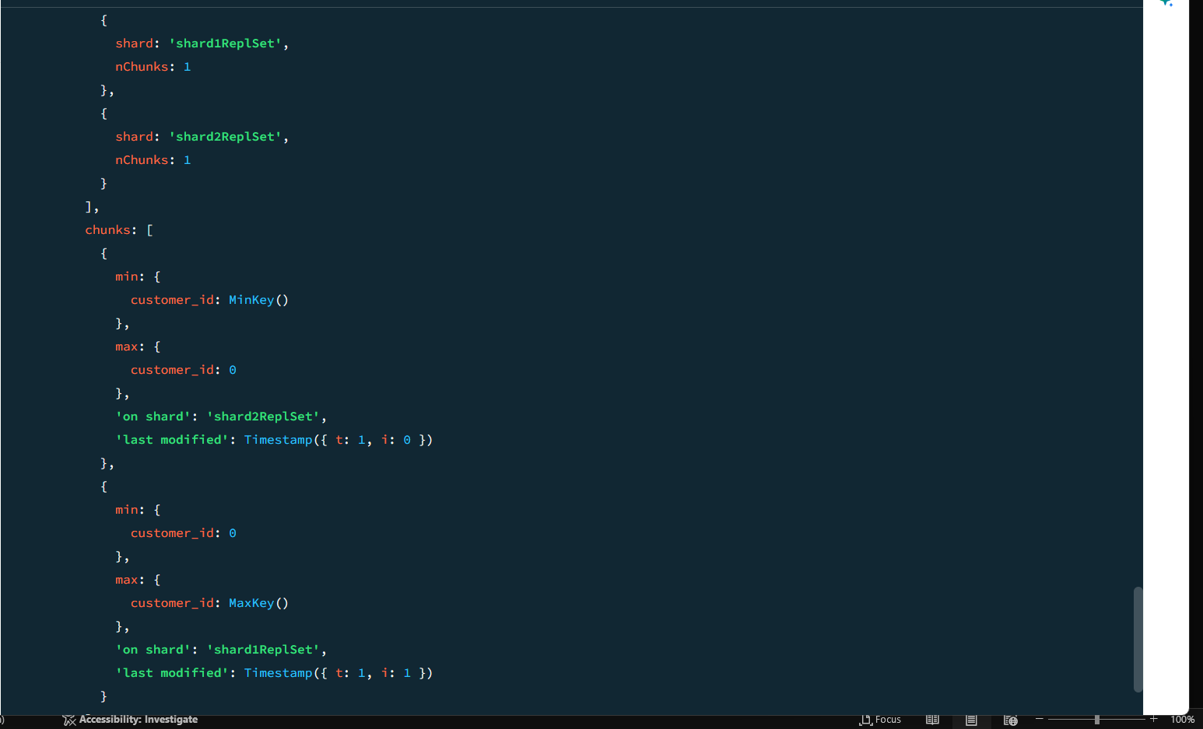 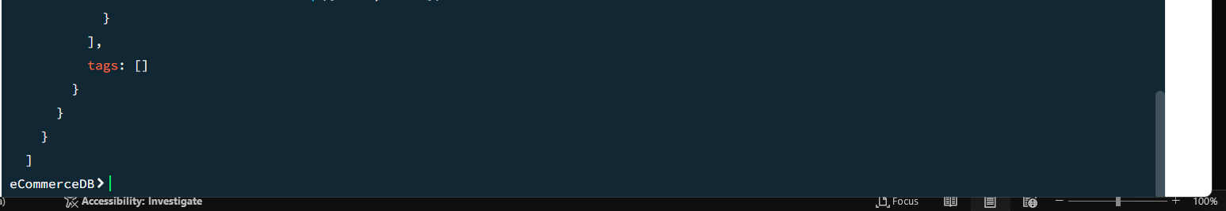

Restart MongoDB service
