Comparing Machine Learning Approaches for Trade Intent Classification from Noisy Livestream Transcripts
Andreas Oberdörfer
15.05.2026
Abstract
Live daytrading streams on platforms such as YouTube contain spoken trade signals (entries, exits, stop adjustments) that are embedded in continuous, informal commentary. Extracting these signals automatically requires converting the audio stream to text via automatic speech recognition (ASR) and then classifying each transcript segment into one of several trading-action categories. This task is complicated by recognition errors, colloquial language, and highly imbalanced class distributions.
This work compares the classification performance of five machine learning approaches on a seven-class trade-intent classification task derived from real livestream transcripts. Three classical pipelines are evaluated: logistic regression, support vector machine (SVM), and a multi-layer perceptron (MLP), all operating on TF-IDF feature vectors. Two transformer-based approaches are also tested: DistilBERT and ModernBERT, both used as frozen encoders with trained linear classification heads. All models are trained and evaluated on the same labelled corpus of 1.442 cleaned examples (1.377 after content-level deduplication at load time) drawn from 103 livestream transcripts, using five-fold cross-validation with transcript-level splits to prevent data leakage. Label quality was validated through manual verification of 203 action labels across 10 transcripts; 202 labels were judged correct or acceptable, with zero clearly incorrect labels and two accepted labels marked as ambiguous. A spot check of unlabelled transcript lines also showed incomplete action coverage, so the benchmark should be read as a high-precision, action-enriched evaluation corpus rather than as a complete representation of every utterance in a live stream.
The results show that the classical TF-IDF-based models, in particular logistic regression and SVM, achieve the strongest aggregate performance, with logistic regression reaching a macro-averaged F1 of 0,70 and an action-detection F1 of 0,89 on the cleaned dataset. This aggregate advantage is supported by feature-importance analysis, which shows a small set of domain-specific keywords driving the classical models, and is consistent with t-SNE projections in which frozen transformer embeddings show no clear label-level cluster structure. Exploratory paired t-tests on macro F1 show that logistic regression outperforms DistilBERT ($p=0,014$), while the remaining pairwise gaps involving the MLP, SVM, and ModernBERT do not reach conventional significance with only five folds. The frozen transformer feature extractors, constrained by fixed encoder weights and a small training set, reach lower aggregate scores despite their considerably larger parameter counts. The MLP, after correction with balanced class weighting, improves substantially over an unweighted baseline but still trails the linear models in aggregate. A per-label analysis reveals that management actions (trim, exit, move stop) are classified reliably using explicit keyword patterns, while entry actions (long, short) remain difficult due to varied and ambiguous language. An error analysis of misclassified examples identifies three dominant failure modes: indirect entry language that the model reads as commentary, exit-adjacent phrasing in non-action segments, and second-person advice mistaken for self-directed action. These findings suggest that for small, domain-specific corpora with formulaic language patterns, sparse bag-of-words features remain highly competitive with frozen pretrained contextual embeddings, and that the added complexity of transformer feature extraction does not translate into better performance when the encoder is not adapted to the task.
Keywords: text classification, trade intent detection, TF-IDF, support vector machine, logistic regression, transformer models, DistilBERT, ModernBERT, automatic speech recognition, livestream transcription
Code and Data: https://github.com/AndiCodesss/stream_copier
Table of Contents

Bachelor Thesis
Comparing Machine Learning
Approaches for Trade Intent
Classification from Noisy
Livestream Transcripts
Andreas Oberdörfer
Date of Birth: 24.12.2002 Student ID: h12217505
Subject Area: Information Business
Studienkennzahl: J 033 561
Supervisor: Johann Mitlöhner
Date of Submission: 15.05.2026
Department of Information Systems & Operations Management, Vienna University of Economics and Business, Welthandelsplatz 1, 1020 Vienna, Austria

Introduction

Motivation
The proliferation of live-streaming platforms has created a new form of real-time financial commentary. On YouTube and Twitch, daytraders broadcast their screens and narrate trading decisions as they happen, announcing entries, exits, position adjustments, and stop-loss moves in natural, spoken language. For viewers who wish to follow or replicate these trades, a fundamental challenge arises: the relevant trading signals are scattered across hours of continuous, unstructured speech that also includes market analysis, viewer interaction, personal commentary, and silence. Identifying the precise moments when a trader commits to an action requires sustained human attention, and any lapse results in missed signals.
The scale of this phenomenon is considerable. Popular daytrading channels on YouTube routinely attract thousands of concurrent viewers during market hours, and many offer real-time commentary on specific instruments such as the Nasdaq micro E-mini futures (MNQ). Unlike written trading signals published on social media or dedicated signal services, the information conveyed in livestreams is ephemeral and unstructured: the trader speaks continuously, and the boundary between commentary (“I’m watching this level”) and commitment (“I’m long here”) can be subtle and context-dependent. A viewer who looks away for thirty seconds may miss a trade entry, and reviewing hours of archived video to find specific moments is impractical.
This setting motivates an automated system capable of (1) transcribing a live audio stream in real time, (2) identifying which transcript segments contain actionable trading signals, and (3) classifying those signals into concrete action categories such as “enter long,” “trim position,” or “move stop.” The first component, speech recognition, has been transformed by recent large-scale models such as Whisper (Radford et al. 2023), which achieve near-human accuracy in many settings. The second and third components constitute a text classification problem: given a short transcript segment and the current trading context, assign one of several predefined labels.
At its core, this is a text classification problem — one of the most studied tasks in natural language processing (NLP) (Kowsari et al. 2019). Classical approaches using bag-of-words features and linear classifiers have long worked well for tasks like sentiment analysis and spam detection (Joachims 1998). More recently, pretrained transformer models such as BERT (Devlin et al. 2019) have pushed the state of the art on many NLP benchmarks by learning rich contextual word representations from large corpora. But transformers are not always better. On small, domain-specific datasets, their advantage can disappear: general-purpose embeddings may simply not capture the specialized vocabulary that matters for classification (Kowsari et al. 2019). This raises the question of whether the added complexity of transformer models is justified for tasks like the one studied here.
What makes this particular domain interesting — and hard — is the combination of challenges it presents. The language is informal and full of trader jargon (“peel some off,” “add to the runner,” “move to breakeven”). The speech recognition layer introduces its own errors: “VWAP” might become “v-wap” or “the WAP,” and “piece” can substitute for “peel.” The class distribution is heavily skewed, since most of what a trader says is commentary rather than an actual trade call. The same action can be phrased in many different ways — a long entry might be “I’m long here,” “let’s try it,” “small size,” or just “here we go.” And the dataset is small by modern NLP standards, with fewer than 1.500 labelled examples. Together, these characteristics make the task a useful testbed for comparing model families: it is practical (a real system depends on it), technically challenging (noisy input, imbalanced classes, small data), and scientifically interesting (classical vs. modern approaches on domain-specific text).

Research Question
The central question addressed in this work is:
Which machine learning approach (classical TF-IDF-based classifiers or pretrained transformer models) provides the most accurate trade-intent classification on noisy livestream transcripts, and does the added complexity of transformer-based methods yield a measurable benefit over simpler approaches on a small, domain-specific corpus?
This question is operationalized through a controlled benchmark comparing five model architectures on the same labelled dataset, using the same evaluation protocol. Two subordinate questions are also examined: (1) Which action classes are most and least amenable to automated detection, and why? (2) What systematic error patterns arise from the interaction between model architecture and the characteristics of trading language?

Scope and Delimitations
The scope of this work is deliberately narrow. The classification task is studied in isolation: the input to each model is a pre-constructed text prompt containing the transcript segment and trading context, and the output is a single predicted action label. The upstream speech recognition pipeline and the downstream trade execution logic are described briefly for context but are not evaluated or optimized as part of this work. Only English-language livestream transcripts of a single daytrading style (micro E-mini Nasdaq futures) are considered. The labelled dataset is constructed from a specific set of archived streams and may not generalize to other traders, instruments, or streaming styles.
Furthermore, all transformer models are used with frozen encoder weights; only a small linear classification head is trained on the labelled data. Full fine-tuning of the transformer encoders is not explored, as it would require a larger dataset and different regularization strategies, and lies outside the scope of a comparison-focused study with the available data. Parameter-efficient alternatives such as LoRA are discussed as future work (Section 5.7).

Structure of This Work
The remainder of this thesis is organized as follows. Section 2 reviews existing approaches to text classification, transformer-based language models, automatic speech recognition, and NLP applications in financial markets. Section 3 describes the experimental procedure in detail: the system pipeline, dataset construction, model architectures, and evaluation protocol. Section 4 presents the experimental results, including aggregate performance metrics, the impact of data cleanup, per-label breakdowns, confusion matrices, feature importance analysis, embedding visualization, error analysis, a TF-IDF vocabulary size ablation, and statistical significance testing. Section 5 interprets the findings, discusses practical implications and limitations, and compares the results to expectations from the literature. Section 6 provides a concluding summary of the question, procedure, and results.

Related Work
This section reviews the methods and research areas that form the foundation of the present work. The discussion proceeds from general text classification concepts to the specific model families evaluated, then covers the speech recognition technology that generates the input data, and concludes with a survey of NLP applications in financial markets.

Text Classification
Text classification, the assignment of predefined labels to natural-language documents, is a foundational task in NLP with applications ranging from spam filtering and sentiment analysis to topic categorization and intent detection (Kowsari et al. 2019). The task requires transforming raw text into a numerical representation and then applying a classification algorithm to that representation. Approaches differ primarily in how the text is represented (feature engineering versus learned representations) and in the complexity of the classifier (linear versus nonlinear, shallow versus deep).
Early influential work in opinion mining by Hu and Liu (Hu and Liu 2004) demonstrated that structured extraction of sentiment from unstructured customer reviews could be achieved with relatively simple pattern-based and statistical methods. This line of research established that domain-specific lexical patterns, i.e. particular words and phrases that signal a category, are often highly predictive, even without deep syntactic or semantic analysis. More recent surveys, such as the comprehensive clinical text mining review by Percha (Percha 2021), document the evolution from rule-based systems through statistical classifiers to neural methods, while noting that the choice of approach should be guided by the size and nature of the available data rather than by the novelty of the method.
A consistent finding across the text classification literature is that the quality and representativeness of the training data frequently matter more than the choice of algorithm (Kowsari et al. 2019). Small, noisy, or imbalanced datasets can nullify the theoretical advantages of sophisticated models, while careful data curation and feature engineering can compensate for architectural simplicity. This observation foreshadows a central tension in the present work: whether the richer representations of pretrained transformers can overcome the disadvantage of a small, noisy, domain-specific corpus, or whether the corpus characteristics dominate the architectural choice.

Feature Extraction: TF-IDF
Term Frequency–Inverse Document Frequency (TF-IDF) is a classical text representation scheme that assigns a numerical weight to each word (or n-gram) in a document based on two factors: how frequently the term appears in the document (term frequency) and how rare it is across the entire corpus (inverse document frequency) (Salton and Buckley 1988; Manning, Raghavan, and Schütze 2008). Formally, for a term $t$ in a document $d$ within a corpus $D$:
$$\text{TF-IDF}\left(t,d,D\right)=\text{tf}\left(t,d\right)×log​\left(\frac{\left|D\right|}{\left|\{d'∈D:t∈d'\}\right|}\right)$$
where $\text{tf}\left(t,d\right)$ denotes the frequency of term $t$ in document $d$, and the logarithmic factor downweights terms that appear in many documents. Sublinear scaling of the term frequency component ($1+log\left(\text{tf}\right)$ instead of raw $\text{tf}$) is commonly applied to reduce the influence of extremely frequent terms (Manning, Raghavan, and Schütze 2008).
TF-IDF produces high-dimensional, sparse feature vectors in which each dimension corresponds to a unique term or n-gram. Despite its simplicity, this representation has proven remarkably effective for text classification, particularly when combined with linear classifiers (Joachims 1998). Its strengths include interpretability (individual features correspond to human-readable terms), computational efficiency (sparse matrix operations), and the ability to capture domain-specific vocabulary directly from the training data without requiring external resources.
The main limitation of TF-IDF is that it treats each term independently, ignoring word order and semantic relationships. Two documents using different words to express the same meaning will have disjoint feature vectors. This limitation motivates the use of word embeddings and contextual representations discussed in subsequent sections. TF-IDF’s reliance on discrete vocabulary entries proves particularly well-suited to the formulaic, keyword-driven language of trading commentary, as the feature importance analysis in Section 4.6 will show.

Classical Classification Algorithms
Three classical classification algorithms are evaluated in this work, all applied to TF-IDF feature vectors.
Logistic Regression is a linear model that predicts class probabilities via the softmax function applied to a linear combination of input features (Hosmer, Lemeshow, and Sturdivant 2013). For a feature vector $x$ and $K$ classes, the probability of class $k$ is:
$$P\left(y=k∣x\right)=\frac{exp\left(w_{k}^{⊤}x+b_{k}\right)}{\sum_{j=1}^{K}{exp}\left(w_{j}^{⊤}x+b_{j}\right)}$$
The parameters $w_{k}$ and $b_{k}$ are optimized by minimizing the cross-entropy loss, typically with L2 regularization to prevent overfitting. Logistic regression is a natural baseline for text classification due to its interpretability, native probability output, and strong performance on high-dimensional sparse features (Joachims 1998).
Support Vector Machines (SVMs) find the hyperplane that maximizes the margin, that is, the distance between the closest training examples of different classes, in the feature space (Cortes and Vapnik 1995). For linearly separable data, the decision function is:
$$f\left(x\right)=w^{⊤}x+b$$
where $w$ and $b$ are chosen to maximize $\frac{2}{∥w∥}$ subject to correct classification of all training examples. Soft-margin extensions handle non-separable data by introducing slack variables controlled by a regularization parameter $C$. SVMs have a strong theoretical foundation and a long history of success in text classification (Joachims 1998). Because SVMs do not natively produce probability estimates, calibration methods such as Platt scaling (Platt 1999) are required when probabilities are needed.
Multi-Layer Perceptrons (MLPs) are feedforward neural networks consisting of an input layer, one or more hidden layers with nonlinear activation functions, and an output layer (Goodfellow, Bengio, and Courville 2016). An MLP with a single hidden layer computes:
$$\hat{y}=\text{softmax}\left(W_{2}⋅σ\left(W_{1}x+b_{1}\right)+b_{2}\right)$$
where $σ$ denotes a nonlinear activation function (e.g., ReLU). Unlike logistic regression and linear SVMs, MLPs can learn nonlinear decision boundaries, which may be beneficial when the relationship between features and labels is not linearly separable. However, additional capacity also increases the risk of overfitting, particularly on small datasets.

Word Embeddings and Pretrained Representations
A fundamental shift in NLP occurred with the introduction of dense, low-dimensional word representations, known as word embeddings, that capture semantic relationships between words. Word2Vec (Mikolov et al. 2013) demonstrated that training shallow neural networks on large unlabelled corpora to predict words from their context (the skip-gram model) or context from a word (the continuous bag-of-words model) could produce embeddings in which semantically similar words are placed close together in vector space. The resulting embeddings exhibit algebraic properties that encode semantic relationships: the vector arithmetic $\text{king}-\text{man}+\text{woman}≈\text{queen}$ became a celebrated illustration of the structure learned by these models.
GloVe (Pennington, Socher, and Manning 2014) achieved similar results through a different mechanism: a global matrix factorization objective that directly decomposes word co-occurrence statistics. Both Word2Vec and GloVe produce static embeddings: each word receives a single fixed vector regardless of the sentence in which it appears. While this is sufficient for many tasks, it cannot handle polysemy: the word “stop” in “stop-loss” and “stop talking” would receive the same embedding.
A further advance came with contextualized embeddings, in which the representation of a word depends on its surrounding context. ELMo (Peters et al. 2018) introduced this concept using bidirectional LSTMs, producing representations that could distinguish between different senses of a polysemous word by conditioning on the full sentence. ELMo demonstrated substantial improvements over static embeddings on tasks such as question answering, sentiment analysis, and named entity recognition. This line of research culminated in transformer-based models, discussed in the following section, which learn contextualized representations through self-attention mechanisms and large-scale pretraining.
The progression from TF-IDF (sparse, high-dimensional, term-independent) through static embeddings (dense, low-dimensional, term-independent) to contextualized embeddings (dense, context-dependent) represents a trend toward richer text representations that capture increasingly subtle linguistic phenomena. However, richer representations come at the cost of increased model complexity and data requirements, and the simpler representations retain advantages in settings where interpretability, computational efficiency, or small dataset size are primary concerns.

Handling Class Imbalance
Class imbalance, the condition in which some classes are represented by far more training examples than others, is a pervasive challenge in real-world classification tasks (Chawla et al. 2002). When the training distribution is skewed, classifiers tend to favor the majority class, as doing so minimizes the overall loss without learning meaningful patterns for minority classes. In the extreme, a classifier may learn to always predict the majority class, achieving high accuracy but zero recall on all other classes.
Several strategies have been proposed to address class imbalance. Oversampling methods such as SMOTE (Chawla et al. 2002) create synthetic examples of minority classes by interpolating between existing examples in feature space. Undersampling methods reduce the majority class to balance the distribution. Cost-sensitive learning modifies the loss function to assign higher penalties to misclassifications of minority classes; the class_weight=balanced parameter used in the logistic regression and SVM models in this work is an instance of this approach, weighting each class inversely proportional to its frequency.
In the present work, a combination of strategies is employed: majority-class downsampling during training set construction (capping NO_ACTION at 2,5 times the total number of action examples, with a hard limit of 6.000) and cost-sensitive loss weighting for the linear classifiers and transformer models. The MLP receives balanced class weighting through oversampling of minority classes, since scikit-learn’s MLPClassifier does not support native cost-sensitive weighting.

Transformer Models
The Transformer architecture, introduced by Vaswani et al. (Vaswani et al. 2017), replaced recurrent processing with a self-attention mechanism that allows each token in a sequence to attend directly to every other token, enabling parallelized computation and effective modelling of long-range dependencies. The core self-attention operation computes:
$$\text{Attention}\left(Q,K,V\right)=\text{softmax}​\left(\frac{QK^{⊤}}{\sqrt{d_{k}}}\right)V$$
where $Q$, $K$, and $V$ are query, key, and value matrices derived from the input, and $d_{k}$ is the dimensionality of the key vectors. Multi-head attention extends this mechanism by running $h$ parallel attention operations with different learned projections, concatenating their outputs, and projecting back to the model dimension. This allows the model to attend to different types of relationships simultaneously.
A complete Transformer encoder layer consists of multi-head self-attention followed by a position-wise feedforward network, with residual connections and layer normalization around each sub-layer. Stacking multiple such layers produces increasingly abstract representations of the input sequence.
BERT (Bidirectional Encoder Representations from Transformers) (Devlin et al. 2019) applied the Transformer encoder to the task of language model pretraining, using a masked language modelling (MLM) objective in which the model predicts randomly masked tokens from bidirectional context, and a next-sentence prediction (NSP) objective. BERT established new state-of-the-art results across a wide range of NLP benchmarks, including the GLUE benchmark, SQuAD question answering, and named entity recognition, and demonstrated that pretrained representations could be effectively transferred to downstream tasks via fine-tuning. The key insight was that bidirectional pretraining, conditioning on both left and right context simultaneously, produces richer representations than unidirectional approaches.
The standard paradigm for applying BERT to downstream tasks involves fine-tuning: adding a task-specific output layer on top of the pretrained encoder and training all parameters jointly on labelled task data. However, fine-tuning the entire model requires sufficient labelled data and careful regularization to avoid overfitting; with small datasets, the risk of overfitting is substantial. An alternative paradigm, feature extraction, uses the pretrained encoder as a fixed feature extractor and trains only a lightweight classification head on top. This approach sacrifices the ability to adapt the encoder to the task but reduces the number of trainable parameters dramatically, making it more suitable for small datasets. The present work employs the feature-extraction paradigm.
DistilBERT (Sanh et al. 2019) addressed the computational cost of BERT by applying knowledge distillation (Hinton, Vinyals, and Dean 2015; Bucilă, Caruana, and Niculescu-Mizil 2006) during pretraining. Knowledge distillation involves training a smaller “student” model to reproduce the output distribution of a larger “teacher” model, transferring not just the hard labels but the full probability distribution over classes, which contains information about inter-class similarities. The resulting model retains 97% of BERT’s language understanding capabilities while being 40% smaller (66 million parameters versus 110 million) and 60% faster at inference. The distillation process uses a triple loss combining the original masked language modelling objective, a cross-entropy distillation loss with respect to the teacher’s output distribution, and a cosine-distance loss between student and teacher hidden representations. The student is initialized by taking one layer out of every two from the teacher model, leveraging the shared hidden-size architecture.
ModernBERT (Warner et al. 2024) is a recent modernization of the BERT architecture that incorporates several architectural improvements developed since the original BERT release. These include rotary position embeddings (RoPE) (Su et al. 2024) for improved positional encoding that supports sequences up to 8.192 tokens; alternating local-global attention patterns in which every third layer uses full global attention while others use local sliding windows of 128 tokens, balancing efficiency with representation quality; Flash Attention (Dao et al. 2022) for memory-efficient computation; GeGLU activation functions instead of the standard GELU; and unpadding techniques that eliminate wasted computation on padding tokens. The base model contains 149 million parameters across 22 layers and was pretrained on 2 trillion tokens of English and code data, an order of magnitude more training data than the original BERT. Despite its larger parameter count, ModernBERT achieves faster inference than BERT due to its architectural optimizations, and sets new state-of-the-art results for encoder-only models across several benchmarks.
While these pretrained models have demonstrated strong performance on standard benchmarks, their effectiveness on small, domain-specific datasets, particularly when full fine-tuning is not feasible, remains an open question. The present work contributes to this question by evaluating frozen transformer encoders as feature extractors on a novel classification task.

Knowledge Distillation
Knowledge distillation, formalized by Hinton et al. (Hinton, Vinyals, and Dean 2015) building on earlier work by Bucilă et al. (Bucilă, Caruana, and Niculescu-Mizil 2006), is a model compression technique in which a smaller model (the student) is trained to mimic the behavior of a larger model (the teacher). The key insight is that the teacher’s soft output probabilities, i.e. the full distribution over classes rather than just the argmax prediction, contain valuable information about the structure of the label space. For example, a teacher’s output distribution for a TRIM example might assign non-negligible probability to EXIT_ALL and MOVE_STOP, encoding the semantic similarity between these management actions. By training the student to reproduce these soft targets (using a temperature-scaled softmax), the distilled model can learn richer representations than training on hard labels alone.
This technique is relevant to the present work in two ways: DistilBERT itself is a product of knowledge distillation, and the choice to use frozen encoders with trained heads can be viewed as an extreme form of knowledge transfer in which the pretrained encoder’s representations are used as-is without any adaptation.

Automatic Speech Recognition
The input data for the classification task in this work is generated by automatic speech recognition (ASR). The field of ASR has undergone a paradigm shift in recent years, moving from pipeline-based systems (acoustic model, language model, decoder) to end-to-end neural models that directly map audio waveforms to text.
Whisper (Radford et al. 2023) is a large-scale ASR model developed by OpenAI, trained on over 680.000 hours of weakly supervised multilingual audio data collected from the internet. It employs a Transformer encoder-decoder architecture: the encoder processes log-Mel spectrogram features extracted from the audio signal, and the decoder generates text tokens autoregressively. The model is trained using a simple sequence-to-sequence objective on paired audio-transcript data, without any self-supervised pretraining or self-training stages. The training data is weakly supervised in the sense that the transcripts are collected from the internet (e.g., from subtitles) rather than manually annotated by human transcribers, introducing some label noise that the model must learn to overcome through scale.
Whisper demonstrates strong zero-shot generalization across diverse acoustic conditions, accents, and domains, often matching or exceeding the performance of domain-specific fine-tuned models. In a direct comparison with human transcribers on multiple benchmarks, Whisper approaches human accuracy and robustness (Radford et al. 2023). The model is available in several sizes, from a 39-million-parameter “tiny” variant to a 1,5-billion-parameter “large” variant, offering a tradeoff between speed and accuracy.
However, Whisper, like all ASR systems, is not error-free. Recognition accuracy degrades on domain-specific jargon, informal speech, overlapping speakers, and low-quality audio. In the context of daytrading livestreams, several categories of systematic transcription error are observed:
- Financial terminology: Domain-specific terms are frequently misrecognized. “VWAP” (Volume Weighted Average Price) may be transcribed as “v-wap,” “v w a p,” or “the WAP.” “MNQ” (Micro E-mini Nasdaq) may become “M and Q” or “MQ.”
- Homophones and near-homophones: “Peel” (as in “peel off some shares”) may be transcribed as “peace” or “piece.” “Breakeven” may be split as “break even” or “break-even.”
- Disfluencies: Traders speaking rapidly under market pressure produce incomplete sentences, mid-sentence corrections, and filler words that Whisper may merge or omit, altering the meaning of the transcript.
- Segment boundaries: Whisper’s chunked processing may split a single utterance across two segments, separating “I’m” from “long here” and making intent detection impossible within a single segment. The production system addresses this through cross-segment stitching.
These errors propagate into the classification pipeline and represent a form of input noise that all downstream models must contend with. A central consequence for the present work is that the downstream classifier must contend with input text that is not merely informal but actively corrupted by systematic transcription artifacts. Any evaluation of classification accuracy must therefore be interpreted in light of this upstream noise. A domain-specific text normalization step is applied between transcription and classification to mitigate the most common errors, as described in Section 3.2.

NLP Applications in Financial Markets
The application of natural language processing to financial data has a substantial and growing research literature. Early work by Loughran and McDonald (Loughran and McDonald 2011) demonstrated that general-purpose sentiment dictionaries perform poorly on financial texts, as words with negative connotations in everyday language (e.g., “liability”) carry neutral or positive meaning in financial contexts. This finding motivated the development of domain-specific lexicons and, subsequently, domain-specific language models.
Bollen et al. (Bollen, Mao, and Zeng 2011) showed that collective mood states derived from Twitter content could predict movements in the Dow Jones Industrial Average, establishing a link between textual sentiment and market behavior. More recent work has applied transformer-based models directly to financial texts: FinBERT (Yang, Uy, and Huang 2020) is a BERT model further pretrained on financial communications that achieves strong performance on financial sentiment classification tasks. Comprehensive surveys by Xing et al. (Xing, Cambria, and Welsch 2018) and Wankhade et al. (Wankhade, Rao, and Kulkarni 2022) document the breadth of NLP applications in finance and sentiment analysis, ranging from news-based prediction to earnings-call analysis.
The present work differs from this prior literature in an important respect: rather than analyzing written financial texts (news articles, regulatory filings, social media posts), it targets spoken trading commentary transcribed in real time. The input is not a polished written document but a noisy, fragmentary transcript of spontaneous speech, introducing challenges that are more characteristic of dialogue systems and spoken language understanding than of traditional financial NLP.

Methodology
This section describes the experimental procedure: the overall system pipeline within which the classification task is situated, the construction and characteristics of the training dataset, the five model architectures evaluated, and the evaluation protocol.

System Pipeline Overview
The classification task studied in this work is one component of a larger system designed to automatically detect and execute trades from live YouTube daytrading streams. The complete pipeline, which is documented in the public repository at https://github.com/AndiCodesss/stream_copier, consists of four stages:
- Audio capture and voice activity detection. Audio is captured from a browser tab via a React-based frontend and processed by a WebRTC-based voice activity detector (VAD) that segments the continuous audio stream into speech segments, discarding silence and background noise.
- Speech-to-text transcription. Speech segments are transcribed using Whisper (Radford et al. 2023) via the faster-whisper implementation, which uses CTranslate2 for optimized inference. Two Whisper model sizes are run in parallel: a smaller model provides fast preview transcriptions, while a larger model produces more accurate final transcripts. A domain-specific text normalization step corrects common transcription errors in trading terminology (e.g., “peace” $→$ “piece,” “v w a p” $→$ “vwap”).
- Intent classification. Each finalized transcript segment is classified into a trading action category. The production system employs a multi-layered approach: a rule engine with over 100 regex patterns provides initial classifications, a local machine learning classifier adds confidence scores, and an optional cloud-based large language model confirms ambiguous cases. The machine learning classifier is the component evaluated in this thesis.
- Risk validation and trade execution. Classified trade signals pass through a risk engine that checks for stale signals, insufficient confidence, and position-size limits before orders are submitted to a NinjaTrader 8 trading platform via a local HTTP bridge.
The present work focuses exclusively on stage 3: given a transcript segment and its trading context, predict the correct action label. The other stages are treated as fixed infrastructure.
Figure 1 illustrates the complete pipeline architecture.
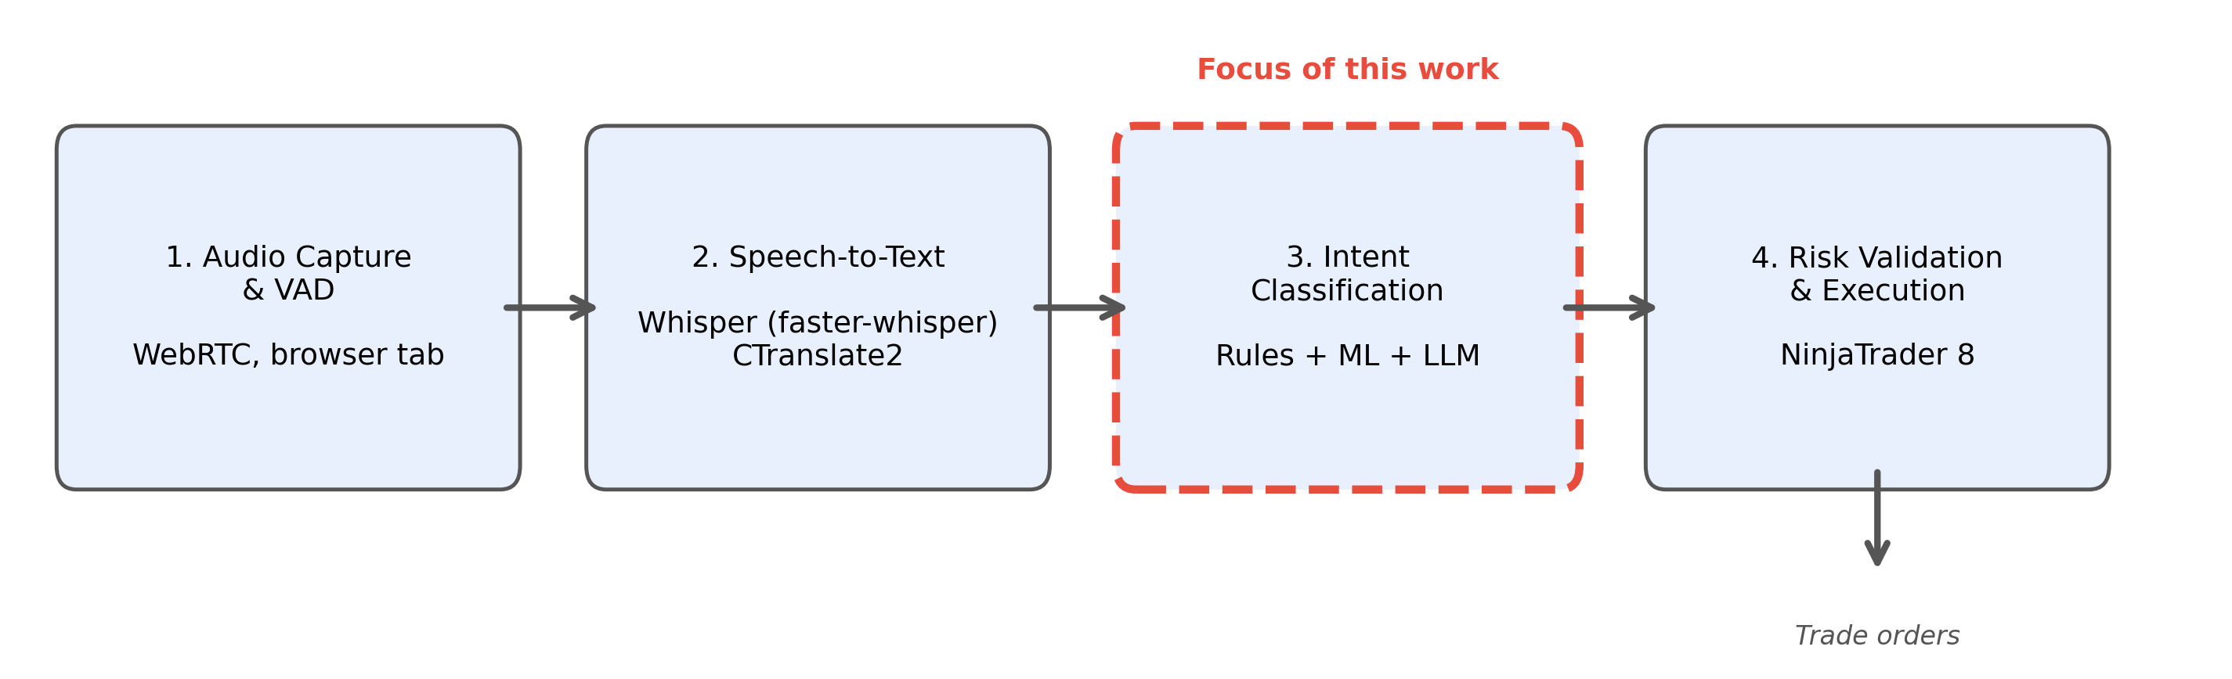
Overview of the four-stage system pipeline. The classification stage (highlighted) is the component evaluated in this thesis. Audio is captured from a browser tab, transcribed by Whisper, classified into trading actions, and validated before execution.

Text Normalization
Between transcription and classification, a domain-specific text normalization step corrects systematic ASR errors that would otherwise degrade classification performance. The normalizer applies 14 regex-based pattern substitutions organized into several categories:
Abbreviation expansion: Whisper frequently splits financial abbreviations into individual letters or syllables. The normalizer reconstitutes these: “v w a p” becomes “vwap”; “m n q” becomes “mnq”; “m e s” becomes “mes”; “n q” becomes “nq”; “e s” becomes “es.”
Homophone correction: Common ASR homophones in trading context are resolved: “peace” $→$ “piece” (when followed by positional words like “on,” “here,” “there”); “view up” $→$ “vwap”; “got my ad on” $→$ “got my add on.”
Compound word normalization: Trading terms that Whisper splits inconsistently are standardized: “break even” and “broke even” both become “breakeven.”
General text cleaning: All text is lowercased, typographic apostrophes are normalized to ASCII, and digit separators are removed (e.g., “24.600” or “24,600” becomes “24600”).
These normalizations are applied as deterministic string substitutions (regular expressions) and do not involve any statistical modelling. While simple, they reduce the vocabulary fragmentation caused by ASR errors, allowing the TF-IDF vectorizer and the tokenizers of the transformer models to produce more consistent feature representations.

Task Definition and Label Set
The classification task assigns one of seven labels to each input example. The labels and their definitions are shown in Table 1.
Label definitions for the trade-intent classification task.
Label | Role | Description
NO_ACTION | Neutral | No trade signal detected
ENTER_LONG | Entry | Open a new long position
ENTER_SHORT | Entry | Open a new short position
TRIM | Management | Reduce position size (partial profit-taking)
EXIT_ALL | Management | Close the entire position
MOVE_STOP | Management | Adjust the stop-loss level
MOVE_TO_BREAKEVEN | Management | Move the stop-loss to the entry price
Each input example is a structured text prompt that encodes the traded instrument, the trader’s current position state, and three overlapping windows of transcript text:
symbol=MNQ 03-26
position=LONG
last_side=LONG
recent=there s a nice shove up. we cleared out
analysis=there s a nice shove up. we cleared out there.
so you got to take a partial
current=there. So, you got to take a partial
The three text windows (recent, analysis, current) provide context at different temporal granularities, allowing the classifier to consider not only the current utterance but also what was said immediately before. The position and last_side fields encode the trader’s current market position, which is essential for distinguishing between management actions (which require an open position) and entry actions (which establish a new position).
This overlapping window design addresses a fundamental challenge of streaming transcription: Whisper segments audio into chunks of approximately 5–30 seconds, and a complete trading utterance may span two or more chunks. For example, a trader might say “I’m” at the end of one segment and “long here” at the beginning of the next. By including overlapping context from adjacent segments, the classifier can reconstruct the complete intent even when the decisive words are split across segment boundaries.
The inclusion of position state as part of the text prompt, rather than as a separate feature, is a deliberate design choice. It allows the same text featurization pipeline to handle both the linguistic content and the trading context. For TF-IDF models, the tokens position=LONG and position=FLAT become standard vocabulary entries that participate in the same feature space as the transcript words. For transformer models, the tokenizer processes them as regular subword tokens that the encoder can attend to alongside the transcript text. This unified representation simplifies the model architecture at the cost of a slightly larger input vocabulary.

Dataset Construction
The training dataset was constructed through a three-stage pipeline involving AI-assisted labelling, human review, and normalization.
Stage 1: AI labelling. Trading livestream transcripts archived from YouTube were processed by large language models (LLMs) which assigned action labels to each transcript line based on the speaker’s words and trading context. Three LLMs were used across different annotation passes: Claude Sonnet produced 278 labelled examples in an initial high-quality pass, Gemini Pro produced 78 examples in a validation run, and Gemini Flash produced 1.139 examples in a bulk labelling pass. This AI-assisted approach to labelling draws on the broader paradigm of weak supervision, in which noisy labelling functions replace or augment manual annotation (Ratner et al. 2017).
Stage 2: Human review. Each AI-generated label was manually reviewed by the author and either accepted, rejected, or corrected. Review decisions were preserved in the dataset as metadata fields (review_status, review_note), enabling downstream analysis of labelling reliability. This human-in-the-loop approach combines the scalability of automated labelling with the quality control of manual review.
Stage 3: Merging and normalization. The reviewed corpora from all three AI models were merged using a deduplication script. During merging, several normalization steps were applied: duplicate labels on the same transcript line were resolved by giving priority to the later corpus; SETUP_LONG and SETUP_SHORT labels (which denote non-actionable market analysis) were remapped to NO_ACTION; and ADD labels (adding to an existing position) were remapped to the appropriate entry label based on position side. The resulting dataset contains 1.466 examples drawn from 103 transcripts.

Label Quality Verification
To validate the reliability of the AI-generated and semi-automatically reviewed labels, a manual verification was conducted on 10 transcripts containing 203 action labels (the 10 transcripts with the highest number of action labels in the dataset). For each labelled line, the surrounding transcript context (2–3 lines before and after) was read to confirm that the assigned label correctly reflects the trader’s action at that moment.
The verification confirmed 202 of 203 action labels as correct or acceptable (99,5% operational label acceptance), with zero clearly incorrect labels. Two of the accepted labels were documented as ambiguous because they involved borderline second-person phrasing. Additionally, the NO_ACTION labels were spot-checked by scanning for unlabelled lines containing trade-related language patterns; approximately 230 potentially unlabelled trade actions were identified across the 10 transcripts, primarily consisting of continuation lines (the same action mentioned across multiple consecutive lines), repeated trims, and stop adjustments mentioned in passing.
This verification establishes that the dataset has high precision but incomplete action coverage: the action labels that exist are reliable, but not every trade action in each transcript is labelled. This is a central methodological limitation. Some examples marked as NO_ACTION may contain weak, repeated, or continuation-style actions, which can blur the boundary between action and non-action during both training and evaluation. The benchmark is therefore best interpreted as a controlled comparison on a curated, high-precision corpus, not as a complete measurement of signal detection on raw livestream speech.

Dataset Characteristics
Table 2 shows the label distribution of the original dataset.
Label distribution in the original dataset (1.466 file entries; 1.407 unique examples after content deduplication).
Label | Count | Percentage
NO_ACTION | 569 | 38,8%
TRIM | 267 | 18,2%
EXIT_ALL | 271 | 18,5%
ENTER_SHORT | 153 | 10,4%
MOVE_STOP | 97 | 6,6%
ENTER_LONG | 94 | 6,4%
MOVE_TO_BREAKEVEN | 15 | 1,0%
Total | 1.466 | 100%
Figure 2 visualizes the class imbalance. The NO_ACTION class dominates at 38,8%, inflated by the remapping of 87 SETUP_LONG and 350 SETUP_SHORT examples. At the other extreme, MOVE_TO_BREAKEVEN has only 15 examples (1,0%), making it extremely difficult for any classifier to learn reliable patterns for this class.
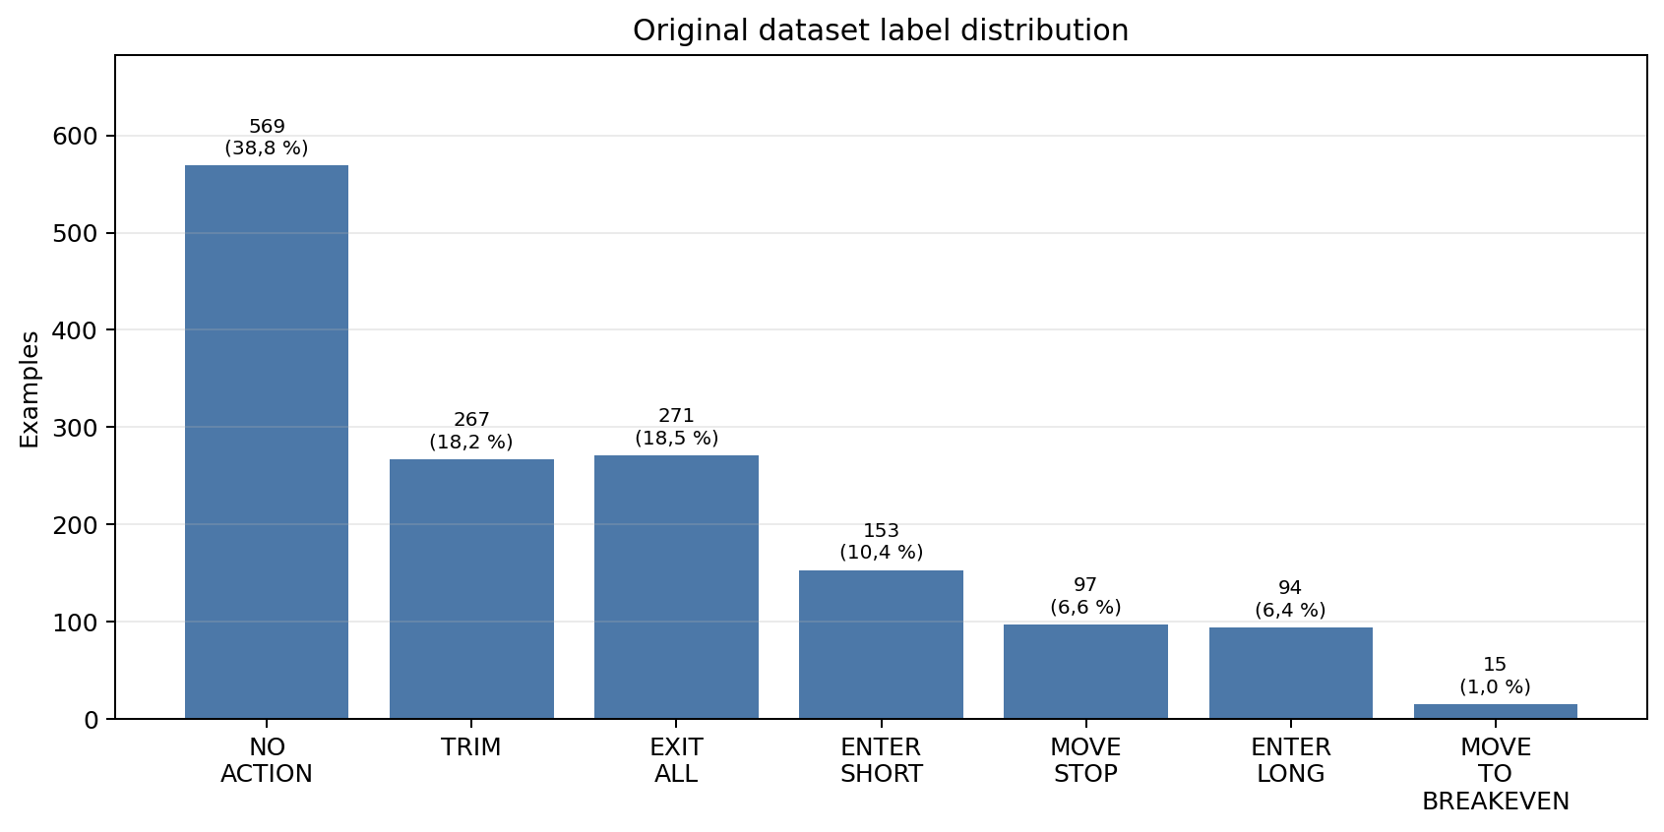
Label distribution in the original dataset (1.466 examples). The dataset exhibits substantial class imbalance, with NO_ACTION comprising 38,8% and MOVE_TO_BREAKEVEN only 1,0% of examples.
The imbalance between action classes and non-action partly reflects the natural distribution of trading activity: in a typical livestream session, the trader spends the majority of time analyzing the market and interacting with viewers, with actual trade actions occurring relatively infrequently. However, the dataset is still action-enriched because it was built from selected labelled lines rather than from every segment in every stream. Consequently, the NO_ACTION share in this benchmark should not be treated as the real prevalence of non-action speech in a full live session.

Data Cleanup
Before model training, several data quality issues in the original 1.466-example dataset were identified and corrected through an automated cleanup pipeline.
Removing placeholder market price. All prompts originally contained a field market_price=24600, a hard-coded placeholder that provided zero information to the classifier. This feature was removed from all examples to prevent models from learning a spurious association with a constant value.
Repairing position state. A subset of management-label examples (e.g., TRIM, EXIT_ALL) carried position=FLAT, an impossible combination since managing a position requires an open position. These entries were repaired by inferring the correct position from the original_side or last_side fields present in the prompt metadata.
Deduplicating consecutive entries. When the same action appeared in multiple consecutive transcript lines (within a window of 3 lines), duplicate labels were removed, retaining only the first occurrence. This step eliminated redundant training signal caused by the trader repeating an action announcement across overlapping transcript segments.
Flagging impossible combinations. After the position-repair step, a rule-based check identified remaining impossible state–label combinations: specifically, management labels (TRIM, EXIT_ALL, MOVE_STOP, MOVE_TO_BREAKEVEN) that were still paired with position=FLAT, i.e. descriptions of managing a position that was never opened. These cases typically arose when the original_side and last_side fields were both missing or NONE, so the position state could not be inferred. Six such examples were separated from the clean training set. Additionally, a second check flagged five action-labelled examples containing second-person advice patterns such as “you can,” “you should,” “your stop,” or “move your.” These examples likely describe advice directed at the audience rather than the speaker’s own trades.
After cleanup, the dataset contains 1.442 clean examples drawn from 103 transcripts.
Content-level deduplication. In addition to the consecutive-entry deduplication described above, the evaluation pipeline applies a content-level deduplication step at load time: examples that are identical in label, prompt text, position side, and last side are collapsed to a single instance. This removes duplicates that arise when different transcript segments produce identical prompt representations after normalization. Table 3 summarizes all four dataset sizes referenced throughout this work.
Dataset size at each stage of the pipeline. The cleaned, content-deduplicated dataset (1.377 examples) is used for the primary evaluation in Section 4.1; the original, content-deduplicated dataset (1.407 examples) is used for the original-dataset baseline in Section 4.2.
Stage | Examples | Used in
Raw merged dataset | 1.466 | —
After cleanup pipeline (Section 3.7) | 1.442 | Abstract, Section 3.7
Original + content-dedup at load time | 1.407 | Section 4.2
Cleaned + content-dedup at load time | 1.377 | Section 4.1 (primary)
All example counts and per-label support figures reported in Section 4 reflect the deduplicated totals.
All subsequent model training and evaluation (Section 4) uses the cleaned, deduplicated dataset as the primary basis for comparison, with results on the original dataset reported for reference.

Model Architectures
Five classifier architectures were evaluated, spanning classical machine learning and transformer-based approaches. All models were implemented in Python using scikit-learn (Pedregosa et al. 2011) for the classical models and the Hugging Face Transformers library (Wolf et al. 2020) with PyTorch (Paszke et al. 2019) for the transformer models.

TF-IDF Feature Extraction (Shared by Classical Models)
All three classical models share the same text featurization step: TF-IDF vectorization with up to 20.000 features, unigrams and bigrams, and sublinear term frequency scaling (i.e., $1+log\left(\text{tf}\right)$ rather than raw term frequency). This configuration captures both individual keywords (e.g., “breakeven,” “partial”) and short phrases (e.g., “small long,” “I’m out”) that are characteristic of specific action types. The high-dimensional sparse vectors produced by TF-IDF are fed directly to each classifier.
To illustrate how TF-IDF captures domain-specific patterns, consider two example transcript segments:
- “taking a partial here on this move up” contains the bigram “taking partial,” which receives a high IDF weight because it appears almost exclusively in TRIM examples. The TF-IDF vector for this segment will have a large value in the dimension corresponding to “taking partial,” providing a strong signal for the classifier.
- “we got a nice shove up, let’s try it” contains no explicit trading keywords. The phrases “let’s try” and “nice shove” are less discriminative and appear across multiple classes, resulting in lower TF-IDF weights. This segment is inherently harder to classify because the entry intent is expressed implicitly rather than through formulaic vocabulary.
The choice of 20.000 maximum features provides a balance between vocabulary coverage and dimensionality. With 1.442 training examples (after data cleanup; see Section 3.7), a vocabulary substantially larger than 20.000 would create a regime in which most features are observed in only one or two examples, leading to overfitting. The inclusion of bigrams is particularly important for this domain: many trading actions are signalled by two-word phrases (“small long,” “move stop,” “I’m out,” “peel off”) that would be indistinguishable at the unigram level.
The structured prompt format (Section 3.3) means that the TF-IDF vectorizer also encodes the position-state tokens. The tokens position=LONG and position=FLAT become features in their own right, allowing the model to learn that management actions are associated with non-flat positions. This implicit encoding of trading context through the feature space is one reason why the simple TF-IDF representation works well for this task: the structured prompt effectively transforms a multi-modal classification problem (text + state) into a pure text classification problem that bag-of-words features can handle.

Logistic Regression
Multinomial logistic regression with L2 regularization is used as the first baseline. Key hyperparameters are $C=1,0$ (regularization strength), balanced class weighting, and a maximum of 1.000 optimization iterations. Balanced weighting up-weights minority classes inversely proportional to their frequency. This model provides a strong linear baseline with native probability output and built-in handling of class imbalance.

Support Vector Machine
A linear SVM (LinearSVC in scikit-learn) is used with $C=1,0$ and balanced class weighting. Because SVMs do not natively produce probability estimates, Platt scaling (Platt 1999) is applied through scikit-learn’s calibrated-classifier wrapper, with two to five calibration folds depending on the smallest class size in the training split. The SVM maximizes the margin between classes, which may provide better generalization when training examples are sparse.

Multi-Layer Perceptron
A two-layer feedforward neural network with hidden layer sizes of 256 and 128 units, ReLU activation, and the Adam optimizer (Kingma and Ba 2015) is used. Early stopping with a 15% validation split prevents overfitting, and the maximum number of training iterations is set to 300. Unlike the linear models, the MLP can learn nonlinear decision boundaries in the TF-IDF feature space. Because scikit-learn’s MLPClassifier does not support a native class-weight parameter, class balance is achieved by computing balanced per-sample weights and oversampling minority classes proportionally. This ensures that rare classes such as MOVE_TO_BREAKEVEN receive adequate representation during optimization.

DistilBERT (Frozen Encoder + Trained Head)
The DistilBERT model (distilbert-base-uncased, 66 million parameters, 6 layers) is used as a frozen feature extractor (Sanh et al. 2019). The encoder weights are not updated during training. The inference procedure for a single example works as follows:
- The structured text prompt is tokenized using DistilBERT’s WordPiece tokenizer, which splits the input into subword tokens from a vocabulary of 30.522 entries. Tokens are truncated or padded to a maximum sequence length of 256 tokens.
- The token IDs are passed through the frozen 6-layer Transformer encoder, producing a sequence of 768-dimensional hidden states, one per token.
- The hidden states are aggregated into a single 768-dimensional sentence embedding by computing the mean across all non-padding tokens (mean pooling). This approach weights each token equally, which is appropriate for short transcript segments where no single token dominates the meaning.
- The sentence embedding is passed through a classification head consisting of LayerNorm (normalizing the embedding to zero mean and unit variance) followed by a single Linear layer that maps the 768-dimensional input to 7 output logits, one per class.
Only the classification head is trained, comprising approximately 6.900 parameters ($768×7$ weights, 7 biases, and LayerNorm scale and bias parameters). Training uses the AdamW optimizer (Loshchilov and Hutter 2019) with a learning rate of $3×{10}^{-3}$, weight decay of 0,01, and a maximum of 20 training epochs with a batch size of 24. The loss function is cross-entropy with class weights inversely proportional to class frequency, ensuring that rare classes like MOVE_TO_BREAKEVEN receive proportionally higher loss contributions.
The decision to freeze the encoder and train only the head is motivated by the small dataset size. With 1.442 examples (the cleaned dataset; see Section 3.7) and 66 million encoder parameters, full fine-tuning would create a strongly overparameterized regime (approximately 45.000 encoder parameters per example) and would require a separate regularization and model-selection study. By freezing the encoder, the effective model complexity is reduced to roughly 6.900 trainable parameters, a ratio of under five trainable parameters per training example, which is more suitable for a controlled comparison on the available corpus.

ModernBERT (Frozen Encoder + Trained Head)
The ModernBERT model (, 149 million parameters, 22 layers) is used identically to DistilBERT: frozen encoder, mean-pooled embeddings, and a trained LayerNorm + Linear classification head (Warner et al. 2024). ModernBERT incorporates several architectural improvements over the original BERT: rotary position embeddings that encode relative rather than absolute position, alternating local-global attention that processes most layers with a sliding window of 128 tokens while every third layer attends globally, and Flash Attention for efficient GPU memory usage. It was pretrained on 2 trillion tokens, compared to approximately 3,3 billion tokens for the original BERT, giving it exposure to a much broader distribution of language.
Despite ModernBERT having more than twice the parameters of DistilBERT (149 million versus 66 million), the number of trainable parameters is identical in both setups, since only the classification head is trained. The difference lies entirely in the quality of the frozen embeddings: ModernBERT’s deeper architecture and larger pretraining corpus may produce richer contextual representations, but these representations must still be linearly separable by the small classification head for the model to succeed on the downstream task.
The training procedure is identical to that of DistilBERT: AdamW optimizer, learning rate $3×{10}^{-3}$, weight decay 0,01, class-weighted cross-entropy loss, 20 epochs, batch size 24. ModernBERT is the model currently deployed in the production system for real-time classification, where its efficient attention mechanisms allow low-latency inference during live trading sessions.

Model Comparison Summary
Table 4 summarizes the key properties of all five models, highlighting the fundamental architectural differences between the classical and transformer-based approaches.
Summary of model architectures and key properties.
Model | Total parameters | Input representation | Task-trained parameters | Class-imbalance handling
Logistic regression | $∼$140.000 | TF-IDF, up to 20.000 features | All | Balanced class weights
Linear SVM | $∼$140.000 | TF-IDF, up to 20.000 features | All | Balanced class weights
Multi-layer perceptron | $∼$5,4 million | TF-IDF, up to 20.000 features | All | Balanced oversampling
DistilBERT frozen head | 66 million + 6.900 | Token sequence | Head only (6.900) | Weighted loss
ModernBERT frozen head | 149 million + 6.900 | Token sequence | Head only (6.900) | Weighted loss
A striking contrast emerges: the classical models train all of their (relatively few) parameters on the target task, while the transformer models freeze more than 99,99% of their parameters and train only a thin linear head. The logistic regression model has a trainable capacity of up to 140.000 parameters (7 classes $×$ 20.000 feature cap); the effective parameter count is closer to 70.000, since the TF-IDF vocabulary saturates at roughly 10.000 features on this corpus (Section 4.11). The transformer classification heads contain approximately 6.900 trainable parameters (7 classes $×$ 768 dimensions + LayerNorm). The task-specific capacity of the TF-IDF models is therefore roughly an order of magnitude larger than that of the transformer heads, a disparity that partially explains the performance gap: the TF-IDF models can dedicate far more learnable parameters to the classification task than the frozen-encoder transformer models can.

Evaluation Protocol

Cross-Validation with Transcript-Level Splits
All models are evaluated using five-fold cross-validation with transcript-level splits. Transcripts (complete livestream sessions) are assigned to folds using a deterministic hash of the file path, ensuring that all examples from a single transcript appear in the same fold. This design choice is critical for obtaining realistic performance estimates and requires further explanation.
In standard k-fold cross-validation, individual examples are shuffled randomly into folds (Kohavi 1995). For independent and identically distributed data, this produces unbiased performance estimates. However, the examples in this dataset are not independent: examples drawn from the same transcript share the same speaker, the same market conditions, the same audio quality, and stylistic patterns that recur throughout a session. If examples from the same transcript appeared in both the training and test sets, the model could exploit these shared characteristics to achieve artificially high accuracy, effectively memorizing speaker-specific patterns rather than learning generalizable classification rules. This phenomenon, known as data leakage, would produce optimistic performance estimates that do not reflect real-world accuracy on unseen livestreams.
Transcript-level splitting eliminates this leakage by ensuring that the model never trains on one part of a session and tests on another part of the same session. The hash-based assignment is deterministic (the same transcript always goes to the same fold), ensuring reproducibility across runs. The 103 transcripts are distributed across 5 folds with approximately 20–21 transcripts per fold, though the number of examples per fold varies due to different transcript lengths.
Within each fold, the training set is rebalanced by downsampling NO_ACTION examples so that the number of NO_ACTION examples does not exceed 2,5 times the total number of action examples, with a hard cap of 6.000 NO_ACTION examples. The downsampling is applied only to the training partition of each fold; the test partition retains the proportions of the curated benchmark corpus. Because the corpus itself is action-enriched (Section 3.5), these proportions should not be interpreted as the true frequency of action and non-action speech in an uninterrupted livestream.

Metrics
Five metrics are reported, following established practice for imbalanced multi-class classification (Sokolova and Lapalme 2009):
- Accuracy: The fraction of correctly classified examples. This metric is simple but can be misleading on imbalanced datasets, as a classifier that always predicts NO_ACTION would achieve approximately 39% accuracy.
- Macro F1: The unweighted mean of per-class F1 scores, treating all seven classes equally. This metric penalizes poor performance on rare classes, providing a more balanced assessment than accuracy.
- Action F1: A binary detection F1 score: any action prediction on an action example counts as a true positive, an action prediction on a NO_ACTION example counts as a false positive, and a NO_ACTION prediction on an action example counts as a false negative. This metric measures whether the system detects that a trading signal occurred, regardless of which specific action it predicts. It is the primary evaluation metric, as it directly measures the system’s ability to distinguish actionable signals from non-actionable commentary.
- Action Precision: Of all examples predicted as any action class, the fraction that were truly actions (not NO_ACTION). High precision means few false alarms.
- Action Recall: Of all true action examples, the fraction predicted as some action class (not misclassified as NO_ACTION). High recall means few missed signals.
The F1 score is the harmonic mean of precision and recall:
$$F_{1}=2⋅\frac{\text{Precision}×\text{Recall}}{\text{Precision}+\text{Recall}}$$
This metric is preferred over accuracy for imbalanced datasets because a model that always predicts the majority class would achieve 0% F1 on all minority classes, making the failure visible in the metric.

Reproducibility Details
All reported primary results are taken from the serialized benchmark artifact , generated from repository commit 056a3f1. The full pipeline can be reproduced with , which runs the cleanup script, the five-fold benchmark, and the post-hoc analysis scripts. The corresponding cleanup statistics are stored in ; feature-importance and statistical-test outputs are stored in .
The TF-IDF vectorizer is fitted separately inside each training fold and then applied to that fold’s held-out test examples, so the vocabulary and inverse document frequencies are not learned from test data. Transcript-to-fold assignment is deterministic, using a stable SHA-256 ordering of transcript file paths. The MLP uses random_state=42. The transformer-head training involves random initialization and minibatch ordering; the stored benchmark artifact preserves the resulting per-fold scores, but exact reruns may vary slightly unless the PyTorch random seed and hardware-level determinism are fixed.
Test-fold composition for the cleaned, content-deduplicated dataset. NO = NO_ACTION, EL = ENTER_LONG, ES = ENTER_SHORT, TM = TRIM, EA = EXIT_ALL, MS = MOVE_STOP, MB = MOVE_TO_BREAKEVEN.
Fold | Transcripts | Examples | NO | EL | ES | TM | EA | MS | MB
1 | 21 | 225 | 87 | 13 | 20 | 43 | 41 | 19 | 2
2 | 21 | 339 | 141 | 24 | 41 | 57 | 56 | 16 | 4
3 | 21 | 287 | 140 | 16 | 23 | 48 | 40 | 19 | 1
4 | 21 | 293 | 109 | 20 | 30 | 55 | 60 | 16 | 3
5 | 19 | 233 | 71 | 19 | 30 | 39 | 47 | 24 | 3
Total | 103 | 1.377 | 548 | 92 | 144 | 242 | 244 | 94 | 13

Results
This section presents the experimental results. The cleaned, content-deduplicated dataset is treated as the primary evaluation corpus, because it removes placeholder features, repaired state inconsistencies, and consecutive duplicate action labels. Results on the original dataset are reported only as a secondary baseline for measuring the effect of cleanup. Subsequent subsections examine per-label breakdowns, confusion matrices, feature importance, statistical significance, embedding visualizations, error analysis, and the TF-IDF vocabulary-size ablation.

Primary Results on the Cleaned Dataset
Table 6 presents the five-fold cross-validation results on the cleaned dataset (1.377 unique examples after content deduplication, 103 transcripts). Values are reported as mean $±$ standard deviation across folds. For this primary evaluation, the MLP uses the balanced oversampling procedure described in Section 3.8.
Five-fold cross-validation results on the cleaned dataset (primary evaluation). Bold indicates best per column.
Model | Accuracy | Macro F1 | Action F1
precision
recall
Linear SVM | 0,795$±$0,021 | 0,688$±$0,062 | 0,884$±$0,011 | 0,900$±$0,031 | 0,870$±$0,020
Logistic regression | 0,785$±$0,021 | 0,703$±$0,045 | 0,887$±$0,024 | 0,863$±$0,033 | 0,914$±$0,024
MLP | 0,763$±$0,024 | 0,634$±$0,049 | 0,850$±$0,006 | 0,898$±$0,037 | 0,809$±$0,031
ModernBERT | 0,727$±$0,012 | 0,649$±$0,060 | 0,872$±$0,031 | 0,833$±$0,044 | 0,917$±$0,037
DistilBERT | 0,676$±$0,065 | 0,588$±$0,029 | 0,848$±$0,034 | 0,801$±$0,070 | 0,909$±$0,071
Figure 3 visualizes the three central aggregate metrics for the cleaned dataset.
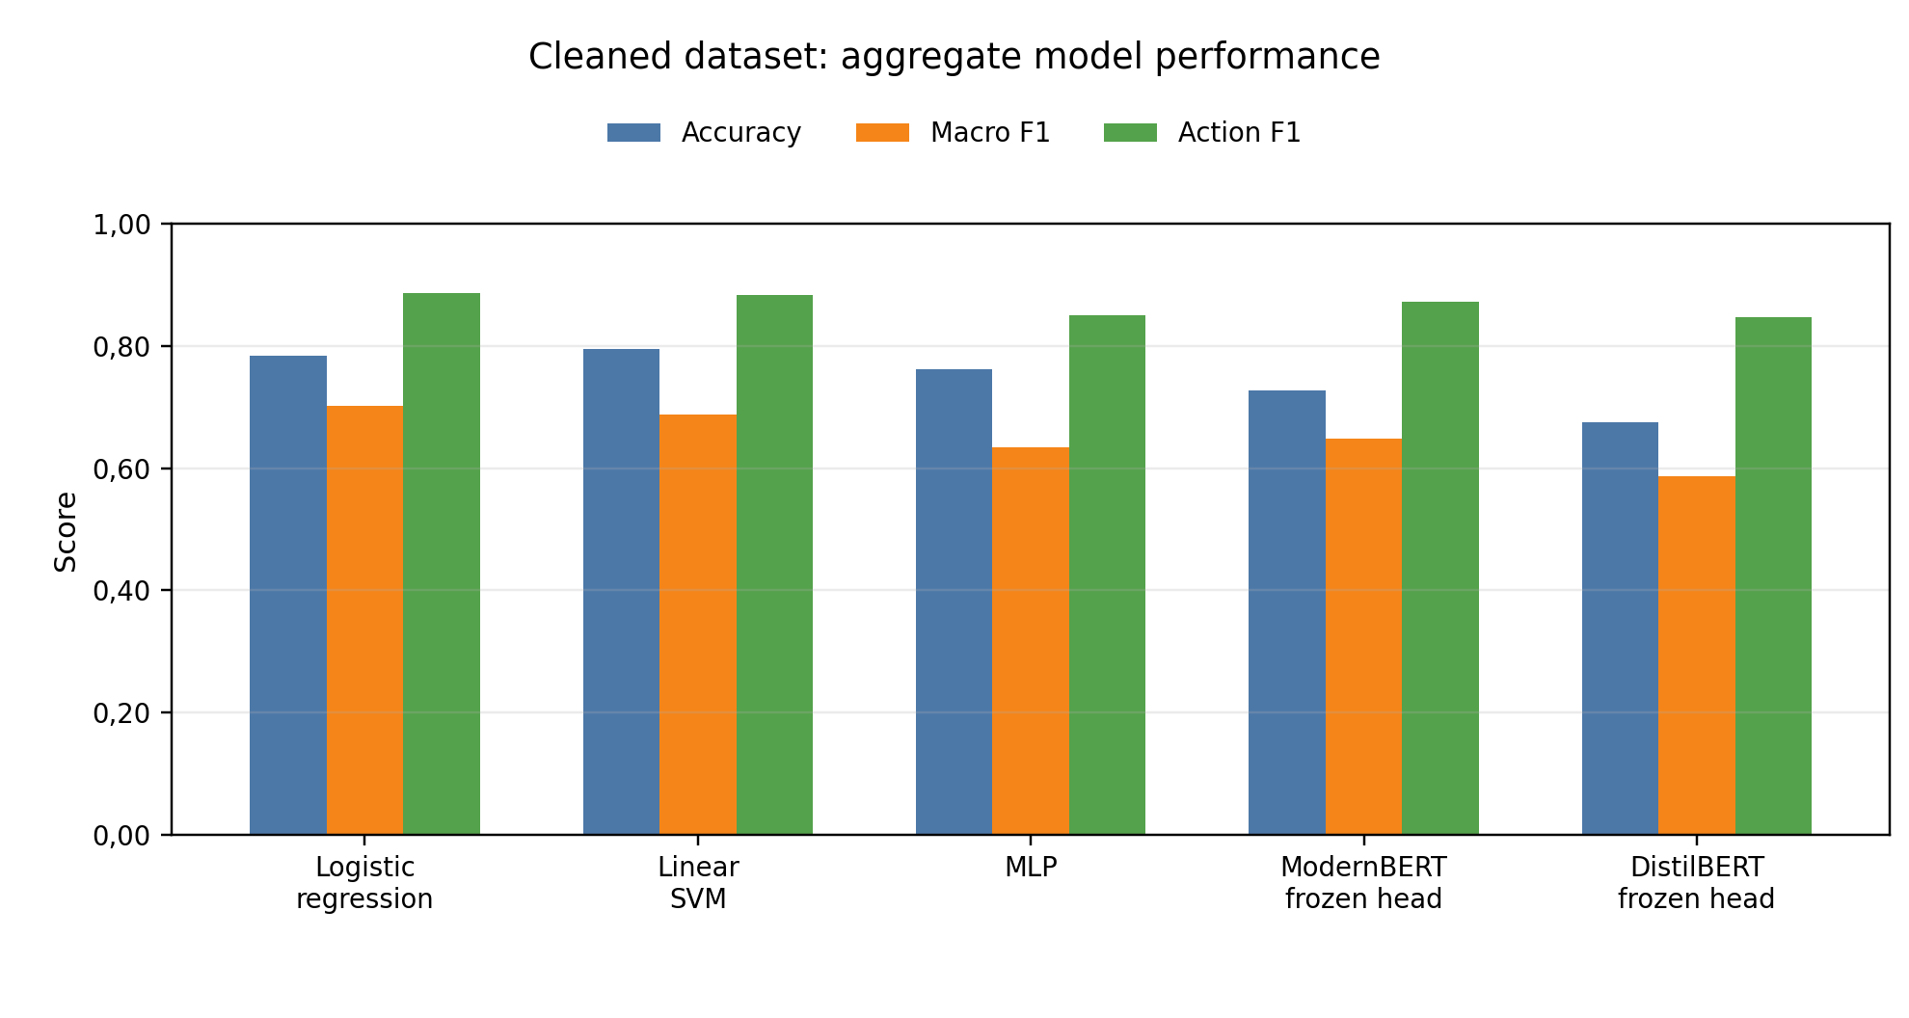
Cleaned-dataset comparison of all five models across accuracy, macro F1, and action F1. The two TF-IDF-based linear models achieve the strongest aggregate performance, while the frozen transformer feature extractors remain competitive on action detection but weaker on macro F1.
The two linear classical models achieve the strongest aggregate performance. Logistic regression reaches the best macro F1 (0,703) and action F1 (0,887), while the SVM reaches the best accuracy (0,795) and action precision (0,900). ModernBERT has the highest action recall (0,917), but this comes with lower precision and lower macro F1. The MLP, after balanced oversampling, occupies a middle position: it is more conservative than the transformers and less accurate than the two linear models. These cleaned-dataset results are the primary findings of this work.

Original Dataset Baseline and Cleanup Effects
Table 7 summarizes the secondary baseline on the original dataset (1.407 unique examples after content deduplication, 103 transcripts). These results are useful for quantifying the impact of cleanup, but they are not used as the primary basis for the later per-label and error analyses.
Five-fold cross-validation results on the original dataset. Bold indicates best per column.
Model | Accuracy | Macro F1 | Action F1
precision
recall
Linear SVM | 0,775$±$0,022 | 0,671$±$0,053 | 0,870$±$0,011 | 0,889$±$0,028 | 0,853$±$0,026
Logistic regression | 0,763$±$0,021 | 0,679$±$0,048 | 0,871$±$0,020 | 0,850$±$0,031 | 0,894$±$0,020
MLP (unbalanced) | 0,733$±$0,016 | 0,592$±$0,011 | 0,809$±$0,019 | 0,904$±$0,045 | 0,735$±$0,035
ModernBERT | 0,679$±$0,013 | 0,602$±$0,052 | 0,855$±$0,028 | 0,804$±$0,038 | 0,916$±$0,036
DistilBERT | 0,638$±$0,044 | 0,594$±$0,068 | 0,837$±$0,041 | 0,763$±$0,064 | 0,931$±$0,050
Table 8 isolates the effect of cleanup by comparing each model against the same configuration on the original dataset. For the MLP, this means the unbalanced MLP configuration is used in both rows; the separate effect of balanced oversampling is shown afterwards in Table 9.
Cleanup-only performance change (cleaned minus original). Positive values indicate improvement. The MLP row uses the unbalanced MLP configuration on both datasets, so the cleanup effect is not mixed with the later balancing change.
Model | $Δ$ Accuracy | $Δ$ Macro F1 | $Δ$ Action F1
Linear SVM | +0,020 | +0,017 | +0,014
Logistic regression | +0,022 | +0,024 | +0,016
ModernBERT | +0,048 | +0,047 | +0,017
DistilBERT | +0,038 | $-$0,006 | +0,011
MLP (unbalanced) | $-$0,006 | $-$0,019 | $-$0,005
Cleanup improved most model metrics, as visualized in Figure 4. ModernBERT gained +0,048 accuracy and +0,047 macro F1, compared to +0,022 and +0,024 for logistic regression. DistilBERT improved in accuracy and action F1 but decreased slightly in macro F1. The unbalanced MLP did not benefit from cleanup alone, which indicates that its earlier weakness was driven more by class-imbalance handling than by the specific noisy examples removed during cleanup.
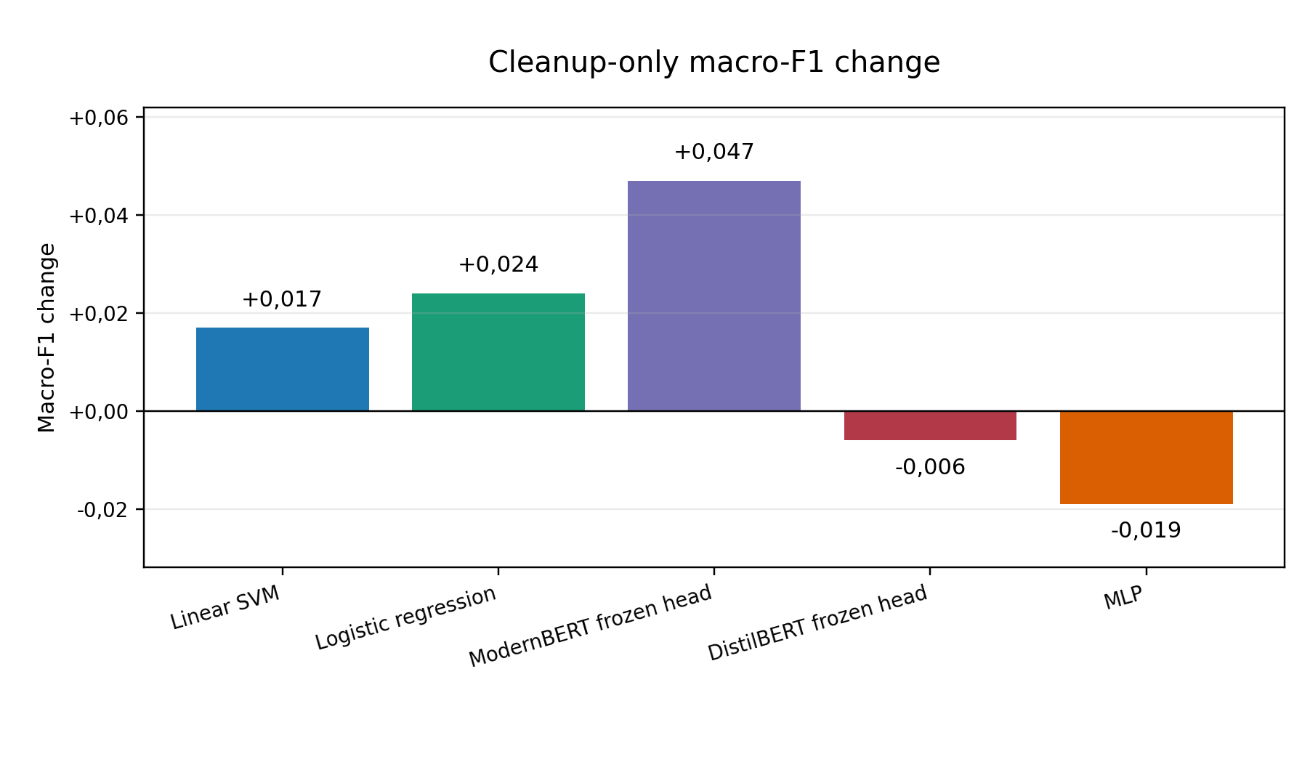
Cleanup-only change in macro F1. The MLP is shown in its unbalanced configuration so that the effect of cleanup is not conflated with the later addition of balanced oversampling.
Effect of balanced oversampling on the MLP after data cleanup. The values compare the unbalanced and balanced MLP configurations on the same cleaned, content-deduplicated dataset.
MLP configuration | Accuracy | Macro F1 | Action F1
Unbalanced MLP | 0,726 | 0,572 | 0,804
Balanced MLP | 0,763 | 0,634 | 0,850
Change | +0,036 | +0,062 | +0,046

Per-Label Performance
Table 10 shows the per-label precision, recall, and F1 for logistic regression on the cleaned dataset, aggregated across all five folds.
Per-label performance for logistic regression on the cleaned dataset.
Label | Precision | Recall | F1 | Support
NO_ACTION | 0,857 | 0,777 | 0,815 | 548
ENTER_LONG | 0,574 | 0,717 | 0,638 | 92
ENTER_SHORT | 0,614 | 0,618 | 0,616 | 144
TRIM | 0,786 | 0,835 | 0,810 | 242
EXIT_ALL | 0,811 | 0,861 | 0,835 | 244
MOVE_STOP | 0,818 | 0,862 | 0,839 | 94
MOVE_TO_BREAKEVEN | 0,800 | 0,308 | 0,444 | 13
A clear hierarchy of difficulty emerges. Management labels (TRIM, EXIT_ALL, MOVE_STOP) achieve F1 scores between 0,810 and 0,839, reflecting the use of explicit, distinctive keywords (“partial,” “taking profit,” “I’m out,” “move my stop”). Entry labels (ENTER_LONG, ENTER_SHORT) are considerably harder, with F1 scores around 0,62–0,64, because entry language is more varied and ambiguous (“let’s try it,” “here we go,” “small size long here”). The rarest class, MOVE_TO_BREAKEVEN, improves to F1 = 0,444 after cleanup but still has only 13 support examples, too few for reliable learning.
Table 11 presents the same breakdown for the SVM.
Per-label performance for SVM on the cleaned dataset.
Label | Precision | Recall | F1 | Support
NO_ACTION | 0,812 | 0,850 | 0,831 | 548
ENTER_LONG | 0,684 | 0,587 | 0,632 | 92
ENTER_SHORT | 0,676 | 0,521 | 0,588 | 144
TRIM | 0,797 | 0,860 | 0,827 | 242
EXIT_ALL | 0,829 | 0,857 | 0,843 | 244
MOVE_STOP | 0,833 | 0,851 | 0,842 | 94
MOVE_TO_BREAKEVEN | 0,750 | 0,231 | 0,353 | 13
The SVM shows a similar pattern but with a sharper precision-recall tradeoff on entry classes. It achieves higher precision on ENTER_LONG (0,684 versus 0,574 for logistic regression) but lower recall (0,587 versus 0,717), indicating that the maximum-margin criterion produces a more conservative decision boundary for these ambiguous classes.

Transformer Model Performance
Tables 12 and 13 present the per-label results for the two transformer models.
Per-label performance for DistilBERT on the cleaned dataset.
Label | Precision | Recall | F1 | Support
NO_ACTION | 0,825 | 0,637 | 0,719 | 548
ENTER_LONG | 0,441 | 0,565 | 0,495 | 92
ENTER_SHORT | 0,436 | 0,542 | 0,483 | 144
TRIM | 0,651 | 0,756 | 0,700 | 242
EXIT_ALL | 0,720 | 0,738 | 0,729 | 244
MOVE_STOP | 0,681 | 0,862 | 0,761 | 94
MOVE_TO_BREAKEVEN | 0,429 | 0,231 | 0,300 | 13
Per-label performance for ModernBERT on the cleaned dataset.
Label | Precision | Recall | F1 | Support
NO_ACTION | 0,855 | 0,712 | 0,777 | 548
ENTER_LONG | 0,516 | 0,533 | 0,524 | 92
ENTER_SHORT | 0,497 | 0,611 | 0,548 | 144
TRIM | 0,714 | 0,826 | 0,766 | 242
EXIT_ALL | 0,709 | 0,771 | 0,739 | 244
MOVE_STOP | 0,821 | 0,830 | 0,825 | 94
MOVE_TO_BREAKEVEN | 0,667 | 0,462 | 0,546 | 13
Both frozen transformer feature extractors show lower precision on entry classes than the two linear models. DistilBERT achieves 0,441 precision on ENTER_LONG (versus 0,574 for logistic regression), while ModernBERT reaches 0,516. The transformers do achieve relatively high recall on several action classes; DistilBERT detects 86,2% of MOVE_STOP actions, but the frequency of false positives lowers their macro F1.
ModernBERT achieves the highest F1 on MOVE_TO_BREAKEVEN (0,546), despite the extreme rarity of this class. This suggests that its contextual embeddings capture some semantic similarity between “breakeven” language and other stop-management language, although this advantage on one rare label does not translate into the best aggregate score.
Figure 5 consolidates the per-label F1 scores across all five models, making the difficulty hierarchy and model differences immediately visible.
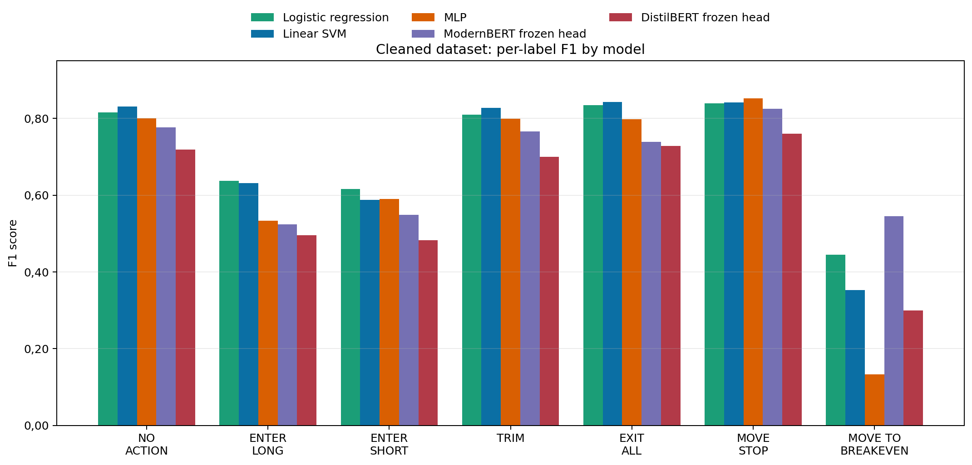
Per-label F1 scores across all five models on the cleaned dataset. Management labels (TRIM, EXIT, MOVE_STOP) are classified reliably across most models. Entry labels (ENTER_LONG, ENTER_SHORT) remain harder and show larger inter-model variation. MOVE_TO_BREAKEVEN remains unstable because only 13 examples are available.

Confusion Matrix Analysis
The confusion matrices (aggregated across all five folds on the cleaned dataset) reveal systematic error patterns. Table 14 presents the confusion matrix for logistic regression, the best model by macro F1 and action F1.
Confusion matrix for logistic regression (cleaned dataset, aggregated across folds). Rows are true labels; columns are predicted labels. NO = NO_ACTION, EL = ENTER_LONG, ES = ENTER_SHORT, TM = TRIM, EA = EXIT_ALL, MS = MOVE_STOP, MB = MOVE_TO_BREAKEVEN.
 | NO | EL | ES | TM | EA | MS | MB
NO | 426 | 25 | 31 | 26 | 32 | 7 | 1
EL | 6 | 66 | 14 | 5 | 1 | 0 | 0
ES | 33 | 15 | 89 | 6 | 1 | 0 | 0
TM | 15 | 4 | 7 | 202 | 12 | 2 | 0
EA | 11 | 3 | 4 | 12 | 210 | 4 | 0
MS | 4 | 2 | 0 | 4 | 3 | 81 | 0
MB | 2 | 0 | 0 | 2 | 0 | 5 | 4
Figure 6 visualizes this matrix as a heatmap, making the diagonal dominance and off-diagonal error patterns immediately apparent.
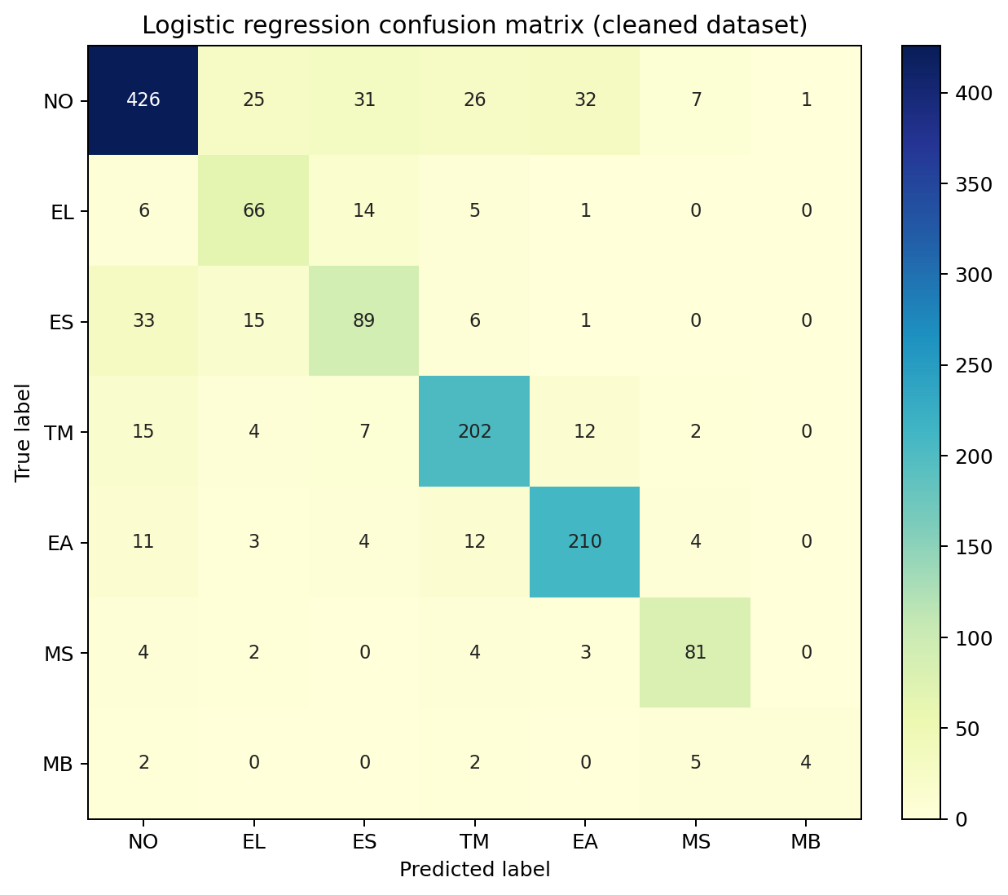
Confusion matrix for logistic regression on the cleaned dataset (aggregated across all five folds). The diagonal shows correct predictions. Off-diagonal entries reveal systematic errors: entry classes (EL, ES) are frequently confused with each other and with NO_ACTION, while management classes (TM, EA, MS) are classified more reliably.
Several error patterns are observed:
Entry-entry confusion. 14 of 92 true ENTER_LONG examples are misclassified as ENTER_SHORT; conversely, 15 of 144 true ENTER_SHORT examples are misclassified as ENTER_LONG. This reflects the fact that entry language is often structurally similar regardless of direction, differing only in a directional keyword (“long” versus “short”) that may be transcribed ambiguously or may be absent from the relevant text window.
Action-to-NO_ACTION leakage. Between 2 and 33 examples of each action class are misclassified as NO_ACTION. This occurs when the transcript segment contains an action but the language is too subtle or ambiguous for the classifier to detect. For example, a trader who says “I’m going to take a little off” rather than using the explicit keyword “partial.”
NO_ACTION-to-action false positives. 122 of 548 NO_ACTION examples (22,3%) are assigned an action label. This indicates that some non-action transcript segments contain language that superficially resembles action language, for example when the trader discusses a hypothetical trade, reviews a past action, or gives advice to viewers. Because the corpus has incomplete action coverage (Section 3.5), a small number of these apparent false positives may also be unlabelled actions.
MOVE_TO_BREAKEVEN misclassification. With only 13 support examples, this class remains unstable. Of the 13 true examples, 4 are classified correctly and 5 are misclassified as MOVE_STOP, an understandable confusion given that moving to breakeven is a specific type of stop adjustment.
The confusion matrices for the SVM and MLP (Tables 15 and 16) reveal instructive contrasts. The SVM produces a similar error pattern to logistic regression but with a more conservative profile: it assigns more examples to NO_ACTION at the cost of lower recall on entry classes. The balanced MLP also remains conservative on entries: 27 true ENTER_LONG and 50 true ENTER_SHORT examples are misclassified as NO_ACTION, even though the balancing correction improves its aggregate metrics relative to the unbalanced baseline.
Confusion matrix for SVM (cleaned dataset, aggregated across folds).
 | NO | EL | ES | TM | EA | MS | MB
NO | 466 | 10 | 15 | 23 | 29 | 4 | 1
EL | 17 | 54 | 15 | 5 | 1 | 0 | 0
ES | 47 | 12 | 75 | 8 | 1 | 1 | 0
TM | 20 | 1 | 1 | 208 | 10 | 2 | 0
EA | 16 | 0 | 3 | 12 | 209 | 4 | 0
MS | 4 | 2 | 1 | 5 | 2 | 80 | 0
MB | 4 | 0 | 1 | 0 | 0 | 5 | 3
Confusion matrix for balanced MLP (cleaned dataset, aggregated across folds).
 | NO | EL | ES | TM | EA | MS | MB
NO | 471 | 4 | 21 | 21 | 29 | 1 | 1
EL | 27 | 40 | 17 | 6 | 2 | 0 | 0
ES | 50 | 8 | 80 | 5 | 1 | 0 | 0
TM | 31 | 5 | 4 | 193 | 8 | 1 | 0
EA | 37 | 0 | 3 | 10 | 192 | 2 | 0
MS | 10 | 1 | 1 | 4 | 3 | 75 | 0
MB | 4 | 0 | 1 | 2 | 2 | 3 | 1
The transformer confusion matrices (Tables 17 and 18) reveal the opposite tendency: both models underpredict NO_ACTION while overpredicting action classes. DistilBERT correctly classifies 349 of 548 NO_ACTION examples and ModernBERT correctly classifies 390. DistilBERT misclassifies 56 NO_ACTION examples as ENTER_SHORT, 50 as TRIM, and 39 as EXIT_ALL; ModernBERT shows a similar but less pronounced pattern. This suggests that the frozen transformer embeddings and thin linear heads tend to err on the side of predicting an action.
Confusion matrix for DistilBERT (cleaned dataset, aggregated across folds).
 | NO | EL | ES | TM | EA | MS | MB
NO | 349 | 34 | 56 | 50 | 39 | 18 | 2
EL | 13 | 52 | 16 | 7 | 3 | 1 | 0
ES | 26 | 22 | 78 | 8 | 5 | 4 | 1
TM | 17 | 5 | 11 | 183 | 18 | 8 | 0
EA | 14 | 4 | 15 | 25 | 180 | 5 | 1
MS | 2 | 1 | 1 | 7 | 2 | 81 | 0
MB | 2 | 0 | 2 | 1 | 3 | 2 | 3
Confusion matrix for ModernBERT (cleaned dataset, aggregated across folds).
 | NO | EL | ES | TM | EA | MS | MB
NO | 390 | 23 | 56 | 28 | 41 | 8 | 2
EL | 12 | 49 | 22 | 6 | 3 | 0 | 0
ES | 26 | 16 | 88 | 5 | 5 | 3 | 1
TM | 9 | 5 | 4 | 200 | 23 | 1 | 0
EA | 16 | 0 | 5 | 32 | 188 | 3 | 0
MS | 3 | 2 | 1 | 6 | 4 | 78 | 0
MB | 0 | 0 | 1 | 3 | 1 | 2 | 6

Feature Importance Analysis
To understand why TF-IDF-based models outperform frozen transformers, the top logistic regression coefficients per class were extracted. Figure 7 shows the five highest-weighted TF-IDF features for three representative action classes.
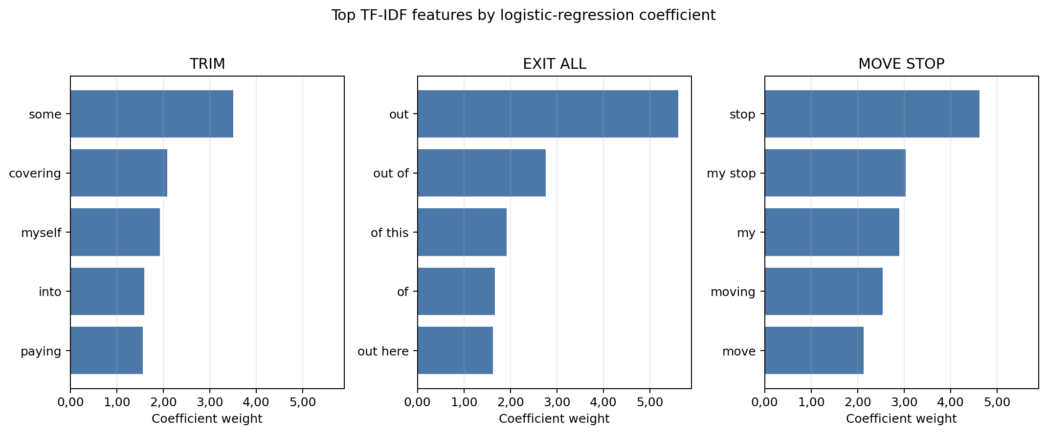
Top-5 TF-IDF features by logistic regression coefficient for three action classes. Each subplot shows the five most predictive words or bigrams for one class. A single token (“out”) dominates EXIT_ALL with weight +5,61, while “stop” dominates MOVE_STOP at +4,62. All subplots share the same x-axis scale, making the relative dominance of top features directly comparable across classes.
The feature weights reveal that trading action language is highly formulaic and keyword-driven. EXIT_ALL is dominated by a single token “out” (weight +5,61); MOVE_STOP by “stop” (+4,62); TRIM by “some” (+3,51). These sparse, high-signal features are directly captured by TF-IDF bigrams but are diluted in transformer embeddings where they are encoded alongside all other tokens in a dense 768-dimensional vector. The position-state features (position flat, position short) also carry high weight, indicating that the structured prompt design contributes meaningful classification signal.

Statistical Significance
Paired t-tests on per-fold macro F1 scores were conducted on the cleaned dataset, with all models in their final configuration (including balanced class weighting for the MLP). These tests are exploratory: only five paired observations are available, and no multiple-comparison correction is applied. The comparison between logistic regression and SVM yields $p=0,54$, so there is no evidence of a reliable difference between the two linear models. The linear models also do not significantly outperform the balanced MLP (logistic regression vs. MLP: $p=0,16$; SVM vs. MLP: $p=0,24$). Among the transformer comparisons, only logistic regression vs. DistilBERT reaches conventional significance ($p=0,014$); comparisons with ModernBERT remain non-significant (logistic regression vs. ModernBERT: $p=0,19$; SVM vs. ModernBERT: $p=0,44$).
The $p$-values for the classical-versus-transformer comparisons should be interpreted with the test design in mind. With only five folds, the paired $t$-test has four degrees of freedom, and its power to detect a moderate effect is limited. The mean scores favor TF-IDF-based linear models, but the fold-level picture is not uniform: ModernBERT achieves the highest macro F1 in one fold, and transformer models achieve the highest action recall in several folds. The feature-importance analysis (Section 4.6) and embedding visualization (Section 4.9) therefore provide supporting evidence for the aggregate performance gap, while the statistical tests caution against overstating fold-by-fold dominance.

MLP Performance with Balanced Class Weighting
The unbalanced MLP configuration resulted in a complete failure on the MOVE_TO_BREAKEVEN class (F1 = 0,000) and depressed recall across minority classes. Enabling the balanced oversampling step (Section 3.8) for the cleaned-dataset evaluation improved macro F1 from 0,572 to 0,634, action F1 from 0,804 to 0,850, and MOVE_TO_BREAKEVEN F1 from 0,000 to 0,133. Table 19 shows the per-label breakdown.
Per-label performance for the MLP with balanced class weighting (cleaned dataset).
Label | Precision | Recall | F1 | Support
NO_ACTION | 0,748 | 0,860 | 0,800 | 548
ENTER_LONG | 0,690 | 0,435 | 0,533 | 92
ENTER_SHORT | 0,630 | 0,556 | 0,590 | 144
TRIM | 0,801 | 0,798 | 0,799 | 242
EXIT_ALL | 0,810 | 0,787 | 0,798 | 244
MOVE_STOP | 0,915 | 0,798 | 0,852 | 94
MOVE_TO_BREAKEVEN | 0,500 | 0,077 | 0,133 | 13
Despite the improvement, the MLP still trails both linear models (logistic regression: macro F1 0,703; SVM: 0,688). The remaining gap is consistent with overfitting or inefficient use of capacity: with 5,4 million trainable parameters and only $∼$1.150 training examples per fold, the MLP’s additional flexibility does not translate into better generalization, even with early stopping. This finding is consistent with the broader observation that nonlinear models often require substantially more data to outperform well-regularized linear classifiers on high-dimensional sparse features (Kowsari et al. 2019).

Embedding Visualization
To investigate why frozen transformer feature extractors have lower aggregate scores than TF-IDF-based classifiers, t-SNE visualizations were generated from the frozen DistilBERT and ModernBERT encoders. For each model, all 1.377 cleaned, content-deduplicated examples were embedded using the same pipeline as the classification task (mean-pooled last hidden states, L2-normalized), and the resulting 768-dimensional vectors were projected to two dimensions using t-SNE with perplexity 30 and 1.000 iterations. Figures 8 and 9 show the results.
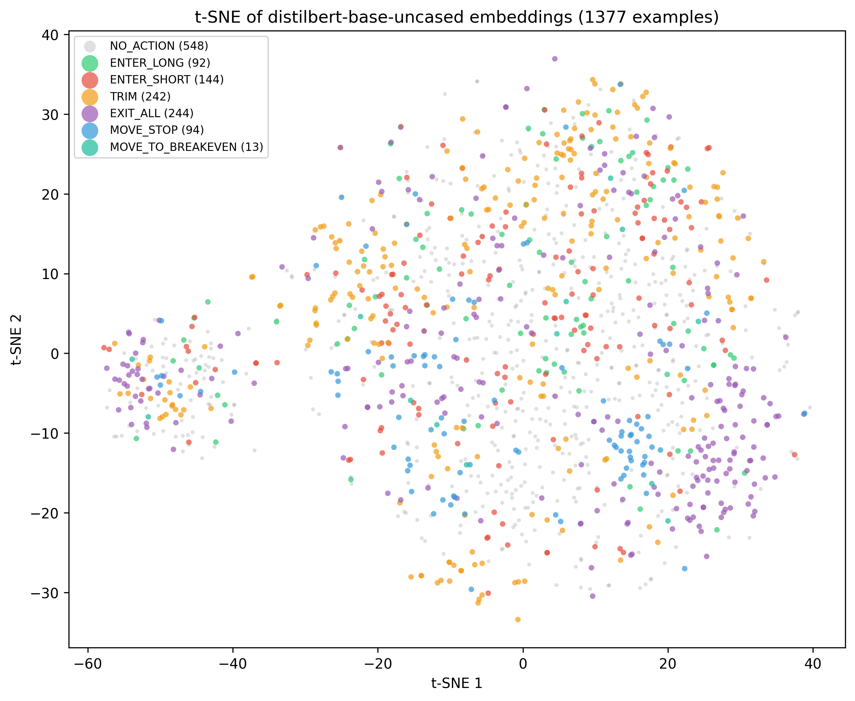
t-SNE projection of frozen DistilBERT embeddings (768-dimensional, mean-pooled) for all 1.377 cleaned, content-deduplicated examples, coloured by true label. No clear label-level clusters are visible; all seven classes are heavily intermixed in this two-dimensional projection.
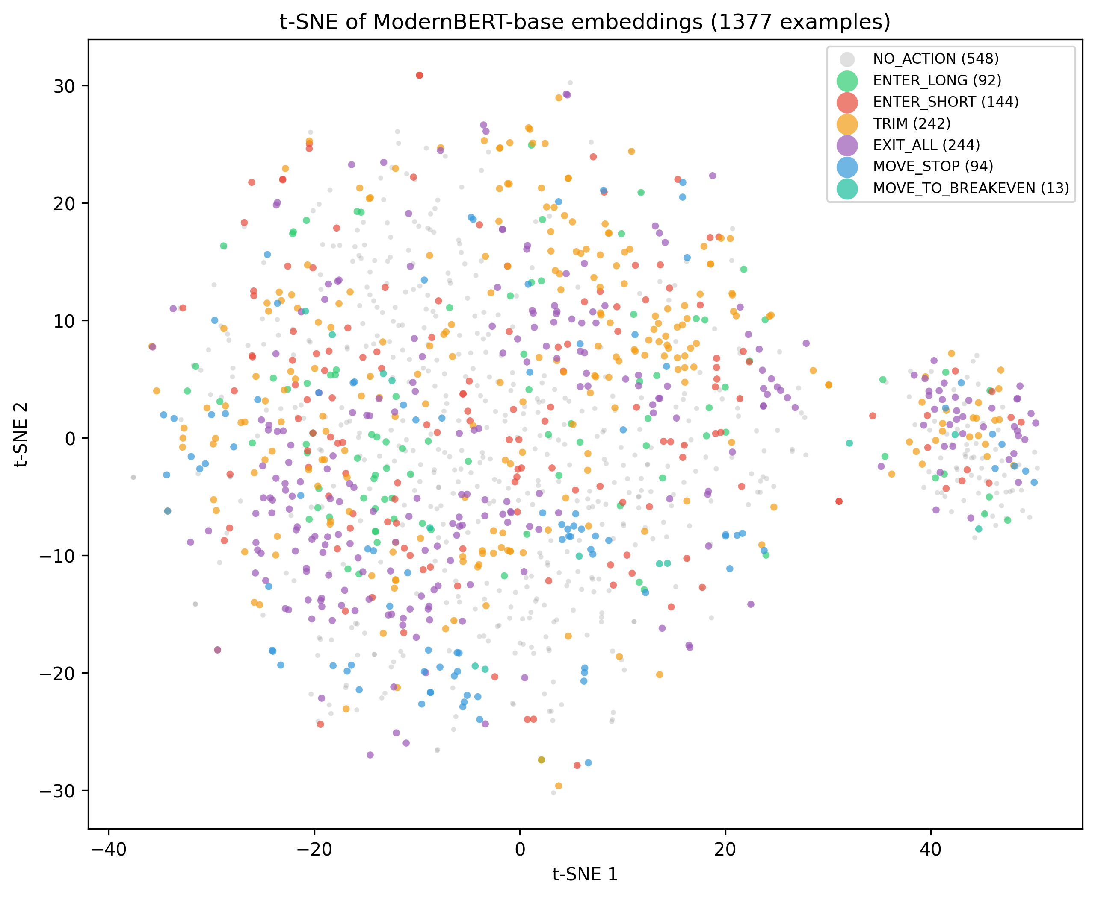
t-SNE projection of frozen ModernBERT embeddings for all 1.377 cleaned, content-deduplicated examples. The point cloud is even more uniform than DistilBERT’s, with less internal sub-structure. MOVE_STOP (blue) shows the most spatial coherence, consistent with its strong keyword signal.
Both plots show no clear label-level clustering in the two-dimensional projections. All seven classes are heavily intermixed: NO_ACTION is distributed across the projected space, and the action classes overlap strongly with each other and with NO_ACTION. Because t-SNE is a visualization method rather than a formal separability test, this evidence should be read as illustrative. It is nevertheless consistent with the weaker macro-F1 scores of the frozen transformer heads.
DistilBERT shows slightly more sub-structure, with loose groupings in certain regions, but these sub-clusters contain mixed labels and likely reflect transcript-level or syntactic similarity rather than semantic trading intent. ModernBERT produces an even more uniform point cloud with less internal structure. In both plots, MOVE_STOP shows the most coherent spatial grouping, consistent with its strong keyword signal: the word “stop” appears in nearly all examples of this class and appears to produce a distinctive embedding pattern even in general-purpose space.
This visualization is consistent with the feature-importance finding: the pretrained representations do not make the trading-intent distinctions easy for a thin linear head to use. A phrase like “peeling some off” (TRIM) and “watching for longs” (NO_ACTION) can be semantically close in general English but require different action labels. TF-IDF bigrams capture these distinctions as separate sparse features, while frozen BERT embeddings may place them near each other in a dense representation space.

Error Analysis
To characterize the practical failure modes of the best-performing model, a misclassification analysis was conducted using logistic regression’s five-fold cross-validation on the cleaned dataset. All test-set errors across folds were collected, totalling 299 misclassifications out of 1.377 examples (21,8% error rate). Because the dataset has incomplete action coverage, some apparent false positives against NO_ACTION may be ambiguous or weakly labelled rather than objectively wrong. Table 20 lists the ten most frequent error patterns.
Top 10 misclassification patterns for logistic regression on the cleaned dataset.
True Label | Predicted | Count | % of Errors
ENTER_SHORT | NO_ACTION | 33 | 11,0
NO_ACTION | EXIT_ALL | 32 | 10,7
NO_ACTION | ENTER_SHORT | 31 | 10,4
NO_ACTION | TRIM | 26 | 8,7
NO_ACTION | ENTER_LONG | 25 | 8,4
ENTER_SHORT | ENTER_LONG | 15 | 5,0
TRIM | NO_ACTION | 15 | 5,0
ENTER_LONG | ENTER_SHORT | 14 | 4,7
EXIT_ALL | TRIM | 12 | 4,0
TRIM | EXIT_ALL | 12 | 4,0
Examination of the misclassified examples reveals three dominant failure modes:
Indirect entry language. The most common error type (33 cases of ENTER_SHORT $→$ NO_ACTION) arises when traders describe entries using past-tense, implicit, or non-formulaic phrasing. For example, “I did enter short versus New York here” uses past tense; “I’ve re-entered versus flow zones now” uses an uncommon verb form; and “All right. In it scalp here” lacks an explicit directional keyword. The classifier has learned to trigger on formulaic patterns like “short here” or “small short,” and misses these variations.
Exit-adjacent commentary. The second pattern (32 cases of NO_ACTION $→$ EXIT_ALL) occurs when the model over-triggers on exit-related language in non-action segments. Typical examples include “Stopped me out by a point or two” (describing a past stop-out, not a live action), “Any push through 11s here. I’m out” (a conditional statement), and “There we build out this right shoulder” (technical analysis where “out” appears in a non-exit context). The strong weight of the keyword “out” (+5,61) makes the model sensitive to any occurrence, including non-action uses.
Advisory framing. The third pattern (26 cases of NO_ACTION $→$ TRIM) involves second-person advice to viewers that superficially resembles self-directed action: “Must be taking partials here, folks,” “Cover a little bit here into 600 just in case,” and “You can cover a piece here.” The keywords “partials,” “cover,” and “piece” are strong TRIM signals, but the second-person framing (“you can,” “folks”) indicates advice rather than a trade the speaker is executing. The current text normalization pipeline does not distinguish between first-person and second-person constructions.
These error patterns suggest specific directions for improvement: richer handling of verb tense and pronoun reference, conditional-versus-committed disambiguation, and explicit modelling of first-person versus second-person speech acts.

TF-IDF Vocabulary Size Ablation
A sensitivity analysis was conducted on the TF-IDF max_features parameter to verify that the default setting of 20.000 is appropriate and to determine the effective dimensionality of the feature space. Logistic regression was evaluated using five-fold cross-validation on the cleaned dataset at four vocabulary sizes. Table 21 presents the results.
Effect of TF-IDF vocabulary size on logistic regression performance (cleaned dataset, five-fold cross-validation).
max_features | Accuracy | Macro F1 | Action F1
5.000 | 0,781$±$0,021 | 0,700$±$0,044 | 0,885$±$0,024
10.000 | 0,785$±$0,021 | 0,703$±$0,045 | 0,887$±$0,024
20.000 | 0,785$±$0,021 | 0,703$±$0,045 | 0,887$±$0,024
50.000 | 0,785$±$0,021 | 0,703$±$0,045 | 0,887$±$0,024
Performance saturates at 10.000 features: increasing to 20.000 or 50.000 produces identical results. The actual vocabulary of the corpus (with unigrams and bigrams) contains approximately 10.000 unique features, so higher caps simply include no additional terms. Even 5.000 features capture 99,7% of the top performance, supporting the conclusion that the classification signal is concentrated in a compact set of domain-specific terms and that the 20.000-feature default is more than sufficient.

Discussion

Classical Models Outperform Frozen Transformer Heads
The most prominent finding of this work is that TF-IDF-based classical models, in particular logistic regression and SVM, outperform the frozen transformer-head models on the aggregate metrics emphasized in this study (accuracy, macro F1, and action F1). This result, while perhaps counter-intuitive given the dominance of transformers in recent NLP benchmarks, can be explained by three interacting factors.
First, the dataset is small. With approximately 1.400 labelled examples, the task provides limited training signal for any model, but the impact is asymmetric across architectures. The TF-IDF features are learned entirely from the training data and therefore automatically capture domain-specific terms and phrases. By contrast, the transformer encoders are frozen at their pretrained weights, which were learned from general-purpose corpora (English Wikipedia, book text, and web data for BERT/DistilBERT; English and code for ModernBERT). These general-purpose embeddings may not meaningfully distinguish between trading-specific phrases that are critical for classification. For example, “peeling some off” (a TRIM action) versus “taking this off” (which could be TRIM or EXIT_ALL depending on context).
Second, trading action language is highly formulaic. Traders tend to use a small set of recurring phrases to announce actions: “small long here,” “partial here,” “I’m out,” “move my stop to breakeven.” These formulaic patterns are efficiently captured by bigram TF-IDF features, which create dedicated dimensions for key phrases. The contextual modelling capacity of transformers, namely their ability to understand complex syntactic structures and long-range dependencies, provides little additional benefit for text that is inherently simple and repetitive.
Third, only the classification head is trained; the transformer encoder weights remain fixed. This design choice reflects the small dataset size and the scope of this thesis: full fine-tuning on 1.400 examples would require a separate regularization, early-stopping, and seed-stability study. In the present setup, the rich representational capacity of the transformer is not adapted to the task. The linear head can only learn a linear mapping from the pretrained embedding space to the label space, which may not be sufficient to separate the subtle distinctions between action classes in a general-purpose embedding space.
This explanation is supported by two complementary analyses. The feature importance analysis (Section 4.6) reveals that classification decisions are driven by a small number of highly weighted domain keywords: a single token (“out”) carries weight +5,61 for EXIT_ALL, while “stop” carries +4,62 for MOVE_STOP. These sparse, high-signal features are exactly what TF-IDF captures and what frozen general-purpose embeddings dilute. The t-SNE embedding visualization (Section 4.9) is consistent with this interpretation: when the frozen transformer embeddings of all 1.377 cleaned, content-deduplicated examples are projected to two dimensions, the seven classes are heavily intermixed rather than visually separated.
These results are consistent with broader findings in the literature. Several studies have observed that simple baselines remain competitive with deep learning on small or domain-specific text classification tasks (Kowsari et al. 2019). The present work adds a concrete data point in the novel domain of real-time trading speech.
An important caveat is in order: this study evaluates transformers exclusively in a feature-extraction setting (frozen encoder, trained head). The results therefore show that frozen pretrained embeddings do not outperform TF-IDF on this task — they do not show that transformers in general are inferior. A fully fine-tuned transformer, or one adapted via parameter-efficient methods like LoRA, might well close or reverse the performance gap. The frozen-encoder constraint was a deliberate choice given the small dataset size, but it means the comparison is between “fully task-adapted classical models” and “minimally task-adapted transformers,” which is not a level playing field for the transformers.

The Precision-Recall Tradeoff
The five models exhibit a clear spectrum along the precision-recall tradeoff for action classes on the cleaned dataset (Figure 10). The SVM and balanced MLP favor precision (0,900 and 0,898 action precision, respectively), while ModernBERT favors recall (0,917 action recall). Logistic regression occupies the most balanced position, with action precision 0,863 and action recall 0,914, giving it the strongest action F1.
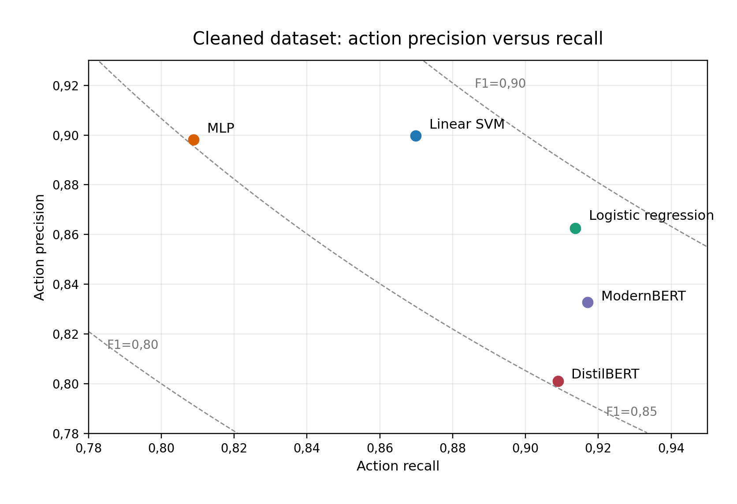
Action-class precision versus recall for all five models on the cleaned dataset. The SVM and balanced MLP favor precision, while ModernBERT favors recall. Logistic regression occupies the strongest balance by action F1. The dashed lines indicate constant F1.
This tradeoff has direct practical implications. In a trading system, the cost of a false positive (executing a trade that the trader did not intend) and the cost of a false negative (missing a trade that the trader did intend) may differ substantially depending on the deployment context. A system that prioritizes safety would favor a precision-leaning configuration such as SVM or the conservative MLP, accepting that some signals will be missed. A system that prioritizes completeness would favor high recall (the transformer models), accepting more false alarms. The balanced performance of logistic regression makes it the most versatile choice for general deployment.

Difficulty Hierarchy Across Label Classes
The per-label results reveal a consistent difficulty hierarchy across the five models:
- Easiest: Management labels (MOVE_STOP, EXIT_ALL, TRIM) with F1 $≈$ 0,70–0,85. These actions use explicit, distinctive vocabulary.
- Medium: NO_ACTION with F1 $≈$ 0,72–0,83. Performance varies across models because the boundary between “no action” and “subtle action” is inherently ambiguous.
- Hard: Entry labels (ENTER_LONG, ENTER_SHORT) with F1 $≈$ 0,48–0,64. Entry language is varied, often implicit, and direction-dependent.
- Hardest: MOVE_TO_BREAKEVEN with highly variable F1 (approximately 0,13–0,55 after cleanup, depending on model). Too few examples for reliable learning.
This hierarchy suggests specific strategies for improvement. Entry classification could benefit from additional training examples with diverse phrasing, as well as features that encode directional context more explicitly. The MOVE_TO_BREAKEVEN class requires a substantially larger number of labelled examples before any classifier can learn its patterns reliably; alternatively, it could be merged with the closely related MOVE_STOP class.

Implications for Production Deployment
The production system currently uses ModernBERT as its deployed classifier, a choice made before the systematic benchmarking reported in this work. The benchmark results suggest that replacing ModernBERT with a logistic regression or SVM classifier trained on TF-IDF features would likely improve standalone benchmark performance. Whether that improvement carries over to live deployment must be tested end to end.
However, deployment involves considerations beyond classification accuracy. The transformer-based pipeline has the advantage of a simple deployment artifact: a single classifier_head.safetensors file that loads at startup, combined with a frozen encoder already available through the Hugging Face Transformers library. A TF-IDF-based pipeline would additionally require serializing and loading the fitted TfidfVectorizer (which stores the complete vocabulary mapping), introducing a deployment dependency not present in the current setup.
In the production system, the machine learning classifier is one of several classification layers. The rule engine (with over 100 regex patterns) provides the primary classification, and the ML classifier adds confidence scores to filter false positives. In this supporting role, even the moderate accuracy of the ModernBERT classifier may be sufficient, as its errors are partially compensated by the rule engine. A thorough evaluation of end-to-end system accuracy, including the rule engine and optional LLM fallback, would be needed to determine whether the classifier swap would improve overall system performance.

Ethical, Legal, and Operational Risk
The application context raises risks that are separate from classification accuracy. A false positive in a trade-copying system is not merely a labelling error; if connected to execution infrastructure, it could create an unintended market order. Any production deployment should therefore keep human override controls, confidence thresholds, stale-signal checks, position-size limits, and audit logs in place. The evaluation in this thesis measures text classification only and should not be interpreted as evidence that fully automated execution is safe.
The data source also requires care. Livestream transcripts are public-facing media, but automated collection and reuse may still be constrained by platform terms, copyright, or streamer-specific expectations. This thesis uses archived transcripts for research and reproducibility, but an operational system should verify that its collection, storage, and use of transcript data are permitted. Finally, detected trade signals should not be presented as financial advice. The system classifies what a speaker appears to say; it does not evaluate whether the trade is suitable, lawful, or economically sound.

Limitations
Several limitations of this work should be acknowledged:
Dataset size and benchmark composition. At 1.442 cleaned examples across 103 transcripts, the dataset is small. After content-level deduplication, the primary evaluation contains 1.377 examples. The corpus is also action-enriched relative to a full livestream: it contains selected labelled lines rather than every speech segment. The results may not generalize to larger or more naturally distributed datasets, and the relative performance of classical versus transformer models may reverse with substantially more training data, particularly if full fine-tuning of the transformer encoders becomes feasible.
Single domain. All transcripts are from a single daytrading style (micro E-mini Nasdaq futures) and a limited number of individual traders. Different traders, instruments, or trading styles may use different language patterns that require separate model training.
Frozen encoders. The transformer models were evaluated exclusively with frozen encoder weights. Full fine-tuning, parameter-efficient fine-tuning (e.g., LoRA), or continued pretraining on trading-domain text might substantially improve their performance but were not explored.
AI-assisted labels and incomplete action coverage. The training labels were initially generated by large language models and then reviewed by the author, with the manual label verification described in Section 3.5. However, action coverage is incomplete: not every trade action is labelled, and some NO_ACTION examples may contain repeated, weak, or continuation-style actions. Two accepted labels were ambiguous, and systematic biases in which actions were selected for labelling may influence the class distribution and the measured false-positive rate.
Temporal dynamics. The current classification approach treats each transcript segment independently. In practice, trading actions occur in sequences (entry $→$ management $→$ exit), and a model that explicitly models these temporal dependencies could achieve higher accuracy.

Future Work
Several directions for future work emerge from the findings and limitations of this study:
Full fine-tuning with more data. The most direct path to improving transformer performance would be to expand the labelled dataset, ideally to several thousand examples across multiple traders, and then fine-tune the full encoder rather than freezing it. With 5.000–10.000 examples, the risk of overfitting during full fine-tuning would be manageable with standard regularization techniques (dropout, weight decay, learning rate warmup), and the pretrained representations could be adapted to the trading domain.
Parameter-efficient fine-tuning. Methods such as LoRA (Low-Rank Adaptation) allow adapting a pretrained model by training only a small number of additional parameters, offering a middle ground between frozen-encoder feature extraction and full fine-tuning. This approach could be feasible even with the current dataset size and would test whether partial adaptation of the transformer is sufficient to close the performance gap with TF-IDF models.
Sequence-level modelling. Incorporating sequential dependencies between transcript segments, for example through a conditional random field (CRF) layer on top of the per-segment classifier or through a sequence-to-sequence model that predicts entire trading sessions, could reduce errors caused by classifying segments in isolation. A model that knows the trader is currently long could suppress ENTER_LONG predictions and boost management predictions, using the trading state as an explicit constraint.
Domain-specific pretraining. Continued pretraining of the encoder on a large corpus of unlabelled trading transcripts (which are freely available on YouTube) could adapt the embeddings to trading vocabulary and reduce the distributional mismatch between general-purpose pretraining data and the classification domain.
Realistic full-stream evaluation. A separate evaluation set should be built from complete livestream transcripts, including all speech segments and therefore the true prevalence of non-action commentary. This would quantify how the classifier behaves under production-like class balance and would clarify how much the action-enriched benchmark overstates precision or recall.
End-to-end system evaluation. The classification task was studied in isolation. A full evaluation of the production system, including the rule engine, the ML classifier, and the optional LLM fallback, would provide a more complete picture of real-world accuracy and would clarify whether the improvements from swapping the classifier would survive the multi-layer decision pipeline.

Summary
This work addressed the question of which machine learning approach provides the most accurate trade-intent classification from noisy livestream transcripts, comparing classical TF-IDF-based methods with frozen transformer feature extractors.
Question. Given a short transcript segment from a daytrading livestream and the current trading context, which model family best predicts the trader’s intended action from a set of seven classes (no action, enter long, enter short, trim, exit all, move stop, move to breakeven)? Which action classes are most and least amenable to automated detection, and what systematic error patterns emerge?
Procedure. A labelled dataset of 1.442 examples from 103 YouTube livestream transcripts was constructed using AI-assisted labelling with human review and data cleanup. The primary evaluation uses 1.377 examples after content-level deduplication. The raw labels were generated by three large language models (Claude Sonnet, Gemini Pro, Gemini Flash) and then individually reviewed by the author. Label quality was verified through manual inspection of 203 action labels across 10 transcripts; 202 labels were judged correct or acceptable, zero were clearly incorrect, and two accepted labels were marked as ambiguous. A spot check also identified incomplete action coverage, so the benchmark is action-enriched and should not be read as a complete full-stream dataset. Five models were compared under identical transcript-level folds: three classical approaches (logistic regression, SVM, and MLP, all on TF-IDF features with up to 20.000 unigram and bigram features) and two transformer-based approaches (DistilBERT with 66 million parameters and ModernBERT with 149 million parameters, both used as frozen encoders with trained linear classification heads). Evaluation used five-fold cross-validation with transcript-level splits to prevent data leakage, with training-set rebalancing to mitigate class imbalance.
Results. On the cleaned dataset, logistic regression achieved the best macro F1 (0,703) and action F1 (0,887), while the SVM achieved the best accuracy (0,795) and action precision (0,900). ModernBERT achieved the highest action recall (0,917) but lower precision and macro F1. The MLP, after the addition of balanced oversampling, improved from macro F1 0,572 to 0,634 but still trailed both linear models. Data cleanup improved most model metrics, but the MLP’s improvement came primarily from balanced oversampling rather than cleanup alone. Feature importance analysis indicates that classification is driven by a small number of domain-specific keywords, and t-SNE visualization of frozen transformer embeddings is consistent with weak label-level separability in the pretrained embedding space. An error analysis of misclassified examples identified three dominant failure modes: indirect entry language missed by the classifier, exit-adjacent commentary triggering false positives, and second-person advice mistaken for self-directed action. A TF-IDF vocabulary ablation showed that performance saturates at 10.000 features, consistent with the compact and formulaic nature of trading action language. Exploratory paired t-tests found no reliable difference between the two linear models ($p=0,54$); among transformer comparisons, only logistic regression versus DistilBERT reached conventional significance ($p=0,014$).
These results show that for small, domain-specific text classification tasks with formulaic language patterns, classical machine learning methods operating on TF-IDF features remain highly competitive. The added complexity of pretrained transformer feature extraction does not translate to better performance when the encoder is frozen and the training set is small.
For practitioners facing similar tasks — classification on small, domain-specific, and often noisy corpora with formulaic target language — these findings suggest starting with simple, well-understood baselines before investing in more complex architectures. The dominance of pretrained transformers on standard benchmarks does not automatically transfer to every setting; when the encoder cannot be fine-tuned and the classification signal concentrates in a small set of domain keywords, a TF-IDF model with a balanced linear classifier remains a competitive, interpretable, and straightforward-to-deploy choice.
The source code, training data pipeline, benchmark scripts, and archived transcripts for this work are publicly available at https://github.com/AndiCodesss/stream_copier, enabling inspection and reproduction of the reported benchmark pipeline.
Bollen, Johan, Huina Mao, and Xiaojun Zeng. 2011. “Twitter Mood Predicts the Stock Market.” Journal of Computational Science 2 (1): 1–8.
Bucilă, Cristian, Rich Caruana, and Alexandru Niculescu-Mizil. 2006. “Model Compression.” In Proceedings of the 12th ACM SIGKDD International Conference on Knowledge Discovery and Data Mining, 535–41.
Chawla, Nitesh V, Kevin W Bowyer, Lawrence O Hall, and W Philip Kegelmeyer. 2002. “SMOTE: Synthetic Minority over-Sampling Technique.” Journal of Artificial Intelligence Research 16: 321–57.
Cortes, Corinna, and Vladimir Vapnik. 1995. “Support-Vector Networks.” Machine Learning 20 (3): 273–97.
Dao, Tri, Dan Y Fu, Stefano Ermon, Atri Rudra, and Christopher Ré. 2022. “FlashAttention: Fast and Memory-Efficient Exact Attention with IO-Awareness.” Advances in Neural Information Processing Systems 35.
Devlin, Jacob, Ming-Wei Chang, Kenton Lee, and Kristina Toutanova. 2019. “BERT: Pre-Training of Deep Bidirectional Transformers for Language Understanding.” In Proceedings of the 2019 Conference of the North American Chapter of the Association for Computational Linguistics: Human Language Technologies, 4171–86.
Goodfellow, Ian, Yoshua Bengio, and Aaron Courville. 2016. Deep Learning. MIT Press.
Hinton, Geoffrey, Oriol Vinyals, and Jeff Dean. 2015. “Distilling the Knowledge in a Neural Network.” arXiv Preprint arXiv:1503.02531.
Hosmer, David W, Stanley Lemeshow, and Rodney X Sturdivant. 2013. Applied Logistic Regression. 3rd ed. John Wiley & Sons.
Hu, Minqing, and Bing Liu. 2004. “Mining and Summarizing Customer Reviews.” In Proceedings of the Tenth ACM SIGKDD International Conference on Knowledge Discovery and Data Mining, 168–77. ACM.
Joachims, Thorsten. 1998. “Text Categorization with Support Vector Machines: Learning with Many Relevant Features.” In European Conference on Machine Learning, 137–42. Springer.
Kingma, Diederik P, and Jimmy Ba. 2015. “Adam: A Method for Stochastic Optimization.” arXiv Preprint arXiv:1412.6980.
Kohavi, Ron. 1995. “A Study of Cross-Validation and Bootstrap for Accuracy Estimation and Model Selection.” In Proceedings of the 14th International Joint Conference on Artificial Intelligence, 2:1137–43.
Kowsari, Kamran, Kiana Jafari Meimandi, Mojtaba Heidarysafa, Sanjana Mendu, Laura Barnes, and Donald Brown. 2019. “Text Classification Algorithms: A Survey.” Information 10 (4): 150.
Loshchilov, Ilya, and Frank Hutter. 2019. “Decoupled Weight Decay Regularization.” arXiv Preprint arXiv:1711.05101.
Loughran, Tim, and Bill McDonald. 2011. “When Is a Liability Not a Liability? Textual Analysis, Dictionaries, and 10-Ks.” The Journal of Finance 66 (1): 35–65.
Manning, Christopher D, Prabhakar Raghavan, and Hinrich Schütze. 2008. Introduction to Information Retrieval. Cambridge University Press.
Mikolov, Tomas, Ilya Sutskever, Kai Chen, Greg S Corrado, and Jeff Dean. 2013. “Distributed Representations of Words and Phrases and Their Compositionality.” In Advances in Neural Information Processing Systems. Vol. 26.
Paszke, Adam, Sam Gross, Francisco Massa, Adam Lerer, James Bradbury, Gregory Chanan, Trevor Killeen, et al. 2019. “PyTorch: An Imperative Style, High-Performance Deep Learning Library.” Advances in Neural Information Processing Systems 32.
Pedregosa, Fabian, Gaël Varoquaux, Alexandre Gramfort, Vincent Michel, Bertrand Thirion, Olivier Grisel, Mathieu Blondel, et al. 2011. “Scikit-Learn: Machine Learning in Python.” Journal of Machine Learning Research 12: 2825–30.
Pennington, Jeffrey, Richard Socher, and Christopher D Manning. 2014. “GloVe: Global Vectors for Word Representation.” In Proceedings of the 2014 Conference on Empirical Methods in Natural Language Processing, 1532–43.
Percha, Bethany. 2021. “Modern Clinical Text Mining: A Guide and Review.” Annual Review of Biomedical Data Science 4: 165–87.
Peters, Matthew E, Mark Neumann, Mohit Iyyer, Matt Gardner, Christopher Clark, Kenton Lee, and Luke Zettlemoyer. 2018. “Deep Contextualized Word Representations.” In Proceedings of the 2018 Conference of the North American Chapter of the Association for Computational Linguistics: Human Language Technologies, 2227–37.
Platt, John C. 1999. “Probabilistic Outputs for Support Vector Machines and Comparisons to Regularized Likelihood Methods.” In Advances in Large Margin Classifiers, edited by Alexander J Smola, Peter L Bartlett, Bernhard Schölkopf, and Dale Schuurmans, 61–74. MIT Press.
Radford, Alec, Jong Wook Kim, Tao Xu, Greg Brockman, Christine McLeavey, and Ilya Sutskever. 2023. “Robust Speech Recognition via Large-Scale Weak Supervision.” In Proceedings of the 40th International Conference on Machine Learning, 202:28492–518. PMLR.
Ratner, Alexander, Stephen H Bach, Henry Ehrenberg, Jason Fries, Sen Wu, and Christopher Ré. 2017. “Snorkel: Rapid Training Data Creation with Weak Supervision.” Proceedings of the VLDB Endowment 11 (3): 269–82.
Salton, Gerard, and Christopher Buckley. 1988. “Term-Weighting Approaches in Automatic Text Retrieval.” Information Processing & Management 24 (5): 513–23.
Sanh, Victor, Lysandre Debut, Julien Chaumond, and Thomas Wolf. 2019. “DistilBERT, a Distilled Version of BERT: Smaller, Faster, Cheaper and Lighter.” arXiv Preprint arXiv:1910.01108.
Sokolova, Marina, and Guy Lapalme. 2009. “A Systematic Analysis of Performance Measures for Classification Tasks.” Information Processing & Management 45 (4): 427–37.
Su, Jianlin, Murtadha Ahmed, Yu Lu, Shengfeng Pan, Wen Bo, and Yunfeng Liu. 2024. “RoFormer: Enhanced Transformer with Rotary Position Embedding.” Neurocomputing 568: 127063.
Vaswani, Ashish, Noam Shazeer, Niki Parmar, Jakob Uszkoreit, Llion Jones, Aidan N Gomez, Łukasz Kaiser, and Illia Polosukhin. 2017. “Attention Is All You Need.” In Advances in Neural Information Processing Systems. Vol. 30.
Wankhade, Mayur, Annavarapu Chandra Sekhara Rao, and Chaitanya Kulkarni. 2022. “A Survey on Sentiment Analysis Methods, Applications, and Challenges.” Artificial Intelligence Review 55 (7): 5731–80.
Warner, Benjamin, Antoine Chaffin, Benjamin Clavié, Orion Weller, Oskar Hallström, Said Taghadouini, Alexis Gallagher, et al. 2024. “Smarter, Better, Faster, Longer: A Modern Bidirectional Encoder for Fast, Memory Efficient, and Long Context Finetuning and Inference.” arXiv Preprint arXiv:2412.13663.
Wolf, Thomas, Lysandre Debut, Victor Sanh, Julien Chaumond, Clement Delangue, Anthony Moi, Pierric Cistac, et al. 2020. “Transformers: State-of-the-Art Natural Language Processing.” In Proceedings of the 2020 Conference on Empirical Methods in Natural Language Processing: System Demonstrations, 38–45.
Xing, Frank Z, Erik Cambria, and Roy E Welsch. 2018. “Natural Language Based Financial Forecasting: A Survey.” Artificial Intelligence Review 50 (1): 49–73.
Yang, Yi, Mark Christopher Siy Uy, and Allen Huang. 2020. “FinBERT: A Pretrained Language Model for Financial Communications.” arXiv Preprint arXiv:2006.08097.

