Andi Elezi gr A1

**Detyra A**

**1) Krijimi I viewve pa informacione personale**

*create VIEW ae_v_employee as Select department_id,salary from employees*

*create VIEW ae_v_departments as Select department_id,department_name from departments*

**2)Krijimi I view nga bashkimi I dy viewve te mesiperme**

*Create view ae_v_employees_departments as*

*SELECT ae_v_departments.department_id,ae_v_departments.department_name,Count(*) as nrPuntorve,Sum(salary) as totali FROM ae_v_departments*

*inner join ae_v_employee on*

*ae_v_departments.department_id=ae_v_employee.department_id GROUP BY (ae_v_departments.department_id,ae_v_departments.department_name)*

**3,4)Fotot E viewve te krijuara**

View ae_v_employee

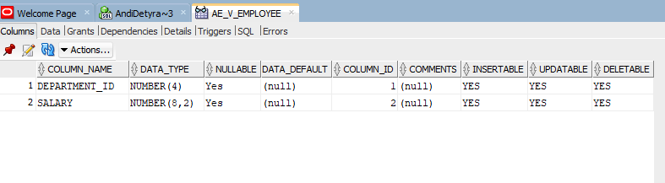

View ae_v_department

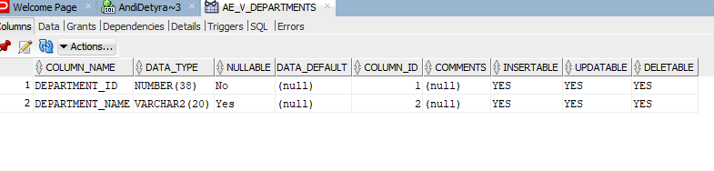

View ae_v_employee_department

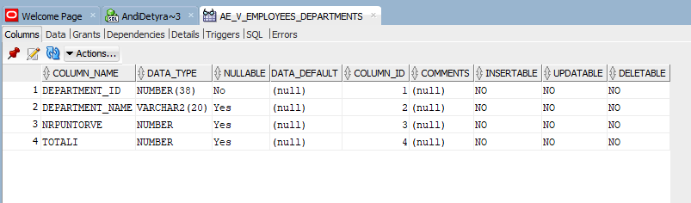

**Detyra B**

**1)krijimi I dy sesioneve**

**2) Krijimi I sekuences**

*create SEQUENCE ae_sekuenca*

*MINVALUE 10*

*START WITH 10*

*INCREMENT BY 1*

*MAXVALUE 15*

*NOCACHE;*

**3)Alternimi I sekuences**

1-select ae_sekuenca.nextval from dual

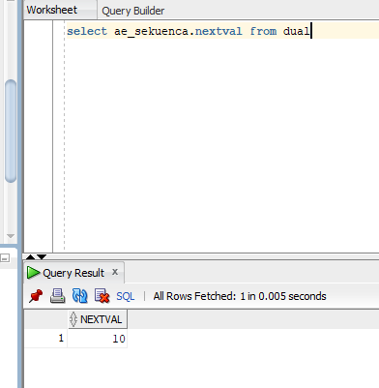

2-select Andi.ae_sekuenca.nextval from dual

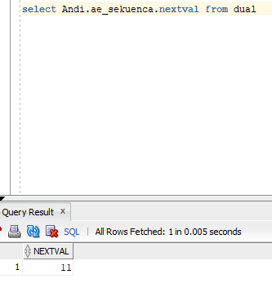

3-select ae_sekuenca.nextval from dual

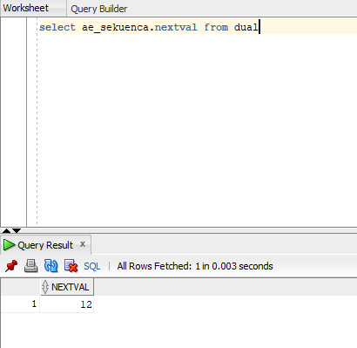

4-select Andi.ae_sekuenca.nextval from dual

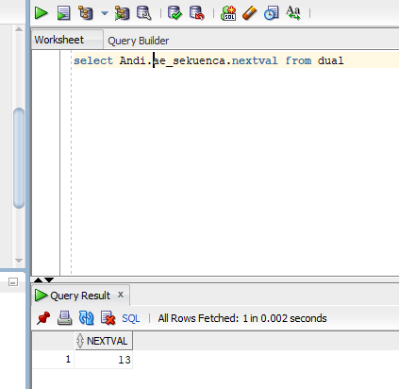

5-select ae_sekuenca.currval from dual

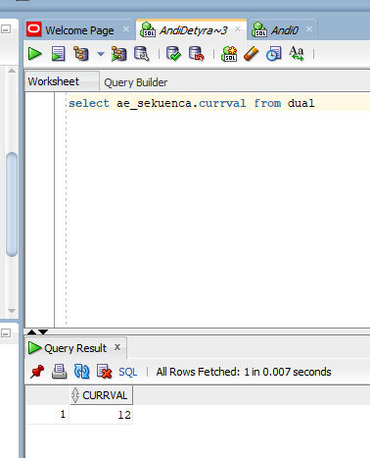

6-select Andi.ae_sekuenca.nextval from dual

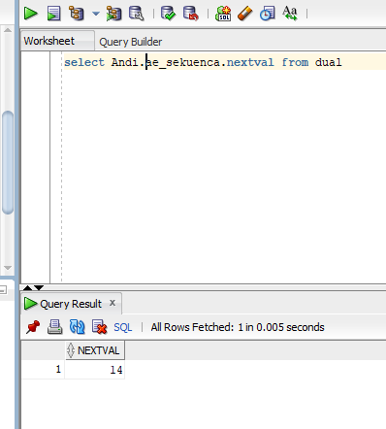

7-select ae_sekuenca.nextval from dual

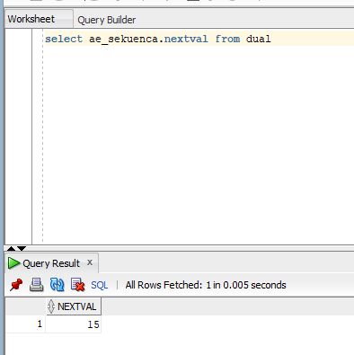

8-select Andi.ae_sekuenca.currval from dual

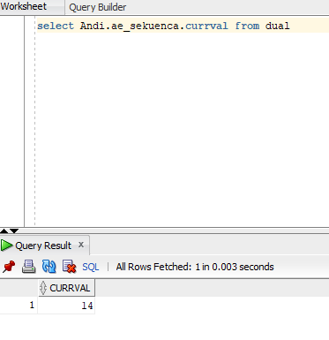

9-select ae_sekuenca.nextval from dual

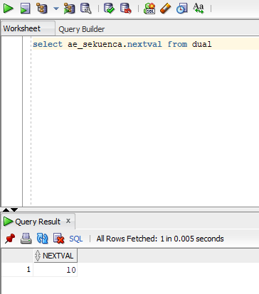

10-select Andi.ae_sekuenca.nextval from dual

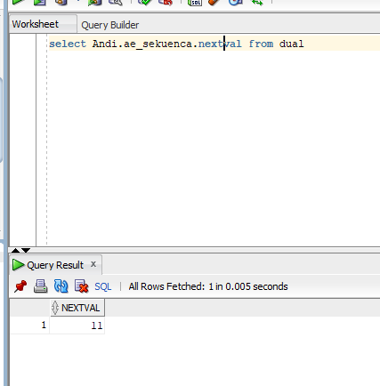

**4)krijimi tabeles sekuenceTab**

*CREATE TABLE SekuenceTab( s1 number primary key, s2 varchar2(10) )*

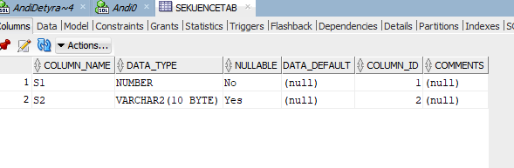

**5)krijimi I sekuences**

*create SEQUENCE ae_sekuenca_primare*

*MINVALUE 0*

*START WITH 0*

*INCREMENT BY 1*

*NOCYCLE*

*NOCACHE;*

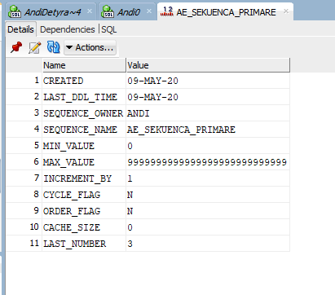

**6) vendosja e nje te dhene ne sesionin e pare dhe dhenia commit**

*insert into sekuenceTab values(AE_SEKUENCA_PRIMARE.nextval,'Andi');*

*commit;*

**7) vendosja e nje te dhene ne sesionin e dyte**

*insert into Andi.sekuenceTab values(Andi.AE_SEKUENCA_PRIMARE.nextval,'Andi1');*

**8) vendosje e nje te dhene ne sesionin pare**

*insert into sekuenceTab values(AE_SEKUENCA_PRIMARE.nextval,'Andi2');*

*commit;*

**9)Ekzekutimi Rollback**

*ROLLBACK*

**10) shikimi Tabeles**

