# Release Information

|  |  |
| --- | --- |
| *Release* | *1* |
| *Leader* | *Logan* |
| *SVN Revision Number* | *1.0* |

In our initial release we created the ability for a user to login and create an account, to create a new expense, to enter actual and projected income, to see their account balance and their transaction history.

# Progress

|  |  |  |  |
| --- | --- | --- | --- |
| **Stories and spike solutions worked on during this release** | | | |
| **Story, Spike** | **Description** | **% Impl.** | **Notes, plan for completion** |
| *SNAL-1* | *Created a login form, user class, and a database* | *100* | *Potential updates to the database* |
| *SNAL-5* | *Created an expense class and a form to enter an expense* | *90* | *Category class is not implemented yet because it’s its own story* |
| *SNAL-2* | *Created a textbox on the form to enter projected income* | *100* |  |
| *SNAL-3* | *Created a textbox on the form to enter actual income* | *100* |  |
| *SNAL-4* | *Created a function to update the balance when a change has occurred to actual income or a new expense. It’s then displayed on the form* | *100* |  |
| *SNAL-16* | *Created a list of transactions to be displayed on the form* | *100* | *Only displays the 10 most previously entered transactions* |
| *SNAL-21* | *User can enter their pay period so the system can track income on a period basis* | *0* | *Pushing to iteration 2* |

|  |  |  |
| --- | --- | --- |
| **Accomplishments by engineer** | | |
| **Team Member** | **Total Time (hrs)** | **Stories, Spikes implemented** |
| *Andi* | *9.08* | *SNAL-5* |
| *Sammy* | *10.95* | *SNAL-3*  *SNAL-4* |
| *Nathan* | *17.1* | *SNAL-2*  *SNAL-16* |
| *Logan* | *15* | *SNAL-1* |
| TEAM TOTAL | ***52.13*** |  |

|  |  |
| --- | --- |
| **Document updates** | |
| **Document** | **Changes** |
| *ClassDiagramIteration1.docx* | *Updated CDD for current understanding of system* |
| *README.txt* | *Updated for iteration 1* |

# Issues

Document anything that is not decided yet and needs to be resolved at some point.

|  |  |  |  |  |
| --- | --- | --- | --- | --- |
| **Issue Number** | **Discovery**  **Date** | **Resolution**  **Date (Est.–Act.)** | **Responsible Person** | **Description (Prob / Resolution)** |
| 1 | 3/8 | 3/11 | Nathan | Pushed changes to other members code without informing properly. Created issue with other’s interaction with the repository but resolved during a meeting. |
|  |  |  |  |  |
|  |  |  |  |  |
|  |  |  |  |  |

# Screen Shots

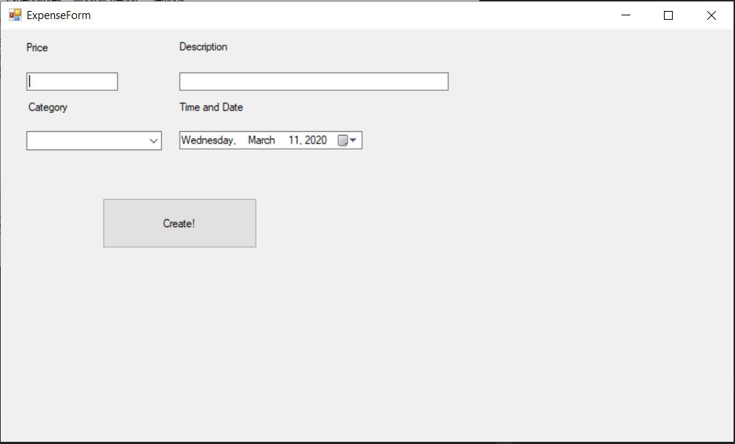

*New expense form that the user can use to create a new expense and returns to main form*

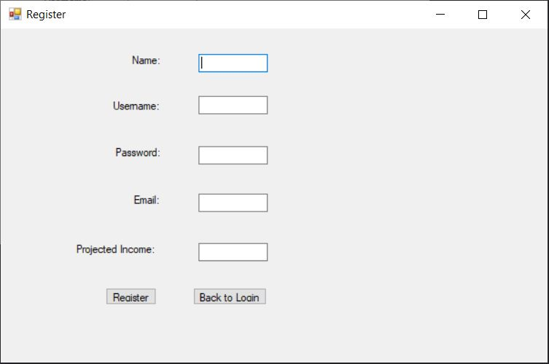

*Register form to register a new user based on the users’ inputs for their account information*

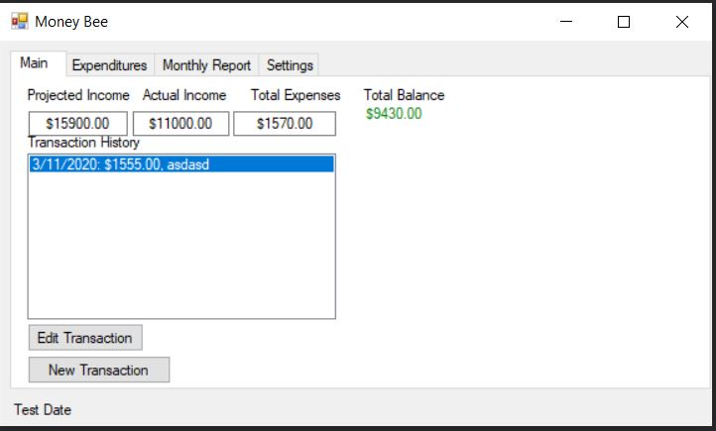

*Main form of the system that presents transaction history, projected income, actual income, total expenses, and the ability to create a new transaction*

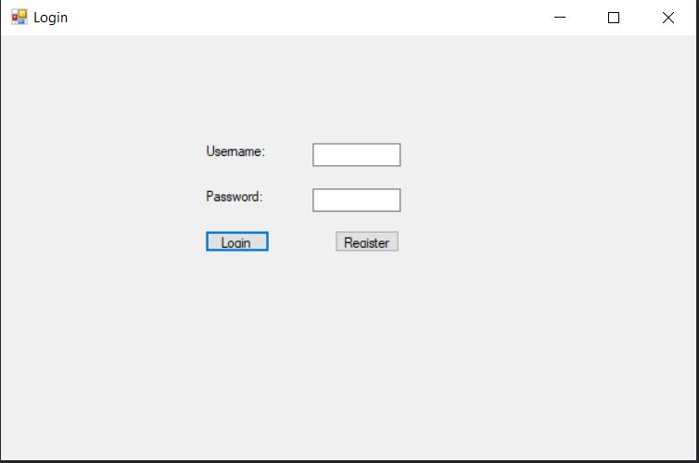

*Login form where the user can login to their account or register a new account*