# Release Information

|  |  |
| --- | --- |
| *Release* | *0* |
| *Leader* | *Nathan Kawula* |
| *SVN Revision Number* | *1* |

The contents of this release include the preparations for the Money Bee application. A mock product is represented as Spike 0 in the repository.

# Progress

|  |  |  |  |
| --- | --- | --- | --- |
| **Stories and spike solutions worked on during this release** | | | |
| **Story, Spike** | **Description** | **% Impl.** | **Notes, plan for completion** |
| *Spike 0* | *A mock, nonformatted version of what the team views as a direction for the application.* | *100* | *Contains basic items for the application, no implementation.* |

|  |  |  |
| --- | --- | --- |
| **Accomplishments by engineer** | | |
| **Team Member** | **Total Time (hrs)** | **Stories, Spikes implemented** |
| *Sammy Edwards* | *3.3* | *Collaborated to finish Class Diagram 0.docx, Spike 0, and all user stories (including acceptance criteria, story points, and priority)* |
| *Andi Fuerst* | *3.3* |
| *Nathan Kawula* | *3.8* |
| *Logan Thompson* | *3.3* |
| TEAM TOTAL | ***13.7*** |

|  |  |
| --- | --- |
| **Document updates** | |
| **Document** | **Changes** |
| *X* | *No updates, only creations of documents above* |

# Issues

Document anything that is not decided yet and needs to be resolved at some point.

|  |  |  |  |  |
| --- | --- | --- | --- | --- |
| **Issue Number** | **Discovery**  **Date** | **Resolution**  **Date (Est.–Act.)** | **Responsible Person** | **Description (Prob / Resolution)** |
| 1 | 2/14 | 2/21 | Nathan Kawula | Planning for Iteration 1 to be formed.  Expected to be completed for Iteration 1 Planning assignment |

# Screen Shots

*All screenshots of Spike 0 contain no functionality behind its representation. Spike 0’s only purpose is to be a visual for the Money Bee application.*

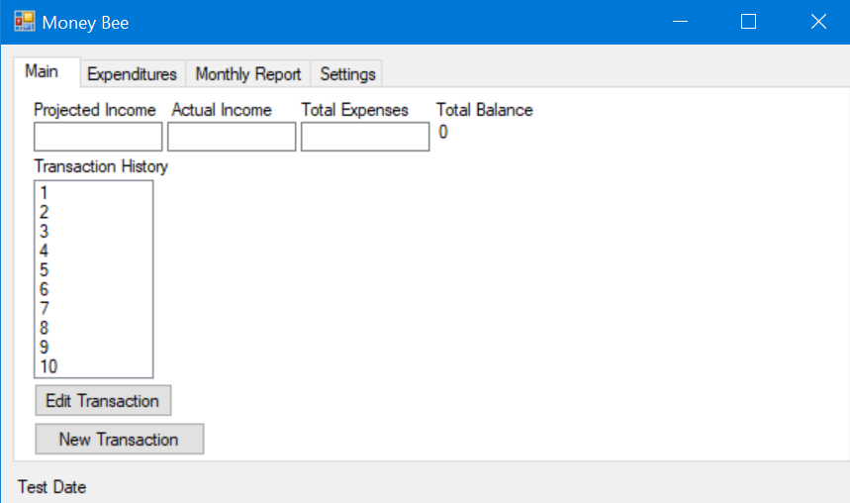

Planned Main Screen contents for Money Bee Application

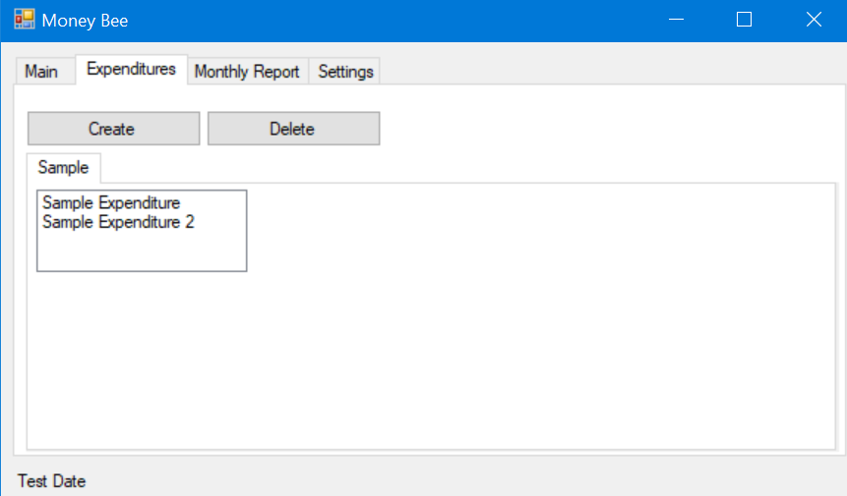

Planned Expenditures Screen contents for Money Bee Application

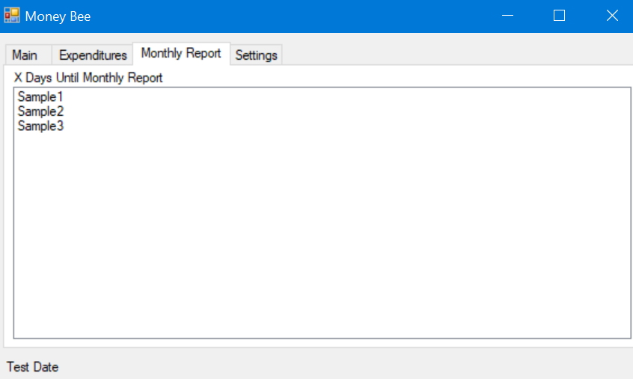

Planned Monthly Report Screen contents for Money Bee Application

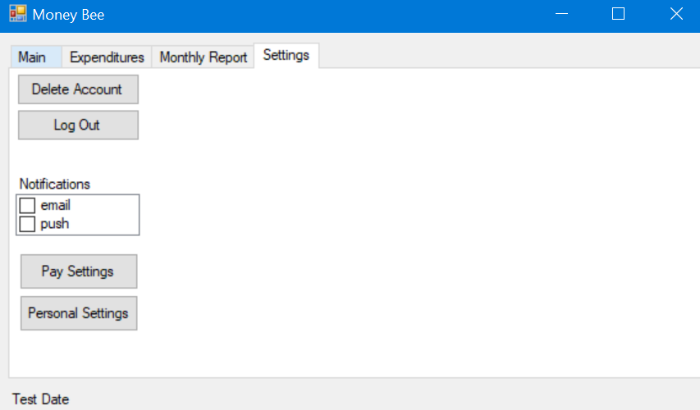

Planned Settings Screen contents for the Money Bee Application