***Monitor Specification***

* **BENQ ET0024TA**
* Display Type LED-backlit LCD monitor / TFT active matrix
* Aspect Ratio 16:9
* ***Native Resolution 1366 x 768***
* Contrast Ratio 500:1 / 5000000:1 (dynamic)
* Controls & Adjustments Color temperature
* Dimensions (WxDxH) 14.9 in x 5.7 in x 11.8 in
* Horizontal Viewing Angle 90
* Vertical Viewing Angle 65
* Pixel Pitch 0.252 mm
* Panel Type TN
* Brightness 250 cd/m²
* Backlight Technology LED backlight
* Manufacturer BenQ America Corp.
* Image Brightness 250 cd/m2
* Image Aspect Ratio 16:9
* Image Contrast Ratio 500:1
* Type LED-backlit LCD monitor
* Brand BenQ
* Product Line BenQ

***VGA Timing Diagram***

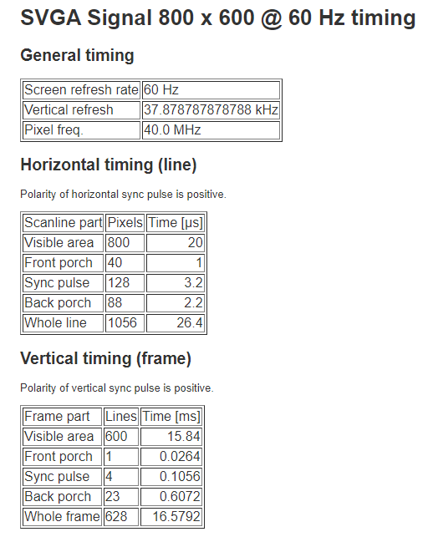

***Source :*** [*http://tinyvga.com/vga-timing*](http://tinyvga.com/vga-timing)

