Mirabeau – Technical design document

# Introduction

Mirabeau is POC site. This has sample air services.

# Technologies used:

## Language and framework:

* Developed Using VS-2017
* .Net Framework 4.6
* .Net MVC 5
* C# 6.0

## tech used:

* Microsoft unity container for IOC
* Newtonsoft for Json serialization
* Bootstrap for html
* Jquery for script actions

**Note:**

Since 4.6 framework and MVC-5 nugget Microsoft.Net.Http is not viable solution.

Since this is older one for the newer versions. Please find the reference below,

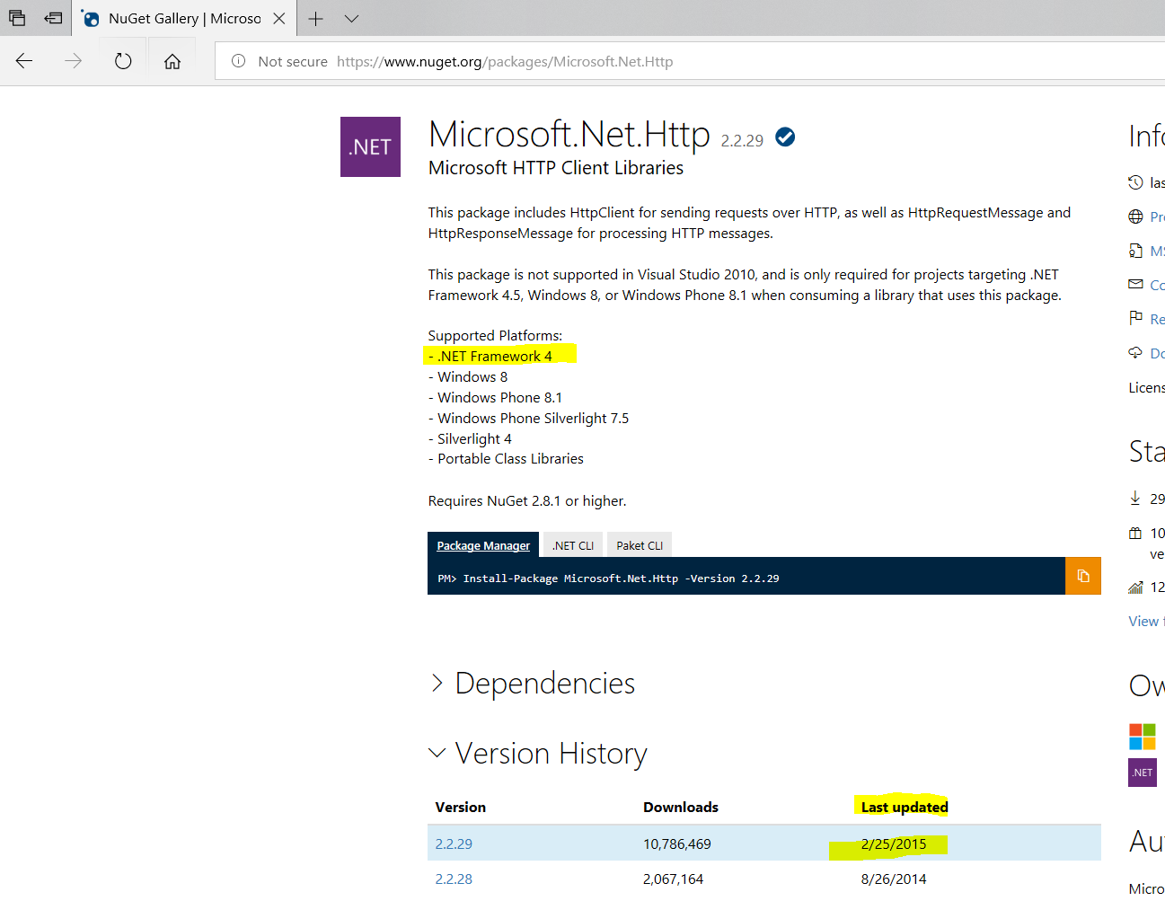

# Design Pattern Involves:

* MVC architectural design pattern for the whole site structure
* Factory pattern for Business and service layers
* Single ton pattern for holding the service data’s.

# Solution structure:

Solution involves five different projects.

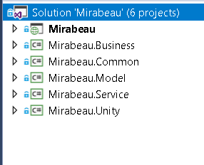

1. Mirabeau
2. Mirabeau.Business
3. Mirabeau.Common
4. Mirabeau.Model
5. Mirabeau.Service
6. Mirabeau.Unity

# Project - Mirabeau

This main mvc site solution,

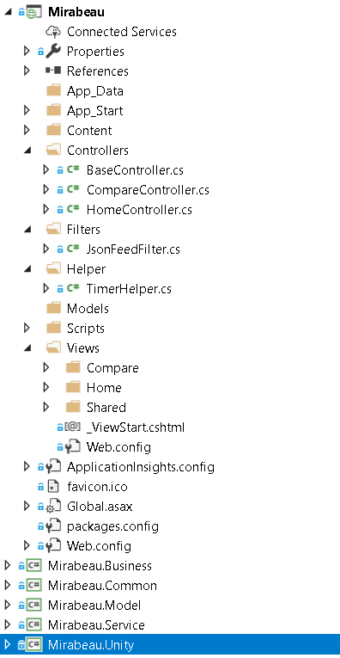

### Controllers:

Home and compare controllers serving pages.

### Filters:

Json Filter attributes to serve header json response ("from-feed", "application/json").

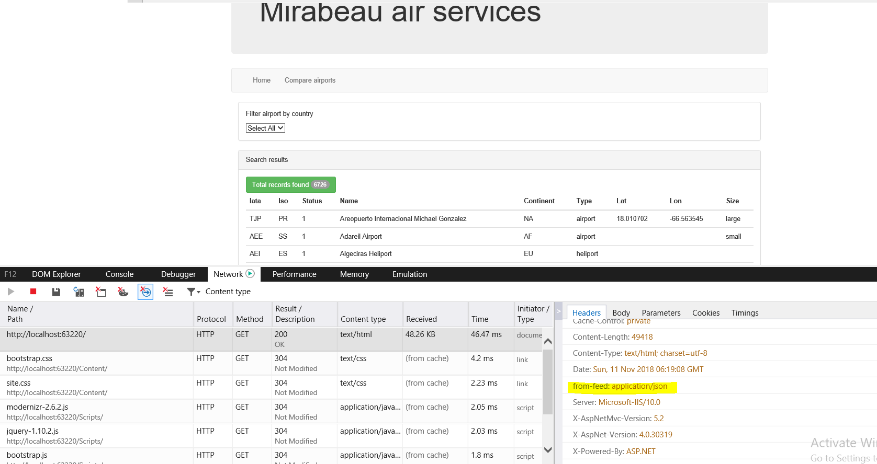

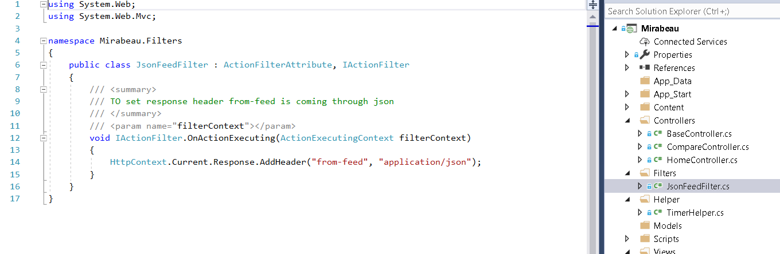

### Timer Helper:

Timer helper is used to maintain the Json data’s for every 5 mins interval. This has registered in Global.asax.

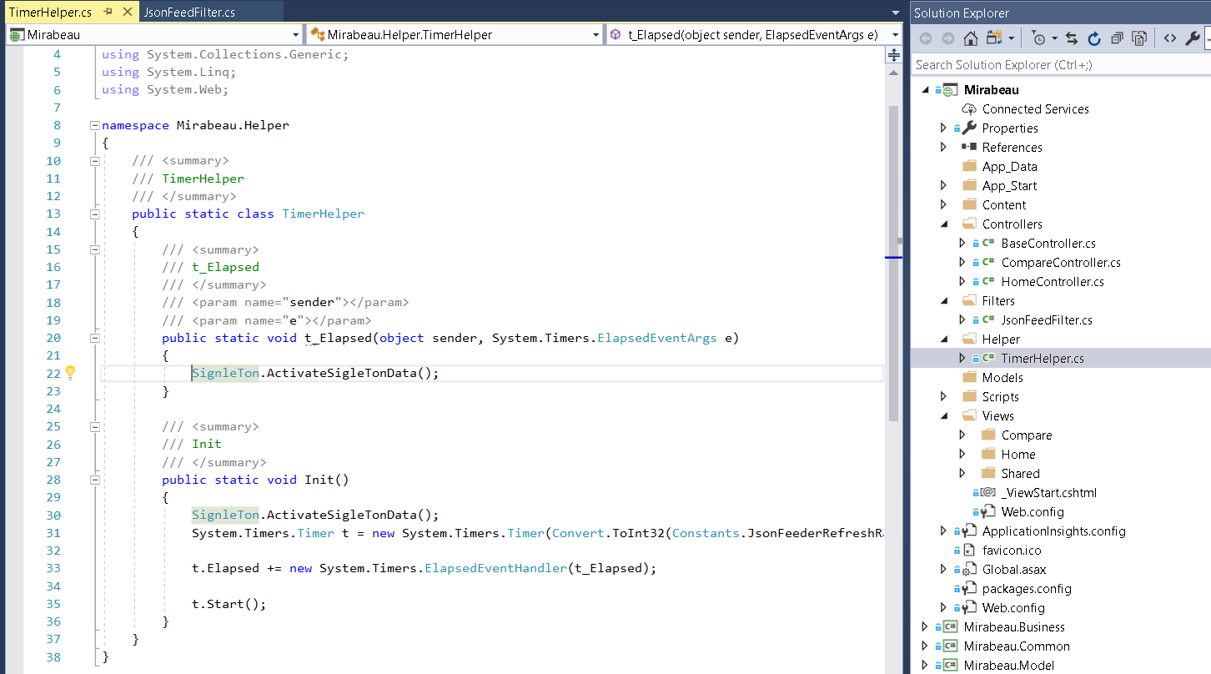

# Project - Mirabeau.Business

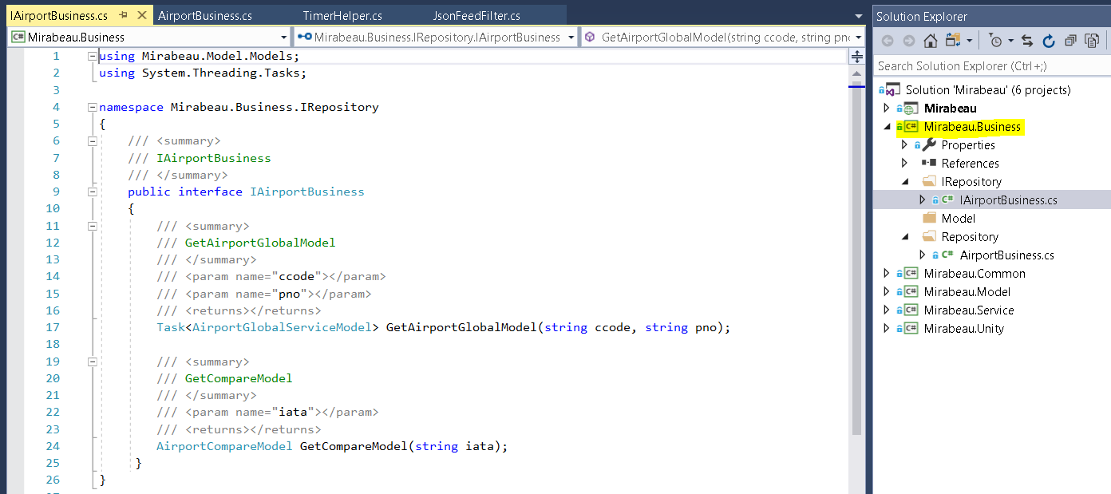

Business follows factory pattern ,

1. This will get json service model from service layer
2. And do the necessary business actions in model and return to the main site.

# Project - Mirabeau. Common

* Common layer has constant utills that holds all constant across the applications

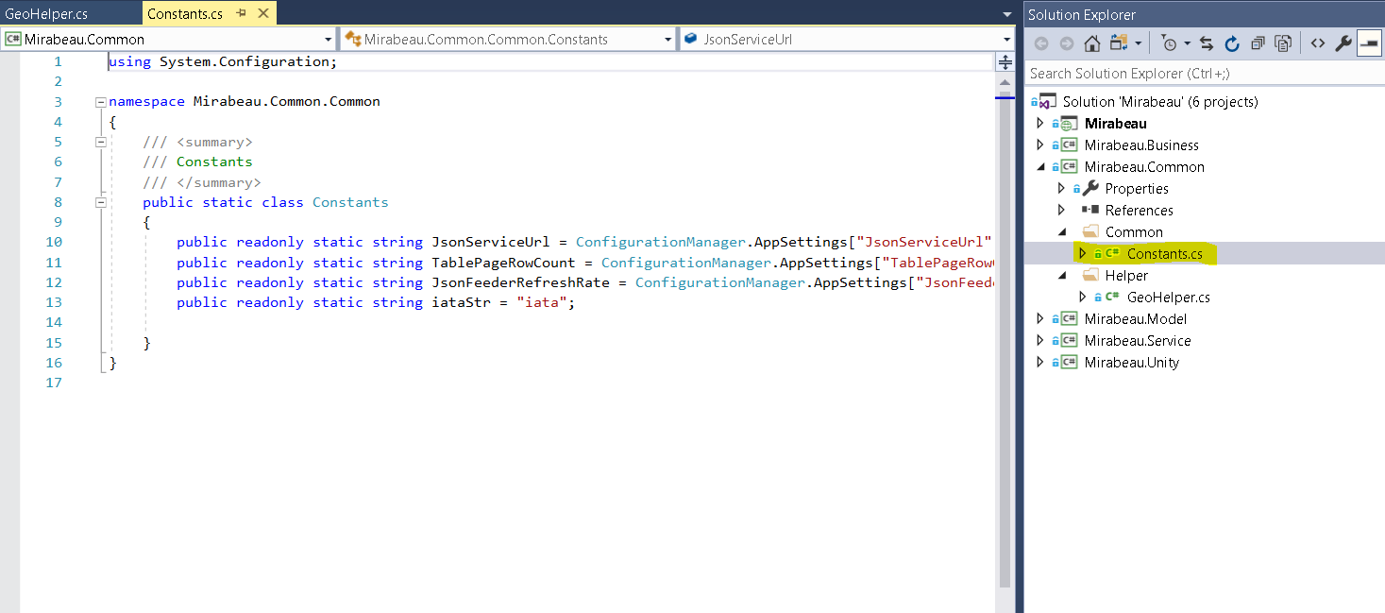

* Common layer has Geo helper for find difference between two airport operations

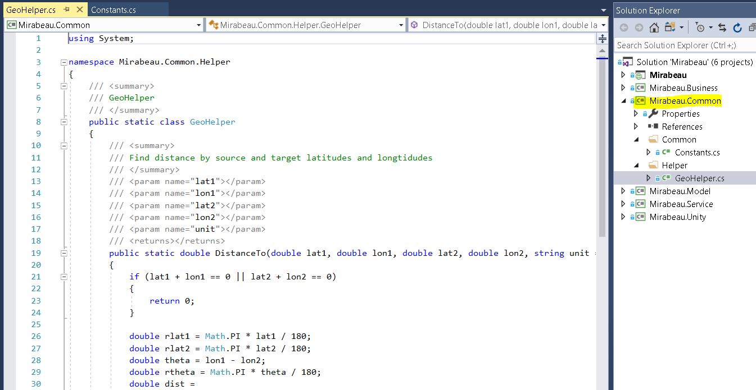

# Project - Mirabeau. Model

# Model holds all project models

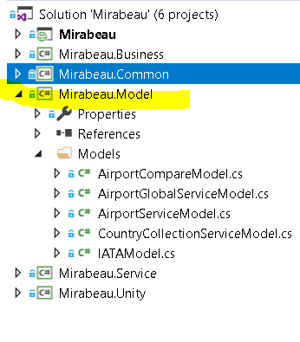

# Project - Mirabeau. Service

Service layer follows factory pattern

This has repository actions for serving a json.

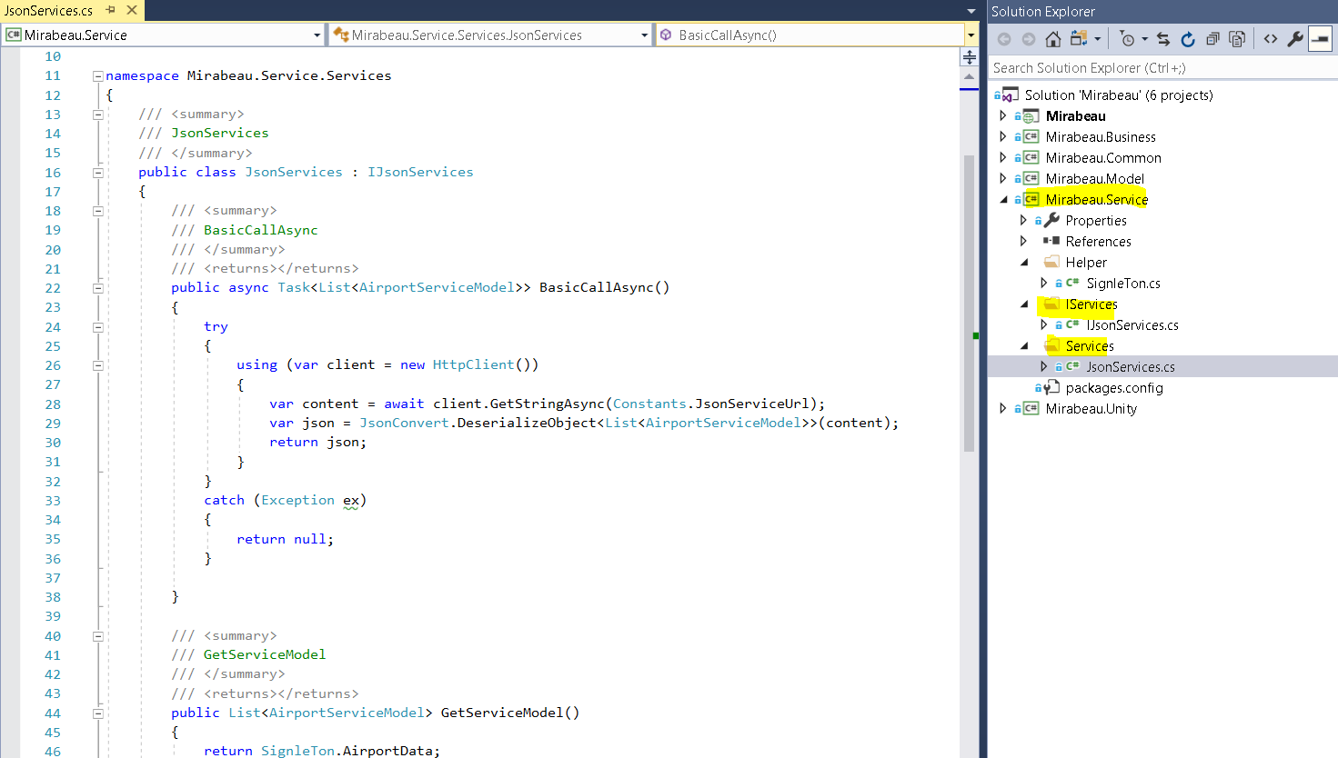

Also Singleton class is used to maintain the json model across applications and this has been refreshed by every 5 mins interval.

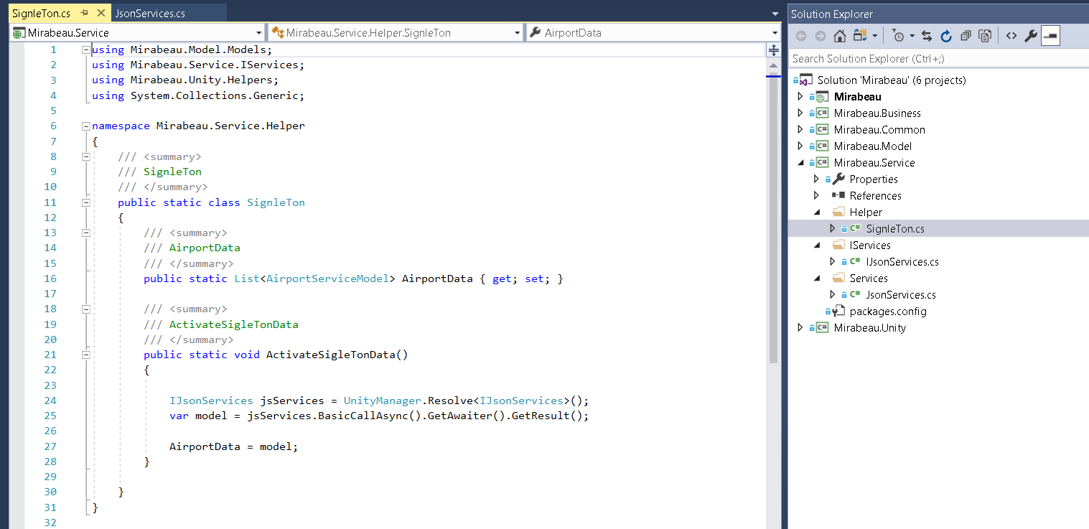

# Project - Mirabeau. Unity

Unity Project is used resolve dependencies in all projects. This using Microsoft unit container.

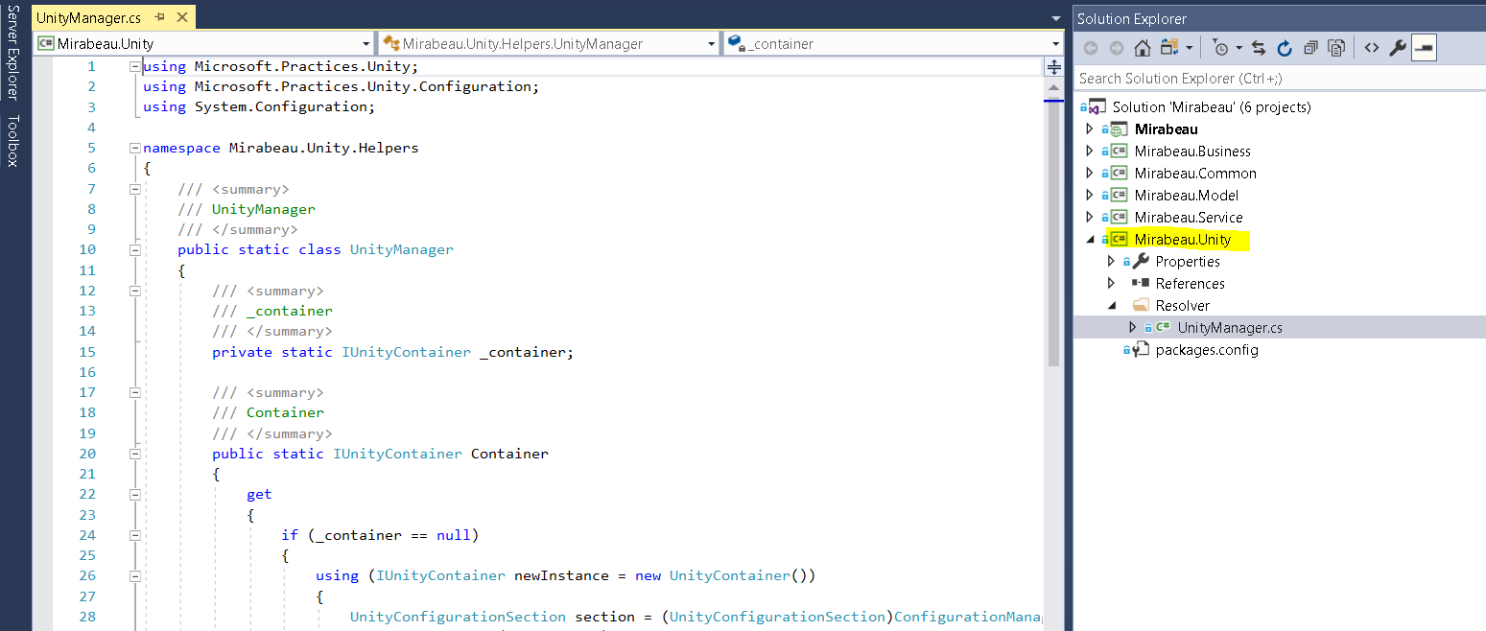

# Web config:

Additional app settings and configurations used in main web config.

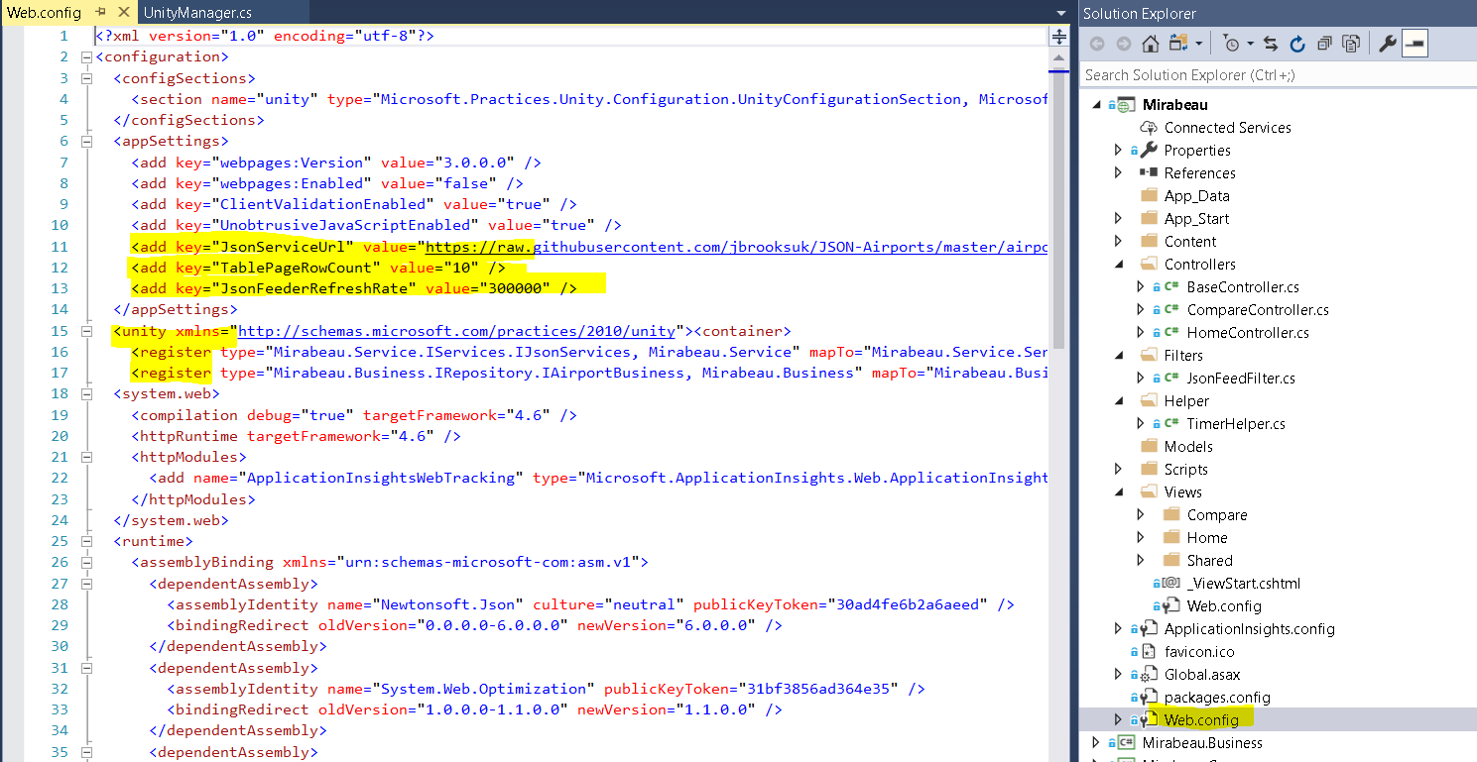

# Since this is exercise:

Since this is exercise I had skipped unittesting projects and exception managements…