Mirabeau - Functional requirement

# Introduction

Mirabeau is POC site. This has sample air services.

# Content:

This site have two pages like below,

1. Home page
2. Compare page

# Home page:

Home page offers list of airports available with the filter option included for country based airports.

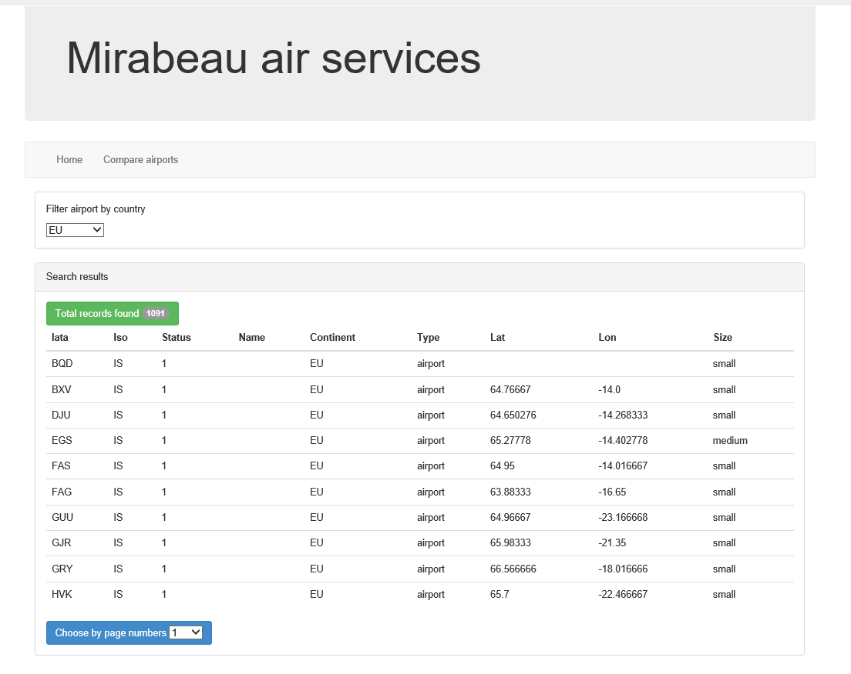

As shown above choose any country and find the airport lists.

# Compare page

Compare page offers to compare two different airports and show the distance between their geo graphical locations.

