CDI College
BDA400 – Data Science Tools and Techniques
Assignment 2
Technical Analysis using R, Preliminary Stage
Student: Anthony Dibor
Course: BDA400 – Data Science Tools and Techniques
Assignment: Assignment 2 (5%)
Date: November 1, 2026
GitHub repository
https://github.com/Andib77/TechnicalAnalysis
(assignment files are in the A02 folder)

Overview
This report documents the preliminary stage of a three-part technical analysis project in R. It covers setting up a GitHub account and the TechnicalAnalysis repository, installing R and RStudio, installing the R packages used for technical analysis, creating a portfolio of stock symbols, and writing R functions that import stock data, compute basic statistics and display the results as tables and charts.
Deliverables in the repository (folder A02):
File | Contents
portfolio.txt | Eight stock symbols, one per line
technical_analysis.R | Functions to install packages, load data, compute statistics and display output
output/ | Charts (PNG) and summary_statistics.csv produced when the script runs
AnthonyDibor_BDA400_A02.docx | This report

1. Setting up a GitHub Account and Repository

1.1 Create the GitHub account
- Go to https://github.com and click Sign up.
- Enter an email address, a password and the username Andib77, then verify the account through the email code.
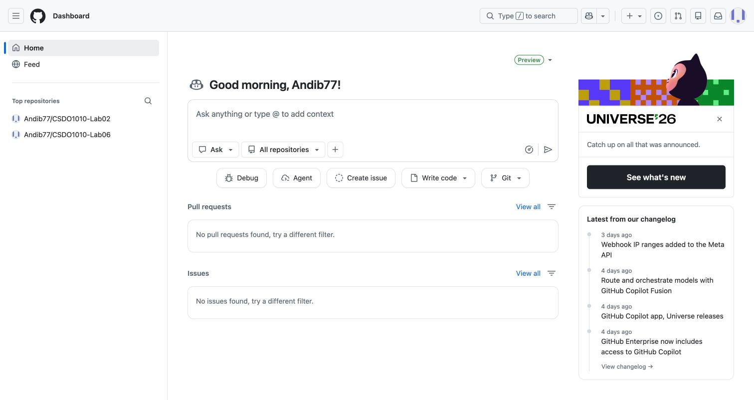
Screenshot 1: GitHub sign-up page / account dashboard after sign-in

1.2 Install and configure Git
- Download Git from https://git-scm.com/downloads and run the installer with the default options.
- Open a terminal (Git Bash on Windows, Terminal on macOS) and confirm the installation and set your identity:
git --version
git config --global user.name "Anthony Dibor"
git config --global user.email "your-email@example.com"

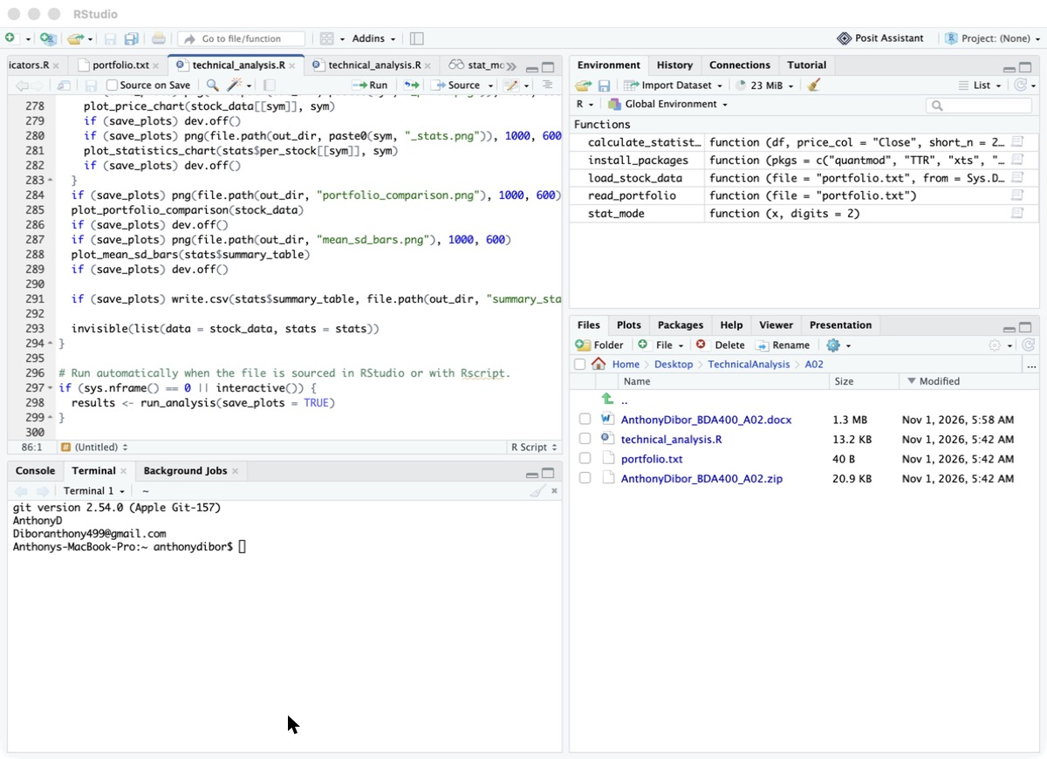
Screenshot 2: Terminal showing git --version and git config output

1.3 Create the TechnicalAnalysis repository
- On GitHub click New repository.
- Name it TechnicalAnalysis, set it to Public and tick Add a README file.
- Click Create repository.
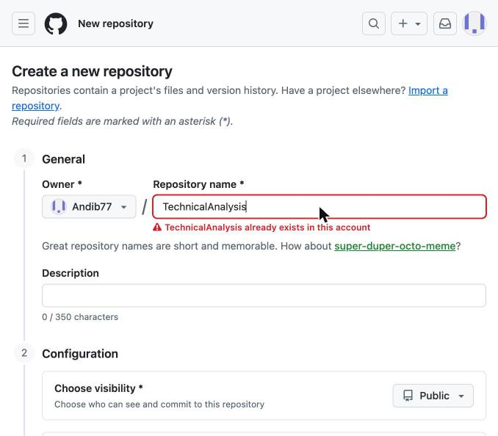
Screenshot 3: New repository form filled in with the name TechnicalAnalysis (captured after the repository was created, so GitHub now reports the name as taken)
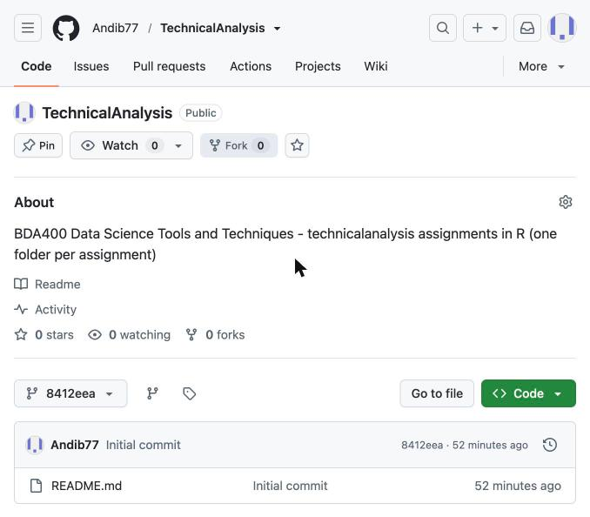
Screenshot 4: The empty TechnicalAnalysis repository page

1.4 Clone the repository and create the assignment folder
Each assignment gets its own subfolder, as required. For this assignment the folder is A02:
git clone https://github.com/Andib77/TechnicalAnalysis.git
cd TechnicalAnalysis
mkdir A02

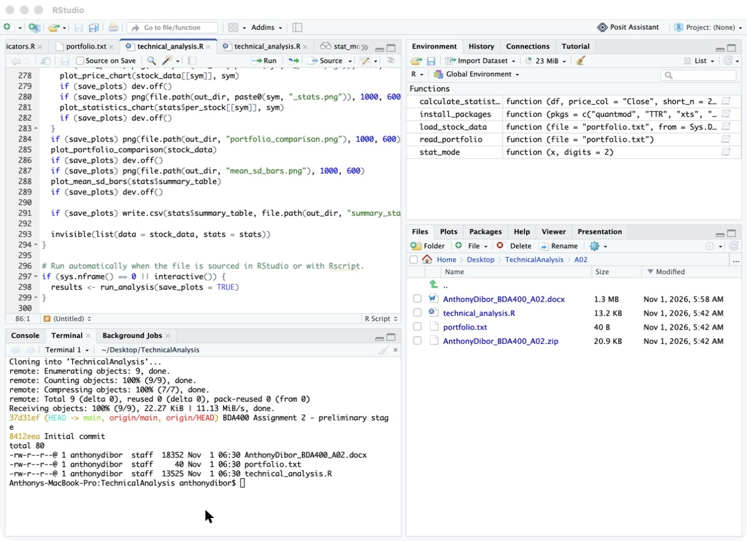
Screenshot 5: Terminal showing the clone and the new A02 folder

2. Installing and Configuring R and RStudio

2.1 Install R
- Go to https://cran.rstudio.com and choose the download for your operating system (Windows, macOS or Linux).
- Windows: click base, then Download R for Windows. macOS: download the .pkg that matches your chip (Apple silicon arm64 or Intel x86_64).
- Run the installer and accept the default options.
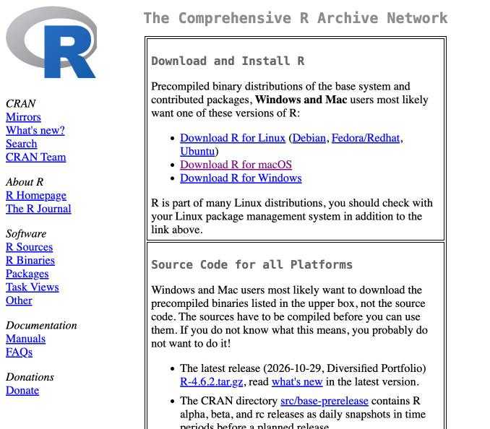
Screenshot 6: CRAN download page
[Insert Screenshot 7: R installer running / completed]

2.2 Install RStudio
- Go to https://posit.co/download/rstudio-desktop and download RStudio Desktop (free).
- Run the installer and accept the defaults.
- Open RStudio. The Console should show the installed R version.
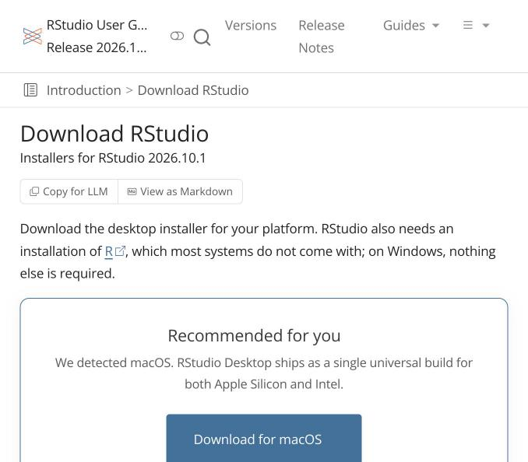
Screenshot 8: RStudio download page
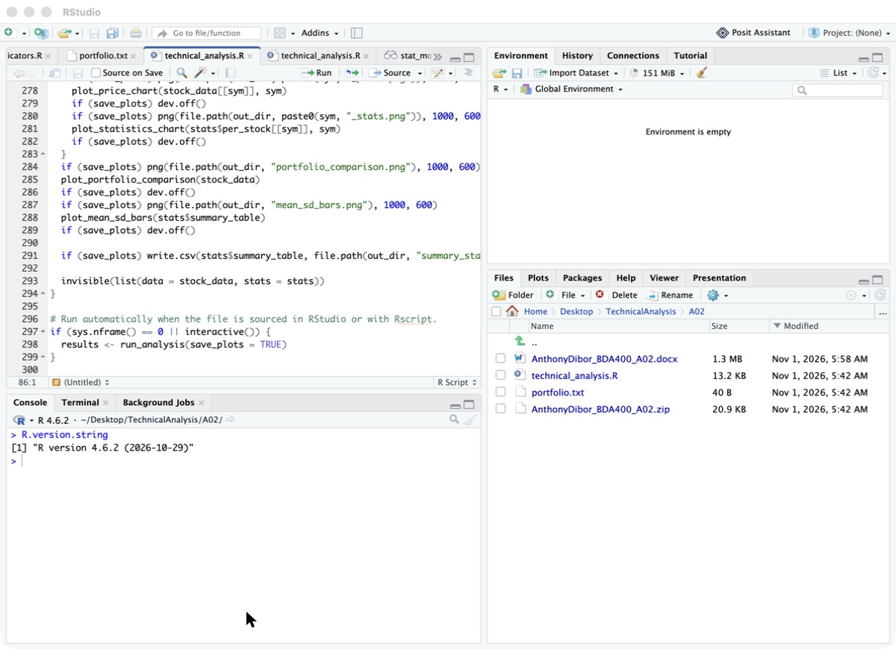
Screenshot 9: RStudio open, Console showing the R version

2.3 Verify the installation
Type the following in the RStudio Console:
R.version.string

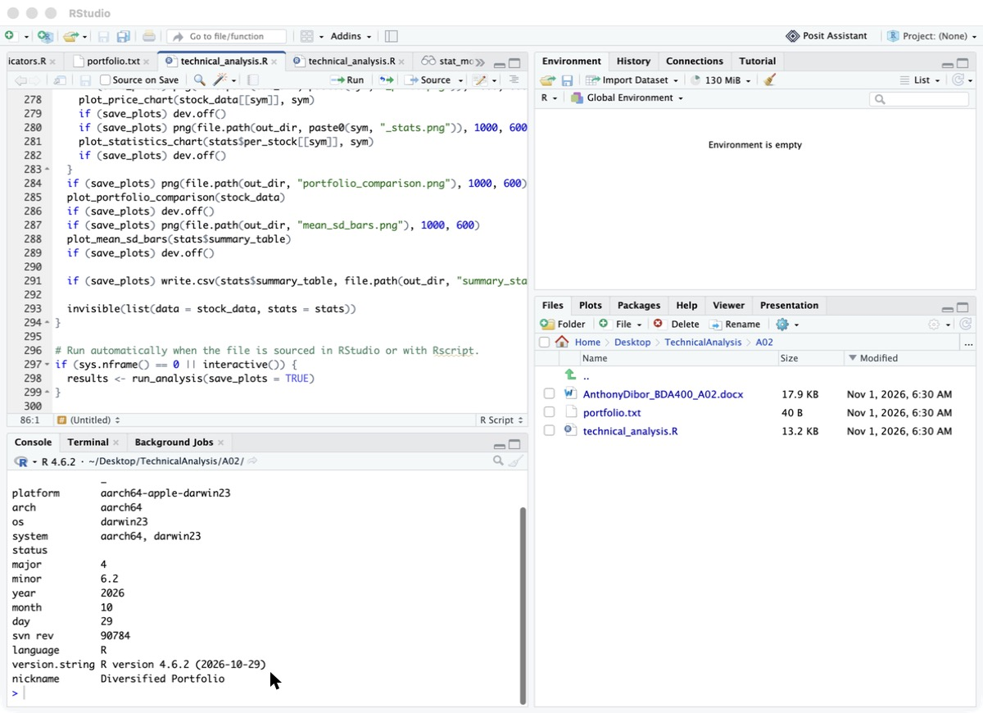
Screenshot 10: Console output of R.version.string

2.4 Create an RStudio project
In RStudio choose File → New Project → Existing Directory and select the TechnicalAnalysis/A02 folder. This sets the working directory so the script can find portfolio.txt.
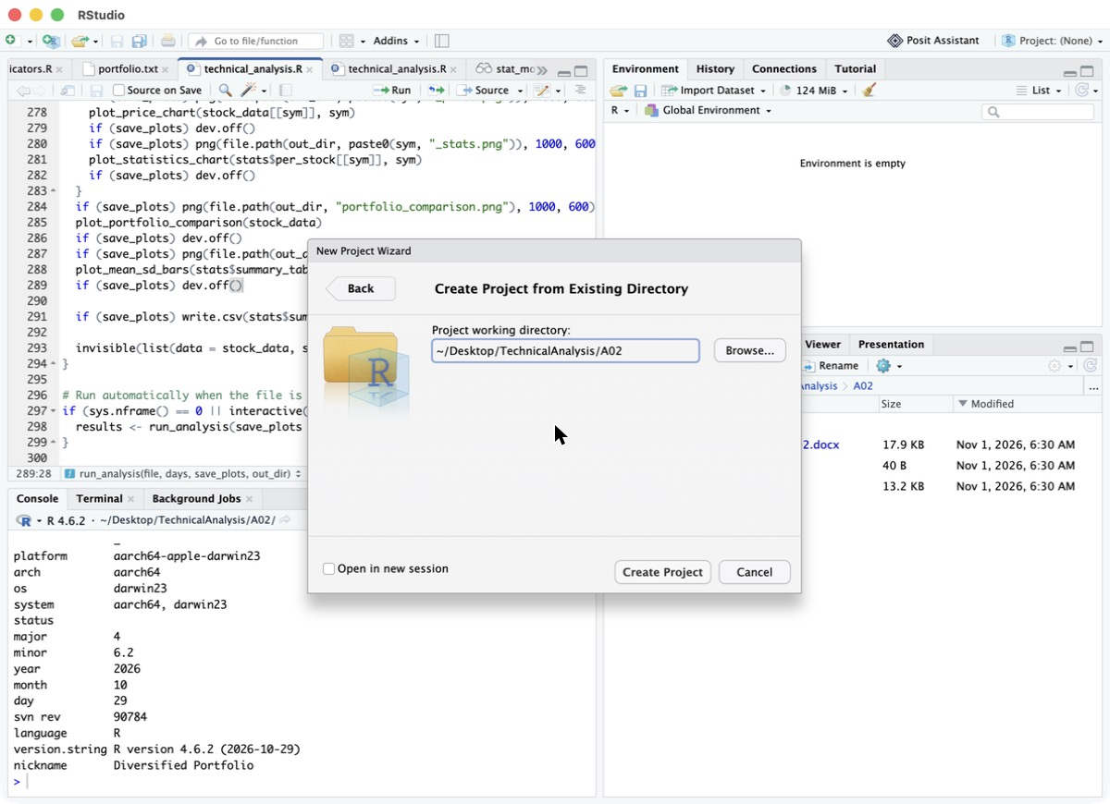
Screenshot 11: New Project dialog pointing at the A02 folder

3. Downloading and Installing R Packages
The following packages are used:
Package | Purpose
quantmod | Downloads stock prices (getSymbols) and draws financial charts (chartSeries)
TTR | Technical Trading Rules: moving averages (SMA, EMA) and other indicators
xts | Extensible time series objects that quantmod returns
zoo | Ordered time series tools that xts is built on

Install them once from the Console:
install.packages(c("quantmod", "TTR", "xts", "zoo"))

Then load them and confirm the versions:
library(quantmod)
library(TTR)
packageVersion("quantmod")
packageVersion("TTR")

The script also contains install_packages(), which installs any package that is missing and loads all of them, so it runs on a fresh computer:
install_packages <- function(pkgs = c("quantmod", "TTR", "xts", "zoo")) {
for (p in pkgs) {
if (!requireNamespace(p, quietly = TRUE))
install.packages(p, repos = "https://cloud.r-project.org")
suppressPackageStartupMessages(library(p, character.only = TRUE))
}
}

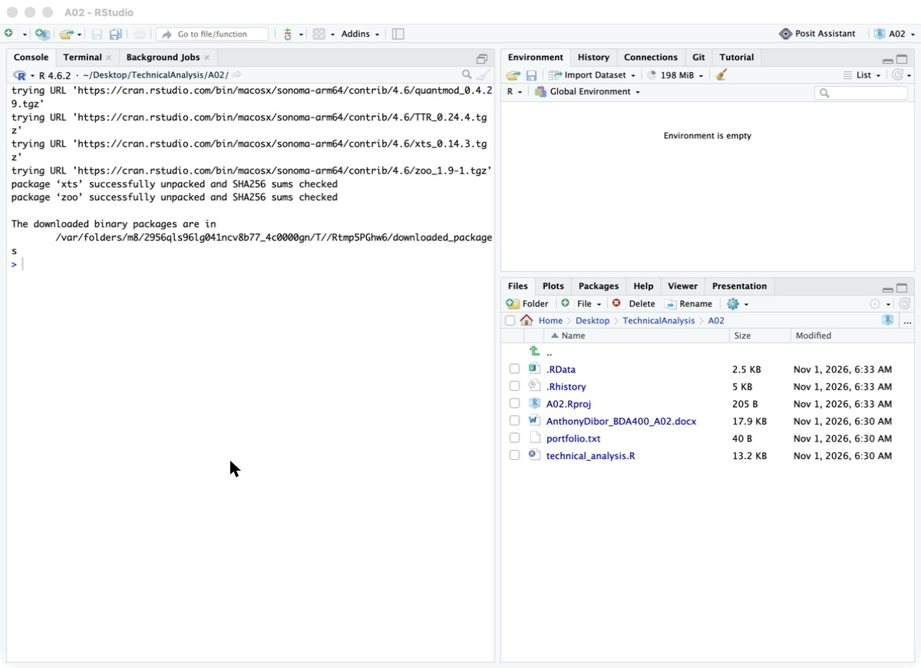
Screenshot 12: Console during install.packages()
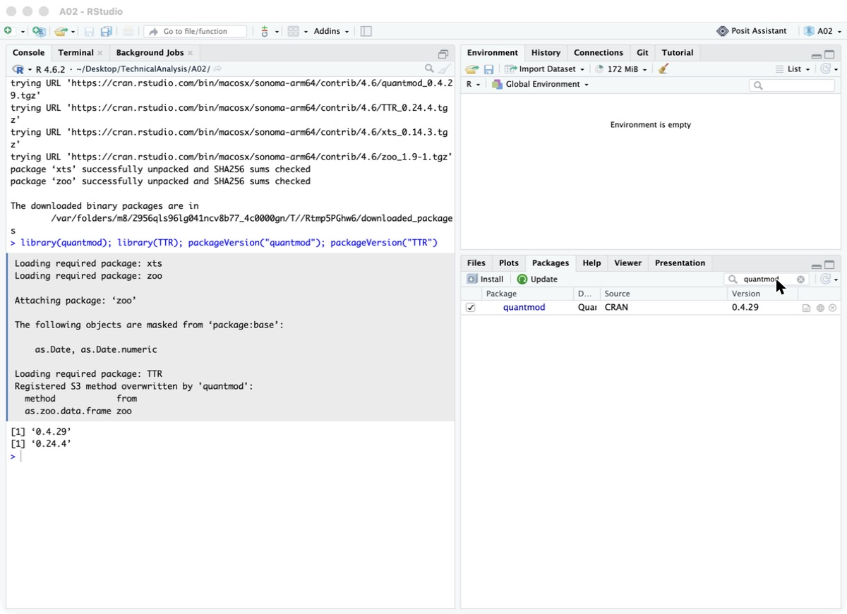
Screenshot 13: RStudio Packages pane with quantmod and TTR ticked

4. Project Configuration and Initialization
A text file named portfolio.txt was created in the A02 folder (File → New File → Text File in RStudio, then saved as portfolio.txt). It lists one stock symbol per line:
AAPL
MSFT
GOOGL
AMZN
NVDA
TSLA
JPM
SHOP

Symbol | Company | Sector
AAPL | Apple Inc. | Technology
MSFT | Microsoft Corporation | Technology
GOOGL | Alphabet Inc. (Class A) | Communication services
AMZN | Amazon.com Inc. | Consumer discretionary
NVDA | NVIDIA Corporation | Semiconductors
TSLA | Tesla Inc. | Automotive
JPM | JPMorgan Chase & Co. | Financials
SHOP | Shopify Inc. | Technology (Canadian)

The mix covers several sectors so later stages can compare how different kinds of stocks behave. To change the portfolio, edit this file only; no code changes are needed.
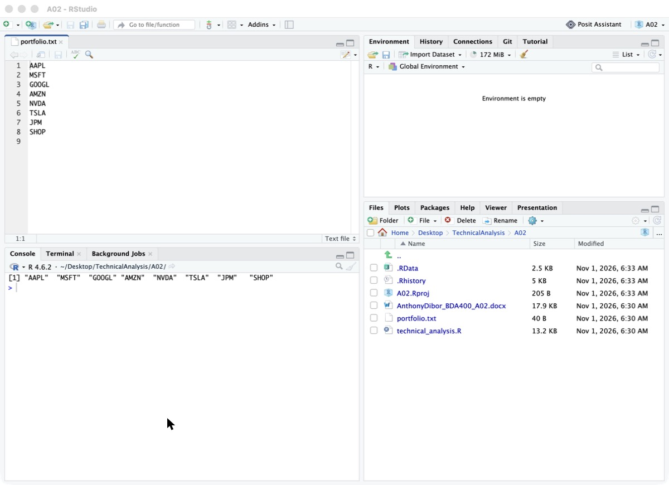
Screenshot 14: portfolio.txt open in RStudio

5. Function to Import and Load Stock Data
load_stock_data() reads portfolio.txt, downloads one year of daily prices for each symbol from Yahoo Finance with quantmod::getSymbols(), and stores each stock as its own data frame.
load_stock_data <- function(file = "portfolio.txt",
from = Sys.Date() - 365, to = Sys.Date(),
src = "yahoo") {
symbols <- read_portfolio(file)
stock_data <- list()
for (sym in symbols) {
result <- tryCatch(
getSymbols(sym, src = src, from = from, to = to, auto.assign = FALSE),
error = function(e) { warning("Could not load ", sym); NULL })
if (is.null(result)) next
df <- data.frame(Date = index(result), coredata(result), row.names = NULL)
names(df) <- c("Date","Open","High","Low","Close","Volume","Adjusted")
stock_data[[sym]] <- na.omit(df)
assign(paste0(sym, "_df"), stock_data[[sym]], envir = .GlobalEnv)
}
stock_data
}

How it works:
- read_portfolio() reads the file, trims spaces, skips blank lines and converts symbols to upper case.
- getSymbols(..., auto.assign = FALSE) returns an xts object with Open, High, Low, Close, Volume and Adjusted columns.
- Each xts object is converted to a data frame with a Date column and consistent column names.
- tryCatch() means one bad symbol produces a warning instead of stopping the whole run.
- Each data frame is returned in a named list (stock_data$AAPL) and also created as a separate variable (AAPL_df, MSFT_df, …) visible in the Environment pane.
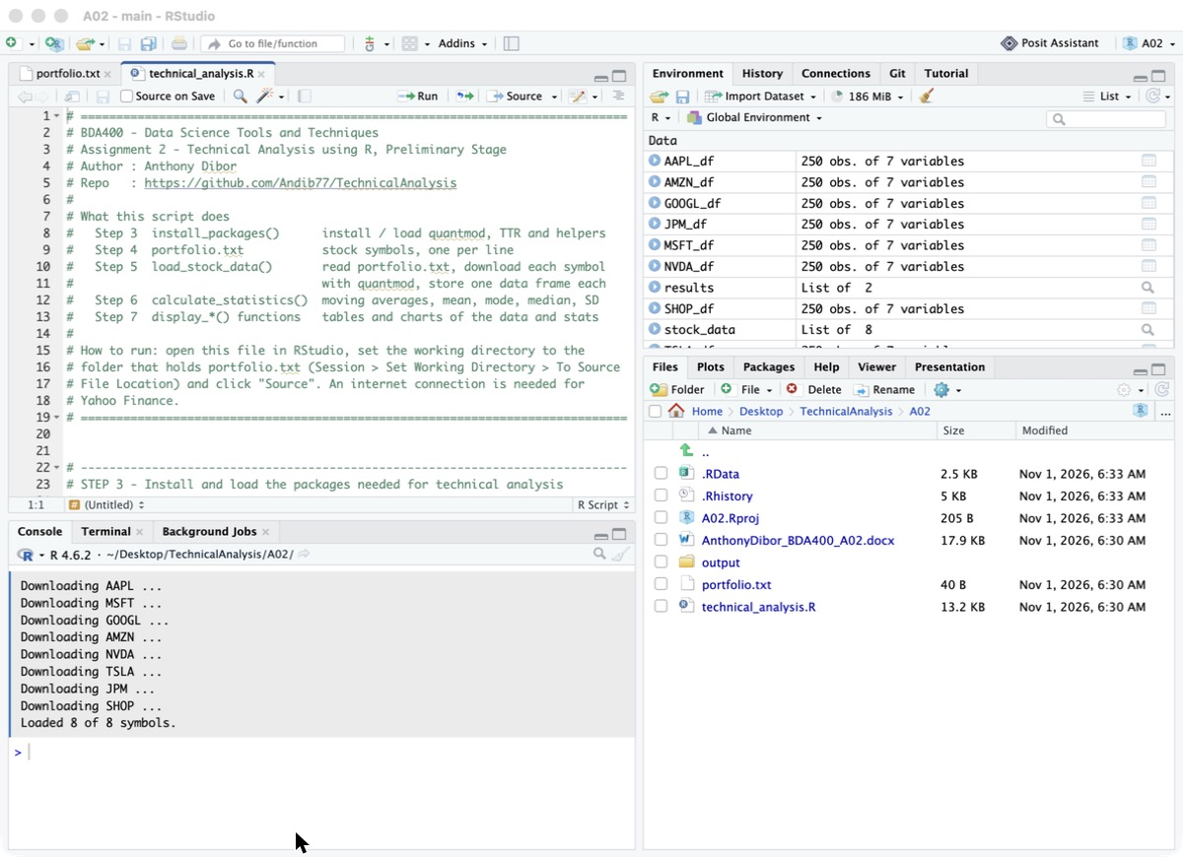
Screenshot 15: Console messages while the data downloads
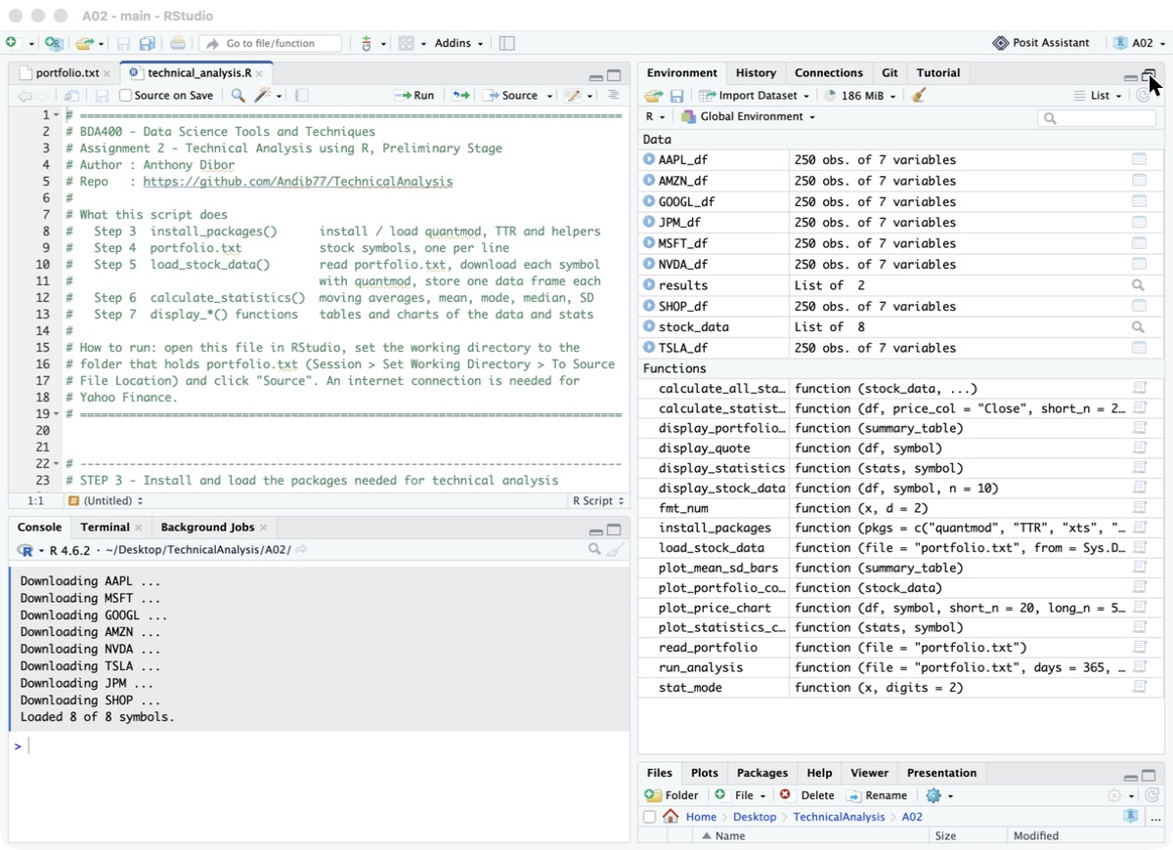
Screenshot 16: Environment pane showing AAPL_df, MSFT_df and the other data frames
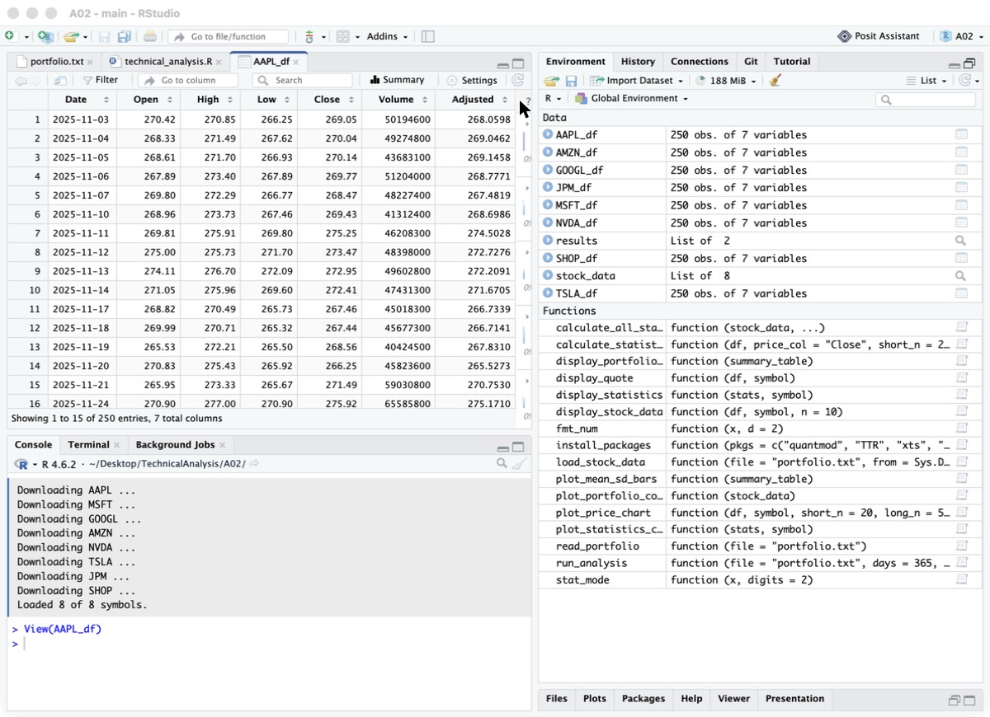
Screenshot 17: View(AAPL_df) showing the first rows

6. Functions to Compute Basic Statistics
calculate_statistics() takes one stock's data frame and returns a list with a one-row summary data frame and the price data with moving averages added. calculate_all_statistics() runs it for every stock and combines the summaries into one table.
Statistic | R function | Meaning
Moving averages | TTR::SMA(), TTR::EMA() | 20-day and 50-day simple averages and a 20-day exponential average; smooth out daily noise
Mean | mean() | Average closing price over the period
Median | median() | Middle closing price; less affected by spikes than the mean
Mode | stat_mode() (custom) | Most frequent closing price, rounded to the cent
Standard deviation | sd() | How widely prices vary around the mean (volatility)
Also included | min(), max(), diff() | Minimum, maximum, period return %, daily returns and average volume

6.1 The mode function
Base R has no function for the statistical mode (R's mode() returns the storage type of an object), so a custom function was written. Because prices are continuous and rarely repeat exactly, they are rounded to two decimals first:
stat_mode <- function(x, digits = 2) {
x <- round(x[!is.na(x)], digits)
counts <- table(x)
as.numeric(names(counts)[which.max(counts)])
}

6.2 calculate_statistics()
calculate_statistics <- function(df, price_col = "Close", short_n = 20, long_n = 50) {
price <- df[[price_col]]
ma <- df
ma$SMA_short <- SMA(price, n = short_n)
ma$SMA_long <- SMA(price, n = long_n)
ma$EMA_short <- EMA(price, n = short_n)
summary <- data.frame(
Mean = mean(price), Median = median(price), Mode = stat_mode(price),
Std_Dev = sd(price), Min = min(price), Max = max(price), ...)
list(summary = summary, moving_averages = ma)
}

The results are stored in a structured format: a list per stock, plus a combined data frame with one row per symbol that is also saved to output/summary_statistics.csv.
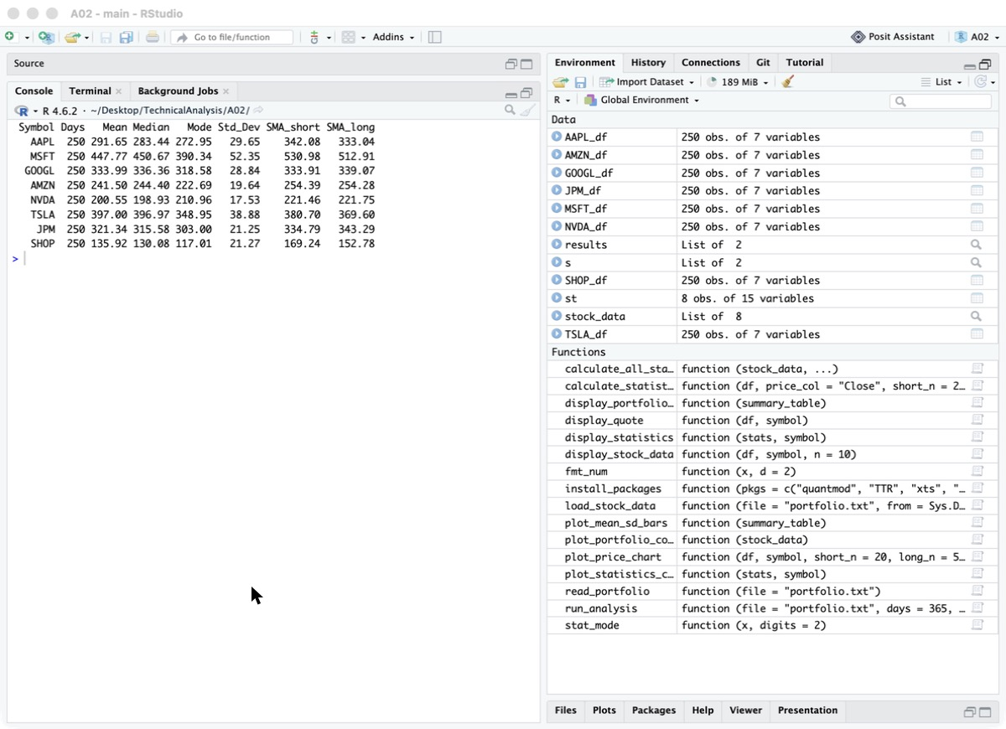
Screenshot 18: Console output of the combined statistics table

7. Utilities to Display Output
After looking at how Yahoo Finance presents market data (a quote header, a Historical Data table, a Statistics tab, interactive charts and comparison charts), the following display functions were written:
Function | What it shows
display_quote() | Yahoo-style header: last price, change and % change, open, day range and volume
display_stock_data() | Historical prices table for the last 10 trading days, newest first, with formatted numbers
display_statistics() | Statistics panel for one stock: mean, median, mode, SD, min, max, moving averages, return
display_portfolio_summary() | One table comparing the statistics of every stock in the portfolio
plot_price_chart() | Candlestick chart (quantmod chartSeries) with volume and 20/50-day SMAs
plot_statistics_chart() | Closing price line with moving averages, mean, median and ±1 standard deviation lines
plot_portfolio_comparison() | Growth of $100 invested in each stock, so stocks at different prices can be compared
plot_mean_sd_bars() | Bar chart of each stock's mean price with standard-deviation error bars

7.1 Running the full analysis
With the working directory set to the A02 folder, source the script in RStudio (click Source). It calls run_analysis(), which installs/loads the packages, loads the data, computes the statistics, prints every table and draws every chart. Charts are also saved as PNG files in the output folder.
source("technical_analysis.R")
# or, to re-run with two years of data:
results <- run_analysis(days = 730, save_plots = TRUE)

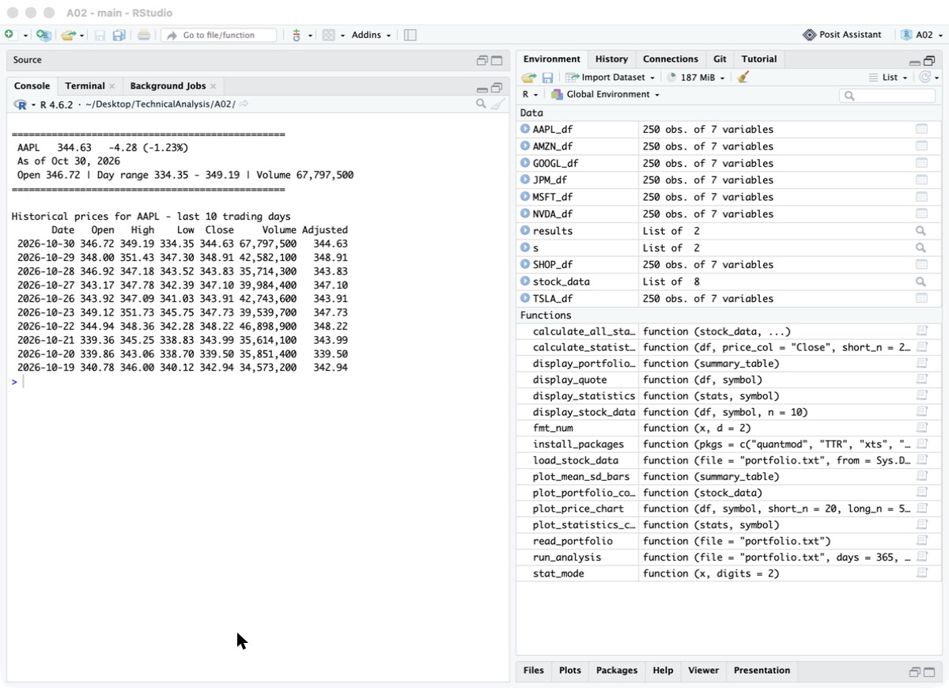
Screenshot 19: Quote header and historical prices table for AAPL
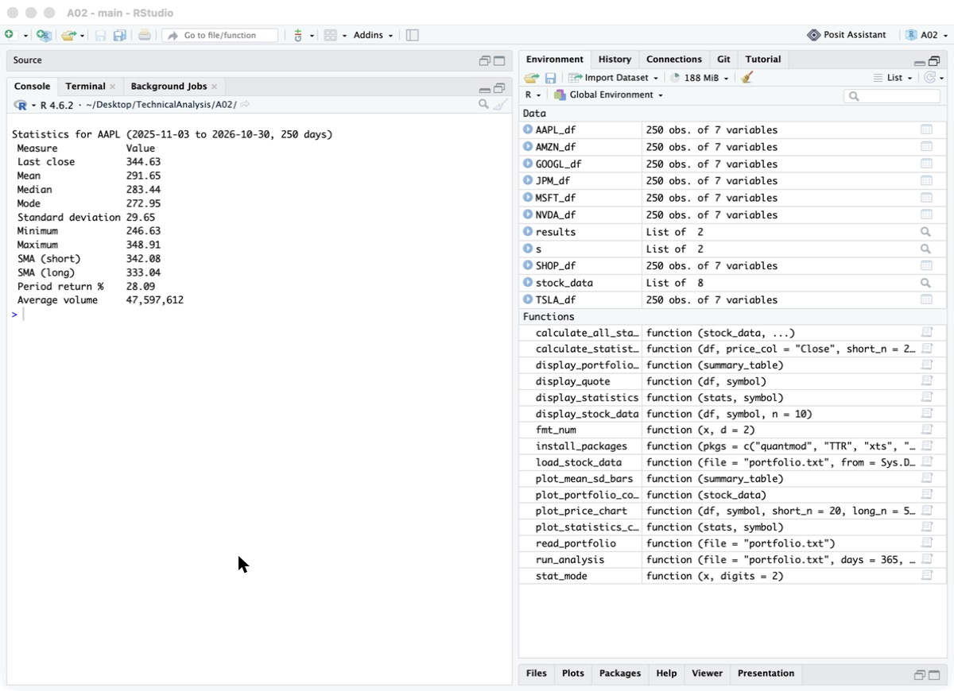
Screenshot 20: Statistics panel for AAPL
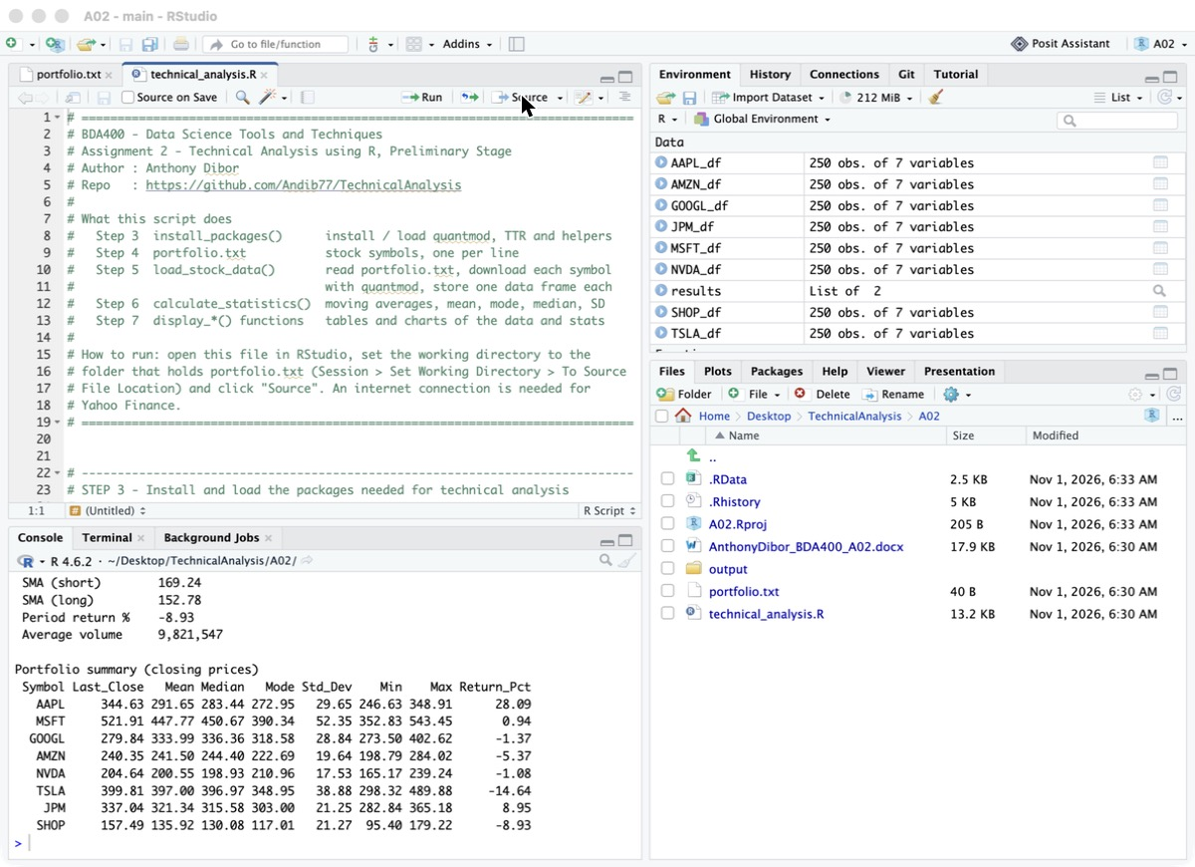
Screenshot 21: Portfolio summary table
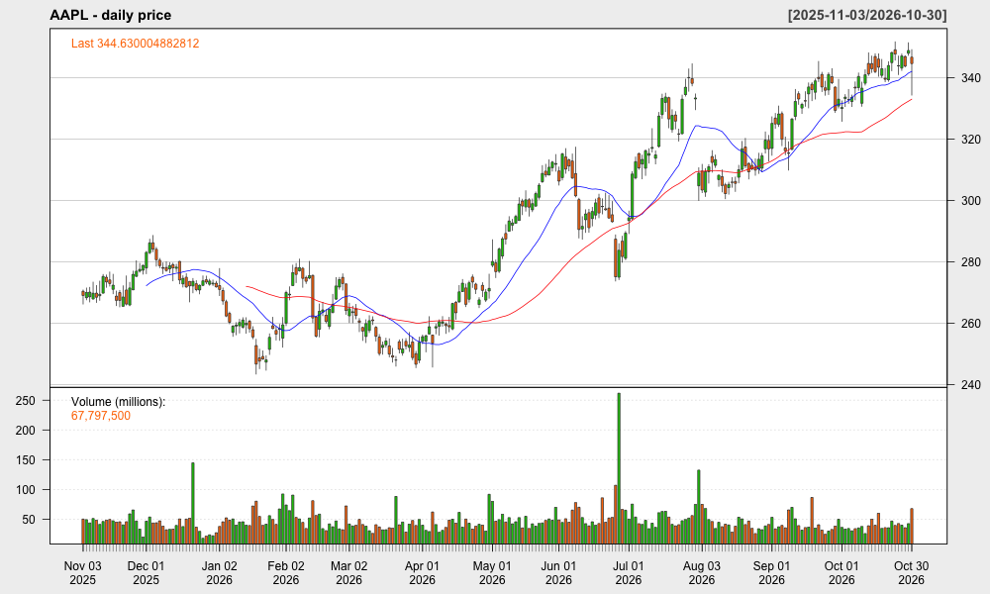
Screenshot 22: Candlestick chart with volume and moving averages (e.g. AAPL)
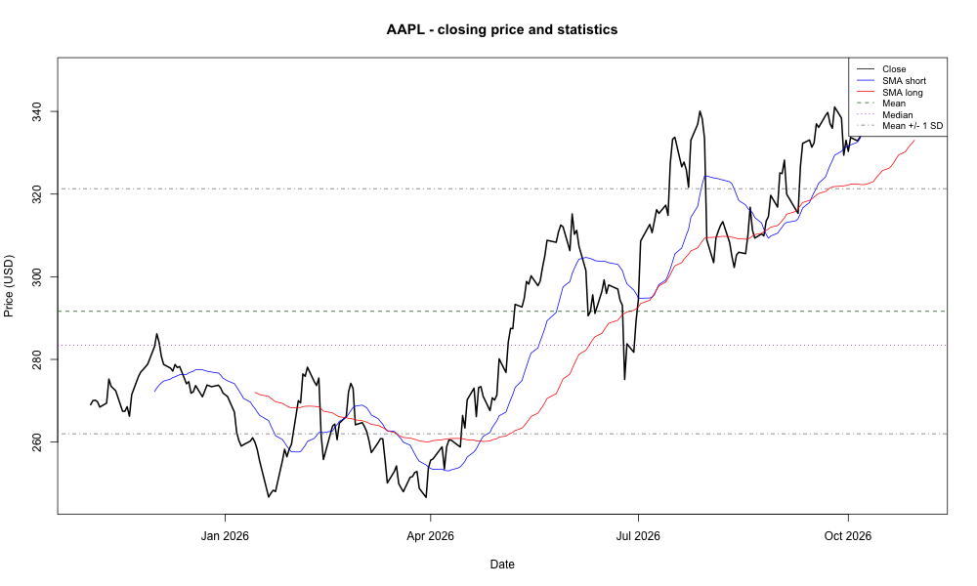
Screenshot 23: Closing price and statistics chart (e.g. AAPL)
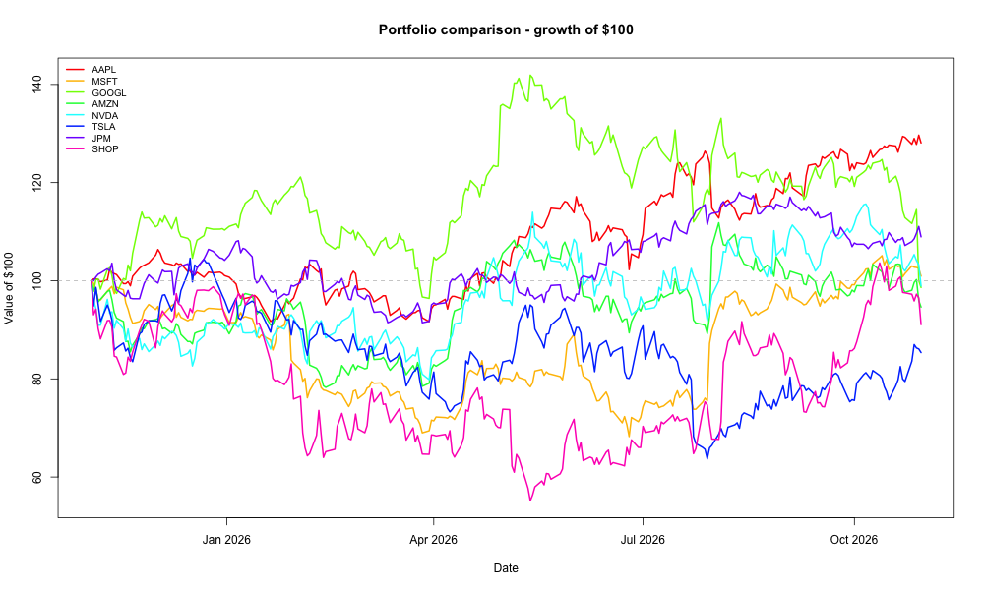
Screenshot 24: Portfolio comparison chart – growth of $100
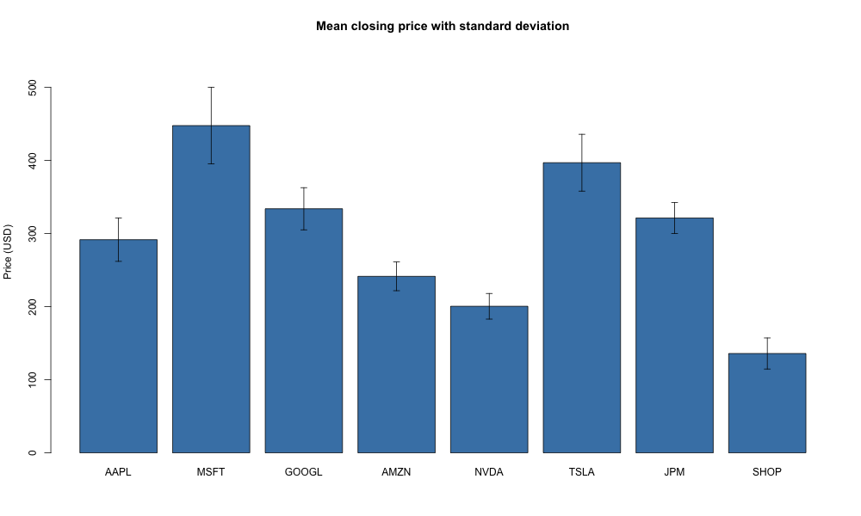
Screenshot 25: Mean price with standard deviation bar chart

8. Uploading the Files to GitHub
The finished files are committed to the A02 folder of the TechnicalAnalysis repository:
cd TechnicalAnalysis
git add A02
git commit -m "BDA400 Assignment 2 - preliminary stage"
git push origin main

Alternatively, on the repository page click Add file → Upload files, type A02/ in front of the file names, drag the files in and commit.
[Insert Screenshot 26: TechnicalAnalysis repository showing the A02 folder and its files]

9. Results and Observations
The script was run on November 1, 2026 with one year of daily Yahoo Finance data (November 3, 2025 to October 30, 2026, 250 trading days for every stock). Volatility is compared using the coefficient of variation (standard deviation divided by mean), so that stocks with very different prices can be compared fairly.
Symbol | Return % | Mean ($) | Std dev ($) | Volatility (SD/mean) | Last close vs 50-day SMA
AAPL | +28.09 | 291.65 | 29.65 | 10.2% | Above (344.63 vs 333.04)
JPM | +8.95 | 321.34 | 21.25 | 6.6% | Below (337.04 vs 343.29)
MSFT | +0.94 | 447.77 | 52.35 | 11.7% | Above (521.91 vs 512.91)
NVDA | -1.08 | 200.55 | 17.53 | 8.7% | Below (204.64 vs 221.75)
GOOGL | -1.37 | 333.99 | 28.84 | 8.6% | Below (279.84 vs 339.07)
AMZN | -5.37 | 241.50 | 19.64 | 8.1% | Below (240.35 vs 254.28)
SHOP | -8.93 | 135.92 | 21.27 | 15.6% | Above (157.49 vs 152.78)
TSLA | -14.64 | 397.00 | 38.88 | 9.8% | Above (399.81 vs 369.60)

- Best performer: AAPL returned about 28% over the year and is the only stock in the portfolio that clearly beat the others; JPM (+9%) was second.
- Weakest performers: TSLA (-14.6%) and SHOP (-8.9%) lost the most. Five of the eight stocks finished the year slightly down.
- Most volatile: SHOP had the largest spread relative to its price (15.6%), followed by MSFT (11.7%). JPM was the most stable stock (6.6%).
- Trend: AAPL, MSFT, SHOP and TSLA closed above their 50-day moving average, a short-term bullish sign. GOOGL, AMZN, NVDA and JPM closed below it; GOOGL is furthest below (about 17%), showing a recent downturn.
- Mean and median are close for most stocks, so prices were not heavily skewed. The mode is less informative for continuous prices, which is why it differs more from the other two measures.
These observations describe past prices only and are not investment advice. They set up the next stage, where technical indicators and trading rules will be applied to the same data.

10. Conclusion
This stage set up the tools and code base for the technical analysis project: a GitHub repository with a folder per assignment, a working R and RStudio installation, the quantmod and TTR packages, a portfolio file, and reusable functions to import data, compute statistics and display results. The next stages will build on these functions to add technical indicators, trading rules and an interactive dashboard.

