Install anaconda

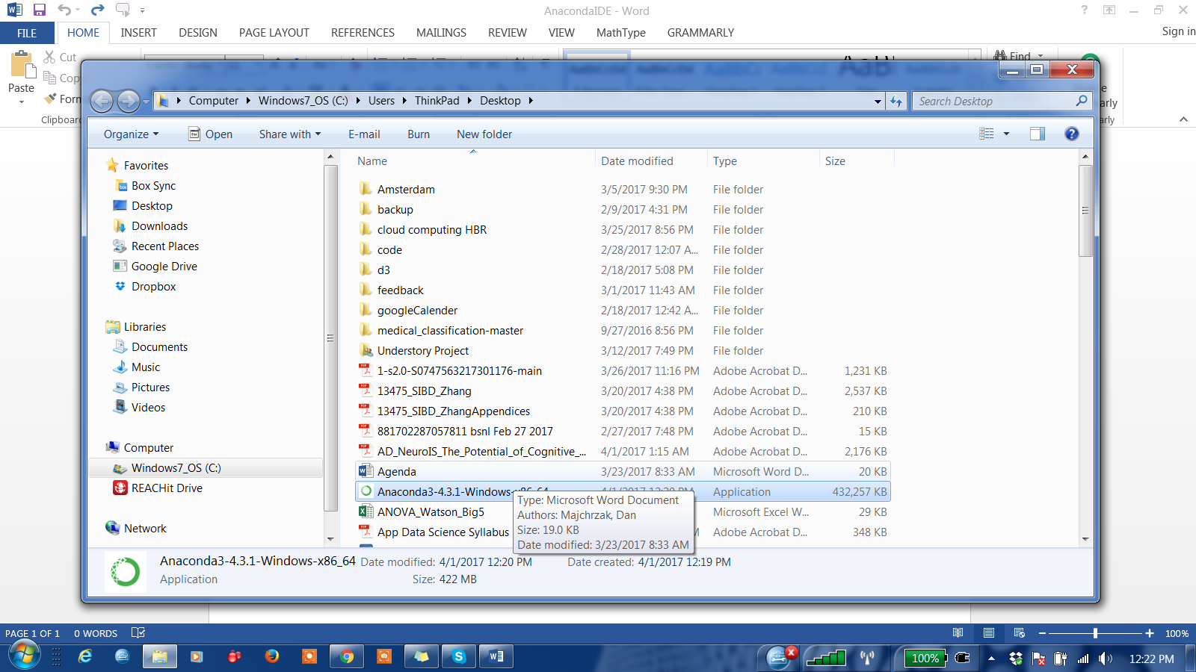

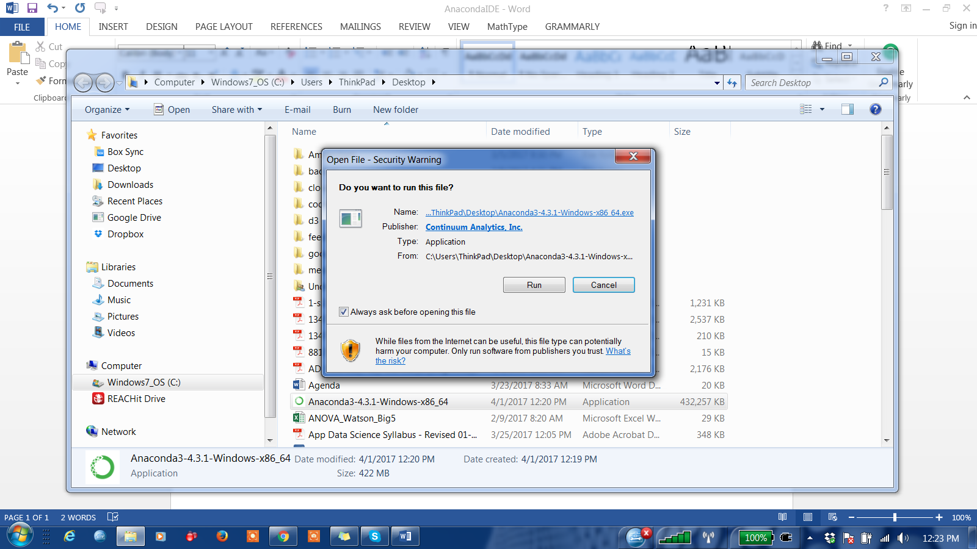

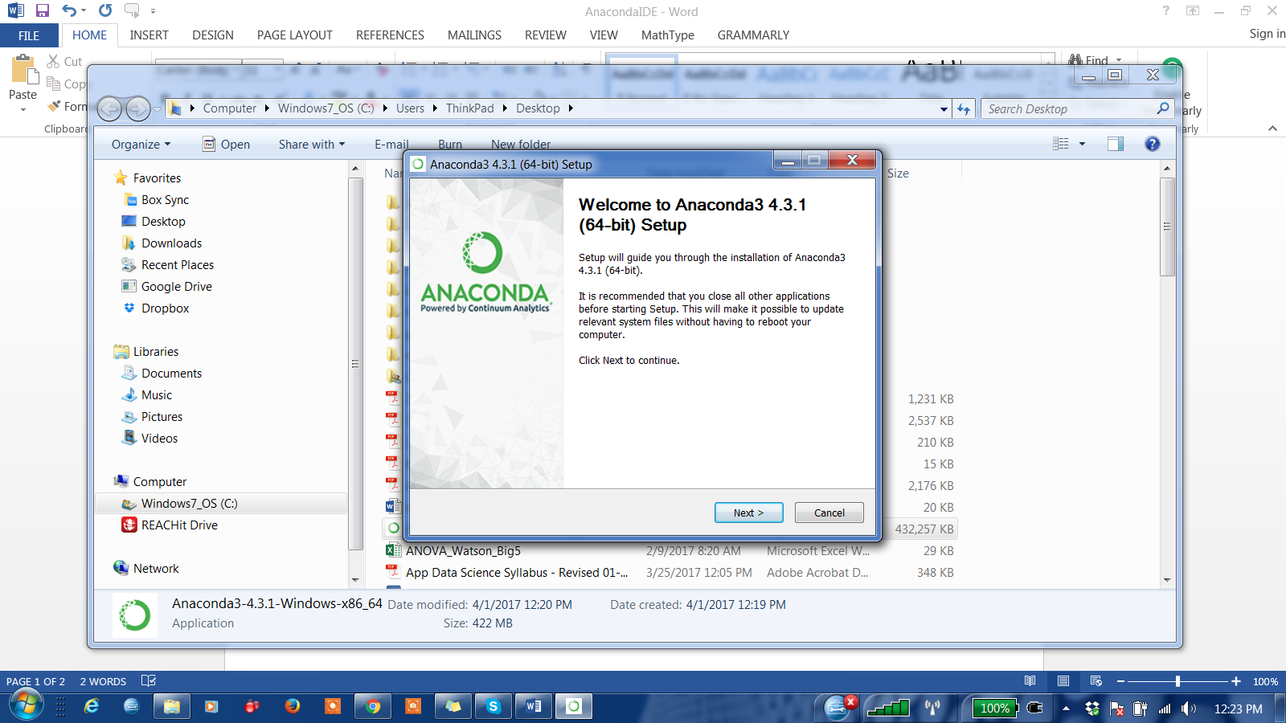

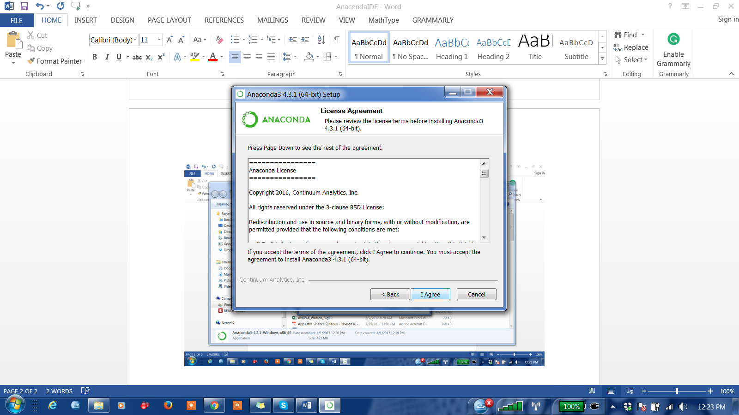

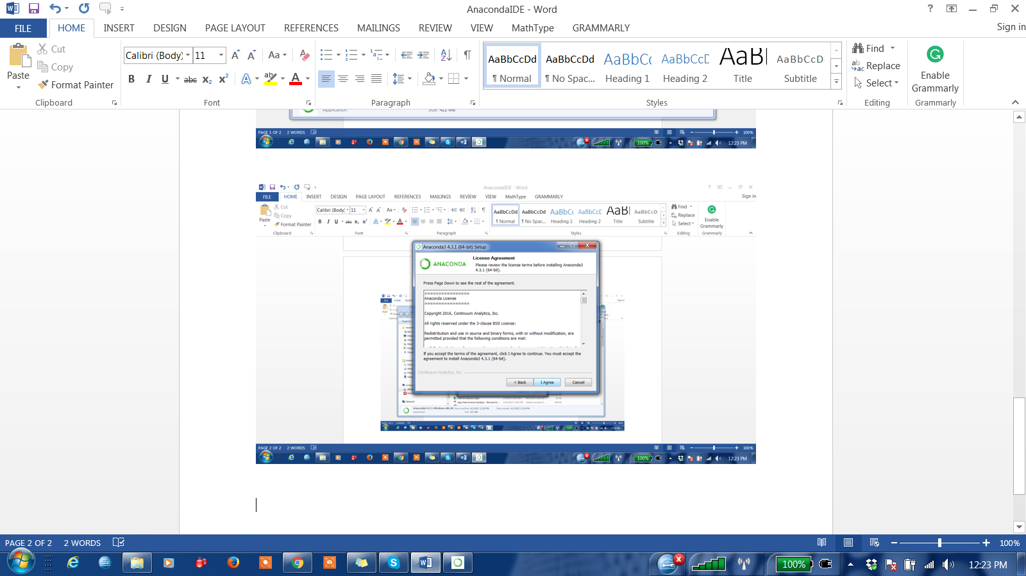

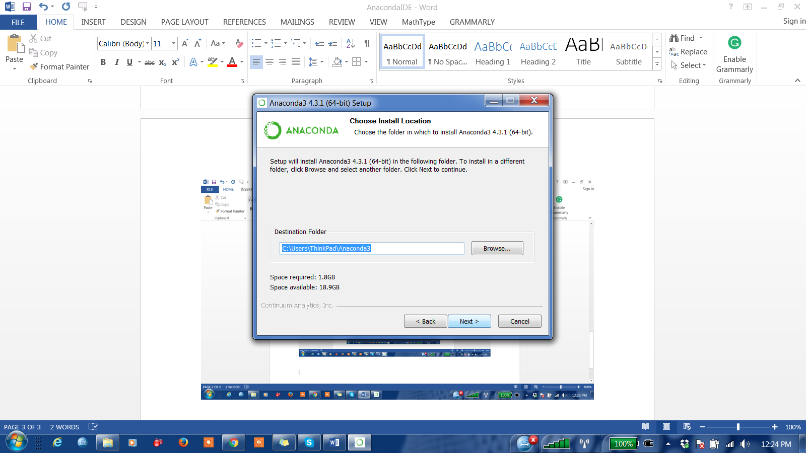

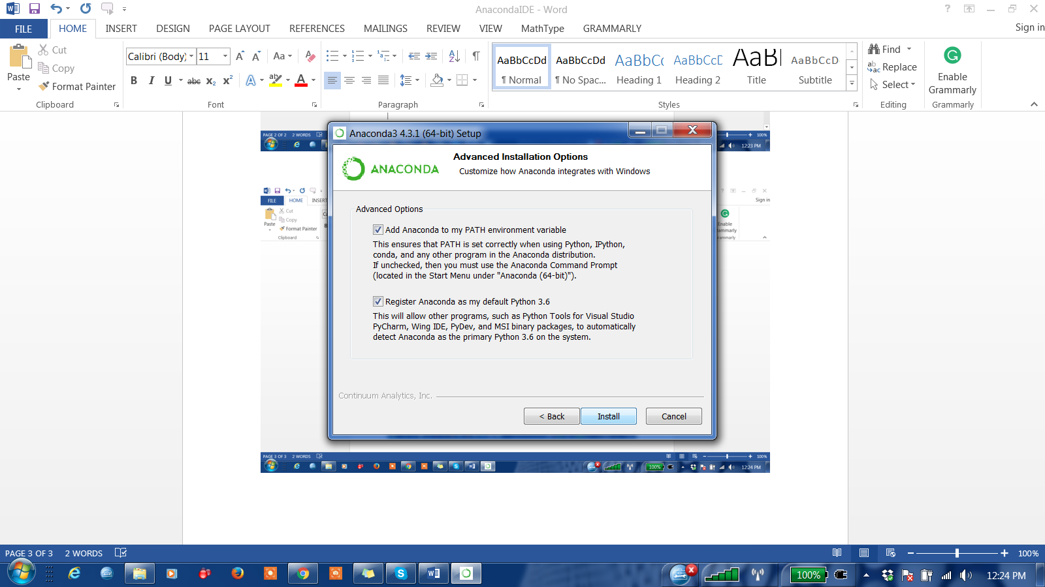

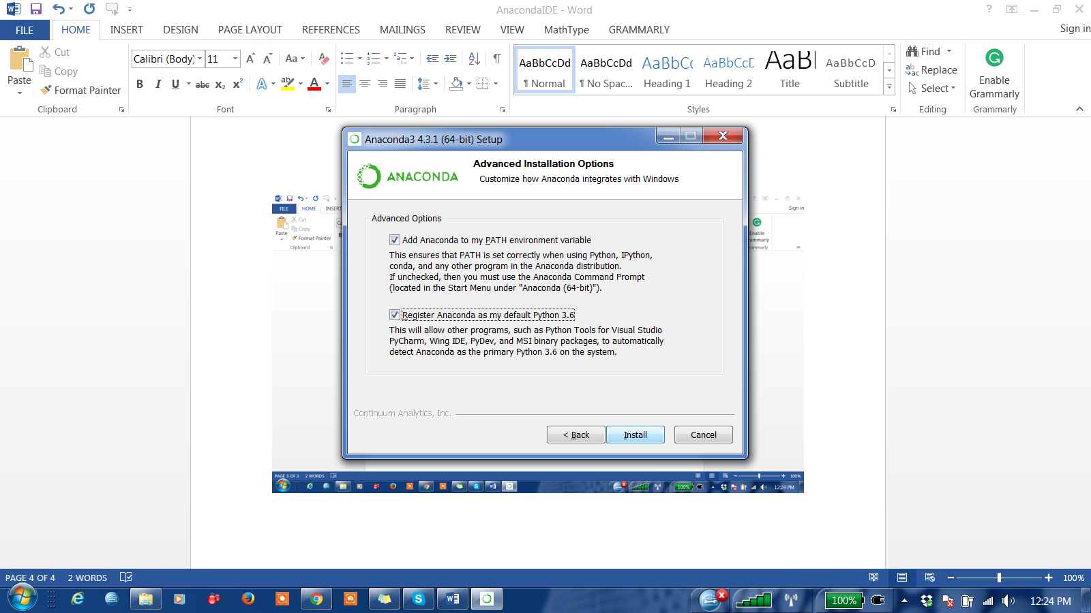

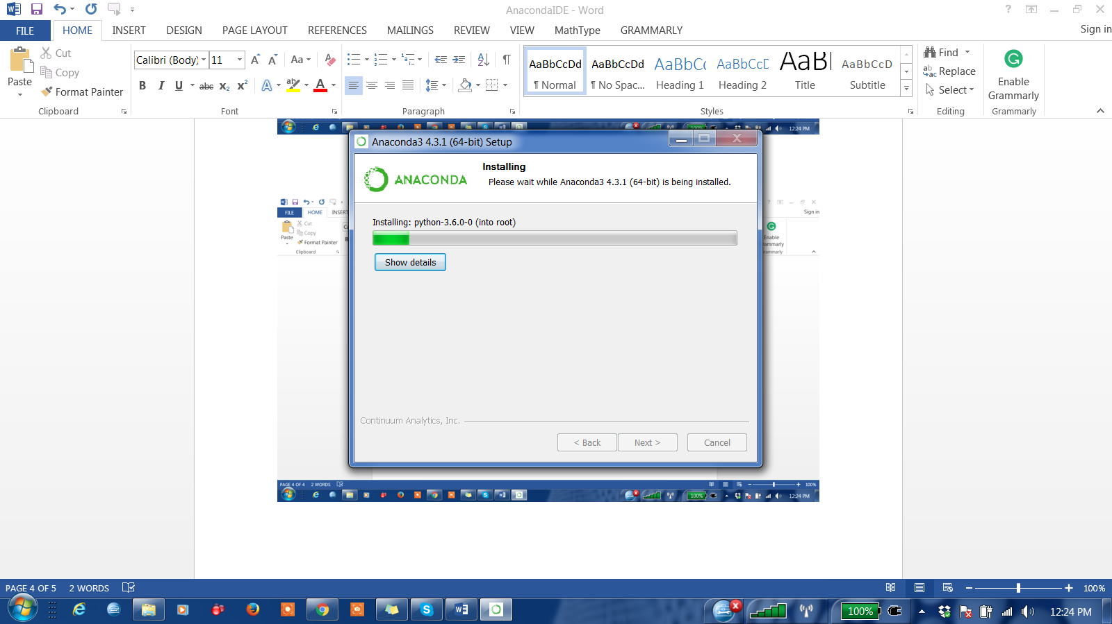

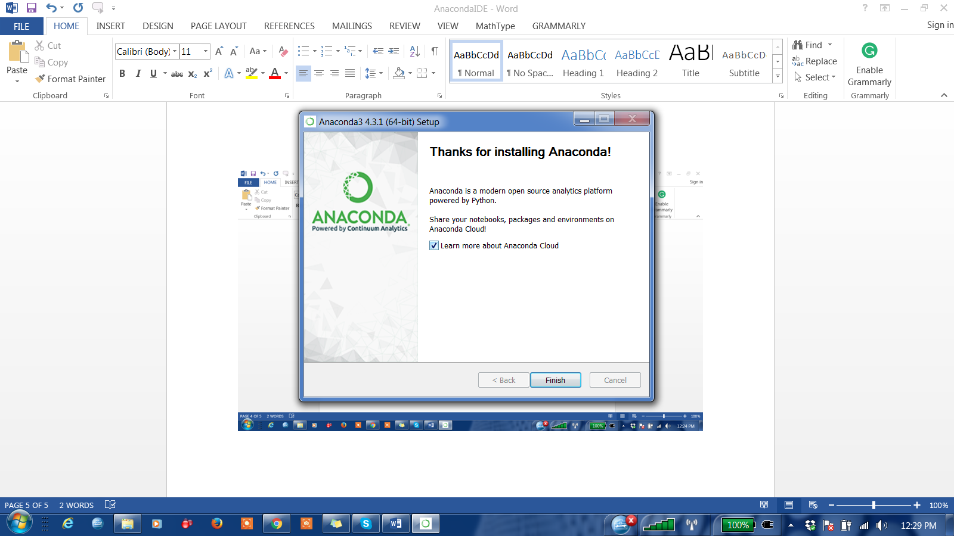

Install new package in anaconda

conda install <package_name>

For example, to install matplotlib

conda install matplotlib

Useful python packages which are available preinstalled with anaconda

* Numpy

To open Jupyter notebook, open anaconda command prompt and type following command:

> jupyter notebook

You default browser will open Jupyter notebook

Jupyter cheat code

To run code – SHIFT +ENTER

Spyder:

Open anaconda navigator and start spyder.

To run code in spyder, select or highlight the code and press SHIFT+ENTER.

To clear the output screen: CTRL +l

To access Jupyter online: try.jupyter.org