Feedback on Power Electronics 3022 final exam
General Comments and Exam Performance
Number of Students: IE = 237 Micro= 127
Average: IE =17.5 Micro = 17
Standard Deviation: IE = 4 Micro=4.4
Individual Question Commentary
Q1.
- 1. Many students did not arrive at the correct answer for the average current, which should be zero.
When calculating the form factor, the following equation should be used..
Some students did not use the absolute value of the current when calculating the denominator.
When calculating the form factor, some students did not take advantage of the current signal’s symmetry. By calculating the RMS and average current values over just one-quarter of the period, the computational effort and time required can be significantly reduced.
b.
- The circuit is shown below. It must have two SCRs in antiparallel, and the circuit must be a circuit. Some students used the DC source instead of the AC source. Some students missed the load R.
- The sketches illustrate an average power of less than 50% (left) and greater than 50% (right). However, some students did not specify which sketch corresponds to which case. Additionally, the waveforms should switch on after a delay at the start of each half-cycle—not off. Some students only labelled the half-cycles without showing this behaviour.

c. MOSFETs’s advantages include:
- Fast switching (10’s → 100’s nS).
- Huge power gain (Very simple gate control).
- Easily paralleled for higher current handling.
Their three main disadvantages are:
- Relatively low blocking voltage (1000V).
- Relatively low current handling (100A).
- Power dissipation can be high.

Most students provided correct answers, but some who were absent from class submitted incorrect responses.

- Most students correctly identified that the MOSFET is safe while the diode is at risk, as shown in their thermal schematic diagrams.
- Fewer students arrived at the correct answer, mainly because they did not account for the total dissipated power of 3.0 W when calculating the heatsink's thermal resistance.
- Most students received full marks; however, a few still made some mistakes.
- They did not realize that the 80 V input voltage on the primary winding of the transformer is an RMS value. To obtain the peak value, it should be multiplied by √2. The peak voltage of the secondary winding should be:
- The question stated that the diode voltage drop is 0.7 V, but some students still used 1.0 V instead. Therefore, the correct peak output voltage should be:

- When calculating the Peak Inverse Voltage (PIV) for each diode, the following equation should be used:

Attempts: compulsory,
For IE: Average: 16.5, Standard Deviation: 4.5, Max: 25/25
For Micro : Average: 17.3, Standard Deviation: 4, Max: 24.5/25

Q2.
- Fewer students answered correctly because they did not recognize that the circuit is a half-wave rectifier, meaning the period is 20 ms rather than 10 ms. The charging time is 30/360×20 ms=1.667 ms, and the discharging time is Δt=18.333 ms.
The peak-to-peak voltage ripple is: ;
The average output load voltage is:
The peak inverse voltage drop V_{D} is:
- The correct answer is shown below:
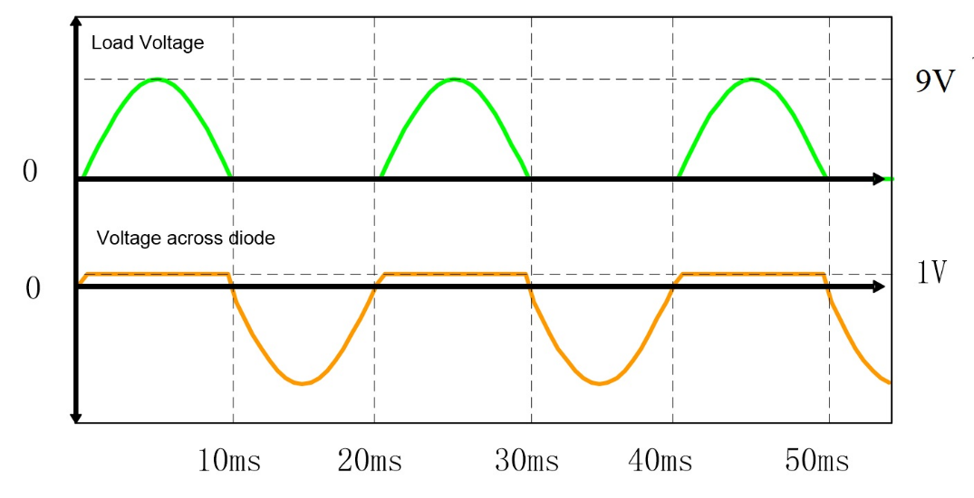
Most students provided the correct answer, but some incorrectly labeled the peak voltages for the load and the diode.
c.
i. When SCRs are triggered on, the trigger gate can not be used to switch the SCRs off.
Most students provided the correct answer.
- SCRs are unsuitable for use in DC-DC conversion because DC voltage cannot provide a negative voltage for the turn-off of the switch.
Most students provided the correct answer.
iii.
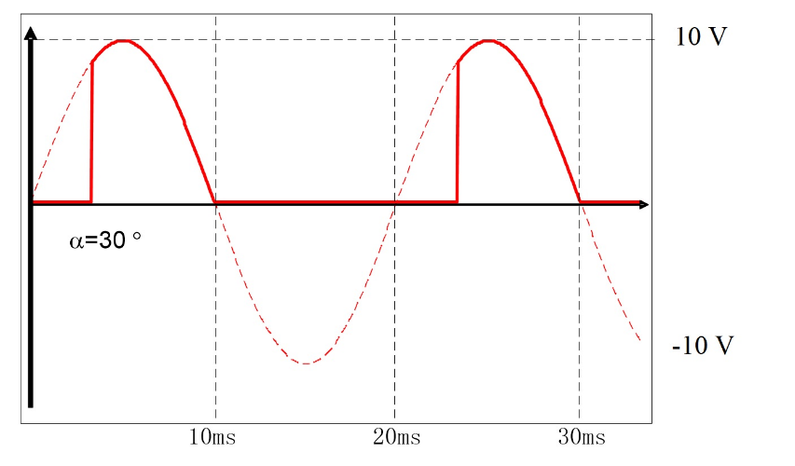
Some students forgot to label the peak voltage of 10 V, the x-axis units, and the delay angle of 30°.
iv.
So the V_{avg}=2.97 V.

Most students correctly calculated the average and RMS values, but some did not realize that the period is 2π rather than π.
Attempts: compulsory,
For IE: Average: 16.3, Standard Deviation: 4.5, Max: 25/25
For Micro : Average: 16, Standard Deviation: 4.5, Max: 25/25

Q3. This question was related to test analytical skill related to buck converter. The overall performance was good.
In part (a), the common mistakes were related to part(a)(iii) were students have not provide all steps required to derive the input-output voltage relation. Another common mistake was related to compute the max and min values of inductor current. Here students added/subtracted ${(∆i_{L})}_{switch closed}$ is inductor average value in place of $\frac{{(∆i_{L})}_{switch closed}}{2}$.
In part (b) which was related to selection of a DC-DC converter in given circumstances, students struggled to answer correctly. Most of the students (who gave wrong answer), confused the correct choice of Flyback Converter with Buck-Boost converter.
Attempts: compulsory,
For IE: Average: 18.3, Standard Deviation: 6.1, Max: 25/25
For Micro : Average: 18, Standard Deviation: 6.9, Max: 25/25

Q4. This question was related to DC-AC inverters where cognitive levels of analysis and evaluation were tested. In part of iv of this question, students confused the required circuit diagram with the resultant DC-AC converter circuit diagram under different switch on-off condition. The right answer was to draw the circuit diagram of mechanism that controls the switches as given below:
Bipolar voltage switching |   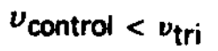 | $T_{A+} and T_{B-}$ on  $T_{B+} and T_{A-}$ on
Unipolar voltage switching | 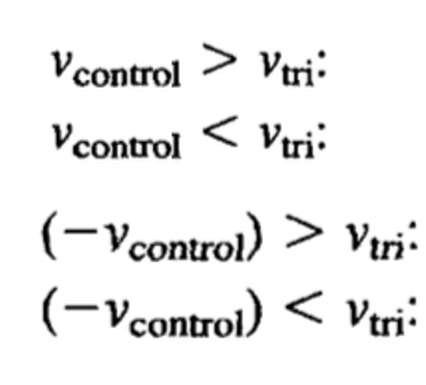 | 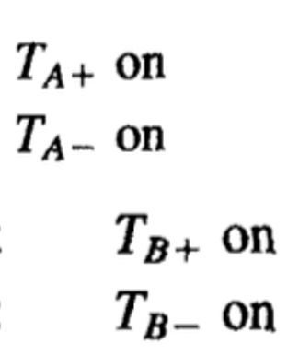

Bipolar voltage switching | 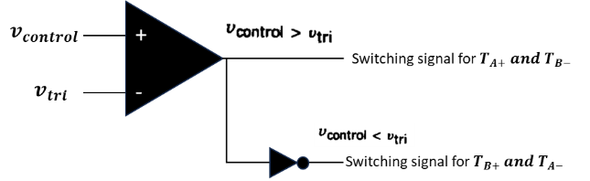
Unipolar voltage switching | 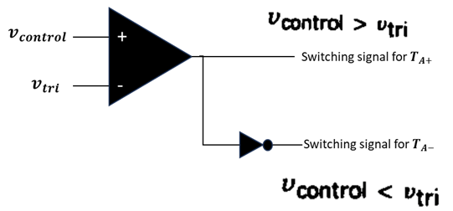  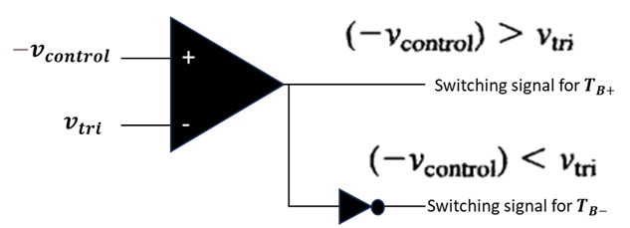

Attempts: compulsory,
For IE: Average: 15.3, Standard Deviation: 7.2, Max: 25/25
For Micro : Average: 13.3, Standard Deviation: 7.9, Max: 25/25

