**PURBANCHAL UNIVERSITY**

**Biratnagar Nepal**



A Project report on

**“LIBRARY BOOKS MANAGEMENT SYSTEM”**

In the partial fulfillment for the requirement of the 1nd Semester Project-I (subject code- BIT 106CO) in the completion of **Bachelor of Information Technology (BIT)** degree at **KIST college** **of Information Technology**, under **Purbanchal University.**

|  |  |  |  |  |  |  |
| --- | --- | --- | --- | --- | --- | --- |
|  | **Submitted By: -** | | |  | **Submitted To: -** | |
| **1)** |  | **Anjan Shrestha** |  |  |  |  |
| **2)** |  | **Pukar Tiwari** | | **Purbanchal University** | | |

1. **Sandip Shrestha**
2. **Saurav Magar**

**Under The Guidance of**

**Mr. Prawesh Dhungana**

**Lecturer, BIT**

**KIST COLLEGE OF INFORMATION AND TECHNOLOGY KAMALPOKHARI, KATHMANDU, NEPAL**

**KIST COLLEGE OF INFORMATION AND TECHNOLOGY**

**KAMALPOKHARI, KATHMANDU NEPAL**



**CERTIFICATE**

This is to certify that the project work entitled **“LIBRARY BOOKS MANAGEMENT SYTEM”** is carried out by **ANJAN SHRESTHA (), PUKAR TIWARI (5429), SANDIP SHRESTHA (5437),** **SAURAV MAGAR (5432),** bona fide students of **KIST COLLEGE OF INFORMATION AND TECHNOLOGY** in partial fulfillment for the award of **BACHELOR IN INFORMATION AND TECHNOLOGY** of the **PURBANCHAL UNIVERSITY, BIRATNAGAR NEPAL**, during the year **2015-2016**. It is certified that all corrections indicatedfor internal assessment have been incorporated in the report submitted in the department library. The project report has been approved, as it satisfied the academic requirements in respect of the project work prescribed for the said degree.

The details of the students are as follows: -

|  |  |  |
| --- | --- | --- |
| **NAME** | **REGISTRATION NO.** | **SYMBOL NO.** |
| Anjan Shrestha | 058-3-2-04716-2020 | 313418 |
| Pukar Tiwari | 058-3-2-04731-2020 | 313432 |
| Sandip Shrestha | 058-3-2-04739-2020 | 313440 |
| Saurav Magar | 058-3-2-04742-2020 |  |

Course Semester: - 1nd Semester

Subject: - Project-I

Subject Code: - BIT (160CO)



Mr. Deepak Khadka

Program Coordinator, BIT



**KIST COLLEGE OF INFORMATION AND TECHNOLOGY KAMALPOKHARI, KATHMANDU**

**Examiner’s Certification**

The Project Report

On

**“LIBRARY BOOKS MANAGEMENT SYSTEM”**

**Developed by**

**Anjan Shrestha**

**Pukar Tiwari**

**Sandip Shrestha**

**Saurav Magar**

Is approved and is acceptable in qualify form.

|  |  |
| --- | --- |
| **Internal Examiner**  Name:  Designation: | **External Examiner**  Name:  Designation: |

**ACKNOWLEDGEMENT**

It is with greatest satisfaction and euphoria that we are submitting our project report entitled **“LIBRARY BOOKS MANAGEMENT SYSTEM”.** We have completed it as a part of the curriculum of **PURBANCHAL UNIVERSITY.**

We also take this opportunity to express a deep sense of gratefulness to our **BIT Coordinator Mr.** **Deepak Khadka** and **BIT Lecturer Mr. Prawesh Dhungana** for their amiable support, valuableinformation and guidance which helped us in completing this task throughout its various stages. We are indebted to all members of **KIST College,** for the valuable support and suggestion provided by them using their specific fields’ knowledge. We are grateful for their cooperation during the period of our project.

Finally, we would also like to express our gratefulness towards **Purbanchal University** for designing such a wonderful course structure. It will help us to get more knowledge in the field of Information Technology & help us to have a bright future in the field of technology.

We hope our university will accept this attempt as a successful project.

Last but not the least, our sincere thanks to our parents, teaching and non-teaching staffs of our college and also my friends.

**ANJAN SHRESTHA (313418)**

**PUKAR TIWARI (313432)**

**SANDIP SHRESTHA (313440)**

**SAURAV MAGAR ()**

**STUDENT’S DECLARATION**

We hereby declare that the project report entitled “**LIBRARY BOOKS MANAGEMENT SYTEM**” is a result of our own work. If we are found guilty of copying any other report or published information and showing as our original work, we understand that we shall be liable and punishable by **Purbanchal University**.

We further certify that this Project submitted in partial fulfillment of the requirement for the award of Bachelor in Information Technology (**BIT**) of the **Purbanchal University** is our original work and has not been submitted for award of any other degree or other similar title or prize.

|  |  |  |  |
| --- | --- | --- | --- |
| S.N. | Name | Registration No. | Symbol No. |
| 1 | Anjan Shrestha | 058-3-2-04716-2020 | 313418 |
| 2 | Pukar Tiwari | 058-3-2-04731-2020 | 313432 |
| 3 | Sandip Shrestha | 058-3-2-04739-2020 | 313440 |
| 4 | Saurav Magar | 058-3-2-04742-2020 |  |

**TO WHOM IT MAY CONCERN**

This is to certify that **Mr. Anjan Shrestha, Mr. Pukar Tiwari, Mr. Sandip Shrestha** and **Mr. Saurav Magar of Bachelor in Information Technology (BIT)** has studied as per the curriculum of **BIT 1nd Semester** and completed the project entitled **“Library Books Management System (LBMS)”**.This project is the original work of **Mr. Anjan Shrestha, Mr. Pukar Tiwari, Mr. Sandip Shrestha and Mr. Saurav Magar** and was carried out under the supervision of **Mr. Prawesh Dhungana** as per the guidelines provided by **Purbanchal University** and certified as per the student’s declaration that project “**Library Books Management System**” has not been presented anywhere as a part of any other academic work.

The detail of the student is as follows:

Name of Students : Anjan Shrestha

Pukar Tiwari

Sandip Shrestha

Saurav Magar

Semester : 1nd

Subject Code : BIT 106C0

Project Title : **Library Books Management System**

…………………………….

Mr. Deepak Khadka  
Program Coordinator, BIT  
KIST College of Information Technology

**ABSTRACT**

The purpose of **“Library Books Management System”** is to automate the existing manual system by the help of computerized equipment’s and full-fledged computer software, fulfilling their requirements, so that their valuable data/information can be stored for a longer period with easy accessing and manipulation of the same. The required software and hardware are easily available and easy to work with.

**Library Books Management System,** as declared above, can lead to error free, secure, reliable and fastmanagement system. It can assist the user to concentrate on their other activities rather to concentrate on the record keeping. Thus, it will help organization in better utilization of resources. The organization can maintain computerized records without redundant entries. That means that one need not be distracted by information that is not relevant, while being able to reach the information.

The aim is to automate its existing manual system by the help of computerized equipment and full-fledged computer software, fulfilling their requirements, so that their valuable data/information can be stored for a longer period with easy accessing and manipulation of the same. Basically, the project describes how to manage for good performance and better services for the clients.

**According’s:** LBMS refers to library books management system.

TABLE OF CONTENTS

Chapter 1 1

1.1 INTRODUCTION 1

1.2 PROBLEM STATEMENT 2

1.3 OBJECTIVES 3

1.4 SCOPE 4

1.5 ADVANTAGES 5

Chapter 2 6

SYSTEM DESIGN 6

2.1 ALGORITHM 6

2.2 FLOWCHART 8

Chapter 3 15

3.1 REQUIREMENTS ANALYSIS & IMPLEMENTATION SYSTEM 15

3.2 SYSTEM METHODOLOGY 16

3.2.1 Requirement and Gathering Analysis 17

3.2.2 System Design 18

3.2.3 Implementation 19

3.2.4 Integration and testing 19

3.2.5 DEPELOYMNET AND MAINTANANCE 20

Chapter 4 21

4.1 CONCLUSION & FUTURE SCOPE 21

4.2 Appendices 22

4.2.1 Screenshots 22

4.2.2 Source code 23

# 

## INTRODUCTION

The LBMS has been developed to override the problems prevailing in the practicing manual system. This software is supported to eliminate and, in some case, reduce the hardships faced by this existing system. Moreover, this system is designed for the particular need of the library departments to carry out operations in a smooth and effective manner.

Library Books Management System is a desktop-based application. This application is developed by using C programming language. It is an easy and time-efficient way of storing the data. These data can be easily accessed by the administration.

Library Books Management System (LBMS) is a system which helps users to insert, name, edit, rename, issue and time & date. By using this system, it will help in control the loss of book. The library staffs can get the right information in time and make further Planning.

This system is developed by using “C Programming” as its backend and This application based on file handling in C, where I have used a file-related function like fopen, fread, fwrite, etc good thing is that “Library Books Management System project” is password-protected, so only authorized person able to login in this application.

The project demonstrates the creation of a user interface of a system, without the use of C Graphics library. The project uses basic C function to generate menus, show message boxes and print text on the screen.

## PROBLEM STATEMENT

A Library books management system has to be developed for automating the Library Management System. Our software provides following facilities: -

1. **LOGIN:** Only the user with specified login id and password can get access to the system. This provides security from unauthorized access. It keeps the data safely.
2. **INSERT RECORD:** A librarian should be able to insert the record of the books. To insert the record the librarian should note the Name of the students, Student ID, Book Id etc. It helps to reduce the misplacing of books. It helps to make the work of the librarian can run the library easily and effectively.
3. **DISPLAY RECORD:** It helps to display the record of the books. It provides the details of issued books which include: Name of the student, Name of the books, Student Id, Book Id, Date of Submission, Fines etc.
4. **UPDATE RECORD:**

## OBJECTIVES

The main objectives behind the development of this project are as follows:

* To utilize the information of Books.
* To store and retrieve books items.
* To manage records of students who.
* To sore and access item in books stocks.
* To manage the particular records of student.
* To generate the report of books.
* To provide the details of issue books.
* To provide the details of issue books.

Thus, there are a number of objectives behind developing the “LIBRARY BOOKS MANAGEMENT SYSTEM” and it reduces a lot of manuals working of the department.

## SCOPE

The scope of this project is as follows:

* To assist the staff in capturing the effort spent on their respective working areas.
* To utilize resources in an efficient manner by increasing their productivity through automation.
* The system generates types of information that can be used for various purposes.

Thus, there are information scopes behind developing the “LIBRARY BOOKS MANAGEMENT SYSTEM” and it reduces a lot of burden of the entry.

## ADVANTAGES

The library management system is designed to contribute well management of library functions. It offers ease to perform day to day library operations electronically. This practice being many advantages like:

* Simple and easy to operate
* Saves time and reduces overheads
* Remove manual processes to issue books and maintain records
* Increase librarian’s efficiencies

# 

## SYSTEM DESIGN

## ALGORITHM

Step 1: Start

Step 2: Welcome Message. Press any key to continue

Step 3: Login! Enter login detail.

Step 4: If matches, goto step 6. Else goto step 5.

Step 5: If step 3 is repeated for many times,

Step 5.1: Display “Login Failed”

Step 5.2: Close the program.

Step 6: Display “Login is Successful”

Step 7: Show Main Menu

Step 8: Enter choice form menu

Step 9: If the choice is between 1 to 6, goto step 10. Else Display Invalid Choice.

Step 10: If choice is 1 “Insert Record”.

Step 10.1: Show Enter the Book ID

Step 10.2: Check the Book ID in Database If match found goto Step 10.3 Else goto Step 10.4

Step 10.3 Display Enter Unique Book ID. Goto step 10.1

Step 10.4: Enter the Detail of Book and Student

Step 10.5: Display “Do you want to insert record of another book” if yes goto step 10.1. Else goto step 7.

Step 11: If choice is 2 “Display Record”.

Step 11.1: Display the List of Books.

Step 11.2: goto step 7.

Step 12: If choice is 3 “Update Record”.

Step 12.1: Enter the Book ID which you want to update. If Book ID matched with database record goto step 12.2. else display “Record not found” goto step 12.

Step 12.2: Display the existing data and Display Enter the New data.

Step 12.3: Display “The record has been successfully updated in the data file”

Step 12.4: goto step 7.

Step 13: If choice is 4 “Delete Record”.

Step 13.1: Display “Enter the Book ID which you want to delete”.

Step 13.2: If record found goto step 13.3. Else display “No record found” goto step 13.1.

Step 13.2: Display “The record has been successfully deleted form the data file”

Step 13.3: goto step 7.

Step 14: If choice is 5 “Search Record”

Step 14.1: Display Search Menu.

Step 14.2: Enter a number between 1 to 4.

Step 14.3: If choice is 1

Step 14.3.1: Enter the Book ID.

Step 14.3.2: If record found Display the record. Else Display no record found goto step 14.1

Step 14.3.3: goto step 7.

Step 14.4: If choice is 2.

Step 14.4.1: Enter the Student Name

Step 14.4.2: If record found Display the desire record. Else Display no record found got to step 14.1

Step

Step 14.5: If choice is 3.

Step 14.5.1 Enter the Book Name

Step 14.6: If choice is 4.

Step 14.6.1: goto step 7.

Step 15: If choice is 6 “Quit”;

Step 15.1: Display “Thank you!”

Step 15.2: Close the program. Else Display “Invalid choice”

Step 15.3: goto step 7.

Step 16: Stop

## FLOWCHART

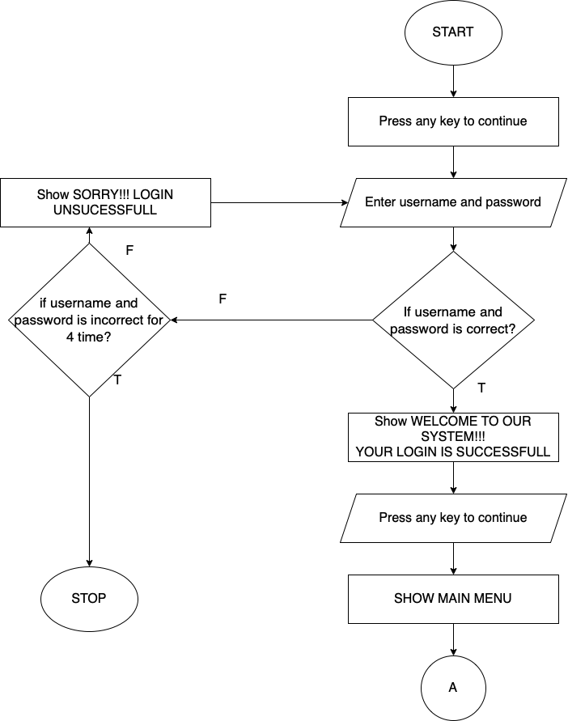

Figure 1 Login Flowchart

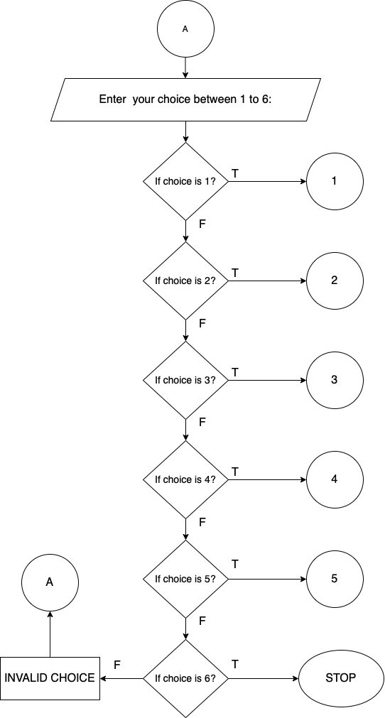

Figure 2 Main menu Flowchart

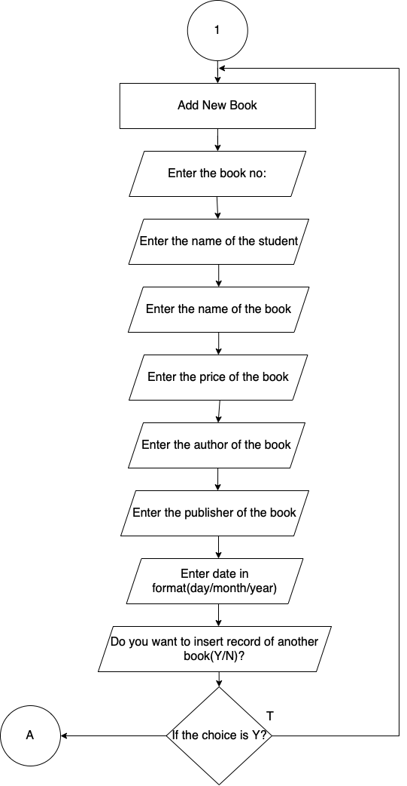

Figure 3 InsertData Flowchart

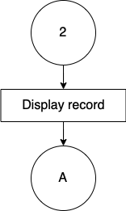

Figure 4 Display Flowchart

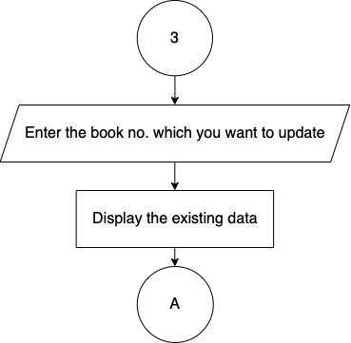

Figure 5 Update Data Flowchart

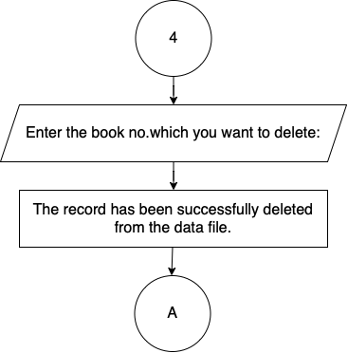

Figure 6 Delete Data Flowchart

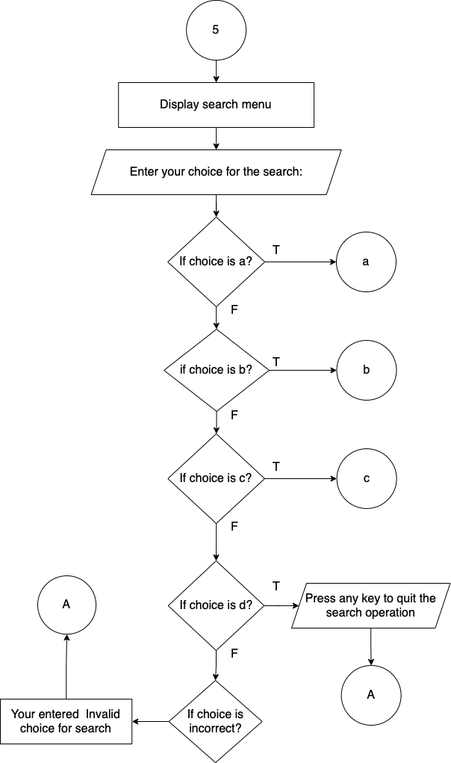

Figure 7 Search Menu Flowchart

Figure 8 Search Menu choice Flowchart

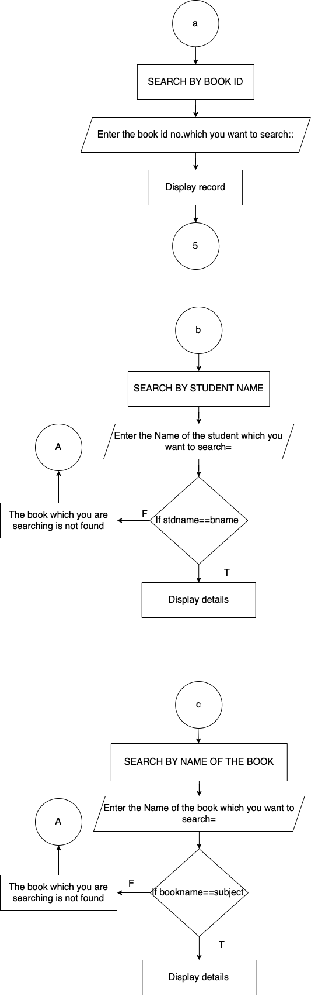

# 

## REQUIREMENTS ANALYSIS & IMPLEMENTATION SYSTEM

Following hardware and software requirement should be met for flawless running of this system:

**Hardware:** Hardware is the collection of physical parts of a computer system. This includes the computer case, monitor, keyboard, and mouse. It also includes all the parts inside the computer case, such as the hard disk drive, motherboard, video card, and many others. Computer hardware is what you can physically touch.

**MINIMUM REQUIREMENTS:**

**PROCESSOR**: PENTIUM-II

**SPEED**: 1.5Hz

**RAM**: 32MB

**HARDDISK**: 20MB (At least 80MB of free space)

**MONITOR**: VGA COLOR MONITOR

**Software:** Software is a set of instructions, data or programs used to operate computers and

execute specific tasks. It is the opposite of hardware, which describes the physical aspects of a computer.

**OPERATING SYSTEM**: WINDOWS XP, 2000 Professional

**COMPILER**: DEV C++, TURBO C, VISUAL STUDIO

## SYSTEM METHODOLOGY

**WATERFALL MODEL**

The waterfall model is a classical model used in system development life cycle to create a system with linear and sequential approach. It is termed as waterfall because the model develops systematically from one phase to another in a downward fashion. This model is divided into different phase and the output of one phase is used as the input of the next phase starts and there is no overlapping of the phase.

The sequential phases described in the Waterfall model are:

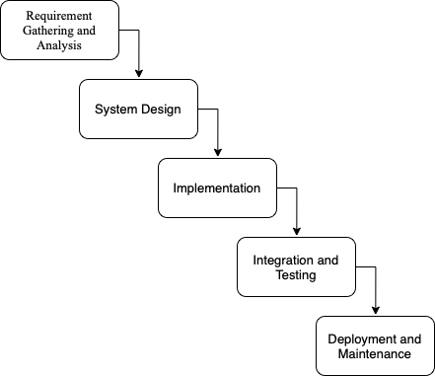

Figure 9 Waterfall Model

### Requirement and Gathering Analysis

**FUNCTIONAL REQUIREMENT**

In software and system engineering, a functional requirement defines a function of a system or its component, where a function is described as a specification of behavior between input and outputs

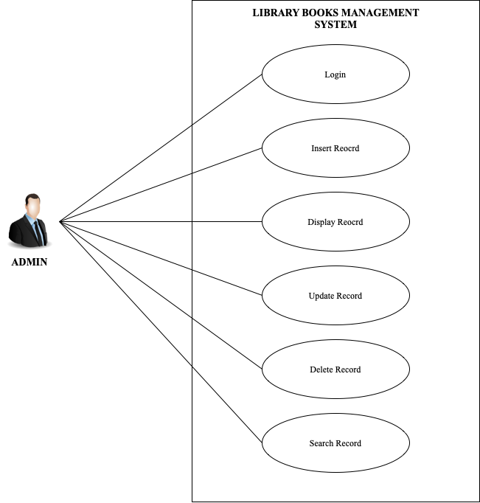

Figure 10 Use Case Diagram

### System Design

In this phase we designed the algorithm and flowchart required for the development of the system.

System design is the process of designing the architecture, components, and interfaces for a system so that it meets the end-user requirements. A good system design is to organize the program modules in such a way that are easy to develop and change. There are many strategies or techniques for performing system design.

* **Importance**:
* If any pre-existing code need to be understood, organized, and pieced together.
* It is common for the project team to have to write some code and produce original programs that support the application logic of the system.

There are many strategies or techniques for performing system design.

* **Top-down approach:** Top-down integration testing is an integration testing technique used in order to simulate the behavior of the lower-level modules that are not yet integrated. Each system is divided into several subsystems and components. Each of the subsystems is further divided into a set of subsystems and components.
* **Advantages of top-down approach:**
* The main advantage of the top-down approach is that its strong focus on requirements helps to make a design responsive according to its requirements.

#### Functional Analysis

|  |  |  |
| --- | --- | --- |
| **No.** | **Function module** | **Function Description** |
| **1.** | **login ()** | This function is for security purpose so that person other than admin cannot manipulate the system or program. |
| **2.** | **insertData ()** | This function opens the binary file in append mode and writes the book and the details. |
| **3.** | **searchData ()** | This function opens the binary file in reading mode and asks the user to enter the book name which wants to search. |
| **4.** | **displayData ()** | It opens the file in reading mode and read and display all the stored book details. |
| **5.** | **deleteData ()** | This function asks the book id form the user for the book want to delete. In this function, I am creating a temporary binary file and copy all the data from the existing file except the book whose book id entered by the user. In the last renamed the temporary bin file with a existing binary file. |
| **6.** | **updateData ()** | This function opens the file in rb+ mode (reading and writing). It asks the user for the new data |
| **7.** | **checkBookNo ()** | This function compares the old book id to new book id. if the book id match, then display the book id which you typed just now, is already exists. |
| **8.** | **findlastBookNo ()** | This function displays the last duplicate book id. and asks to enter a unique book id no. |

### Implementation

It is the process of using the project in client’s computer. After the executive file has been created, this project can be copied from saved source to any secondary storage device and pasted to the required system. The project can be operated by opening it, completely replacing the existing manual system.

### Integration and testing

Testing in a project development is a very important task to find out the possible mistakes made by the developers. The system cannot give the correct output until the project contains no errors at all. This project has checked the possible errors by using the following approaches:

1. Black Box Testing Approach: This approach concentrates on the basic requirements of the project. It simply checks direct matching of records of particular book, after we select a book no of a particular student.
2. White Box Testing Approach: This approach concentrates on the actual codes written during the development of the project. It checks every line of codes in all the functions of the program.

This project has fully tested by using both approach’s and ensures the correct output

### DEPELOYMNET AND MAINTANANCE

When time changes, the requirements of the organization also changes and this project can no longer fulfill its requirements. The changes are necessary to keep the project running and useful to college. Maintenance may be required when the college changes its requirements.

# 

## CONCLUSION & FUTURE SCOPE

**CONCLUSION**

## Appendices

### Screenshots

### Source code

#include<stdio.h>

#include<conio.h>

#include<time.h>

#include<process.h>

#include<string.h>

#include<stdlib.h>

#include<windows.h>

#define MAX_YR 9999

#define MIN_YR 1900

//structure to store date

typedef struct

{

int yyyy;

int mm;

int dd;

} Date;

//Code to declare function prototype

void printMessageCenter(const char* message)

{

int len = 0;

int pos = 0;

len = (78 - strlen(message))/2;

printf("\t\t\t");

for(pos=0;pos<len;pos++)

{

printf(" ");

}

printf("%s",message);

}

void headMessage(const char *message)

{

system("cls");

time_t currentTime;

time(&currentTime);

printf("\t\t\t%s\n", ctime(&currentTime));

printf("\t\t\t\xdb\xdb\xdb\xdb\xdb\xdb\xdb\xdb\xdb\xdb\xdb\xdb\xdb\xdb\xdb\xdb\xdb\xdb\xdb\xdb\xdb\xdb\xdb\xdb\xdb\xdb\xdb\xdb\xdb\xdb\xdb\xdb\xdb\xdb\xdb\xdb\xdb\xdb\xdb\xdb\xdb\xdb\xdb\xdb\xdb\xdb\xdb\xdb\xdb\xdb\xdb\xdb\xdb\xdb\xdb\xdb\xdb\xdb\xdb\xdb\xdb\xdb\xdb\xdb\xdb\xdb\xdb\xdb\xdb\xdb\xdb\xdb\xdb\xdb\xdb");

printf("\n\t\t\t\xdb\xdb\xdb\xdb\xdb\xdb\xdb\xdb\xdb\xdb\xdb\xdb \xdb\xdb\xdb\xdb\xdb\xdb\xdb\xdb\xdb\xdb\xdb\xdb");

printf("\n\t\t\t\xdb\xdb\xdb\xdb\xdb\xdb\xdb\xdb\xdb\xdb\xdb\xdb LIBRARY BOOKS MANAGEMENT SYSTEM Project in C \xdb\xdb\xdb\xdb\xdb\xdb\xdb\xdb\xdb\xdb\xdb\xdb");

printf("\n\t\t\t\xdb\xdb\xdb\xdb\xdb\xdb\xdb\xdb\xdb\xdb\xdb\xdb \xdb\xdb\xdb\xdb\xdb\xdb\xdb\xdb\xdb\xdb\xdb\xdb");

printf("\n\t\t\t\xdb\xdb\xdb\xdb\xdb\xdb\xdb\xdb\xdb\xdb\xdb\xdb\xdb\xdb\xdb\xdb\xdb\xdb\xdb\xdb\xdb\xdb\xdb\xdb\xdb\xdb\xdb\xdb\xdb\xdb\xdb\xdb\xdb\xdb\xdb\xdb\xdb\xdb\xdb\xdb\xdb\xdb\xdb\xdb\xdb\xdb\xdb\xdb\xdb\xdb\xdb\xdb\xdb\xdb\xdb\xdb\xdb\xdb\xdb\xdb\xdb\xdb\xdb\xdb\xdb\xdb\xdb\xdb\xdb\xdb\xdb\xdb\xdb\xdb\xdb");

printf("\n\t\t\t---------------------------------------------------------------------------\n");

printMessageCenter(message);

printf("\n\t\t\t---------------------------------------------------------------------------");

}

void welcomeMessage()

{

system("color 90");

headMessage("KIST COLLEGE");

printf("\n\n\n\n\n");

printf("\n\t\t\t\t **-**-**-**-**-**-**-**-**-**-**-**-**-**-**-**-**-**-**\n");

printf("\n\t\t\t\t =-=-=-=-=-=-=-=-=-=-=-=-=-=-=-=-=-=-=-=-=-=-=");

printf("\n\t\t\t\t = WELCOME =");

printf("\n\t\t\t\t = TO =");

printf("\n\t\t\t\t = LIBRARY BOOK =");

printf("\n\t\t\t\t = MANAGEMENT =");

printf("\n\t\t\t\t = SYSTEM =");

printf("\n\t\t\t\t =-=-=-=-=-=-=-=-=-=-=-=-=-=-=-=-=-=-=-=-=-=-=");

printf("\n\t\t\t\t **-**-**-**-**-**-**-**-**-**-**-**-**-**-**-**-**-**-**\n");

printf("\n\n\n\t\t\t Press any key to continue.....");

getch();

}

// Function to check leap year.

//Function returns 1 if leap year

int IsLeapYear(int year)

{

return (((year % 4 == 0) &&

(year % 100 != 0)) ||

(year % 400 == 0));

}

// returns 1 if given date is valid.

int isValidDate(Date *validDate)

{

//check range of year,month and day

if (validDate->yyyy > MAX_YR ||

validDate->yyyy < MIN_YR)

return 0;

if (validDate->mm < 1 || validDate->mm > 12)

return 0;

if (validDate->dd < 1 || validDate->dd > 31)

return 0;

//Handle feb days in leap year

if (validDate->mm == 2)

{

if (IsLeapYear(validDate->yyyy))

return (validDate->dd <= 29);

else

return (validDate->dd <= 28);

}

//handle months which has only 30 days

if (validDate->mm == 4 || validDate->mm == 6 ||

validDate->mm == 9 || validDate->mm == 11)

return (validDate->dd <= 30);

return 1;

}

void insertData();

void displayData(void);

void updateData(int);

void deleteData(int);

void searchData(void);

int checkBookNo(int);

int findLastBookNo(void);

void login();

//Code to declare file pointer

FILE *fp,*fp1;

//Code to design structure

struct book

{

int bn;

char stdName[200];

char bookName[100];

float price;

int nob;

char author[100];

char publisher[100];

Date bookIssueDate;

};

//Code to declare structure variable

struct book b;

//Code to declare main function

/*############################################################ main() ######################################################################*/

main()

{

welcomeMessage();

system("cls");

//login();

int choice;

int bn;

while(1)

{

system("cls");

//Code to display menu

headMessage("MAIN MENU");

printf("\n\n\n\t\t\t1. Insert Record");

printf("\n\t\t\t2. Display Record");

printf("\n\t\t\t3. Update Record");

printf("\n\t\t\t4. Delete Record");

printf("\n\t\t\t5. Search Record");

printf("\n\t\t\t6. Quit");

printf("\n\n\t\t\tEnter your choice between 1 to 6 : ");

scanf("%d",&choice);

switch(choice)

{

case 1:

//Code to call insertData function

insertData();

break;

case 2:

//Code to call displayData function

displayData();

break;

case 3:

//Code to call updateData function

printf("\n\t\t\tEnter the book no. which you want to update = ");

scanf("%d",&bn);

updateData(bn);

break;

case 4:

//Code to call deleteData function

headMessage("DELETE MENU");

printf("\n\t\t\tEnter the book no. which you want to delete = ");

scanf("%d",&bn);

deleteData(bn);

break;

case 5:

//Code to call searchData function

searchData();

break;

case 6:

printf("\n\n\n\t\t\t\tThank you!!!\n\n\n\n\n");

exit(0);

default:

headMessage("INVALID INPUT");

printf("\n\n\n\t\t\tSORRY!!! INVALID INPUT!!!\n");

printf("\t\t\tPlease, Enter the valid choice between 1 to 6");

getch();

}

}

}

//Code to declare function defination

/*############################################################ insertData() #####################################################################*/

void insertData()

{

char next='y';

int duplicatebookno=0,lastbookno;

system("cls");

while(next=='y'||next=='Y')

{

aa:

system("cls");

headMessage("ADD NEW BOOKS");

printf("\n\t\t\tEnter the book no\t= ");

scanf("%d",&b.bn);

//Code to call function to check the book no. has been repeated or not

duplicatebookno=checkBookNo(b.bn);

if(duplicatebookno==1)

{

printf("\n\t\t\tThe book no. which you typed just now, is already exists in the data file!!!!\n");

printf("\n\n\t\t\tPlease, Enter the unique Book ID.!!!");

lastbookno=findLastBookNo();

printf("\n\n\t\t\tThe last book no. is : %d",lastbookno);

getch();

goto aa;

}

fflush(stdin);

printf("\n\t\t\tEnter the Name of the Student = ");

gets(b.stdName);

printf("\n\t\t\tEnter the Name of the book = ");

gets(b.bookName);

printf("\n\t\t\tEnter the price of the book = ");

scanf("%f",&b.price);

printf("\n\t\t\tEnter the no. of book = ");

scanf("%d",&b.nob);

fflush(stdin);

printf("\n\t\t\tEnter the author of the book = ");

gets(b.author);

printf("\n\t\t\tEnter the publisher of the book = ");

gets(b.publisher);

printf("\n\t\t\tEnter date in format (day/month/year) = ");

scanf("%d/%d/%d",&b.bookIssueDate.dd,&b.bookIssueDate.mm,&b.bookIssueDate.yyyy);

fp=fopen("Book.dat","a");

if(fp==NULL)

{

printf("\n\t\t\tFile creation error has occurred!!!");

}

else

{

fwrite(&b,sizeof(b),1,fp);

fclose(fp);

printf("\n\n\t\t\tDo you want to insert record of another book (Y/N)?");

next=getche();

}

}

}

/*############################################################ displayData() ######################################################################*/

void displayData(void)

{

system("cls");

headMessage("BOOKS LIST");

fp=fopen("Book.dat","r");

rewind(fp);

if(fp==NULL)

{

printf("\n\n\t\t\tRead operation failure as the file which your are searching does not exixt!!!");

}

else

{

printf("\n\tBook ID No. Student Name\tBook Name\t\tPrice\t\tNo. of Books\tAuthor\t\t\tPublisher\tDate\t\tRenew Date");

while(fread(&b,sizeof(b),1,fp)==1)

{

printf("\n\t %-8d %s\t\t%s\t\t\tRs.%.2f\t\t%d\t%s\t\t\t%s\t\t%d/%d/%d\t%d/%d/%d",b.bn,b.stdName,b.bookName,b.price,b.nob,b.author,b.publisher,b.bookIssueDate.dd,b.bookIssueDate.mm,b.bookIssueDate.yyyy,b.bookIssueDate.dd+15,b.bookIssueDate.mm,b.bookIssueDate.yyyy);

}

fclose(fp);

}

getch();

}

/*############################################################ updateData() ######################################################################*/

void updateData(int bn)

{

//headMessage("UPDATE MENU");

fp=fopen("Book.dat","r");

fp1=fopen("newBook.dat","w");

if(fp==NULL||fp1==NULL)

{

printf("\n\t\t\tFile Operation failed.");

}

else

{

//code to show the existing data

printf("\n\n\t\t\tThe followings are the existing data!!!!!");

while(fread(&b,sizeof(b),1,fp)==1)

{

if(b.bn==bn)

{

printf("\n\t\t\tBook ID No. : %d",b.bn);

printf("\n\t\t\tStudent Name : %s",b.stdName);

printf("\n\t\t\tBook Name : %s",b.bookName);

printf("\n\t\t\tPrice : Rs. %2f",b.price);

printf("\n\t\t\tNo. of Books : %d",b.nob);

printf("\n\t\t\tPublisher : %s",b.publisher);

}

}

//code to enter new data

rewind(fp);

//headMessage("Enter the new correct data");

printf("\n\n\t\t\tEnter the new correct data");

while(fread(&b,sizeof(b),1,fp)==1)

{

if(bn==b.bn)

{

printf("\n\n\n\t\t\tEnter the Book ID = ");

scanf("%d",&b.bn);

fflush(stdin);

printf("\n\t\t\tEnter the Name of the Student = ");

gets(b.stdName);

printf("\n\t\t\tEnter the Name of the book = ");

gets(b.bookName);

printf("\n\t\t\tEnter the price of book = ");

scanf("%f",&b.price);

printf("\n\t\t\tEnter the no. of book = ");

scanf("%d",&b.nob);

fflush(stdin);

printf("\n\t\t\tEnter the author of the book = ");

gets(b.author);

printf("\n\t\t\tEnter the publisher of the book = ");

gets(b.publisher);

fwrite(&b,sizeof(b),1,fp1);

}

else

{

fwrite(&b,sizeof(b),1,fp1);

}

}

fclose(fp);

fclose(fp1);

remove("Book.dat");

rename("newBook.dat","Book.dat");

printf("\n\n\t\t\tThe record has been successfully updated in the data file");

}

getch();

}

/*############################################################ deleteData() ######################################################################*/

void deleteData(int bn)

{

int found = 0;

headMessage("DELETE MENU");

fp=fopen("Book.dat","r");

fp1=fopen("newBook.dat","w");

if(fp==NULL||fp1==NULL)

{

printf("\nFile Operation failed");

}

else

{

while(fread(&b,sizeof(b),1,fp))

{

if(bn!=b.bn)

{

fwrite(&b,sizeof(b),1,fp1);

//continue;

}

else

{

found = 1;

}

}

fclose(fp);

fclose(fp1);

remove("Book.dat");

rename("newBook.dat","Book.dat");

(found)? printf("\n\t\t\tRecord deleted successfully....."):printf("\n\t\t\tRecord not found");

//printf("\n\n\t\t\tThe record has been successfully deleted from the date file.");

}

getch();

}

/*############################################################ searchData() ######################################################################*/

void searchData(void)

{

int bn,found=0;

char bname[100],subject[100];

unsigned int countBook = 1;

char ch;

system("cls");

headMessage("SEARCH MENU");

printf("\n\t\t\ta. Search by Book No.");

printf("\n\t\t\tb. Search by Student Name");

printf("\n\t\t\tc. Search by Book Name");

printf("\n\t\t\td. Quit Search");

printf("\n\n\t\t\tEnter your choice for search => ");

scanf("%c",&ch);

switch(ch)

{

case 'a':

//search on the basis of book no.

system("cls");

fp=fopen("Book.dat","r");

headMessage("SEARCH BY BOOK ID ");

printf("\n\n\t\t\tEnter the book id no. which you want to search : ");

scanf("%d",&bn);

if(fp==NULL)

{

printf("\n\t\t\tFile seach operation failed!!!!!");

}

else

{

while(fread(&b,sizeof(b),1,fp)==1)

{

if(b.bn==bn)

{

headMessage("RECORD");

printf("\n\t\t\tBook ID No : %d",b.bn);

printf("\n\t\t\tStudent Name : %s",b.stdName);

printf("\n\t\t\tBook Name : %s",b.bookName);

printf("\n\t\t\tPrice : Rs. %2f",b.price);

printf("\n\t\t\tNo. of Books : %d",b.nob);

printf("\n\t\t\tAuthor : %s",b.author);

printf("\n\t\t\tPublisher : %s",b.publisher);

found=1;

getch();

}

}

if(found==0);

{

headMessage("WARNING!!!");

printf("\n\t\t\t!!!!!!!!!!!!!!!!!");

printf("\n\t\t\tThe book which you are searching is not found");

}

fclose(fp);

}

break;

case 'b':

//seach on the basis of Student Name

system("cls");

fflush(stdin);

headMessage("SEARCH BY STUDENT NAME ");

printf("\n\n\t\t\tEnter the Name of the Student which you want to search = ");

gets(bname);

fp=fopen("Book.dat","r");

if(fp==NULL)

{

printf("\n\t\t\tFile search operation failed!!!!!");

}

else

{

while(fread(&b,sizeof(b),1,fp)==1)

{

if(strcmpi(b.stdName,bname)==0)

{

printf("\n\t\t\tBook Count = %d\n",countBook);

printf("\n\t\t\tBook ID No. : %d",b.bn);

printf("\n\t\t\tBook Name : %s",b.bookName);

printf("\n\t\t\tStudent Name : %s",b.stdName);

printf("\n\t\t\tPrice : Rs.%2f",b.price);

printf("\n\t\t\tNo. of Books : %d",b.nob);

printf("\n\t\t\tAuthor : %s",b.author);

printf("\n\t\t\tPublisher : %s",b.publisher);

printf("\n\t\t\tBook issue date(day/month/year) : (%d/%d/%d)\n",b.bookIssueDate.dd,b.bookIssueDate.mm, b.bookIssueDate.yyyy);

printf("\n\t\t\tBook Expire date(day/month/year) : (%d/%d/%d)\n",b.bookIssueDate.dd,b.bookIssueDate.mm+3, b.bookIssueDate.yyyy);

++countBook;

found=1;

}

if(found==0)

{

printf("\n\t\t\t!!!!!!!!!!");

printf("\n\t\t\tThe book which you are searching is not found");

}

fclose(fp);

}

break;

}

case 'c':

//search on the basis of Book Name

system("cls");

headMessage("SEARCH BY NAME OF THE BOOK ");

fflush(stdin);

printf("\n\n\t\t\tEnter the Name of the book which you want to search = ");

gets(subject);

fp=fopen("Book.dat","r");

if(fp==NULL)

{

printf("\n\t\t\tFile search operation failed!!!!");

}

else

{

while(fread(&b,sizeof(b),1,fp)==1)

{

if(strcmpi(b.bookName,subject)==0)

{

printf("\n\t\t\tBook Count = %d\n",countBook);

printf("\n\t\t\tBook ID No. : %d",b.bn);

printf("\n\t\t\tStudent Name : %s",b.stdName);

printf("\n\t\t\tBook Name : %s",b.bookName);

printf("\n\t\t\tPrice : Rs.%2f",b.price);

printf("\n\t\t\tNo of Books : %d",b.nob);

printf("\n\t\t\tAuthor : %s",b.author);

printf("\n\t\t\tPublisher : %s\n",b.publisher);

++countBook;

found=1;

}

}

if(found==0)

{

printf("\n\t\t\t!!!!!!!!!!");

printf("\n\t\t\tThe book which you are searching is not found");

}

fclose(fp);

}

break;

case 'd'||'q':

//code to close search window

printf("\n\t\t\tPress any key to quit the search operation");

break;

default:

printf("\n\t\t\tYou entered invalid choice for search");

}

getch();

}

/*############################################################ checkBookNo() ######################################################################*/

int checkBookNo(int bn)

{

int repeated=0,lastbookno;

struct book b1;

fp=fopen("Book.dat","r");

if(fp==NULL)

{

printf("\n\n\t\t\tRead operation failure as the file which you are searching does not exist!!!");

}

else

{

while(fread(&b1,sizeof(b1),1,fp)==1)

{

if(b1.bn==bn)

{

repeated=1;

break;

}

}

fclose(fp);

}

return(repeated);

}

/*############################################################ findLastBookNo() ######################################################################*/

int findLastBookNo()

{

int lastbookno;

struct book b2;

fp=fopen("Book.dat","r");

if(fp==NULL)

{

printf("\n\n\t\t\tFile open operation failure!!!");

}

else

{

while(fread(&b2,sizeof(b2),1,fp)==1)

{

lastbookno=b2.bn;

}

fclose(fp);

}

return(lastbookno);

}

/*############################################################ Login menu() ######################################################################*/

void login()

{

int a=0,i=0;

char uname[10],c=' ';

char pword[10],code[10];

char user[10]="user";

char pass[10]="pass";

do

{

headMessage("Login");

printf("\n\n\t\t\tUsername: ");

scanf("%s", &uname);

printf("\n\t\t\tPassword: ");

while(i<10)

{

pword[i]=getch();

c=pword[i];

if(c==13) break;

else printf("*");

i++;

}

pword[i]='\0';

i=0;

if(strcmp(uname,"kist")==0 && strcmp(pword,"kist")==0)

{

printf("\n\n\n\t\t\tLOGIN IS SUCCESSFUL");

printf("\n\n\n\t\t\tPress any key to continue...");

getch();

break;

}

else

{

printf("\n\n\n\t\t\tLogin Failed! Enter Again Username & Password");

a++;

getch();

system("cls");

}

}

while(a<=2);

if (a>2)

{

headMessage("Login Failed");

printf("\n\t\t\tYou have attempted to Login with wrong password too many times.");

getch();

exit(0);

}

system("cls");

}