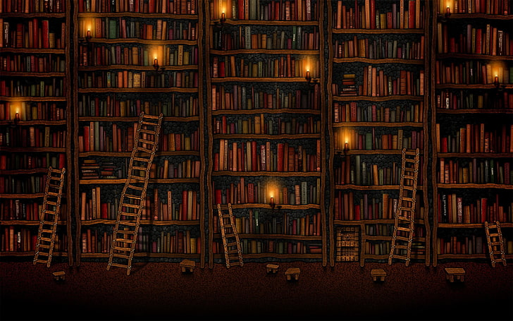

**SUBMITTED BY**

Anjan Shrestha (5418)

Pukar Tiwari (5429)

Sandip Shrestha (5437)

**SUBMITTED TO**

Mr. Deepak Khadka

**Library Management System**