ASEAN Energy Transition
A Cross-Country Data Analysis of Renewable Energy, Emissions, and Electricity Access, 2000 to 2022
Andita Rachmania (Dwipayani)
September 2026

Abstract
ASEAN spans a roughly 180-fold income gap between its richest and poorest member states, which makes any single narrative about a regional energy transition potentially misleading. This paper examines four World Bank World Development Indicators, renewable energy share, CO2 emissions per capita, electricity access, and GDP per capita, across all 10 ASEAN member states from 2000 to 2022, to see which patterns hold once countries are compared individually rather than as a bloc. The analysis finds that renewable energy share is declining in several of the region's largest economies, driven by coal expansion rather than a slowdown in renewable adoption; that headline renewable statistics substantially overstate clean energy progress in lower-income states due to traditional biomass use; that CO2 emissions are rising fastest in the economies that most need continued growth; and that electricity access has improved dramatically almost everywhere except Myanmar. The analysis is descriptive and exploratory; associations discussed are consistent with, but not tested as, causal relationships.

1. Background
ASEAN is frequently discussed as a single economic bloc, but its ten member states differ enormously: a roughly 180-fold gap separates GDP per capita at the top and bottom of the region, and energy systems, policy capacity, and development priorities differ accordingly. Regional or global reporting on energy transition progress often aggregates ASEAN into a single figure, which can obscure sharply divergent country-level trajectories and, in some cases, produce a misleadingly optimistic picture of clean energy progress.
This analysis disaggregates four widely used World Bank indicators by country and by year to test whether commonly cited regional narratives, a renewable energy transition underway, convergence in emissions and income, hold up at the country level, and where they do not.

2. Research Questions
Is fossil fuel growth outpacing the renewable energy transition across ASEAN, or is the headline renewable share misleading? How are CO2 emissions per capita evolving across the region's income spectrum? Which countries have reached near-universal electricity access, and which remain behind? And is there early evidence of CO2-income decoupling in wealthier ASEAN states?

3. Data Source
Data is drawn from the World Bank World Development Indicators (WDI), retrieved April 2026, covering all 10 ASEAN member states from 2000 to 2022 (23 annual observations per country). Four indicators are used: renewable energy consumption as a share of total final energy consumption (EG.FEC.RNEW.ZS), CO2 emissions per capita in metric tons (EN.ATM.CO2E.PC), access to electricity as a percentage of population (EG.ELC.ACCS.ZS), and GDP per capita in current US dollars (NY.GDP.PCAP.CD). Linear interpolation was applied where intermediate annual values were unavailable.

4. Methodology
The analysis is descriptive and exploratory. For each indicator, trends are plotted across all 10 countries over the full time series and summarized as a 2022 cross-country snapshot. A composite Energy Transition Readiness score is constructed as an unweighted average of four normalized (0 to 1) sub-scores: current renewable share, CO2 per capita (inverted, so lower emissions score higher), electricity access, and the percentage-point change in renewable share from 2000 to 2022. This composite is illustrative rather than a validated index; equal weighting is a modeling choice, not an empirical result. All analysis was conducted in Python (pandas, numpy, matplotlib); the full code is in the accompanying notebook.

5. Findings

5.1 Renewable share is falling where fossil generation is growing faster
Indonesia's renewable share fell from about 44% to 15% between 2000 and 2022, not because renewable adoption declined in absolute terms, but because coal-fired power expansion outpaced it. Cambodia, Vietnam, and the Philippines show a similar falling-floor pattern. Vietnam is a partial exception: a feed-in tariff programme introduced after 2018 triggered a solar and wind boom that reversed its earlier decline, illustrating how a specific policy lever can shift a country's trajectory relatively quickly.
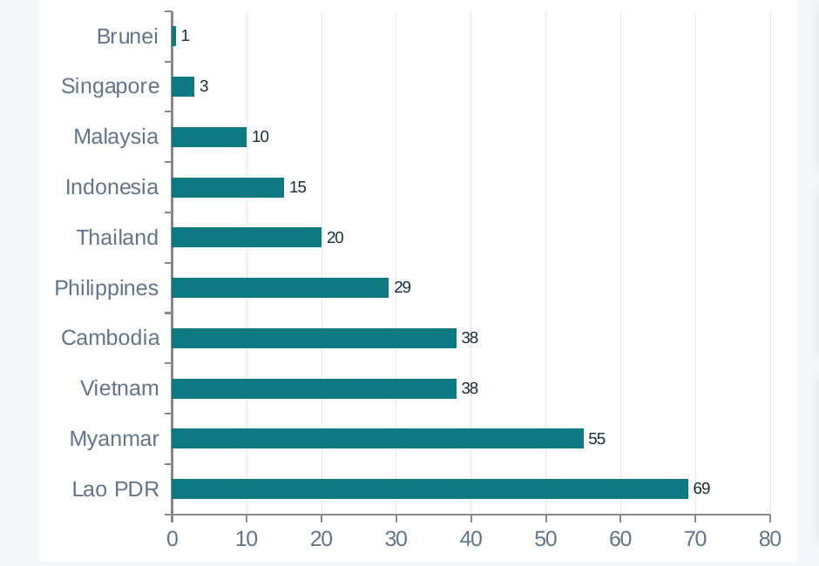
Figure 1. Renewable energy share (% of total final energy consumption), 2022.

5.2 Headline renewable statistics overstate clean energy progress in lower-income states
Lao PDR, Myanmar, and Cambodia post the highest renewable shares in the region (69%, 55%, and 38% respectively), but this is driven mainly by traditional biomass use, cooking on wood and charcoal, rather than modern renewables such as solar, wind, or hydro. This reflects a development gap rather than a clean energy achievement, and treating the two as equivalent overstates the region's actual transition progress.

5.3 CO2 emissions are rising fastest where growth is most needed
Vietnam's per-capita emissions grew roughly sixfold between 2000 and 2022 (0.5 to 3.0 metric tons), tracking rapid, coal-heavy industrialization; Cambodia, Lao PDR, and Indonesia show similar upward trajectories. Malaysia's emissions appear to be stabilizing around 7.5 to 8 metric tons despite continued GDP growth, and Singapore shows a flat or slightly declining trend since roughly 2010, both tentative signs of income-emissions decoupling. Brunei is a clear outlier in the other direction, at 20 metric tons per capita, far above what its income level would predict, consistent with heavy energy subsidies and a fossil-fuel-dependent economy.
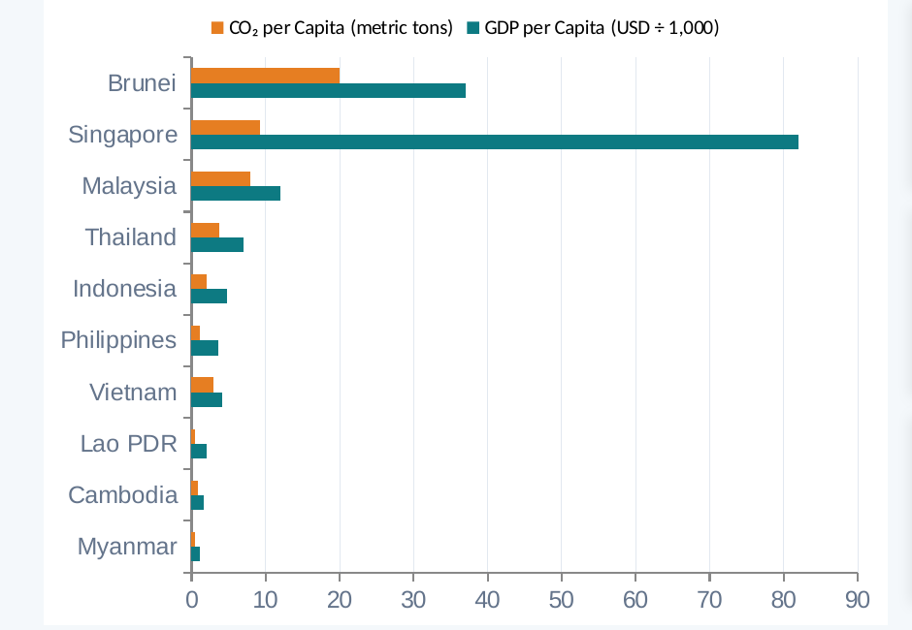
Figure 2. GDP per capita and CO2 emissions per capita, 2022.
The economies with the fastest-rising emissions, Vietnam, Cambodia, Lao PDR, and Indonesia, are also those that most need continued economic growth. This is a genuine tension for regional climate policy: the power and industrial infrastructure being built now typically operates for 30 to 40 years, so decisions made in the next few years will shape emissions trajectories well past 2050.

5.4 Electricity access has improved dramatically, with one clear exception
Cambodia went from about 20% to 87% electricity access between 2000 and 2022, Lao PDR from 35% to 92%, and Indonesia from 72% to 99%, among the largest electrification gains recorded anywhere in this period. Five countries, Brunei, Malaysia, Singapore, Thailand, and Vietnam, have reached or are approaching universal access. Myanmar is the exception, at 65% access and the lowest in the region; political instability since 2021 appears to have reversed some earlier infrastructure gains, making its energy access gap difficult to separate from a governance problem.
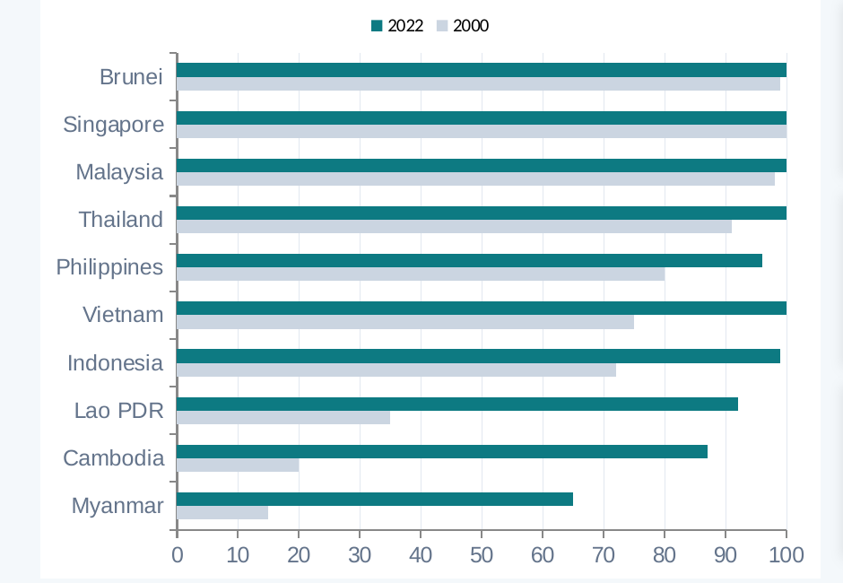
Figure 3. Electricity access (% of population), 2000 versus 2022.

5.5 Composite readiness ranking
Combining all four indicators into an illustrative composite score, Lao PDR ranks highest and Brunei lowest. This ranking should be read cautiously: Lao PDR's high score is substantially inflated by traditional biomass counted as renewable energy, which is exactly the measurement problem described in Section 5.2.

6. Limitations
- Traditional biomass use inflates renewable energy percentages for lower-income countries in a way that is not comparable to modern renewable generation, and the underlying indicator does not separate the two.
- Linear interpolation was used to fill gaps between annual observations, which smooths short-term volatility that may itself be analytically meaningful.
- The composite index uses equal weighting across four sub-scores as a simplifying choice, not an empirically derived one; a different weighting scheme would produce a different ranking.
- GDP figures are in current US dollars rather than purchasing-power-adjusted terms, which affects cross-country income comparisons.
- This is a descriptive analysis. Associations discussed here, for example between specific policy changes and renewable share shifts, are consistent with a causal story but are not tested as one.

References
World Bank (2026). World Development Indicators. https://databank.worldbank.org/source/world-development-indicators. Indicator codes: EG.FEC.RNEW.ZS, EN.ATM.CO2E.PC, EG.ELC.ACCS.ZS, NY.GDP.PCAP.CD.

