Data Quality Risk in the Verra VCS Registry: A Scoring Framework for Corporate Carbon Credit Due Diligence

Andita Rachmania Dwipayani
Data Analyst, South Pole

Working paper – 2026

Supplementary materials: https://anditarachmania.github.io/verra-carbon-registry-analysis/

Abstract
The voluntary carbon market has emerged as a critical mechanism for corporate climate action, yet persistent concerns regarding credit integrity have created a significant knowledge gap between project developers and corporate buyers. This paper develops and applies a data quality scoring framework to 1,700 energy sector projects in the Verra Verified Carbon Standard (VCS) public registry, drawing on Wang and Strong’s (1996) foundational dimensions of information quality and Akerlof’s (1970) theory of markets under asymmetric information. The framework operationalizes eight registry fields as weighted proxies for credit verifiability, producing risk classifications across high, medium, and low tiers. Four empirical patterns are identified: 597 projects (35.1%) carry Late-to-Verify status, representing approximately 51 million tCO₂e in stalled annual emission reductions; 58.5% of Late-to-Verify projects registered in 2020, a concentration attributable to CDM-to-VCS legacy migration; 55% of all projects are missing crediting period dates; and 408 projects (24%) exhibit backdated crediting, a consistency anomaly distinct from field completeness failure. The study contributes a preliminary, reproducible scoring framework for Verra VCS registry data quality assessment, with direct implication for corporate ESG due diligence. All findings are treated as indicative and preliminary, consistent with the exploratory scope of this investigation.

Keywords: Voluntary carbon market, data quality, information asymmetry, carbon credit integrity, Verra VCS registry

- Introduction
The integrity of voluntary carbon markets has attracted sustained scholarly and public scrutiny, with concerns reaching critical mass following investigative reporting by The Guardian and Zeit Online in 2023, which raised substantial questions about the validity of offset credits certified under the Verra Verified Carbon Standard – the world’s largest voluntary carbon standard by issuance volume. These revelations triggered a measurable decline in market confidence and intensified calls for structural reform from regulatory bodies including the International Organization of Securities Commissions (IOSCO, 2023) and the Integrity Council for the Voluntary Carbon Market (ICVCM, 2023). The underlying challenge these events exposed is not merely one of project performance, but of information architecture: the structural conditions under which buyers, sellers, and regulators access, interpret and act on information about credit quality.
Corporate purchasers of carbon credits occupy a position of particular vulnerability within this architecture. Organizations making net-zero commitments rely on voluntary carbon credits as transitional instruments for addressing residual emissions, yet the quality dimensions most relevant to credit validity – additionality, permanence, and leakage prevention – are not directly observable form market-facing information systems. Carbon Direct (2024) assessed that fewer than 10% of projects evaluated in its voluntary carbon market review met meaningful quality criteria. This dynamic is consistent with the theoretical structure described by Akerlof (1970), wherein the inability of buyers to verify quality prior to purchase creates conditions for adverse selection and market deterioration.
Public carbon credit registries represent an underexplored source of structured, auditable data that may yield systematic signals of integrity risk prior to transaction. The Verra VCS registry records project registration, methodology adoption, crediting period definitions, verification status, and credit issuance and retirements, a multi-dimensional dataset that, when subject to systematic quality analysis, may reveal patters consistent with elevated risk profiles. Despite the registry’s public availability, no published research has applied a systematic data quality scoring framework to extract integrity signals from registry fields as a decision-support input for corporate buyers, analysts, and researchers working with voluntary carbon market data.
This paper addresses that gap. The research question guiding this study is: what data quality patterns are detectable in the Verra VCS public registry, and what do these patterns signal about the verifiability of energy sector carbon credits? The paper contributes a reproducible scoring framework applied to 1,700 VCS energy sector projects, characterizes the resulting risk distribution, and identifies three empirical patterns of practical consequence: the prevalence of Late-to-Verify status, a 2020 registration spike attributable to CDM-to-VCS migration, and systematic missing field patterns that constrain registry-based analysis. Whether these patters generalize across registries, project types, and time periods, and whether they can be developed into a broader early warning system for market integrity risk, are questions explicitly reserved for future research.
The paper proceeds as follows: Section 2 reviews the theoretical foundations; Section 3 describes the methodology; Section 4 presents the empirical findings; Section 5 discusses theoretical and practical implications; Sections 6 and 7 address limitations and future directions before Section 8 concludes.

- Theoretical Background and Literature Review
  - Data Quality in Information Systems
Wang and Strong’s (1996) foundational investigation of data quality established that quality is a multi-dimensional construct, best understood as fitness for use from the perspective of data consumers rather than adherence to a single normative standard. Their framework identified four principal dimensions: accuracy, completeness, consistency, and timeliness. Of these, completeness, the extent to which data are not missing and are of sufficient scope for the task at hand, and timeliness, whether data are sufficiently current for their intended purpose, are the dimensions most directly operationalizable from registry records, and they anchor the scoring framework developed in this paper. In a carbon registry context, timeliness manifests specifically as verification currency: whether a project record reflects a completed, up-to-date verification cycle, or whether it has remained open and unresolved beyond the standard monitoring window.
Completeness failures in registry data are not neutral administrative oversights; they have functional consequences for the analysts and decision-makers who depend on those records. Kariluoto et al. (2021) demonstrate that data quality deficiencies in source systems propagate systematically through downstream analytical and decision-support processes, amplifying rather than absorbing incompleteness. Pipino et al. (2002) operationalized Wang and Strong’s dimensions through ratio-based objective metrics directly analogous to the field-level scoring approach developed here. The contribution of the present paper lies in applying this accumulated apparatus to voluntary carbon markets, a domain not previously examined through the lest of formal information quality theory.

  - Information Asymmetry in Carbon Markets
Akerlof’s (1970) theory of markets under asymmetric information demonstrates that when sellers possess superior knowledge of product quality relative to buyers, adverse selection dynamics can drive high-quality goods from the market as prices converge toward the mean under buyer uncertainty. Carbon credits are, in the terminology of consumer economics, credence goods – goods whose quality cannot be evaluated either before or after purchase without specialist third-party assessment (Darby & Karni, 1973). A corporate buyer acquiring credits carrbon independently verify whether the underlying project genuinely achieved the claimed emission reductions, whether baseline emissions were accurately estimated, or whether reductions are additional to business-as-usual. The buyer must instead rely on the certification infrastructure: standard bodies, third-party auditors, and the registry system – to provide reliable quality signals.
The 2023 Guardian/Zeit investigation constituted an empirical demonstration of information asymmetry consequences at scale: a substantial volume of certified credits was subsequently characterized as significantly overstating climate impact. Carbon direct (2024) corroborated the systemic dimension, with fewer than 10% of assessed projects meeting rigorous quality criteria. IOSCO (2023) identified the absence of robust integrity safeguards as a central risk to market function. Against this backdrop, registry data quality scores are positioned in the present study not as direct measures of environmental integrity, which remains unobservable from registry fields alone, but as proximate signals of the reliability of the information infrastructure itself. A record that is incomplete or temporally degraded is one from which less can be inferred about the quality of the underlying project.

  - Registry Systems as Information Infrastructure
Carbon credit registries function as centralized information systems maintaining authoritative records of project registration, credit issuance, transfer, and retirement. In the terminology of Hanseth and Lyytinen (2010), registries constitute information infrastructure – stable, shared platforms upon which higher-level processes are built. The World Bank (2024) estimated that voluntary carbon markets trade credits representing hundreds of millions of tonnes of CO₂ equivalent annually, with Verra accounting for the majority of certified issuances globally. The ICVCM (2023) Core Carbon Principles, which establish normative standards for credible carbon credits, explicitly invoke a Transparency Principle: project data must be public, structured, and auditable by independent parties. This principle presupposes that registry records provide the informational foundation necessary to support independent scrutiny – yet no systematic framework has been published for assessing whether registry records, in practice, meet that standard. The present paper proposes that such a framework is both feasible and consequential.
- Methodology
  - Data Source and Collection
The empirical basis of this study is the Verra VCS public registry (registry.verra.org). The primary dataset comprises 1,700 energy sector projects exported from the registry interface on 26 March 2026, encompassing all project status tiers: 1,387 Registered projects (including Late-to-Verify), 176 pipeline projects, and 102 Inactive projects. The energy sector was selected as the primary domain for three reasons: it is among the most mature and voluminous project categories in the VCS registry; energy methodology families are among the most standardized, reducing variability attributable to methodology heterogeneity; and it provides a well-defined scope for an initial framework validation. Data were exported manually from the public registry interface. No API access was used. All data are publicly available and contain to personally identifiable information.

  - Data Quality Scoring Framework
A structured scoring framework was developed to operationalize Wang and Strong’s (1996) completeness, consistency, and timeliness dimensions as measurable attributes of individual project registry records. The framework assigns weighted point scores to eight fields, with an additional consistency bonus, yielding a maximum score of 100 points per project. Table 1 presents the complete framework.

Table 1. Data Quality Scoring Framework — Field Weights and Justifications
Field | Weight | Justification
Methodology | 20 pts | Mandatory per VCS Standard; absence renders emission calculation unverifiable
Registration Date | 15 pts | Temporal legitimacy anchor for the project record
Crediting Period Start | 15 pts | Defines commencement of emission reduction claims
Crediting Period End | 15 pts | Together with start date, bounds the credit validity window
Emission Reductions | 10 pts | Core volumetric claim; absence prevents credit volume verification
Region Classification | 10 pts | Geographic integrity; supports leakage assessment
Project Name | 5 pts | Minimum traceability requirement
Project Proponent | 5 pts | Accountability traceability
Valid Date Order (bonus) | +5 pts | Logical consistency: end date must follow start date

The weighting scheme reflects the relative criticality of each field to credit verifiability under the VCS Standard. Methodology (20 points) receive the highest weight because it constitutes the foundational calculation basis for emission reductions: without a verifiable methodology reference, quantitative claims cannot be reproduced or assessed. Crediting period start and end dates (15 points each) define the temporal scope of emission reduction claims – their absence renders it impossible to assess whether credited reductions fall within any verifiable period. Registration date (15 points) establishes temporal legitimacy. Emission reductions (10 points) and region classification (10 points) support volume verification and leakage assessment respectively. Project name (5 points) and proponent (5 points) constitute minimum traceability requirements. The valid date order bonus (+5 points) rewards logical internal consistency.
The weighting scheme is author-defined, based on structured assessment of field criticality relative to VCS Standard requirements. Alternative schemes could produce different classifications for individual projects. This is acknowledged as a limitation in Section 6.

  - Risk Classification
Risk classification proceeds in two steps. The first step assigns a descriptive quality band based on the raw score alone: project scoring 76-100 are designated Good, reflecting strong field completeness across the primary dimensions; projects scoring 51-75 are designated Fair, indicating partial completeness with one or more fields absent; and projects scoring 50 or below are designated Poor or Critical, indicating that the majority of critical validation information is absent. These bands, as summarized in Table 2, provide an initial, score-only view of registry completeness before status flags are considered.

Table 2. Quality Score Bands
Band | Score Range | Description
Good | 76-100 | Strong field completeness
Fair | 51-75 | Partial completeness, one or more fields absent
Poor/Critical | 0-50 | Majority of critical validation information absent

The second step applies status flags to produce the final risk tier classification used throughout the analysis. High Risk applies to projects with a quality score below 50, a missing methodology field, Withdrawn or Rejected status, or a quality score below 75 combined with two or more additional risk flags. A score below 50 indicates that the majority of critical validation information is absent, materially undermining credit verifiability. Methodology absence is treated as an independent high risk trigger because it renders emission calculation impossible regardless of other field completeness. Medium Risk applies to projects with scores between 50 and 75, or Late-to-Verify status, or missing crediting period dates. Low Risk is reserved for projects scoring 75 or above with no critical flags. Table 3 summarizes the risk tier classification. The two-step structure means that a project with a nominally Fair score can be elevated to Medium Risk if it carries Late-to-Verify status, a condition that reflects temporal degradation of the record regardless of field completeness.

Table 3. Risk Tier Classification
Risk Tier | Score Condition | Status Flag Conditions
High Risk | Score < 50, or score <75 with 2+ flags. | Missing methodology; Withdrawn/Rejected status
Medium Risk | Score 51-75 | Late-to-Verify; missing crediting period dates
Low Risk | Score ≥ 75 | No critical flags

A definitional note is essential: risk classifications in this study refer specifically to data quality risk – the degree to which registry records support or undermine credit verifiability. This is distinct from project performance risk, environmental integrity risk, or financial risk. High data quality risk does not imply that the underlying project has failed to achieve its stated emission reductions; it implies that the registry record does not provide sufficient information to assess whether those reductions have been achieved.

  - Analytical Approach
The analytical approach is descriptive, consistent with the exploratory scope of the study. Frequency distributions were computed for quality scores, risk tiers, and field-level completeness rates across the full dataset and by project status tier. Risk distribution analysis examined proportions across lifecycle stages. A spotlight analysis was conducted on Late-to-verify projects, including temporal analysis of registration years to identify structural patterns. All analyses were conducted in Python using pandas, numpy, and matplotlib. The complete code, dataset documentation, and an interactive visualization dashboard are available at https://anditarachmania.github.io/verra-carbon-registry-analysis/.

- Results and Findings
  - Overall Data Quality Profile
As described in Section 3.3, risk classification proceeds in two steps: a score-based quality band assessment followed by status flag adjustment. The results of each step are presented here in sequence.
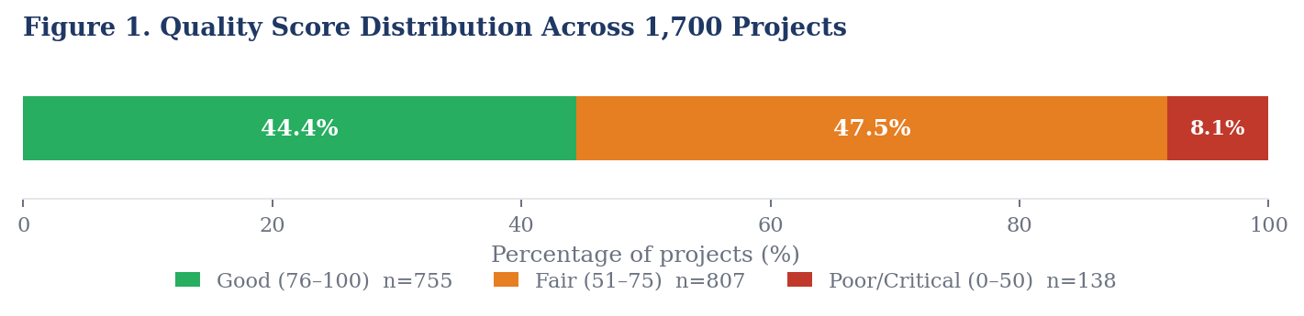
Figure 1. Quality score distribution across 1,700 Verra VCS energy sector projects

Step one – raw score distribution. Applying the scoring framework to all 1,700 projects produces a broadly bimodal distribution across three quality bands. A substantial cluster achieves Good scores (76-100), representing 755 projects (44.4%). The largest group – 807 projects (47.5%), falls in the Fair band (51-75), indicating partial completeness with one or more fields absent. A further 138 projects (8.1%) score at 50 or below, placing them in the Poor or Critical band. Figure 1 illustrates this distribution.
Step two – risk tier classification. Applying status flags to the score-based bands produces the final risk tier distribution. The most consequential adjustment is the elevation of Fair-scoring projects that carry Late-to-Verify status into the Medium Risk tier, reflecting temporal degradation of their records regardless of field completeness. Table 4 and Figure 2 present the resulting distribution.
Table 4. Risk Tier Distribution Across 1,700 Energy Sector Projects
Risk Tier | Projects (n) | Share (%) | Primary Classification Criteria
High Risk | 103 | 6.1% | Score < 50, or missing methodology, or Withdrawn/Rejected status
Medium Risk | 1,046 | 61.5% | Score < 75, or Late-to-Verify status, or missing crediting period dates
Low Risk | 551 | 32.4% | Score ≥ 75, no critical flags

The shift from Step 1 to Step 2 is instructive: comparing the Fair band (47.5% by raw score) with the Medium Risk tier (61.5% by final classification) illustrates that status flags, particularly Late-to-Verify, elevate a meaningful proportion of projects beyond what raw score alone would suggest. The High Risk tier at 6.1% is broadly consistent with the Poor/Critical band at 8.1%, the difference reflecting projects that score poorly but do not carry additional critical flags, and vice versa. Only 32.4% of projects achieve Low Risk classification, underscoring that the registry as a whole presents material completeness limitations for credit verification purposes.

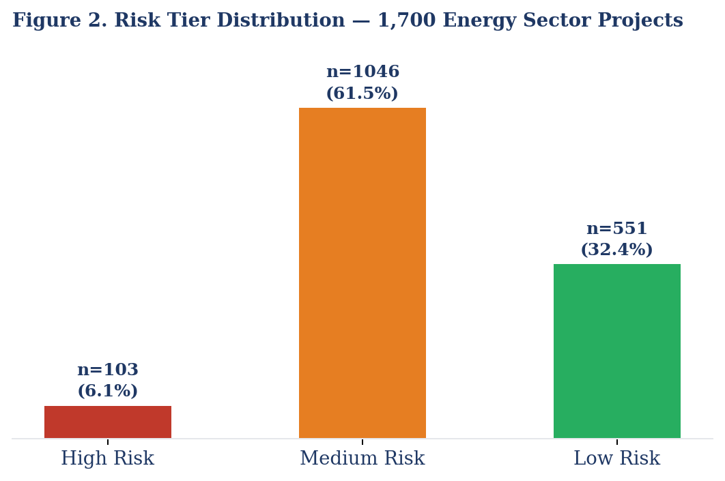
Figure 2. Risk tier distribution from 1,700 energy sector projects

  - Finding 1: The Late-to-Verify Signal
The most significant finding of this analysis is the prevalence of Late-to-Verify status. A total of 597 projects (35.1%) carry a Late-to-Verify designation, meaning their registry records have not been updated with verification outcomes within the five-year maximum monitoring window specified under the VCS Standard. In data terms, these are open lifecycle records without a documented closure event: active in the registry, but carrying no verification outcomes. Figure 3 illustrates the proportion of the dataset affected.
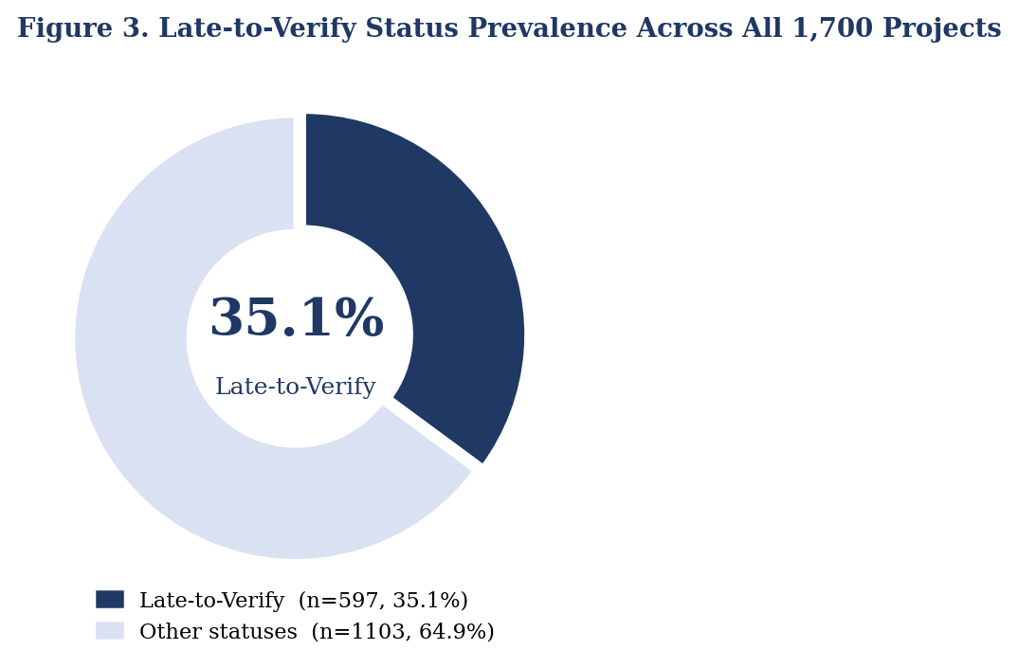
Figure 3. Late-to-Verify status prevalence across all 1,700 projects

The quality score differential between Late-to-Verify and active Registered projects is measurable and meaningful: Late-to-Verify projects have a mean quality score of 74.4, compared with 83.5 for Registered projects, a 9.1-point gap that reflects the cumulative effect of incomplete records across the stalled cohort. The market significance of this backlog extends beyond data quality: the 597 Late-to-Verify projects collectively represent approximately 51 million tCO₂e in stalled annual emission reductions – credits that cannot be issued until verification is completed, representing a substantial volume of the energy sector pipeline that is currently locked out of the market.
This finding is theoretically significant because the MRV process (Measurement, Reporting, and Verification) constitutes the primary mechanism by which the knowledge gap between project developers and corporate buyers is supposed to be resolved. Independent third-party verification is the point at which project-level claims transition from assertions to certified facts. A 35.1% prevalence of Late-to-Verify status indicates not an isolated administrative anomaly, but a structural feature of the registry landscape with direct implications for the reliability of registry data as a due diligence input. For corporate buyers, credits associated with Late-to-Verify projects carry elevated uncertainty: the accuracy of claimed emission reductions has not been independently confirmed within the required period.

  - Finding 2: The 2020 CDM Migration Spike
Temporal analysis of Late-to-Verify projects reveals a highly concentrated registration pattern that provides a structural explanation for the finding above. Of 597 Late-to-Verify projects, 349 (representing 58.5%) registered in a single year: 2020. Figure 4 presents the full registration year distribution.
This concentration aligns with the sunsetting of the United Nations Clean Development Mechanism (CDM), which prompted migration of legacy projects to Verra standards around 2020. The data quality signature of this cohort is distinctive: only 28.4% of the 2020 migration cohort have crediting period dates recorded, compared with 45% across the full dataset, confirming that legacy migration imported structurally incomplete records rather than the incompleteness arising from current administrative failure. The mean quality score of the 2020 cohort is 73.3, marginally below the overall Late-to-Verify average of 74.4.

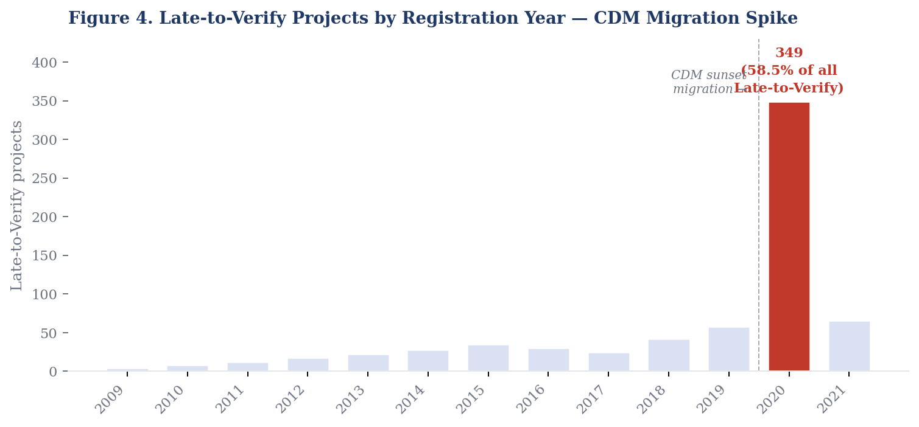
Figure 4. Late-to-Verify projects by registration year – CDM migration spike

The remaining 238 Late-to-Verify projects that registered before 2020 represent a qualitatively different category: genuine stalls. These projects have been in the registry for an average of 13.9 years since registration, with the longest-stalled project carrying a registration date of 2009 – 17.1 years without a completed verification cycle. This cohort is more likely to represent projects that encountered substantive operational, financial, or methodological difficulties rather than legacy data migration issues. Analysts and buyers should treat pre-2020 Late-to-Verify projects as carrying a materially different risk profile from the 2020 migration cohort.

  - Finding 3: Systematic Field Completeness Gaps
Beyond the Late-to-Verify pattern, the dataset exhibits systematic field completeness gaps that constrain registry utility as an analytical resource. Figure 5 presents the three most prevalent missing field patterns.
The 55% rate of missing crediting period dates is the most operationally significant gap: crediting period boundaries are the temporal foundation for any time-based analysis of project performance, and their absence in more than half of all records limits the depth of analysis possible from registry data alone. Registration date is absent for 17% of projects (n=286), and region classification for 8% (n=132).

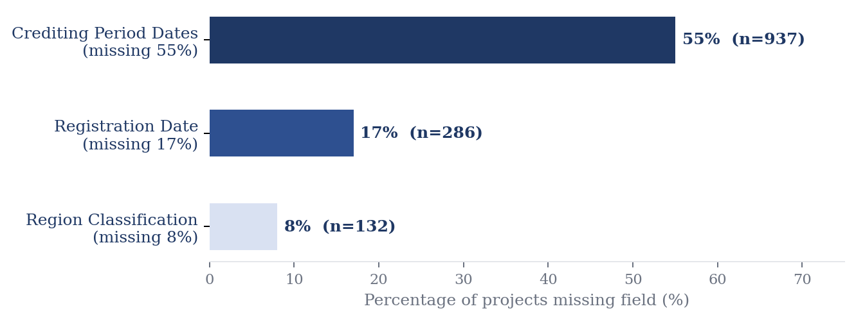
Figure 5. Most frequently missing registry fields

Geographic analysis reveals that three countries: India (652 projects, 38.4% of dataset), China (417 projects, 24.5%), and Turkey (181 projects, 10.6%), account for 74% of all energy sector projects. Table 5 presents High Risk rates by country.
Table 5. Geographic distribution and high risk rates – top countries by project volume
Country | Projects (n) | High Risk (n) | High Risk Rate | Share of Dataset
India | 652 | 39 | 6.0% | 38.4%
China | 417 | 32 | 7.7% | 24.5%
Turkey | 181 | 11 | 6.1% | 10.6%
South Africa | 36 | 1 | 2.8% | 2.1%

High Risk rates across the three dominant geographies: 6.0% from India, 7.7% from China, and 6.1% from Turkey – are broadly consistent with the dataset-wide average of 6.1% suggesting that data quality risk is proportional to project volume rather than geographically concentrated. Risk is a structural feature of the registry that manifests consistently across the major project geographies, not a regional anomaly attributable to any single country.

  - Finding 4: AMS-I.D. Methodology Structural Stall
Disaggregation of Late-to-Verify status by methodology reveals a pronounced concentration in a single methodology family: AMS-I.D. (small-scale renewable energy projects, encompassing small wind and hydropower installations) carries a Late-to-Verify rate of 53.2%, meaning more than half of all energy projects registered under this methodology are currently stalled in verification. Figure 6 presents Late-to-Verify rates for the five most prevalent methodologies in the dataset, with AMS-I.D. shown against the dataset-wide average of 35.1%.

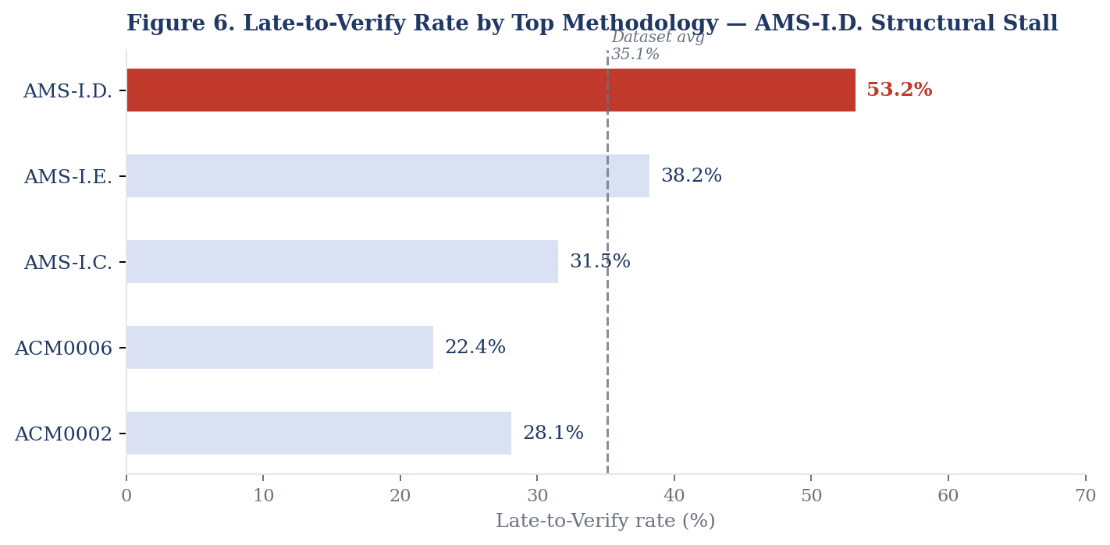
Figure 6. Late-to-Verify rate by top methodology – AMS-I.D. structural stall

The structural explanation for this concentration is the economics of small-scale project verification. AMS-I.D. projects are, by design, smaller in scale than large renewable installations, which means their emission reduction volumes are correspondingly lower. Periodic third-party verification audits represent a fixed administrative cost that does not scale proportionally with project size, making the cost-benefit calculation of maintaining an active verification cycle particularly unfavorable for smaller projects, especially older CDM-era projects now migrated to VCS. This methodology-level pattern suggests that Late-to-Verify is not uniformly distribute across the registry even among non-2020 registrations, but is structurally concentrated in methodology families where verification economics are most challenging.
This finding has direct practical implications for buyers. Credit screening that relies solely on registry status without disaggregating by methodology will treat all Late-to-Verify projects as a uniform risk category, masking the structural divergence between methodology families with economically rational verification constraints and those where stalling reflects project-level distress. Methodology-level Late-to-Verify rates are proposed as an additional screening variable for corporate due diligence workflows.

- Discussion
  - Implications for Information Quality Theory
The findings provide an empirical demonstration of Wang and Strong’s (1996) data quality dimensions in a novel and practically significant context. The scoring framework operationalizes completeness as a field-level presence measure and demonstrates that this dimension is both measurable and variable across a real-world information system serving consequential decision-making purposes. The 55% rate of missing crediting period dates and 17% rate of missing registration dates confirm that registry incompleteness is structural rather than marginal, consistent with Wang and Strong’s empirical observation that completeness is among the dimensions most frequently identified as deficient by data consumers.
The Late-to-Verify finding extends the practical relevance of timeliness as a detectable registry signal. The identification of 35.1% of energy sector projects as overdue for verification demonstrates that timeliness failures constitute a structural feature of the registry landscape, not isolated anomalies. The 2020 CDM migration finding deepens this interpretation: the concentration of Late-to-Verify projects in a single registration year reveals that timeliness degradation is not uniformly distributed but is structurally anchored in a historical data migration event. This is a theoretically meaningful distinction, as it suggests that registry timeliness failures can arise form system-level transition events, not only from project-level performance failures. Together, these findings establish that the Wang and Strong framework retains explanatory power across a wider range of information systems, and that voluntary carbon markets represent a domain in which information quality theory has direct applied relevance.

  - Implications for Carbon Market Information Asymmetry
The empirical patterns identified support the information asymmetry framing developed in Section 2.2. A 35.1% Late-to-Verify rate indicates that the primary mechanism by which information asymmetry is theoretically resolved (third-party verification) is not functioning within required parameters for a substantial share of the registry. The 2020 CDM migration finding adds important nuance: a significant component of registry incompleteness is a structural inheritance from a historical transition event rather than evidence of uniform current market failure. This distinction matters practically. A buyer screening registry records without awareness of the migration pattern may over-interpret legacy incompleteness as current project distress, or, once the migration explanation becomes apparent, under-weight legitimate completeness concerns in genuinely stalled projects. The temporal decomposition of Late-to-Verify registrations developed in this paper provides a tractable method for making that distinction, and in doing so represents a step toward operationalizing ISOCO’s (2023) call for robust, evidence-based integrity safeguards in voluntary carbon markets.

  - Practical Implications
For corporate buyers, projects classified as High Risk on data quality grounds, or carrying Late-to-Verify status, warrant additional investigation before transacting. The 2020 registration spike should prompt buyers to examine whether specific credits originate from CDM migration. For standard bodies, the Late-to-Verify prevalence and CDM migration concentration represent two distinct governance challenges: a current verification throughput bottleneck, and a legacy data remediation challenge for migrated records that entered the registry with incomplete fields. For analysts and researchers working with Verra registry data, the scoring framework provides a reusable, transparent starting point for registry-based analysis, one that makes explicit the completeness assumptions embedded in any analytical pipeline built on this data, and that can be adapted or extended for cross-registry applications.

- Limitations
Several limitations attend the findings of this study. First, the analysis is restricted to registry data: environmental quality dimensions (additionality, permanence, leakage, and baseline accuracy) are not directly measurable from registry fields. Data quality risk is a proxy for record verifiability, not a measure of project environmental performance, and the two should not be treated as interchangeable.
Second, the weighting in scheme is author-defined. Alternative weights could produce different risk classifications for individual projects, and the sensitivity of findings to alternative weights has not been systematically assessed. Third, the primary analysis covers the energy sector only; broader application to AFOLU, Waste Management, and other project categories requires validation. Fourth, the analysis is a cross-sectional snapshot at a specific export date; registry records are updated continuously. Fifth, all associations are correlational. No causal claims are made, and confounding factors not accounted for in this analysis may explain observed patterns.

- Future Research Directions
The framework developed here is explicitly a foundation for subsequent research. The most immediate extension is a systematic cross-project-type analysis applying the full scoring framework to AFOLU, Waste Management, and other project categories. Additionally, the AMS-I.D methodology concentration (Section 4.5) suggests that methodology family is meaningful moderating variables in registry integrity signal analysis, but it requires systematic validation with consistent scoring and controlled comparisons before conclusions can be drawn.
Cross-registry validation: applying the framework to the Gold Standard, American Carbon registry, and Australian Carbon Credit Unit scheme would assess generalizability across the voluntary carbon market. Longitudinal analysis, tracking quality score distributions and Late-to-Verify rates across successive registry exports, would enable assessment of quality trend direction and provide leading indicators of market-wide integrity risk. The AMS-I.D. stall pattern specifically warrants longitudinal monitoring: if verification economics for small-scale methodology projects are structurally unfavorable, the stall rate may worsen over time rather than self-correct.
The descriptive and anomaly-detection findings reported in this paper establish the empirical foundation for a more ambitious research agenda: the development of an AI-driven framework for systematic carbon credit data quality assessment to support ESG decision-making under uncertainty. Secondary work applying a Random Forest classifier to registry metadata across a broader dataset encompassing Energy, AFOLU, and Waste Management project types demonstrates that reliability classifications are learnable from upstream registry signals – including methodology, registration year, and completeness patterns. This extends the registry signal detection approach from descriptive pattern identification to predictive classification, directly engaging the research question of AI-driven analysis of public market information systems can support business decision-making under uncertainty.

- Conclusion
This paper has presented an exploratory data quality scoring framework applied to 1,700 energy sector projects in the Verra VCS public registry, asking what data quality patterns are detectable in this registry and what those patterns signal about the verifiability of energy sector carbon credits. Grounded in Wang and Strong’s (1996) information quality theory and Akerlof’s (1970) analysis of markets under asymmetric information, the framework operationalizes registry field completeness and logical consistency as proximate indicators of credit verifiability risk.
Four empirical findings emerge from the primary analysis. First, 597 projects (35.1% of the dataset) carry Late-to-Verify status, with a mean quality score of 74.4 versus 83.5 for active Registered projects, representing approximately 51 million tCO₂e in stalled annual emission reductions. Second, 58.5% of Late-to-Verify projects registered in 2020, a concentration attributable to CDM-to-VCS migration, with the 2020 cohort recording only 28.4% crediting period date completeness. Third, 55% of all projects are missing crediting period dates. Fourth, AMS-I.D. methodology projects carry a 53.2% Late-to-Verify rate, revealing that verification stalling is structurally concentrated in methodology families where verification economics are most challenging.
The contribution of this paper is a transparent, reproducible, and publicly available scoring framework for Verra VCS registry data quality assessment, with supplementary code and visualization materials available at https://anditarachmania.github.io/verra-carbon-registry-analysis/. The broader question: whether systematic registry analysis can provide early warning signals of integrity risk across multiple registries, project types, and time periods, and whether AI-driven classification can extend this from description to prediction. This is explicitly reserved for future research.

References
Akerlof, G. A. (1970). The market for lemons: Quality uncertainty and the market mechanism. Quarterly Journal of Economics, 84(3), 488–500. https://doi.org/10.2307/1879431
Carbon Direct. (2024). Voluntary carbon market report 2024. Carbon Direct. https://www.carbon-direct.com
Darby, M. R., & Karni, E. (1973). Free competition and the optimal amount of fraud. Journal of Law and Economics, 16(1), 67–88.
Hanseth, O., & Lyytinen, K. (2010). Design theory for dynamic complexity in information infrastructures: The case of building internet. Journal of Information Technology, 25(1), 1–19. https://doi.org/10.1057/jit.2009.19
ICVCM. (2023). Core Carbon Principles, assessment framework and assessment procedure. Integrity Council for the Voluntary Carbon Market. https://icvcm.org/core-carbon-principles/
IOSCO. (2023). Good practices for regulation of voluntary carbon markets. International Organization of Securities Commissions. https://www.iosco.org
Kariluoto, A., Hautala, M., Heinonen, K., Bhatt, M., & Lehto, L. (2021). Data quality issues and data quality dimensions in AI applications. In Proceedings of the 29th European Conference on Information Systems (ECIS 2021). Association for Information Systems.
Pipino, L. L., Lee, Y. W., & Wang, R. Y. (2002). Data quality assessment. Communications of the ACM, 45(4), 211–218. https://doi.org/10.1145/505248.506010
Verra. (2024). VCS Standard v4.7. Verified Carbon Standard Program. https://verra.org/programs/verified-carbon-standard/
Wang, R. Y., & Strong, D. M. (1996). Beyond accuracy: What data quality means to data consumers. Journal of Management Information Systems, 12(4), 5–33. https://doi.org/10.1080/07421222.1996.11518099
World Bank. (2024). State and trends of carbon pricing 2024. World Bank Group. https://doi.org/10.1596/978-1-4648-2133-0

