Screenshots

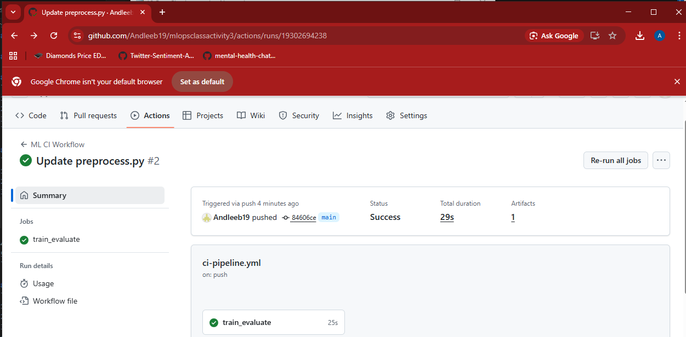

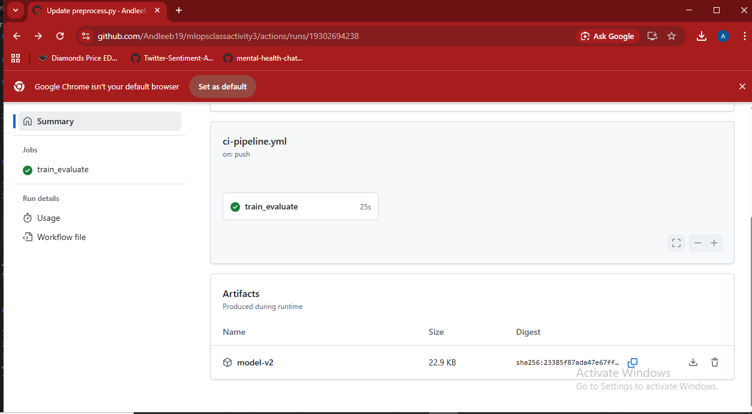

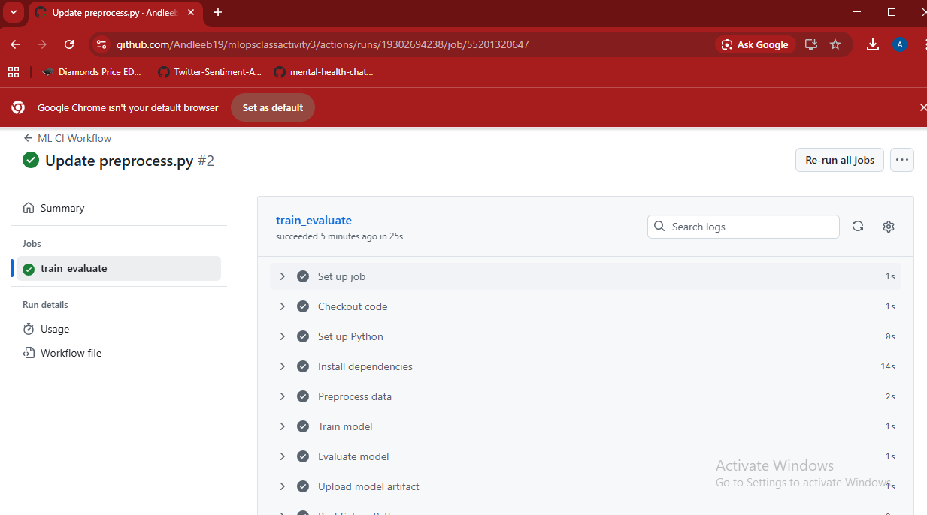

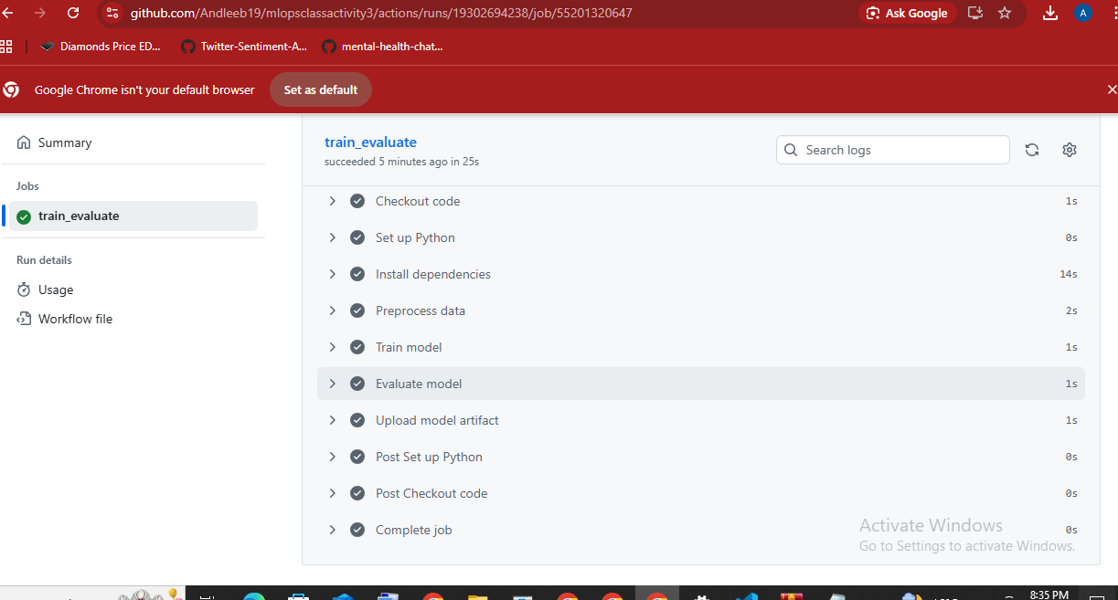

DISCUSSION QUESTIONS - ANSWERS

Question 1: How does CI/CD improve collaboration in ML teams?
Answer: CI/CD improves ML team collaboration by:
- Automation: Eliminates manual, repetitive tasks
  - Team members don't waste time running scripts manually
  - Reduces human errors
- Consistency: Everyone uses the same pipeline
  - Training happens the same way every time
  - No "it works on my machine" problems
- Version Control: All changes are tracked
  - Easy to see who changed what and when
  - Can roll back to previous versions if needed
- Faster Feedback: Immediate results from automated tests
  - Know if your changes broke something within minutes
  - Can iterate and improve faster
- Transparency: Everyone can see the pipeline status
  - Shared visibility into model performance
  - Better communication across team members

Question 2: What happens if the evaluation score is below a defined threshold?
Answer:
When the evaluation score is below the threshold:
- The workflow fails (shows ❌ red X in GitHub Actions)
- The model is NOT deployed to production
  - Prevents bad models from reaching users
  - Acts as a safety checkpoint
- The team is notified:
  - GitHub sends notifications
  - Team can investigate why the model performed poorly
- Possible reasons for low scores:
  - Bad training data
  - Incorrect hyperparameters
  - Code bugs
  - Data drift (data changed over time)
- Next steps:
  - Debug the issue
  - Retrain with better data or parameters
  - Fix bugs in the code
  - Re-run the pipeline
Example Implementation:
yaml
- name: Check Accuracy Threshold
run: |
if [ $(cat accuracy.txt) < 0.85 ]; then
echo "Accuracy below 85% threshold!"
exit 1 # This fails the workflow
fi

Question 3: How can retraining or drift detection be integrated into this workflow?
Answer:
A. Automated Retraining:
- Schedule-based retraining:
yaml
on:
schedule:
- cron: '0 0 * * 0' # Run every Sunday at midnight
- Data-driven retraining:
  - Trigger retraining when new data arrives
  - Monitor data folder for changes
yaml
on:
push:
paths:
- 'data/**'
- Performance-based retraining:
  - If model accuracy drops in production
  - Set up monitoring that triggers workflow
B. Drift Detection:
- Add a drift detection step:
yaml
- name: Detect Data Drift
run: |
python detect_drift.py
# Compares new data distribution vs training data
- Use drift detection libraries:
  - Evidently AI: Monitors data drift
  - Great Expectations: Validates data quality
  - Alibi Detect: Detects distribution shifts
- Example drift detection code:
python
# detect_drift.py
from evidently.dashboard import Dashboard
from evidently.tabs import DataDriftTab

# Compare current data vs reference data
dashboard = Dashboard(tabs=[DataDriftTab()])
dashboard.calculate(reference_data, current_data)

# If drift detected, trigger retraining
if drift_detected:
print("Drift detected! Triggering retraining...")
# Trigger retraining workflow
- Workflow integration:
yaml
drift-and-retrain:
runs-on: ubuntu-latest
steps:
- name: Check for drift
run: python detect_drift.py

- name: Retrain if drift detected
if: ${{ steps.drift.outputs.drift_detected == 'true' }}
run: python train.py

Question 4: What steps are needed to deploy this workflow to production?
Answer:
Deployment Steps:
- Choose a Deployment Platform:
  - AWS: SageMaker, EC2, Lambda
  - Azure: Azure ML
  - GCP: Vertex AI
  - Kubernetes: For container orchestration
- Containerize the Model:
yaml
- name: Build Docker Image
run: |
docker build -f Dockerfile.serve -t my-ml-model:latest .
- Push to Container Registry:
yaml
- name: Push to DockerHub
run: |
docker login -u ${{ secrets.DOCKER_USERNAME }} -p ${{ secrets.DOCKER_PASSWORD }}
docker push my-ml-model:latest
- Deploy to Kubernetes:
yaml
- name: Deploy to Kubernetes
run: |
kubectl apply -f deployment.yaml
kubectl rollout status deployment/ml-model
- Deploy to AWS (Example):
yaml
- name: Deploy to AWS Lambda
uses: aws-actions/configure-aws-credentials@v1
with:
aws-access-key-id: ${{ secrets.AWS_ACCESS_KEY_ID }}
aws-secret-access-key: ${{ secrets.AWS_SECRET_ACCESS_KEY }}
aws-region: us-east-1

- name: Deploy function
run: |
aws lambda update-function-code \
--function-name my-ml-model \
--image-uri my-dockerhub/ml-model:latest
- Add Deployment Steps to Workflow:
yaml
deploy:
needs: [preprocess-train-evaluate]
if: github.ref == 'refs/heads/main'
runs-on: ubuntu-latest
steps:
- name: Download model artifact
uses: actions/download-artifact@v2

- name: Deploy to production
run: |
# Your deployment script here
- Set up Secrets in GitHub:
  - Go to: Repository → Settings → Secrets and variables → Actions
  - Add secrets for:
    - DOCKER_USERNAME
    - DOCKER_PASSWORD
    - AWS_ACCESS_KEY_ID
    - AWS_SECRET_ACCESS_KEY
- Create a Deployment Environment:
  - Staging: Test deployment first
  - Production: Final deployment
yaml
deploy-prod:
environment: production
needs: [deploy-staging]
- Add Health Checks:
yaml
- name: Test Deployed Model
run: |
curl -X POST https://api.mymodel.com/predict \
-d '{"data": [1,2,3]}'
- Monitor in Production:
  - Set up logging (CloudWatch, Datadog)
  - Monitor performance metrics
  - Set up alerts for failures

