Report

Introduction:

In this assignment, we already have some java file like BST, BSTSimple, BSTTest, Queue etc. What we need to do is to insert and delete key value n times in order to let the depth of binary tree ***O***(N^1/2) instead of ***O***(lg N) . As we know, there are 100 keys with initial range 200. And we need to change the range in order to get the required consequence.

Implementation

First, we need to create a method to calculate the depth of binary tree:

**int** length(Node root){

**int** depth1;

**int** depth2;

**if**(root == **null**) **return** 0;

depth1 = length(root.larger);

depth2 = length(root.smaller);

**if**(depth1>depth2)

**return** depth1+1;

**else**

**return** depth2+1;

}

I write this method in BSTSimple to get the depth.

Then we need to write the main function to create the initial node:

BSTSimple<Integer,Integer> bst = **new** BSTSimple<>();

Random random = **new** Random();

**for**(**int** j =0; j<100;j++) {

**int** i = random.nextInt();

**int** z = random.nextInt(200);

bst.put(z, i);

}

But because we need to change the range of the key value and record the time, so I write the final test code:

BSTSimple<Integer,Integer> bst = **new** BSTSimple<>();

**for** (**int** cutoff = 10;cutoff<500;cutoff+=10) {

Random random = **new** Random();

**for**(**int** j =0; j<100;j++) {

**int** i = random.nextInt();

**int** z = random.nextInt(cutoff);

bst.put(z, i);

}

**long** startTime = System.*nanoTime*();

**for**( **int** m = 0; m<=1000;m++) {

**int** n = random.nextInt(2);

**if**(n==0)

bst.put(random.nextInt(cutoff), random.nextInt());

**else**

bst.delete(random.nextInt(cutoff));

}

**long** endtime = System.*nanoTime*();

**long** count = endtime-startTime;

System.***out***.println("Key range" + cutoff);

System.***out***.println(count+"nanosec");

System.***out***.println("depth: "+bst.length(bst.root));

System.***out***.println();

Experiment:

I run the program for four times to get the result and let me show you one of these result in console and picture view:

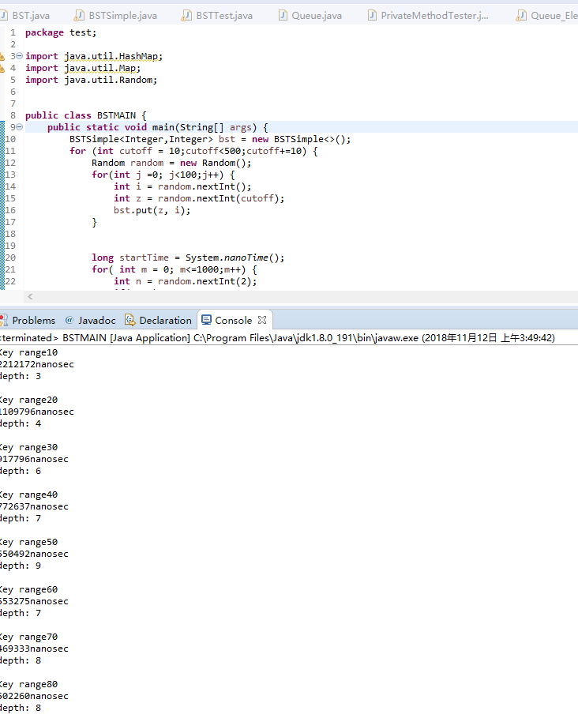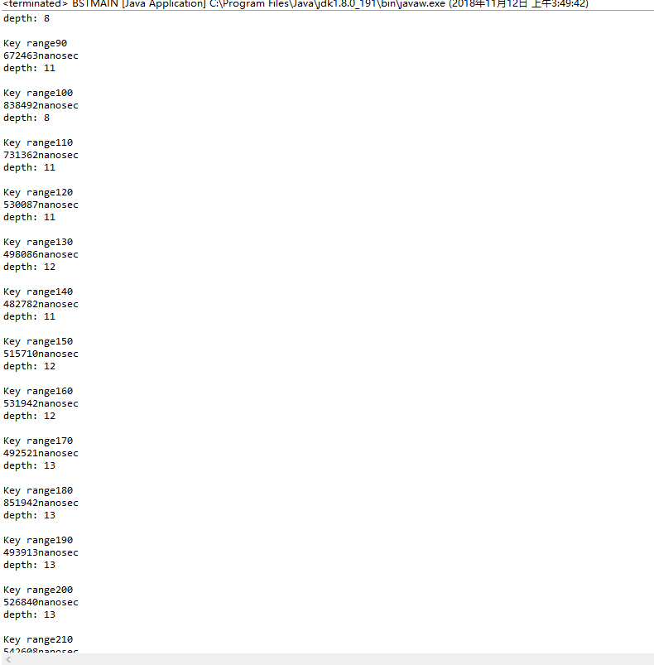

This graph is about the four experiments.

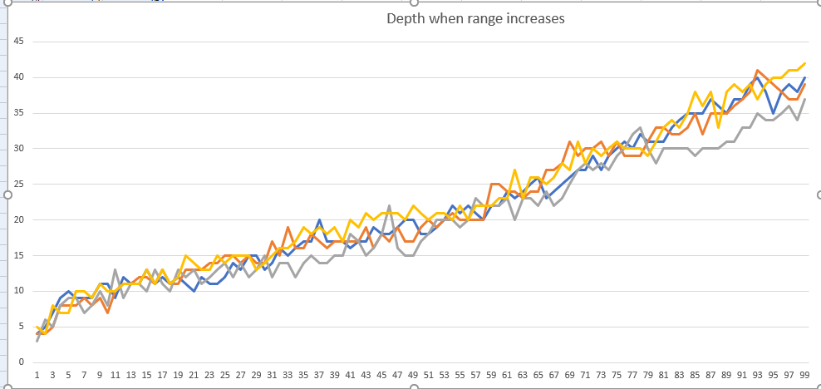

Conclusion:

Though we can’t get the exact value of the required value, we can get the a overall conclusion that the depth increases when the range increased. And because there are 100 keys. So ***O***(N^1/2) is 10, in the graph above, we can get a general range in which we can get the required ***O***(N^1/2). The range is about from 100 to 200.