Nayel BLIDI CDI
Léo DESCHAMPS
Clément POISSONNET

Project In512
Unlock Boxes

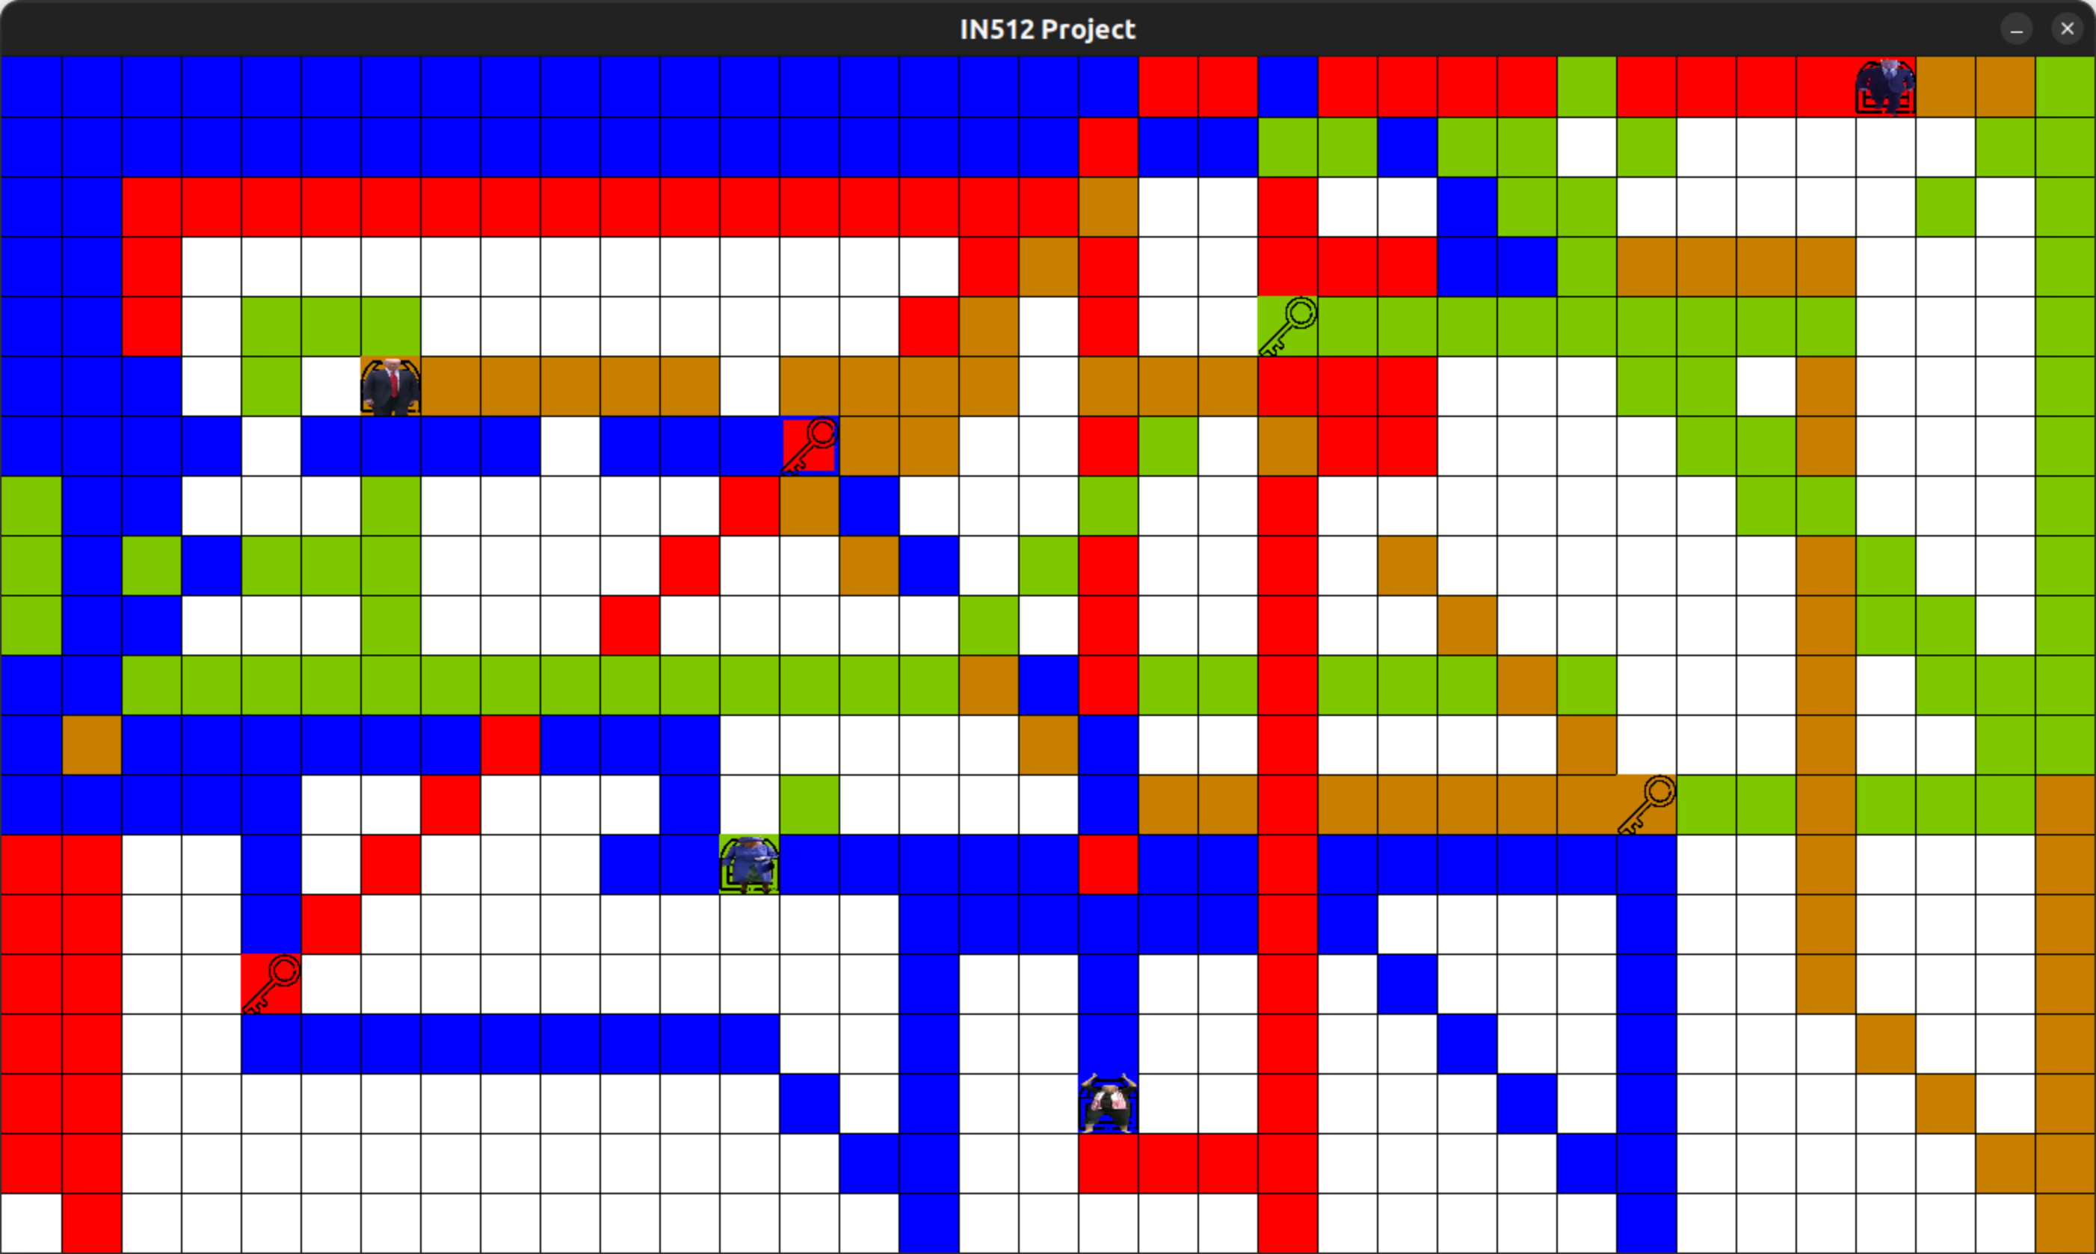

January 24th 2024

Name : Strategy 2

Strategy 2 is a purely algorithmic strategy that operates in three modes: exploration mode, prospection mode and reaching mode. For the first phase, robots locate all Points of Interest (PoI), during this phase they switch between exploration and prospection mode. When all PoI are located, robots enter in the second phase with the reaching mode. Each robot has his own map representation. If the value on its map is -1, the case is unexplored. In this case the robot will ask to the game to retrieve the value of the case and store it into its own map. We will now explain the goal of each mode:

- Exploration mode: This is the default mode for the robot. When it is in this mode, the robot moves straight ahead. When the case in front of him is already explored or if it is a wall, the robot will change direction to an unexplored case around him (the eight cases around him). If all cases around him are explored, it continues straight ahead even if the is a wall. In this case, it choose randomly the next direction to follow. During this mode, the robot also check the value of the case. If this value is strictly greater than 0, it switches to prospection mode.

- Prospection mode: The goal of this mode is to locate a PoI. This mode is triggered when it encounters a value strictly greater than 0. To choose the direction the robot check if the value of the case is increasing, decreasing or stay stable. If it increasing, the robot continue straight ahead. If it decrease, the robot turn back. Finally, if the value is stable, it means the direction is perpendicular to the PoI so it turns to the right. When the PoI is located, the robot saves data, send it to other robots and consider all cases around PoI as explored. Then, it switches back to exploration mode.

- Reaching mode: Regularly, each robot checks if the PoI list is completed or not. If it is, robot switches to reaching mode. In this mode, the robot computes the shortest path from its position to the key and then to the chest. After that, the mission is accomplished.

To summarize all these ideas, the UML activity diagram below shows all the Strategy 2 process:

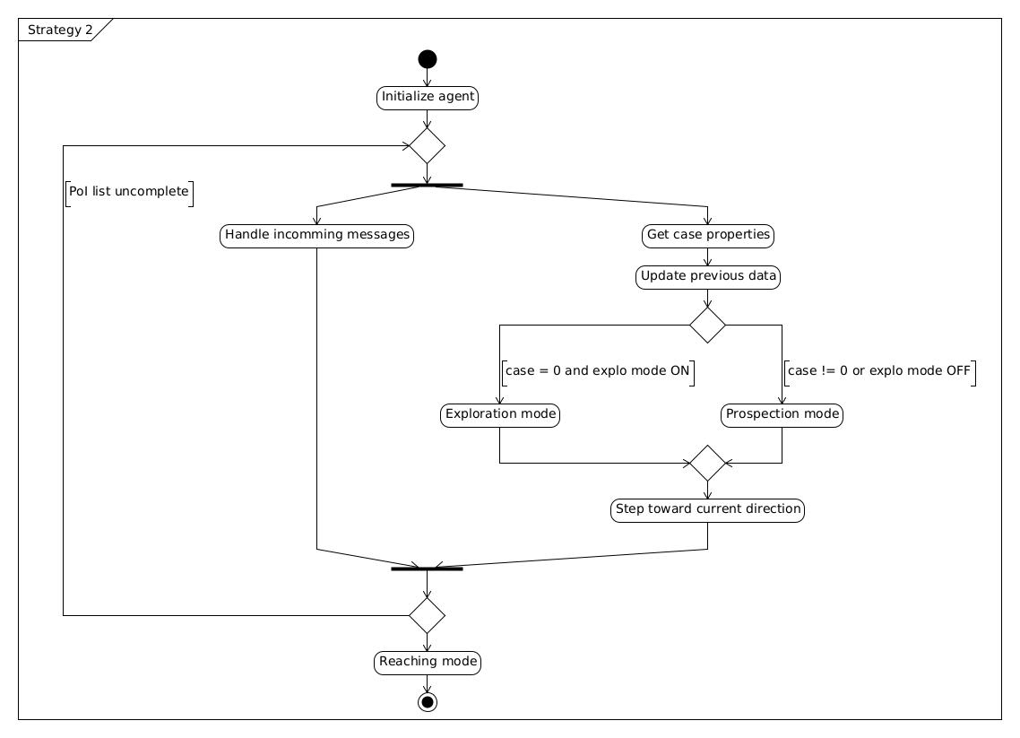
You can find in appendix the detailed UML activity diagram of Strategy 2

Advantage of this strategy is it never block itself. It always converge because when robot seem to be blocked, it choose a random direction.

Limits and possible upgrades

- A first thing that we can see with strategy 2 is robots persist to explore small part of the map where obviously PoI cannot be here. To improve that we can implement a second state map to see where PoIs cannot be there because we know values in an area of five by five around a PoI are different from 0. We think this improvement is hard to add to our strategy and can greatly increase efficiency.
- A second improvement that can be done is when a robot found its own PoI it can directly bring it without waiting for the reaching mode. This improvement can be easy to implement but it will not increase a lot the efficiency particularly if the number of robot is high.
- A third improvement that can be done is to use triangulation during prospection mode to locate faster the PoI. We think this improvement is hard to add to our strategy and can increase very marginally efficiency because PoI area are pretty small.

Appendix

