**LAPORAN PRAKTIKUM**

**PEMROGRAMAN WEB I**

**MODUL 6**



**BOOTSTRAP**

**Oleh:**

**Andra Braputra Akbar Saleh NIM. 23108171210001**

**PROGRAM STUDI TEKNOLOGI INFORMASI**

**FAKULTAS TEKNIK**

**UNIVERSITAS LAMBUNG MANGKURAT**

**JUNI 2024**

# LEMBAR PENGESAHAN

**LAPORAN PRAKTIKUM PEMROGRAMAN WEB I**

**MODUL 6**

Laporan Praktikum Pemrograman I Modul 6: Bootstrap ini disusun sebagai syarat lulus mata kuliah Praktikum Pemrograman I. Laporan Prakitkum ini dikerjakan oleh:

Nama Praktikan : Andra Braputra Akbar Saleh

NIM : 2310817210001

|  |  |
| --- | --- |
| Menyetujui,  Asisten Praktikum  Muhammad Shandy Dailami  NIM. 2210817210013 | Mengetahui,  Dosen Penanggung Jawab Praktikum  Muti’a Maulida, S.Kom., M.TI.  NIP. 19881027 201903 2 013 |

# DAFTAR ISI

LEMBAR PENGESAHAN 2

DAFTAR ISI 3

DAFTAR GAMBAR 4

DAFTAR TABEL 5

SOAL 1 6

A. Source Code 6

B. Output Program 11

C. Pembahasan 11

# DAFTAR GAMBAR

Gambar 1. Screenshot Hasil Jawaban Soal 1A 11

# DAFTAR TABEL

Tabel 1 Soal 1 **Error! Bookmark not defined.**

Tabel 2 Soal 1 **Error! Bookmark not defined.**

# SOAL 1

Buatlah sebuah website berdasarkan desain berikut semirip mungkin dengan menggunakan framework Bootstrap. Simpan dengan nama_nim

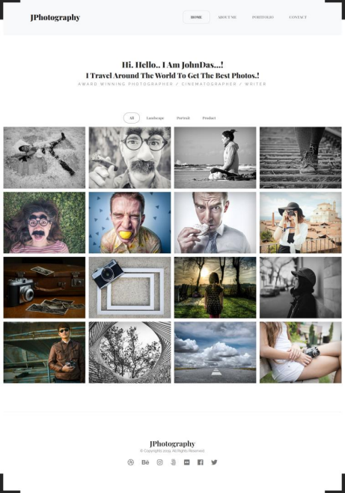

Gambar 1. Screenshot Soal

## Source Code

|  |
| --- |
| <!DOCTYPE html>  <html lang="en">  <head>  <meta charset="UTF-8" />  <meta name="viewport" content="width=device-width, initial-scale=1.0" />  <title>Documnent</title>  <link  rel="stylesheet"  href="https://cdn.jsdelivr.net/npm/bootstrap@5.3.3/dist/css/bootstrap.min.css"  integrity="sha256-PI8n5gCcz9cQqQXm3PEtDuPG8qx9oFsFctPg0S5zb8g="  crossorigin="anonymous"  />  <link  rel="stylesheet"  href="https://cdn.jsdelivr.net/npm/bootstrap-icons@1.11.3/font/bootstrap-icons.min.css"  />  </head>  <style>  ul {  list-style-type: none;  }  ul li a {  text-decoration: none;  }  ul li a.active1 {  border: 1px solid #000;  border-radius: 10px;  }  ul li a.active2 {  border: 1px solid #000;  border-radius: 20px;  }  </style>  <body>  <header class="row header" style="background-color: azure">  <div class="col-4 d-flex justify-content-center align-items-center">  <h1>Logo</h1>  </div>  <div class="col-2"></div>  <div class="col-6 d-flex align-items-center justify-content-center">  <nav>  <ul class="d-flex mt-3">  <li>  <a class="px-4 py-2 list text-dark active1" href="#">HOME</a>  </li>  <li><a class="px-4 py-2 list text-dark" href="#">ABOUT</a></li>  <li><a class="px-4 py-2 list text-dark" href="#">PORTFOLIO</a></li>  <li><a class="px-4 py-2 list text-dark" href="#">CONTACT</a></li>  </ul>  </nav>  </div>  </header>  <section class="row carousel">  <div  class="col d-flex flex-column justify-content-center align-items-center"  >  <h2>Hi... Hello.. I am Johnson...!</h2>  <h2>I travel Around</h2>  <p class="desc">Award winning</p>  </div>  </section>  <section class="borders">  <div class="brTR"></div>  <div class="brTL"></div>  <div class="brBL"></div>  <div class="brBR"></div>  </section>  <section class="row container-fluid">  <div class="col d-flex align-items-center justify-content-center">  <ul class="d-flex mt-3">  <li><a class="px-4 py-2 list text-dark active2" href="#">ALL</a></li>  <li><a class="px-4 py-2 list text-dark" href="#">Landscape</a></li>  <li><a class="px-4 py-2 list text-dark" href="#">Portrait</a></li>  <li><a class="px-4 py-2 list text-dark" href="#">Product</a></li>  </ul>  </div>  </section>  <section class="row d-flex align-items-center justify-content-center mb-4">  <div class="col d-flex align-items-center justify-content-center">  <div class="row">  <div class="col-3">  <img src="image.jpeg" alt="Image 1" />  </div>  <div class="col-3">  <img src="image.jpeg" alt="Image 2" />  </div>  <div class="col-3">  <img src="image.jpeg" alt="Image 3" />  </div>  <div class="col-3">  <img src="image.jpeg" alt="Image 6" />  </div>  </div>  </div>  </section>  <section class="row d-flex align-items-center justify-content-center mb-4">  <div class="col d-flex align-items-center justify-content-center">  <div class="row">  <div class="col-3">  <img src="image.jpeg" alt="Image 4" />  </div>  <div class="col-3">  <img src="image.jpeg" alt="Image 5" />  </div>  <div class="col-3">  <img src="image.jpeg" alt="Image 6" />  </div>  <div class="col-3">  <img src="image.jpeg" alt="Image 6" />  </div>  </div>  </div>  </section>  <section class="row d-flex align-items-center justify-content-center mb-4">  <div class="col d-flex align-items-center justify-content-center">  <div class="row">  <div class="col-3">  <img src="image.jpeg" alt="Image 4" />  </div>  <div class="col-3">  <img src="image.jpeg" alt="Image 5" />  </div>  <div class="col-3">  <img src="image.jpeg" alt="Image 6" />  </div>  <div class="col-3">  <img src="image.jpeg" alt="Image 6" />  </div>  </div>  </div>  </section>  <div class="row bottom">  <div  class="col d-flex flex-column align-items-center justify-content-center"  >  <h1 class="Logo">LOGO</h1>  <p>&copy; Copyrights 2024 All Rights Reserved</p>  <div class="icon">  <i class="bi bi-behance"></i>  <i class="bi bi-instagram"></i>  <i class="bi bi-linkedin"></i>  <i class="bi bi-facebook"></i>  <i class="bi bi-twitter-x"></i>  </div>  </div>  </div>  <script  src="https://cdn.jsdelivr.net/npm/@popperjs/core@2.11.8/dist/umd/popper.min.js"  integrity="sha256-whL0tQWoY1Ku1iskqPFvmZ+CHsvmRWx/PIoEvIeWh4I="  crossorigin="anonymous"  ></script>  <script  src="https://cdn.jsdelivr.net/npm/bootstrap@5.3.3/dist/js/bootstrap.min.js"  integrity="sha256-3gQJhtmj7YnV1fmtbVcnAV6eI4ws0Tr48bVZCThtCGQ="  crossorigin="anonymous"  ></script>  </body>  </html> |

Tabel 1. Source Code Soal 1

## Output Program

Gambar 2. Screenshot Hasil Jawaban Soal 1A

## Pembahasan

# LINK GITHUB