Exercise 4: Cluster Analysis
Course Instructor: Dr. Suborna Ahmed
Submission: Brandon Weigland and Sandra Inusah
- Write your code and answers in this RMD file
- Knit your completed RMD file to WORD document
- Check and upload your WORD document to Exercise 4 on Canvas

Exercise Objectives
- Write your code and answers in this RMD file
- Knit your completed RMD file to WORD document
- Check and upload your WORD document to Exercise 4 on Canvas

Exercise Objectives
- To become familiar with Cluster Analysis as a tool to uncover “natural” groups in data.
- To learn how to obtain clustering solutions for alternative methods (and distance metrics) and choose one of the results.

General Description
In Exercise 4, you will again use the data gathered by Tracy Hooper on bird abundances, along with vegetation and other variables in a grassland area (a subset of her data is used in FRST 531 with her approval). The data have been provided as TRABREV3.txt. Using cluster analysis, you will cluster the sites based on bird compositions. NOTE: The variable names are standard 4-letter bird species codes that you can find on the web if you wish.
The overall objective is to final “natural” clusters in the bird data. For this, you will use a few alternative hierarchical methods, and then the k-means non-hierarchical method. From the results, you will choose one of the clustering solutions that best segregates the sites by bird composition.

Process
- For this analysis, the data have been provided as TRABREV3.txt along with R code as Exercise 4: Cluster Analysis - Student File. Rmd.
- Specifically, there are four sections in this exercise:
- In Part 1 (Data preparation), you will need to run the R code so as to read and clean the original data in preparation for your cluster analyses.
- In Part 2 (Hierarchical clustering of sites by bird composition), you will examine four hierarchical clustering alternatives (hc1 to hc3 provided in the R code, plus you will add code for hc4) and answer Questions 1 to 4 to guide you through the outputs and interpret the results.
- In Part 3 (Non-Hierarchical clustering of sites by bird composition), you will perform analysis using k-means clustering altering the number of clusters from one to six, with a graph showing the within sums of squares. You will need to run the R code and get/understand/interpret the outputs from running the code. You will be answering Questions 5 to 7 to compare different methods and make your choice.
- The last part contains extra R code where the data are transposed. In Parts 1 to 3, the question is: Which sites have a similar bird composition? Now, the transpose of the data is done, and the goal is to cluster the birds using the sites. The question becomes: Which bird species occur on the same sites? This part is just for fun, and shows how the clustering can be altered to group variables instead of observations to match the question posed.
NOTE: Under each question in the Rmd file, you will see dedicated code chunks or blank spaces that are prepared for you to write your own code and add your answers. As you answer the questions, paste in the relevant R outputs to support your answers.

Process
- For this analysis, the data have been provided as TRABREV3.txt along with R code as Exercise 4: Cluster Analysis - Student File. Rmd.
- Specifically, there are four sections in this exercise:
- In Part 1 (Data preparation), you will need to run the R code so as to read and clean the original data in preparation for your cluster analyses.
- In Part 2 (Hierarchical clustering of sites by bird composition), you will examine four hierarchical clustering alternatives (hc1 to hc3 provided in the R code, plus you will add code for hc4) and answer Questions 1 to 4 to guide you through the outputs and interpret the results.
- In Part 3 (Non-Hierarchical clustering of sites by bird composition), you will perform analysis using k-means clustering altering the number of clusters from one to six, with a graph showing the within sums of squares. You will need to run the R code and get/understand/interpret the outputs from running the code. You will be answering Questions 5 to 7 to compare different methods and make your choice.
- The last part contains extra R code where the data are transposed. In Parts 1 to 3, the question is: Which sites have a similar bird composition? Now, the transpose of the data is done, and the goal is to cluster the birds using the sites. The question becomes: Which bird species occur on the same sites? This part is just for fun, and shows how the clustering can be altered to group variables instead of observations to match the question posed.
NOTE: Under each question in the Rmd file, you will see dedicated code chunks or blank spaces that are prepared for you to write your own code and add your answers. As you answer the questions, paste in the relevant R outputs to support your answers.

Part 1: Data Preparation
Data from an outside text file from a birds in grasslands study by Tracy Hooper (subset of her data used by permission) is brought in to R from an outside space-delimited text file. Alternatively, you could bring the text file into EXCEL and save it as a .csv file. Using only information on bird species, the goal is to cluster the sites using the bird species.

Read the data
Let’s first load it to R as “studydat”.
# Make sure you put this RMD file and TRABREV3.txt in the same folder before running the code
studydat<- read.table("TRABREV3.txt", header=T)
#studydat<-read.csv("TRABREV3 (1).txt", header=T) # this line of code can read the comma delimited file instead.
Let’s print out some aspects of the data to just check it out.
class(studydat) # what type of object is it?
names(studydat) # print out the column (i.e., variable) names
dim(studydat)# number of rows and columns
head(studydat)

Data Cleaning
For our exercise, keep only the site information and the bird information for clustering. Keep only 50 sites also. Name the subset of data as “clusdat”.
clusdat<-cbind(studydat[1:50,1:2],studydat[1:50,5:14])
names(clusdat)
str(clusdat) # point could be used as a label for the sites.
dim(clusdat)

Summary Statistics
Get basic stats that is min, max, mean, std.dev. using a function from the package pastecs.
# Tell R you want to use the package pastecs.
library(pastecs) # won't work if you have not installed the package first!!
# set the number of decimals to be 2
options(digits=2)
#Use the function stat.desc from this package to get some basic stats.
stat.desc(clusdat)

Part 2: Hierarchical clustering of sites by bird composition
In this part, you will examine four hierarchical clustering alternatives. The first three alternatives (hc1 to hc3) are provided in the R code, and you will need to add in code for one more hierarchical clustering analysis (hc4). For that, you can choose to change the distance metric used and/or the method used. See Cluster examples 531 2022.R for some ideas. The output will include hierarchical clustering results and a tree dendrogram for each of the four alternatives. Then, you will be answering Questions 1 to 4 to guide you through the outputs and interpret the results.
Let’s look at the first hierarchical clustering alternative (hc1).

hc1
For hc 1, the euclidean distance is chosen. The following code calculates the distance matrix via the function dist()! (There are other distance methods in the function dist(), including “euclidean”, “maximum”, “manhattan”, “canberra”, “binary” or “minkowski”.)
justx<-clusdat[,3:12] # just the bird info.
head(justx) # print the first few lines
# Calculate the distance matrix.
d <- dist(justx, method = "euclidean")
#d
Next, we pass the calculated distance matrix to the function hclust() to cluster using hierarchical methods. In hclust(), hierarchical methods can be one of “ward.D”, “ward.D2”, “single”, “complete”, “average” (= UPGMA), “mcquitty” (= WPGMA), “median” (= WPGMC) or “centroid” (= UPGMC). For hc1, the complete method is chosen.
# pass the distance matrix to hclust().
hc1 <- hclust(d,method = "complete") # apply hierarchical clustering
# check the class created by the hclust() function.
class(hc1)
Then, we plot the tree dendrogram.
# plot the dendrogram,
plot(hc1, labels =clusdat$point,hang = -1, main="Complete, Euclidean",cex=0.6) # Use the labels (uses hc$order to put the correct labels on), and place the labels at the same level.

hc2
For the second alternative (hc2), we retain the calculated distance matrix from hc1, pass it to hclust() again using a different method, and plot the dendrogram.
# pass the distance matrix to hclust() again.
hc2 <- hclust(d,method = "single") # apply hierarchical clustering
# check the class created by the hclust() function.
class(hc2)
# plot the dendrogram
plot(hc2, labels =clusdat$point,hang = -1, main="Single, Euclidean",cex=0.6)

hc3
For the third option (hc3), we use standardized x’s instead to calculate the distance matrix and then pass it to hclust(). The dendrogram is plotted as well.
# Try again but use standardized x's instead.
justx.scaled <- scale(justx, center = TRUE, scale = TRUE)
dscale <- dist(justx.scaled,method = "euclidean")
# pass the distance matrix to hclust()
hc3 <- hclust(dscale,method = "complete") # apply hirarchical clustering
# check the class created by the hclust() function.
class(hc3)
# plot the dendrogram
plot(hc3, labels =clusdat$point,hang = -1,
main="Complete, Standardized, Euclidean",cex=0.6)

hc4
There are lots more options for hierarchical clustering using different distance metrics and/or methods. It’s time for you to add your own here as hc4.
#help(hclust)
#Going to try two methoods: Ward's and Manhattan and see which is better
#Manhattan
d_man <- dist(justx, method = "manhattan")
hc5 <- hclust(d_man, method = "average")
plot(hc5, labels = clusdat$point, hang = -1,
main = "Average, Manhattan Distance", cex = 0.6)
#Ward
hc4 <- hclust(d, method = "ward.D2")
plot(hc4, labels = clusdat$point, hang = -1,
main = "Ward.D2, Euclidean", cex = 0.6)
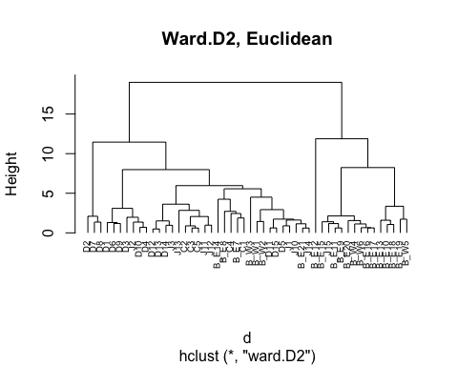
Note: The Ward plot showed clear and immediate branching in two directions, but the Manhattan plot was more gradual with fewer obvious breaks. The Ward plot seems more straightforward for interpretation.
Looking at how to break things up:
# Ward dendrogram into 2
plot(hc4, labels = clusdat$point, hang = -1,
main = "Ward.D2, Euclidean",
xlab = "Sites", ylab = "Height", cex = 0.6)
# Then add rectangles for 2 clusters
rect.hclust(hc4, k = 2, border = 2)
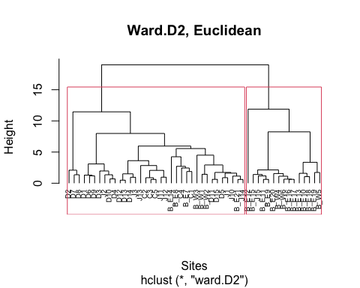
and then 3 clusters for Ward:
plot(hc4, labels = clusdat$point, hang = -1,
main = "Ward.D2, Euclidean",
xlab = "Sites", ylab = "Height", cex = 0.6)
rect.hclust(hc4, k = 3, border = 2:4)
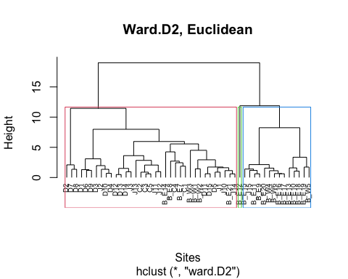
Now for Manhattan
plot(hc5, labels = clusdat$point, hang = -1,
main = "Average, Manhattan Distance",
xlab = "Sites", ylab = "Height", cex = 0.6)
rect.hclust(hc5, k = 2, border = 2:4)
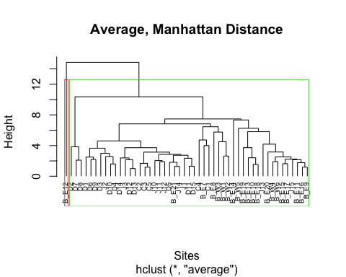
and now Manhattan into 3 clusters:
plot(hc5, labels = clusdat$point, hang = -1,
main = "Average, Manhattan Distance",
xlab = "Sites", ylab = "Height", cex = 0.6)
rect.hclust(hc5, k = 3, border = 2:4)
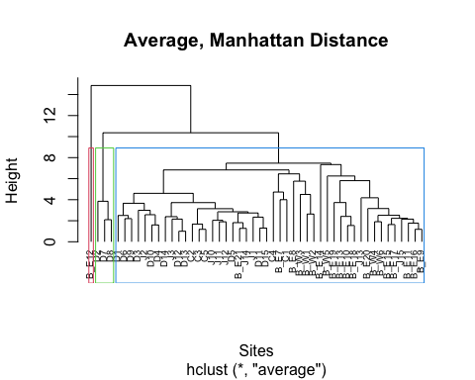
Again, it seems that Ward’s method is better for interpretation. Both have one small branch, but otherwise Ward makes a cleaner and more balanced clustering. We’ll go with Ward’s.

QUESTION 1.0: Show the tree dendrogram for each of the four alternative hierarchical clustering analysis (i.e., hc1 to hc3, plus hc4 that you just added in). These will be very large; you may want to adjust the layout for each figure. Remember to include a figure caption at the bottom of each of the four figures (e.g., Figure 1. Euclidean distance and nearest neighbour clustering).
Notes: - hc1: Complete linkage clustering using Euclidean distance - hc2: Single linkage (nearest neighbour) clustering using Euclidean distance - hc3: Complete linkage clustering using Euclidean distance with standardized bird abundance variables - hc4: Ward’s hierarchical clustering using Euclidean distance

Important note: while the plots below use k=3 to divide breaks for visual clarity (which we used to help compare plots), this should not imply that all dendrograms truly display 3 clusters.
Notes: - hc1: Complete linkage clustering using Euclidean distance - hc2: Single linkage (nearest neighbour) clustering using Euclidean distance - hc3: Complete linkage clustering using Euclidean distance with standardized bird abundance variables - hc4: Ward’s hierarchical clustering using Euclidean distance
plot(hc1, labels = clusdat$point, hang = -1,
main = "Complete linkage with Euclidean distance",
xlab = "Sites", ylab = "Height", cex = 0.5)
rect.hclust(hc1, k = 3, border = 2:4)
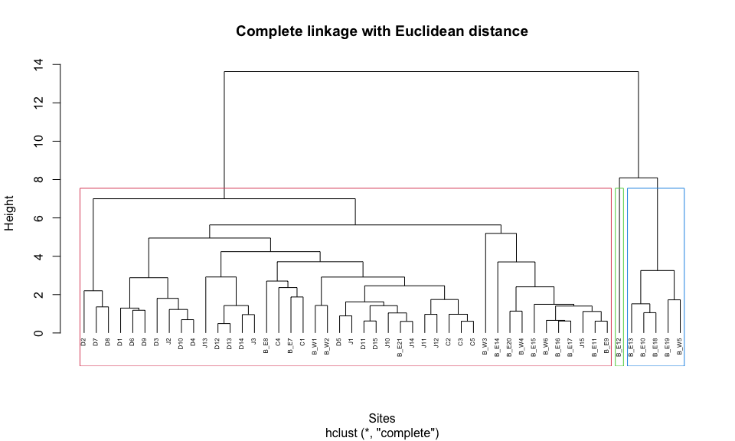
Figure 1. Tree dendrogram for hc1 using complete linkage with Euclidean distance, showing a 3-cluster cut.
plot(hc2, labels = clusdat$point, hang = -1,
main = "Single linkage (nearest neighbour) clustering using Euclidean distance",
xlab = "Sites", ylab = "Height", cex = 0.5)
rect.hclust(hc2, k = 3, border = 2:4)
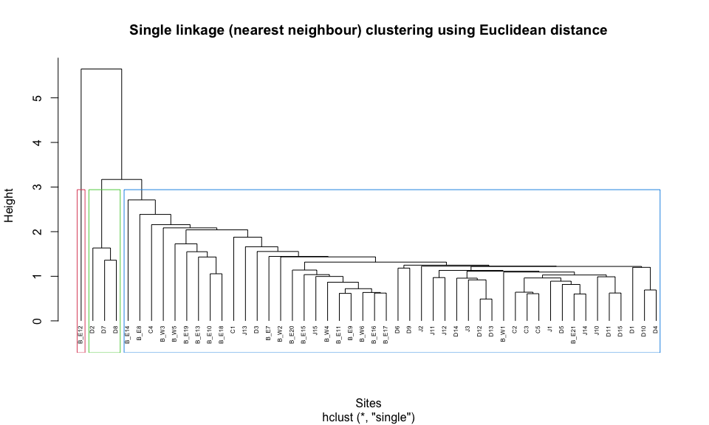
Figure 2. Tree dendrogram for hc2 using single linkage (nearest neighbor) with Euclidean distance, showing a 3-cluster cut.
plot(hc3, labels = clusdat$point, hang = -1,
main = "Complete linkage clustering using Euclidean distance with standardized bird abundance variables",
xlab = "Sites", ylab = "Height", cex = 0.5)
rect.hclust(hc3, k = 3, border = 2:4)
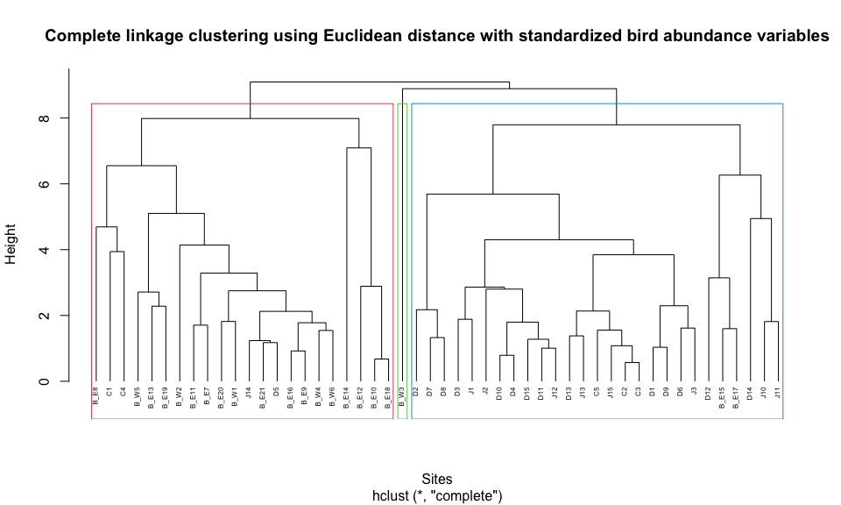
Figure 3. Tree dendrogram for hc3 using complete linkage with Euclidean distance on standardized bird abundance variables, showing a 3-cluster cut.
plot(hc4, labels = clusdat$point, hang = -1,
main = "Ward’s hierarchical clustering using Euclidean distance",
xlab = "Sites", ylab = "Height", cex = 0.6)
rect.hclust(hc4, k = 3, border = 2:4)
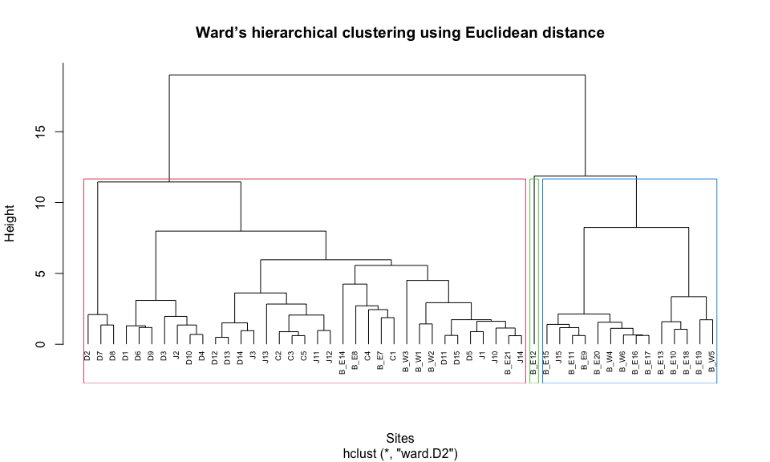
Figure 4. Tree dendrogram for hc4 using Ward’s method with Euclidean distance, showing a 3-cluster cut.
QUESTION 2.0: Compare the results for your four alternative hierarchical clustering analyses. For this comparison, make a table showing:
- the label for the cluster analysis (e.g., hc1)
- the distance measure used (e.g., Euclidean)
- the method used (e.g., nearest neighbour/simple)
- the number of clusters based on your interpretation of the dendrogram, and why
- whether or not chaining occurred, and why
- whether there was clear separation by distance between the clusters, and why
# QUESTION 2.0 - Template Code
# ## Uncomment the code chunk
# ## Write your answers to question 2.0 in the corresponding "..." slots
#
# answer2.0 <- data.frame(
# # write the label for each cluster analysis (e.g., hc1)
# `Label` = c("hc1",
# "...",
# "...",
# "..."),
#
# # write the distance measure used (e.g., Euclidean)
# `Distance Measure` = c("Euclidean", # for hc1
# "...", # for hc2
# "...", # for hc3
# "..."), # for hc4
#
# # write the method used (e.g., nearest neighbour/simple)
# `Method` = c("...",
# "...",
# "...",
# "..."),
#
# # write the number of clusters based on your interpretation of the dendrogram, and why
# `Number Of Clusters` = c("...",
# "...",
# "...",
# "..."),
#
# # write whether or not chaining occurred, and why
# `Chaining` = c("...",
# "...",
# "...",
# "..."),
#
# # write whether there was clear separation by distance between the clusters, and why
# `Separation` = c("...",
# "...",
# "...",
# "...")
#
# )
#
# ## Knit the table. Remember to include a table caption at the top of the table.
# knitr::kable(answer2.0, row.names = NA,
# caption = "Table 1. Cluster results for ...")
Your Answer:
answer2.0 <- data.frame(
`Label` = c("hc1",
"hc2",
"hc3",
"hc4"),
`Distance Measure` = c("Euclidean",
"Euclidean",
"Euclidean (standardized variables)",
"Euclidean"),
`Method` = c("Complete linkage",
"Single linkage (nearest neighbour)",
"Complete linkage (standardized data)",
"Ward's method"),
`Number Of Clusters` = c("2 clusters, possibly 3. In the dendrogram, 2 clear clusters emerge on the left and right. On the right, though, another separate branch emerges but only for one site (B_E12). However, this may represent an outlier.",
"1 cluster. In the dendrogram, chaining on the right complicates things. B_E12 emerges as a separate possible cluster again, but might be an outlier. Otherwise, 1 cluster appears around a height of 3.",
"3 clusters. The dendrogram shows three major branches before the final merge at about height 9. One large branch occurs on the left, merging with the rest of the sites at around height 8, while two additional branches occur on the right and merge at lower heights (~6). The large vertical distances between these merges suggest that these groups of sites are relatively dissimilar and thus represent meaningful clusters.",
"2 clusters. The Ward’s dendrogram shows two clear, large groups on the left and right that both remain distinct from ~11 height until merging at a very high dissimilarity level of ~18, indicating strong separation between them."),
`Chaining` = c("No strong chaining. In the dendogram, there might be some slight chaining on the left after the break at height 7. However, the clusters are still tightly grouped after this break, without a clear visual pattern indicating strong chaining.",
"Yes, chaining is evident. Sites merge quickly and sequentially from the right to the left until a height of 3. The ladder-like appearance with low heights suggests a chaining event.",
"No evident chaining. Sites form compact subclusters that merge at progressively higher heights, with no ladder-like structure that would indicate chaining.",
"No chaining. For one, Ward’s method minimizes within cluster variance, producing compact clusters. Second, the there is no ladder-like structure evident in the dendrogram. The sites form compact subclusters and merge at progressively higher heights."),
`Separation` = c("Moderate separation. Vertical distance represents dissimilarity. There is a 6-height separation between the top and the closest clusters showing less dissimilarity, but the clusters thereafter are closer in vertical distance, displaying more dissimilarity afterward.",
"Weak separation. In the dendrogram, clusters merge very gradually with little distance gaps between groups until a height of ~3.",
"Strong separation. Sites begin to merge within clusters at relatively low heights, but the clusters only merge at much higher distances (~8), indicating clear differences between groups.",
"Very strong separation. The large vertical distance before the final merge indicates the two clusters are highly dissimilar.")
)
knitr::kable(answer2.0, row.names = NA,
caption = "Table 1. Comparison of hierarchical clustering methods used to group sites based on bird composition.",
align = "l")
Table 1. Comparison of hierarchical clustering methods used to group sites based on bird composition.
Label | Distance.Measure | Method | Number.Of.Clusters | Chaining | Separation
hc1 | Euclidean | Complete linkage | 2 clusters, possibly 3. In the dendrogram, 2 clear clusters emerge on the left and right. On the right, though, another separate branch emerges but only for one site (B_E12). However, this may represent an outlier. | No strong chaining. In the dendogram, there might be some slight chaining on the left after the break at height 7. However, the clusters are still tightly grouped after this break, without a clear visual pattern indicating strong chaining. | Moderate separation. Vertical distance represents dissimilarity. There is a 6-height separation between the top and the closest clusters showing less dissimilarity, but the clusters thereafter are closer in vertical distance, displaying more dissimilarity afterward.
hc2 | Euclidean | Single linkage (nearest neighbour) | 1 cluster. In the dendrogram, chaining on the right complicates things. B_E12 emerges as a separate possible cluster again but might be an outlier. Otherwise, 1 cluster appears around a height of 3. | Yes, chaining is evident. Sites merge quickly and sequentially from the right to the left until a height of 3. The ladder-like appearance with low heights suggests a chaining event. | Weak separation. In the dendrogram, clusters merge very gradually with little distance gaps between groups until a height of ~3.
hc3 | Euclidean (standardized variables) | Complete linkage (standardized data) | 3 clusters. The dendrogram shows three major branches before the final merge at about height 9. One large branch occurs on the left, merging with the rest of the sites at around height 8, while two additional branches occur on the right and merge at lower heights (~6). The large vertical distances between these merges suggest that these groups of sites are relatively dissimilar and thus represent meaningful clusters. | No evident chaining. Sites form compact subclusters that merge at progressively higher heights, with no ladder-like structure that would indicate chaining. | Strong separation. Sites begin to merge within clusters at relatively low heights, but the clusters only merge at much higher distances (~8), indicating clear differences between groups.
hc4 | Euclidean | Ward’s method | 2 clusters. The Ward’s dendrogram shows two clear, large groups on the left and right that both remain distinct from ~11 height until merging at a very high dissimilarity level of ~18, indicating strong separation between them. | No chaining. For one, Ward’s method minimizes within cluster variance, producing compact clusters. Second, the there is no ladder-like structure evident in the dendrogram. The sites form compact subclusters and merge at progressively higher heights.

QUESTION 3: Based on your comparison table for hierarchical methods and your tree dendrograms:
- QUESTION 3.1: Was there consistency in the number of clusters, or did this vary greatly over the four analyses? Explain briefly.
The number of clusters was fairly consistent across most methods, but there were some differences. The complete linkage (hc1) and Ward’s method (hc4) both suggested at least two main clusters, while the standardized complete linkage (hc3) indicated three clusters. In contrast, the single linkage method (hc2) resulted in only 1 somehat ambiguous cluster (due to chaining).
# Provide your R codes here (if applicable)
- QUESTION 3.2: Which cluster analysis gave the clearest result? Justify your answer briefly.
Ward’s method produced the clearest result. The dendrogram shows two clear clusters that remain separate until merging at a very high dissimilarity height (~18), indicating strong separation between groups. This method also avoids the problematic chaining seen in the single linkage dendrogram and produces more compact clusters than the complete linkage methods.
- QUESTION 3.2: Which cluster analysis gave the clearest result? Justify your answer briefly.
Ward’s method produced the clearest result. The dendrogram shows two clear clusters that remain separate until merging at a very high dissimilarity height (~18), indicating strong separation between groups. This method also avoids the problematic chaining seen in the single linkage dendrogram and produces more compact clusters
# Provide your R codes here (if applicable)
QUESTION 4.0: Select one of your hierarchical cluster methods. For the selected method, annotate the tree dendrogram to show the clusters and add this as a new figure. Remember to include a figure caption at the bottom of your figure. (i.e., Figure 5. ?? caption here??…)
Your Answer:
Providing the k=2plot from earlier, with extra annotations.
par(mar = c(8,4,4,2))
plot(hc4, labels = clusdat$point, hang = -1,
main = "Ward.D2, Euclidean",
xlab = "Sites", ylab = "Height", cex = 0.6)
rect.hclust(hc4, k = 2, border = c("red","blue"))
# Add cluster labels (adjust x/y slightly if needed)
text(x = 12, y = 17, labels = "Cluster 1", col = "red", font = 2)
text(x = 45, y = 17, labels = "Cluster 2", col = "blue", font = 2)
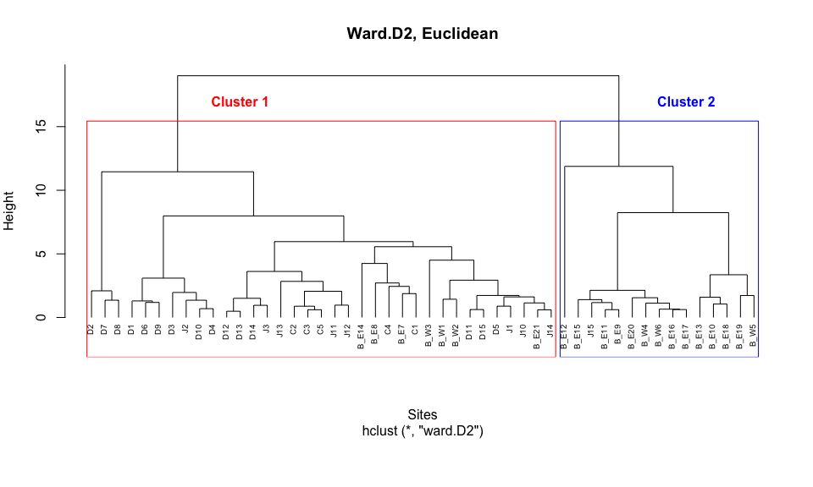
Figure 5. Annotated dendrogram for Ward’s hierarchical clustering using Euclidean distance, showing two clusters.
[Write your answer to QUESTION 4.0 here…You might want to add the annotated dendrogram to the WORD document directly after knitting the RMD file]

Part 3: Non-Hierarchical Clustering of sites by bird composition
In Part 3, you will use k-means non-Hierarchical clustering to cluster sites based on bird composition. Remember that the number of clusters is an input variable for k-means. The following code will try inputting 1 to 6 clusters separately, and you will need to interpret the results and choose the likely “natural” number of clusters.
# Again, subset the data to retain just the bird info.
justx<-clusdat[,3:12]
n <- nrow(justx)
## calculate the within sums of squares (wss) for 1 to 6 clusters
wss <- rep(0, 6)
# calculate the wss when only having 1 cluster
wss[1] <- (n - 1) * sum(sapply(justx, var))
# calculate wss when having 2 to 6 clusters for k-means
for (i in 2:6)
wss[i] <- sum(kmeans(justx, centers = i)$withinss)
# print out the wss for each scenario
wss
In order to choose the likely “natural” number of clusters, plotting the within sums of squares against the number of of clusters could be beneficial.
plot(1:6, wss, type = "b", xlab = "Number of groups",
ylab = "Within groups sum of squares")
In addition to the wss plot, graphing the clustering results also helps us make a decision. The following code shows an example of where three clusters are formed (but that three-clusters may not be the best choice). You can modify the code and try to graph other scenarios.
## clustering results when forming 3 groups
require(graphics, stats)
# k-means with 3 clusters
(threegroups <- kmeans(justx, centers = 3)) # since this is in brackets, the object - threegroups - is created and then also "printed" out.
# add the cluster no to justx
str(threegroups)
names(justx)
Keep <- data.frame(justx, as.factor(threegroups$cluster))
head(Keep) # cluster number is added to the data.
# shows the summary of clusters
summary(Keep) # most are in Cluster 1 here, with the 3 cluster solution.
We could also graph showing the clusters number and two of the bird species. The example below indicates which sites have a similar bird composition in terms of “hola” and “vesp” under the 3-cluster solution.
plot(justx[ ,c("hola","vesp")], xlab = "hola",
ylab = "Vesper sparrow", pch = 16, col = threegroups$cluster,
cex = 2.0)
text(clusdat[ ,"hola"], clusdat[ ,"vesp"],
labels = row.names(justx),cex=0.7,
pos = 3)
QUESTION 5.0: Using the k-means non-hierarchical method, how many natural clusters does there seem to be? For this, show the graph of the within sums of squares versus the number of clusters and add a figure caption. Then use this in justifying your choice of the number of clusters.
Your Answer:
# Provide your R codes here (if applicable)
Until now, you have explored various hierarchical and non-hierarchical clustering analyses. It’s time for you to make a detailed comparison and choose your best segregation solution.
Your Answer:
The plot shows a clear elbow at k = 2, where the decrease in within-group sum of squares begins to level off more gradually. The WSS drops sharply from 496.22 with one cluster to 300.76 with two clusters, which is the largest reduction in within-group variation. After this point, the reductions become progressively smaller (300.76 to 225.69 for three clusters, then to 174.74, 138.77, and 120.84 for four to six clusters). This pattern suggests that most of the variation in the data is explained by dividing the sites into two clusters, while additional clusters provide only modest improvements. Overall, it appears that there are two natural clusters.
# Provide your R codes here (if applicable)
# Subset bird data
justx <- clusdat[,3:12]
n <- nrow(justx)
# calculate WSS
wss <- rep(0,6)
# 1 cluster
wss[1] <- (n-1) * sum(sapply(justx, var))
# 2–6 clusters
for(i in 2:6){
wss[i] <- sum(kmeans(justx, centers=i)$withinss)
}
# plot elbow plot
plot(1:6, wss,
type="b",
pch=19,
xlab="Number of Clusters",
ylab="Within Groups Sum of Squares",
main="Fig. 6. Elbow Method for Determining Optimal Clusters")
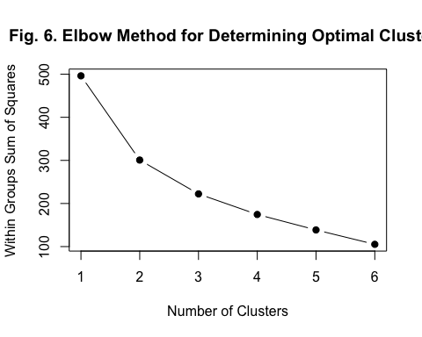

Until now, you have explored various hierarchical and non-hierarchical clustering analyses. It’s time for you to make a detailed comparison and choose your best segregation solution.
QUESTION 6.0: Compare your selected hierarchical clustering analysis to the non-hierarchical k-means results in terms of: 1) Was there consistency in the number of natural clusters? and 2) Which was easier to interpret/use for this problem?
Your Answer:
The hierarchical clustering results were generally consistent with the k-means clustering results. The Ward hierarchical method suggested two main clusters, and the k-means elbow method also indicated two natural clusters. This consistency suggests confidence in the clustering result.
In terms of interpretation, hierarchical clustering was easier to interpret because the dendrogram visually shows how sites merge at different dissimilarity levels, making it easier to see the cluster structure and relationships among sites. In contrast, k-means primarily provides cluster assignments and requires additional plots or diagnostics, like the elbow plot, to determine the number of clusters.
# k-means with 2 clusters
set.seed(123)
twogroups <- kmeans(justx, centers = 2)
# Ward clusters cut into 2 groups
ward_clusters <- cutree(hc4, k = 2)
# Compare assignments
comparison <- data.frame(
Site = row.names(justx),
Ward_Cluster = ward_clusters,
Kmeans_Cluster = twogroups$cluster
)
knitr::kable(comparison,
caption = "Table 2. Comparison of site assignments between Ward hierarchical clustering and k-means clustering using two clusters.")
Table 2. Comparison of site assignments between Ward hierarchical clustering and k-means clustering using two clusters.
Site | Ward_Cluster | Kmeans_Cluster
1 | 1 | 2
2 | 1 | 1
3 | 1 | 2
4 | 1 | 2
5 | 2 | 1
6 | 1 | 1
7 | 1 | 1
8 | 1 | 1
9 | 1 | 2
10 | 1 | 2
11 | 1 | 1
12 | 2 | 1
13 | 2 | 1
14 | 2 | 1
15 | 1 | 1
16 | 2 | 1
17 | 2 | 1
18 | 2 | 1
19 | 1 | 1
20 | 1 | 2
21 | 1 | 1
22 | 2 | 1
23 | 2 | 1
24 | 2 | 1
25 | 2 | 1
26 | 2 | 1
27 | 2 | 1
28 | 2 | 1
29 | 2 | 1
30 | 2 | 1
31 | 2 | 1
32 | 2 | 1
33 | 2 | 1
34 | 2 | 1
35 | 2 | 1
36 | 2 | 1
37 | 2 | 1
38 | 2 | 1
39 | 2 | 1
40 | 2 | 1
41 | 2 | 1
42 | 2 | 1
43 | 2 | 1
44 | 2 | 1
45 | 2 | 1
46 | 2 | 1
47 | 2 | 1
48 | 1 | 1
49 | 2 | 1
50 | 2 | 1

QUESTION 7.0: Overall, based on your analyses and interpretation, which clustering method would you recommend of the five methods used? Briefly explain your choice.
Your Answer:
In comparing the five methods tested here, Ward’s method produced the clearest and most reliable clustering structure. The single linkage method showed evidence of chaining, where sites merged sequentially rather than forming distinct groups, making the resulting cluster structure difficult to interpret. The complete linkage methods (hc1 and hc3) produced more compact clusters, but the separation between groups was moderate and less distinct than with Ward’s method. The Manhattan distance clustering also produced clusters, but the separation was not as clear as with Ward’s method.
The dendrogram produced by Ward’s method also showed a clear separation between two main groups of sites, suggesting that the dataset naturally divides into two clusters based on bird species composition. This interpretation was further supported by the k means analysis, where the elbow plot indicated that two clusters best represented the natural structure of the data.
Overall, because Ward’s method produced the most compact clusters, the clearest separation between groups, and results consistent with the k means analysis, it appears to be the most appropriate clustering approach for this dataset.
# Provide your R codes here (if applicable)

Extra R code, Part 4: Non-Hierarchical Clustering of birds by locations
Below is extra code where the data are transposed and the objective is to cluster the birds based on locations that they exist (i.e., Which birds appear to be together?) This is just for fun, and shows how the clustering can be altered to group variables instead of observations to match the question posed.

Data Preparation
First, let’s just take 25 rows this time and transpose the data.
justxT<-t(justx[1:25,])
head(justxT)

K-means clustering
Using k-means, cluster the birds into into 1 to 6 clusters based on sites where they occur. Then, choose the likely “natural” number of clusters.
n <- nrow(justxT)
wss <- rep(0, 6)
wss[1] <- (n - 1) * sum(sapply(justxT, var)) # 1 cluster wss
for (i in 2:6)
wss[i] <- sum(kmeans(justxT,
centers = i)$withinss)
wss # within sums of squares for 1 to 6 clusters
plot(1:6, wss, type = "b", xlab = "Number of groups",
ylab = "Within groups sum of squares")
Graph the three-group solution in below… but that may not be the best one?
## clustering results when forming 3 groups
require(graphics, stats)
(threegroups <- kmeans(justxT, centers = 3))
str(threegroups) # includes the cluster no, etc.
Keep3<-data.frame(justxT,as.factor(threegroups$cluster) )
head(Keep3) # cluster number is added to the data.
summary(Keep3) # most are in Cluster 1 here.
Let’s check the four-group solution as well.
## clustering results when forming 4 groups
(fourgroups <- kmeans(justxT, centers = 4))
str(fourgroups) # includes the cluster no, etc.
Keep4<-data.frame(justxT,as.factor(fourgroups$cluster) )
head(Keep4) # cluster number is added to the data.
summary(Keep4) # most are in Cluster 3 here, with the 4 cluster solution.
Here is another graphic, showing the scatterplot matrix, but with points labelled. The upper panel is the 4-group solution and the lower panel is the 3-group solution. color schemes for K-means… adapted from Zellerman code example.
colorlow <- rainbow(3)[threegroups$cluster]
colorup <- rainbow(4)[fourgroups$cluster]
panel.up <- function(x, y, ...)
{ # function to produce scatterplot in pairs()
usr <- par("usr") # save par() values
on.exit(par(usr)) # set par() at end
par(usr = c(max(y), min(y), max(x), min(x))) # set bounds
points(y, x, col = colorup, pch = 16) # plot data points
}
pairs(justxT, pch = 16, gap = 0, xaxt = "n", yaxt = "n",
col = colorlow, upper.panel = panel.up)
## Warning in par(usr): argument 1 does not name a graphical parameter
## Warning in par(usr): argument 1 does not name a graphical parameter
## Warning in par(usr): argument 1 does not name a graphical parameter
## Warning in par(usr): argument 1 does not name a graphical parameter
## Warning in par(usr): argument 1 does not name a graphical parameter
## Warning in par(usr): argument 1 does not name a graphical parameter
## Warning in par(usr): argument 1 does not name a graphical parameter
## Warning in par(usr): argument 1 does not name a graphical parameter
## Warning in par(usr): argument 1 does not name a graphical parameter
## Warning in par(usr): argument 1 does not name a graphical parameter
## Warning in par(usr): argument 1 does not name a graphical parameter
## Warning in par(usr): argument 1 does not name a graphical parameter
## Warning in par(usr): argument 1 does not name a graphical parameter
## Warning in par(usr): argument 1 does not name a graphical parameter
## Warning in par(usr): argument 1 does not name a graphical parameter
## Warning in par(usr): argument 1 does not name a graphical parameter
## Warning in par(usr): argument 1 does not name a graphical parameter
## Warning in par(usr): argument 1 does not name a graphical parameter
## Warning in par(usr): argument 1 does not name a graphical parameter
## Warning in par(usr): argument 1 does not name a graphical parameter
## Warning in par(usr): argument 1 does not name a graphical parameter
## Warning in par(usr): argument 1 does not name a graphical parameter
## Warning in par(usr): argument 1 does not name a graphical parameter
## Warning in par(usr): argument 1 does not name a graphical parameter
## Warning in par(usr): argument 1 does not name a graphical parameter
## Warning in par(usr): argument 1 does not name a graphical parameter
## Warning in par(usr): argument 1 does not name a graphical parameter
## Warning in par(usr): argument 1 does not name a graphical parameter
## Warning in par(usr): argument 1 does not name a graphical parameter
## Warning in par(usr): argument 1 does not name a graphical parameter
## Warning in par(usr): argument 1 does not name a graphical parameter
## Warning in par(usr): argument 1 does not name a graphical parameter
## Warning in par(usr): argument 1 does not name a graphical parameter
## Warning in par(usr): argument 1 does not name a graphical parameter
## Warning in par(usr): argument 1 does not name a graphical parameter
## Warning in par(usr): argument 1 does not name a graphical parameter
## Warning in par(usr): argument 1 does not name a graphical parameter
## Warning in par(usr): argument 1 does not name a graphical parameter
## Warning in par(usr): argument 1 does not name a graphical parameter
## Warning in par(usr): argument 1 does not name a graphical parameter
## Warning in par(usr): argument 1 does not name a graphical parameter
## Warning in par(usr): argument 1 does not name a graphical parameter
## Warning in par(usr): argument 1 does not name a graphical parameter
## Warning in par(usr): argument 1 does not name a graphical parameter
## Warning in par(usr): argument 1 does not name a graphical parameter
## Warning in par(usr): argument 1 does not name a graphical parameter
## Warning in par(usr): argument 1 does not name a graphical parameter
## Warning in par(usr): argument 1 does not name a graphical parameter
## Warning in par(usr): argument 1 does not name a graphical parameter
## Warning in par(usr): argument 1 does not name a graphical parameter
## Warning in par(usr): argument 1 does not name a graphical parameter
## Warning in par(usr): argument 1 does not name a graphical parameter
## Warning in par(usr): argument 1 does not name a graphical parameter
## Warning in par(usr): argument 1 does not name a graphical parameter
## Warning in par(usr): argument 1 does not name a graphical parameter
## Warning in par(usr): argument 1 does not name a graphical parameter
## Warning in par(usr): argument 1 does not name a graphical parameter
## Warning in par(usr): argument 1 does not name a graphical parameter
## Warning in par(usr): argument 1 does not name a graphical parameter
## Warning in par(usr): argument 1 does not name a graphical parameter
## Warning in par(usr): argument 1 does not name a graphical parameter
## Warning in par(usr): argument 1 does not name a graphical parameter
## Warning in par(usr): argument 1 does not name a graphical parameter
## Warning in par(usr): argument 1 does not name a graphical parameter
## Warning in par(usr): argument 1 does not name a graphical parameter
## Warning in par(usr): argument 1 does not name a graphical parameter
## Warning in par(usr): argument 1 does not name a graphical parameter
## Warning in par(usr): argument 1 does not name a graphical parameter
## Warning in par(usr): argument 1 does not name a graphical parameter
## Warning in par(usr): argument 1 does not name a graphical parameter
## Warning in par(usr): argument 1 does not name a graphical parameter
## Warning in par(usr): argument 1 does not name a graphical parameter
## Warning in par(usr): argument 1 does not name a graphical parameter
## Warning in par(usr): argument 1 does not name a graphical parameter
## Warning in par(usr): argument 1 does not name a graphical parameter
## Warning in par(usr): argument 1 does not name a graphical parameter
## Warning in par(usr): argument 1 does not name a graphical parameter
## Warning in par(usr): argument 1 does not name a graphical parameter
## Warning in par(usr): argument 1 does not name a graphical parameter
## Warning in par(usr): argument 1 does not name a graphical parameter
## Warning in par(usr): argument 1 does not name a graphical parameter
## Warning in par(usr): argument 1 does not name a graphical parameter
## Warning in par(usr): argument 1 does not name a graphical parameter
## Warning in par(usr): argument 1 does not name a graphical parameter
## Warning in par(usr): argument 1 does not name a graphical parameter
## Warning in par(usr): argument 1 does not name a graphical parameter
## Warning in par(usr): argument 1 does not name a graphical parameter
## Warning in par(usr): argument 1 does not name a graphical parameter
## Warning in par(usr): argument 1 does not name a graphical parameter
## Warning in par(usr): argument 1 does not name a graphical parameter
## Warning in par(usr): argument 1 does not name a graphical parameter
## Warning in par(usr): argument 1 does not name a graphical parameter
## Warning in par(usr): argument 1 does not name a graphical parameter
## Warning in par(usr): argument 1 does not name a graphical parameter
## Warning in par(usr): argument 1 does not name a graphical parameter
## Warning in par(usr): argument 1 does not name a graphical parameter
## Warning in par(usr): argument 1 does not name a graphical parameter
## Warning in par(usr): argument 1 does not name a graphical parameter
## Warning in par(usr): argument 1 does not name a graphical parameter
## Warning in par(usr): argument 1 does not name a graphical parameter
## Warning in par(usr): argument 1 does not name a graphical parameter
## Warning in par(usr): argument 1 does not name a graphical parameter
## Warning in par(usr): argument 1 does not name a graphical parameter
## Warning in par(usr): argument 1 does not name a graphical parameter
## Warning in par(usr): argument 1 does not name a graphical parameter
## Warning in par(usr): argument 1 does not name a graphical parameter
## Warning in par(usr): argument 1 does not name a graphical parameter
## Warning in par(usr): argument 1 does not name a graphical parameter
## Warning in par(usr): argument 1 does not name a graphical parameter
## Warning in par(usr): argument 1 does not name a graphical parameter
## Warning in par(usr): argument 1 does not name a graphical parameter
## Warning in par(usr): argument 1 does not name a graphical parameter
## Warning in par(usr): argument 1 does not name a graphical parameter
## Warning in par(usr): argument 1 does not name a graphical parameter
## Warning in par(usr): argument 1 does not name a graphical parameter
## Warning in par(usr): argument 1 does not name a graphical parameter
## Warning in par(usr): argument 1 does not name a graphical parameter
## Warning in par(usr): argument 1 does not name a graphical parameter
## Warning in par(usr): argument 1 does not name a graphical parameter
## Warning in par(usr): argument 1 does not name a graphical parameter
## Warning in par(usr): argument 1 does not name a graphical parameter
## Warning in par(usr): argument 1 does not name a graphical parameter
## Warning in par(usr): argument 1 does not name a graphical parameter
## Warning in par(usr): argument 1 does not name a graphical parameter
## Warning in par(usr): argument 1 does not name a graphical parameter
## Warning in par(usr): argument 1 does not name a graphical parameter
## Warning in par(usr): argument 1 does not name a graphical parameter
## Warning in par(usr): argument 1 does not name a graphical parameter
## Warning in par(usr): argument 1 does not name a graphical parameter
## Warning in par(usr): argument 1 does not name a graphical parameter
## Warning in par(usr): argument 1 does not name a graphical parameter
## Warning in par(usr): argument 1 does not name a graphical parameter
## Warning in par(usr): argument 1 does not name a graphical parameter
## Warning in par(usr): argument 1 does not name a graphical parameter
## Warning in par(usr): argument 1 does not name a graphical parameter
## Warning in par(usr): argument 1 does not name a graphical parameter
## Warning in par(usr): argument 1 does not name a graphical parameter
## Warning in par(usr): argument 1 does not name a graphical parameter
## Warning in par(usr): argument 1 does not name a graphical parameter
## Warning in par(usr): argument 1 does not name a graphical parameter
## Warning in par(usr): argument 1 does not name a graphical parameter
## Warning in par(usr): argument 1 does not name a graphical parameter
## Warning in par(usr): argument 1 does not name a graphical parameter
## Warning in par(usr): argument 1 does not name a graphical parameter
## Warning in par(usr): argument 1 does not name a graphical parameter
## Warning in par(usr): argument 1 does not name a graphical parameter
## Warning in par(usr): argument 1 does not name a graphical parameter
## Warning in par(usr): argument 1 does not name a graphical parameter
## Warning in par(usr): argument 1 does not name a graphical parameter
## Warning in par(usr): argument 1 does not name a graphical parameter
## Warning in par(usr): argument 1 does not name a graphical parameter
## Warning in par(usr): argument 1 does not name a graphical parameter
## Warning in par(usr): argument 1 does not name a graphical parameter
## Warning in par(usr): argument 1 does not name a graphical parameter
## Warning in par(usr): argument 1 does not name a graphical parameter
## Warning in par(usr): argument 1 does not name a graphical parameter
## Warning in par(usr): argument 1 does not name a graphical parameter
## Warning in par(usr): argument 1 does not name a graphical parameter
## Warning in par(usr): argument 1 does not name a graphical parameter
## Warning in par(usr): argument 1 does not name a graphical parameter
## Warning in par(usr): argument 1 does not name a graphical parameter
## Warning in par(usr): argument 1 does not name a graphical parameter
## Warning in par(usr): argument 1 does not name a graphical parameter
## Warning in par(usr): argument 1 does not name a graphical parameter
## Warning in par(usr): argument 1 does not name a graphical parameter
## Warning in par(usr): argument 1 does not name a graphical parameter
## Warning in par(usr): argument 1 does not name a graphical parameter
## Warning in par(usr): argument 1 does not name a graphical parameter
## Warning in par(usr): argument 1 does not name a graphical parameter
## Warning in par(usr): argument 1 does not name a graphical parameter
## Warning in par(usr): argument 1 does not name a graphical parameter
## Warning in par(usr): argument 1 does not name a graphical parameter
## Warning in par(usr): argument 1 does not name a graphical parameter
## Warning in par(usr): argument 1 does not name a graphical parameter
## Warning in par(usr): argument 1 does not name a graphical parameter
## Warning in par(usr): argument 1 does not name a graphical parameter
## Warning in par(usr): argument 1 does not name a graphical parameter
## Warning in par(usr): argument 1 does not name a graphical parameter
## Warning in par(usr): argument 1 does not name a graphical parameter
## Warning in par(usr): argument 1 does not name a graphical parameter
## Warning in par(usr): argument 1 does not name a graphical parameter
## Warning in par(usr): argument 1 does not name a graphical parameter
## Warning in par(usr): argument 1 does not name a graphical parameter
## Warning in par(usr): argument 1 does not name a graphical parameter
## Warning in par(usr): argument 1 does not name a graphical parameter
## Warning in par(usr): argument 1 does not name a graphical parameter
## Warning in par(usr): argument 1 does not name a graphical parameter
## Warning in par(usr): argument 1 does not name a graphical parameter
## Warning in par(usr): argument 1 does not name a graphical parameter
## Warning in par(usr): argument 1 does not name a graphical parameter
## Warning in par(usr): argument 1 does not name a graphical parameter
## Warning in par(usr): argument 1 does not name a graphical parameter
## Warning in par(usr): argument 1 does not name a graphical parameter
## Warning in par(usr): argument 1 does not name a graphical parameter
## Warning in par(usr): argument 1 does not name a graphical parameter
## Warning in par(usr): argument 1 does not name a graphical parameter
## Warning in par(usr): argument 1 does not name a graphical parameter
## Warning in par(usr): argument 1 does not name a graphical parameter
## Warning in par(usr): argument 1 does not name a graphical parameter
## Warning in par(usr): argument 1 does not name a graphical parameter
## Warning in par(usr): argument 1 does not name a graphical parameter
## Warning in par(usr): argument 1 does not name a graphical parameter
## Warning in par(usr): argument 1 does not name a graphical parameter
## Warning in par(usr): argument 1 does not name a graphical parameter
## Warning in par(usr): argument 1 does not name a graphical parameter
## Warning in par(usr): argument 1 does not name a graphical parameter
## Warning in par(usr): argument 1 does not name a graphical parameter
## Warning in par(usr): argument 1 does not name a graphical parameter
## Warning in par(usr): argument 1 does not name a graphical parameter
## Warning in par(usr): argument 1 does not name a graphical parameter
## Warning in par(usr): argument 1 does not name a graphical parameter
## Warning in par(usr): argument 1 does not name a graphical parameter
## Warning in par(usr): argument 1 does not name a graphical parameter
## Warning in par(usr): argument 1 does not name a graphical parameter
## Warning in par(usr): argument 1 does not name a graphical parameter
## Warning in par(usr): argument 1 does not name a graphical parameter
## Warning in par(usr): argument 1 does not name a graphical parameter
## Warning in par(usr): argument 1 does not name a graphical parameter
## Warning in par(usr): argument 1 does not name a graphical parameter
## Warning in par(usr): argument 1 does not name a graphical parameter
## Warning in par(usr): argument 1 does not name a graphical parameter
## Warning in par(usr): argument 1 does not name a graphical parameter
## Warning in par(usr): argument 1 does not name a graphical parameter
## Warning in par(usr): argument 1 does not name a graphical parameter
## Warning in par(usr): argument 1 does not name a graphical parameter
## Warning in par(usr): argument 1 does not name a graphical parameter
## Warning in par(usr): argument 1 does not name a graphical parameter
## Warning in par(usr): argument 1 does not name a graphical parameter
## Warning in par(usr): argument 1 does not name a graphical parameter
## Warning in par(usr): argument 1 does not name a graphical parameter
## Warning in par(usr): argument 1 does not name a graphical parameter
## Warning in par(usr): argument 1 does not name a graphical parameter
## Warning in par(usr): argument 1 does not name a graphical parameter
## Warning in par(usr): argument 1 does not name a graphical parameter
## Warning in par(usr): argument 1 does not name a graphical parameter
## Warning in par(usr): argument 1 does not name a graphical parameter
## Warning in par(usr): argument 1 does not name a graphical parameter
## Warning in par(usr): argument 1 does not name a graphical parameter
## Warning in par(usr): argument 1 does not name a graphical parameter
## Warning in par(usr): argument 1 does not name a graphical parameter
## Warning in par(usr): argument 1 does not name a graphical parameter
## Warning in par(usr): argument 1 does not name a graphical parameter
## Warning in par(usr): argument 1 does not name a graphical parameter
## Warning in par(usr): argument 1 does not name a graphical parameter
## Warning in par(usr): argument 1 does not name a graphical parameter
## Warning in par(usr): argument 1 does not name a graphical parameter
## Warning in par(usr): argument 1 does not name a graphical parameter
## Warning in par(usr): argument 1 does not name a graphical parameter
## Warning in par(usr): argument 1 does not name a graphical parameter
## Warning in par(usr): argument 1 does not name a graphical parameter
## Warning in par(usr): argument 1 does not name a graphical parameter
## Warning in par(usr): argument 1 does not name a graphical parameter
## Warning in par(usr): argument 1 does not name a graphical parameter
## Warning in par(usr): argument 1 does not name a graphical parameter
## Warning in par(usr): argument 1 does not name a graphical parameter
## Warning in par(usr): argument 1 does not name a graphical parameter
## Warning in par(usr): argument 1 does not name a graphical parameter
## Warning in par(usr): argument 1 does not name a graphical parameter
## Warning in par(usr): argument 1 does not name a graphical parameter
## Warning in par(usr): argument 1 does not name a graphical parameter
## Warning in par(usr): argument 1 does not name a graphical parameter
## Warning in par(usr): argument 1 does not name a graphical parameter
## Warning in par(usr): argument 1 does not name a graphical parameter
## Warning in par(usr): argument 1 does not name a graphical parameter
## Warning in par(usr): argument 1 does not name a graphical parameter
## Warning in par(usr): argument 1 does not name a graphical parameter
## Warning in par(usr): argument 1 does not name a graphical parameter
## Warning in par(usr): argument 1 does not name a graphical parameter
## Warning in par(usr): argument 1 does not name a graphical parameter
## Warning in par(usr): argument 1 does not name a graphical parameter
## Warning in par(usr): argument 1 does not name a graphical parameter
## Warning in par(usr): argument 1 does not name a graphical parameter
## Warning in par(usr): argument 1 does not name a graphical parameter
## Warning in par(usr): argument 1 does not name a graphical parameter
## Warning in par(usr): argument 1 does not name a graphical parameter
## Warning in par(usr): argument 1 does not name a graphical parameter
## Warning in par(usr): argument 1 does not name a graphical parameter
## Warning in par(usr): argument 1 does not name a graphical parameter
## Warning in par(usr): argument 1 does not name a graphical parameter
## Warning in par(usr): argument 1 does not name a graphical parameter
## Warning in par(usr): argument 1 does not name a graphical parameter
## Warning in par(usr): argument 1 does not name a graphical parameter
## Warning in par(usr): argument 1 does not name a graphical parameter
## Warning in par(usr): argument 1 does not name a graphical parameter
## Warning in par(usr): argument 1 does not name a graphical parameter
## Warning in par(usr): argument 1 does not name a graphical parameter
## Warning in par(usr): argument 1 does not name a graphical parameter
## Warning in par(usr): argument 1 does not name a graphical parameter
## Warning in par(usr): argument 1 does not name a graphical parameter
## Warning in par(usr): argument 1 does not name a graphical parameter
## Warning in par(usr): argument 1 does not name a graphical parameter
## Warning in par(usr): argument 1 does not name a graphical parameter
## Warning in par(usr): argument 1 does not name a graphical parameter
## Warning in par(usr): argument 1 does not name a graphical parameter
## Warning in par(usr): argument 1 does not name a graphical parameter
## Warning in par(usr): argument 1 does not name a graphical parameter
## Warning in par(usr): argument 1 does not name a graphical parameter
## Warning in par(usr): argument 1 does not name a graphical parameter
## Warning in par(usr): argument 1 does not name a graphical parameter
## Warning in par(usr): argument 1 does not name a graphical parameter
You can use the following code to generate statistics by cluster.
dim(Keep4)
summary(Keep4)
cluster1<-Keep4[(Keep4$as.factor.fourgroups.cluster==1),]
cluster2<-Keep4[(Keep4$as.factor.fourgroups.cluster==2),]
cluster3<-Keep4[(Keep4$as.factor.fourgroups.cluster==3),]
cluster4<-Keep4[(Keep4$as.factor.fourgroups.cluster==4),]
dim(cluster1)
dim(cluster2)
dim(cluster3)
dim(cluster4)
rownames(cluster1) # what birds in cluster 1?
rownames(cluster2)
rownames(cluster3)
rownames(cluster4)

