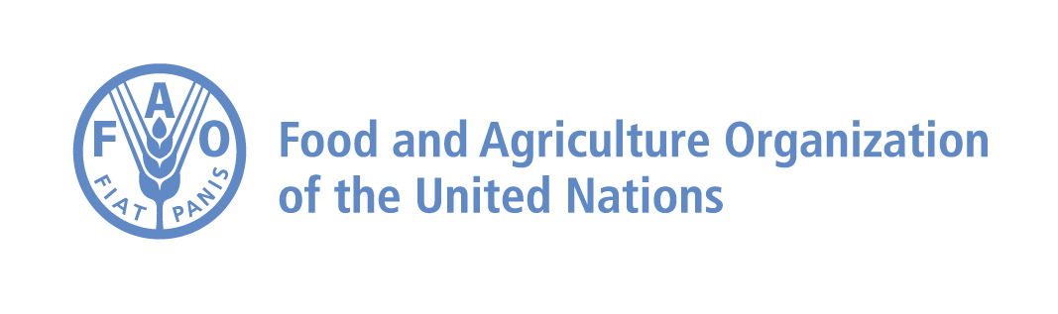
Explore data, analysis and tools at the DIEM Hub
DIEM Flood Package
From flood hazard and exposure to evidence for early action, response and recovery
Audience: FAO and other UN agencies; donors; government counterparts; emergency officers and food-security analysts.
Purpose: A modular package that connects hazard and exposure, satellite observation, field evidence and impact analysis into one decision-ready workflow.
The opportunity. Flood decisions are strongest when they answer four linked questions: Where are flood hazard and exposure concentrated? What is happening now? What does it mean on the ground? What are the likely consequences for livelihoods and the food economy?

One package, complementary evidence
The DIEM Flood Package combines tools that work at different time horizons and levels of detail. Used together, they create a clear line of sight from preparedness to targeted validation and impact estimates - without asking a single source to do every job.
Component | What it provides | Why it matters for decisions
Floodex | Modelled flood hazard and exposure view. | Uses a static model to show where flood hazard intersects people, agriculture and other exposed assets.
EVE 2.0 | Satellite-based observations of flood and water conditions. | Provides a timely, consistent picture of the evolving event to target follow-up and support situation analysis.
VISTA | Historical flood and surface-water reference from satellite records. | Places an event in local seasonal and historical context, including an exceptionality analysis for unusual conditions.
Mobile field data collection tools | Geo-tagged field reports, structured observations and photos. | Tests what satellite signals mean on the ground and captures impacts that cannot be seen reliably from space.
Impact briefs | Context-specific analysis combining DIEM and external data. | Translates evidence into estimates of harvest losses, damages and losses, including monetary value where data allow.
Explore the tools: Floodex | EVE 2.0 | VISTA

HOW THE PACKAGE WORKS IN PRACTICE
A practical pathway from alert to decision
The package is designed to be adapted to the country, event and information environment. It can support anticipatory action, rapid assessment, response prioritization and recovery planning.
1. Prepare and prioritize - Use Floodex to identify modelled hazard and exposed locations, and VISTA to understand recurrent flooding and agree where monitoring and field teams should focus.
2. Observe the event - Use EVE 2.0 to follow satellite-observed flood conditions and identify areas requiring rapid verification or support to local partners. VISTA compares each observed event with the historical pattern for that place and time of year, highlighting unusually extensive or persistent flooding through its exceptionality analysis.
3. Verify impacts in the field - Deploy phone- and tablet-based field data collection tools and a tailored review application to connect geo-tagged submissions and photos with satellite flood extent in near real time.
4. Translate evidence into action - Combine DIEM outputs with available crop calendars, production and price data, exposure data, infrastructure information and local knowledge to prepare a concise, decision-focused impact brief.
Field reporting: making observations usable
Mobile field data collection tools are deliberately practical. A reporter records location and the observed area, whether flooding is active, approximate depth, duration and affected share, and a photograph. They can also document crop type, crop maturity and loss; livestock carcasses; agricultural and fisheries infrastructure damage; road blockages; displacement; and access to food and water.
Already operational. Field-data review applications were built for the Mozambique floods (January 2026) and the Madagascar cyclone (February 2026), demonstrating how submissions and pictures can be reviewed alongside satellite-derived flood extent.

The decision product
For each event, DIEM analysts can produce a tailored two-page assessment that connects the evidence chain and makes assumptions transparent. Depending on local data availability, it can estimate the scale and value of harvest losses, damages to productive assets and other losses, identify the most affected places and groups, and highlight priority information gaps.
What partners receive
A coherent, scalable package that can be configured from a light-touch situation overview to a more detailed impact assessment - with clear provenance from hazard and exposure context, to satellite observation, to field evidence, to decision-ready analysis.

