My Test Manuscript

Abstract

Hier kommt das Abstract

# Preface

# Abstract

(Knuth 1984)

# Introduction

## Complexity of Phosphorous

Phosphorous displays a wide range of behaviours in soils, in places where organic, mineral and aqueous phases interface. In phases that contain oxygen Phosphorous is almost exclusively present as several derivates of Orthophosphate It can be found as organic molecules as anhydric- and ester-groups, being needed by all known species as a constituent of DNA and energy transfer-processes. It can be present as anorganic Phosphate either as mono-orthophosphate or poly-orthophosphate , where it can strongly interact with water, forming, depending on pH or . The dissolved species of phosphate are subject to adsorption to clay- and oxide-surfaces of the solid soil-phase, they also form fallout-products such as Apatite, Vivianite etc. With the present metal-cations in the solution. While the solubility constant of most phosphate-salts are comparably low (Wert eingeben), meaning that the fallout and formation of minerals happens at low chemical activities of phosphate, phosphate often is leached from soil-surface-layers, heavily reducing the efficacy of P-fertilization and presenting a disturbance to P-limited ecosystems. Those phenomena, many of them being physicochemically controlled, are influenced by parameters such as pH, ionic-strength, clay-content, specific-surface of the solid phase, amorphous -content amorphous -content, in short the phenomena depend heavily on the composition, distribution and geometry of the soil. Those properties are considered to be stable respectively long-term properties of a soil, when looked at it with the interest of modelling the transport processes of Phosphate in soils. Factors such as water-content, temperature, vegetation and precipitation are factors that temporally can vary fast and to a certain degree unpredictably. Organic forms of phosphates, prominently DNA or oligonucleotides and phytate are also subject to physicochemical reactions, mainly decomposition, but are foremost controlled in their presence by enzymatic processes, where i.e. plants form phytates in seeds to provide the embryo a compact and specific reserve of phosphate, but many bacteria possess via Phytases the ability to hydrolyse phytate and use it for their own means. To assess and cover those phenomena, models, dynamically describing the motion of Phosphorous in soils, differentiate several pools of Phosphorous, most prominently the organic-P, dissolved-P, adsorbed-P, mineral-P, where the difference in temporal behaviour, such as the mean-reside-time can lead to a differentiation between labile-P, semi-labile-P and so on.

# Plants as Phosphate sinks

When a soil is used agronomically, P-sinks such as leaching and plant P-uptake

#|include: false  
  
library(multcomp)

Loading required package: mvtnorm

Loading required package: survival

Loading required package: TH.data

Loading required package: MASS

Attaching package: 'TH.data'

The following object is masked from 'package:MASS':  
  
 geyser

library(car)

Loading required package: carData

library(tidyr)  
library(lme4)

Loading required package: Matrix

Attaching package: 'Matrix'

The following objects are masked from 'package:tidyr':  
  
 expand, pack, unpack

library(ggplot2)  
library(ggtext)  
library(ggpmisc)

Loading required package: ggpp

Registered S3 methods overwritten by 'ggpp':  
 method from   
 heightDetails.titleGrob ggplot2  
 widthDetails.titleGrob ggplot2

Attaching package: 'ggpp'

The following object is masked from 'package:ggplot2':  
  
 annotate

library(nlme)

Attaching package: 'nlme'

The following object is masked from 'package:lme4':  
  
 lmList

library(latex2exp)  
library(kableExtra)  
library(broom)  
library(dplyr)

Attaching package: 'dplyr'

The following object is masked from 'package:kableExtra':  
  
 group_rows

The following object is masked from 'package:nlme':  
  
 collapse

The following object is masked from 'package:car':  
  
 recode

The following object is masked from 'package:MASS':  
  
 select

The following objects are masked from 'package:stats':  
  
 filter, lag

The following objects are masked from 'package:base':  
  
 intersect, setdiff, setequal, union

library(MuMIn)

Registered S3 methods overwritten by 'MuMIn':  
 method from   
 nobs.multinom broom  
 nobs.fitdistr broom

library(sjPlot) # table functions  
library(sjmisc) # sample data

Attaching package: 'sjmisc'

The following object is masked from 'package:tidyr':  
  
 replace_na

library(lme4) # fitting models  
library(report)  
library(performance)  
  
load("~/Documents/Master Thesis/Master-Thesis-P-kinetics/data/results_coefficient_analysis")

## Research Questions:

### How well can current GRUD measurements of predict the relative Yield, P-Uptake and P-Balance?

* Hypothesis I: The measurements of the equlibrium concentrations of Phosphorus in a solvent do not display significant effects on relative Yield and consequently P-Uptake, since it is strongly dependent on yield. relates strongly to the amount of Phosphorus applied, the P-balance might well be siginificantly correlated to but not explain a lot of variance.

#|code-fold: true  
#|tidy: true   
  
ggplot(D[D$soil_0_20_P_CO2!=0,],aes(y=Ymain_rel, x=soil_0_20_P_CO2, col=Site, size = Treatment)) +  
 geom_point(shape = 7) +   
 scale_x_log10() + scale_y_log10() +  
 labs(x=TeX("$P_{CO_{2}}(mg/kg Soil)$"),  
 y="relative Yield (%)") +  
 facet_wrap( ~ Site, nrow = 2)

Warning: Using size for a discrete variable is not advised.

Warning: Removed 200 rows containing missing values or values outside the scale range  
(`geom_point()`).

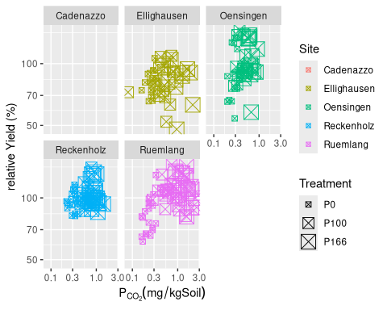

ggplot(D[D$soil_0_20_P_AAE10!=0,],aes(y=Ymain_rel, x=soil_0_20_P_AAE10, col=Site, size = Treatment)) +  
 geom_point(shape = 7) +   
 scale_x_log10() + scale_y_log10() +  
 labs(x=TeX("$P_{AAE10}(mg/kg Soil)$"),  
 y="relative Yield (%)") +  
 facet_wrap( ~ Site, nrow = 2)

Warning: Using size for a discrete variable is not advised.

Warning: Removed 259 rows containing missing values or values outside the scale range  
(`geom_point()`).

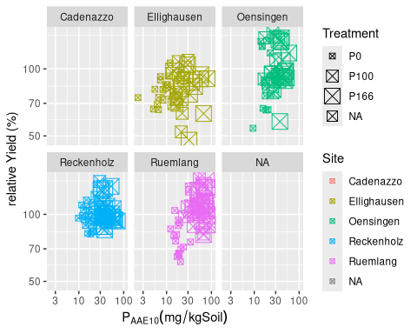

ggplot(D[D$soil_0_20_P_CO2!=0&D$annual_P_uptake!=0,],aes(y=annual_P_uptake, x=soil_0_20_P_CO2, col=Site, size = Treatment)) +  
 geom_point(shape = 7) +   
 scale_x_log10() + scale_y_log10() +  
 labs(x=TeX("$P_{CO_{2}}(mg/kg Soil)$"),  
 y=TeX("Annual P-Uptake $kg~P/ha$")) +  
 facet_wrap( ~ Site, nrow = 2)

Warning: Using size for a discrete variable is not advised.

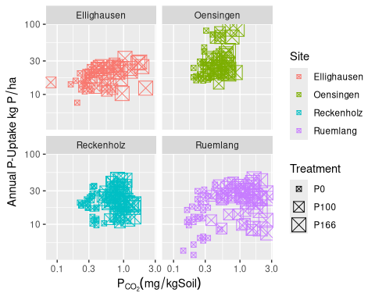

ggplot(D[D$soil_0_20_P_AAE10!=0&D$annual_P_uptake!=0,],aes(y=annual_P_uptake, x=soil_0_20_P_AAE10, col=Site, size = Treatment)) +  
 geom_point(shape = 7) +   
 scale_x_log10() + scale_y_log10() +  
 labs(x=TeX("$P_{AAE10}(mg/kg Soil)$"),  
 y=TeX("Annual P-Uptake $kg~P/ha$")) +  
 facet_wrap( ~ Site, nrow = 2)

Warning: Using size for a discrete variable is not advised.

Warning: Removed 50 rows containing missing values or values outside the scale range  
(`geom_point()`).

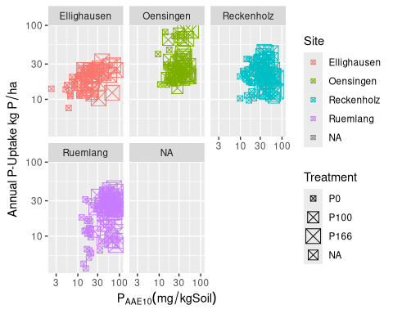

ggplot(D[D$soil_0_20_P_CO2!=0&D$annual_P_balance!=0,],aes(y=annual_P_balance, x=soil_0_20_P_CO2, col=Site, size = Treatment)) +  
 geom_point(shape = 7) +   
 scale_x_log10() + scale_y_log10() +  
 labs(x=TeX("$P_{CO_{2}}(mg/kg Soil)$"),  
 y=TeX("Annual P-Balance $kg~P/ha$")) +  
 facet_wrap( ~ Site, nrow = 2)

Warning: Using size for a discrete variable is not advised.

Warning in transformation$transform(x): NaNs produced

Warning in scale_y_log10(): log-10 transformation introduced infinite values.

Warning: Removed 131 rows containing missing values or values outside the scale range  
(`geom_point()`).

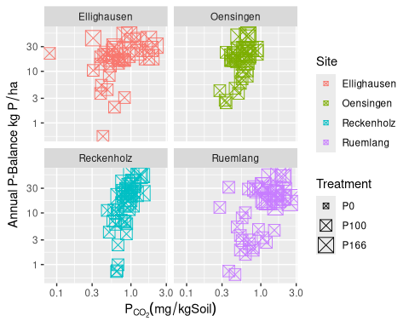

ggplot(D[D$soil_0_20_P_AAE10!=0&D$annual_P_balance!=0,],aes(y=annual_P_balance, x=soil_0_20_P_AAE10, col=Site, size = Treatment)) +  
 geom_point(shape = 7) +   
 scale_x_log10() + scale_y_log10() +  
 labs(x=TeX("$P_{AAE10}(mg/kg Soil)$"),  
 y=TeX("Annual P-Balance $kg~P/ha$")) +  
 facet_wrap( ~ Site, nrow = 2)

Warning: Using size for a discrete variable is not advised.

Warning in transformation$transform(x): NaNs produced

Warning in scale_y_log10(): log-10 transformation introduced infinite values.

Warning: Removed 187 rows containing missing values or values outside the scale range  
(`geom_point()`).

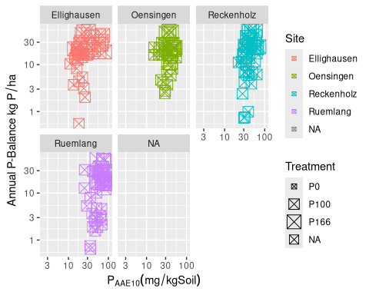

Now we want to check the strength of the models in terms of and the significance of the effects in terms of p-values:

#|code-fold: true  
#|tidy: true  
  
#tab_model(fit.grud.Yrel,fit.grud.Puptake,fit.grud.Pbalance)  
report(fit.grud.Yrel)

Loading required namespace: lmerTest

Formula contains log- or sqrt-terms.  
 See help("standardize") for how such terms are standardized.

boundary (singular) fit: see help('isSingular')

Formula contains log- or sqrt-terms.  
 See help("standardize") for how such terms are standardized.

boundary (singular) fit: see help('isSingular')

We fitted a linear mixed model (estimated using REML and nloptwrap optimizer)  
to predict Ymain_rel with soil_0_20_P_CO2, soil_0_20_P_AAE10 and Treatment  
(formula: Ymain_rel ~ log(soil_0_20_P_CO2) + log(soil_0_20_P_AAE10) +  
Treatment). The model included year as random effects (formula: list(~1 | year,  
~1 | Site, ~1 | Site:block, ~1 | Site:Treatment)). The model's total  
explanatory power is substantial (conditional R2 = 0.58) and the part related  
to the fixed effects alone (marginal R2) is of 0.10. The model's intercept,  
corresponding to soil_0_20_P_CO2 = 0, soil_0_20_P_AAE10 = 0 and Treatment = P0,  
is at 70.66 (95% CI [38.22, 103.10], t(202) = 4.30, p < .001). Within this  
model:  
  
 - The effect of soil 0 20 P CO2 [log] is statistically non-significant and  
positive (beta = 1.16, 95% CI [-6.67, 8.98], t(202) = 0.29, p = 0.771; Std.  
beta = -0.28, 95% CI [-0.97, 0.42])  
 - The effect of soil 0 20 P AAE10 [log] is statistically non-significant and  
positive (beta = 8.10, 95% CI [-0.14, 16.33], t(202) = 1.94, p = 0.054; Std.  
beta = 0.93, 95% CI [0.17, 1.68])  
 - The effect of Treatment [P100] is statistically non-significant and positive  
(beta = 4.06, 95% CI [-5.90, 14.02], t(202) = 0.80, p = 0.422; Std. beta =  
0.29, 95% CI [-0.18, 0.76])  
 - The effect of Treatment [P166] is statistically non-significant and positive  
(beta = 1.60, 95% CI [-10.64, 13.84], t(202) = 0.26, p = 0.797; Std. beta =  
0.20, 95% CI [-0.39, 0.80])  
  
Standardized parameters were obtained by fitting the model on a standardized  
version of the dataset. 95% Confidence Intervals (CIs) and p-values were  
computed using a Wald t-distribution approximation.

report(fit.grud.Puptake)

Formula contains log- or sqrt-terms.  
 See help("standardize") for how such terms are standardized.  
boundary (singular) fit: see help('isSingular')

Random effect variances not available. Returned R2 does not account for random effects.

Formula contains log- or sqrt-terms.  
 See help("standardize") for how such terms are standardized.  
boundary (singular) fit: see help('isSingular')

Random effect variances not available. Returned R2 does not account for random effects.

We fitted a linear mixed model (estimated using REML and nloptwrap optimizer)  
to predict annual_P_uptake with soil_0_20_P_CO2, soil_0_20_P_AAE10 and  
Treatment (formula: annual_P_uptake ~ log(soil_0_20_P_CO2) +  
log(soil_0_20_P_AAE10) + Treatment). The model included year as random effects  
(formula: list(~1 | year, ~1 | Site, ~1 | Site:block, ~1 | Site:Treatment)).  
The model's explanatory power related to the fixed effects alone (marginal R2)  
is 0.05. The model's intercept, corresponding to soil_0_20_P_CO2 = 0,  
soil_0_20_P_AAE10 = 0 and Treatment = P0, is at 14.25 (95% CI [-3.31, 31.81],  
t(402) = 1.59, p = 0.112). Within this model:  
  
 - The effect of soil 0 20 P CO2 [log] is statistically non-significant and  
positive (beta = 2.08, 95% CI [-1.75, 5.92], t(402) = 1.07, p = 0.286; Std.  
beta = 0.15, 95% CI [-0.29, 0.60])  
 - The effect of soil 0 20 P AAE10 [log] is statistically non-significant and  
positive (beta = 0.82, 95% CI [-3.27, 4.91], t(402) = 0.40, p = 0.693; Std.  
beta = 0.16, 95% CI [-0.35, 0.66])  
 - The effect of Treatment [P100] is statistically non-significant and positive  
(beta = 1.52, 95% CI [-2.04, 5.09], t(402) = 0.84, p = 0.401; Std. beta = 0.12,  
95% CI [-0.10, 0.35])  
 - The effect of Treatment [P166] is statistically non-significant and positive  
(beta = 1.18, 95% CI [-3.83, 6.19], t(402) = 0.46, p = 0.643; Std. beta = 0.10,  
95% CI [-0.22, 0.42])  
  
Standardized parameters were obtained by fitting the model on a standardized  
version of the dataset. 95% Confidence Intervals (CIs) and p-values were  
computed using a Wald t-distribution approximation.

report(fit.grud.Pbalance)

Formula contains log- or sqrt-terms.  
 See help("standardize") for how such terms are standardized.  
boundary (singular) fit: see help('isSingular')

Random effect variances not available. Returned R2 does not account for random effects.

Formula contains log- or sqrt-terms.  
 See help("standardize") for how such terms are standardized.  
boundary (singular) fit: see help('isSingular')

Random effect variances not available. Returned R2 does not account for random effects.

We fitted a linear mixed model (estimated using REML and nloptwrap optimizer)  
to predict annual_P_balance with soil_0_20_P_CO2, soil_0_20_P_AAE10 and  
Treatment (formula: annual_P_balance ~ log(soil_0_20_P_CO2) +  
log(soil_0_20_P_AAE10) + Treatment). The model included year as random effects  
(formula: list(~1 | year, ~1 | Site, ~1 | Site:block, ~1 | Site:Treatment)).  
The model's explanatory power related to the fixed effects alone (marginal R2)  
is 0.51. The model's intercept, corresponding to soil_0_20_P_CO2 = 0,  
soil_0_20_P_AAE10 = 0 and Treatment = P0, is at -16.64 (95% CI [-35.71, 2.43],  
t(402) = -1.72, p = 0.087). Within this model:  
  
 - The effect of soil 0 20 P CO2 [log] is statistically significant and negative  
(beta = -5.00, 95% CI [-9.65, -0.35], t(402) = -2.12, p = 0.035; Std. beta =  
-0.05, 95% CI [-0.48, 0.37])  
 - The effect of soil 0 20 P AAE10 [log] is statistically non-significant and  
negative (beta = -1.12, 95% CI [-6.04, 3.80], t(402) = -0.45, p = 0.655; Std.  
beta = -0.43, 95% CI [-0.90, 0.03])  
 - The effect of Treatment [P100] is statistically significant and positive  
(beta = 22.38, 95% CI [18.03, 26.72], t(402) = 10.13, p < .001; Std. beta =  
1.12, 95% CI [0.91, 1.33])  
 - The effect of Treatment [P166] is statistically significant and positive  
(beta = 38.89, 95% CI [32.78, 44.99], t(402) = 12.52, p < .001; Std. beta =  
1.95, 95% CI [1.65, 2.26])  
  
Standardized parameters were obtained by fitting the model on a standardized  
version of the dataset. 95% Confidence Intervals (CIs) and p-values were  
computed using a Wald t-distribution approximation.

(**Frank?**), here I also show the non linear mixed models, following the Mitscherlich saturation curve:

library(nlme)  
  
# Make sure grouping variables are factors  
D$year <- as.factor(D$year)  
D$Site <- as.factor(D$Site)  
D$block <- as.factor(D$block)  
D$crop <- as.factor(D$crop)  
# Fit the model  
fit.mitscherlich.CO2.Yrel <- nlme(  
 Ymain_rel ~ A * (1 - exp(-k * soil_0_20_P_CO2 + E)),   
 fixed = A + k + E ~ soil_0_20_clay + soil_0_20_pH_H2O + ansum_sun + ansum_prec,  
 random = A ~ 1 | year/Site/block,  
 data = D,  
 start = c(  
 A = 220, A1 = 0, A2 = 0, A3 = 0, A4 = 0,  
 k = 0.05, k1 = 0, k2 = 0, k3 = 0, k4 = 0,  
 E = -3, E1 = 0, E2 = 0, E3 = 0, E4 = 0  
 ),  
 control = nlmeControl(maxIter = 500),  
 na.action = na.omit  
)  
  
summary(fit.mitscherlich.CO2.Yrel)

Nonlinear mixed-effects model fit by maximum likelihood  
 Model: Ymain_rel ~ A * (1 - exp(-k * soil_0_20_P_CO2 + E))   
 Data: D   
 AIC BIC logLik  
 744.5163 792.8389 -353.2581  
  
Random effects:  
 Formula: A ~ 1 | year  
 A.(Intercept)  
StdDev: 0.001170608  
  
 Formula: A ~ 1 | Site %in% year  
 A.(Intercept)  
StdDev: 1.560869  
  
 Formula: A ~ 1 | block %in% Site %in% year  
 A.(Intercept) Residual  
StdDev: 4.988193e-05 10.27543  
  
Fixed effects: A + k + E ~ soil_0_20_clay + soil_0_20_pH_H2O + ansum_sun + ansum_prec   
 Value Std.Error DF t-value p-value  
A.(Intercept) 193.7899 63.1614 48 3.0681695 0.0035  
A.soil_0_20_clay -0.0020 0.3174 48 -0.0062559 0.9950  
A.soil_0_20_pH_H2O 2.1577 3.3046 48 0.6529475 0.5169  
A.ansum_sun -0.0321 0.0178 48 -1.7992514 0.0783  
A.ansum_prec -0.0582 0.0193 48 -3.0115355 0.0041  
k.(Intercept) 1052.4990 607.1499 48 1.7335077 0.0894  
k.soil_0_20_clay 0.1588 0.1220 48 1.3012499 0.1994  
k.soil_0_20_pH_H2O -49.3388 28.7546 48 -1.7158575 0.0926  
k.ansum_sun -0.2481 0.1432 48 -1.7328670 0.0895  
k.ansum_prec -0.2283 0.1294 48 -1.7646583 0.0840  
E.(Intercept) 267.9738 165.2244 48 1.6218779 0.1114  
E.soil_0_20_clay 0.2363 0.1424 48 1.6594850 0.1035  
E.soil_0_20_pH_H2O -8.7078 5.6370 48 -1.5447609 0.1290  
E.ansum_sun -0.0690 0.0422 48 -1.6349736 0.1086  
E.ansum_prec -0.0863 0.0509 48 -1.6957763 0.0964  
 Correlation:   
 A.(In) A.s_0_20_ A._0_20_H A.nsm_s A.nsm_p k.(In) k.s_0_20_  
A.soil_0_20_clay -0.526   
A.soil_0_20_pH_H2O -0.768 0.646   
A.ansum_sun -0.911 0.297 0.539   
A.ansum_prec -0.566 -0.105 0.077 0.518   
k.(Intercept) 0.250 -0.143 -0.354 -0.165 -0.070   
k.soil_0_20_clay 0.178 -0.103 -0.273 -0.109 -0.039 0.641   
k.soil_0_20_pH_H2O -0.250 0.146 0.356 0.163 0.068 -1.000 -0.645   
k.ansum_sun -0.249 0.141 0.351 0.165 0.071 -1.000 -0.629   
k.ansum_prec -0.252 0.142 0.356 0.165 0.073 -0.998 -0.671   
E.(Intercept) 0.260 -0.151 -0.360 -0.173 -0.076 0.998 0.630   
E.soil_0_20_clay 0.193 -0.061 -0.287 -0.126 -0.073 0.944 0.796   
E.soil_0_20_pH_H2O -0.262 0.164 0.375 0.169 0.065 -0.996 -0.629   
E.ansum_sun -0.258 0.146 0.353 0.176 0.077 -0.997 -0.617   
E.ansum_prec -0.255 0.141 0.352 0.168 0.084 -0.996 -0.665   
 k._0_20_H k.nsm_s k.nsm_p E.(In) E.s_0_20_ E._0_20_H E.nsm_s  
A.soil_0_20_clay   
A.soil_0_20_pH_H2O   
A.ansum_sun   
A.ansum_prec   
k.(Intercept)   
k.soil_0_20_clay   
k.soil_0_20_pH_H2O   
k.ansum_sun 0.999   
k.ansum_prec 0.998 0.996   
E.(Intercept) -0.997 -0.998 -0.997   
E.soil_0_20_clay -0.943 -0.941 -0.955 0.940   
E.soil_0_20_pH_H2O 0.996 0.995 0.993 -0.997 -0.930   
E.ansum_sun 0.996 0.998 0.994 -0.999 -0.937 0.995   
E.ansum_prec 0.995 0.995 0.998 -0.997 -0.957 0.992 0.995   
  
Standardized Within-Group Residuals:  
 Min Q1 Med Q3 Max   
-3.52454696 -0.29064469 0.01534025 0.42451197 4.41233128   
  
Number of Observations: 94  
Number of Groups:   
 year Site %in% year block %in% Site %in% year   
 2 8 32

anova(fit.mitscherlich.CO2.Yrel)

numDF denDF F-value p-value  
A.(Intercept) 1 48 5602.523 <.0001  
A.soil_0_20_clay 1 48 24.781 <.0001  
A.soil_0_20_pH_H2O 1 48 16.273 0.0002  
A.ansum_sun 1 48 3.585 0.0644  
A.ansum_prec 1 48 3.689 0.0607  
k.(Intercept) 1 48 41.991 <.0001  
k.soil_0_20_clay 1 48 7.496 0.0086  
k.soil_0_20_pH_H2O 1 48 0.758 0.3883  
k.ansum_sun 1 48 0.424 0.5182  
k.ansum_prec 1 48 16.020 0.0002  
E.(Intercept) 1 48 25.335 <.0001  
E.soil_0_20_clay 1 48 0.152 0.6987  
E.soil_0_20_pH_H2O 1 48 0.931 0.3396  
E.ansum_sun 1 48 0.253 0.6170  
E.ansum_prec 1 48 2.876 0.0964

model_performance(fit.mitscherlich.CO2.Yrel)

# Indices of model performance  
  
AIC | AICc | BIC | RMSE | Sigma  
---------------------------------------------  
796.042 | 806.312 | 844.365 | 10.189 | 10.275

r.square <- 1-sum(residuals(fit.mitscherlich.CO2.Yrel)^2)/sum((D$Ymain_rel-mean(D$Ymain_rel,na.rm=TRUE))^2,na.rm = TRUE)

With the covariate and random effect used as by Juliane Hirte we obtain 0.9749806, I don’t know how to interpret that, I fear that the model is overfitting data.

### How do GRUD-measurements of relate to the soil properties -content, clay-content, silt-content and pH?

* Hypothesis II:

# Method

print(19)

[1] 19

plot(1:10,1:10)

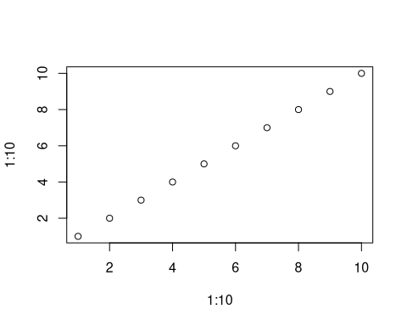

# Results

# Discussion

# Conclusion

# Acknowledgments

# Legal Disclosure

# References

Knuth, Donald E. 1984. “Literate Programming.” *Comput. J.* 27 (2): 97–111. <https://doi.org/10.1093/comjnl/27.2.97>.

# Appendix

# Supplements