Kinetic Model Coefficient Analysis

Marc Pérez

2025-05-22

Model Agroscope

$$Y_{rel}∼A*\left(1−e^{rate*P_{CO_{2}}+Env}\right)$$

Wir ersetzen nur rate mit unserer Schätzung k:

$$Y_{rel}∼A*\left(1−e^{k*P_{CO_{2}}+Env}\right)$$

Sind unsere Modelparameter gute Prediktoren??

$$Y_{rel}∼A*\left(1−e^{k*PS+Env}\right)$$

Es gibt noch die Kovariaten Niederschlag pro Jahr, Jahresdurchschnittstemperatur und Temperatur in Jugendphase

#|code-fold: true  
#|tidy: true  
  
  
  
  
  
  
library(GGally)

Registered S3 method overwritten by 'GGally':  
 method from   
 +.gg ggplot2

ggpairs(D,   
 aes(col=Site, shape = Treatment,alpha = 0.6),   
 columns = c("soil_0_20_P_AAE10", "soil_0_20_P_CO2", "PS", "k", "kPS"),  
 lower = list(continuous = wrap("points", size = 1.3)),  
 upper = list(continuous = "blank", combo = "blank", discrete = "blank")) # Adjust size here

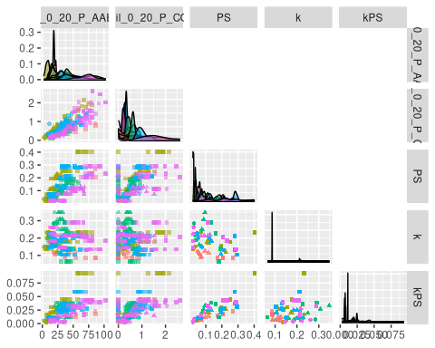

p6 <- ggplot(D,aes(y=soil_0_20_P_AAE10, x=soil_0_20_P_CO2, col=Site, size = Treatment)) +  
 geom_point(shape = 7) +   
 scale_x_log10() + scale_y_log10() +  
 labs(x=TeX("$P_{H_2O10}(mg/kg Soil)$"),  
 y=TeX("$P_{AAEDTA}(mg/kg Soil)$")); p6

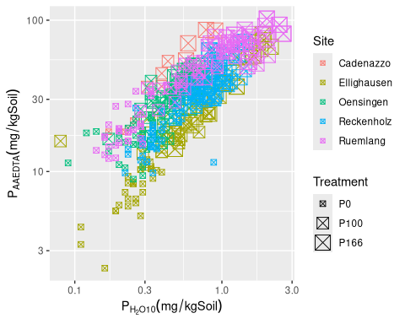

p7 <- ggplot(D,aes(y=PS, x=soil_0_20_P_CO2, col=Site, size = Treatment)) +  
 geom_point(shape = 7) +  
 scale_x_log10() + scale_y_log10() +  
 labs(x=TeX("$P_{CO_2}(mg/kg Soil)$"),  
 y=TeX("$PS(mg/kg Soil)$")); p7

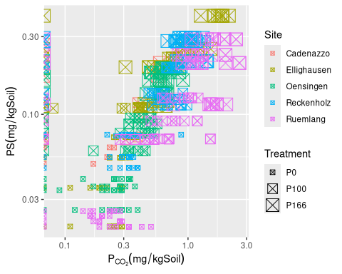

p8 <- ggplot(D,aes(y=k, x=soil_0_20_P_CO2, col=Site, size = Treatment)) +  
 geom_point(shape = 7) +  
 scale_x_log10() +  
 labs(x=TeX("$P_{CO_2}(mg/kg Soil)$"),  
 y=TeX("$k(1/s)$")); p8

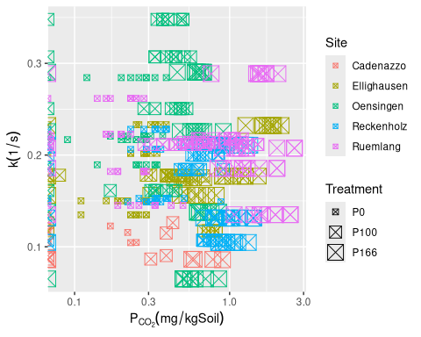

p9 <- ggplot(D,aes(y=k*PS, x=soil_0_20_P_CO2, col=Site, size = Treatment)) +  
 geom_point(shape = 7) +  
 scale_x_log10() + scale_y_log10() +  
 labs(x=TeX("$P_{CO_2}(mg/kg Soil)$"),  
 y=TeX("$v=k*PS(mg/s*kg Soil)$"));p9

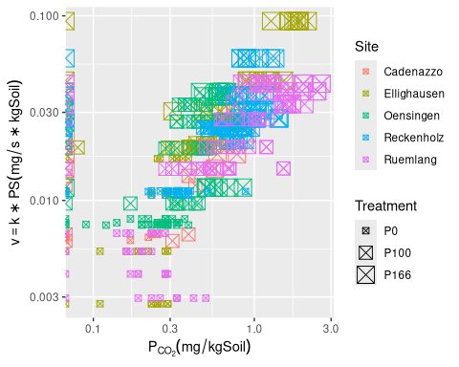

p11 <- ggplot(D,aes(y=PS, x=soil_0_20_P_AAE10, col=Site, size = Treatment)) +  
 scale_x_log10() + scale_y_log10() +  
 geom_point(shape = 7) +  
 labs(x=TeX("$P_{AAEDTA}(mg/kg Soil)$"),  
 y=TeX("$PS(mg/kg Soil)$")); p11

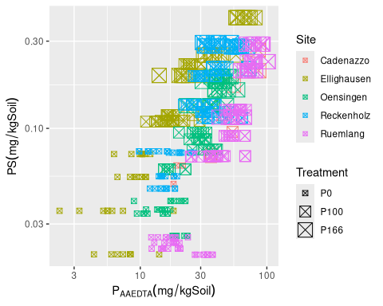

p12 <- ggplot(D,aes(y=k, x=soil_0_20_P_AAE10, col=Site, size = Treatment)) +  
 geom_point(shape = 7) +  
 scale_x_log10() + scale_y_log10() +  
 labs(x=TeX("$P_{AAEDTA}(mg/kg Soil)$"),  
 y=TeX("$k(1/s)$"))  
  
p12

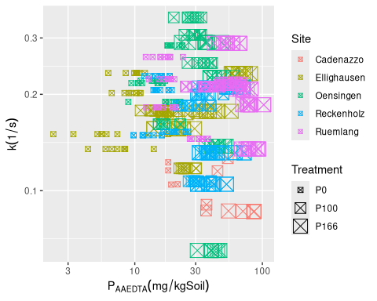

p13 <- ggplot(D,aes(y=k*PS, x=soil_0_20_P_AAE10, col=Site, size = Treatment)) +  
 scale_x_log10() + scale_y_log10() +  
 geom_point(shape = 7) +  
 labs(x=TeX("$P_{AAEDTA}(mg/kg Soil)$"),  
 y=TeX("$log(v)=log(k*PS)(mg/s*kg Soil)$"))  
  
p13

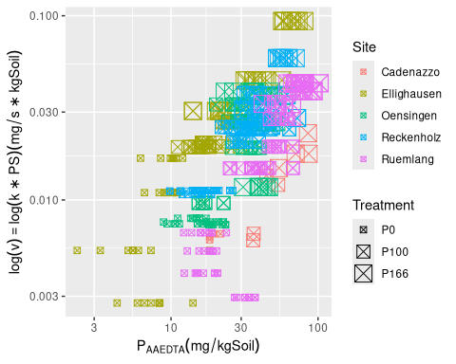

Nun noch die Linearen Regressionen, die ausstehend sind:

(1|year) + (1|Site) + (1|Site:block) + (Treatment|Site)

Random intercept per year and site, block nested in site. and Treatment nested in site (could also be modelled as a random slope to allow for correlations)

#|code-fold: true  
#|tidy: true  
  
  
# Wovon hängen Modelparameter ab?  
  
library(lmerTest)

Attaching package: 'lmerTest'

The following object is masked from 'package:lme4':  
  
 lmer

The following object is masked from 'package:stats':  
  
 step

fit.soil.PS <- lmer(log(PS) ~ soil_0_20_clay+ soil_0_20_pH_H2O + soil_0_20_Corg + soil_0_20_silt + Treatment + (1|year) + (1|Site) + (1|Site:block) + (1|Site:Treatment), D)

boundary (singular) fit: see help('isSingular')

fit.soil.k <- lmer(k ~ soil_0_20_clay+ soil_0_20_pH_H2O + soil_0_20_Corg + soil_0_20_silt + Treatment + (1|year) + (1|Site) + (1|Site:block) + (1|Site:Treatment), D)

boundary (singular) fit: see help('isSingular')

fit.soil.kPS <- lmer(I(log(k*PS))~ soil_0_20_clay+ soil_0_20_pH_H2O + soil_0_20_Corg + soil_0_20_silt + Treatment + (1|year) + (1|Site) + (1|Site:block) + (1|Site:Treatment), D)

boundary (singular) fit: see help('isSingular')

fit.soil.CO2 <- lmer(log(soil_0_20_P_CO2)~ soil_0_20_clay+ soil_0_20_pH_H2O + soil_0_20_Corg + soil_0_20_silt + Treatment + (1|year) + (1|Site) + (1|Site:block) + (1|Site:Treatment), D)

boundary (singular) fit: see help('isSingular')

fit.soil.AAE10 <- lmer(log(soil_0_20_P_AAE10)~ soil_0_20_clay+ soil_0_20_pH_H2O + soil_0_20_Corg + soil_0_20_silt + Treatment + (1|year) + (1|Site) + (1|Site:block) + (1|Site:Treatment), D)  
  
  
fit.kin.Yrel <- lmer(Ymain_rel ~ k * log(PS) + Treatment + (1|year) + (1|Site) + (1|Site:block) + (1|Site:Treatment), D)

boundary (singular) fit: see help('isSingular')

fit.kin.Puptake <- lmer(annual_P_uptake ~ k * log(PS) + Treatment + (1|year) + (1|Site) + (1|Site:block) + (1|Site:Treatment), D)

boundary (singular) fit: see help('isSingular')

fit.kin.Pbalance <- lmer(annual_P_balance ~ k * log(PS) + Treatment + (1|year) + (1|Site) + (1|Site:block) + (1|Site:Treatment), D)

boundary (singular) fit: see help('isSingular')

anova(fit.soil.PS)

Type III Analysis of Variance Table with Satterthwaite's method  
 Sum Sq Mean Sq NumDF DenDF F value Pr(>F)   
soil_0_20_clay 0.0719 0.0719 1 70.835 2.3900 0.1265690   
soil_0_20_pH_H2O 0.0152 0.0152 1 89.035 0.5061 0.4787086   
soil_0_20_Corg 0.4704 0.4704 1 65.081 15.6423 0.0001915 ***  
soil_0_20_silt 0.1061 0.1061 1 70.745 3.5286 0.0644392 .   
Treatment 10.0459 5.0230 2 6.055 167.0386 5.047e-06 ***  
---  
Signif. codes: 0 '***' 0.001 '**' 0.01 '*' 0.05 '.' 0.1 ' ' 1

#summary(glht(fit.PS))  
# Fazit: PS wird von treatment stark beeinfluss, k eher nicht (dafür von site)  
anova(fit.soil.k)

Type III Analysis of Variance Table with Satterthwaite's method  
 Sum Sq Mean Sq NumDF DenDF F value Pr(>F)   
soil_0_20_clay 0.0098143 0.0098143 1 69.314 10.0428 0.002277 **  
soil_0_20_pH_H2O 0.0091422 0.0091422 1 102.384 9.3551 0.002838 **  
soil_0_20_Corg 0.0014112 0.0014112 1 98.359 1.4440 0.232372   
soil_0_20_silt 0.0046704 0.0046704 1 75.910 4.7792 0.031888 *   
Treatment 0.0059043 0.0029521 2 5.405 3.0209 0.131613   
---  
Signif. codes: 0 '***' 0.001 '**' 0.01 '*' 0.05 '.' 0.1 ' ' 1

summary(glht(fit.soil.k))

Simultaneous Tests for General Linear Hypotheses  
  
Fit: lmer(formula = k ~ soil_0_20_clay + soil_0_20_pH_H2O + soil_0_20_Corg +   
 soil_0_20_silt + Treatment + (1 | year) + (1 | Site) + (1 |   
 Site:block) + (1 | Site:Treatment), data = D)  
  
Linear Hypotheses:  
 Estimate Std. Error z value Pr(>|z|)   
(Intercept) == 0 0.074168 0.150771 0.492 0.9965   
soil_0_20_clay == 0 -0.007001 0.002209 -3.169 0.0103 *  
soil_0_20_pH_H2O == 0 0.033720 0.011024 3.059 0.0149 *  
soil_0_20_Corg == 0 -0.034533 0.028737 -1.202 0.7770   
soil_0_20_silt == 0 0.005864 0.002683 2.186 0.1650   
TreatmentP100 == 0 0.003910 0.015506 0.252 0.9999   
TreatmentP166 == 0 -0.031147 0.015685 -1.986 0.2541   
---  
Signif. codes: 0 '***' 0.001 '**' 0.01 '*' 0.05 '.' 0.1 ' ' 1  
(Adjusted p values reported -- single-step method)

anova(fit.soil.kPS)

Type III Analysis of Variance Table with Satterthwaite's method  
 Sum Sq Mean Sq NumDF DenDF F value Pr(>F)   
soil_0_20_clay 0.0055 0.00551 1 77.626 0.1043 0.747639   
soil_0_20_pH_H2O 0.3773 0.37731 1 101.942 7.1335 0.008807 **   
soil_0_20_Corg 0.0105 0.01052 1 93.639 0.1990 0.656575   
soil_0_20_silt 0.0036 0.00360 1 80.228 0.0681 0.794743   
Treatment 4.0339 2.01697 2 5.847 38.1329 0.000442 ***  
---  
Signif. codes: 0 '***' 0.001 '**' 0.01 '*' 0.05 '.' 0.1 ' ' 1

summary(glht(fit.soil.kPS))

Simultaneous Tests for General Linear Hypotheses  
  
Fit: lmer(formula = I(log(k * PS)) ~ soil_0_20_clay + soil_0_20_pH_H2O +   
 soil_0_20_Corg + soil_0_20_silt + Treatment + (1 | year) +   
 (1 | Site) + (1 | Site:block) + (1 | Site:Treatment), data = D)  
  
Linear Hypotheses:  
 Estimate Std. Error z value Pr(>|z|)   
(Intercept) == 0 -6.657570 1.107392 -6.012 <0.001 ***  
soil_0_20_clay == 0 -0.005316 0.016463 -0.323 0.9997   
soil_0_20_pH_H2O == 0 0.216354 0.081005 2.671 0.0471 *   
soil_0_20_Corg == 0 0.094691 0.212278 0.446 0.9980   
soil_0_20_silt == 0 0.005221 0.020000 0.261 0.9999   
TreatmentP100 == 0 1.064948 0.189188 5.629 <0.001 ***  
TreatmentP166 == 0 1.634290 0.190050 8.599 <0.001 ***  
---  
Signif. codes: 0 '***' 0.001 '**' 0.01 '*' 0.05 '.' 0.1 ' ' 1  
(Adjusted p values reported -- single-step method)

anova(fit.kin.Yrel)

Type III Analysis of Variance Table with Satterthwaite's method  
 Sum Sq Mean Sq NumDF DenDF F value Pr(>F)  
k 146.11 146.11 1 151.805 0.4824 0.4884  
log(PS) 44.91 44.91 1 226.958 0.1483 0.7005  
Treatment 740.92 370.46 2 4.838 1.2232 0.3716  
k:log(PS) 324.35 324.35 1 172.913 1.0710 0.3022

anova(fit.kin.Puptake)

Type III Analysis of Variance Table with Satterthwaite's method  
 Sum Sq Mean Sq NumDF DenDF F value Pr(>F)  
k 41.986 41.986 1 456.19 0.3035 0.5819  
log(PS) 6.315 6.315 1 457.82 0.0457 0.8309  
Treatment 129.470 64.735 2 443.37 0.4680 0.6266  
k:log(PS) 39.416 39.416 1 457.86 0.2850 0.5937

anova(fit.soil.CO2)

Type III Analysis of Variance Table with Satterthwaite's method  
 Sum Sq Mean Sq NumDF DenDF F value Pr(>F)   
soil_0_20_clay 0.0118 0.01181 1 48.798 0.1428 0.7071250   
soil_0_20_pH_H2O 0.0686 0.06858 1 65.341 0.8297 0.3657041   
soil_0_20_Corg 0.2993 0.29934 1 37.017 3.6216 0.0648334 .   
soil_0_20_silt 0.0665 0.06645 1 22.514 0.8040 0.3793909   
Treatment 4.8977 2.44886 2 5.827 29.6281 0.0008839 ***  
---  
Signif. codes: 0 '***' 0.001 '**' 0.01 '*' 0.05 '.' 0.1 ' ' 1

anova(fit.soil.AAE10)

Type III Analysis of Variance Table with Satterthwaite's method  
 Sum Sq Mean Sq NumDF DenDF F value Pr(>F)   
soil_0_20_clay 0.0491 0.0491 1 58.650 1.1361 0.2908517   
soil_0_20_pH_H2O 0.2473 0.2473 1 75.287 5.7214 0.0192552 *   
soil_0_20_Corg 0.2830 0.2830 1 45.764 6.5490 0.0138669 *   
soil_0_20_silt 0.0572 0.0572 1 87.560 1.3231 0.2531704   
Treatment 7.5352 3.7676 2 4.841 87.1720 0.0001598 ***  
---  
Signif. codes: 0 '***' 0.001 '**' 0.01 '*' 0.05 '.' 0.1 ' ' 1

anova(fit.kin.Pbalance)

Type III Analysis of Variance Table with Satterthwaite's method  
 Sum Sq Mean Sq NumDF DenDF F value Pr(>F)   
k 20.3 20.3 1 457.51 0.0960 0.7568   
log(PS) 12.9 12.9 1 455.60 0.0613 0.8046   
Treatment 15488.3 7744.1 2 379.27 36.7144 2.658e-15 ***  
k:log(PS) 10.1 10.1 1 455.83 0.0477 0.8272   
---  
Signif. codes: 0 '***' 0.001 '**' 0.01 '*' 0.05 '.' 0.1 ' ' 1

summary(fit.kin.Pbalance)

Linear mixed model fit by REML. t-tests use Satterthwaite's method [  
lmerModLmerTest]  
Formula: annual_P_balance ~ k * log(PS) + Treatment + (1 | year) + (1 |   
 Site) + (1 | Site:block) + (1 | Site:Treatment)  
 Data: D  
  
REML criterion at convergence: 3854.5  
  
Scaled residuals:   
 Min 1Q Median 3Q Max   
-3.8654 -0.5354 -0.0249 0.5914 3.3879   
  
Random effects:  
 Groups Name Variance Std.Dev.  
 Site:block (Intercept) 0.00 0.000   
 Site:Treatment (Intercept) 0.00 0.000   
 year (Intercept) 51.80 7.197   
 Site (Intercept) 21.44 4.631   
 Residual 210.93 14.523   
Number of obs: 471, groups:   
Site:block, 20; Site:Treatment, 15; year, 8; Site, 5  
  
Fixed effects:  
 Estimate Std. Error df t value Pr(>|t|)   
(Intercept) -16.980 10.354 231.810 -1.640 0.102   
k -12.679 40.918 457.507 -0.310 0.757   
log(PS) -0.916 3.701 455.596 -0.248 0.805   
TreatmentP100 21.950 2.907 382.869 7.552 3.18e-13 ***  
TreatmentP166 37.991 4.435 317.155 8.566 4.74e-16 ***  
k:log(PS) -3.788 17.345 455.832 -0.218 0.827   
---  
Signif. codes: 0 '***' 0.001 '**' 0.01 '*' 0.05 '.' 0.1 ' ' 1  
  
Correlation of Fixed Effects:  
 (Intr) k lg(PS) TrP100 TrP166  
k -0.590   
log(PS) 0.888 -0.713   
TretmntP100 -0.542 -0.165 -0.407   
TretmntP166 -0.627 -0.126 -0.481 0.868   
k:log(PS) -0.565 0.944 -0.776 -0.140 -0.126  
optimizer (nloptwrap) convergence code: 0 (OK)  
boundary (singular) fit: see help('isSingular')

fit.kin.Pbalance |> r.squaredGLMM()

R2m R2c  
[1,] 0.4228263 0.5715903

fit.kin.Puptake |> r.squaredGLMM()

R2m R2c  
[1,] 0.01723874 0.6121275

fit.kin.Yrel |> r.squaredGLMM()

R2m R2c  
[1,] 0.03304352 0.8042098

# Verhalten der Modelparameter und Ertragsdaten auf P-CO2 und P-AAE10

Since we now model two measurement methods, we do not expect correlations by Site/year/etc

#|code-fold: true  
#|tidy: true  
# fit.PS <- lm(PS ~ soil_0_20_P_CO2 + soil_0_20_P_AAE10, D)  
fit.grud.PS <- lm(log(PS) ~ log(soil_0_20_P_CO2) + log(soil_0_20_P_AAE10), D)  
fit.grud.k <- lm(k ~ log(soil_0_20_P_CO2) + log(soil_0_20_P_AAE10), D)  
fit.grud.kPS <- lm(I(log(k*PS)) ~ log(soil_0_20_P_CO2) + log(soil_0_20_P_AAE10), D)  
  
fit.grud.Yrel <- lmer(Ymain_rel ~ log(soil_0_20_P_CO2) + log(soil_0_20_P_AAE10) + Treatment + (1|year) + (1|Site) + (1|Site:block) + (1|Site:Treatment), D)  
  
# this is hopeless, since cannot log becaus of 0's  
fit.grud.Puptake <- lmer(annual_P_uptake ~ log(soil_0_20_P_CO2) + log(soil_0_20_P_AAE10) + Treatment + (1|year) + (1|Site) + (1|Site:block) + (1|Site:Treatment), D)

boundary (singular) fit: see help('isSingular')

fit.grud.Pbalance <- lmer(annual_P_balance ~ log(soil_0_20_P_CO2) + log(soil_0_20_P_AAE10) + Treatment + (1|year) + (1|Site) + (1|Site:block) + (1|Site:Treatment), D)

boundary (singular) fit: see help('isSingular')

#summary(glht(fit.PS))  
# Fazit: PS wird von treatment stark beeinfluss, k eher nicht (dafür von site)  
summary(glht(fit.grud.PS))

Simultaneous Tests for General Linear Hypotheses  
  
Fit: lm(formula = log(PS) ~ log(soil_0_20_P_CO2) + log(soil_0_20_P_AAE10),   
 data = D)  
  
Linear Hypotheses:  
 Estimate Std. Error t value Pr(>|t|)   
(Intercept) == 0 -1.59063 0.23863 -6.666 <1e-04 ***  
log(soil_0_20_P_CO2) == 0 1.02613 0.06084 16.866 <1e-04 ***  
log(soil_0_20_P_AAE10) == 0 -0.02995 0.06127 -0.489 0.793   
---  
Signif. codes: 0 '***' 0.001 '**' 0.01 '*' 0.05 '.' 0.1 ' ' 1  
(Adjusted p values reported -- single-step method)

summary(glht(fit.grud.k))

Simultaneous Tests for General Linear Hypotheses  
  
Fit: lm(formula = k ~ log(soil_0_20_P_CO2) + log(soil_0_20_P_AAE10),   
 data = D)  
  
Linear Hypotheses:  
 Estimate Std. Error t value Pr(>|t|)   
(Intercept) == 0 0.103889 0.028977 3.585 < 0.001 ***  
log(soil_0_20_P_CO2) == 0 -0.026427 0.007388 -3.577 < 0.001 ***  
log(soil_0_20_P_AAE10) == 0 0.021027 0.007440 2.826 0.00859 **   
---  
Signif. codes: 0 '***' 0.001 '**' 0.01 '*' 0.05 '.' 0.1 ' ' 1  
(Adjusted p values reported -- single-step method)

summary(glht(fit.grud.kPS))

Simultaneous Tests for General Linear Hypotheses  
  
Fit: lm(formula = I(log(k * PS)) ~ log(soil_0_20_P_CO2) + log(soil_0_20_P_AAE10),   
 data = D)  
  
Linear Hypotheses:  
 Estimate Std. Error t value Pr(>|t|)   
(Intercept) == 0 -3.63331 0.24159 -15.039 <0.001 ***  
log(soil_0_20_P_CO2) == 0 0.90485 0.06160 14.690 <0.001 ***  
log(soil_0_20_P_AAE10) == 0 0.04814 0.06203 0.776 0.586   
---  
Signif. codes: 0 '***' 0.001 '**' 0.01 '*' 0.05 '.' 0.1 ' ' 1  
(Adjusted p values reported -- single-step method)

summary(fit.grud.Yrel)

Linear mixed model fit by REML. t-tests use Satterthwaite's method [  
lmerModLmerTest]  
Formula:   
Ymain_rel ~ log(soil_0_20_P_CO2) + log(soil_0_20_P_AAE10) + Treatment +   
 (1 | year) + (1 | Site) + (1 | Site:block) + (1 | Site:Treatment)  
 Data: D  
  
REML criterion at convergence: 1726.8  
  
Scaled residuals:   
 Min 1Q Median 3Q Max   
-2.98805 -0.62531 -0.03449 0.57660 3.15994   
  
Random effects:  
 Groups Name Variance Std.Dev.  
 Site:block (Intercept) 1.815 1.347   
 Site:Treatment (Intercept) 26.585 5.156   
 year (Intercept) 175.180 13.236   
 Site (Intercept) 22.431 4.736   
 Residual 194.780 13.956   
Number of obs: 212, groups:   
Site:block, 16; Site:Treatment, 12; year, 5; Site, 4  
  
Fixed effects:  
 Estimate Std. Error df t value Pr(>|t|)   
(Intercept) 70.659 16.451 69.722 4.295 5.54e-05 ***  
log(soil_0_20_P_CO2) 1.155 3.967 152.164 0.291 0.7713   
log(soil_0_20_P_AAE10) 8.099 4.176 78.407 1.939 0.0561 .   
TreatmentP100 4.062 5.052 9.299 0.804 0.4414   
TreatmentP166 1.599 6.208 18.950 0.258 0.7996   
---  
Signif. codes: 0 '***' 0.001 '**' 0.01 '*' 0.05 '.' 0.1 ' ' 1  
  
Correlation of Fixed Effects:  
 (Intr) l(_0_20_P_C l(_0_20_P_A TrP100  
l(_0_20_P_C 0.722   
l(_0_20_P_A -0.867 -0.602   
TretmntP100 0.019 -0.179 -0.278   
TretmntP166 0.013 -0.329 -0.307 0.663

summary(fit.grud.Puptake)

Linear mixed model fit by REML. t-tests use Satterthwaite's method [  
lmerModLmerTest]  
Formula: annual_P_uptake ~ log(soil_0_20_P_CO2) + log(soil_0_20_P_AAE10) +   
 Treatment + (1 | year) + (1 | Site) + (1 | Site:block) +   
 (1 | Site:Treatment)  
 Data: D  
  
REML criterion at convergence: 3112.7  
  
Scaled residuals:   
 Min 1Q Median 3Q Max   
-2.5656 -0.4852 0.0615 0.5877 4.0429   
  
Random effects:  
 Groups Name Variance Std.Dev.  
 Site:block (Intercept) 0.000 0.000   
 Site:Treatment (Intercept) 0.000 0.000   
 year (Intercept) 144.870 12.036   
 Site (Intercept) 8.992 2.999   
 Residual 107.132 10.350   
Number of obs: 412, groups:   
Site:block, 20; Site:Treatment, 15; year, 7; Site, 5  
  
Fixed effects:  
 Estimate Std. Error df t value Pr(>|t|)  
(Intercept) 14.2487 8.9343 57.6545 1.595 0.116  
log(soil_0_20_P_CO2) 2.0836 1.9505 283.2590 1.068 0.286  
log(soil_0_20_P_AAE10) 0.8228 2.0797 128.3639 0.396 0.693  
TreatmentP100 1.5242 1.8127 372.9659 0.841 0.401  
TreatmentP166 1.1812 2.5495 364.9432 0.463 0.643  
  
Correlation of Fixed Effects:  
 (Intr) l(_0_20_P_C l(_0_20_P_A TrP100  
l(_0_20_P_C 0.679   
l(_0_20_P_A -0.808 -0.613   
TretmntP100 0.109 -0.267 -0.374   
TretmntP166 0.071 -0.408 -0.357 0.797  
optimizer (nloptwrap) convergence code: 0 (OK)  
boundary (singular) fit: see help('isSingular')

summary(fit.grud.Pbalance)

Linear mixed model fit by REML. t-tests use Satterthwaite's method [  
lmerModLmerTest]  
Formula: annual_P_balance ~ log(soil_0_20_P_CO2) + log(soil_0_20_P_AAE10) +   
 Treatment + (1 | year) + (1 | Site) + (1 | Site:block) +   
 (1 | Site:Treatment)  
 Data: D  
  
REML criterion at convergence: 3269.3  
  
Scaled residuals:   
 Min 1Q Median 3Q Max   
-4.3875 -0.5837 -0.1052 0.6817 2.9298   
  
Random effects:  
 Groups Name Variance Std.Dev.  
 Site:block (Intercept) 0.00 0.000   
 Site:Treatment (Intercept) 0.00 0.000   
 year (Intercept) 61.91 7.868   
 Site (Intercept) 10.76 3.280   
 Residual 160.52 12.670   
Number of obs: 412, groups:   
Site:block, 20; Site:Treatment, 15; year, 7; Site, 5  
  
Fixed effects:  
 Estimate Std. Error df t value Pr(>|t|)   
(Intercept) -16.640 9.699 84.718 -1.716 0.0899 .   
log(soil_0_20_P_CO2) -5.004 2.365 257.039 -2.116 0.0353 *   
log(soil_0_20_P_AAE10) -1.120 2.504 104.202 -0.447 0.6556   
TreatmentP100 22.377 2.210 361.468 10.127 <2e-16 ***  
TreatmentP166 38.888 3.105 349.644 12.523 <2e-16 ***  
---  
Signif. codes: 0 '***' 0.001 '**' 0.01 '*' 0.05 '.' 0.1 ' ' 1  
  
Correlation of Fixed Effects:  
 (Intr) l(_0_20_P_C l(_0_20_P_A TrP100  
l(_0_20_P_C 0.751   
l(_0_20_P_A -0.895 -0.609   
TretmntP100 0.114 -0.273 -0.369   
TretmntP166 0.072 -0.414 -0.354 0.796  
optimizer (nloptwrap) convergence code: 0 (OK)  
boundary (singular) fit: see help('isSingular')

fit.grud.Pbalance |> r.squaredGLMM()

R2m R2c  
[1,] 0.4145326 0.5969757

fit.grud.Puptake |> r.squaredGLMM()

R2m R2c  
[1,] 0.02058153 0.5979709

fit.grud.Yrel |> r.squaredGLMM()

R2m R2c  
[1,] 0.09773311 0.5823498

save.image(file = "~/Documents/Master Thesis/Master-Thesis-P-kinetics/data/results_coefficient_analysis")