scope_of_the_project

## scope_of_the_project

* Objective 1
* Objective 2
* Objective 3

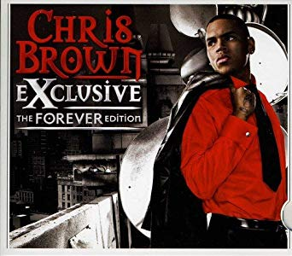

Chris Brown Exclusive