ARA Map Project Review and Required Corrections
To the project associate | Review date 17 September 2026
Decision The project is approved for an internal demonstration, but it is not approved for final delivery to management. The main workflow is reliable and well designed; however, saved-map behavior, map merging, comparison clarity, and one-click installation must be corrected before handoff.

Executive Summary
- The core workflow works: Excel import, validation, map display, terrain detail, filtering, export, saved maps, and two-base overlays were verified.
- All 157 automated tests passed in a compatible Python environment. Browser verification found no runtime errors at desktop and laptop dimensions.
- The supplied workbook imported 79 terrains: 39 were mapped and 40 were clearly listed as lacking coordinates. Validation correctly surfaced the known data issues.
- The product is a strong pilot. Final approval depends on the four required corrections and the release checklist in this report.

Review Scope and Evidence
I reviewed the application as an operational tool for answering customer questions about terrain inventory. The review covered the source code, database model, import and validation rules, automated tests, browser behavior, responsive layout, persistence, and the complete import-to-comparison journey.
Check | Observed result
Automated regression | 157 of 157 tests passed
Workbook import | 79 terrains read from the supplied Excel file
Map placement | 39 mapped; 40 retained in the unlocated list
Data quality | Duplicate, missing coordinate, numeric, price, and affected-area findings displayed
Saved map | Created, listed, reopened, and persisted in SQLite
Comparison | Two bases displayed with distinct colors and concentric markers
Browser quality | No console or page errors during the tested workflow
Responsive check | Comparison remained usable at 1024 by 768 pixels
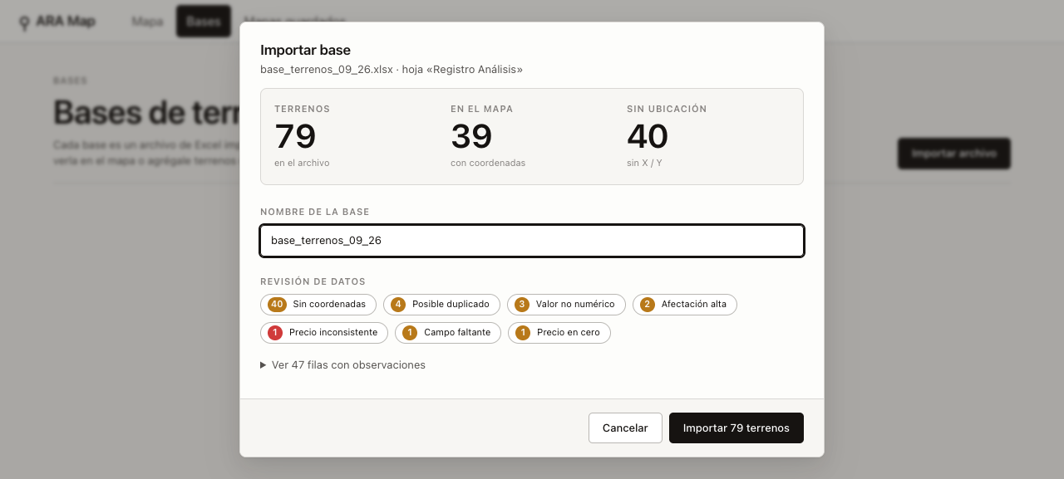
Figure 1 Import preview with terrain counts and data-quality findings

Requirement Assessment
Requirement | Status | Current behavior | Release expectation
Import a datasheet | Pass | Accepts .xlsx and .xlsm, previews rows and findings before writing. | Retain the current preview-first workflow.
Display terrain locations | Pass | Maps valid coordinates and retains unlocated records visibly. | No silent dropping or guessed locations.
Show information on click | Pass | Detail panel presents price, area, location, coordinates, extras, and findings. | Keep details readable in map and table workflows.
Save maps for later use | Partial | Saves a named reference to live bases, not a frozen view or snapshot. | Document live behavior or implement immutable snapshots; preserve intended view state.
Compare maps | Partial | Overlays two or three bases successfully; comparison table does not identify source base. | Show source period or base and meaningful differences.
Merge existing maps | Gap | The builder selects bases, not existing saved maps. | Allow two or more saved maps to be selected and merged, or obtain explicit scope approval.

Required Corrections Before Final Delivery

1 Implement the requested saved map merge
Priority P0. The current comparison builder receives and lists imported bases. The original requirement calls for creating a new map by merging two or more existing saved maps. Although merging bases produces a useful overlay, it is not the same object model or user workflow.
Acceptance criteria
- The comparison dialog can select two or more saved maps, including maps that already contain multiple layers.
- Duplicate underlying layers are handled predictably and the user sees what will be included before saving.
- The merged map can be named, saved, closed, reopened after an application restart, and tested through the API and browser.
- If the three-layer limit remains, the interface explains the limit before selection and the product owner approves it.

2 Define and protect saved map persistence
Priority P0. A saved map currently stores references to live bases. Appending or changing a base changes the saved map, and deleting a base removes the corresponding layer. This behavior may be valid for a live inventory view, but it does not satisfy the ordinary expectation of a saved snapshot unless it is made explicit.
Recommended decision
- Use immutable snapshots for saved maps intended for customer conversations and historical comparison.
- Store or reconstruct the saved filter state, basemap, color mode, visible layers, map or table mode, and viewport where they form part of the saved view.
- Prevent base deletion from silently leaving empty or incomplete saved maps. Offer blocking, archival, or explicit dependency removal behavior.
- Add migration and regression tests for maps created before the change.

3 Deliver a one click installation
Priority P0. The launcher depends on whichever python3 command appears first and then requires openpyxl to be installed manually. In the reviewed environment, the default Python did not contain that dependency even though another Python installation did. A management handoff should not require package installation or terminal troubleshooting.
Acceptance criteria
- The application opens from one icon on a clean supported Mac without asking the user to install Python packages.
- Startup errors state the problem and recovery action in plain language without immediately closing.
- A clean-machine release test covers first launch, import, restart, backup location, and upgrade behavior.

4 Identify the source in comparison tables
Priority P1. The comparison map communicates source through color, but the table shows duplicate-looking rows without a Base or Period column. This makes it difficult to explain which month or dataset a terrain belongs to when values are identical or nearly identical.
Acceptance criteria
- Add a Base or Period column, a matching color marker, and sorting or filtering by source.
- For matched terrains, show whether the record is new, removed, unchanged, or changed, with the changed fields identified.
- Exported comparison data includes the source base and does not create ambiguous duplicate rows.
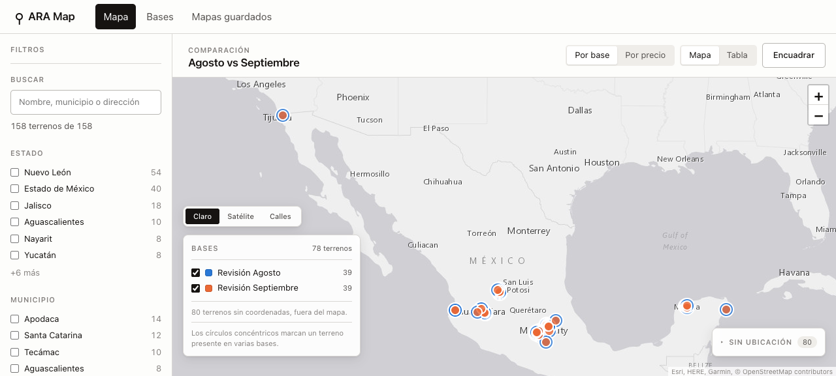
Figure 2 Two-base comparison overlay with distinct layer colors

Accepted Strengths to Preserve
- The preview-first import prevents accidental writes and makes data quality visible before confirmation.
- The importer correctly handles the source workbook convention where X is latitude and Y is longitude.
- Unlocated terrains remain accessible instead of being dropped or placed by guesswork.
- The map, table, filters, search, detail view, and export share the same terrain data and remain consistent.
- Validation messages are specific enough to help correct source data, including the known ten-times price inconsistency.
- The local-only server, host restrictions, path protections, SQLite persistence, and automatic backups are appropriate for the current operating model.
- The interface is polished, accessible by keyboard, and usable at a common laptop resolution.

Recommended Enhancements After Release
Enhancement | Value
Change report | Automatically classify terrains as new, removed, unchanged, or changed between periods, with price, area, and coordinate differences.
Customer brief | Generate a one-page PDF with a map image, selected terrain facts, source date, data warnings, and optional confidential fields.
Coordinate correction | Allow authorized users to add or correct coordinates inside the application, with an audit trail and export back to Excel.
Parcel boundaries | Support KML, GeoJSON, or polygon coordinates so the map can show actual parcel shapes instead of points when boundary data is available.
Freshness and source labels | Display the source filename, import date, last update date, and a stale-data warning in saved maps and terrain details.
Internal and customer views | Provide a controlled view that hides asking prices, internal findings, or other sensitive fields when sharing externally.

Release Acceptance Checklist
Final management delivery should occur only after every item below has evidence attached to the release candidate.
[ ] A clean supported Mac opens the application from one icon with no manual dependency installation.
[ ] Two or more saved maps can be selected and merged into a new saved map.
[ ] Saved-map behavior is explicitly approved as snapshot or live and is reflected in the data model and interface.
[ ] A saved map reopens correctly after restart and remains valid after source-base changes or deletion according to the approved rule.
[ ] Comparison tables and exports identify the source base or period for every terrain.
[ ] Saved view state includes all settings management expects to recover later.
[ ] Automated tests pass, including new persistence, merging, migration, and packaging tests.
[ ] The complete flow is retested with at least two real monthly workbooks, not two copies of the same fixture.
[ ] Backup and recovery are demonstrated using a copy of the production database.
[ ] A short user guide and a 10-minute associate-led demonstration are ready for management.

Technical References for the Corrections
• web/components/maps/OverlayBuilder.js - comparison selection currently iterates through bases
• server/db.py - map layers reference bases with cascading deletion
• web/components/terrain/TerrainTable.js - comparison table columns omit source base or period
• ARA Map.command - launcher checks the first python3 and requires openpyxl
• tests/ - existing regression suite provides a strong base for the required new cases

Final Direction
Please keep the current visual design and validated import behavior. Concentrate the next revision on the four required corrections, then return the release candidate with test evidence against the acceptance checklist. Once those items pass, the project will be suitable for management handoff and customer-facing operational use on the designated Mac.

