Exercises

Lab01

1. **An API is a document that lists all relevant information about each class. Consult the "Unit1 API" found at** <http://academics.tjhsst.edu/compsci/CSweb/Unit1/webdemos/index.html>
   1. *Fields* store an object’s private information about its state. List all the fields of the Robot class: direction, beepers and location (x,y).
   2. What methods in Robot have we used so far?

move()

pickBeeper()

putBeeper()

turnLeft()

* 1. What methods in Display have we used so far?

openWorld, setSize, setSpeed

2) **Circle the identifiers that will compile. Put a star by the identifiers that by convention identify a class.**

|  |  |  |  |  |  |  |
| --- | --- | --- | --- | --- | --- | --- |
| mrsAdams | mr.chips | class | r2_d2 | c-3po | Hal9000* | 7_of_9 |

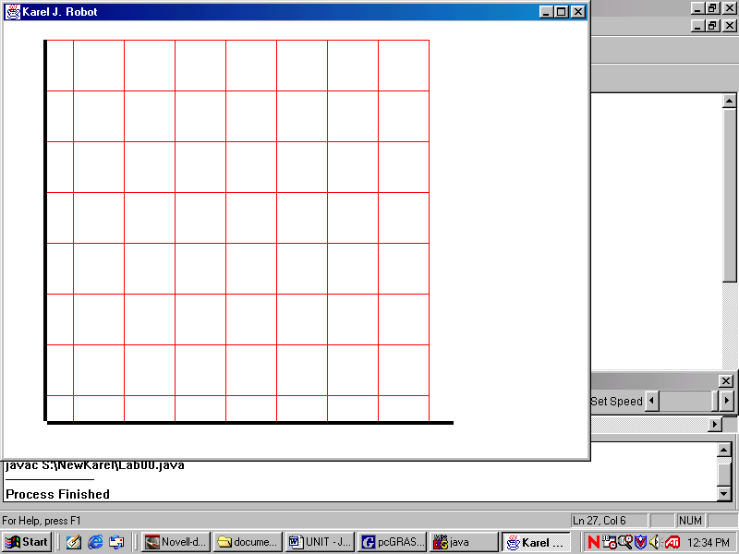

3) **Mark the following points A(1, 1), B(6, 7), C(5, 2), D(3, 8), E(8, 1) on the robot-map shown.**

4) **What has the size of this robot-map been set to?**

8x8

5) **Give the command to set that size.**

6) Lisa is a teacher at the local high school. She needs to store some books in the storage room downstairs. Lisa takes the books from the math office to the student lounge, where eager students wait to help their teachers. Lisa gives the books to pete, who cheerfully stores the books on the smallest pile.

Identify the nouns in the story above:

Identify the verbs in the story above:

7) In objected oriented programming, nouns turn into __________.

8) In objected oriented programming, verbs turn into _____ _________.

9) Our Lab01 program models the story from Question #6 using robots and books. Think of other classes that could have been used instead to solve the same problem.

10) In terms of your new classes, what should be the fields (private data) of each class?

11) Thinking about your new classes, what behaviors would it be useful to have?