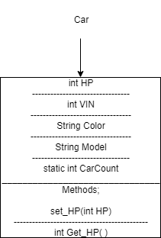

**ADP 1**

Final Exam

Part 1: Multiple Choice Questions

Read the questions carefully, You are directed to choose more than one answer if the question has more than one answer, If you feel that you need to add comments feel free to do so. (Each question has two marks)

1. Which of the following options explain internal sorting ( choose all that apply)
2. The number of items to be sorted is small
3. The number of items to be sorted is large
4. All items could be held in memory
5. There is not enough space to hold all items in memory
6. All items are accessed easily and randomly
7. A block of items accessed in each pass
8. Consider that you are working with a computer that has only 1 MB of memory, 16 bits wide. You are supposed to sort about 800,000 integer elements. Which one of the following sort methods you would (or in other words you can) choose to perform your task. ( choose all that apply)
9. Quick sort
10. Heap sort
11. Insertion sort
12. Tag sort
13. Radix sort
14. Bubble sort
15. You are creating a multi-user web based game. The rule of the game is in the ways that whichever player that has higher score gets to shoot first. Every player has a thread of his own when he starts the game. You are responsible to create a scheduler for giving proper shooting turn to your players, what data structure would you choose to implement this?
16. Binary Search Tree
17. Priority Queue
18. Array
19. Stack
20. Doubly linked list
21. Simple hash table
22. Which one of the following statements is correct?
23. Each heap is a binary tree
24. Each Binary search tree is a heap
25. Hash Table can only be implemented with STL’s Map
26. Merge sort can be used only if the number of items to be sorted is even
27. Consider that you have a hand made computer with a very small memory. Memory width is 16 bit and you have only 20 rows in your memory. using an array what is the max numbers of integers you can sort in this machine
    1. 20
    2. 18
    3. 19
    4. Less than 13
    5. More than 20
28. You have been over clocking your CPU for the past few months. Today your computer is very slow. You have restarted the computer a few times, tried defragging the disk and used any trick to make it faster but it didn’t work. Unfortunately you need to create a SORTED document for a very important meeting so you need to sort a few numbers. Which method is the best method for sorting considering your situation?
    1. Using an array
    2. Using a linked list
    3. Using a binary tree
    4. Using a double subscripted array
29. One of the major draw backs for using recursive algorithms is that
    1. It is so advanced and it may be confusing
    2. It consumes lots of memory
    3. It has CPU overhead
    4. Many programming languages don’t support it
    5. It is only used for tree processing
30. A binary search tree can be simulated with
    1. Two double linked list
    2. Two linked lists with the same head
    3. A circular list
    4. Two circular lists
    5. An array and a linked list
    6. None of the above

Part 2:

In this part you are asked questions that need explanation or description of intermediate stages of an algorithm.

1. Consider that you are working in a typical car factory and you are supposed to create a program to do a daily task at a car factory. Design a class that describes a car. It should have at least 4 data members, 2 methods and a static data member. Use UML Class Diagram to represent your class. (5 marks)



10. Consider you have an array of six elements A={32, 11, 6, 47, 23, -1}

Using bubble sort algorithm, write the array in different stages until it is sorted.(5 marks)

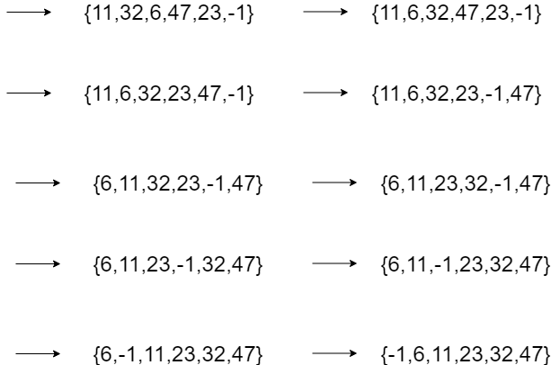

11. Consider that you have an array of integers A = {44, 75, 23, 43, 55, 12, 64, 77, 33}

Using Quick sort Algorithm Show the intermediate stage of the array until it is sorted.

(10 marks)

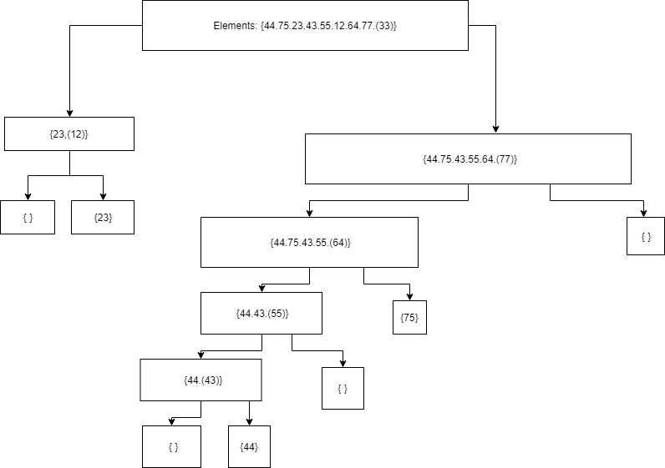

12. Using top down merge sort algorithm sort the following array of characters

C = {a, m, c, b, f, k, l} (5 marks)

13. Using heap up algorithm heapify the following Tree.(10 Marks)

16

10

4

1

8

2

3

9

7

14

14. Consider the following items with their corresponding keys.(15 marks )

|  |  |  |  |  |  |  |  |
| --- | --- | --- | --- | --- | --- | --- | --- |
| Key | 0.513 | 0.175 | 0.308 | 0.410 | 0.233 | 0.782 | 0.644 |
| Item | A | M | T | Z | Q | V | S |

Now consider that you have only 4 rows to create your hash table. Using modular hash algorithm, find your hash function and implement a collision handled hash table.

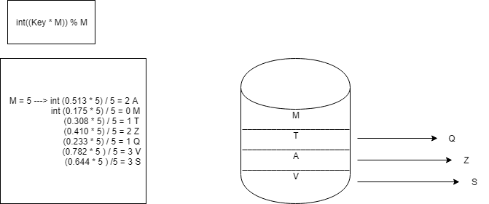

15. Consider the following tree, First Change it to binary search tree and then traverse it in PreOrder, and Inorder and PostOrder and write the results. (10 Marks)

8

2

3

92

7

14

10

41

16

1

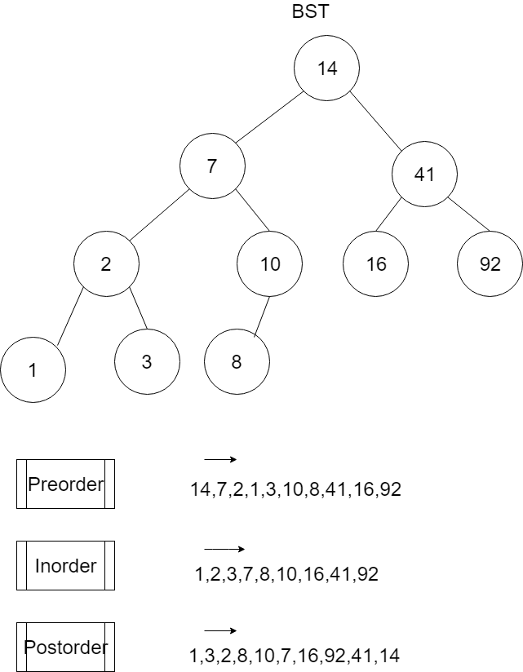

Part 3. Open Book

In This part you are supposed to make a program, you may be using your book for this part, good luck! (24 marks)

You are supposed to create a class called student that has sensitive data including Student name, surname, address, phone number and GPA. Since all data members of this class need to be hidden you should create a proxy class for this class. All construction and destruction for student class should take place using the proxy class. Using a driver program show that your class student is never exposed to the driver program.

**Good luck**