LockedMe.com App

By: André Bessa

**ScreenShots**

**From Code**

Project packages and classes:

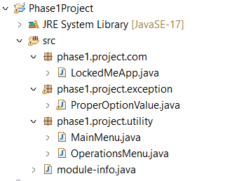

Class LockedMeApp:

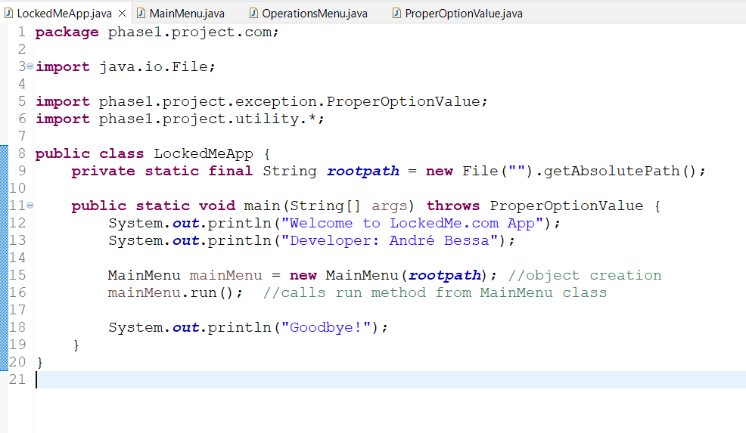

Class MainMenu:

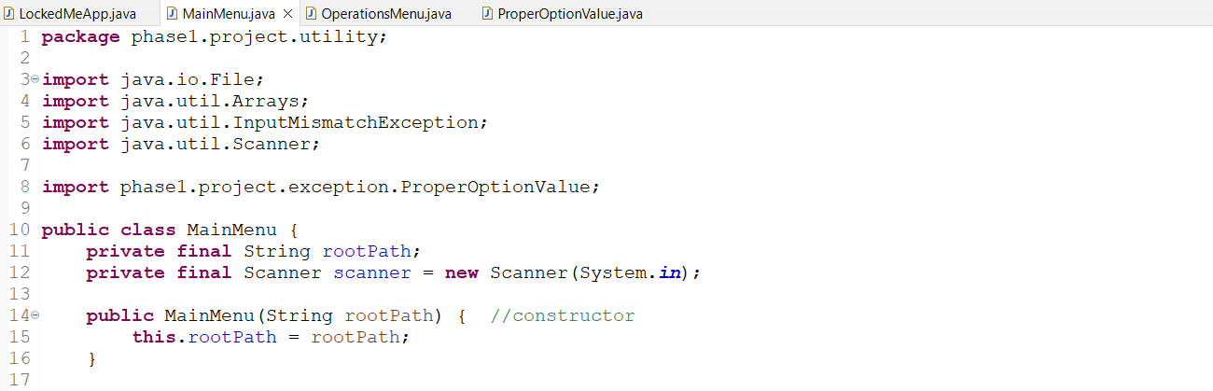

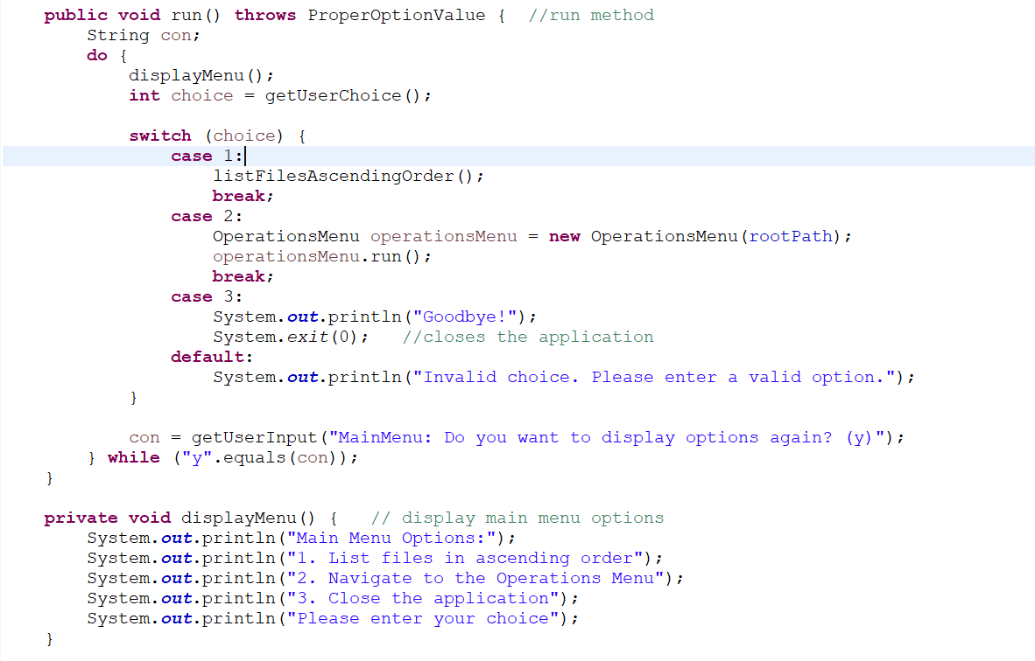

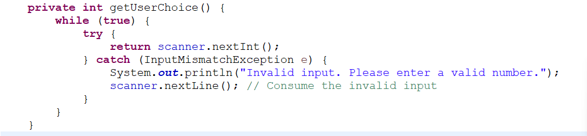

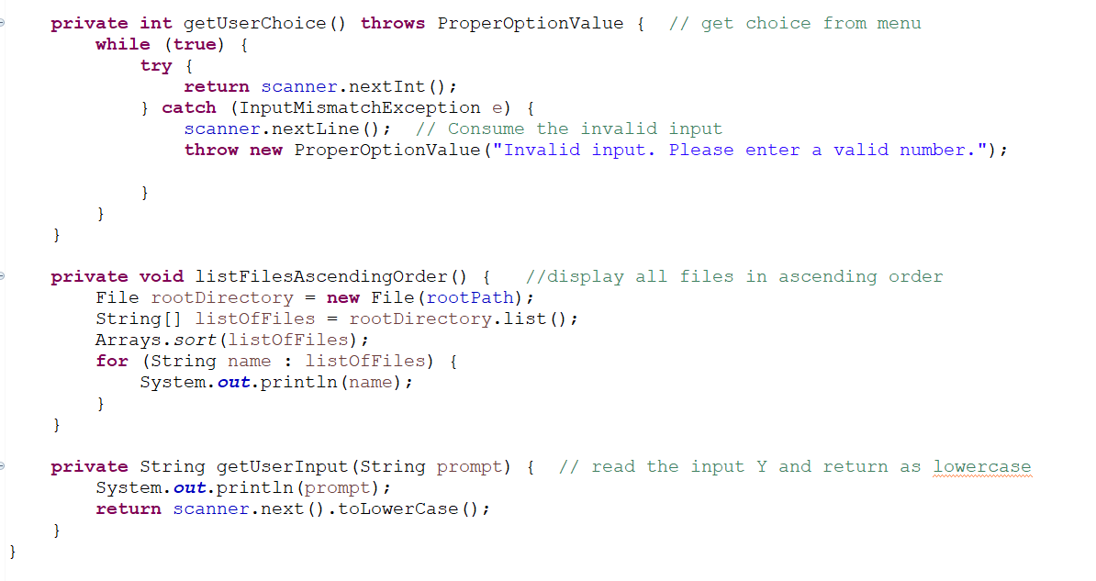

class OperationsMenu:

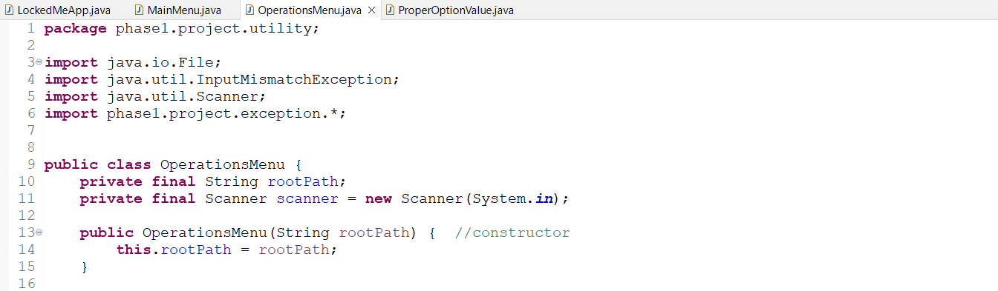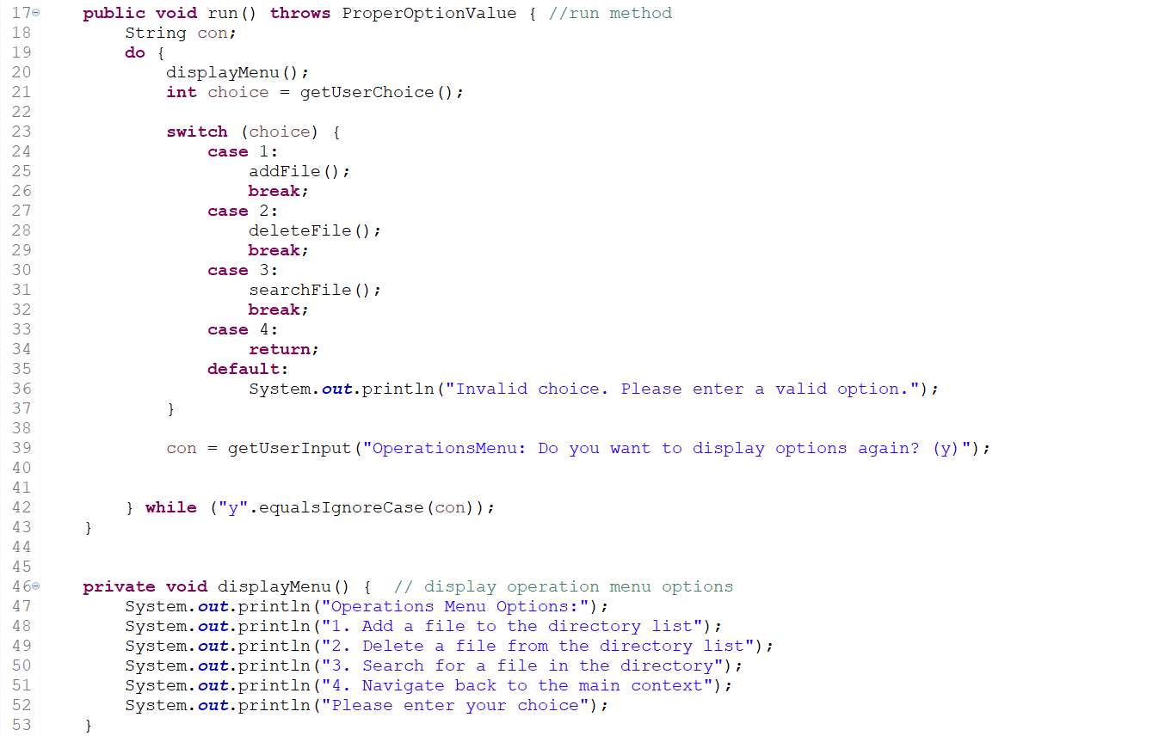 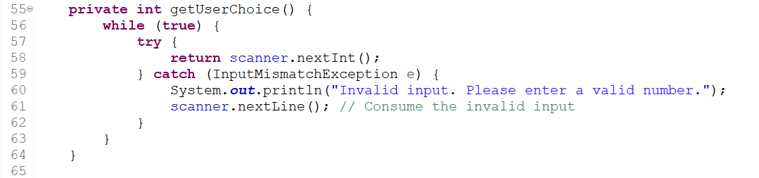

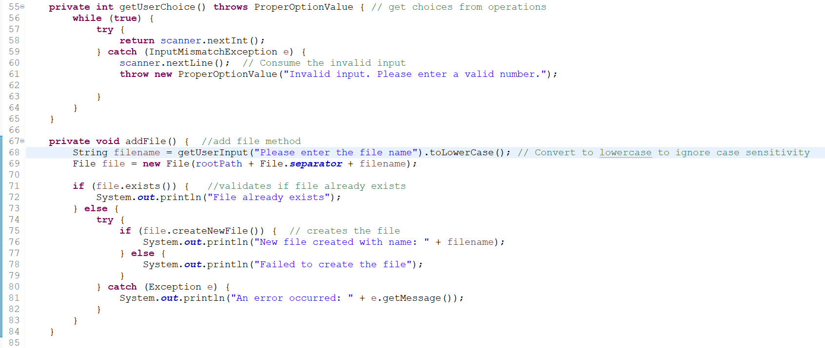

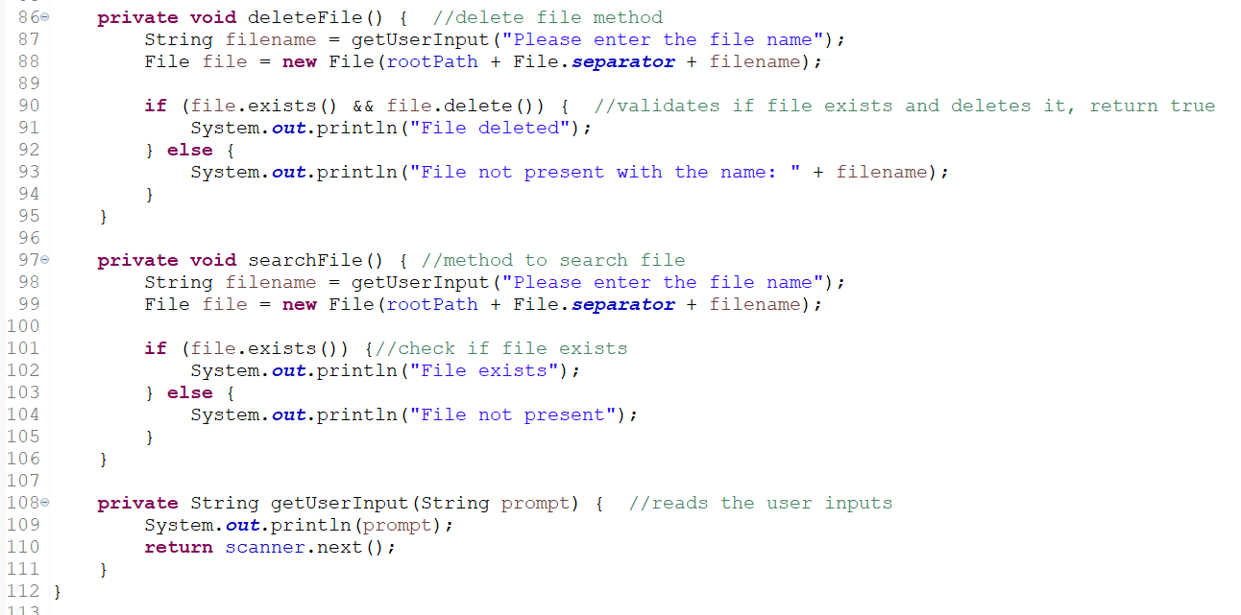

Class ProperOptionValue:

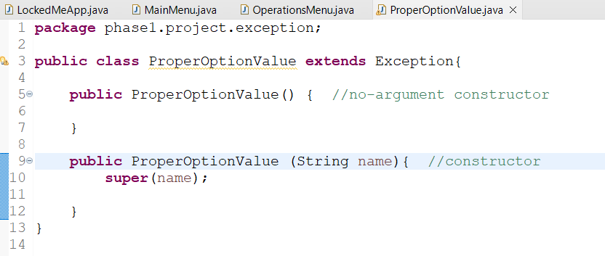

**ScreenShots**

**From Console**

MainMenu Option List Files(1), Continue(y), Not Continue (!y) and Close Application(3):

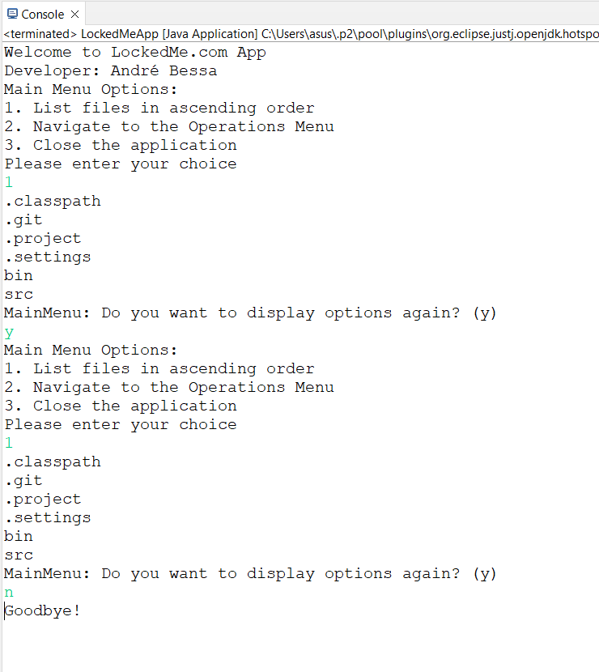 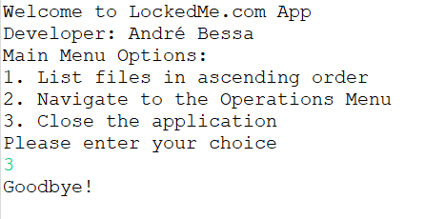

OperationsMenu(2), BackToMainMenu(4), SearchFile NotPresent(3), No Display Options(!y)

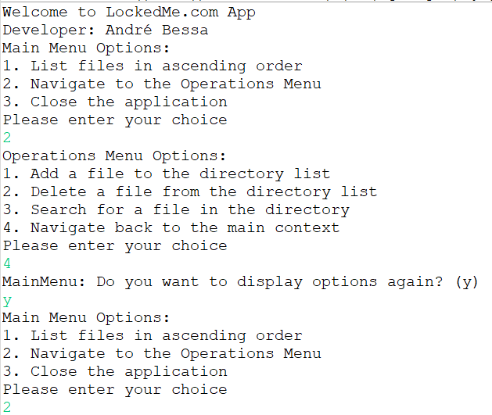

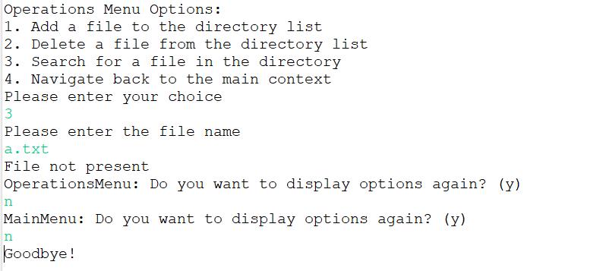

OperationsMenu(2),AddFile(1),AddFileAlreadyPresent(1), SearchFilePresent(3),SearchFileNotPresent(3)

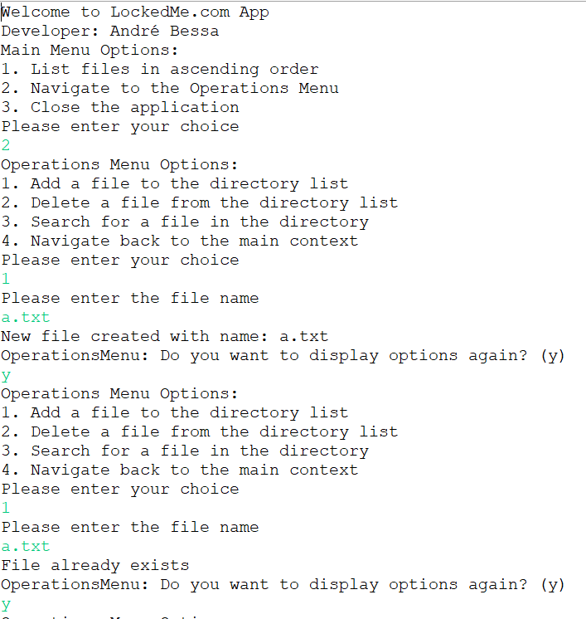

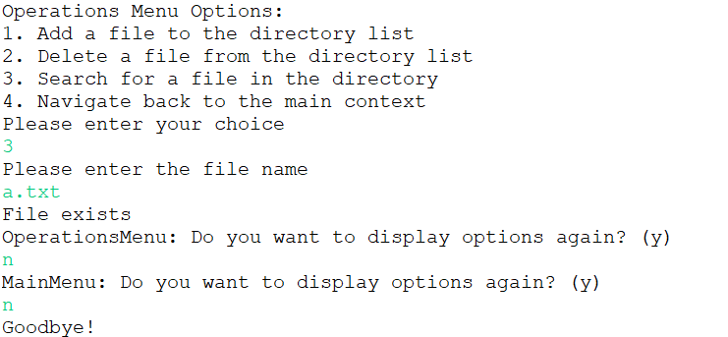 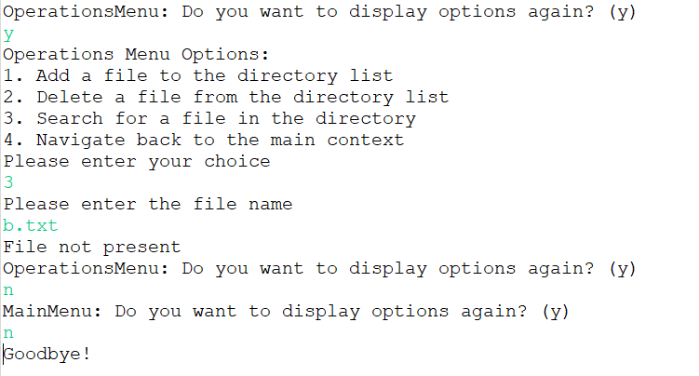

OperationsMenu(2), DeleteFileNotPresent(2), DeleteFilePresent(2)

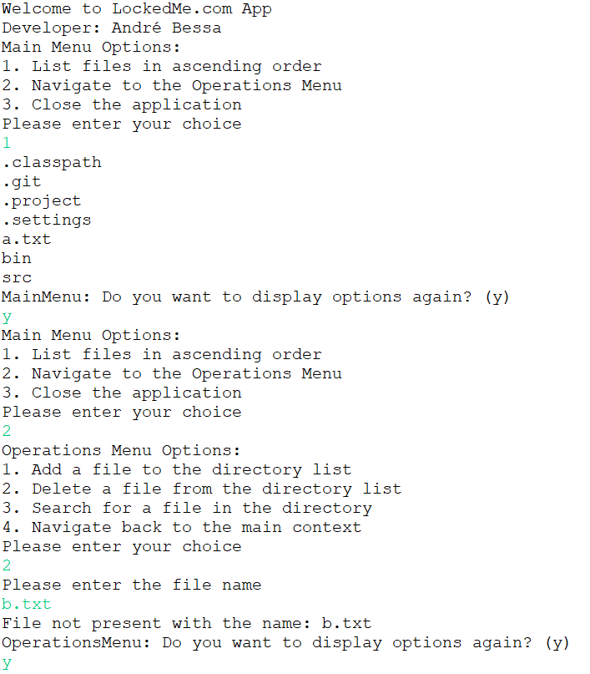

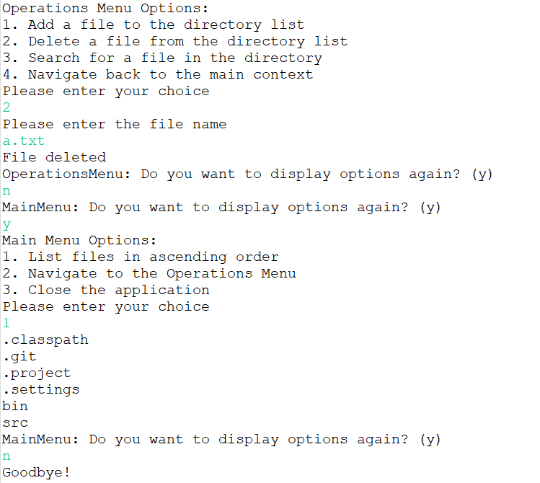

InvalidInputs

