**Monitoring multiple vital signs through a**

**wireless ear probe**

by

Andre Bestbier

*Thesis presented in partial fulfilment of the requirements for   
the degree of Master of Engineering (Mechanical) in the   
Faculty of Engineering* at *Stellenbosch University*

Supervisor: Prof. PF. Fourie

September 2017

**Chapter 1**

1

**Introduction**

This thesis reports on a project undertaken in die biomedical field of wearable electronics. Great advances in the miniaturization of electronics and wire­less communication have challenged and transformed the norm of how we use electronics to listen to the language of our bodies.

This project revolves around the continuous measurement of vital signs. These signs are objective parameters that give an indication of physical well­being and the state of essential physiological functions. For example, infections are indicated by a rise in core temperature (DerSarkissian, 2016), pneumonia can be detected by a shortness of breath (Mayo Clinic, 2017), an abnormal decrease in blood oxygen saturation during sleep can be a warning sign for sudden infant death syndrome (Thach, 2008) and a rise in heart rate can in­dicate physical stress (Karriem-Norwood, 2017). These signs can be detected electronically before traditionally observable symptoms appear. In many cases, the deciding factor in the success of a treatment is whether the illness is de­tected early enough.

Because of this, the importance and usefulness of a continuous, wearable health monitor should not be underestimated. Access to accurate, long term data can lead to improved diagnosis of health issues and a better understanding of how our bodies react to drugs, exercise, emotions and the environment around us. Traditionally, vital sign monitoring is done with a stationary, dedicated device for each signal to be measured. Due to the many large, stationary equipment needed for traditional patient monitoring, it is obvious that this is not suitable for continuous and mobile vital sign monitoring.

This project concerns the design, development and evaluation of a proof of concept device that will overcome the limitations of these traditional methods. The device is to be worn in the ear like an earphone or hearing aid. It will make multi-parameter vital sign measurements and transmit collected data through a wireless connection to a supporting system for storage and analysis. In this project, the supporting system will be on a laptop, but it can also be on the smart-phone of the wearer or on a cloud server. This supporting system

can be used by a physician, caretaker or the wearer self, to monitor and track his/her health.

*CHAPTER 1. INTRODUCTION* **2**

From here onwards, this device will be referred to as the *Ear-Monitor.* This report will discuss the project aim and objectives, relevant literature and the design, manufacturing and testing of the Ear-Monitor.

**1.1 Aim/Research Question**

To develop and test a proof of concept wearable device that can monitor vital signs and transmit collected data wirelessly to a warning and storage system. Vital signs include core temperature, heart rate, respiratory rate and blood oxygen saturation.

In order to achieve the aim of this project the following three objectives have to be met:

* Develop a device to measure core temperature, heart rate, respiratory rate and blood oxygen saturation through the external ear of the wearer.
* Conduct a trial experiment to determine the functionality of this device.
* Subsequently, evaluate the feasibility of an ear worn vital sign monitor

**1.2 Motivation**

This project originated from a need found in medical practice and expressed by the proposer/advocate of this topic. It is the need for better vital sign monitoring methods for neonates and infants in hospital nurseries and at home. High-risk patients are placed in ICUs and are thoroughly monitored, whereas lower risk patients are left in the nursery or sent home (Barfield *et al.,* 2012). These patients are poorly monitored while at a fragile age, increasing the risk of health issues. Insufficient health monitoring for neonates and infants is due to the lack of a practical monitoring method. The solution to this issue is the development of an unobtrusive, wearable health monitor.

While contemplating and researching this idea, it was found that a much larger group can benefit from such a device. This lead to the project pivoting toward a more general purpose vital sign monitoring device. This device will prove if it is practical to measure the mentioned vital signs through the external

ear canal. If this proof of concept is successful, the methods developed during this project can be used to develop specialized ear-worn devices for various applications. In practice, such a device can transmit health statistics and warnings in real time to a physician or caretaker. Applications include:

*CHAPTER 1. INTRODUCTION* **3**

* Monitoring neonate- and infant health in nurseries and at home.
* Monitoring health of patients with chronic illnesses.
* Studying the effect of prescription drugs or other treatments.
* Monitoring the health of people working under strenuous conditions like heavy machinery operators and soldiers.
* Tracking the health and fitness of athletes.

The ear was chosen as location for various reasons. Firstly, the anatomy of the ear and the proximity of an ear-worn device to the tympanic membrane, means that al the mentioned vital signs mentioned can theoretically be mea­sured from this location. This eliminates the need for multiple devices or the need for wires connecting sensors on different parts of the body. The absence of sensors on traditional locations such as the chest or limbs and the absence of connective wires mean that the ear-worn device is minimally obstructive for the wearer, especially through freeing up the hands and allowing free move­ment. Secondly, the shape of the external ear is ideal for supporting a device without the need for straps or adhesives. Furthermore, the head remains rela­tively still in relation to the rest of the body. This reduces the risk of motion artefacts corrupting the signals of interest. An ear-worn device can be em­bedded in the already familiar shape of an earphone or hearing aid. The final motivation for using the ear as location for the health monitor is its novelty. As will be apparent from Chapter 2 of this document, there is opportunity for research to be done in the unsaturated field of ear-worn health monitors.

**Chapter 2**

**4**

**Literature Review**

This chapter aims to describe the biological context within which the project is undertaken. An overview of the anatomy of the ear, which is relevant to this study, will be given. Thereafter, background will be given of the physi­ology of each of the four vital signs. Finally, the technology relevant to the measurement of each vital sign required of the Ear-Monitor will be discussed in terms of theory and the work done by others.

**2.1 Ear Anatomy**

The area that is available for the Ear-Monitor to make the vital sign measure­ments is the external ear. It includes the auricle, ear canal with surrounding tissue and the lateral side of the tympanum. Each part of the ear anatomy will be discussed, especially with regards to its ability to emit information related to vital signs or to support the device in another way.

**2.1.1 Auricle**

The auricle is the visible part of the ear. It forms a C-shaped funnel that protrudes from the scull. Its structure is predominantly formed by yellow elastic cartilage covered in skin. Its complex folded shape differs from person to person, but certain structures are present in all normal auricles and have been named. As can be seen on Figure 2.1, the concha is the indented part next to the ear canal. This area is an ideal location for a wearable device. The device can be held in place by the tragus and a probe can easily extend into the ear canal.

The external ear is supplied with blood from the auricular arteries. These arteries branch from the carotid artery which supplies the rest of the brain with blood. Being made mostly of cartilage and located at an extremity of the body, the auricle is not a suitable location for taking temperature measurements for its temperature is easily influenced by the ambient conditions.

*CHAPTER 2. LITERATURE REVIEW* **5**

|  |  |  |
| --- | --- | --- |
| Tragus |  | Concha  Earlobe |

Figure 2.1: Anatomical structures of the auricle

The layer of skin covering the auricle contains blood vessels and therefore the earlobe is a popular location for traditional pulse oximetry measurements. This is a possible location for an ear-worn device to make a heart rate and peripheral blood oxygen saturation (SpO2) measurement (Poh *et al.,* 2010). The earlobe's blood vessels are, however, susceptible to vasoconstriction due to cold or hypovolaemia (World Health Organization, 2011). This will reduce the blood perfusion of the subcutaneous tissue making it harder to record accurate heart rate and SpO2 measurements.

**2.1.2 Ear Canal**

The external ear canal is the tube running from the floor of the auricle to the middle ear, ending blindly at the tympanic membrane or tympanum. Fig­ure 2.2 depicts the structure of the ear as seen from a coronal plane section. The auricle is visible and the shape and relative size of the canal can be ob­served. The ear canal in adults is approximately 25 mm long and have a diameter of 5 to 7 mm (Alvord and Farmer, 1997). The outer third of the external ear canal is surrounded by cartilage and fibrous tissue (Encyclopaedia Britannica, 2015). The inner two thirds is surrounded by the temporal bone. Thin skin forms the lining of the canal and contains glands secreting ear wax. Hairs are found in the outer part of the canal. The ear canal of infants starts out relatively straight, but obtains a definite S-shape as the head develops (Alvord and Farmer, 1997). This S-shape is important to keep in mind when placing a sensor to measure tympanic temperature. Ear canal size also varies from person to person. Therefore, an ear probe should be designed to fit in a variety of ear canal shapes and sizes.

*CHAPTER 2. LITERATURE REVIEW* **6**

Figure 2.2: Structure of the ear (Drake et al: Gray's Anatomy for Students)

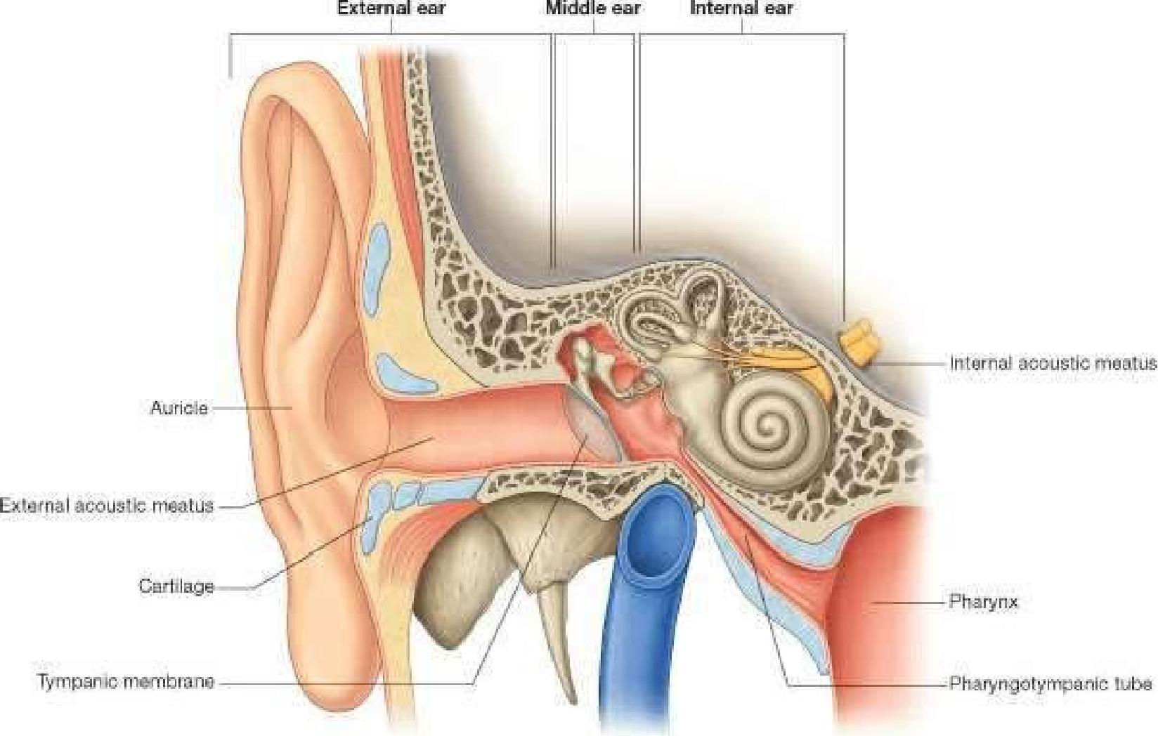

Auricle

External acouslIc meatus —

Cartilage

Pharynx

Tympanic membrane

Pliairsitigdivrnpanle tube

External ea'

Middle ear

Internal ear

Internal acautlo meatus

The secluded nature of the ear canal means that it has a relatively constant temperature. Air trapped in the canal by a plug of high thermal resistance will reach thermal equilibrium close to the temperature of the canal wall and tympanum. This is a better location for a core temperature measurement, but will still be influenced by the ambient temperature. The wall of the ear canal is well supplied with blood. Blood vessels just beneath the thin layer of skin make the ear canal a possible location for measuring heart rate and blood oxygen saturation. The still nature of the head will minimize movement artefacts.

**2.1.3 Tympanic Membrane**

The tympanum forms the medial boundary of the external ear canal. It is a smooth elliptical membrane with a thickness of about 0.074 mm (Alvord and Farmer, 1997). The membrane is slanted relative to the external ear canal.

As with the rest of the external ear, the tympanum is supplied with blood from a branch of the carotid artery, therefore sharing its supply with the brain, including the hypothalamus, the thermoregulation centre of the body. It is the most medial part of the external ear, and is therefore the least susceptible to be influenced by the ambient temperature. This is the reason why the tympanum is one of the best locations to measure core body temperature. The location is used by physicians to measure core temperature, for it is quick and minimally invasive (Gasim *et al.,* 2013). Variations in body temperature can be sensed faster on the tympanic membrane than on other locations on the body. Contact with the tympanum can cause discomfort and harm to the patient, so non-contact infrared thermometers are usually used.

**2.2 Vital Sign Physiology**

*CHAPTER 2. LITERATURE REVIEW* **7**

This section reviews the theory and research done on the physiological aspects of each vital sign that the Ear-Monitor is required to measure. The importance of each of the four vital signs will be discussed, including the typical range of measurements expected from healthy adults and the causes and implications of deviations from these measurements.

**2.2.1 Core Temperature**

Thermoregulation is the body's way of keeping its internal temperature within certain limits to create a favourable environment for chemical reactions to take place (Holland, 2016). The temperature control centre of the body is in the hypothalamus and it regulates temperature by maintaining a fine balance between heat production and heat loss. Normal human core temperature varies between 36.5 °C and 37.5 °C (Jones, 2010). Inability to maintain this balance may indicate problems in the well-being of a person. Elevated temperature (hyperthermia) due to a fever can indicate the presence of an infectious disease. Abnormally low temperature (hypothermia) can be caused by exposure to cold, metabolic disorders or infection. Both hyper- and hypothermia can be life threatening. A core temperature measurement is often a key indication to start a treatment or not. Therefore, temperature measurement is part of a full clinical examination.

The location where temperature is measured is a key factor, for temperature is not constant throughout the body. This is because heat production and heat loss are not constant throughout the body, which means extremities are usually cooler than the core. Traditional locations for measuring temperature are the tympanic membrane, axilla, mouth, rectum, oesophagus, forehead and urinary bladder. The mean temperature of these areas varies as well. A systematic literature review done by Sund-Levander *et al.* (2002) combined the results of 20 studies to identify oral, rectal, tympanic and axillary temperature ranges in healthy humans. Figure 2.3 illustrates the results.

Studies have also been done comparing measurements at distinct locations to pulmonary artery temperature in ill patients. One of these found the fol­lowing standard errors for temperatures at different locations: to ear-based 0.07 ± 0.41 °C; urinary bladder 0.03 ± 0.23 °C; oral 0.05 ± 0.26 °C; and axil­lary —0.68 ± 0.57 °C. The accuracy of each method varied with the level of pulmonary artery temperature. Repeated measurements with all four meth­ods had mean standard deviation values within ±0.2 °C (Erickson and Kirklin, 1993).

A second study done by Lefrant *et al.* (2003) showed the following standard errors: oesophageal 0.11±0.30 °C, rectal -0.07±0.40 °C, axillary 0.27±0.45 °C, inguinal 0.17 ± 0.4 °C and urinary bladder -0.21 ± 0.20 °C.

*CHAPTER 2. LITERATURE REVIEW* **8**

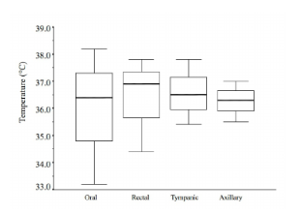

Figure 2.3: The results from 20 studies reviewed by Sund-Levander *et al.*(2002)

The location of the device in development is restricted to the ear, therefore the tympanic membrane is the preferred location for temperature measure­ments. The referenced studies show that the tympanic membrane is a valid location to measure accurate core temperature.

**2.2.2 Heart Rate**

The presence of a heart beat is paramount to sustain the vital cardiac output, supplying blood to the whole body. Heart rate can be controlled or maintained through two different regulatory systems: The intrinsic conduction system and the nervous system. The intrinsic conduction system works through the rhythmic contraction and relaxation of the heart muscle tissue. The heart rhythm is regulated by the sinoatrial node. The nervous system can influence the heart rate through sympathetic and parasympathetic nerves running from the cardiovascular centre in the medulla oblongata to the heart. The heart beat rate is varied to control the blood flow and blood pressure in the body.

The heart is the source of a group of bio-signals. The firing of nodes and propagation of electrical charges through neurons and the conductive cardiac muscles emit electrical signals that can be detected. The contraction of the ventricles forces blood into the arteries, causing a temporary increase in blood pressure. This pressure increase propagates through the arteries as a wave, causing a temporary local increase in blood volume. Pressure- and volume changes can be detected. Blood turbulence and the opening and closing of heart valves cause the characteristic heart sound and chest movements, both indications of heart rate.

Heart rate is influenced by numerous physiological factors including O2, *CO2, H+* levels, blood pressure, stress and exercise. Pathological factors can include fever, sepsis, heart disease and anaemia. Tachycardia is abnormally high resting heart rate, generally above 100 bpm, whereas bradycardia is a lower than normal resting heart rate, usually below 60 beats per minute (bpm)

(Laskowski, 2015). Although these two conditions are not necessarily danger signs, it may be an indication of health problems and therefore heart rate measurement is part of any medical examination.

*CHAPTER 2. LITERATURE REVIEW* **9**

**2.2.3 Respiratory Rate**

Respiration is the first step in the chain of events to get oxygen to the body's cells for metabolism to provide the body with energy. Respiration ventilates the lungs with air through inhalation and exhalation. The respiratory rate of a healthy adult at rest is usually between 12 and 20 breaths per minute (Charbek, 2015). This can vary drastically if the body is experiencing physical or emotional stress. An increase in respiratory rate can be caused by a fever, pulmonary dysfunction or any one of numerous medical conditions.

Respiratory rate monitoring is especially useful for diagnosing sleep ap­noea. Symptoms include regular pauses in respiration or periods of shallow breathing (hypopnea) during sleep. This causes an oxygen deficiency in the body and lowers the quality of sleep. Short term symptoms include excessive daytime sleepiness, morning headaches, impaired alertness, and vision prob­lems. If left untreated, sleep apnoea can lead to high blood pressure, diabetes, depression, worsening of ADHD, stroke, heart failure, irregular heartbeats, and heart attacks (Bland, 2016). Sufferers may be unaware of their condition and a sure-fire method of diagnosing it is by monitoring respiratory rate during sleep, traditionally done during an overnight sleep study.

**2.2.4 Blood Oxygen Saturation**

Haemoglobin is the oxygen transporter protein found in red blood cells of blood. Blood gets oxygenated in the lungs and then carries O2 to the rest of the body for aerobic respiration necessary to produce energy. The correct levels of oxygen in the blood are vital to the health of the individual.

Arterial oxygen saturation, SaO2, refers to the concentration fraction of oxygenated haemoglobin to total concentration of haemoglobin in arterial blood. This fraction can be calculated by Equation 2.1.

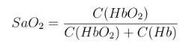

(2.1)

Where *C(HbO2)* is the concentration of deoxygenated haemoglobin (deoxy­haemoglobin) and *C(Hb)* is the concentration of oxygenated haemoglobin (oxy­haemoglobin).

Blood oxygen saturation of 95-100% is normal in healthy humans. Hy­poxaemia is the condition when the saturation is below 90%. This can be an indication of circulatory or ventilatory problems, anaemia or sleep apnoea.

Levels below 80% can impede organ function and can lead to organ failure and cardiac- or respiratory arrest. The brain is extremely susceptible to damage when deprived of oxygen. Cerebral hypoxia is the insufficient supply of oxygen to the brain. This can cause brain damage and in severe cases, brain death.

*CHAPTER 2. LITERATURE REVIEW 10*

**2.3 Vital Signs Measurement Theory**

This section will accumulate a thorough understanding of the theory and cur­rent state of technology relevant to the measurement of each vital sign required of the Ear-Monitor. Attention will be given to the different methods available to determine each vital sign. This section will also make reference to various articles and studies done by other researchers in this field of study. The aim is to gather all the relevant information to make an informed selection of the methods and sensors the Ear-Monitor will use to measure each vital sign.

**2.3.1 Core Temperature Measurement**

Various methods are available for measuring core temperature. Non-electric, fluid-filled thermometers was the first to be used (Pearce, 2002). The mercury-filled thermometer was used by early physicians to study the thermoregulation of the human body and crudely identify fevers. Since then, the mercury has been replaced by coloured alcohol or another heat sensitive liquid, due to toxicity of mercury.

Another type of fluid-filled thermometer is the liquid-crystal thermometer. It contains liquid crystals that change colour at different temperatures. The use of these two types of fluid-filled thermometers has decreased significantly due to the accuracy, speed and convenience of digital thermometers.

Digital thermometers are now the industry standard of measuring core tem­perature. Central to any digital thermometer lies a transducer that convert temperature to an electrical signal. Resistance temperature detectors, ther­mocouples thermistor and thermopiles will be discussed. They can be divided into contact and non-contact thermometers.

**2.3.1.1 Contact Thermometers**

These are a family of thermometers that measure their own temperature with the assumption they and the object whose temperature is of interest, are in thermal equilibrium. Therefore, they are usually placed in contact with the object. When using a contact thermometer in the ear, the sensor part of the thermometer can be placed in contact with the ear canal wall, the air inside the canal or with the tympanic membrane itself. Several types of contact thermometers exist, including resistance temperature detectors, thermocouples and thermistors.

**Resistance Temperature Detector**

*CHAPTER 2. LITERATURE REVIEW 11*

Resistance temperature detectors (RTDs) use the temperature-resistance relationship for metals to measure temperature. Thin wire coils or films of platinum, copper or nickel are usually preferred for they have a stable and repeatable temperature-resistance relationship over a wide temper­ature range.

**Thermocouple**

Thermocouples make use of the thermo-electric effect to make a tempera­ture measurement. They consist of two dissimilar conductors connected at the one end, knows as the hot junction (measuring junction). The other ends of the two wires are known as the cold junction (reference junction) and are connected to a voltage meter via common conductors. A voltage is generated dependent on the temperature difference between the measuring- and reference junctions. Thermocouples do not respond to absolute temperature; therefore, their accuracy depends on how well the reference temperature can be defined. Reference temperatures are usually determined by a precise thermistor. Thermocouples are very ver­satile and widely used in clinical applications, but the downside is that their output signal is low and non-linear, therefore requiring a sensitive and stable voltage measuring device (Jones, 2010).

Thermocouples can be connected in series and are then called thermopiles. This configura­tion sums the output voltages, resulting in temperature averaging. This method improves accuracy by reducing noise.

**Thermistor**

A thermistor is a type of semiconductor whose resistance varies with changes in temperature. They differ from RTDs in that they are usually made of ceramics, they have higher precision over a smaller temperature range and they can have a negative relation to temperature. Thermis­tors are preferred above RTDs and thermocouples for use as biomedical sensors due to their faster response time and higher sensitivity over a smaller range. The smaller range does not matter, for the temperature range of interest in bio-sensors is small and well defined.

**Contact Thermometer Application**

In the case of RTDs and thermistors, the measuring element is placed in position and a current is sent through the sensor. By measuring the voltage across the resistive element, it is possible to calculate the voltage and subsequently determine the temperature. In the case of a thermo­couple, the hot junction can be placed in contact with the canal wall or tympanum. Typically, the hot junction will be enclosed in a soft material to protect the canal and tympanum. The canal is sealed off and time is allowed for the area to equilibrate to tympanic temperature. Placing a

thermometer in contact with the tympanic membrane will give an accu­rate measurement, but can cause discomfort to the wearer. There is also a risk of harming the tympanic membrane. Sensors in contact with the ear canal wall or the air inside the canal run the risk of making errors by measuring the temperature of objects that are not in thermal equilibrium with the tympanic membrane. Therefore, non-contact thermometers will be considered.

*CHAPTER 2. LITERATURE REVIEW* **12**

**2.3.1.2 Non-contact Thermometers**

Thermopiles can be used to detect thermal radiation without being in contact with the object. All matter with temperatures above 0 K radiates electromag­netic radiation according to the Stefan-Boltzman law. The thermal radiation, *Q,* per unit area is given by Equation 2.2.

 (2.2)

Where *ε*is the emissivity, σthe Stefan-Boltzman constant and *T* the tem­perature of the object. The wavelength distribution varies according to the temperature of the object and is described by Planck's law, given by Equation 2.3.

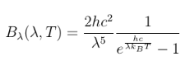 (2.3)

Where Bλ is the spectral radiance, λ the radiation wavelength, *h* Planck's constant, *kB* Boltzman's constant *c* the speed of light and *T* the temperature of the object. By maximizing Bλ, it is possible to find the dominant wavelength that is emitted at a certain temperature. Figure 2.4 depicts a plot made of spectral radiance versus wavelength at *T =* 37°C, the core temperature of humans. It is evident that the dominant wavelength is at 9.35 pm. This is in the infrared range, and therefore this type of thermal radiation thermometer is called an infrared thermometer.

In the case of measuring the temperature of the tympanic membrane, the temperature of the hot junction will be determined by the radiation received from the tympanum minus the radiation radiated by the sensor itself.

When dealing with thermal radiation, an important aspect is emissivity. Emissivity is the ability of an object to radiate thermal energy. It is quantified as a ratio of thermal energy emitted by a surface relative to the thermal energy emitted by an ideal blackbody at the same temperature. A blackbody has an idealized surface that reflects no radiation, which means all energy radiated from the surface is due to the temperature of the surface. Thus, a blackbody has an emissivity of 1 and has the maximum theoretical thermal radiation at a given temperature. The accuracy of an infrared sensor depends on the abil­ity of the object to emit sufficient thermal radiation for the sensor to detect.

*CHAPTER 2. LITERATURE REVIEW* **13**

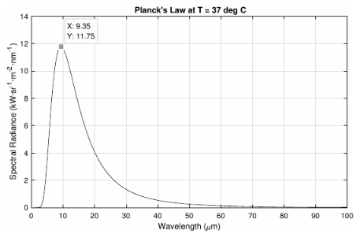

Figure 2.4: Dominant radiation wavelength at 37°C using Planck's law

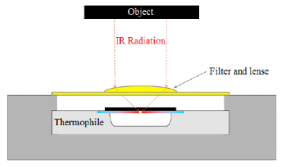

Figure 2.5: Infrared thermometer diagram (Karaki and Polyziev, 2014)

Cross-referencing various emissivity tables, it was found that the emissivity of human skin is 0.98, which means that it is an excellent emitter of ther­mal energy (Stumme *et al.,* 2003; ThermoWorks; Optotherm, 2017). The ear drum is covered with skin, making it an ideal target object for a non-contact thermometer.

An infrared thermometer generally consists of a thermophile attached to a blackbody and shielded by an infrared filter that also acts as a lens to focus infrared waves (Karaki and Polyziev, 2014). This setup, depicted in Figure 2.5, allows for the non-contact temperature sensing of the tympanic membrane. Unlike pulse and respiratory rates, core body temperature varies slowly. It takes minutes to vary significantly. Therefore, the sampling period of core temperature can be as long as 10 seconds.

**2.3.2 Commercial Temperature Monitoring Devices**

*CHAPTER 2. LITERATURE REVIEW* **14**

Ear thermometers are widely used at home and in hospitals. Ear contact ther­mometers like Novatemp® and Starboard® claim a ±0.2 °C accuracy (No­vatemp, 2011; Starboard, 2016). Non-contact infrared ear thermometers usu­ally have a similar rated accuracy. None of these are, however, wearable de­vices.

The Degree®, Figure 2.6, is a continuous in-ear thermometer for children, developed by Cosinuss, a company specialising in wearable sensors. The bulk of the device is worn behind the ear, and a wire runs over the auricle to the ear canal, in which a probe is placed. The device takes its temperature measure­ments with a sensor placed in contact with the canal wall. The manufacturer claims an accuracy of 10.1 °C (Cosinuss, 2017b). It monitors temperature continuously and sends real time data to a mobile phone.



Figure 2.6: CAD model of the Degree from the Cusinuss website (Cosinuss,   
2017b)

Apart from the Degree, there is not much literature on wearable ear ther­mometers. Two patents were found describing similar devices: US 6556852 B1 and US 20090221888 Al. The first proposes the use of an infrared sen­sor pointed at the tympanic membrane, and the latter does not specify the method of measuring. The trial planned as part of this project will add to this insufficient body of knowledge.

**2.4 Heart Rate**

There are many options available to monitor heart rate. Electronic monitoring methods include electrocardiography, photoplethysmography, ballistocardiog­raphy, phonocardiography and doppler flow-meters.

**2.4.1 Electrocardiography**

*CHAPTER 2. LITERATURE REVIEW* **15**

Electrocardiography (ECG) is a recording of the electrical activity of the heart over a period of time. Electrical activity arises from the depolarization and re-polarization of the heart muscle during the cardiac cycle. The most prominent electrical charge is the QRS complex, which corresponds to the ventricular depolarization and is visible on the electrocardiogram as a sharp peak in the millivolt range. ECG is the recommended way of monitoring heart rate in most intensive care units. A cardiologist will use a 12 lead ECG with 10 electrodes placed in a specific configuration on the chest. Various wearable devices use ECG to measure heart rate. Fitness monitors normally use a chest strap with electrodes to detect the electrical activity of the heart.

Studies have been done developing wearable ECG devices for clinical use. The latest in wearable ECG electrodes is the use of dry polymer-based mate­rials (Wang *et al.,* 2010) or non-contact electrodes that can be place on top of clothing (Lin *et al.,* 2013). This is an improvement on the standard conductive gels or adhesives and can be used repeatedly. But these electrodes still need to be placed on the chest.

An ear located ECG monitor has been developed by Winokur *et al.* (2012). This device uses a single lead setup with one electrode placed on the mastoid bone behind the ear and a reference electrode placed on the neck. This config­uration relies on the conductive properties of human tissue to carry electrical charges from the heart to the ear. They were able to use the electrocardiogram in conjunction with PPG and BCG to determine various heart intervals and track changes in mean arterial blood pressure. Figure 2.7 depicts Winokur *et al.* (2012)'s device and a plot of its electrocardiogram. No heart rate infor­mation was extracted.

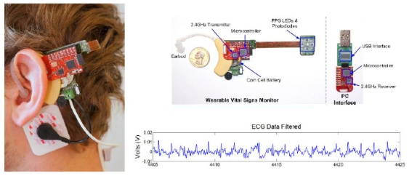

Figure 2.7: Ear-worn device developed by Winokur *et al.* (2012)

**2.4.2 Photoplethysmography**

*CHAPTER 2. LITERATURE REVIEW* **16**

Photoplethysmography (PPG) produces an optically obtained plethysmogram, which plots the volume of an organ over time. PPG can be used to measure the change in the volume of blood vessels close to the skin surface. When the left ventricle contracts a pressure pulse propagates through the arteries from the heart to the extremities of the body. This wave corresponds to the systolic blood pressure. Blood vessel walls contain elastic fibres that allow it to stretch. This means that the diameter of vessels will increase when the blood pressure increases, causing arteries to stretch and contract with each cardiac cycle. PPG can be used to determine heart rate by measuring this volumetric variation.

A photoplethysmograph can non-invasively determine peripheral arterial blood volume by shining light through the skin surface, into the dermis and subcutaneous tissue and collecting the light transmitted or reflected. Light shined into the tissue can either be reflected, absorbed or allowed to transmit through. This leads to the two modes of PPG operation depicted by Figure 2.8.

Transmission Reflection



PD LED PD

(a) (b)

Figure 2.8: The two modes of Photoplethysmography (Tamura *et al.,* 2014)

In (a) the emitter and detector face each other and are separated by tissue that can transmit the light, leading to a transmission mode PPG. Transmission mode PPG is limited to locations on the body where transmitted light can be detected, like the finger, ear lobe, concha and tragus. These locations have limited blood profusion, especially at low temperatures. In (b) the emitter and detector are placed on the same plane and both faces towards the tissue. Light from the emitter is reflected by the tissue and captured by the detector, leading the reflection mode PPG. The emitter and detector need to be optically isolated so that light cannot pass from the one to the other without going through the tissue. Reflectance mode PPG can be used at more locations, but is more susceptible to motion artefacts (Tamura *et al.,* 2014).

According to Lambert's law, the amount of light absorbed is proportional to the length of the path that the light has to travel in the absorbing substance (Encyclopaedia Britannica, 2009). Therefore, a change in blood vessel diameter

will increase the distance the light has to travel causing a change in light absorption. This can be detected by measuring reflected or transmitted light. Variation in the light reflected or transmitted will be synchronised with the heart rate.

*CHAPTER 2. LITERATURE REVIEW* **17**

Shorter light wavelengths are mostly absorbed by the tissue, while longer wavelengths can penetrate deeper. Red and near infrared light are preferred for transmission PPG. Green light is becoming more popular for shallow re­flectance PPG, due to larger light variations during the cardiac cycle and less noise than near infrared PPG (Tamura *et al.,* 2014).

The signal read by the photo detector of the pulse oximeter consists of an AC component superimposed on a DC signal. The DC component is due to the constant transmission or reflection of light by the body's tissue: skin, fat, venous blood and the non-pulsating arterial blood. The AC component is the variation in transmitted or reflected light due to the change in diameter of the arteries and therefore synchronised to the heart rate. The AC component is usually between 0.5 - 2% of the DC component (Tavakoli Dastjerdi, 2006). Figure 2.9 illustrates the way in which the heart rate is visible in a photo­plethysmograph. It can be seen that the blood volume increases with each heartbeat, and that this causes more light to be absorbed, thus less detected by the photodiode.

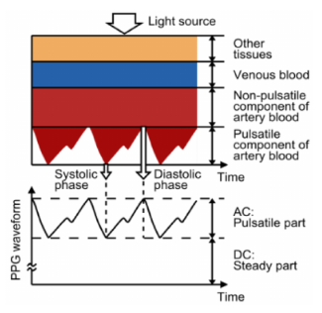

Figure 2.9: Basic operating principles of PPG (Tamura *et al.,* 2014)

**2.4.2.1 Work done by others in Ear PPG**

A review of work done by others in the field of ear PPG reveals six devices relevant to this study.

Shin *et al.* (2009) present a wearable music headset with an integrated transmission PPG ear clip that attaches to the ear lobe. The device includes an accelerometer to aid in the removal of motion artefacts. Evaluation was done through a study comparing the heart rate from the device to that made with a conventional ECG recorder. This study revealed a heart rate error of 0.6%.

*CHAPTER 2. LITERATURE REVIEW* **18**

Poh *et al.* (2010) designed a wearable PPG with a magnetic earring sensor. The bulk of device sits in front of the ear and is held in place by a band around the auricle, as can be seen from Figure 2.10. A reflective PPG sensor is held against the ear lobe by placing a magnet on the opposite side. The device also includes an accelerometer to make baseline measurements for motion artefact cancellation. A study was conducted to compare the PPG signals measured by the wearable device to chest ECG signals collected by a FDA-approved commercial system. Whilst standing motionless, the study found a very high correlation between the ear PPG and the chest ECG with a mean bias of 0.62 ± 4.51% with ECG reference measurements.

Figure 2.10: Wearable ear PPG device by Poh *et al.* (2010)

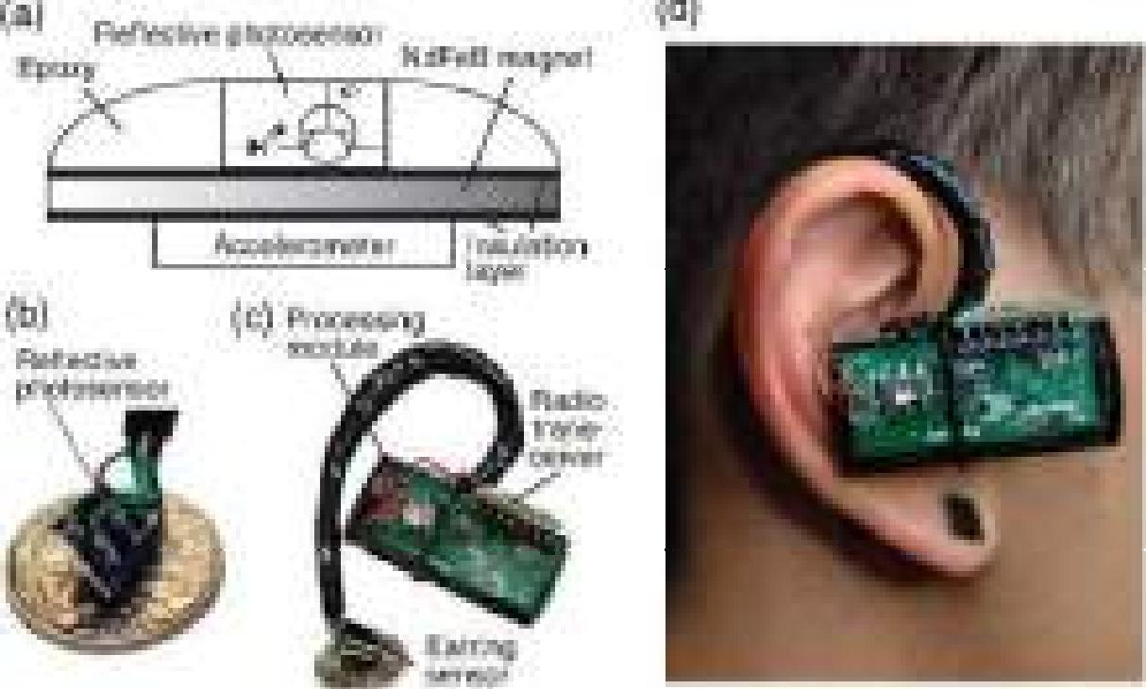

**1111 FleiN len' I 14115:Kire-Ay**

**14 IRO mei ;**

**eFccrl.**

Da He *et al.* (2010) researched an ear worn heart rate monitor containing a PPG sensor in reflectance mode. Red light is shined into the tissue behind the ear and collected by a photodiode chip with an integrated transimpedance am­plifier. Signals were not digitalised on the device, but recorded and processed on MATLAB. The collected signal was compared with a transition finger PPG and a chest ECG. Figure 2.11 illustrates this comparison.

Winokur *et al.* (2012) developed a similar device that shines 660nm and 940nm light waves through tissue at the mastoid bone and collecting the re­flected light with 4 photodetectors. A PPG front end conditioned the signals and their device sent the raw heart beat information to a PC through a radio connection. This is the same device that records ECG and is used to analyse heart intervals and mean blood pressure rather than heart rate

*CHAPTER 2. LITERATURE REVIEW* **19**

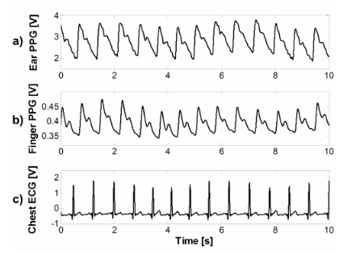

Figure 2.11: Comparing ear PPG to finger PPG and chest ECG (Da He *et al.,* 2010)

Buske *et al.* (2009) proposed yet another location. They modified a pair of headphones to measure a transmission PPG from the concha. During the testing phase, the device showed an average heart rate accuracy of around 85% when compared to an ECG.

The Cosinuss One® is a commercial device that monitors heart rate through the ear canal. The earpiece presses against the ear canal wall and records a PPG in reflection mode. It targets athletes that want to monitor their bodies during exercise.

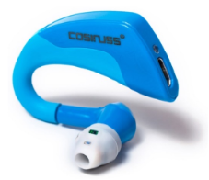

Figure 2.12: Cosinuss One® ear worn heard rate device (Cosinuss, 2017a)

**2.4.3 Ballistocardiography**

Ballistocardiography (BCG) is the measurement of the mechanical effects of   
the beating heart on the body over time. Typically, accelerometers or pressure

sensors are used to measure movement or forces on the surface of the body. BCG has been researched for use in ear heart rate extraction.

*CHAPTER 2. LITERATURE REVIEW* **20**

In a wearable device proposed by Da He *et al.* (2010), mechanical vibrations associated with heart rate are converted to electronic signals through capacitive sensing electrodes placed behind the ear. This method works by measuring the change in capacitance between the two electrodes as the distance between them changes due to heart rate vibrations.

A study by Winokur *et al.* (2012) proposed measuring the head-to-foot axis recoil due to the blood-volume shift during cardiac ejection. This is done by placing a MEMS accelerometer behind the auricle. Due to the movement dependent method of operation this technology is extremely susceptible to motion artefacts and it can only be used when the body is stationary.

A variation of this technology is discussed in an article by Park *et al.* (2015). They propose using a scissor shaped hinge mechanism in the ear canal that measures the change in the canal size due to the in-ear blood pulse waves. The mechanical movement is converted to an electrical signal through a piezoelectric film sensor. Figure 2.13 shows a drawing of this device from Park's 2015 article.

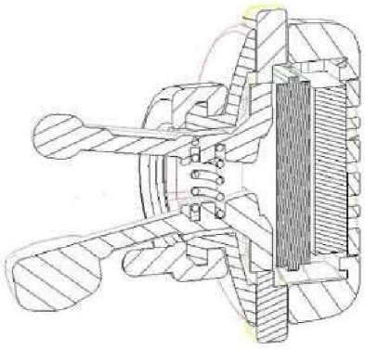

Figure 2.13: Device to measure in ear pulse waves due to the heart beat   
(Park *et al.,* 2015)

**2.4.4 Other Heart Rate Methods**

Electronic stethoscopes use a microphone to record heart sounds. The heat makes a distinct series of sounds during the cardiac cycle due to blood turbu­lence and the shutting of heart valves. A plot of the heart sounds is known as a phonocardiogram. The period of this sound series can be used to determine heart rate and it does not require skin-contact.

A Doppler flow-meter can be used to detect the alternating blood current component in near-surface arteries. This component is synchronised to the

heart rate frequency. The device can use ultrasound or electromagnetic waves to achieve the Doppler shift.

*CHAPTER 2. LITERATURE REVIEW* **21**

**2.5 Respiratory Rate**

Unlike the other vital signs, a person cannot measure his or her own respiratory rate. As soon as a person is consciously thinking about respiration, breathing usually slows. Measuring needs to happen while the person's thoughts are otherwise occupied. Therefore, a continuous measuring method is preferred. Typically, a nasal mask or chest strap will be used to measure respiration.

**2.5.1 Respiratory Rate Ear Sensors**

Ear located devices that extract respiration information are rare, but some literature sources are available.

Goverdovsky *et al.* (2016) tested an ear probe with two embedded micro­phones. The microphones could detect the sound created by turbulence in the airways for breathing rates higher than 12 breaths per minute. Figure 2.14 shows a plot of the normalised sound amplitude at two different breathing rates. Variation during breathing can be seen in both recordings.

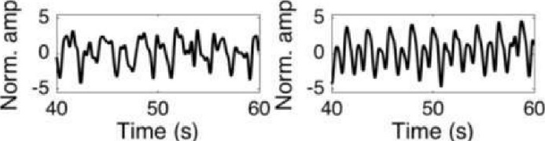

Figure 2.14: Breathing detected through microphones inside the ear canal   
(Goverdovsky *et al.,* 2016)

Da He *et al.* (2010) did extensive research on the ear as a location for vital sign monitoring. They extracted respiratory rate from baseline oscillations in a BCG signal recorded by capacitive electrodes placed behind the ear. Mechan­ical movement is converted to electrical signals by these electrodes. Therefore, the movement of the head due to respiration is seen on the BCG as baseline oscillations, Figure 2.15.

**2.5.2 Respiratory related Heart Rate Characteristics**

A different approach is to extract respiratory rate by analysing the heart rate. A PPG signal contains three distinct respiratory related characteristics: am­plitude modulation (AM), respiratory-induced intensity variation (RIIV) and frequency modulation (Johansson, 2003).

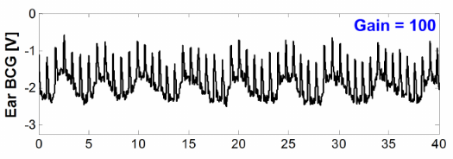

Figure 2.15: Baseline oscillations in behind the ear BCG due to breathing   
(Da He *et al.,* 2010)

Amplitude modulation is due to blood pressure changes during the res­piratory cycle called Pulsus Paradoxus. RIIV is changes in the volume of the dermis and subcutaneous capillary bed. It is visible as baseline variation in the PPG signal. Frequency modulation of the heart rate synchronised to respiration rate, called respiratory sinus arrhythmia (RSA).

RSA can also be detected in ECG, but differs from the fluctuations seen in chest ECG, due to electrodes movement relative to the heart and changes in chest impedance during the respiratory cycle (Moody *et al.,* 1986). These fluc­tuations cannot be detected in the ear. RSA is observed as baseline oscillation in heart rate in synchrony with the respiratory rate. Heart rate increases dur­ing inspiration and decreases during expiration (Yasuma and Hayano, 2004). According to a study done by Stratton *et al.* (2003), the variation in heart rate due to RSA is higher in younger test subjects, with a 74% increase in children versus a 52% increase in adults.

Research has been done to develop algorithms to utilise these characteris­tics to extract respiratory rate from PPG signals. Clifton *et al.* (2007) used wavelet analysis and achieved a respiratory rate accurate to within 1 breath per minute and Leonard *et al.* (2006) documented a respiratory rate error of 7.9%. Johansson (2003) developed two neural network algorithms that use the different respiratory related characteristics of PPG signals to detect breaths. Table 2.1 shows the results of the best algorithm.

Table 2.1: Results of the respiratory rate extraction through neural networks (Johansson, 2003)

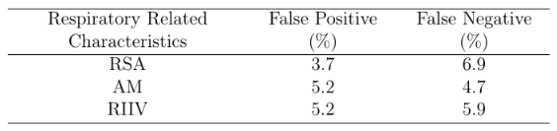

*CHAPTER 2. LITERATURE REVIEW* **22**

**2.6 Blood Oxygen Saturation**

*CHAPTER 2. LITERATURE REVIEW* **23**

Oxygen saturation can be measured by means of an arterial blood gas test re­sulting in an arterial oxygen saturation reading. This requires drawing a blood sample for testing and therefore is not relevant to this study. An alternative method is pulse oximetry. This method estimates peripheral capillary oxy­gen saturation, SpO2, through the spectrophotometric analysis of PPG signals captured at two different wavelengths. This is a clinically accepted estimation of the arterial oxygen saturation (Aoyagi, 2003).

**2.6.1 Pulse Oximetry Theory**

Blood oxygen saturation estimation through pulse oximetry relies on the dif­ferent adsorption spectra of oxyhaemoglobin and deoxyhaemoglobin. Figure 2.16 shows the absorption spectra of oxy- and deoxyhaemoglobin.

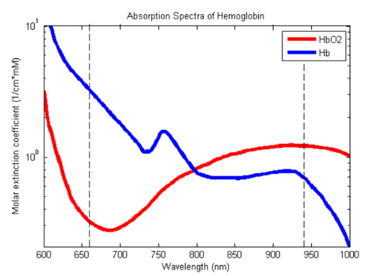

Figure 2.16: Absorption spectra of oxy- and deoxyhemoglobin

It can be noted that deoxyhaemoglobin has a significantly higher absorption of red light while oxyhaemoglobin has a slightly higher absorption of infrared light.

According to Beers law, the amount of light absorbed by a dissolved sub­stance is proportional to its concentration (Encyclopaedia Britannica, 2009). Therefore, oxygenated blood (with a higher concentration of oxyhaemoglobin) will absorb more infrared light and reflect more red light. Whereas deoxy­genated blood (with a higher concentration of deoxyhaemoglobin) will absorb

more red light and reflect more infrared light. This explains why oxygenated blood appears bright red, while deoxygenated blood is a darker shade of red.

*CHAPTER 2. LITERATURE REVIEW* **24**

Red and infrared light are shined into the peripheral tissue and the light reflected or transmitted is measured for both wavelengths. Literature and commercial devices usually use wavelengths of 660 nm (red) and 940 nm (near infrared) (Tytler and Seeley, 1986; Chan and Underwood, 2005; Bagha and Shaw, 2011; Bheema lingaiah *et al.,* 2013; Duun *et al.,* 2007). The ratio of reflected or transmitted light is unique to a certain level of blood oxygen sat­uration and is used to estimate blood oxygen saturation.

The Beer-Lambert law describes the absorption of a specific wavelength of light by a substance in a homogeneous solution (Bagha and Shaw, 2011). It can be used to calculate light intensity as show by Equation 2.5 or it can be manipulated to give what is called the unscattered absorption factor as shown in Equation 2.4 (Kennedy, 2015).



A is the dimensionless adsorption factor, *E* is the wavelength dependant molar absorptivity, *c* is the concentration of the substance and *L* is the path length the light needs to travel through the substance. /0 is the intensity of the light entering the solution and I is the intensity of light passing though the solution.

Equation 2.4 can be used to calculate the concentration of oxyhaemoglobin in the blood of the peripheral tissue, provided that the absorptivity and path length of all materials inside the tissue is known. This is not practical, for the thickness and absorptivity of skin and subcutaneous tissue varies between individuals. Furthermore, this equation is also not valid when taking into account the reflection of light, which is fundamental when the application requires reflection mode pulse oximetry.

To solve this problem, a modulated relationship, seen in Equation 2.6, is used that compensate for the different DC absorption between patients (Konig *et al.,* 1998; Duun *et al.,* 2007; Bheema lingaiah *et al.,* 2013; Bagha and Shaw, 2011; Nitzan *et al.,* 2014; Oak and Aroul, 2015).



Where *R* is the SpO2 modulation ratio. This ensures that the O2 saturation of only the arterial blood is calculated. The ration can be checked against an empirical determined curve. The standard formula for this curve is found in

literature as % *SpO2 =* 110 - 25R, (Oak and Aroul, 2015) but it can vary from device to device.

*CHAPTER 2. LITERATURE REVIEW* **25**

As mentioned, O2 can be calculated using reflected or transmitted light. Light that is not absorbed or scattered by tissue can be either reflected, or transmitted. Thus, both reflected and transmitted light is proportional to the mount of light absorbed. Transmittance mode pulse oximeters are more common, but their use is restricted to parts of the body that allow light to pass through, like a fingertip or earlobe.

Pulse oximetry is clinically accepted and currently the most accurate way to monitor O2 saturation non-invasively (Aoyagi, 2003; DeMeulenaere, 2007; Chan *et al.,* 2013; Lee *et al.,* 2016). This being said, note should be taken of the limitations of this method. Pulse oximeters measures O2 saturation indirectly by analysing differences in light absorption, rather than directly measuring oxygen concentration in the blood as is done during a blood gas test. This allows ease of use and non-invasive measurement abilities, but sacrifices some accuracy. Various studies have been conducted to quantify the accuracy of the pulse oximeter. Table 2.2 sums up some of these studies.

Table 2.2: SpO2 Accuracy

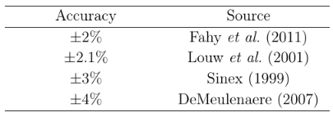

The results differ in their exact quantities, but there is no doubt about a uncertainty factor of at least ±2% that should be kept in mind when taking measurements with an pulse oximeter, especially during the trial period of this project.

**2.6.2 Work done by others in ear pulse oximetry**

Standard locations for pulse oximetry include the fingertip, earlobe, ankle and forehead. A study comparing fingertip and earlobe pulse oximetry to an arterial blood gas test found that finger pulse oximetry differed by a mean of -0,71% and earlobe pulse oximetry differed by a mean of +4.2% (Olive *et al.,* 2016). Literature and commercial wearable pulse oximeters typically utilise a finger clip to measure SpO2 (Watthanawisuth *et al.,* 2010; Pujary *et al.,* 2003; Huang *et al.,* 2014; Khalifa *et al.,* 2014). This location is not ideal for continuous monitoring and is especially susceptible to motion artefacts.

Although the fingertip location is not of interest to this study, the literature is still reviewed for similar principals can be applied to ear pulse oximetry.

*CHAPTER 2. LITERATURE REVIEW* **26**

Ear lobe pulse oximetry is usually done through a sensor that clips to the ear lobe, and is attached to a stationary device. Wearable ear pulse oximetry is still novel and not well covered in literature. There are some patents filed for wearable ear SpO2 devices (US 20050177034 Al, US 4086915 A, US 3412729 A and US 6556852 Bl) and the Bragi Dash (Bragi, 2017), as can be seen in Figure 2.17, is one of the first commercial devices to claim this ability. However, little academic material is available.

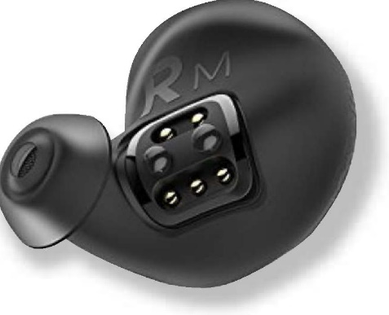

Figure 2.17: Bragi Dash

A study done by (Aziz *et al.,* 2006) tested a wireless earlobe-mounted pulse oximeter on a group of subjects. Subjects were tested while sitting, walking and running. During the sitting and walking phases they recorded an SpO2 reading of above 95%, which is "as expected" according to them. But during the running phase they could not obtain any accurate reading.

**Chapter 3**

**27**

**Concept Selection**

This chapter builds on the knowledge gained in the literature review and ex­plains the logic used to select the methods and sensors to realize each vital sign monitoring requirement of the Ear-Monitor. Selections are made by analysing advantages and disadvantages of each option and combining it with sound engineering judgement.

**3.1 Temperature**

The Ear-Monitor measures core temperature from the inside of the ear canal. The main criteria are sensor size and measurement accuracy. The method-and sensor selection are discussed separately.

**3.1.1 Temperature measurement method**

Two temperature measuring methods are considered, namely contact- and non-contact thermometers.

**3.1.1.1 Contact thermometers**

A contact RTD, thermocouple or thermistor is placed in contact with the canal wall, canal air or tympanic membrane. Table 3.1 summarises the evaluation.

*CHAPTER 3. CONCEPT SELECTION* **28**

Table 3.1: Contact thermometers evaluation

|  |  |  |
| --- | --- | --- |
|  |  | **Advantages**   * Available in small sizes, ideal for the size restrictions of the ear canal. * Good accuracy. * Converting transducer voltage to temperature is simpler than with non-contact thermometers. |
| IMAGE |
|  |
| Sensor size: 0.5x2.3 mm  Measurement accuracy:  0.15 °C | | **Disadvantages**   * Canal wall and canal air temperature measurements can easily be influenced by ambient temperature conditions. * Tympanic membrane contact can cause discomfort and harm to the wearer. * More time is needed to take measurements, for the sensor needs to be in thermal equilibrium with the object. |

**3.1.1.2 Non-contact Thermometers**

A non-contact, infrared sensor is placed inside the ear canal and pointed at the tympanic membrane. Table 3.2 summarises the evaluation.

*CHAPTER 3. CONCEPT SELECTION* **29**

Table 3.2: Non-contact thermometers evaluation

|  |  |  |
| --- | --- | --- |
|  |  | **Advantages**   * The sensor can measure the temperature of the tympanic membrane directly, which is the best representation of core temperature in the ear. * Temperature conversion compensates for different ambient temperature conditions. * No contact with the tympanic membrane significantly lowers the injury risk to the user. |
| IMAGE |
|  |
| Sensor size: 1.6 - 4 mm ØMeasurement accuracy: 0.2-0.5 °C | | **Disadvantages**   * Non-contact temperature sensors are typically bigger than contact thermometers, adding to the size limitation challenge. * If the tympanic membrane does not fill a considerable fraction of the sensor's field of view, erroneous measurements can occur. |

**3.1.1.3 Temperature measurement method choice**

A non-contact, infrared sensor is selected for the Ear-Monitor. User safety, without significant performance compromise gives it superiority over contact thermometers for this application. The lower accuracy is justified by the fact that the tympanic membrane is a better representation of the core body tem­perature.

**3.1.2 Temperature measurement sensor**

To realize non-contact temperature measurement, two infrared sensors are con­sidered: The ST60 Micro from Dexter Research Center Inc and the TMP006 from Texas Instruments.

**3.1.2.1 ST60 Micro**

The ST60 Micro is a one channel, 80-junction, completely analogue tempera-   
ture sensing device. It is enclosed in a Micro-TO package which is 4.09 mm   
in diameter as shown in Figure 3.1. The manufacturer emphasizes the ST60

*CHAPTER 3. CONCEPT SELECTION* **30**

Micro's versatility and proposes use in tympanic ear thermometers. A die temperature thermistor is available for ambient temperature compensation. Four wires are used to supply the sensor with power and to read transduced voltages.

|  |  |  |
| --- | --- | --- |
|  | WIND. SHOWN .080 x 080 x .020 |  |
| TOP VIEW  WITHOUT COVER |  |

Figure 3.1: ST60Micro diagram from the datasheet

**3.1.2.2 TMP006**

The TMP006 is a fully integrated infrared sensor measuring only 1.6x1.6x0.8 mm, ideally suited for a narrow ear canal. Thermophile voltage and sensor temperature are made digitally available through hardware registers. These two values can be used to calculate the object temperature. Registers are accessed by a MCU though I2C communication. Values are digitalized by a 16-bit on-chip ADC, eliminating the need for supporting analogue filters and amplifiers. The user guide of the TMP006 suggests that it be used to calculate the surface temperature of target objects with emissivity values greater than 0.7, and preferably greater than 0.9. The literature study revealed that the emissivity of the eardrum is 0.98, placing it well within the required range.

**3.1.2.3 Temperature measurement sensor choice**

The simple shape of the ST60 Micro makes it easy to mount, but the diameter of the package may not fit in smaller ear canals and leave little room for the other sensors. Therefore, the ST60 Micro is eliminated.

The smaller package size and on-chip ADC justify the selection of the TMP006 for use in the Ear-Monitor. The TMP006 needs no separate ana­logue filter and amplifier. Furthermore, the manufacturer supplies detailed calibration documentation, allowing for more accurate and time effective cali­bration.

**3.2 Heart Rate**

*CHAPTER 3. CONCEPT SELECTION* **31**

The Ear-Monitor extracts heart rate from in or around the ear canal. The main criteria are sensor size, unobtrusiveness and the susceptibility of the signal to noise. The method- and sensor selection are discussed separately.

**3.2.1 Heart rate measurement method**

The following five methods from literature are considered to measure heart rate.

**3.2.1.1 Ear ECG**

As shown by Winokur *et al.* (2012), an electrocardiogram can be detected behind the ear. One electrode is placed behind the ear on the mastoid bone and the other on the back of the neck. A differential amplifier and ADC is used to acquire the signal. Table 3.3 summarises the evaluation.

Table 3.3: Ear ECG

|  |  |  |
| --- | --- | --- |
|  |  | **Advantages**   * ECG is the standard method used by  cardiologists to measure heart rate. * Other cardiac information can be extracted from ECG i.e. heart rhythm, heart damage and the state of the conductive heart tissue. * No pulse transit time delay. |
| IMAGE |
|  |
|  |
|  | |
| Sensor size: 10 mm Ø electrodes  Unobtrusiveness: Bad -  electrode needed behind  ear and on neck  Signal robustness: Noisy  (Winokur *et al.,* 2012). | | **Disadvantages**   * The sensor cannot be fitted entirely inside the ear canal. * Two electrodes are needed. * Separate signal acquisition electronics are needed. |
|  |

**3.2.1.2 Ear PPG**

A LED and photodiode are used to detect variation in subcutaneous tissue blood volume due to the beating heart. Literature identifies three possible locations: inside the ear canal, the earlobe and the concha. With unobtrusive­ness in mind, the ear canal method is selected. This means reflective PPG is used. Table 3.4 summarises the evaluation.

*CHAPTER 3. CONCEPT SELECTION* **32**

Table 3.4: Ear PPG

|  |  |  |
| --- | --- | --- |
|  |  | **Advantages**   * A substantial pressure pulse can be  detected in and around the ear. * Pulse oximetry, a type of PPG, is a tried and tested way of measuring heart rate and SpO2. * Respiratory related characteristics like amplitude modulation,   respiratory-induced intensity variation and frequency modulation can be found only in PPG signals and can be used to determine respiratory rate. |
| IMAGE |
|  |
|  |
| Sensor size: Smallest -  1.9x2.6x0.8 mm  Unobtrusiveness: Good -  fits inside ear canal  Signal noise: Low - clear  pressure wave visible  (Da He *et al.,* 2010) | | **Disadvantages**   * PPG is susceptible to motion artefacts   and variation in blood profusion.   * Few PPG sensor packages are available to   fit inside the ear canal.   * Using separate LEDs and photo detectors   increases the complexity and size for the  proof of concept Ear-Monitor. |

**3.2.1.3 Ear BCG**

A pressure sensitive sensor or accelerometer is placed inside the ear canal to detect the mechanical effects of the pulsating heart. Table 3.5 summarises the evaluation.

*CHAPTER 3. CONCEPT SELECTION* **33**

Table 3.5: Ear BCG

|  |  |  |
| --- | --- | --- |
|  | | **Advantages**   * Pressure sensors can be made small enough for the limited space in the ear canal. * Accelerometer can also be used to measure respiratory rate. |
|  |  |
| IMAGE |
|  |
|  |
|  |
| Sensor size: Smallest -  3 x 3 x 1 mm (ST Electronics, 2016a)  Unobtrusiveness: A part of  the sensor protrudes from  the ear, can be made  smaller  Signal noise: High (Da He  *et al.,* 2010; Winokur *et al.,*  2012) | | **Disadvantages**   * The signal detected by Da He *et al.*   (2010) and Winokur *et al.* (2012) appears  noisy and detecting beats will be  troublesome.   * This method will be influenced by motion   artefacts to such an extent that it will be  unusable for most forms of practical use. |
|  |

**3.2.1.4 Phonocardiogram**

A microphone is placed inside the ear canal and identifies heart beats by analysing the sound produced by the cardiac cycle. Table 3.6 summarises the evaluation.

Table 3.6: Ear Phonocardiogram

|  |  |  |
| --- | --- | --- |
|  |  | **Advantages** |
| IMAGE |
|  | * Can be used to detect breathing as well,  as shown by Goverdovsky *et al.* (2016). |
|  |
| Sensor size: 3.35 x 2.5 x  0.98 mm (ST Electronics,  2016b)  Unobtrusiveness: Can fit inside the ear canal  Signal noise: High | | **Disadvantages**   * Sounds from other sources like movement and speaking can corrupt the signal. |
|  |

**3.2.1.5 Heart rate method choice**

Ear PPG is selected as the Ear-Monitor's method of measuring heart rate.   
PPG produces a clear signal that will allow for accurate beat detection. This

method can also be incorporated into the SpO2 measurement sensor, eliminat­ing the need for two different sensors. The entire sensor fit inside the ear canal, making it unobtrusive. This method is also less susceptible to noise than ear BCG or a phonocardiogram.

*CHAPTER 3. CONCEPT SELECTION* **34**

**3.2.2 Heart rate measurement sensor**

Reflexive ear canal PPG is selected to measure heart rate. Three PPG sen­sors options are considered namely: separate LEDs and photodetector, the NJL5501R from JRC and the MAX30100 by Maxim Integrated.

**3.2.2.1 Separate LEDs and photodetector**

SMD LEDs are used with one or more photo detectors. The components are mounted on a thin PCB and placed in the ear probe. The LEDs and photo detectors can be placed in various precise configurations and a wider choice of individual transducers can be used. Additional analogue electronics are needed to drive the LEDs, conditioning the detector signal output and compensate for ambient lighting. A commercial integrated analogue front-end chip like Texas Instruments' AFE4400 is used to perform this task.

**3.2.2.2 NJL5501R**

The NJL5501R is a surface mounted photo-emitter and -detector contained in one 1.9 x 2.6 x 0.8 mm package shown in Figure 3.2. Red and infrared LEDs make it suitable for reflective pulse oximetry and heart beat detection. Its small size allows it to fit in the ear canal while leaving adequate space for other sensors. It requires all the same supporting electronics such as using the separate LEDs and a photo-detector method.

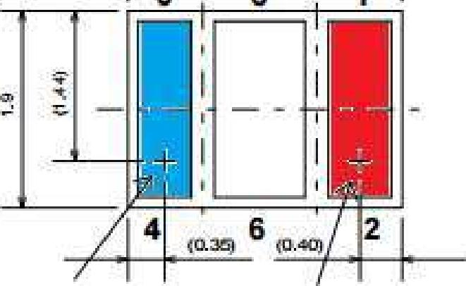

**IR LED RED LED**

Figure 3.2: NJL5501R diagram from the datasheet

**3.2.2.3 MAX30100**

*CHAPTER 3. CONCEPT SELECTION* **35**

The MAX30100 is a single chip pulse oximeter and heart rate detector. It has red and infrared LEDs, a photodetector, a 16-bit ADC and digital filters all in one 5.6 x2.8 x 1.2 mm, 14-Pin package. The LEDs and photodetector are in the same plane, which means it operates in reflective mode. Like the TMP006 it uses the I2C protocol to communicate with a MCU. Configuration registers allow the designer to specify sample rate, LED currents and LED pulse width. Figure 3.3 shows a block diagram of the internal systems of the MAX30100.

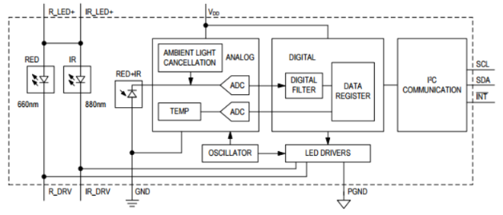

Figure 3.3: MAX30100 block diagram from the datasheet

The MAX30100 uses a 3.3V supply and programmable current sources to drive the LEDs, whilst digital operations are done at 1.8V. It draws between 6 and 12 mA mA while recording red and infrared PPGs. It has a digital 50Hz/60Hz notch filter to reject powerline interference. LEDs can be varied individually from 0 to 50 mA and the alternating LED pulse widths can be varied from 0.2 to 1.6 ms. A sample rate can be selected between 5 and 1000 samples per second. An important feature of the MAX30100 is its 64-byte deep FIFO register which is used to store the output values. Each output set consists of a 16-bit red and 16-bit infrared value, which means that there are 4 bytes per output and therefore 16 sets of output values can be held in the FIFO at any time. The MCU reads 4 bytes at a time from the FIFO to obtain the latest red and infrared values.

**3.2.2.4 Heart rate sensor choice**

The MAX30100 is selected for use in the Ear-Monitor. It has optimized optics to guide outgoing and incoming light. It has integrated ambient light cancel­lation. Its entire AFE is integrated which means that no additional electronics are needed, apart from the 12C lines and power regulators. This gives it a big

advantage over the more complex separate LEDs and photodetector method. Its small size and reflective mode of operation allows it to be placed inside the ear canal. Data recorded by the MAX30100 will be used to calculate heart rate and SPO2.

*CHAPTER 3. CONCEPT SELECTION* **36**

**3.3 Respiratory Rate**

The Ear-Monitor measures respiratory rate from inside the ear canal. The main criteria are sensor size and susceptibility to noise corruption.

**3.3.1 Respiratory rate measuring method**

The following three respiratory rate measuring methods from literature are considered.

**3.3.1.1 Accelerometer**

A small MEMS accelerometer is placed inside the ear canal and measures the movement of the head caused by breathing. Table 3.7 summarises the evaluation.

Table 3.7: Ear Accelerometer

|  |  |  |
| --- | --- | --- |
|  |  | **Advantages**   * The accelerometer can serve the dual   purpose of measuring breathing and heart rate, thus saving space. |
| IMAGE |
|  |
|  |
| Sensor size: 3 x 3 x 1 mm  (ST Electronics, 2016a)  Noise: Very high | | **Disadvantages** |
| * This method is extremely vulnerable to   noise form other movements. |

**3.3.1.2 Microphone**

A microphone is placed inside the ear canal and records the sound of air moving through the respiratory tracts, allowing the respiratory rate to be determined. Table 3.8 summarises the evaluation.

*CHAPTER 3. CONCEPT SELECTION* **37**

Table 3.8: Ear Microphone

|  |  |  |
| --- | --- | --- |
|  |  | **Advantages**   * The microphone can serve the dual   purpose of measuring breathing and heart rate, thus saving space. |
|  |
| IMAGE |  |
|  |
| Sensor size: 4 x 3 x 1 mm  (ST Electronics, 2016b)  Noise: Very high | | **Disadvantages**   * This method is extremely vulnerable to   noise form other sounds, like talking or  ambient noise. |

**3.3.1.3 Respiratory related heart rate characteristics**

The variations in heart rate are used to determine the respiratory rate. These include amplitude modulation, respiratory-induced intensity variation and fre­quency modulation of the heart rate in synchronization with the respiration rate. Table 3.9 summarises the evaluation.

Table 3.9: Respiratory related heart rate characteristics

|  |  |  |
| --- | --- | --- |
|  |  | **Advantages**   * No dedicated sensor is needed. * Less susceptible to noise than accelerometer or microphone method. |
| IMAGE |
|  |
| Sensor size: No sensor needed  Noise susceptibility: Low | | **Disadvantages**   * Only steady and relatively slow respiratory rates can be detected. |

**3.3.1.4 Respiratory Rate Sensor Choice**

Respiration measurement through analysing respiratory related heart rate char­acteristics, of which heart rate frequency modulation through respiratory sinus arrhythmia (RSA) is found to be the most detectable, is selected for use in the Ear-Monitor. This method saves space by not requiring a dedicated sensor. It is also the least susceptible to noise from other sources. No sensor selection is needed for this vital sign, as all the work is done by the micro controller.

**3.4 Blood oxygen saturation**

*CHAPTER 3. CONCEPT SELECTION* **38**

Pulse oximetry is the only practical way for the Ear-Monitor to measure blood oxygen saturation. The MAX30100 selected for measuring heart rate is equipped for this task. A red and infrared LED as well as a photo-detector are available for the joint function for measuring heart rate and SpO2.

**3.5 Final concept**

The final concept is obtained by combining the methods and sensors selected in this chapter which are summarised as follows:

* Core body temperature is measured by the TMP006 infrared sensor, located at the tip of the Ear-Monitor's ear probe and pointed at the tympanic membrane.
* Heart rate is measured by the MAX30100 reflective pulse oximeter placed on the side of the ear probe and facing the canal wall. The PPG signal is used to calculate heart rate.
* Respiratory rate is calculated by analysing respiratory sinus arrhythmia (RSA), which is the frequency modulating respiratory related heart rate characteristic.
* SpO2 is also measured by the MAX30100. The red and infrared PPGs obtained from the ear canal wall are used for this calculation.

Additionally, a microcontroller unit (MCU), battery and wireless transceiver are selected for the Ear-Monitor. The Arduino Pro Mini MCU has the neces­sary I/O pins for serial communication with the sensors and wireless module. It is also easy to program, making it ideal for the proof of concept version of the Ear-Monitor. Lithium polymer (LiPo) batteries are currently the best choice when regarding capacity, compactness, rechargeability and price. It is therefore selected to supply the power to the Ear-Monitor. Bluetooth is the typically used standard for transmitting data over short distances and is supported by most modern smart devices. The HC-05 Bluetooth modem is se­lected and allows the Ear-Monitor to send data to a supporting device through a wireless connection. Figure 3.4 shows a diagram of the Ear-Monitor concept with a more detailed drawing of the ear probe with the selected sensor

*CHAPTER 3. CONCEPT SELECTION* **36**

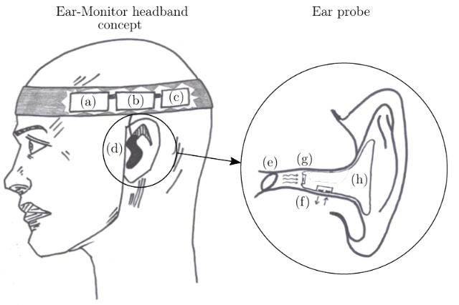

|  |  |
| --- | --- |
| (a) LiPo battery  (b) Arduino Pro Mini MCU  (c) HC-05 Bluetooth modem  (d) Ear probe | (e) Tympanic membrane  (f) MAX30100 pulse oximeter  (g) TMP006 infrared sensor  (h) Rubber plug |

Figure 3.4: Ear-Monitor concept with components labelled

**Chapter 4**

**Detailed Design**

This chapter documents the detailed design of the subsystems of the Ear-Monitor. The hardware and software facets are discussed separately.

**4.1 Hardware**

A typical telemedicine configuration is used for the Ear-Monitor and its sup­porting system. It is similar to the configuration used by Wang *et al.* (2010) and Prawiro *et al.* (2016) for their respective wearable health monitors. The ear probe is the signal acquisition module of the Ear-Monitor and contains the sensors. A microcontroller unit (MCU) is used to control the flow of data within the Ear-Monitor. Data is sent by means of a wireless transceiver to a device running supporting software, where data is stored for later access. Figure 4.1 illustrates the flow of information through the hardware set-up.

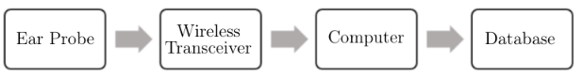

Figure 4.1: Flow of information in a typical telemedicine set-up

**40**

The detailed design of each of the key parts of hardware of the Ear-Monitor is documented in the following section.

**4.1.1 Temperature sensor**

The non-contact infrared TMP006 is selected to measure tympanic membrane   
temperature in the Ear-Monitor. Four wires are connected for power and serial   
communication lines. The package has eight solder balls for surface mounting

on a printed circuit board (PCB). A big challenge was to mount this micro-component. Various methods were tested:

*CHAPTER 4. DETAILED DESIGN* **41**

* A PCB was designed and manufactured, but mounting the miniature TMP006 on this PCB proved to be problematic.
* The device footprint and wire connection pads were etched into copper clad flexible circuit board sheets. Solder paste and a heat gun was used to mount the TMP006. Etching the flexible circuit board worked well, but mounting the TMP006 proved to be unreliable, for connections were sometimes not made properly or the component got damaged.
* Pre-mounted boards were acquired and the excess material was cut away to allow wires to be soldered to the exposed tracks.

This last method proved to be the best solution for the proof of concept ver­sion of the Ear-Monitor. It was necessitated by the lack of advanced facilities to mount micro surface-mount technology (SMT) components. The flexible circuit board method will be preferable when a SMT component placement system is available. Figure 4.2 shows the procured, pre-mounted boards and the cut-out component with the four connections. 3.3V and ground (GND) are connected to a power regulator and the two serial communication wires are connected to the serial communication input/output (I/O) pins of the MCU.

Figure 4.2: (a) TMP006 pre-mounted board and (b) the cut-out sensor   
segment with four connections labelled

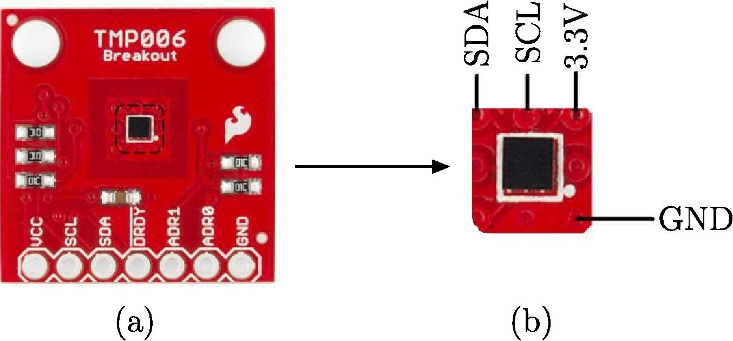

(a)

(b)

**TMP006**

**Breakout**

**01,**

According to the user guide of the TMP006, the sensor captures radiation form almost its entire 180° field of view (FOV), but most the received signal comes from sources that are parallel to, and precisely in front of the sensor. The final target object temperature is an integration of all the radiation signals captured across the FOV of the sensor.

The user guide also states that the smaller the object is, the closer it should be placed to the sensor to prevent other objects from entering the field of vision. The TMP006 is placed at the tip of the ear probe within 5 mm of

the tympanic membrane. This position removes the risk of contact with the membrane, while still ensuring thermal radiation from the canal is detected. Energy from the ear canal itself is inevitably detected by the sensor, but the majority of the radiation comes from the membrane and it is assumed that the wall near the membrane is in thermal equilibrium with the membrane within an acceptable margin.

*CHAPTER 4. DETAILED DESIGN* **42**

Energy radiated or conducted between the PCB and the sensor can cause temperature calculation errors. To prevent this, the sensor and PCB should be kept at the same temperature. The ear probe set-up of the Ear-Monitor is favourable for this task, as the PCB is very small and contains no other heat generating components. Also, the target object (tympanic membrane), stays at a constant temperature, so the sensor experiences no heat fluctuations. It is, however, necessary to allow time for the sensor and PCB to reach thermal equilibrium once placed inside the ear canal, before accurate measurements can be taken. This is not a problem, for the device is designed to be worn continuously for long periods of time.

**4.1.2 Pulse Oximeter**

The MAX30100 pulse oximeter is selected to record red and infrared pho­toplethysmographs from inside the ear canal. These are used for determining heart rate and SpO2. The MAX30100 is controlled through 5 connection wires, connected to 7 of the 14 pins of the package. Figure 4.3 shows a diagram of the MAX30100 package and the required connections for operation. 3.3 V, 1.8 V and GND are connected to a power regulator and the two serial com­munication lines are connected to the serial communication I/O pins of the MCU.

*CHAPTER 4. DETAILED DESIGN* 43

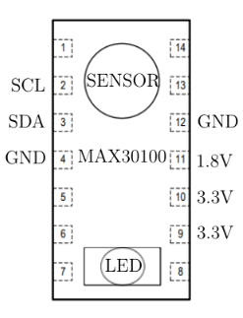

Figure 4.3: MAX30100 package diagram with required connections for   
operation.

As with the TMP006, the mounting of the extremely small MAX30100 was a great challenge. The first attempt was to design and manufacture a PCB on the typically used, 1.6 mm thick, FR4 PCB material. This PCB proved to be too thick and its inflexibility caused additional problems in ensuring firm contact with the ear canal wall. The solution was to etch the footprint, tracks and pads into flexible circuit board material. The etching process involves the following:

* Design the layout on EAGLE PCB open source software.
* Print the mirrored layout on toner transfer paper.
* Prepare the copper clad material by cleaning it with rubbing alcohol.
* Transfer the ink from the toner transfer paper to the copper clad material by applying heat and pressure.
* Submerge the copper clad material with ink layout in ferric chloride (FeCL3).
* Remove the remaining ink with acetone to reveal the copper tracks.

The ferric chloride dissolves all the copper that is exposed, leaving copper tracks that were covered by the ink during etching. The flexible copper clad material is 60 pm thick, which is ideal for the size limitations inside the ear canal. Figure 4.4 shows the layout designed and resulting etched flexible circuit

board. The flexible nature of the circuit board allows it to be folded in halve to form a two-sided circuit board, saving space and placing all the connection pads on the same end. It also allows for uniform and firm contact between the MAX30100 and the ear canal wall. Wires for power and communication are soldered to the five connection pads.

*CHAPTER 4. DETAILED DESIGN* 44

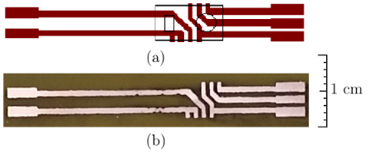

Figure 4.4: (a) is the layout as designed on EAGLE PCB with the outline of   
the MAX30100 shown in black and (b) is the finished flexible PCB with   
copper tracks

**4.1.3 Control and Communication Hardware**

The remaining electronic components consisted of the Arduino MCU, HC-05 Bluetooth modem and battery. A PCB is designed to integrate all the different hardware subsystems. Additional electronics include the power regulators, VC pull-up resistors and a charging circuit for the LiPo battery. An on-off switch and power-on indicator LED are also added.

10 kΩ pull-up resistors on the SDA and SCL lines are recommended for standard I2C communication and are therefore included in the design. A 7.4 V, 1000 mAh rechargeable LiPo battery is selected to supply power to the Ear-Monitor. The Ear-Monitor can be operated for 40 hours on a single charge (Calculations in Appendix A). The Arduino has its own power regulation circuitry on board and can be connected directly to the battery. Two low drop­out voltage regulators are selected to supply 1.8 V and 3.3 V to the sensors and Bluetooth modem. A charging circuit is added to allow the battery to be charged without physically disconnecting it from the device. Decoupling capacitors are added to all power supply lines. Figure 4.5 depicts a block diagram of the hardware of the Ear-Monitor. The diagram is split between the PCB components worn on the head and the components in the ear probe.

*CHAPTER 4. DETAILED DESIGN* **45**

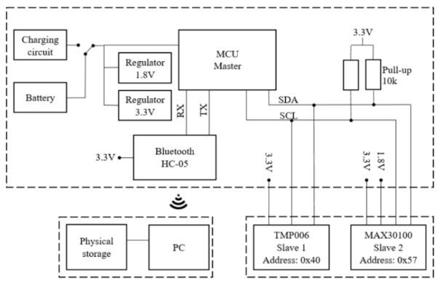

Figure 4.5: Block diagram of the Ear-Monitor’s hardware components

A schematic diagram and PCB layout are included in Appendix B. Cal­culations to select passive components is included in Appendix C. The MCU, battery, Bluetooth modem and PCB are worn in a headband around the head in this proof of concept version of the Ear-Monitor. Only the TMP006 and MAX30100 are located at their correct positions in the ear canal, and held in place by the ear probe. The ear probe is connected by a wire to the electronics in the headband. Data is sent from the headband to the PC through the wire­less connection. It is well within the abilities of the current state of technology to reduce the size of all the electronics to a hearing aid, or even ear probe size device. Such miniaturisation is, however, not within the scope of this project.

An ear probe is designed to hold the MAX30100 and TMP006 in the correct positions in the ear canal and restrict their movement to minimize artefacts. Sugru® is the brand name for a mouldable silicone elastomer which is ideal for this application. According to the product documentation it is non-toxic and does not cause skin irritation. The mouldable putty is pressed into the ear and assumes its shape, but does not conform completely. Therefore, it allows the probe to fit in different ear shapes. When cured, it has a sturdy, but flexible structure. Slots and holes are cut into the moulded probe to hold the sensors and wires. Figure 4.6 is a photo of the completed ear probe and Figure 4.7 depicts the entire hardware set-up of the Ear-Monitor.

*CHAPTER 4. DETAILED DESIGN* **46**

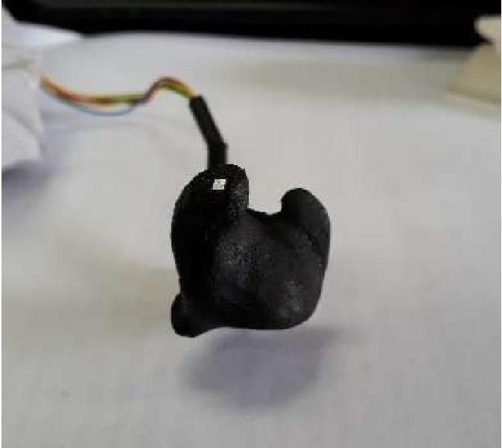

Figure 4.6: Ear probe with TMP006 visible

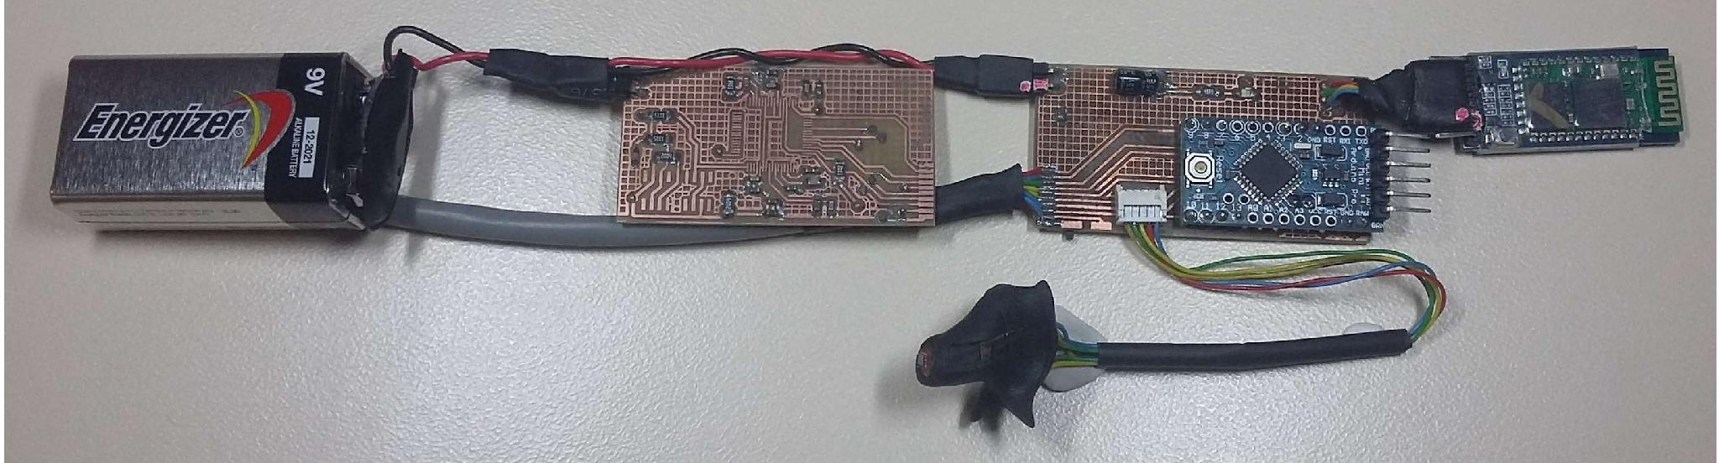

Figure 4.7: Hardware of the Ear-Monitor

**4.2 Software**

Software is written for the MCU and for the PC receiving and storing the data. MCU software is C++ based and developed using the Arduino IDE. MCU soft­ware handles sensor communication, timing, selected processing functions and the transmission of collected data via the Bluetooth modem. The PC software is Java based and developed using the Processing IDE. The PC software listens on the Bluetooth serial port, processes received data, displays the data via a user interface and stores the received data on the local hard drive.

Figure 4.8 describes the flow of data through the various software functions. The final calculated vital signs are shown in blue. The diagram is split between the MCU functions and PC functions. MCU and PC software are connected through the Bluetooth connection. The main functions are discussed in this section.

*CHAPTER 4. DETAILED DESIGN* **47**

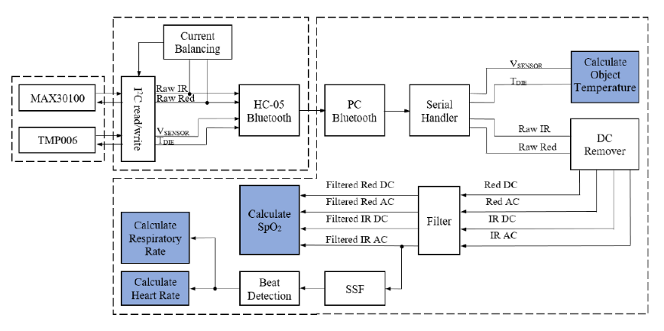

Figure 4.8: Block diagram of the flow of information through the various   
software functions. Final calculated vital signs are shown in blue

**4.2.1 Sensor Communication Software**

Software is written for the MCU to communicate with the sensors and Blue-tooth module. The MAX30100 and TMP006 have different default addresses and can share one 12C bus for communication with the MCU. 12C communi­cation happens one byte at a time with no parity and MSB first. The eighth bit of the address indicates a read or write request. Figure 4.9 shows how the software reads 16-bit values from the TMP006 registers. Values form the MAX30100 are read in a similar way.

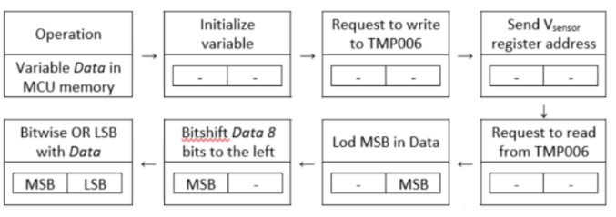

Figure 4.9: How the software reads 16-bit values from the TMP006 registers

Communication with sensors consists of two steps, configuration and read­ing data

**4.2.1.1 Sensor Configuration**

*CHAPTER 4. DETAILED DESIGN* **48**

Upon power on, both sensors start with default configurations. The MCU is programmed to reconfigure both sensors on start-up. This is done by writing values to the various configuration registers. The MAX30100 is set to SpO2 mode with 1600 ps LED pulse width, 50 Hz sampling rate and 50 mA current supply to both LEDs. The TMP006 is set to use the average of 16 conversions per output, meaning it will sample at 0.25 Hz. This is done, because the application does not demand a high sampling rate and increasing the number of samples per output will reducing noise (±0.125 °C). These configurations are done every time the Ear-Monitor is powered on.

**4.2.1.2 Reading data from sensors**

After configuration is done, the MCU enters a continuous loop of sensor data reading. The MAX30100 uses one FIFO register to store the latest 16 infrared and red photo-detector voltages and the TMPO6 has two separate registers for die temperature and sensor voltage. These registers are red through Arduino's Wiring library. The MAX30100 outputs at 50 Hz and the TMP006 at 0.025 Hz. A timing loop is created to ensure that the values are red from the sensors in time.

**4.2.2 Temperature related software**

After start-up configuration, two values, VSENSOR and TDIE, are read from the TMP006 through the I2C connection every 4 seconds.

TDIE is measured by an on-chip precision thermistor and digitalized to a 14-bit value in binary two's compliment, signed integer format with one LSB equal to 0.03125 °C. After two bytes has been read from the TMP006's TDIE register (as shows in Figure 4.9), it is bitshifted twice to the right to get the 14-bit value and then divided by 32 to get the temperature in °C. Table 4.1 show an example calculation to obtain TDIE. This conversion is done on the MCU and the value in °C is transmitted over the Bluetooth connection.

Table 4.1: TDIE example calculation

|  |  |  |  |
| --- | --- | --- | --- |
| Digital output | Right shifted twice | Decimal | ÷ 32 |
| 0000 1100 1000 0000 | 0000 0011 0010 0000 | 800 | 25 °C |

VSENSOR is the output of the thermopile and ranges from -5.12 to 5.12 mV. The 16-bit ADC converts this analogue value to a digital value with a LSB

equal to 156.25 nV. Conversion to voltage is done prior to sending the voltage value over the Bluetooth connection.

TDIE and VSENSOR are received by the PC software, where they are used to calculate TOBJ. One sensor voltage and die temperature conversion cycle takes 250 ms, and the device gives the designer an option to choose the number of conversions (N) per output sample. The average of the N samples is loaded into the output register every Nx 250 ms. In this design N is chosen to be 16 and the time per register output equals 4 seconds.

*CHAPTER 4. DETAILED DESIGN* **49**

**4.2.3 Calculating Tow**

TDIE and VSENSOR are used to calculate TOBJ. The TMP006's datasheet sug­gests using the relationship:



Where f(VSENSOR) is a function that compensates for heat flow in the form of convection and conduction. The function is described in two stages by:



and



Where Vos is a compensating offset voltage, TREF is a reference temperature equal to 25 °C and B0, B1, B2 and Care calibration parameters.

S takes into account the object emissivity (ε)*,* Stefan-Boltzman constant (σ) and the non-ideal absorption of the sensor itself. It is described by:



Where S0 = εσ*,* TREF *=* 25 °C and Al and A2 are parameters experimentally derived through calibration.

The TMP007 is the same sensor as the TMP006, but with a built-in math engine. The recommended calibration parameters from the TMP007's data sheet is shown in Table 4.2. These parameters can also be seen as the default calibration parameters for the TMP006 and is a good starting point for the calibration process.

Table 4.2: TDIE example calculation

|  |  |  |  |  |  |  |
| --- | --- | --- | --- | --- | --- | --- |
| SO | C | Al | A2 | BO | B1 | B2 |
| 4.43e-14 | 0 | 9.99e-4 | -6.02e-6 | -3.09e-5 | -8.72e-8 | 1.30e-8 |

*CHAPTER 4. DETAILED DESIGN* **50**

The TMP006 in the Ear-Monitor will operate in a relatively narrow tem­perature range. Plotting the Tofu equation over the range Tow = 35 to 40 °C, TDIE = 35 to 39 °C and VSENSOR -46.88 to 23.44 μV with recommended cali­bration parameters (Table 4.2) relieves a surface resembling a flat plane. This plot can be seen in Figure 4.10.

**TOBJ calculation equation with recommended calibration parameters**

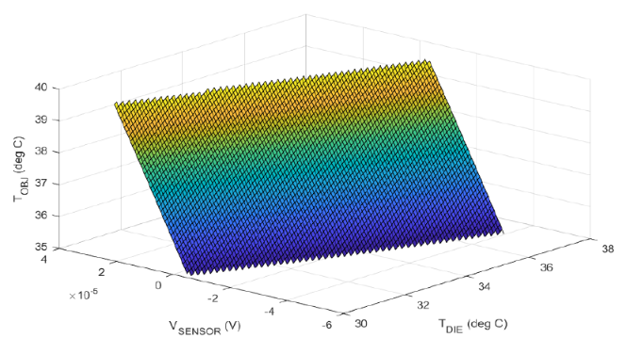

Figure 4.10: Plot of the TOBJ equation with recommended calibration parameters over the operating temperature range of the Ear-Monitor

This linear characteristic of the TMP006 in the operating temperature range of the Ear-Monitor can be used to simplify the Tofu calculation method as described in Equations 4.1 to 4.4. These bulky recommended equations can be replaced by a first-degree polynomial formula for a flat plane as described by:



Where P0, P1 and P2 are parameters to be determined by a calibration process that follows the trial stage.

**4.2.4 PPG signal processing**

The PPG signal is crucial to the calculation of heart rate, respiratory rate and SpO2. This signal is captured by the MAX30100 pulse oximeter. Some noise is present in the measured signal. The MAX30100 has on chip digital filters for 50Hz/60Hz interference and low-frequency ambient noise. Despite on-chip filtering, signal drift and high frequency noise still contaminate the signal. This causes the detection of false heart beat peaks and noisy SpO2 calculations. An AC and DC extraction algorithm and low-pass filter is designed to prime the signal for further processing. Figure 4.11 shows how the signal samples for the

MAX30100 are processed. *xn* is the PPG signal measured by the MAX30100 in the ear canal and yn is the processed signal.

*CHAPTER 4. DETAILED DESIGN* **51**

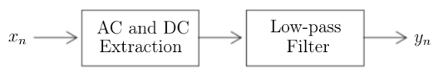

Figure 4.11: The raw PPG signal, xn, is sent through AC and DC extraction   
and filtering functions

**4.2.4.1 AC and DC separation**

An algorithm is implemented to digitally separate the AC and DC components of the red and infrared signals. Signal separation need to be done in real time and with the minimal computational overhead, because it is executed on the MCU. The following infinite impulse response (IIR) filter is used for AC extraction (Koblenski, 2015):



Where *xn* is the raw ADC value from the MAX30100, wn is an intermediate value and yn is the filter output. This filter has a narrow stop band at the DC frequency when the scale factor, α, is close to 1. Scale factor α= 0.7 is chosen as it gives the best DC rejection while maintaining an acceptable response time. Figure 4.12 shows the PPG signal before and afted the C extraction function.

*CHAPTER 4. DETAILED DESIGN* 52

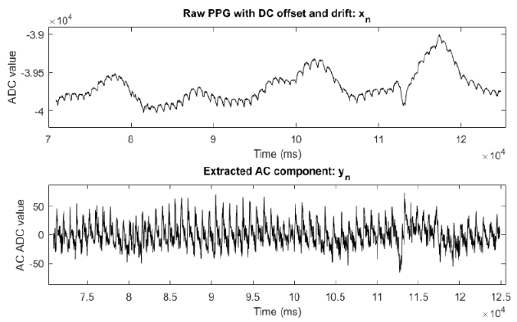

Figure 4.12: (a) the raw infrared signal contaminated by DC offset and drift   
and (b), the extracted AC component of the signal

The DC component of the signal is used during LED bias adjustment and SpO2 calculations. To get the DC value, the AC value is subtracted from the raw signal. Alternative AC extraction methods tested were high-pass FIR filtering and moving average subtraction. These methods were rejected, be­cause a high-pass FIR filter is to computationally intensive and moving average subtraction will attenuate frequencies close to DC as well.

**4.2.4.2 Low-pass filter**

The separated AC and DC component of the red and infrared signals are passed through a third order IIR Butterworth filter. The coefficients were calculated with MATLAB for a cut-off frequency of 3 Hz. Equation 4.8 is the transfer function H(z) of the filter.



Figure 4.13 shows the effect of the low-pass filter on the AC signal as extracted in the AC and DC separation function.

*CHAPTER 4. DETAILED DESIGN*

53

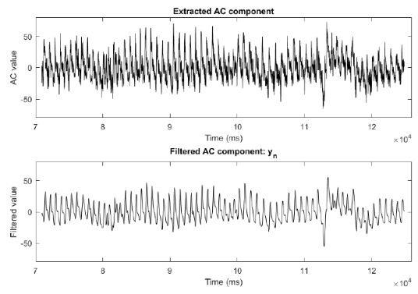

Figure 4.13: (a) the AC component of the infrared signal before filtering and   
(b), after filtering

4.2.5 Beat Detection

Heart beats appear as peaks on the inverted PPG signal. The infrared PPG is chosen for beat detection, for infrared light absorption by oxyhaemoglobin is higher than that of red light. Therefore, infrared pulse peaks are more prominent, thus better suited for the detection of heart beats. A software algorithm is developed to detect these peaks in order to calculate average heart rate, breathing rate and SpO2. The algorithm takes as input the filtered infrared PPG signal yn, and outputs a timeseries of the heart beats. Figure 4.14 shows a plot of a PPG signal with characteristic features labelled.

*CHAPTER 4. DETAILED DESIGN* 54

**Filtered AC component of PPG**

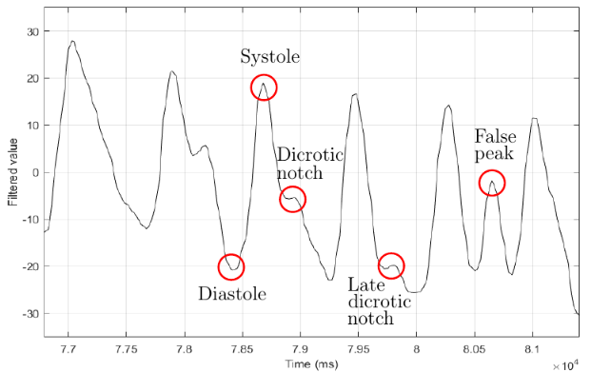

Figure 4.14: Filtered AC component of PPG with important features labelled

This signal extract shows the challenges of the peak detection algorithm. The amplitude of the peaks varies significantly and local maxima which can trigger false positives are present. The intermediate peak in the descending part of the peak is the dicrotic notch, due to the aortic valve closing. Only true systolic peaks should be registered as a hear beat. The beat detection algorithm needs to be robust, computationally inexpensive and should not require any user-specific modifications.

These obstacles are overcome by a two-stage peak detection algorithm de­veloped specifically for the Ear-Monitor's PPG. The algorithm builds on the work done by Park *et al.* (2015), Zong *et al.* (2003) and Elgendi *et al.* (2013) as well as adding new elements like the ...

Stage 1 is a morphological conversion in the form of a slope summing function (SSF). This method is also used by Zong *et al.* (2003), Park *et al.* (2015) and Elgendi *et al.* (2013). The SSF is defined piecewise according on its derivative, Ayn, as shown by Equation 4.9. The aim of the SSF is to enhance the rising section of the pulse peak while suppressing the falling section.



The nth SSF output value, *zn*, equals the sum of the previous *w* filtered PPG slopes as defined by the conditions in Equation 4.9. Zong *et al.* (2003) suggest choosing *w* as the typical duration of the pulse up-slope, so a moving

*CHAPTER 4. DETAILED DESIGN* **55**

sum window of *w* = 10 was selected. Figure 4.15 shows (a) the extracted and filtered AC component and (b) the output of the SSF.

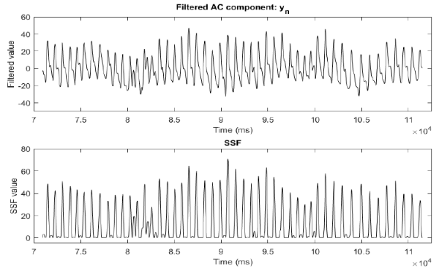

Figure 4.15: (a) the AC component of the infrared signal before filtering and   
(b), after filtering

Stage 2 of the beat detection function is a set of decision rules determine if a peak is present. Some of the rules were adapted form Park *et al.* (2015). Their algorithm is applied to in-ear pulse waves, which is closer to a ballistocardio­gram than a PPG. Therefore, the decision rules in this function are chosen specifically for the Ear-Monitor and determined through experimentation.

Rule 1: Adaptive threshold. The adaptive threshold applied to this algo­rithm is related to the mean of the previous 3 detected SSF peak heights by Equation 4.10.



Where *c* is an experimentally determined scaling factor equal to 0.5. If the SSF signal amplitude rises above the threshold, a potential peak is awaited. Zong *et al.* (2003) uses a threshold equal to 60% of the previous SSF peak amplitude, but this method proved to miss heartbeats if subsequent SSF max­ima varies more that the threshold percentage. This problem is mitigated by basing the threshold on the previous three-peak average.

Rule 2: Local maximum point. Following the crossing of the threshold, the algorithm monitors the SSF for a local maximum. This occurs at *SSFn-1* when: *SSFn-2* < *SSFn-1* > *SSFn.*

Rule 3: Waiting period If a local maximum is detected, the time elapsed since the previous successfully detected beat is tested. If the time is less than

*CHAPTER 4. DETAILED DESIGN* **56**

a dynamic waiting period, the local maximum is rejected. The waiting period is set to be 70% of the mean of the previous 10 beat periods.

Only if all three rules apply to a SSF value, will it be registered as a peak. The time difference between the newly detected peak and the previous one is the heart beat period. Another element to the beat detection algorithm is the threshold reset. If no local maximal is detected above the threshold for longer than 2 times the mean of the previous 10 beat periods, the threshold is reset to 1. This is in case the amplitude of the SSF peaks drops below the threshold and no beats is registered to update the threshold to a lower value. Figure 4.16 shows the example signal's SSF with detected beats. This example illustrates how the algorithm can successfully detect peaks of varying amplitude and using the threshold method and how the time delay prevent the triggering of a false peak.

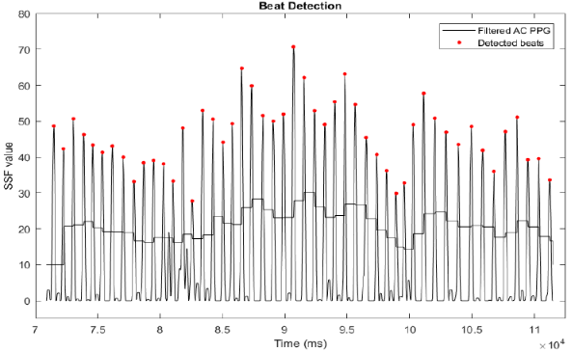

Figure 4.16: SSF with detected beats and threshold plotted.

**4.2.5.1 Heart- and Respiratory Rate Calculation**

The Ear-Monitor uses a moving average of the previous 10 heart beat periods to calculate heart rate in beats per minute. This calculation is executed every time a heartbeat is detected and is done by the PC software.

Respiration rate is determined by monitoring respiratory sinus arrhythmia (RSA), the frequency modulating respiratory related heart rate characteristic. During inhalation, the heart rate increases and during exhalation it decreases. RSA in not easily observed in a PPG plot, but becomes visible when plotting the heart beat periods. Figure 4.17 shows plots of the heart beat period and of the chest expansion due to the respiratory cycle. The synchronisation to

*HAPTER 4. DETAILED DESIGN* **57**

the heart period variation and the respiratory rate is clearly visible, with each chest expansion maximum corresponding with a heartbeat period minimum.

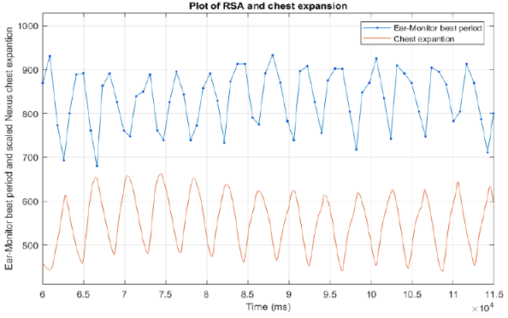

Figure 4.17: Plots of heart beat periods and chest expansion.

To remove noise and reduce false positives, a two-period moving average is taken of the beat period signal. A inhalation is registered each time a local maximum is detected on this filtered signal. The number of inhalations detected in a minute is used to calculate the respiratory rate in breaths per minute.

The heart beat periods can be seen as samples, and therefore the heart rate as the sample rate. This means that, according to the Nyquist theorem, the highest theoretical respiration rate that can be measured by the Ear-Monitor will equal half the heart rate.

**4.2.6 SpO2 Calculation**

The MAX30100 outputs digitals value representing the intensity of red and infrared light reflected by the tissue. Due to the different absorption spectra of oxygenated and deoxygenated blood, these values can be used to determine the fraction of peripheral blood oxygen saturation. PC software is written to calculate the SpO2 and MCU software is written to control the sensor.

**4.2.6 Current Balancing**

The ratio of ratios method, discussed in the literature review and shown in Equation 4.11, is used to calculate SpO2.

*CHAPTER 4. DETAILED DESIGN* 58



The motivation behind using this method is that it compensates for differ­ences in DC reflection from person to person. For this to work, the difference between the red and infrared DC values used in the equation needs to be as small as possible. The current to the red and infrared LED of the MAX30100 are set to 50 mA upon start-up configuration. To compensate for the fact that infrared light is reflected differently by the tissue than red light, a dynamic current balancing function is written.

The MAX30100 has a programmable register that allows for the individual current adjustment of red and infrared LED drivers. A negative feedback control system is implemented on the MCU to adjust the individual LED currents in order to lower the difference in reflection. A lower current equal a lower light intensity and subsequently, less reflection.The function checks the difference in infrared and red DC levels every second and adjusts the current to the LEDs until the difference are within an acceptable margin. Figure 4.18 shows a plot of this process. The difference in reflection starts out at 15000, with both LED currents equal to 50 mA, and after five adjustments the difference is lowered to 1000, with the red LED current unchanged and the infrared LED equal to 33.9 mA. As can be seen from Figure 4.18, the current adjustments happen in a stepwise fashion, with each step about 2700. Therefore, to avoid oscillations, the margin is set to 2000.

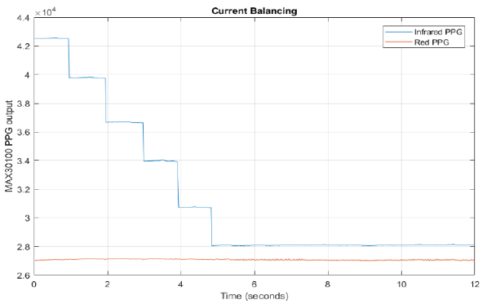

Figure 4.18: Plot showing the effect of the current balancing function   
implemented on the MAX30100 lowering the difference in detected light   
between red and infrared LED by adjusting the current to the infrared LED

*CHAPTER 4. DETAILED DESIGN* **59**

**4.2.8 Moving average SpO2**

SpO2 calculation is done by the PC interface software. The filtered AC and DC components of the infrared and red PPG signals, as calculated in the PPG signal processing section, are used in the ratio of ratios method. *R* is calculated using the mean of the absolute AC and DC values of the previous 12 heartbeats. These values are updated each time new PPG data is available.

The relationship between *R* and SpO2 is unique for different devices and measurement locations. Calibration is needed to find the relation for die Ear-Monitor. The relationship used in literature (Oak and Aroul, 2015) was ad­justed though a calibration process to achieve a desirable level of accuracy. Equation 4.12 shows the relationship used by the Ear-Monitor to calculate SpO2.

111.2 — (25 *R)* (4.12)

*R* and SpO2 are calculated on every heartbeat using the moving data win­dow of the previous 12 heartbeats.

**4.2.9 PC Interface**

A graphical user interface is written in Processing to display the measurements   
on the computer screen and allow the user to set alarms and save the data. The   
interface receives variables from the various functions discussed. It displays these variables along with a series of real-time graphs and has the option to save the measured Ear-Monitor data in a .csv file for later reference or analysis. Figure 4.19 shows a screen-shot of the user interface with (a) the SSF with detected beats, (b) the AC components of the red and infrared PPGs, (c) respiration illustrated in plotting the heart beat period, (d) temperature, (e) data written to .csv files and (f) alarm conditions.

*CHAPTER 4. DETAILED DESIGN* **60**

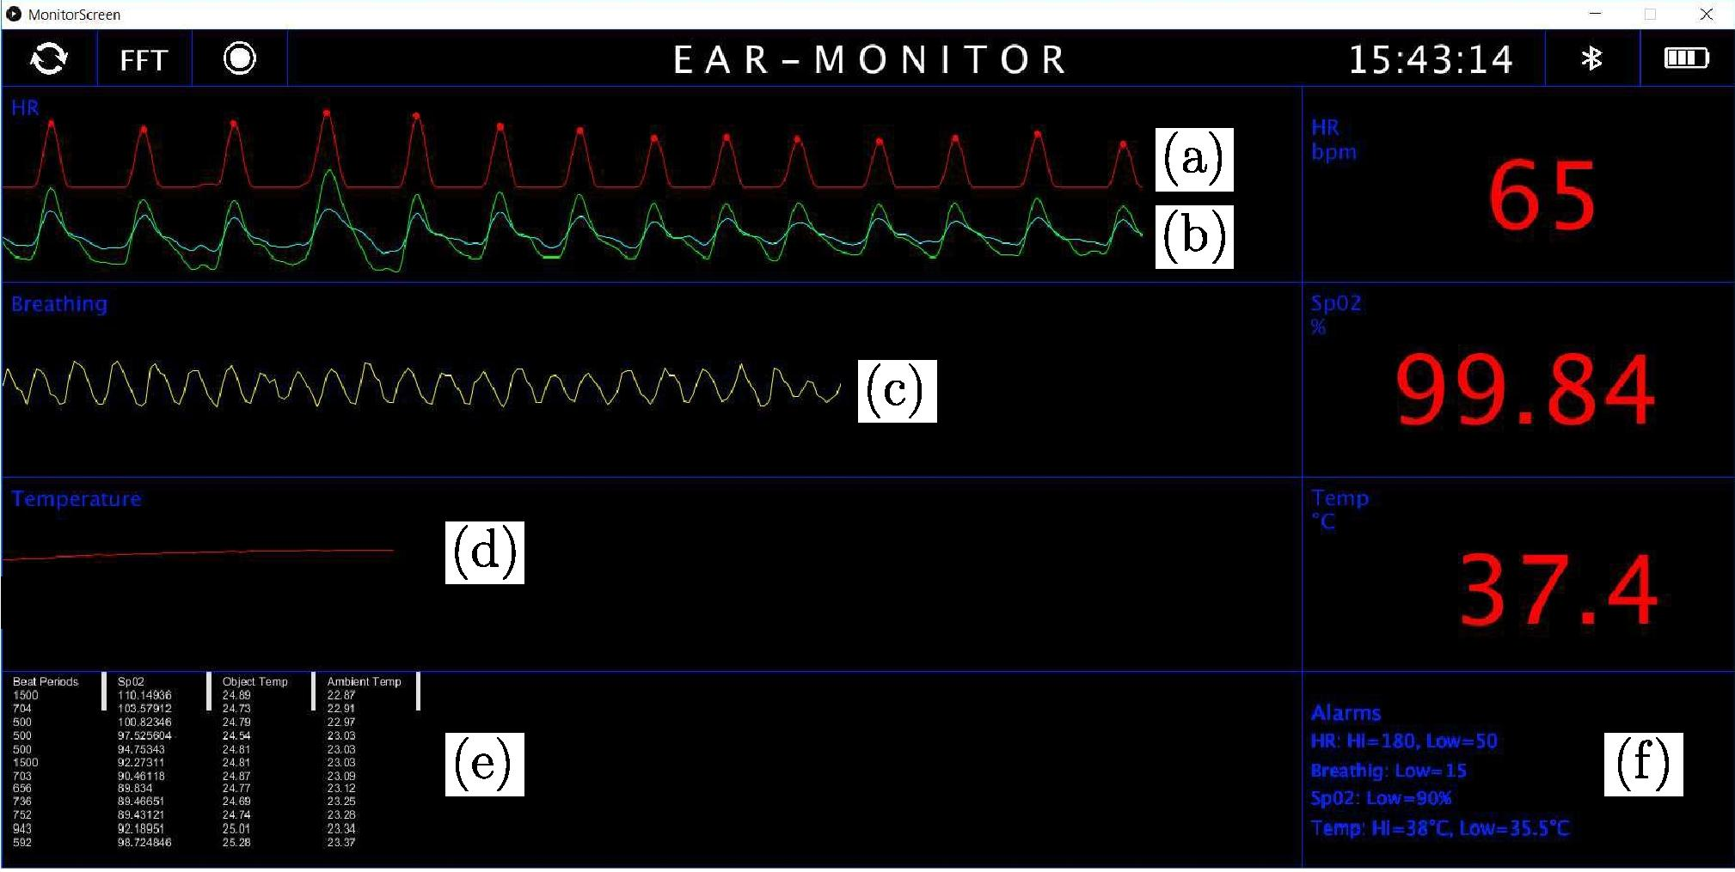

Figure 4.19: Ear-Monitor user interface

**Chapter 5**

**61**

**Trial Period**

A trial is conducted during which the Ear-Monitor is tested on a group of 16 healthy, adult volunteers. The trial's goal is twofold: firstly, to calibrate the temperature and SpO2 algorithms and secondly to evaluate the accuracy of the Ear-Monitor's measurements. This chapter describes the trial environment and the method used to collect data for calibration and evaluation. Ethical approval is obtained for this trial form the Health Research Ethics Committee of Stellenbosch University, under the reference number M16/09/038 (proof of approval included in Appendix X).

**5.1 Participant Selection**

Participants for the study are invited via a recruitment email sent to students and staff at the faculty building. Inclusion criteria are physical health, ages from 18 to 60 years and volunteers of any gender or race. Exclusion criteria are small ear canal size, ear abnormalities or injuries and general health issues. If the individual's ear canal is smaller than 5 mm diameter the Ear-Monitor's probe will not fit. This also applies to ear abnormalities or injuries that will prevent the use of an ear probe, for example an abnormal sharp bend in the ear canal or an inflamed or infected ear canal due to i.e. otitis externa (swimmers ear). Individuals with self-diagnosed illness that will cause them risk if they participate, are also excluded. Potential participants are screened through a pre-test physical examination to determine if they meet all the criteria. Table 5.1 gives a demographic summary of the participants that are selected for the trail.

Table 5.1: Demographic summary of participants

*CHAPTER 5. TRIAL PERIOD* **62**

|  |  |  |
| --- | --- | --- |
|  | n | Average age |
| Male | 13 | 24.5 ± 0.7 |
| Female | 3 | 23.3 ± 0.3 |
| Total | 16 | 24.3 ± 0.6 |

**5.2 Benchmark Validation**

Evaluation is done for all four vital signs measure by the Ear-Monitor, namely core temperature, heart rate, respiratory rate and SpO2. Evaluation entails comparing the vital sign measurements made by the Ear-Monitor to measure­ments made, in the same conditions, by industry standard medical devices, referred to as benchmark devices. The measurements made by benchmark device is referred to as benchmark measurements. In this trial, a device that conforms to the EC requirements qualifies as a benchmark device. The CE mark is sign that the benchmark device complies with the ISO 13485 standard for medical devices, which requires industry standard accurate measurements.

Three benchmark devices, shown in Figure 5.1, are selected to provide the various benchmark measurements. A concise technical overview is given of each.

Figure 5.1: Benchmark devices: (a) Nexus-10, (b) SureSigns VM1 and (c)   
EM 100-A

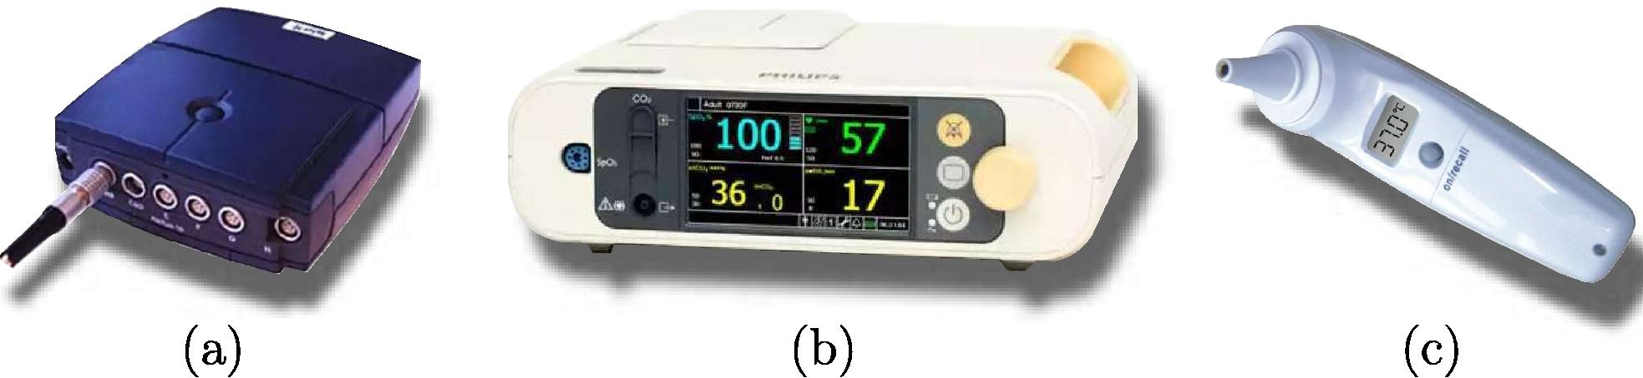

(a)

(b)

The Nexus-10 physiological monitoring platform is selected to provide bench­mark heart rate and respiratory rate measurements. The Nexus-10 is a data acquisition device with a 24-bit analogue to digital converter and an accuracy of ±2% according to the manufacturer. It has a blood volume sensor, which measures a PPG signal from the fingertip at a sampling rate of 128 Hz. This PPG signal is used to provide the benchmark heart rate measurement. It also has an elastic chest strap to measure respiratory rate. The movement of the chest during the respiratory cycle is converted to a voltage signal and digital­ized at a sampling rate of 32 Hz. This signal is used to provide the benchmark respiratory rate measurement. It uses a Bluetooth connection to send data to

a computer. The BioTrace+ software package is used to display the recorded data in real time as well as store the data for later processing.

*CHAPTER 5. TRIAL PERIOD* **63**

The SureSigns VM1 patient monitor from Philips is selected to provide benchmark SpO2 measurements. The SureSigns VM1 uses a pulse oximeter attached to the fingertip to measure SpO2. Data is logged on the device's screen and updated at 1 Hz and stored on a computer for later processing. The device is recommended for use by healthcare professionals, emphasizing its accuracy and reliability.

The ET-100A infrared ear thermometer is selected to provide the bench­mark tympanic ear temperature measurements. The ET-100A complies with the EN12470-5:2003 standard for clinical thermometers, therefore satisfies an accuracy of ±0.2 °C over the range of 35.5 °C to 42 °C. Its measurements are displayed on the device's screen and data is entered and stored on a computer for later processing.

**5.3 Method**

Data is recorded from one participant at a time. A recording session involves collecting four benchmark- and four Ear-Monitor vital sign measurements si­multaneously from one participant. Each recording session lasts for 2 minutes and is conducted twice per participant to ensure repeatability. Figure 5.2 shows a diagram of how all the devices are connected to the participant and which measurements are made by each.

*CHAPTER 5. TRIAL PERIOD* 64

|  |  |  |
| --- | --- | --- |
| ET 100-A Temperature  Nexus-10 Respiration Rate  Nexus-10 Heart Rate |  | Ear-Monitor Temperature Heart Rate Respiration Rate  SpO2  SureSigns VM1 SpO2 |

Figure 5.2: Diagram showing how devices are connected to the participant   
during the recording session

The recording session can be summed up as follows:

* The trial environment is set up before the participant arrives. Equipment   
  is disinfected and connected to the computer, ready for data capture.
* The participant arrives and is briefed about the procedure and signs an informed consent form. The participant is also asked to clean his/her ear with surgical spirits.
* The participant is seated stationary in front of a table containing all the equipment. Sensors are placed on the participant as shown in Figure 5.2. Three tympanic temperature benchmark measurements are taken from the participant with the ET 100-A.
* The recording session starts. The participant sits still the entire time and breaths normally for the first 60 seconds, after which the partici­pant is asked to breath at 15 breaths per minute by following breathing metronome for another 60 seconds.
* After 60 of controlled breathing (120 seconds recording time in total) the recording session is concluded. Three more temperature benchmark measurements are taken with the ET 100-A.

• Data from the Ear-Monitor and benchmark devices is stored on a com­puter in .csv format for later processing and analysis.

*CHAPTER 5. TRIAL PERIOD* **65**

The breathing exercise is included due to the uncertainty that the RSA will be detectable during normal breathing. During prototyping, it was more visible in beeper forced breathing. Therefore, if it is not detectable in normal breathing, the controlled breathing data can still be analysed to produce some results.

Figure 5.3 shows an image of one of the participants during a data recording session. The labelled equipment is (a) the computer with the Ear-Monitor user interface, (b) the Ear-Monitor on the participant with the red light of the MAX30100 visible through the tragus. (c) is the SureSigns VM1 and (d) its SpO2 finger clip. (e) is the Nexus-10 and (f) its blood volume sensor finger clip and (g) its chest strap for measuring respiration. The ET 100-A tympanic thermometer is labelled (h).

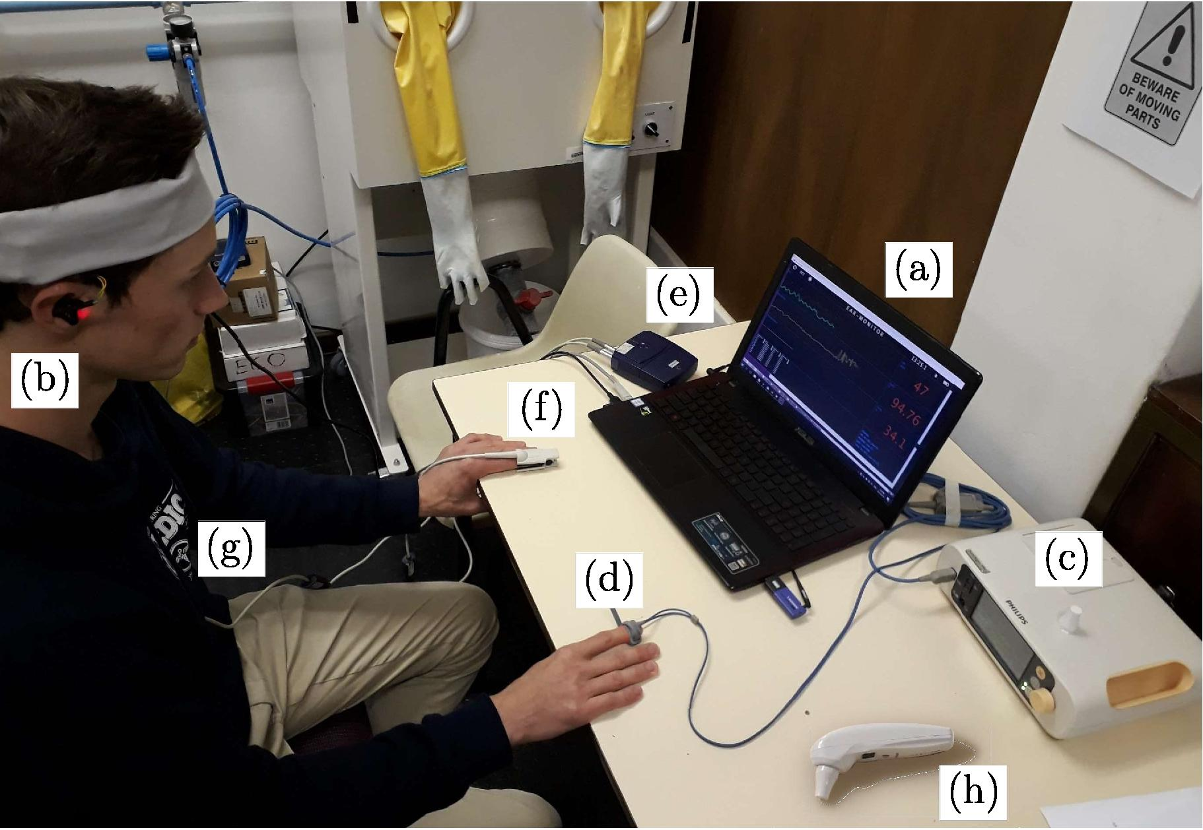

Figure 5.3: Recording session set-up with participant

**Chapter 6**

**66**

**Calibration**

Data collected during the trial is used to calibrate the equations used to cal­culate tympanic temperature and SpO2. The calibration process for the two different vital signs are discussed separately in this chapter.

**6.1 Temperature Calibration**

As discussed in Section 4.2.2, the TMP006 measures die temperature, TDIE, and thermopile sensor voltage, VSENSOR• These two measurements are used to calculate the temperature of the object, TOBJ, which in the case of the Ear-Monitor is the tympanic membrane.

Each data recording session in the trial produced 15 Ear-Monitor measure­ments and 3 ET 100-A benchmark measurements. Measurements from both devices are averaged separately to get one average Ear-Monitor and one aver­age ET 100-A measurement per session. Two different calibration approaches are discussed: the calibration group approach and the intra-participant cali­bration approach.

**6.1.1 Calibration group approach**

In this approach, 5 recording session are used to calibrate the temperature calculation equation, Equation 4.5. MATLAB's curve fitting tool is used to fit a first order polynomial plane to the data points. The equation with calibration coefficients is shown by Equation 6.1.



This equation is applied to all Ear-Monitor temperature measurements. The advantage of the calibration group approach is that calibration is done only once and no patient specific calibration is needed.

*CHAPTER 6. CALIBRATION* **67**

A box and whisker plot can be seen in Figure 6.1 and shows the error between the ET 100-A benchmark temperature and the Ear-Monitor temper­ature before and after calibration. Improvements in accuracy and precision are clearly visible in this graphical representation of the data.

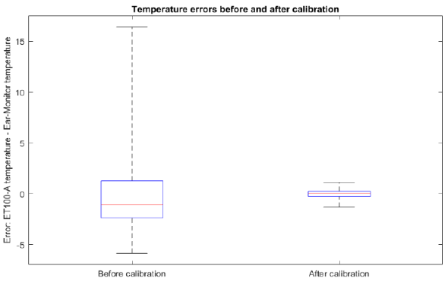

Figure 6.1: Temperature errors before and after calibration

**6.1.2 Intra-participant calibration approach**

In this approach, the first recording session is used to calibrate the calibration coefficients for each participant individually. The first recording session data is entered into Equation 6.1 and the error between the Ear-Monitor and ET 100-A data is used to adjust Equation 6.1.

The advantage of this approach is that the Ear-Monitor can adjust to patient specific parameters, i.e. tympanic membrane size, the sensor's distance from the membrane and the fraction of the FOV that is occupied by the canal wall. The trade-off is that the Ear-Monitor needs to be calibrated for each participant individually. This is not a complicated process, calibration can be done in one minute and is only needed once per individual.

**6.2 SpO2 Calibration**

According to Oak and Aroul (2015) the modulated ratio, R (Equation 4.11), is linearly related to SpO2. The relationship they propose is given by Equation 6.2.

(6.2)

With *x* equal to 110 and *m* equal to 25. The relationship will vary for different pulse oximeters, and the calibration parameters for the MAX30100 in the Ear-Monitor are calculated empirically through experimentation. Equation 6.2 is used as a starting point and the gradient, *m,* is constrained to be larger or equal to 15 in order to ensure R's weight in the calculated SpO2 value. The remaining calibration parameter, *x,* is systematically incremented until the desired fit is achieved. Equation 6.3 describes the relationship between *R* and SpO2 selected for the Ear-Monitor.

*CHAPTER 6. CALIBRATION* **68**

*Sp*O2*=* 110 - 25*R (6.3)*