Log du Projet de Bachelor

22/02 : RDV avec le responsable de projet.

Je commence le travail sur les données récoltées depuis le 09/11/2015.
Data are on JSON format and need to be filtred and transformed into CSV format. There is a lot of useless data ; we need only
-route
-date when we got the data (Unix)
-date when the flight happen (Unix)
-price.

Data are organized this way : first a folder, (which is the date where we gather the data), then, for each route analysed, we got 12 files in JSON format. Each of this file are like this : one big array (42 for large data set), in each element, we see : arrivalStationCode, date of the day we are looking at, DepartureStationCode, then another array with the flights in. If there is a flight, we see the departure and the arrival time. It seems like we don't have the price for evey flight, but only the lowest price.

So : for each folder{
get the date of the folder
for each file{
get the route
for each element in the array (date) {
for each flight{
get the price
get the time of the flight
write in the csv file a new line
}
}
}

23/02 : JSON data are now also in th CSV format. Next step is to look in it (using MatLab) to try to find some pattern.

24/02 : Uppon trying to use the CSV file in matlab, some errors appeared. Need to go back on java to transform every route into a number (id of the route) and to change every price in €.
Done. However, some currency are not readable (z??, ??? and ??) which makes it pretty hard to change them in €...

25/02 : working on the currency, but it looks like data are corrupted. So I'm writing a checker to run some test on them.
Checker show some bugs. So working on it.

01/03 : RDV avec le respo
-fix the program : okay?
-add info in the info.txt (currency for the route, average price, etc.) : almost done
-change currency also depending on route : done
-get statistics about the data (multiple ways to do it)
-try to see if there is other compagny that we can extract info of (easyJet?)
-if multiple flight, we have only one price, so we need to know which one it is : for what I saw, the first one is usually the cheaper, so we can discard the 2nd one.
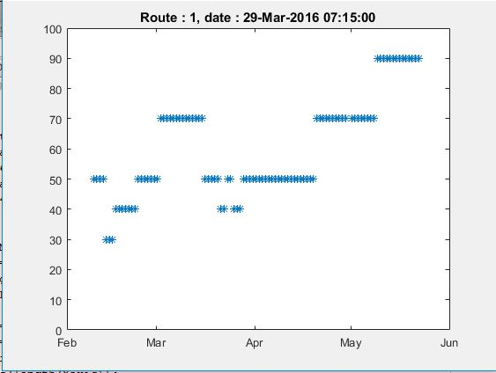
-extract more data in another .txt

02/03
Trying to get the average date where the price of a flight changes the most.

17/03 :
RDV avec le respo
Launching the linear regression, we're trying to get a model.
-> Dummy var
-> Regularization

21/03 : Starting the model
1° We start with defining our Flight Price prediction h(x) = Theta(0)*x(0) + Theta(1)*x(1)
with x(0) = 1 and x(1) = time before flight
Went kinda well.

9/04 : Showed some visualization.
Model seems wrong, so I build a new one, simplest one and try to make it work. I'll only take one route into account.
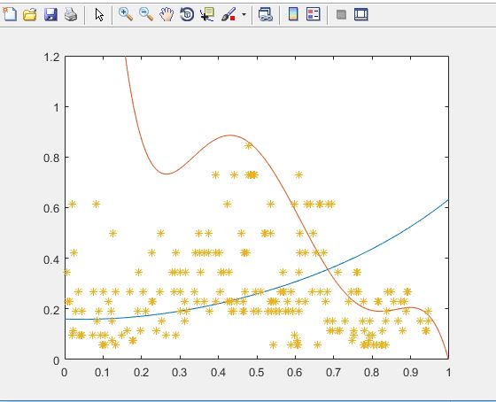
10/04 : The new model is better.
I build my own LinearRegression algo with my gradient descent, my hypothesis and my cost function. My model differ by a lot from the result got with regress() from matlab.

(blue is the result from my model, red from the regress() method. X axis : time before flight, Y axis : price)
The result from matlab is far from being right.

After "some" work, I fixed the bug about the method from matlab.
My methods still give often garbage, but sometimes the result is the expected one.
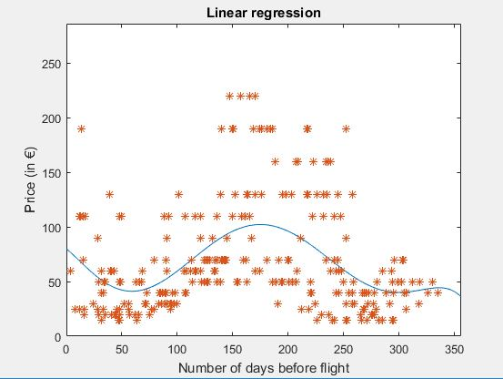
Mathlab result now looks like this :

I droped my model as the matlab's one is definitly better and gives way less error.

~20/04
After a lot of work, here what I got
-First iteration, I try ridge regression with different number of parameter (degree of the hypothesis) ie I try for i=1:8 multiple Theta.
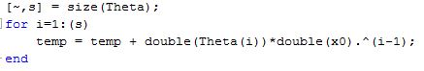
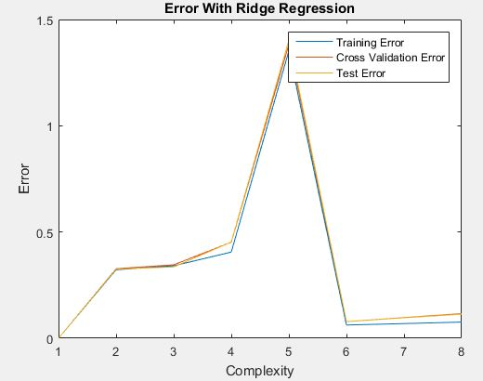
For this, i tried different lambda but not a lot and choose one thanks to cross validation error.
Once I chosed the right number of features with cross validation error (usually 4 or 6), I do a second iteration with the number of feature set and search for the right lambda.
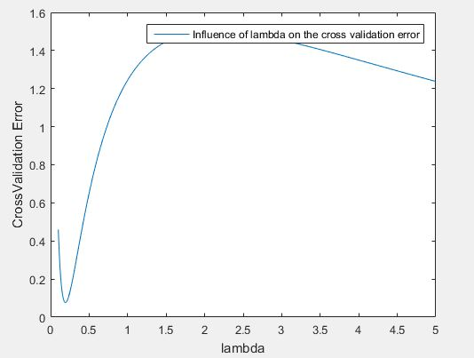
I try a lot of different lambda and usually, it's between 0.16 and 0.22

Once I found the right lambda and the right number of features, I do a last iteration where I try with less data than I have, and mesure the training error, the cross validation error and the test error.

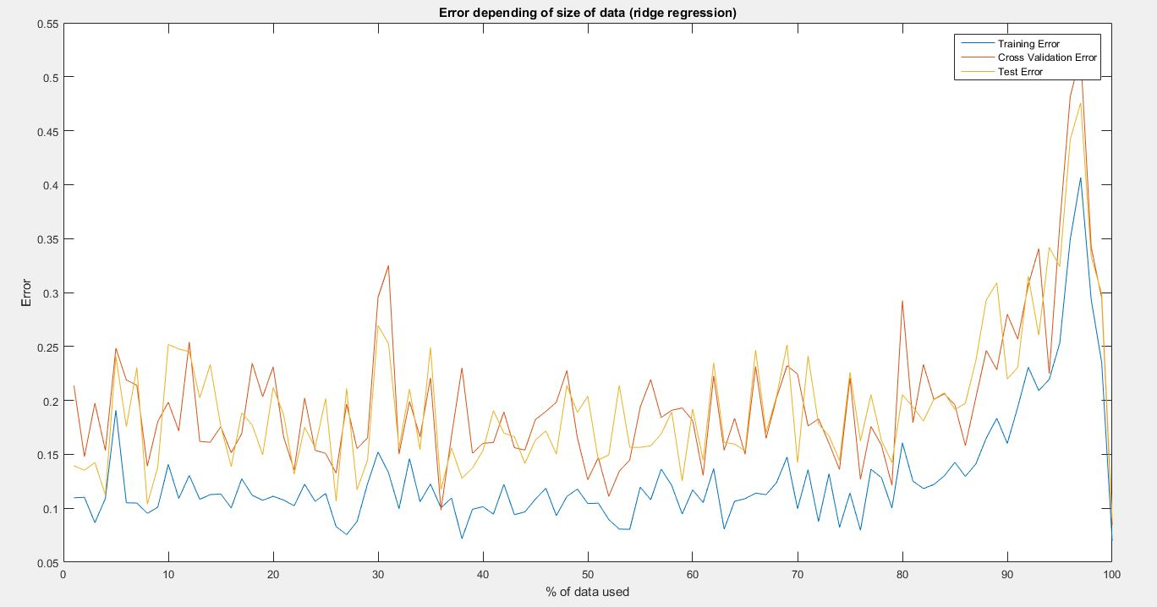
But this is not what i excpected to see :(

But the good thing is that it allows me to have a really good model :
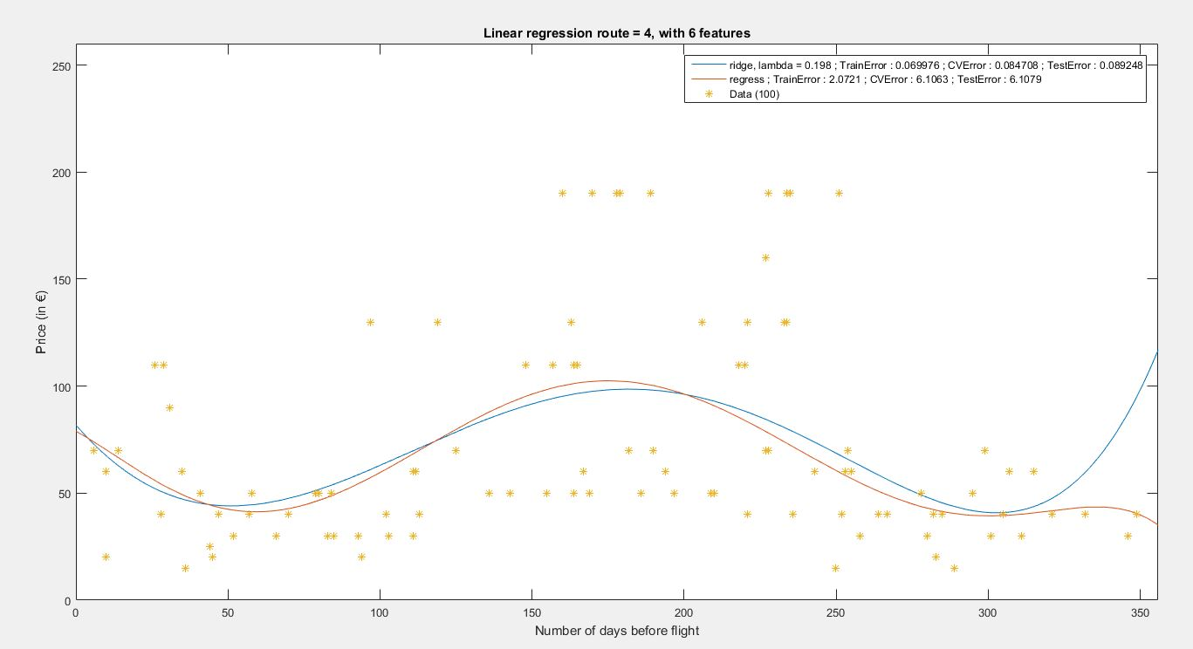
I think the next step is to find a way to mix the data of the different route, and try to understand why the T,CV and Te Errors are so erratic with less data

Rdv with responsable
Cross v e with k replacement
find average error AND variance
change lambda increasing from 10^-5 to 10^2
get learning curves
add features (month) then routes
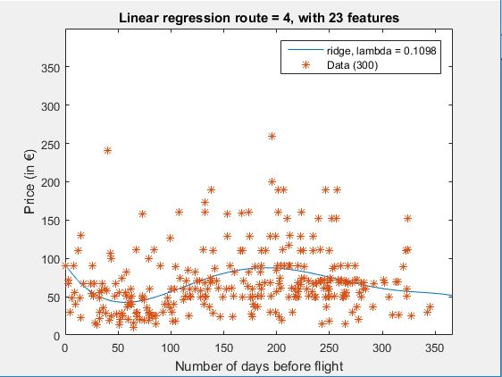
Ridge Regression (taking route into account)

It looks good but god it takes time to compute the CVE with 10 replacement... And I'm supposed to add more feature.
So I started to factorize my code with one analyser and one displayer so i can run my code during the night.

RDV
Mixture of expert flexmix : multiple
python tansey regrssion mixture
Test set

