**Premissa: ter contratado um SSL, por exemplo Godaddy, que fornece arquivos crt.**

**Part 1 - Snap-In Configuration**  
  
Use the following steps to add the Certificates snap-in:

1. Click **Start**, and then click **Run**.
2. Type in ***mmc*** and click **OK**.
3. From the File menu, choose **Add/Remove Snap-in**.
4. In the new window that appears, click **Add**.
5. Select **Certificates** and then click **Add**.  
     
   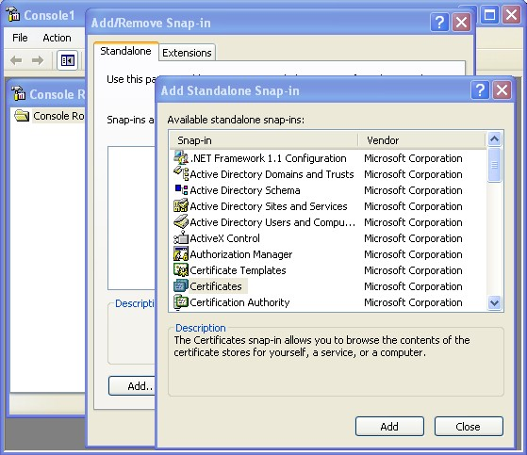

1. Choose the **Computer account** option and click **Next**.  
     
   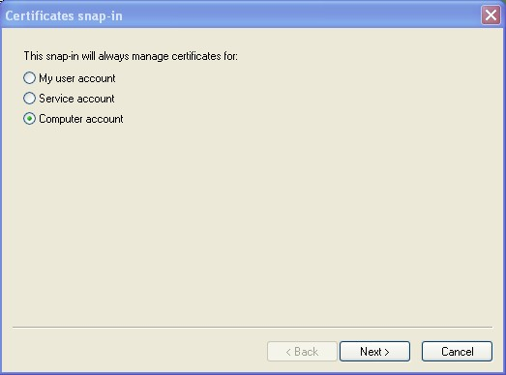

1. Select **Local Computer** and then click **Finish**.  
     
   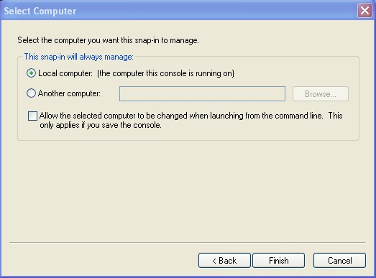

1. Click **Close**, and then click **OK**. The snap-in for **Certificates (Local Computer)** appears in the console.  
     
   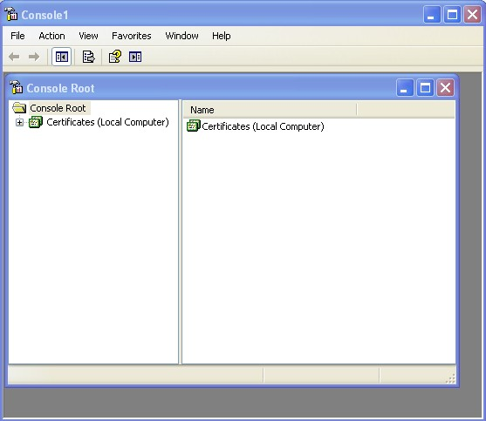

**Part 2 - Import the Server Certificate**  
  
Use the following steps to import your Server Certificate into the Personal certificate store. (If the Server Certificate has already been imported into the Personal store, you may skip this step.)  
  
From the MMC console opened in the above steps:

1. Expand the **Certificates (Local Computer)** tree in the left preview panel.  
     
   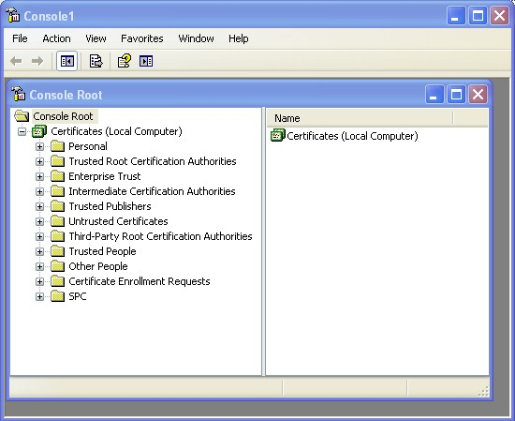

1. Right-click **Personal** and select **All Tasks > Import**.

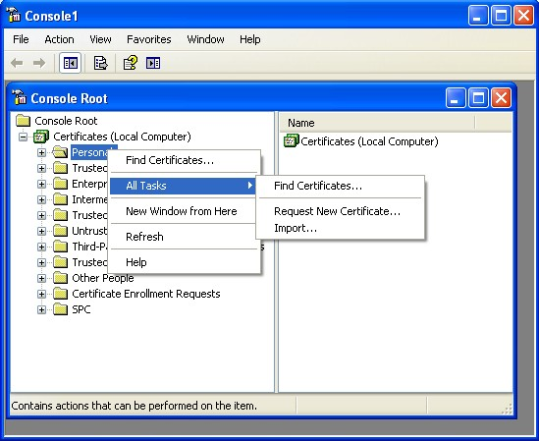

1. The Certificate Import Wizard appears. Click **Next**.
2. Browse to the location of your Server Certificate file and click **Next**.  
     
   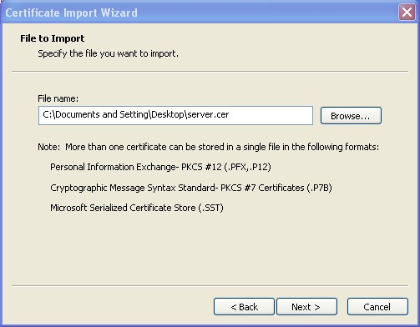

1. Select **Place all certificates in the following store** and click **Next**.  
     
   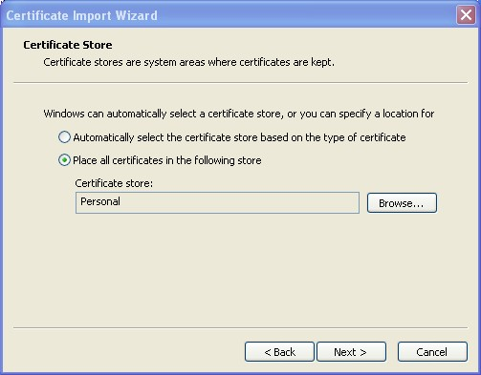

1. Click **Finish** to complete the Certificate Import Wizard.  
     
   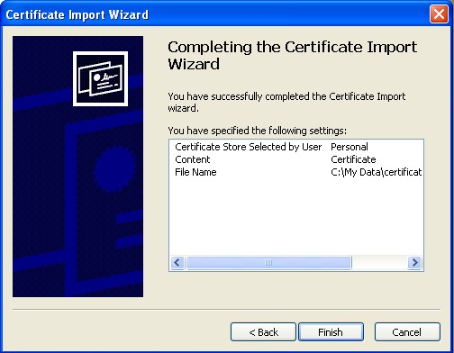

1. A dialog box appears indicating the import was successful. Click **OK**.  
     
   

**Part 3 - Recover the Private Key**  
  
Use the following steps to recover your private key using the **certutil** command.

1. Locate your Server Certificate file (for example, server.cer) and double-click it. The Certificate dialog box appears.  
     
   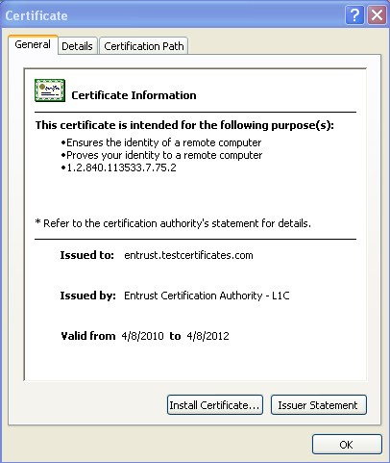

1. Click the **Details** tab. Write down the 8-character serial number of the certificate.  
     
   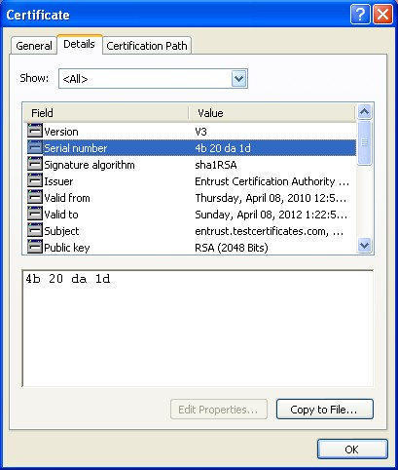

1. Click **Start >** **Run**.
2. Type ***cmd*** and click **OK**. A Command Prompt window opens.
3. Enter the following command at the prompt:

***certutil –repairstore my*** *<serial number>*

Where *<serial number>* is the 8-character serial number obtained in Step 2 (spaces removed).

6.      If Windows is able to recover the private key, you see the following message:

**CertUtil:  -repairstore command completed successfully.**

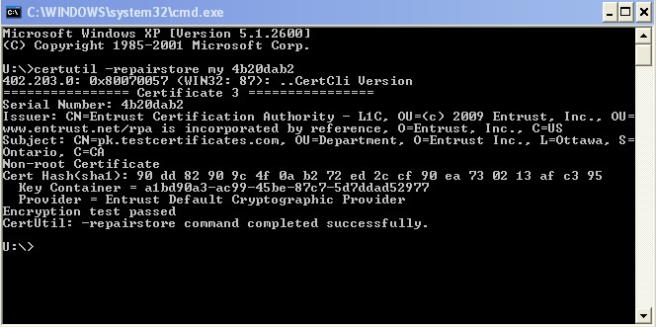

**7.** If your private key was recovered successfully, your Server Certificate installation is complete. If the private key was not recovered successfully, you will need to [generate a new Certificate Signing Request](http://www.entrust.net/knowledge-base/technote.cfm?tn=8138) and submit it to Entrust to have your certificate re-issued.

To Insert ssl in specific site

• Na janela **Gerenciador de serviços de informação da Internet (IIS)**, selecione o nome do servidor onde você instalou o certificado.

• Clique no + ao lado de **Sites** e selecione o site a ser protegido com o certificado SSL.

• No painel **Ações** à direita, clique em **Vinculações...**.

• Clique em **Adicionar...**.

• Na janela **Adicionar vinculação de sites**:

* Em **Tipo**, selecione **https**.
* Em **Endereço IP**, selecione **Todos os não atribuídos** ou o endereço IP do site.
* Em **Porta**, digite **443**.
* Em **Certificado SSL**, selecione o certificado SSL que você acaba de instalar e clique em **OK**.

• Feche a janela **Vinculações de sites**.

• Feche a janela **Gerenciador dos Serviços de Informações da Internet (IIS)**. A instalação do certificado SSL foi concluída.