**Peer-to-Peer**- Each device provides file share with all other devices on the network.

**Subnet**- Part of the network where the computers share the same network with the same router.

**PAN**- (Personal Area Network) only few feet away created by a bluetooth connection.

**LAN**- multiple networks that are connected together (local area network).

**MAN**- multiple LANs connected together (metropolitan area network).

**WAN**- multiple MANs or LANs connected on a network usually a city (Wide area Network).

**Internetwork**- When two separate networks are connected together ex. Two MANs connected together.

**Internet**- a connection where they all have a connection where they all can access data, entry points are with ISP (internet service provider).

**Intranet**- mini internet (private) could be connected with the public (then extranet).

**Extranet**- intranet that is made available to the public.

**Topology**- (Physical) Computer are actually connected by wires. (Logical) how the files transfer. Features below.

**BUS**- Files go down the wire to every computer. **Trunk cable.**



**Ring**- Data is forwarded from each computer to

get to the correct computer, one computer is connected to two.



**Star**- Where the central location is a **SWITCH** that is connected to all computer so they send the data directly to the computer that needs it.



**Mesh**- every computer has a direct link to each other. Rarely implemented with wires, more practical if it's wireless.

**OSI**- connects two hosts (sender) and (receiver) with 7 layers; ***Applications, Presentation, Session (Application layers),***

***Transport, Network (Transport layers), Data link, Physical (Architectural Layers).***

|  |  |
| --- | --- |
| ***Applications (HTTP)*** | Integrating network services with the operating system. HTTP,FTP. |
| ***Presentation (ASCII)*** | Formatting. Syntax, Encryption. |
| ***Session (Session ID)*** | Connecting communication between devices. Session ID |
| ***Transport*** (TCP) &(UDP) (port numbers) | Delivering Data on a network and divides big files into **segments.** |
| ***Network (***Packet**)(Router)** | Moving Data between systems to destination. Assigned IP address |
| ***Data link (Switches)*** | Files become a packet and files are given a MAC address. Called a **Frame,** LLC (logical link control) CRC (Cyclic Redundancy Check) |
| ***Physical (wireless access point)*** | Hardware with cables and identify the cable connections. |

**Bit**- (0101001011) to translate the frame in the physical model.

**Data link**- Controlling how the messages are propagated through the network, Identifying physical network devices.

**Network**- Routes messages between networks.

**Presentation**- encrypt and compress data & specify data format.

**Application**- enabling communication between network clients and services & integration of network functionality into the host operating system.

**Physica**l- movement of data across network cables.

**Data link**- LLC & MAC

**MAC**- letting devices on the network have access to the LAN & defining a unique hardware address for each device on the network.

**Transport-** Responsible for guaranteeing reliable message delivery.

|  |  |
| --- | --- |
| TCP/IP model layer | OSI Model layer |
| Application | Application, Presentation, Session |
| Transport | Transport |
| Internet | Network |
| Network interface | Data Link |
| (hardware) | Physical |

**Network-** router operate to forward network messages.

**Data Link**- a Bridge that filters packets based on MAC address. Switches & network interface cards (NICs) are also located.

**Physical**- Hubs operate at the first layer. \***Network signaling\***

**Data Link (Layer 2)**- Switches and network interface card.

**Network (Layer 3)**- router & firewall

**Physical (Layer 1)**- Hub & repeater

**Digital Signal**- pulses of current interpreted as Bits (+)=1 (-)=0

**Analog Signal**- Continuous electrical current. +5 or -5 (modulation). 3 Hz.

**Modem**- Demodulates FM and AM signals into data.

**Return to zero**- Self clocking

**Non return to zero**- uses ½ the bandwidth and needs a separate clock signal.

**Manchester**- Self Clocking, switches to (+)=0 (-)=1

**Baud Rate**- how fast that waves/signal moves per second.

**BPS**= Baud x number of bits per baud.

**Broadband system**- Analog signal over multiple frequencies (two cables must be used)

**Muxing**- maximize the use of a signal transmission resource.

**FDM**- frequency range split into several distinct frequency channels ex. Cable TV.

**OFDM**- (orthogonal frequency division multiplexing) splits transmission signal to distinct frequency, but the ranges are a bit smaller and works together to transmit information.

**Baseband System**- use digital signal, use entire bandwidth, and can send and receive information on the same cable.

**TDM**- (Time Division Multiplexer) all the signals cannot be sent at once so it sets a time window the information can be send across the cable.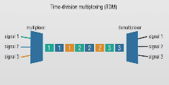

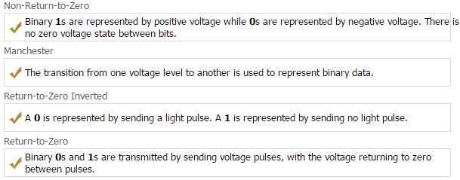

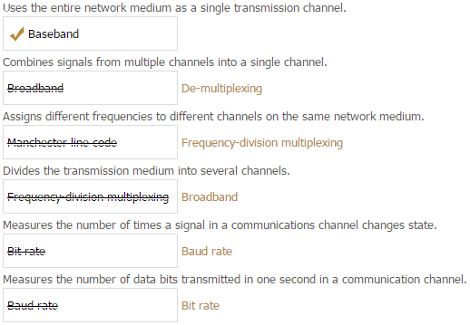

**Transmission control protocol (TCP)**- Sender computer will try to make sure no errors are taken place.

**IP**- internet Protocol.

**User Datagram Protocol (UDP)**- Connectionless, transmits messages regardless whether errors occur, Although UDP is much faster than TCP.

**Hypertext Transfer Protocol (HTTP)**- used by internet browsers and websites to return information and display on your screen. **HTTPS same as (HTTP)** with security protocols to keep private information safe. Ex, Credit cards

**Secure Socket Layer (SSL) & Transport Layer Security (TLS)**- security for HTTPS and protect data from wiretapping and other attacks by encrypting data while it travels between client and server.

**File Transfer Protocol (SFTP) & (SCP)**- Secure copy Protocol transfer files across a network with protection.

**Simple mail Transport Protocol (SMTP)**- if both email servers use SMTP then both can send emails between each other **(POP3)** downloads the email so you can access them when offline.

(**IMAP**) saves the emails on a **server** so you can access the emails on multiple devices offline.

**Dynamic Host Configuration Protocol**- Configures an address like an IP, (**DNS**) logical name that connects you to a server ex. [*www.testout.com*](http://www.testout.com)*.*

**Server**- physical computer or specific network service.

**Web server**- provides web pages and use web browser to access web pages.

**FTP**- connect server to client to transfer data, but not secure.

**DHCP**- automatically configures network hosts with IP addressing information, without it people would have to manually visit and configure an IP address for every system.

**Directory service**- SPECIFY A CERTAIN COMMAND TO EACH COMPUTER (com A) printer, (com B) emails.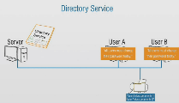

**Secure Shell (SSH)**- remotely access a computer and authenticate certain commands as if it was that computer. 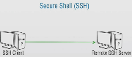

**Mail transfer agent (MTA)**- can forward an email from the server to a certain client.

**SMB & CIFS**- Files share programs **Server message block** works on linux and **Common internet file system** works on windows and both are interchangeable.

**Put and Get**- Put places files on to the cloud and Get recieves flies from the cloud.

**Simple mail transfer protocol (SMTP)**- specifies how messages are exchanged between email servers.

**Transmission Control Protocol (TCP)**- guarantee delivery through errors and error checks.

**Network time protocol (NTP)**- lets you keep clocks synchronized.

**SMTP**- Sends emails to a mail server.

**IMAP4**- stores emails on the mail server and can access from different locations.

**POP3**- Part of the TCP/IP protocol and retrieves emails from a remote server to a local client.

**UDP transport**- Low Overhead and Connectionless datagram services.

**HTTPS-** securely browses a website.

**Internet Control message Protocol (ICMP**)- allows hosts to exchange messages to indicate the status of a packet.

**Binary**- computer language with only 1 and 0s.

10101100 =28=256 possible numbers= 128+32+8+4=

Hexadecimal-

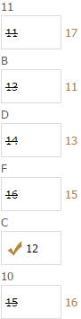

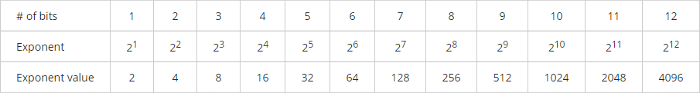

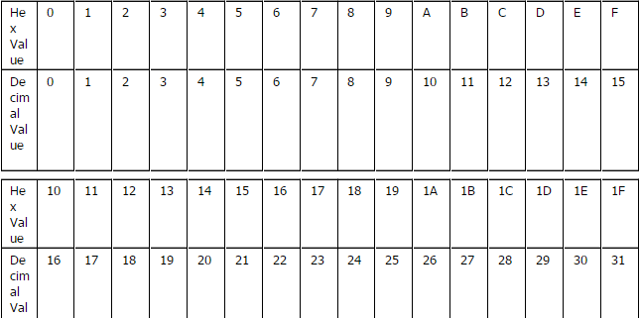

**Twisted pair wiring**- 22 to 24 gauge copper, flexible, inexpensive, easy to install

Disadvantages interferences, susceptible to eavesdropping.

**Cross-talk**- neighboring wires could absorb the signal of a close wire.

**UTP-** cat3 (old) slow, CAT5, CAT5e better cross-talk protection, CAT6 support high bandwith 10GB network but has to be short cable to support that, CAT6a can use long cables and suport them

**RJ11-** telephone wire 2 connectors

**RJ45-** internet cable 8 connectors

**Plenum-** is fire resistant and non toxic, must be used when wiring above ceiling tiles

**RJ48c-** connects T1 WAN

**Coaxial-** Bus Topology, center is copper then PVC then mesh conductor to ground and lastly PVC coating. Advantages- resistance to electromagnetic interference and physical damage.

Disadvantages- Expensive, Thick, hard to install and not flexible, and does not support modern networks.

**RG58-** supports 50 ohms of resistance and center plated in

**RG59-** copper plated 75 ohms, used for TV distribution

**RG6-** Solid copper and uses 75 ohms, Thicker used for satellite TV systems and connecting cable modems to cable tv providers.

BNC-

**Fiber Optic- needs to be polished** glass core and doesn't use electricity, Cladding bounces **light** back to the core. Resistance to eavesdropping.high data transmission, very expensive.

**Single mode**- single light center 8-10.5 micro, very fast and can travel long distance. 10GB 80 km

**Multimode Short distance**- thickers 50-100 micron, transfer depends on how long the cable is. ST, SC, MTRJ, LC, and FC(ceramic in the center)

**ST-** Twist

**LC**- use housing and latch system similar to RJ-45 UTP & half the size of standard connectors.

**MT-RJ** - they can be used with multimode fiber optic cables & use a metal guide pin to ensure accurate alignment.

**MT- RJ & LC**- include both cables in a signal connector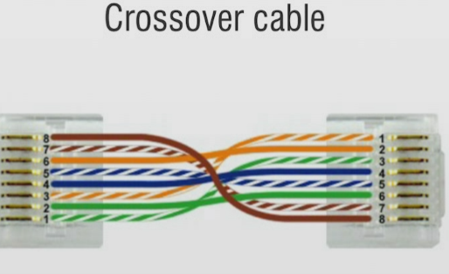

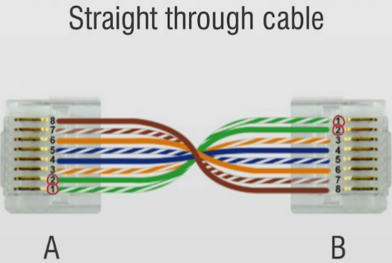

**Crossover**- puts the transmitter cable with the receiver port

**Straight through**- used to connect (daisy chain) two routers

