Milestone Two Narrative – Software Design & Engineering Enhancement

Artifact: Travlr Getaways (CS-465 full-stack project)
Student: Andre Espinoza
Course: CS 499 – Milestone Two

1) Brief description of the artifact
Travlr Getaways is a MEAN-style application I originally built in CS-465. It has a Node and Express backend with MongoDB and an Angular admin site used to manage trip information. For Milestone Two, I focused on strengthening the software design and improving the security model. I added user roles, expanded the Express middleware, and updated the Angular client so the admin interface follows those rules correctly. These enhancements build directly on my original project and help me show real software engineering skills in a full-stack context.

2) Why I selected this artifact and what skills it showcases
I chose Travlr because it is the closest thing to a real application I built in the program. It touches every layer: routes, middleware, data models, UI, guards, and template logic. Enhancing it gave me a chance to show how I think about design, separation of concerns, and security. It also allowed me to fix weaknesses from the original version and demonstrate growth.
Originally, the API only checked for a token. Any logged-in user could write to the database, and the Angular guard simply checked whether a token existed. Error messages were inconsistent, and the server didn’t differentiate between user types. After the enhancement, the project now uses role-based access control. The server enforces requireAuth and requireRole(‘admin’) on write routes, while reads remain public. Tokens now carry the user’s role, and Angular honors this with a guard that reads route metadata and template logic that hides the Add and Edit buttons unless the user is an admin. I also standardized error responses so the API behaves predictably and is easier to demonstrate in Postman and the admin UI.
To support this, I updated user.js to include a role field, added role information to JWT creation, expanded the middleware to include requireRole, and protected POST, PUT, and DELETE requests on the trip routes. On the frontend, I updated the guard to check allowed roles, adjusted the routing module, added a simple role helper in auth.service.ts, and updated templates so the UI matches the security rules from the server.

The screenshots I included in the submission show all of this in action: logging in as admin, logging in as a user, being blocked with 401 and 403 responses, successfully creating trips as an admin, viewing trips publicly, and seeing the admin-only interface appear or disappear based on role. These concrete examples show back-and-forth communication between the two sides of the app and demonstrate practical software engineering and security work.

3) Course outcomes I targeted and progress
My main focus in this milestone was the software engineering and design outcome. I used well-established practices like JWTs, Express middleware, and Angular route guards to implement a cleaner and more realistic structure. Server-side enforcement is stricter and more secure, and the frontend now respects the backend’s rules instead of trying to create its own.
I also made progress toward the security mindset outcome. I tested multiple failure paths such as no token, invalid token, and wrong role, and made sure the API responded with clear and appropriate status codes. This helped me understand how important predictable error handling is for both debugging and user experience.

The communication outcome also plays a role here. I completed an informal code-review video, documented what changed, wrote clear comments, and captured screenshots that show the entire flow from seed to login to permissions. The combination of code updates, testing, and communication helped me understand the artifact from a higher-level perspective.

Algorithms and database enhancements are planned for later milestones, so this submission stays focused on design and security improvements.
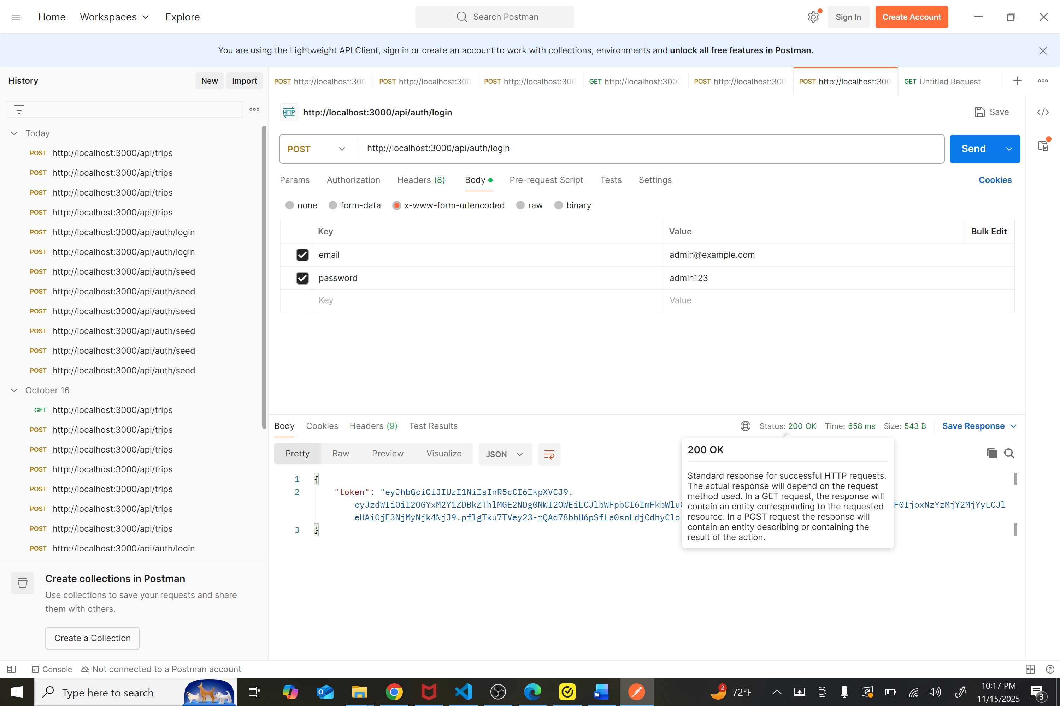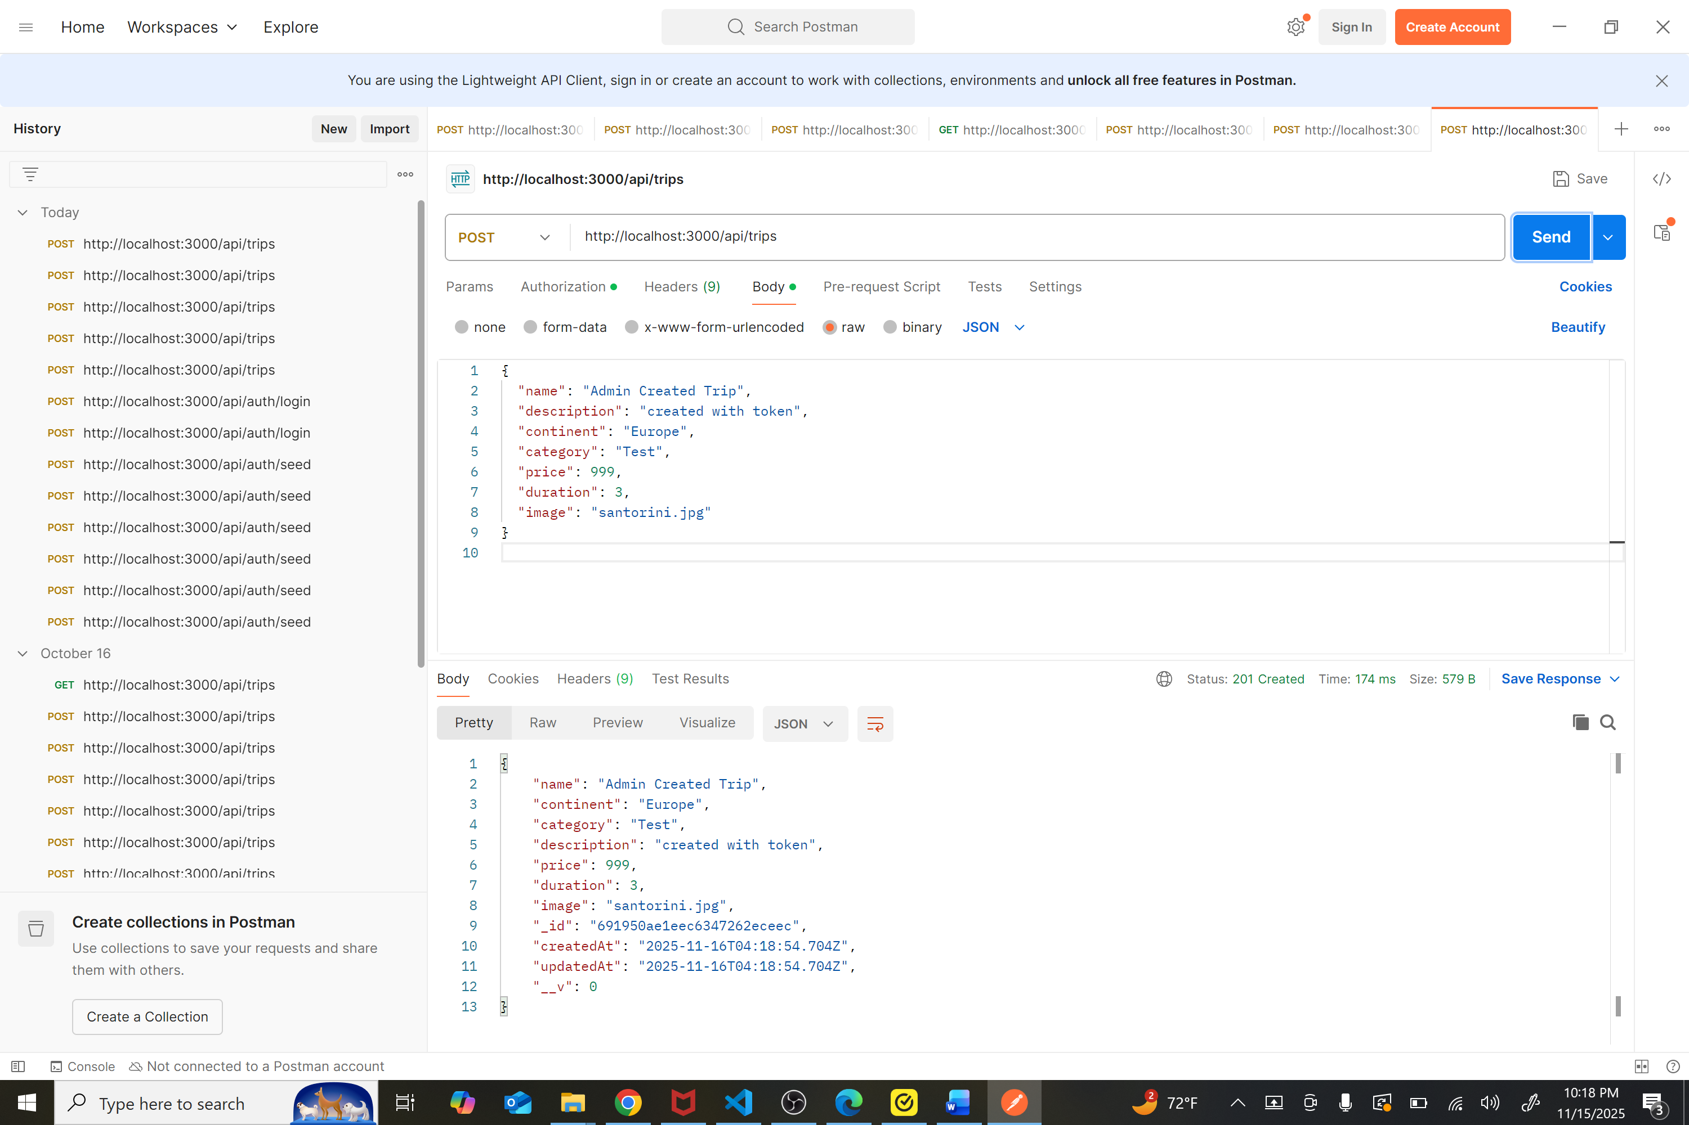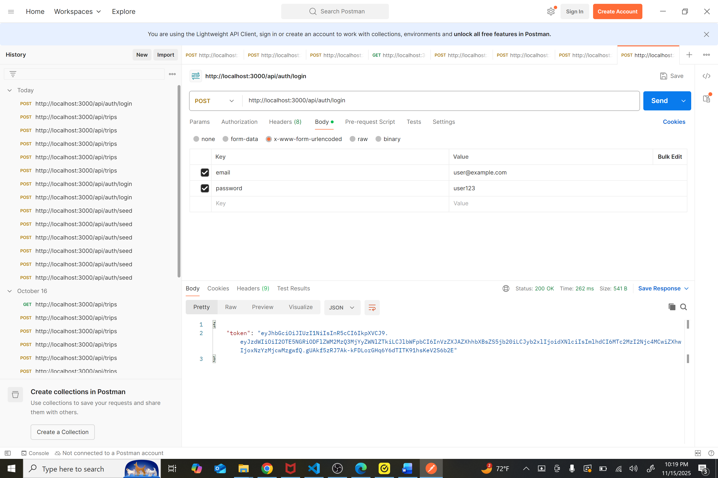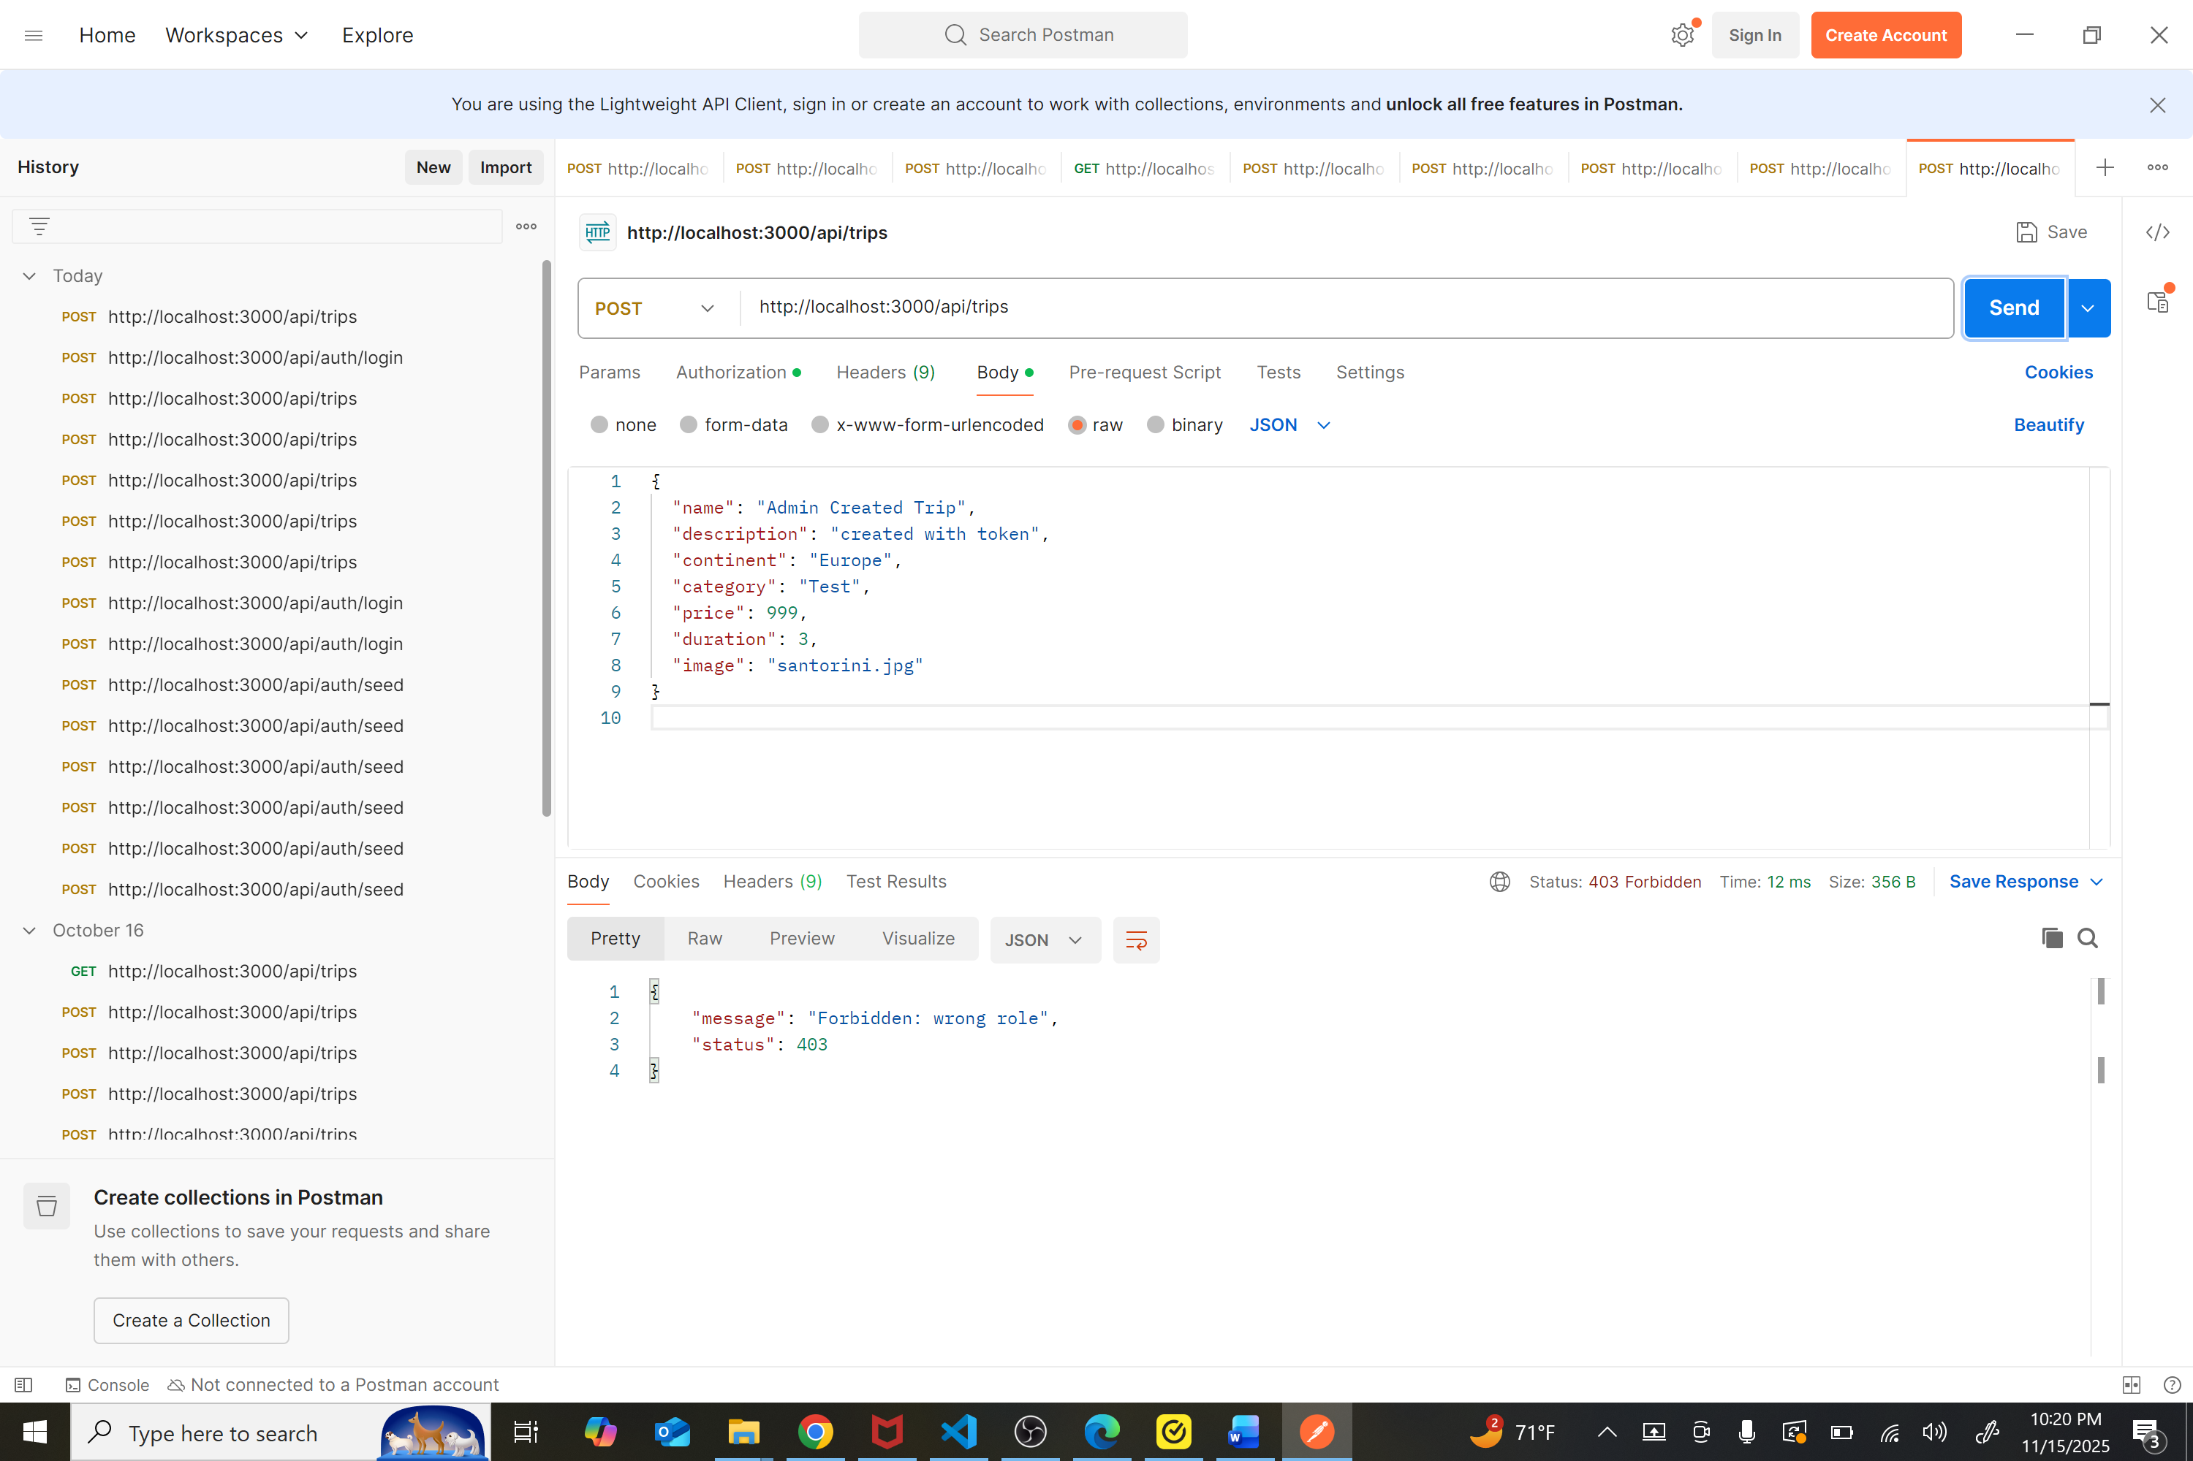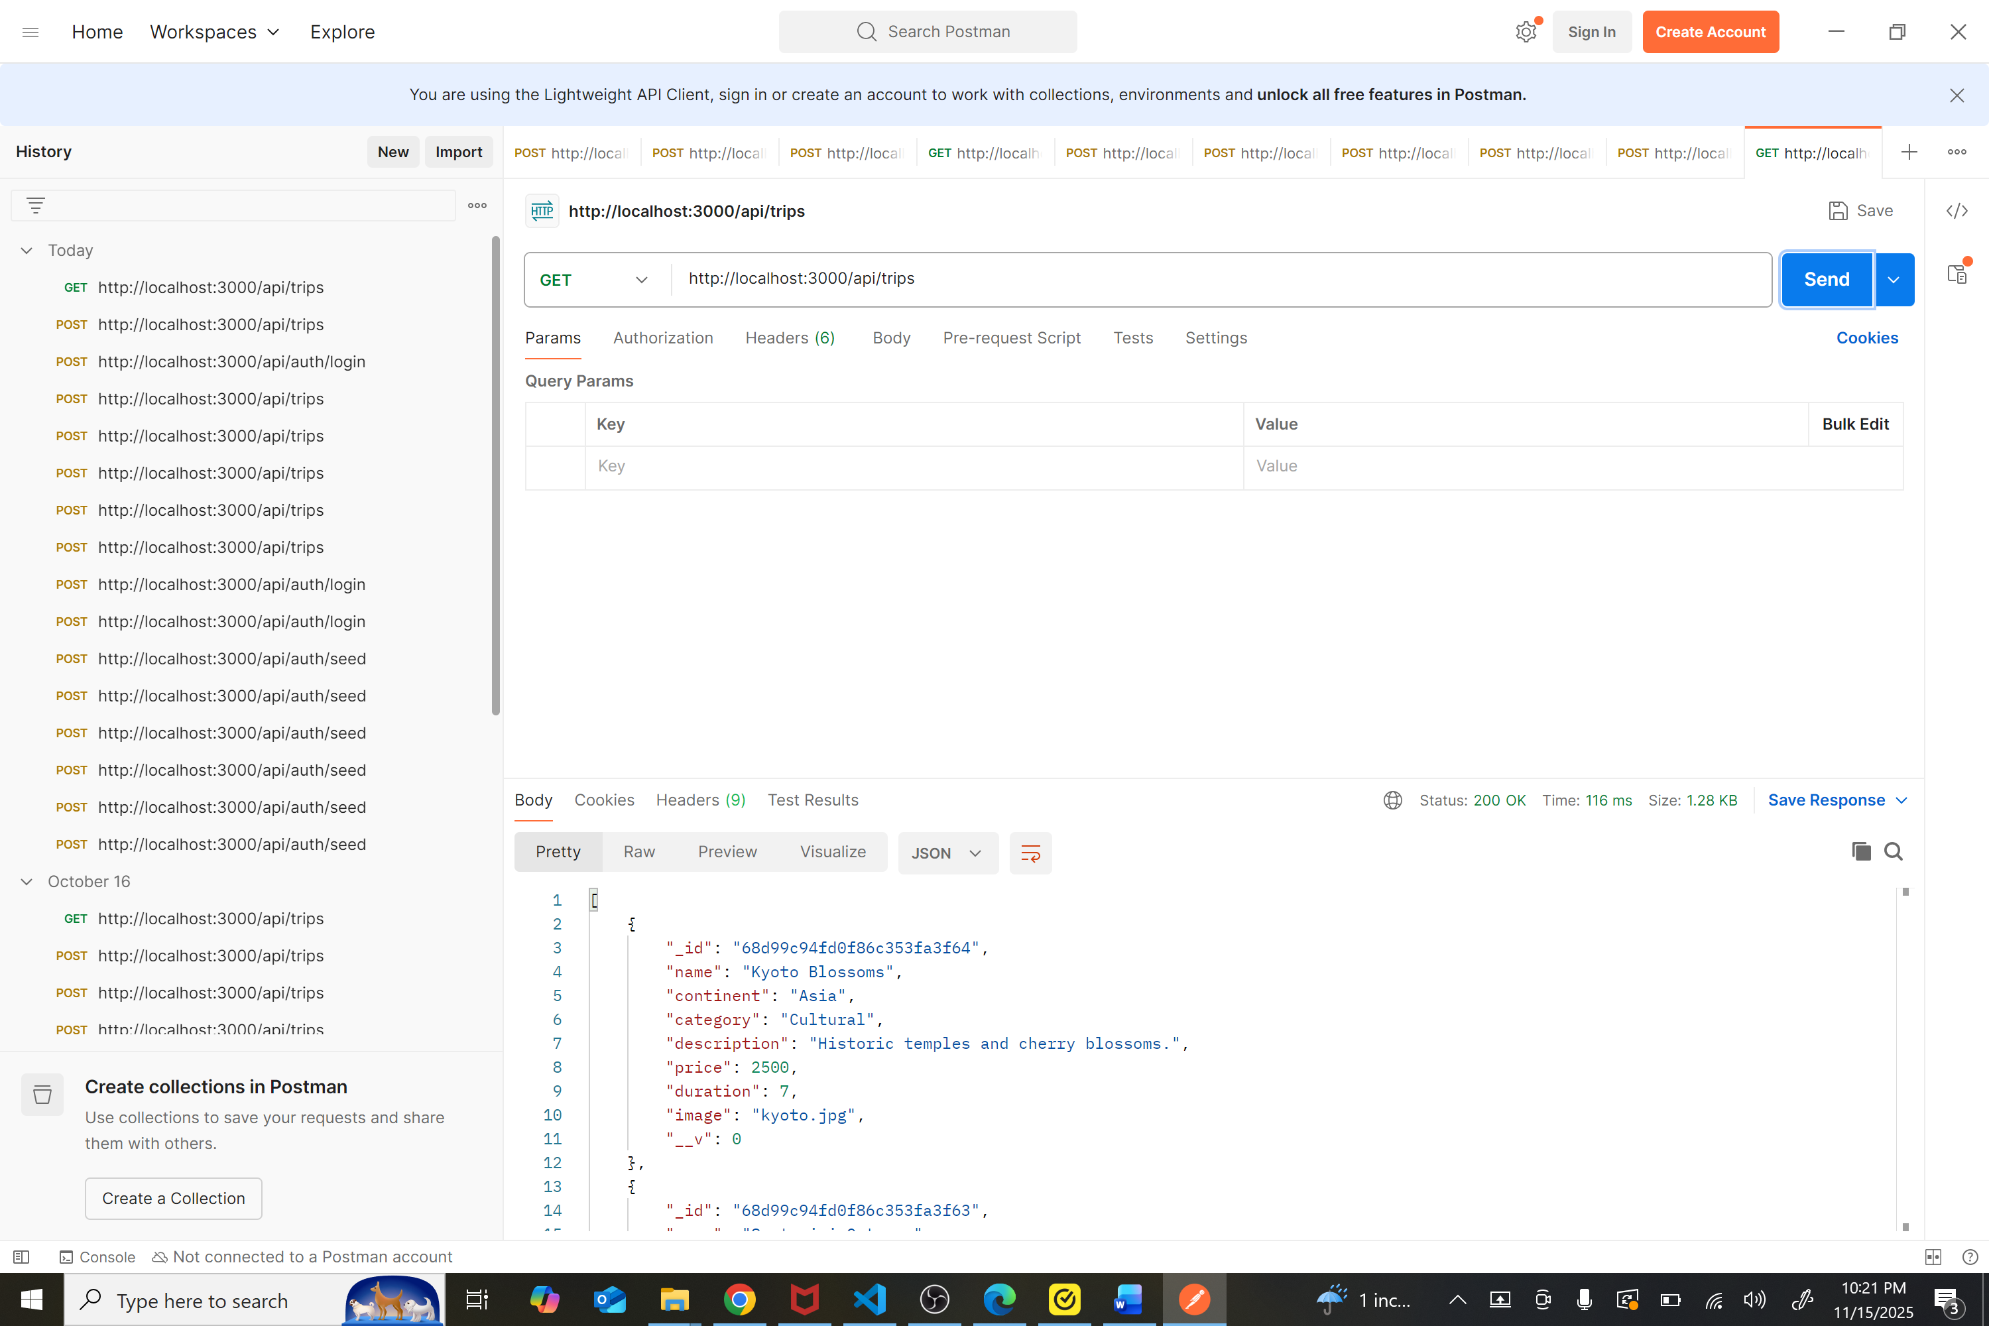

4) Reflection on the process

Enhancing the artifact taught me a few important lessons. The first is that the backend is the real source of truth. Hiding buttons on the frontend is good for usability, but actual security lives in middleware. Adding role checks and enforcing permissions at the API level made the system more trustworthy and closer to approaches used in real applications.
I also learned the value of making roles easy to work with. By including the role directly inside the JWT, the Angular app can check permissions quickly without making additional API calls. It keeps the project simple while still showing I understand the concept.
Consistency ended up being more helpful than I expected. Standardizing error responses made the project easier to test, demonstrate, and expand. It also made the Postman screenshots cleaner and the logic easier to explain in my code review.
There were a few challenges. I needed the seed endpoint to reliably create both an admin and a regular user, otherwise showing the 401 and 403 flows was confusing. I also had to make sure the Angular routes included role metadata; without it, the guard couldn’t enforce anything. Finally, I synced the UI so it matched the backend rules, because seeing a button but being blocked by the server creates bad UX.
Going forward, I want to add server-side validation for trip fields, implement the recommendation logic I planned earlier, and build the bookings feature with atomic updates so two users can’t overbook at the same time.

Summary
This enhancement improved the overall structure and security of my Travlr Getaways project. I added role-based access control, cleaned up the server logic, updated the Angular client to follow those rules, and created consistent error handling to tie everything together. The final result is a safer, clearer, and more professional version of the original artifact that fits well in my ePortfolio and shows strong progress in software design and engineering.

