Milestone Four Narrative: Databases Enhancement
Artifact: Travlr Getaways, originally built in CS-465 (June 2024)
Student: Andre Espinoza

1) What the artifact is and when it was first built
This milestone continues my Travlr Getaways project from CS-465 back last semester. The original version used Node, Express, MongoDB with Mongoose, and Angular. At that time the application could only store and display trips, descriptions, prices, and images. For Milestone Four, I built out a real booking system so users could actually reserve trips instead of just viewing them. This meant creating a new database model, expanding the schema, writing new API routes, and connecting everything into the UI just enough to prove the feature works. I finished this enhancement in November of 2025, and this is the most complete backend feature I’ve built in the CS program.
2) Why I chose this artifact and how it was improved
I selected this artifact because it let me demonstrate actual database logic instead of basic CRUD. A booking feature forced me to think about schema design, permissions, data integrity, and safe update behavior. That is more realistic and more valuable than simply adding another endpoint.
I created a Booking model with userId, tripId, party size, and timestamps. I also updated the Trip model by adding a capacity field so that every reservation reduces the remaining available seats. I added an index to booking queries using userId, tripId, and createdAt so both admin and user lookups run efficiently.
The most important improvement is the atomic update. I used one database write to handle capacity and booking together:
FindOneAndUpdate where capacity is greater than or equal to partySize, combined with an increment that reduces available seats.
If capacity is too low, the write never happens and the API returns 409. This removes the risk of overbooking without rollbacks or collision issues.

I added the POST /api/bookings route for creating bookings, GET /api/bookings?me=true to view a user’s own bookings, and GET /api/bookings for admin-level viewing. I tested all cases in Postman and watched capacity decrease correctly while oversized bookings failed exactly as expected.
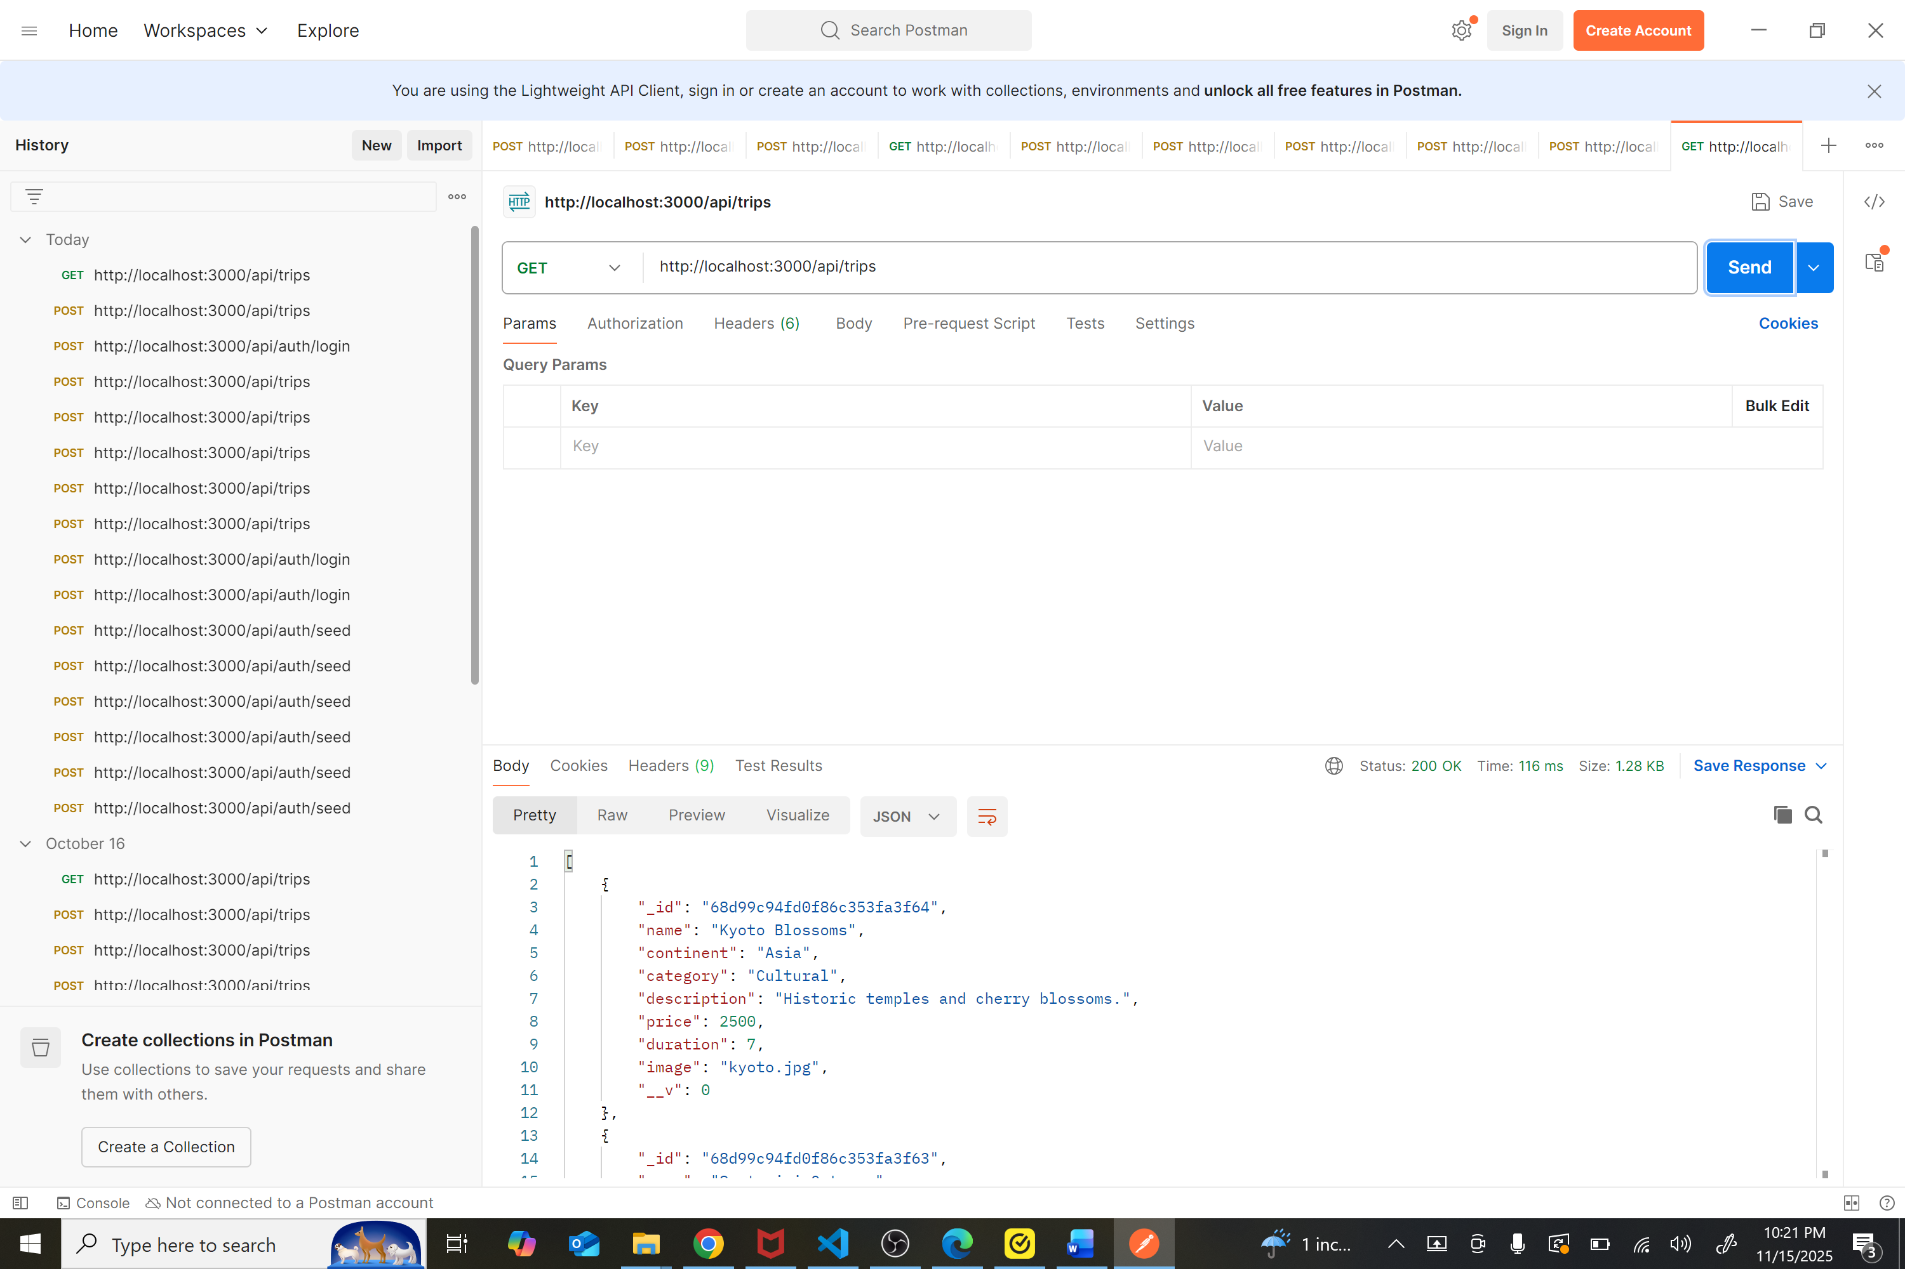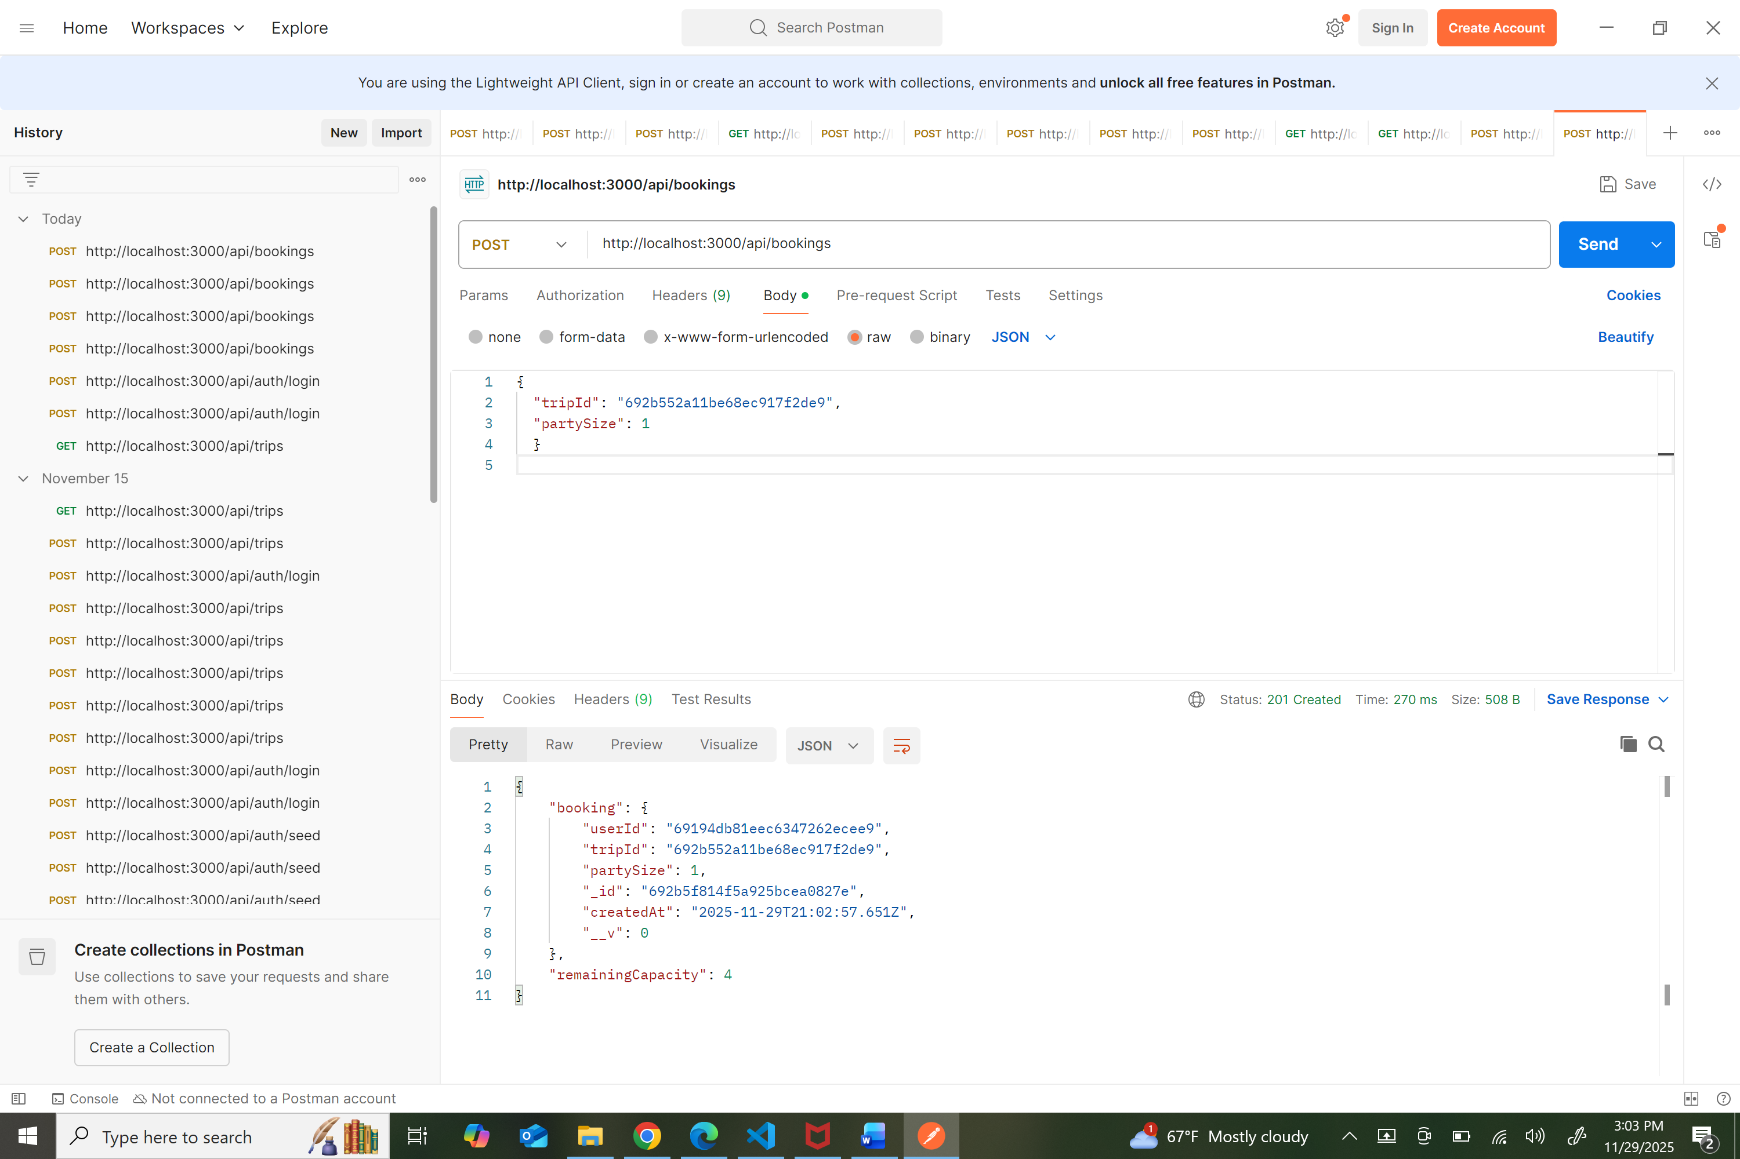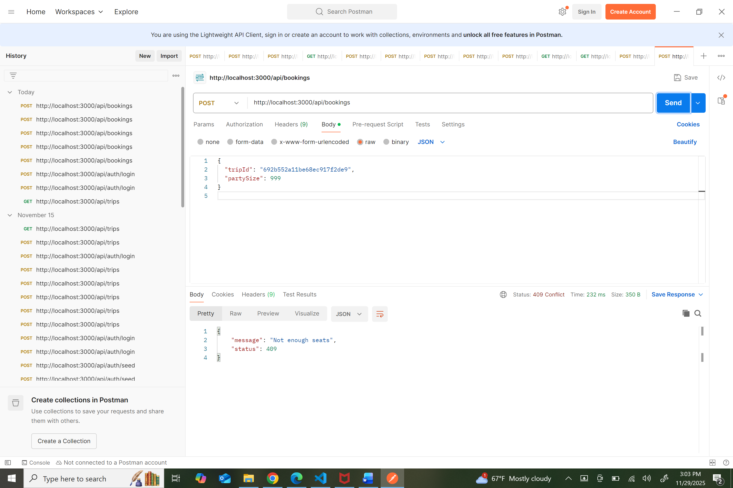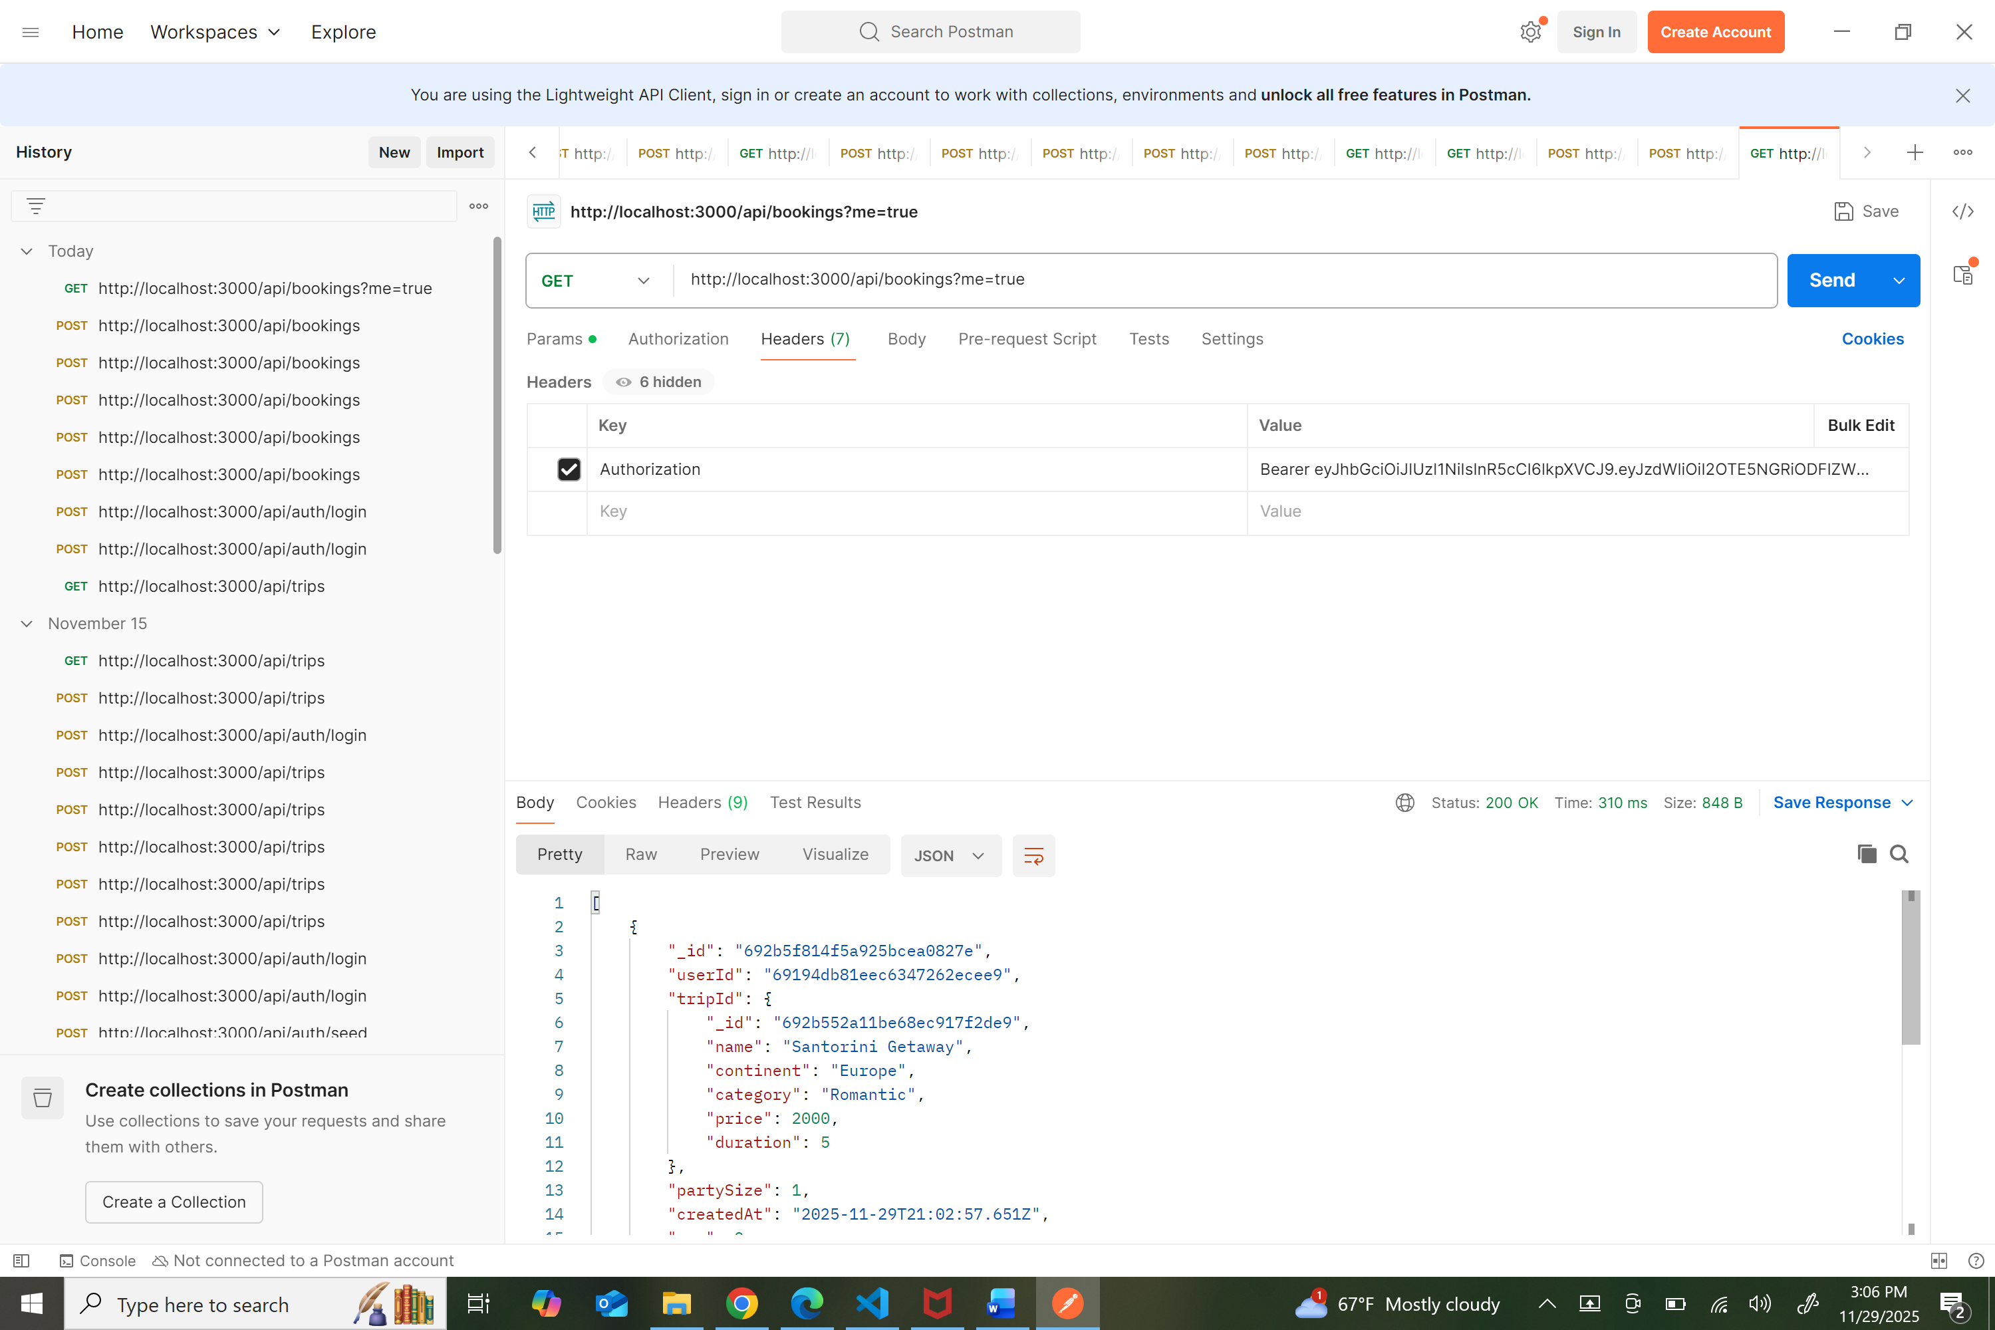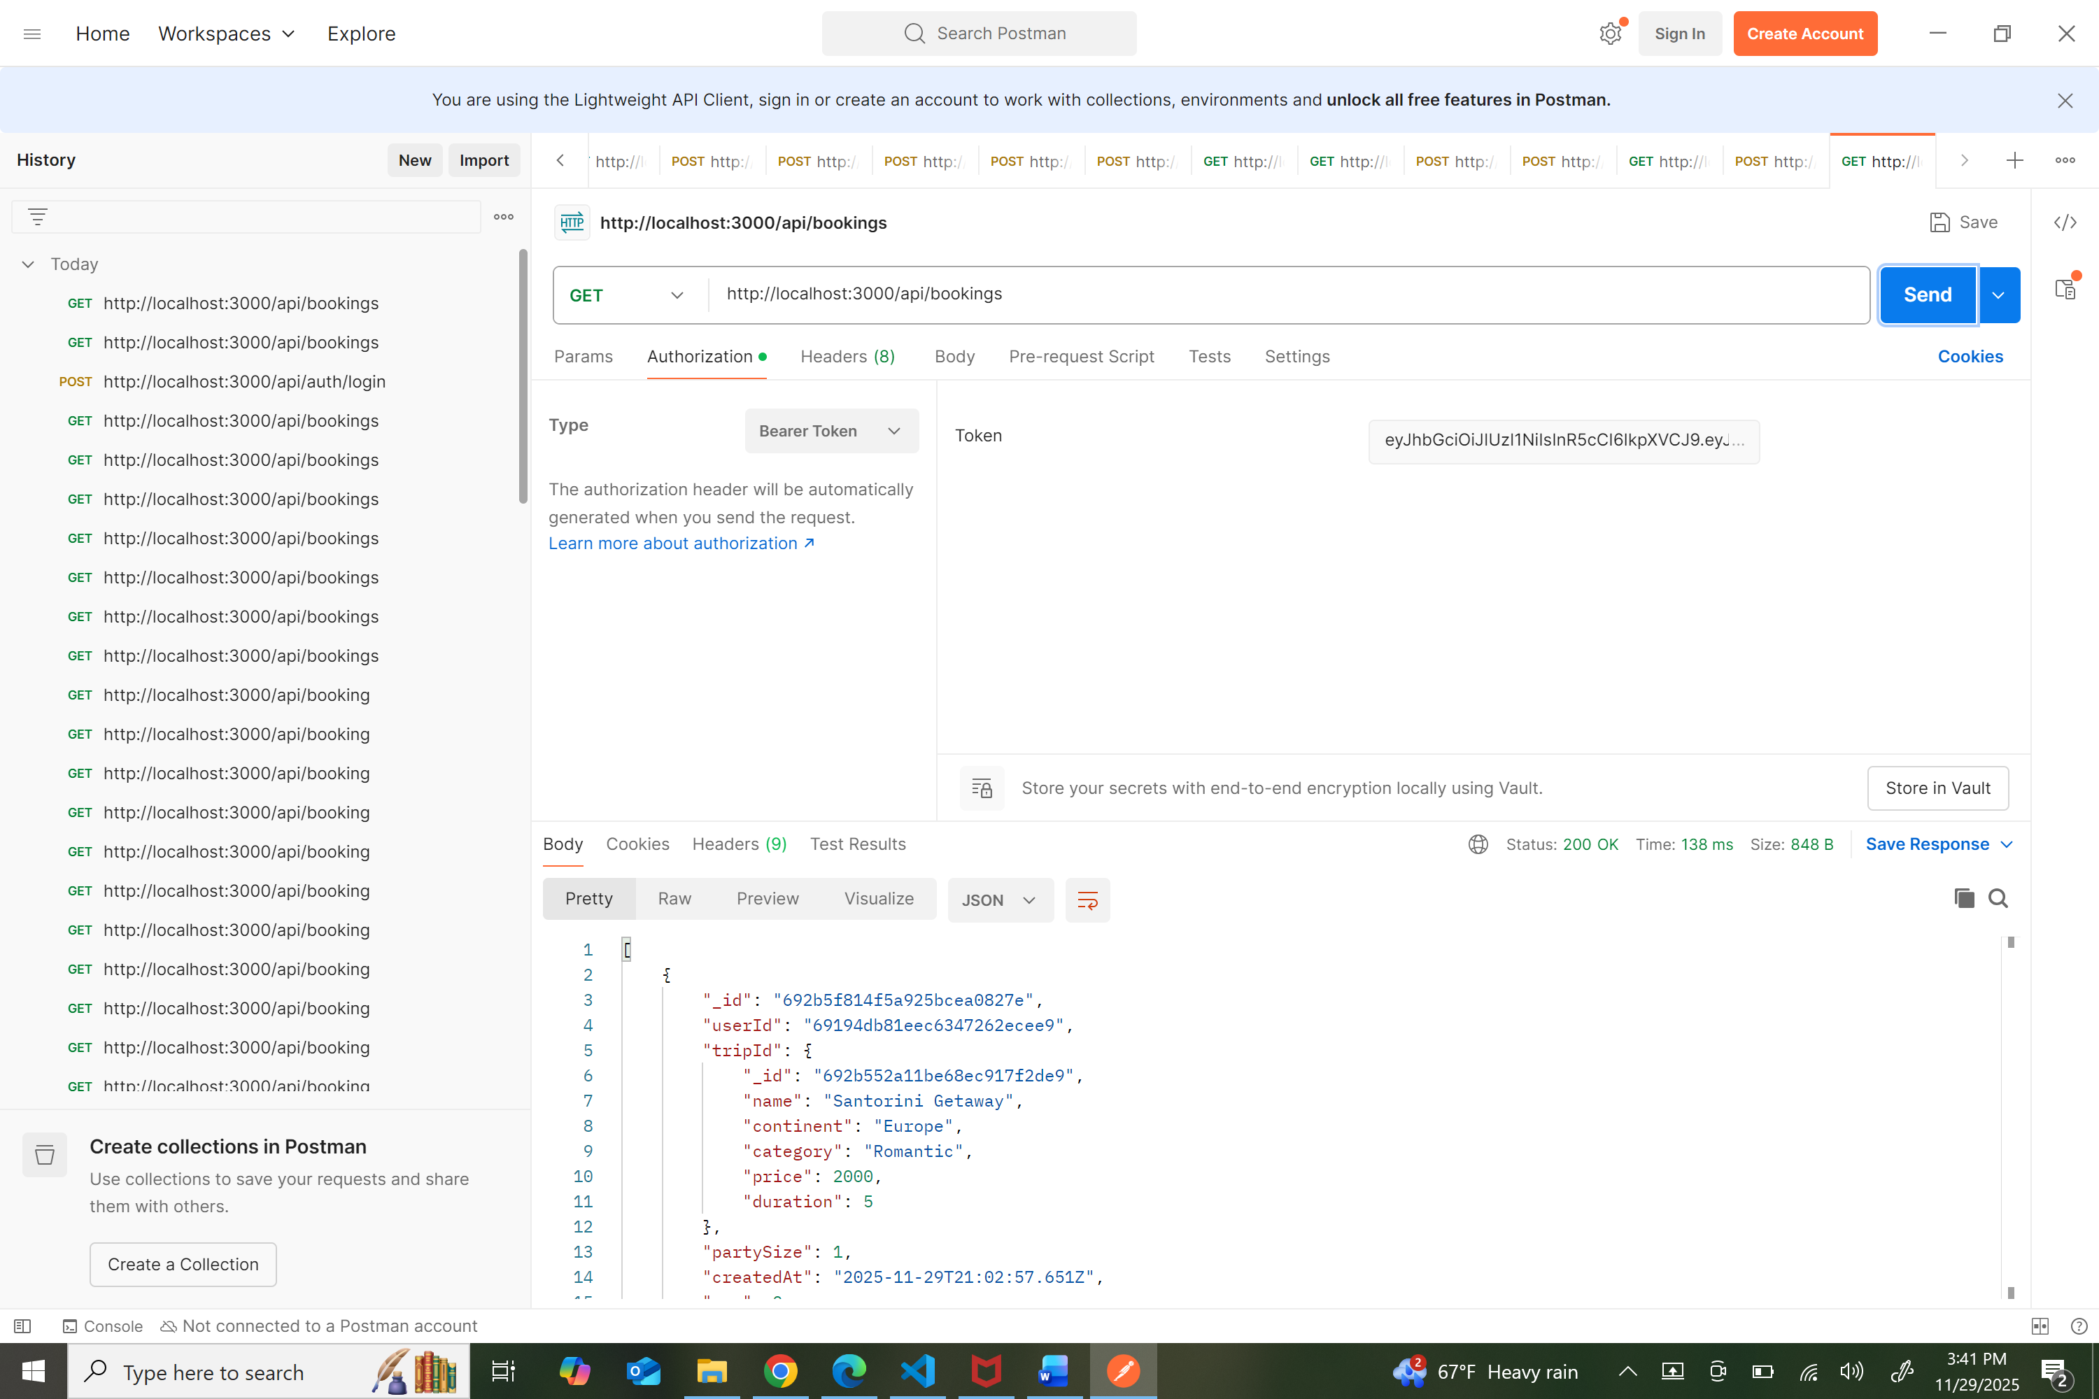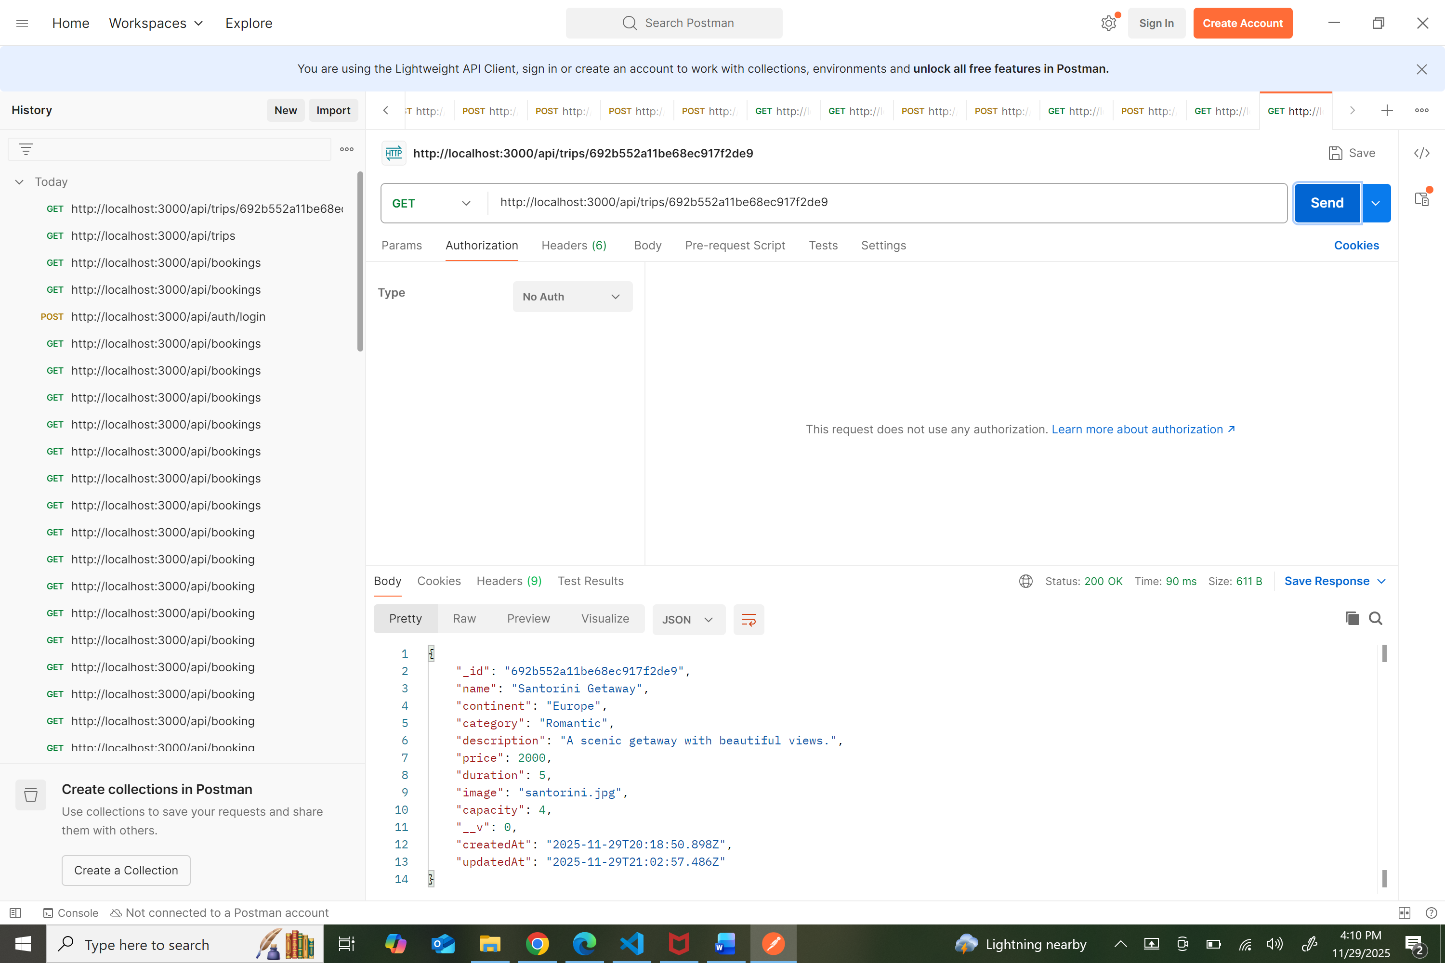

3) Outcomes achieved and progress
This directly fulfills the database outcome. It shows that I can design schemas, apply data integrity rules, and create working backend features. It also demonstrates software engineering and security outcomes through authentication, admin route restrictions, and consistent JSON responses. Algorithms and data structures were addressed previously in Milestone Three through the recommendation system, so no changes are needed to my plan.
4) Reflection and what I learned
The biggest lesson here is that protecting data is just as important as storing it. If availability is checked before updating, users could book at the same time and break the system. By using a single atomic update with the capacity check and decrement, the rule is enforced by the database itself. Testing in Postman made that clear: valid bookings reduced capacity, invalid ones returned 409 and changed nothing. Users only saw their own reservations, and the admin account could see all bookings.
Token handling in Postman was the biggest challenge. If the token was expired or attached incorrectly, the request was blocked. The UI was kept simple on purpose since the milestone focused on the backend. If I expand this later, I would create an Angular admin dashboard and possibly add media uploads. For now, the feature works exactly as intended and meets the database outcome fully. Luffy the main protagonist in One piece didn’t get into gear Five overnight. This is extremely challenging for me and I am proud of how far I came.
This enhancement shows that I can build scalable database features, enforce security, prevent race conditions, design clean API routes, and verify the results through testing. Along with my first two milestones, this completes all three CS-499 enhancement categories.

